APPLICATION FOR FULL PLANNING PERMISSION
CASE OFFICER REPORT

APPLICATION REFERENCE: | PL/2025/09391
APPLICATION TYPE: | Full planning permission
SITE ADDRESS: | Cereal Partners, Staverton, Trowbridge, BA14 6PG
DEVELOPMENT DESCRIPTION: | Construction of new factory building (use class b2) and associated works/infrastructure (2no.silos)
RECOMMENDATION: | Approve with Conditions

SITE DESCRIPTION/CONTEXT: The application site relates to an existing and established factory site located in Staverton, to the south of the River Avon.

The application site is located within various buffer zones associated with the Bath and Bradford on Avon Bat Special Area of Conservation (SAC). There is a bridleway to the south of the existing factory (reference STAV1), but this would not be impacted by the proposals.

With reference to the Flood Map for Planning the site is located in Flood Zones 2 and 3, with aspects of the site also being susceptible to surface water flooding. The Council’s Strategic Flood Risk Assessment (SFRA), also illustrates part of the site falling in an area susceptible to high groundwater flooding, as shown in the below extract:

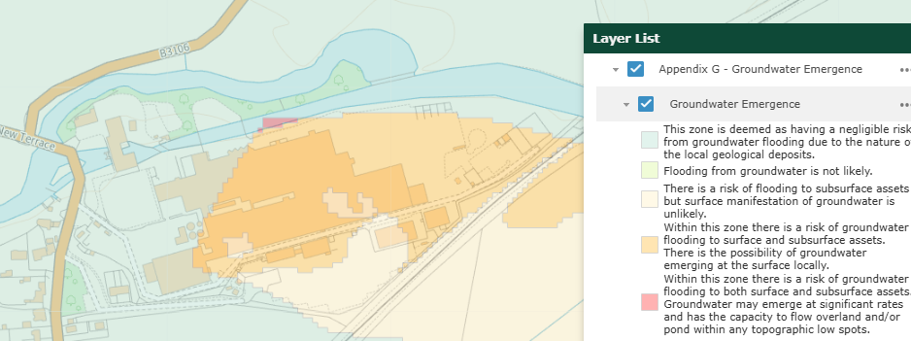

There is a Grade II listed bridge to the west of the existing factory site, the setting of which is already influenced by the existing factory buildings and infrastructure. The listed bridge is well trafficked at present, as it is the main route between Hilperton, Staverton, Holt and Bradford on Avon.

PROPOSAL: The proposal is seeking planning permission for the construction of a new factory building (Use Class B2) and associated infrastructure, including two new silos, within the north‑east corner of the existing Cereal Partners UK (CPUK) factory site at Staverton, Trowbridge.

The proposal is in effect an extension to the existing factory, comprising approximately 2400 sqm (ground floor plus a mezzanine), with a building height of 20m, to support the manufacture of ‘ready to eat’ breakfast cereals. The building is intended to provide additional space for raw material intake, processing, packaging and storage, enabling production levels to return to historical peak levels (around 2020), as stated in 3.1 of the submitted Planning, Design and Access Statement.

The new structure would be located on an existing area of hardstanding, away from nearby residential properties and the public highway, and would be connected to the existing factory via an enclosed link, as illustrated in the extract below taken from the submitted proposed site plan (drawing no. 01005)

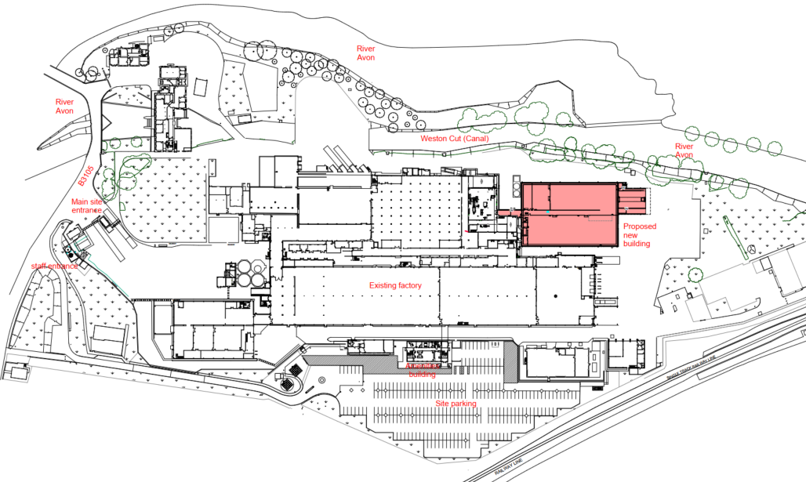

The submitted Planning, Design and Access Statement describes the proposal as a strategic investment (£67m) to support future growth, improve operational efficiency, and ensure the long‑term viability of the Staverton site. It is expected to result in:

- Around 50 new jobs;
- Additional employment during the construction phase;
- Approximately 21 additional daily deliveries, accommodated within existing access arrangements.

Section 6.3 of the Planning, Design and Access Statement confirms that there would be no additional car parking, as the existing provision is considered sufficient to accommodate the additional traffic associated with the proposed new development. The development would result in approximately 21 additional delivery events per day, equating to 42 vehicle movements (two-way trips).

The design is described as functional and purposeful, with a simple industrial form dictated by manufacturing needs, including a milling tower as the tallest element, and materials chosen for durability, hygiene and efficiency.

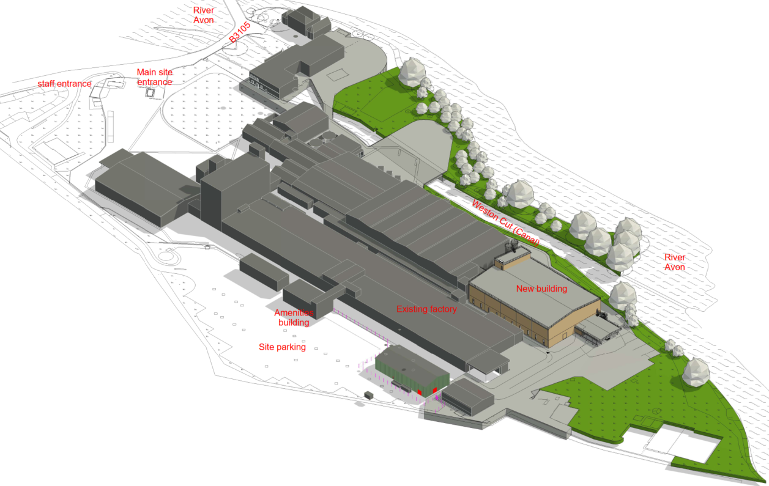

Extract of the ISO Plan View of the Proposed Building – drawing no. 01002

RELEVANT PLANNING HISTORY: There is a lot of planning history on this site, but the most recent applications on this site, as listed below:

PL/2025/09515 - Screening Opinion - TCPA EIA 2006 – Request to provide a formal EIA Screening Opinion from the Local Planning Authority under Regulation 6 of the Town and Country Planning (Environmental Impact Assessment) Regulations 2017 (the ‘EIA Regulations’) to determine whether the construction of a new factory building at the Cereal Partners manufacturing site in Staverton, Trowbridge constitutes ‘EIA development’ (as defined in Regulation 6 (2)) – EIA not required

PL/2025/09247 - Screening Opinion - TCPA EIA 2006 – Request for Screening Opinion under the Town & Country Planning (Environmental Impact Assessment) Regulations 2017 in respect of proposed flood defence measures as submitted under planning application ref: PL/2025/07023 – Undetermined

PL/2025/07023 - Full planning permission – Installation of Flood Resilience Measures approx. 490 metres in length to include; removal of existing concrete kerb and replacement with new (max 450mm in height), installation of new concrete kerb (450mm in height) and flood gates – Undetermined

21/01038/FUL - Full planning permission Decision - Approve with Conditions Date: 20/4/2021 – Proposed new sprinkler tanks, pump house and associated foundation base

RELEVANT LEGISLATION, POLICIES AND GUIDANCE

National Planning Policy: National Planning Policy Framework (NPPF); Planning Practice Guidance (PPG); National Design Guide

Development Plan: The development plan for Wiltshire comprises the Wiltshire Core Strategy (WCS) (adopted January 2015) and any made neighbourhood plans, which remain the principal statutory planning document guiding development across the county. In line with Section 38(6) of the Planning and Compulsory Purchase Act 2004, planning decisions must be made in accordance with the development plan unless material considerations indicate otherwise.

Though the development plan is considered as a whole, those parts deemed to be particularly relevant to this application are listed below:

The adopted Wiltshire Core Strategy (WCS), with particular regard to:

- Core Policy 1 Settlement Strategy;
- Core Policy 2 Delivery Strategy;
- Core Policy 3 Infrastructure Requirements;
- Core Policy 7 Spatial Strategy: Bradford on Avon Community Area;
- Core Policy 34 Additional Employment Land;
- Core Policy 35 Existing Employment Land
- Core Policy 41 Sustainable Construction and Low-Carbon Energy;
- Core Policy 50 Biodiversity and Geodiversity;
- Core Policy 51 Landscape;
- Core Policy 52 Green Infrastructure;
- Core Policy 55 Air Quality;
- Core Policy 57 Ensuring High Quality Design and Place Shaping;
- Core Policy 58 Ensuring the Conservation of the Historic Environment;
- Core Policy 60 Sustainable Transport;
- Core Policy 61 Transport & Development;
- Core Policy 62 Development Impacts on the Transport Network;
- Core Policy 64 Demand Management;
- Core Policy 67 Flood Risk

Draft Wiltshire Local Plan Policies: At Full Council on 19 May 2026, the elected members of Wiltshire Council agreed to withdraw the emerging WLP. It will now be subject to a legal process to finalise its withdrawal, which is likely to happen in July and August 2026. As such, the WLP has no material weight for the purposes of the application.

Supplementary Planning Documents and other Guidance:
- Wiltshire Design Guide (adopted April 2024)
- Trowbridge and Westbury Bat Mitigation Strategy (TWBMS), July 2025
- Wiltshire Local Transport Plan 2011-2026 (LTP3), adopted 2015 - including the Car Parking Strategy and Cycling Strategy
- Wiltshire Council Local Transport Plan 2025 -2038 (LTP4), adopted March 2025
- Wiltshire Council’s Waste Storage and Collection: Guidance for Developers Supplementary Planning Document, January 2017
- A Green & Blue Infrastructure Strategy for Wiltshire: Wiltshire’s Natural Environment Plan 2022-2030
- Air Quality SPD, July 2023

ISSUES: Principle of the development; design and visual impact; heritage; amenity; highways; ecology; and drainage

CONSULTATION RESPONSES

Bradford on Avon Town Council: Object for the following reasons: “In line with the Environment Agency comments the town council would like to see a Flood Risk assessment which takes into consideration the impact further downstream at Bradford on Avon as the proposed development could exacerbate the town's flooding issues further. The town council would also expect to comment on any revised flood risk assessment the developer presents which takes any consequences downstream into consideration”.

Environment Agency: No objection, subject to conditions

Holt Parish Council: Issued a mixed response, raising concerns regarding cumulative impacts, traffic pressures from additional vehicle movements and lack of sustainable travel options, flood-related disruption, but supports the continued operation of the Cereal Partners site.

Staverton Parish Council: No objection, but have commented on the increased use of B3105 from traffic generated from the Cereal Partners and Apetito factories, and from local housing developments.

Wiltshire Council Arboricultural Officer: No objection, subject to conditions

Wiltshire Council Conservation: No objection

Wiltshire Council Drainage: No objection

Wiltshire Council Ecology: No objection, subject to conditions

Wiltshire Council Highways: No objection, subject to conditions

Wiltshire Council Landscape: No objection

Wiltshire Council Public Protection: No objection, subject to conditions

REPRESENTATIONS: In accordance with the requirements of the Town and Country Planning (Development Management Procedure) (England) Order 2015 (as amended), the application was publicised by way of:

- Neighbour notification letters sent to adjoining and nearby properties;
- A site notice displayed near the site;
- An advertisement placed in the local press

These methods were used to inform interested parties and provide a period of 21 days for comments to be submitted.

Below is a summary of the representations received during the consultation period. Only material planning considerations have been taken into account in the assessment of this application. Non-material issues, such as property values or private legal disputes, cannot be considered in the determination process.

A total of 11 representations have been received, with 2 providing comments, 6 raising objections and 3 in support but raising concerns regarding additional traffic.

Salisbury & Wilton Swifts: Advised on the need to provide habitat opportunities and the inclusion of bird boxes.

Third-Party Representations: The following summarised concerns and comments were received over the course of the application’s determination period:

- Cumulative impact of the proposal with other developments, specifically in terms of traffic
- Improvements needed to the existing access to prevent vehicles from holding up traffic
- Traffic calming measures or path widening needed
- Increase in lorries and HGV using the road and bridge
- Impact of additional traffic using bridges which are already at capacity
- Vehicles failing to obey speed limit
- Risk of additional traffic to existing residents and pedestrians
- Visual impact
- Flood risk
- Impact on neighbouring amenity from additional traffic
- Lack of renewable energy measures
- Noise, smell/odour, lighting, dust impacts from the proposal

ASSESSMENT: Section 38(6) of the Planning and Compulsory Purchase Act 2004 states:

"If regard is to be had to the development plan for the purposes of any determination to be made under the planning Acts, the determination must be made in accordance with the plan unless material considerations indicate otherwise."

In accordance with this statutory requirement, this application has been assessed against the relevant policies of the Development Plan, including the Wiltshire Core Strategy (2015) and, where applicable, any made Neighbourhood Plans. Consideration has also been given to the policies of the National Planning Policy Framework (NPPF) as a material consideration in the assessment.

Environmental Impact Assessment (EIA) Screening: In accordance with the Town and Country Planning (Environmental Impact Assessment) Regulations 2017 (as amended), the local planning authority has considered whether the proposed development constitutes EIA development.

A formal screening opinion (under application reference: PL/2025/09515) has been issued by the local planning authority, which concluded that the proposal does not constitute EIA development as the proposal is not likely to have significant effects on the environment.

Principle of Development: Policy CP1 of the adopted Settlement Strategy of the WCS establishes a hierarchy of settlements to guide where development should be focused. The policy prioritises growth in:
- Principal Settlements (e.g., Salisbury, Chippenham, Trowbridge) – main focus for strategic growth.
- Market Towns – support local services and employment; suitable for sustainable development.
- Local Service Centres – smaller towns and villages with a range of services; limited development supported.
- Large and Small Villages – development should be limited and respond to local needs.
- Outside the defined settlements – development is strictly controlled and generally not supported unless exceptional circumstances apply.

Policy CP2 of the WCS sets out how development would be distributed and delivered across Wiltshire. The policy emphasises:
- Sustainable patterns of growth, reducing the need to travel and supporting local services.
- Development should be plan-led, aligning with the settlement strategy and supported by infrastructure.
- Windfall development (not allocated in plans) must still comply with the principles of sustainable development.
- Development outside settlement boundaries is generally not permitted, unless it meets specific policy exceptions (as set out in paragraph 4.25 of the WCS).

Together, CP1 and CP2 ensure that new development is strategically located, sustainable, and supports the character and function of Wiltshire’s communities.

The application site is located outside the defined settlement boundary for both Trowbridge to the south and Holt to the north. Staverton itself is listed in Appendix F of the adopted WCS as a small village that does not have a boundary. Therefore, in policy terms of the application site is located in open countryside. However, the subject site is located within the confines of an existing established industrial site, where a factory has been present for several decades.

It is duly noted that the existing factory has not been identified within the adopted WCS as a Principal Employment Area (as identified and safeguarded by CP35 and the relevant spatial strategies). However, the site does have a historic B2 use, with this proposal providing additional employment and manufacturing to the area through the expansion of the existing factory. Supporting text to policy CP35 at paragraph 6.16 states that “it will also be important to retain existing employment uses outside the Principal Employment Areas to maintain diversity and choice of sites for employers and allow for local business expansion”. The proposed location of the new factory building would be located within the existing factory complex on an existing area of hardstanding within the established industrial site. The proposal would be viewed in the context of the existing factory buildings and infrastructure.

CP34 allows for employment development outside principal settlements where these are adjacent to these settlements and seek to retain or expand businesses currently located within or adjacent to the settlements. It also permits employment development that supports food production and is for existing rural based businesses within or adjacent to large and small villages where they are considered essential to the wider strategic interests of the economic development of Wiltshire.

The policy requires such developments to be supported where they meet sustainable objectives set out in the adopted WCS, provided they are consistent in scale with their location, do not adversely affect nearby buildings or detract from residential amenity. Developments must demonstrate that they are required to benefit the local economic and social needs and should not undermine the delivery of strategic employment allocations and are supported by adequate infrastructure.

The proposed development is an expansion of an existing business for food production adjacent to a settlement comprising a small village that is considered essential to the wider economic development of Wiltshire given it is a successful growing local business of international reputation.

The technical detail sections below assess the sustainability of the proposals as well as the scale, design, impact on residential amenity and infrastructure. These sections conclude that the proposal is acceptable in these regards. The submission demonstrates it is required to benefit local and social economic needs by virtue of it being for an expanding business and the retention of local employment and the creation of at least 50 new local jobs. With reference to the submitted Planning, Design and Access Statement, this proposal would create the following economic and social benefits:
- Creation of around 50 new jobs at the facility;
- Additional jobs during the construction phase;
- Secures existing employment at the site (circa 200 existing staff);
- Represents a £67 million investment in the local area

Given it is the expansion of an existing established successful industrial site, its expansion would not undermine the larger strategic employment allocations identified. Accordingly, subject to the detailed technical considerations set out below, the proposed development is acceptable in this regard.

Furthermore, the supporting text for CP7 notes the loss of employment land to housing and emphasises the need to resist further losses while supporting the provision of additional employment opportunities.

Paragraph 85 of the NPPF states that planning policies and decisions should help create conditions in which businesses can invest, expand and adapt. It requires that significant weight is placed on the need to support economic growth and productivity, taking into account both local business needs and wider opportunities for development.

Paragraph 87 of the NPPF states that planning decisions should recognise and address the specific locational requirements of different sectors. This includes, in criterion c) the expansion or modernisation of industries to support economic growth and resilience.

The principle of development is therefore considered acceptable, subject to assessment of other material and technical considerations.

Design, Landscape Impact, and Visual Impact on the Character and Appearance of the Area: Policy CP57 of the WCS requires a high-quality design that:
- Enhances local character.
- Responds to the natural, historic, and built environment.
- Retains important features (e.g., trees, hedges).
- Supports sustainable construction and compatibility with surrounding uses.
- Creates safe, legible, and accessible spaces.

In addition to the above, CP51 of the Wiltshire Core Strategy requires development to:
- Protect, conserve, and enhance landscape character and quality.
- Respect local distinctiveness, key views, and visual receptors.
- Give particular weight to impacts on National Landscapes (formerly AONBs) and locally valued landscapes.

Section 12 of the NPPF emphasises design that is:
- Visually attractive.
- Functionally effective.
- Contributes to the quality of the built environment.

The NPPF also emphasises the need to protect and enhance valued landscapes, particularly those with scenic, historic, or ecological significance. Planning decisions should:
- Recognise the intrinsic character and beauty of the countryside.
- Safeguard key views, local distinctiveness, and landscape settings.
- Ensure development is well-integrated into its surroundings and avoids visual intrusion, especially in sensitive or designated areas.

The Wiltshire Design Guide encourages sensitivity to local character, materials, and architectural styles and supports modern living standards while maintaining aesthetic and functional quality.

Building for a Healthy Life Framework promotes healthy, inclusive, and sustainable places. The document encourages:
- Walkability.
- Access to green space.
- Active design principles for well-being.

The application is seeking planning permission for a new factory building comprising a total GIA of 2400sqm (comprising of ground floor and mezzanine) within the grounds of an established factory site, so it is appreciated that, given the industrial nature of the proposal, there would be some visual impact. However, the proposed development would be sited within the north-east corner of the site, adjacent to the existing factory complex, positioned away from residential areas. The proposed building would also be positioned away from the River Avon.

The scale of the proposed development has been dictated by the operational requirements of the proposed development, but the scale and mass of the building have been designed as low as possible to prevent the building from appearing visually obtrusive and to ensure the scale remains consistent with its location.

Due to the nature of the proposal, the design of the factory would be functional and industrial in appearance, and would be of a design to positively reflect that of the existing building, as illustrated by the extracts of the submitted elevation drawing provided below:

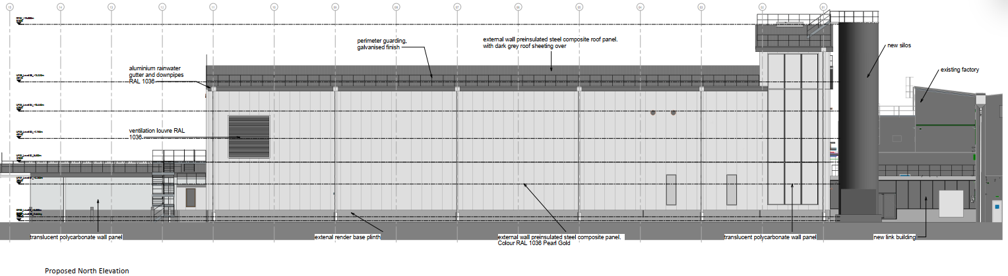
Proposed north elevation as taken from drawing no. 01009

It is acknowledged from the submitted representations that concerns have been raised regarding the visual impact of the proposed development on existing dwellings to the north of the application site, from residents of Gaston, Holt which are located over 480m north of the existing cereal site. Whilst it is duly noted from the submitted representations that the factory is visible from the existing dwellings and the operational activity of the factory can have some impact on existing residents (in terms of lighting, noise, odour), it must be appreciated that this application is seeking permission for what is in effect an extension to the existing established factory and the design and scale of the proposal would respect and complement existing buildings on the site. As such, the impact the proposal would have on the existing properties at Gaston is considered to be limited given the separation distances and appreciation to the existing context and use of the site, and a refusal on this basis would not be warranted.
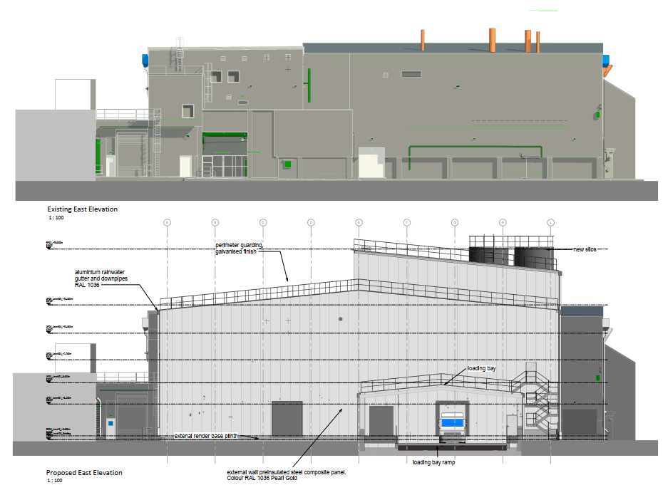
Existing and proposed east (side) elevation as taken from drawing no. 01010

The proposal would be completed in steel cladding and sandwich panels (completed in RAL 1036 Pearl Gold), so would maintain an industrial appearance, which is acceptable in this location and would be visually appropriate in this location.

In terms of the height of the building, this would have a maximum height of 20m and would integrate with the existing factory complex, with the new building appearing as a functional extension of the existing buildings rather than as an independent new building of a markedly different design and form. The proposed silos would be higher than the main building mass, but when measured from the submitted elevation drawings (drawing no. 01012) these would not exceed 20.3m in height, including the railings at the top. It is therefore considered that the design and scale of the proposed development would be acceptable in this context and would comply with the above-listed policies.

The proposal accords with the Wiltshire Design Guide (2024) in respect of functional industrial design that relates to existing buildings on-site.

In relation to trees, the submitted Arboricultural Impact Assessment & Method Statement (produced by Acer Tree Surgeons) identifies several trees along the bank of the River Avon, but none of these would be affected by the proposed development, and therefore, no tree works are required. The submitted tree assessment specifies measures to be implemented to prevent and avoid damage to the existing roots and to ensure that any materials and storage are placed away from the trees. The Council’s tree officer has confirmed that they are satisfied with the information that has been submitted and has raised no objections, subject to the tree reports being conditioned and no fires being set near existing trees.

The application has also been accompanied by a Landscape and Visual Impact Assessment (LVIA) (prepared by Goodger Design Associates). It is appreciated that the proposed development would be sited within the River Avon floodplain, with the existing factory being a prominent feature in the landscape. The submitted LVIA demonstrates that the proposed development would produce some limited public views from the nearby public rights of way to the south of the site, especially at close range, without mitigation.

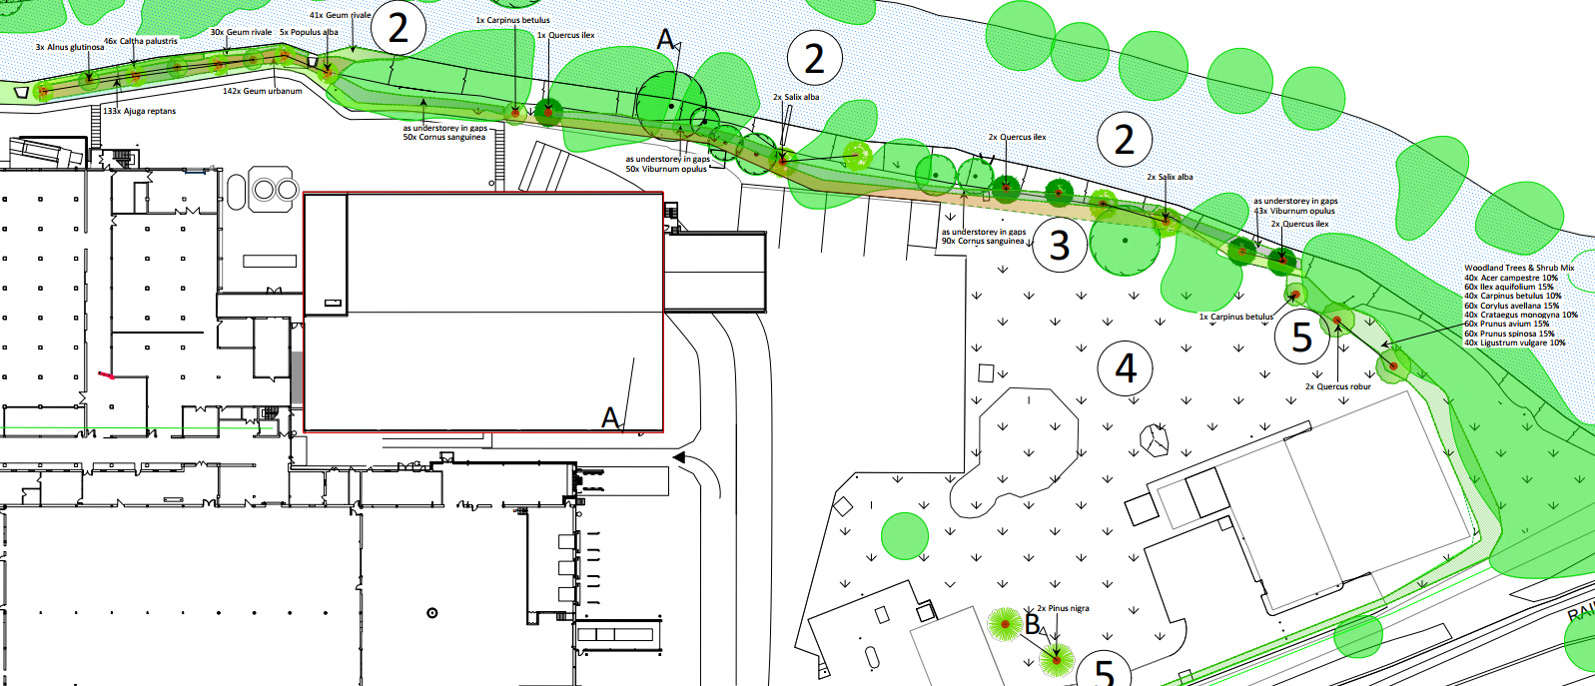

Extract taken from the submitted Landscape Strategy and Planting Proposals (drawing no. 480/03) with the new trees depicted by the red circles

The Council’s landscape officer has confirmed that they have no in-principle objections to the proposal.

The proposal does include a comprehensive planting strategy (an extract of which is provided above), which would strengthen the existing woodland belt, with the planting of semi-mature trees and native hedgerows, in addition to an area of wildflower meadow. It is considered that the proposed soft landscaping would assist in screening the development and would ensure the proposal is integrated within the landscape without significant adverse impacts.

Impact on Heritage Assets: From the point of view of the historic environment the main statutory tests are set out within the Planning (Listed Building and Conservation Areas) Act 1990.

Section 66 requires that special regard be given to the desirability of preserving listed buildings, their settings or any features of special architectural or historic interest which they possess.

The NPPF outlines government policy for planning. Chapter 16 of the NPPF 'Conserving and enhancing the historic environment' sets out the Government's high-level policies concerning heritage and sustainable development. In particular:

Paragraph 208 requires LPAs to “avoid or minimise any conflict” between the heritage asset’s conservation (which includes achieving its optimum viable use) and any aspect of a proposal.

Paragraph 210 requires local planning authorities to take account of the desirability of sustaining and enhancing the significance of heritage assets and putting them to viable new uses, and of new development making a positive contribution to local character and distinctiveness.

Paragraph 212 requires “great weight” to be given to an asset’s conservation “irrespective of whether any potential harm amounts to substantial harm, total loss or less than substantial harm to its significance.”

Paragraph 213 advises that harm to the significance of a designated heritage asset should require “clear and convincing justification”.

Paragraphs 214-216 require a balanced approach, with any harm which would be caused being weighed against the potential public benefits which might be achieved.

Policy CP58 requires that designated and non-designated heritage assets, and their settings, are conserved, and where appropriate enhanced, in a manner appropriate to their significance and encourages proposals which improve the condition of heritage assets at risk.

Policy CP57 requires a high quality of design in all new developments and for proposals to “demonstrate how the proposal will make a positive contribution to the character of Wiltshire through (amongst other things) responding to the value of the natural and historic environment and being sympathetic to and conserving historic buildings and landscapes”. Development is required to respond positively to the existing in terms of building layouts, built form, height, mass, scale, building line, plot size, elevational design, materials, streetscape and rooflines to effectively integrate the building into its setting.

Whilst there are no heritage assets within the immediate location of the proposed development, the site is accessed from the north over the Grade II bridge over the River Avon that forms part of the B3105 road. There are also other Grade II listed buildings within the wider setting of the site, including the Wesleyan Chapel and the Old Bear Inn to the south-west, and the Church of St Paul (with associated but separately listed gates, gate piers and overthrow) to the west.

The submitted Heritage Statement (produced by Stride Treglown) confirms that the proposal would not have a direct physical impact on any heritage assets, with the overall harm being at the lower end of “less than substantial” due to the limited visibility of the new factory building from the church. As directed by the NPPF, in weighing the harm against the public benefits, the benefits of the proposal are considered to derive from the creation of new employment opportunities, the investment into the area, the expansion of an existing building and the location of the new factory on an existing factory site. Taking this into account, it is considered that there are robust public benefits of the proposal to outweigh any harm.

In terms of the impact of the other heritage assets, it is considered that there would be negligible harm due to the distances between the existing buildings and the proposed building at the Cereal Partners site, the intervening development and existing screening.

The Council’s conservation department were consulted as part of this application and have confirmed that due “to the nature of the site, and the siting of the new factory building at the rear of the existing factory complex, the development will be associated with these industrial buildings, and as a result, the proposals will not have any impact on the setting of any heritage assets, designated or non-designated”.

Having regard to the Conservation Officer’s advice, the proposal would not result in harm to the significance or setting of designated heritage assets. Whilst a minor degree of change is perceived to the setting of one heritage asset within the wider vicinity of the application site, this would fall at the very lowest end of less than substantial harm, and the harm posed to the Grade II listed church would be outweighed by public benefits.

Amenity: Policy CP57 (Point vii) of the WCS requires development to respect the amenity of existing occupants and ensure appropriate amenity levels for future residents.

Paragraph 135 of the NPPF, reinforces the need for development to provide a high standard of amenity for both existing and future users. Criterion 135(f) requires that development ensure a high standard of amenity for existing and future users.

The comments contained within the submitted third-party representations are duly noted, and the concerns regarding the expansion of the existing factory and the associated impact on nearby residential properties are appreciated. However, the proposed siting of the new factory building would be to the north-east of the existing factory buildings, with the closest residential property over 250m to the west. The existing factory buildings and associated infrastructure would remain closer to the existing residential use than the proposed new building. As previously discussed within this report, the scale and height of the proposed development would be comparable to the existing buildings on-site.

As set out within section 3.1 of the submitted Planning, Design & Access Statement, the site already operates on a 24‑hour delivery basis, and the proposal seeks to maintain this arrangement, meaning no new operational disturbance is introduced.

The applicant has submitted an Air Quality Assessment (produced by SLR Consulting Ltd, dated 30 October), which considers the potential effects arising from the proposed development in terms of construction dust and operational traffic emissions. The assessment confirms that no additional process-related emissions are anticipated from the proposal, and therefore the primary emission sources assessed are construction activities (demolition, earthworks and building works) and vehicle movements associated with the operational phase.

The assessment has been undertaken in accordance with recognised guidance, including IAQM and EPIC methodologies. Construction phase effects have been assessed using the IAQM construction dust risk-based approach, which considers the magnitude of dust emissions alongside the sensitivity of surrounding receptors to determine likely impacts. For the operational phase, a screening assessment of traffic emissions has been carried out using EPIC and IAQM indicative thresholds, comparing predicted changes in vehicle flows against established criteria to determine whether detailed dispersion modelling is required. No detailed air quality modelling has been undertaken as the development does not exceed relevant screening thresholds.

The assessment finds that construction activities have the potential to generate dust emissions, with risks ranging from low to medium prior to mitigation, particularly in relation to dust soiling during the main construction phase. Impacts on human health are assessed as negligible to low risk. With the implementation of standard best practice mitigation measures, these effects are reduced to not significant.

During operation, the predicted increase in traffic flows is small (64 light-duty vehicles and 42 heavy-duty vehicles per day) and falls well below the relevant screening thresholds, both within and outside Air Quality Management Areas. As such, the development is not predicted to result in any exceedances of air quality objectives or any measurable deterioration in air quality for either human or ecological receptors.

Overall, the assessment concludes that the proposed development would have no significant adverse effects on local air quality. Construction effects would be temporary and can be effectively mitigated, while operational impacts are assessed as negligible. The development is therefore considered acceptable in air quality terms.

In addition to the above, a Noise Impact Assessment (produced by SLR Consulting Limited, dated 1 December 2025) has been submitted. This assessment establishes baseline noise conditions through survey monitoring at representative locations and identifies nearby residential receptors. Operational noise from the proposed plant and activities has been modelled using ISO 9613-2:2024 within CadnaA software and assessed in accordance with BS 4142:2014 and relevant Wiltshire Council guidance. The results indicate that during the daytime, predicted noise levels would be between 2–9dB below existing background levels at all receptors, representing a low impact. During the nighttime, levels would remain below background at most receptors and only marginally exceed (by 1dB) background sound levels at one location; however, when considered in context, including low absolute noise levels, this is not considered to give rise to a significant impact on the overall amenity of the occupiers. Overall, the assessment concludes that the proposed development would give rise to a low noise impact and would not result in unacceptable harm to residential amenity, with no mitigation measures being required.

It is noted that some of the submitted representations raised concerns of smell and odour. It is important to mention that the existing site is a well-established cereal manufacturing factory, and this proposal seeks to extend this. Given that the nature of the proposal is consistent with the existing cereal production use, it is considered that there would be no new odour-generating processes beyond those already experienced. The Council’s public protection officer has raised no objections to the proposal, and it is therefore considered that the development would not give rise to unacceptable odour impacts.

As stated above, the Council’s public protection department has been consulted and has raised no objections to the proposal, subject to conditions. The applicant has submitted a Construction Environmental Management Plan (CEMP), which is discussed separately below.

In assessing the proposal against CP57 (criterion vii) and paragraph 135(f) of the NPPF, it is considered that the proposal would not have an adverse impact on the amenity of neighbouring occupiers to warrant the refusal of the application. Therefore, the proposal accords with CP57 and the NPPF.

Highways Impacts and Parking: Transport implications are a key factor in assessing planning applications, especially for larger developments. Proposals must demonstrate:
- Safe and suitable access for all users, including pedestrians, cyclists, and those with mobility impairments.
- No severe residual impacts on the surrounding highway network.
- Promotion of sustainable travel, reducing reliance on private vehicles.
- Adequate parking and cycle provision, in line with adopted standards.
- Protection and enhancement of public rights of way and active travel routes.

Relevant policies include policies CP60–64 of the WCS, supported by the Wiltshire Local Transport Plan, Car Parking Strategy, and Cycling Strategy. The Local Cycling and Walking Infrastructure Plan (LCWIP) and LTN 1/20 (DfT) provide further design guidance for active travel infrastructure.

As set out within the application particulars the proposal is seeking consent for the construction of a new B2 factory building for use in connection with the existing cereal production operation on the wider site. The proposed building consists of 2,400m2 of gross floor space and would generate 50 additional jobs, with staff working on a shift basis.

Cereal Partners UK have been a long-established operator on this site, and the proposals set out as part of this application do not seek to make any access alterations, with the existing separate staff and delivery accesses being retained as existing. Additionally, no new car parking spaces are proposed, with 154 spaces available within the site.

The submitted Planning, Design & Access Statement states that the existing cycle parking provision (providing 20 cycle parking spaces) is already provided within the car park, and this is deemed appropriate for the increased staffing levels. Although the development would generate approximately 21 new daily deliveries, the submitted Transport Statement concludes that the impact on the local network would not be severe. The document states that “no change to current pedestrian and vehicle flows” is required, demonstrating that the scheme integrates safely and efficiently with existing access arrangements.
The submission includes a Transport Statement (produced by SLR Consulting Ltd, dated November 2025), which aims to demonstrate the impact of the proposed development on the local highway network. The assessment has been informed by site surveys, Automatic Traffic Count (ATC) data surveys at the existing access points to establish baseline traffic data, gatehouse delivery records and parking accumulation analysis.

The subject site is an established industrial site, with existing access arrangements via two junctions on New Terrace (B3105), serving both staff and delivery vehicles. The factory currently employs approximately 200 staff and provides 154 car parking spaces.

The submitted assessment confirms that the site is located in an accessible location, with good connectivity to surrounding settlements. The site is within reasonable walking distance of Staverton and parts of Trowbridge, supported by footways and crossing facilities along New Terrace. The site is also accessible by cycling, with the site located within a 30-minute cycle catchment of Trowbridge, Bradford-on-Avon, Melksham and adjacent areas, and benefitting from nearby National Cycle Network routes.

The assessment considers public transport accessibility to be good, with bus stops located approximately 170 m from the site providing connections to Trowbridge and Melksham, and Trowbridge railway station located 3.6 km away offering regional connections.

In highway terms, the site has good access to the local road network via New Terrace, a 30 mph single carriageway road connecting to the wider highway network. The submitted report concludes based on accident data (2020–2024) that there are no inherent highway safety issues, with only eight recorded collisions, none of which were fatal and no identifiable pattern or cluster.

The assessment shows that the delivery access experiences 64 two-way trips, with 7 in the AM peak and 2 in the PM peak. Using the ATC data, a trip rate has been derived for the proposed development and this states that the delivery access would attract an additional 42 two-way trips daily, with an additional 5 in the AM peak and 1 in the PM peak. It should be noted that the site accepts deliveries over a 24-hour period.

The proposed development would increase floorspace by approximately 8.6% and introduce approximately 50 additional staff, with 21 new daily deliveries, which would equate to an increase of approximately 106 two-way delivery trips in a day, which the assessment considered to represent low-frequency additional movements (typically one vehicle every 4-9 minutes in peak periods) and is therefore not considered to materially affect the operation of the surrounding highway network. The Council’s highways engineers concur with the view that the additional level of traffic would not be considered significant.

In terms of car parking provisions, it is noted that the proposal does not include any additional on-site car parking; however, the site already provides 154 car parking spaces and 20 cycle parking spaces, and the analysis confirms significant spare capacity, especially with staff operating on a shift basis. No objections have been raised by the local highways authority on this matter, and it is considered that the existing site has adequate car parking provision.

Following the highways engineer’s initial comments, additional information has been submitted on swept path analysis, which demonstrates that the site can safely accommodate 16.5 m articulated HGVs, ensuring safe and efficient servicing without disruption to existing operations, without obstructing the highway. The Council’s highways engineer is satisfied with the proposed vehicle delivery and processing/checking-in process, which would ensure that vehicles are not waiting on or overhanding the public highway for a significant time, with there being arrangements in place to ensure that such instances are managed as soon as possible.

It is noted from the submitted representations that concerns have been raised regarding traffic on the B3105 and over Staverton Bridge and on New Terrace. The Council’s highways engineers have offered the following comment on this:

“Whilst these concerns are noted, as many of the objections highlight it is mainly the accumulated traffic volumes, vehicle speeds and substandard pedestrian provision along New Terrace that create the safety concerns. The proposals subject to this application will attract additional traffic as noted, however, the issues highlighted are not of a direct and sole result of the CPUK site and given the scale and impact of the proposals in traffic terms, the concerns do not meet the threshold for a highway refusal, as defined in the National Planning Policy Framework”.

As confirmed by the Highway Authority, the scale of additional traffic generated by the proposal would be modest and would not materially exacerbate existing network constraints or result in severe impacts in NPPF terms.

To conclude, the submitted Transport Assessment demonstrates that the site benefits from good accessibility by a range of transport modes, with well-established access arrangements and no existing highway safety concerns. Whilst the proposed development would generate an increase in trips to and from the site, this would represent a modest increase in trips, which can be accommodated within the existing highway network and on-site infrastructure without adverse effects.

The proposed development would not result in an unacceptable impact on highway safety and the residual cumulative impacts on the road network would not be severe taking into account all reasonable future scenarios.

Accordingly, the development is considered to be acceptable in highway terms and complies with the relevant policies of the WCS and the NPPF.

Ecology and Biodiversity: The ecological impact of development is a key planning consideration, especially for larger schemes. Proposals must assess and address potential effects on:
- Protected species
- Priority habitats
- Ecological networks
- Green and blue infrastructure

Core Policy 50 of the Wiltshire Core Strategy requires development to:
- Avoid harm to ecological assets.
- Deliver measurable Biodiversity Net Gain (BNG), in line with the Environment Act 2021.
- Support habitat restoration and connectivity.
- Integrate biodiversity into site design.

The Green & Blue Infrastructure Strategy (2022–2030) promotes nature recovery, ecosystem services, and habitat connectivity through development.

Unless exempt, National policy requires a minimum of 10% Biodiversity Net Gain (BNG) for major developments, demonstrated via:
- Biodiversity Metric calculations
- Ecological assessments (e.g. PEAs, Phase 1 surveys, protected species surveys)

A Preliminary Ecological Appraisal (PEA) was undertaken by SLR Consulting Ltd (dated September 2025), which confirms that the site extends to approximately 1.4 ha and is dominated by hardstanding and existing buildings, with areas of amenity grassland, scrub, hedgerow and a strip of woodland along the northern boundary adjacent to the River Avon.

The desk study identified a number of statutory and non-statutory designated sites within the wider area, including the Bath & Bradford-on-Avon Bats SAC (within 10 km) and several Local Wildlife Sites, notably the Bristol Avon River Local Wildlife Site (LWS) immediately adjacent to the northern boundary (c.12 m).

Field survey results confirmed that habitats within the site are common and widespread, with no priority or high-value habitats recorded within the development footprint. The site does support potential for protected species, particularly birds, bats and hedgehogs, although overall ecological value is limited and largely confined to boundary habitats associated with the River Avon corridor.

The PEA also sets mitigation measures, to ensure compliance with the relevant ecological legislation and planning policy, which includes: vegetation clearance to be undertaken outside the bird nesting season (March–August) (or otherwise to be checked by an ecologist); precautionary method of works for hedgehogs; a buffer to the Rover Avon to prevent polluted runoff; sensitive lighting (which would be controlled by way of planning condition) and enhancement opportunities including bird boxes, hedgehog boxes, habitat management and tree planting, supporting biodiversity net gain.

The Council’s ecology department were consulted on this application and have offered the following comments:

Bath and Bradford-on-Avon Bats Special Area for Conservation (SAC): The site lies within a consultation zone for greater horseshoe bat associated with the Bath and Bradford-on-Avon Bats SAC and therefore has potential to result in significant adverse impact on the special features of that site. It is considered that no Likely Significant Effects will occur due to the distance from the SAC and no anticipated indirect impacts due to the small scale of the development the majority of which will affect existing made ground within an existing industrial development with no change of use. Light spill on the adjacent designated sites should be prevented by development of a sensitive lighting scheme which will minimise any increase of current light levels along the boundary to the Bristol Avon LWS.

County Wildlife Site (CWS): Bristol Avon River lies adjacent to the site. Wiltshire Core Policy 50 requires that CWSs are protected from the effects of development and should be enhanced where possible. As stated in the PEA, the extension is planned to be no closer than 50m to the River Avon and no impact is expected. Additionally, the expanse of grass and strip of woodland between the construction works and the river are likely to absorb any surface run off due to the works before they reach the river, negating any negative impacts surface runoff would have on the water quality within the River Avon. Nevertheless, pollution prevention measures will be required.

Protected Species: No evidence of protected species on the site according to the PEA, beyond nesting bird species.

In terms of Biodiversity Net Gain (BNG), the proposal would not impact any priority habitat and would impact less than 25m2 of on-site habitat, as the proposed siting of the development would be on an existing area of hardstanding immediately adjacent to the existing factory building. Therefore, the proposal falls below the de minimis threshold for mandatory Biodiversity Net Gain (impacting less than 25sqm of non-priority habitat), as set out in Schedule 7A of the Town and Country Planning Act 1990 (as amended) and no mandatory BNG would be required in this instance, and this has been accepted by the Council’s ecology department. Notwithstanding this, on-site enhancements are proposed within the PEA which would be conditioned.

The PEA demonstrates that the site is of low ecological value, with ecological interest largely confined to retained boundary habitats associated with the River Avon. It is considered that, subject to the implementation of standard and proportionate mitigation measures as set out within the PEA, the proposed development would not result in significant adverse ecological effects and demonstrates no net loss of biodiversity on site therefore meeting requirements of both the WCS and the NPPF.

Flood Risk and Drainage: Policy CP67 of the adopted WCS and NPPF paragraphs 170–182 require:
- Avoidance of increased flood risk.
- Use of appropriate mitigation measures.
- Application of the sequential and exception tests for developments in Flood Zones 2 or 3.

Sustainable Drainage Systems (SuDS) are required for all major developments and must:
- Manage runoff near its source.
- Improve water quality.
- Support biodiversity and amenity.
- Be integrated into the site layout and green infrastructure.

A Flood Risk Assessment (FRA) and Drainage Strategy has been prepared by Edenvale Young (dated 27 November 2025) to support the proposed factory extension. The assessment draws upon Environment Agency (EA) mapping, site inspection, detailed topographical survey work, and site-specific hydraulic modelling of the River Avon and Weston Cut, which has been reviewed and confirmed as “fit for purpose” by the EA. As set out in section 1 of the submitted FRA, “The modelling has revealed that the Design Flood Event remains in the channel and does not flood the site”.

The site is located on an existing hardstanding service area adjacent to the Weston Cut (a main river) and the River Avon, and the existing factory building. While the Environment Agency’s (EA) Flood Map for Planning data indicates the site falls within Flood Zones 2 and 3, the site-specific modelling demonstrates that the site would remain outside the modelled extent of the design flood event, including appropriate climate change allowances. Residual risks, including exceedance and blockage scenarios, have been considered and are addressed through finished floor levels. Therefore, the modelling illustrates that any flooding would not inundate the site, indicating a materially lower level of risk than national mapping suggests.

It is important to mention that there is a separate application at this site (reference PL/2025/07023), which seeks planning permission for additional flood resilience measures around the existing site.

The Council’s drainage department acknowledges that the site is currently shown in Flood Zones 2 and 3, but the applicant’s flood zone modelling (which has been approved by the EA) demonstrates the site to be above predicted flood levels, with a minimum of 500 mm freeboard above the design flood level and significantly greater clearance at the proposed finished floor level (FFL). The modelling demonstrates that the design flood event remains in the channel, without flooding the site, with additional flood mitigation proposed, such as raised kerbs and raised FFLs.

It is important to mention that the proposed development is classified as ‘less vulnerable’ development, and based on the outcomes of the site-specific modelling, the site is shown to be at very low risk of flooding and should therefore be categorised as Flood Zone 1. On this basis, a site-specific Sequential Test is not required. The submitted FRA demonstrates that the development would be safe for its lifetime, without increasing flood risk elsewhere, and, where possible, would reduce flood risk overall, in accordance with the NPPF and CP67.

It is proposed that surface water drainage would be connected to the existing drainage network at the site, ensuring no additional outfall is required. An additional attenuation tank would be constructed.

The applicant is proposing to discharge at 22l/s, providing 30% betterment on the 1 in 1 year pre-development brownfield runoff event. The drainage strategy provides sufficient water quality treatment prior to discharge.

No objections have been raised by the EA or the Council’s drainage department. The comments from Bradford on Avon Town Council are duly noted however the submitted information confirms that flood risk and drainage can be adequately managed on-site and therefore would not exacerbate flood risk in the immediate area, as the proposed development incorporates appropriate finished floor levels, a robust surface water drainage, and attenuation measures to deliver betterment over the existing situation.

In response to comments made within the EA’s representations, the applicant’s agent has confirmed that the foul drainage would be managed on-site via the main sewer.

Accordingly, the development is considered to comply with CP67 of the WCS and the NPPF, with no residual flood risk constraints that would preclude planning permission.

Construction Environmental Management Plan (CEMP): Several of the consultees requested the submission of a CEMP, which the applicant provided upfront and was subject to a fresh round of consultation prior to the determination of this application.

The CEMP acknowledges that the site is located approximately 10-12 m south of the River Avon and the Weston Cut (Main River), which form the principal environmental receptor for pollution risk. The Bristol Avon River LWS lies immediately to the north of the site boundary, and the surrounding area supports protected species including bats, otter and notable bird species associated with the river corridor. There are also existing residential properties within the wider vicinity of the site.

As mentioned above, the site is shown to be located within Flood Zones 2 and 3, although the applicant’s hydraulic modelling confirms that the development platform is not at risk of flooding during the design event.

The CEMP sets out a comprehensive suite of mitigation measures, designed to reduce environmental impacts to acceptable levels. The CEMP proposes the: establishment of a buffer zone along the northern boundary to protect the River Avon from discharge and to prevent the storage of materials and plant within this area; the retention and protection of existing habitats, including tree root protection areas (RPAs); post-construction habitat enhancement including tree and wildflower planting; following Application of Best Practicable Means in accordance with BS 5228; restricted working hours and use of low-noise plant where practicable; implementation of IAQM best practice measures including water suppression, covering stockpiles and controlling vehicle movements; prevention of pollution through controlled storage and handling of materials.

Overall, the CEMP demonstrates that the environmental effects of construction have been comprehensively assessed and would be effectively managed through a robust framework of mitigation measures, monitoring and controls. Given the site’s location within an existing industrial area and the implementation of best practice environmental management, the proposed development would result in temporary and localised environmental effects.

Other Matters: Correspondence has been received from a resident to the north of the application site, raising concerns regarding the publicity and consultation undertaken for the proposal. It is important to note that the consultation and publicity requirements for planning applications are set out nationally within the Town and Country Planning (Development Management Procedure) (England) Order 2015 (DMPO).
In this instance, as a major application, the DMPO requires the proposal to be publicised by way of a press advertisement in a local newspaper (the Wiltshire Times in this case), the display of a site notice (which was erected by the case officer in January 2026), and neighbour notification. Statutorily, the Council is only required to notify those properties adjoining the application site’s red line boundary. However, it should be noted that residents are not required to receive a direct notification to be able to submit comments on a planning application; any interested party can submit a representation, and these shall be considered where they raise material planning considerations.

It is therefore considered that the Council has fulfilled its statutory obligations in this instance and that the application has been publicised appropriately in accordance with the requirements of the DMPO.

PLANNING BALANCE AND CONCLUSION: The principle of development is considered acceptable when assessed against the settlement strategy of the Wiltshire Core Strategy and the NPPF.

The proposal is considered compliant with relevant local and national planning policies in respect of design, scale, residential amenity, heritage, highway safety, flood risk and drainage, ecology and biodiversity, and environmental impacts, subject to the recommended conditions and any necessary mitigation measures.

The proposal represents a proportionate and logical expansion of an established industrial site and would deliver significant economic benefits, including job creation and long-term investment in the local economy. These benefits attract substantial weight in the planning balance. The development would give rise to limited environmental effects, all of which have been robustly assessed and are either negligible, mitigated, or acceptable within policy thresholds.

When assessed as a whole, there are no adverse impacts which would significantly and demonstrably outweigh the benefits of the development. The proposal therefore accords with the development plan when read as a whole.

No material considerations have been identified that would significantly and demonstrably outweigh these benefits or indicate that permission should be refused, having regard to the assessment above and the representations received.

Accordingly, the proposal is considered acceptable in planning terms and in accordance with the Wiltshire Core Strategy, the National Planning Policy Framework, and all other relevant material considerations.

RECOMMENDATION: That Planning Permission be GRANTED, subject to conditions

Get flood risk information for planning in England - Flood map for planning - GOV.UK

