HOUSEHOLDER PLANNING APPLICATION.
CASE OFFICER REPORT

APPLICATION REFERENCE: | PL/2026/02848
APPLICATION TYPE: | Householder
SITE ADDRESS: | 5 Palairet Close, Bradford On Avon, BA15 1US
DEVELOPMENT DESCRIPTION: | Proposed Single Storey Front Extension
RECOMMENDATION: | Approve with Conditions.

PROPOSAL
The proposal seeks planning permission for the construction of a single storey front facing extension, that would provide an enlarged lounge and front porch area. The extension would be of a ‘lean to’ design and would continue the established design and built form from the existing garage and porch, incorporating a pitch roof gable feature over the front door for articulation of the entrance.

SITE DESCRIPTION/CONTEXT
The site is a corner located two-storey detached dwelling located with the market town of Bradford on Avon and is within an established residential housing estate of similar sized properties. The building is constructed from a light coloured ‘Bradstone’ type of reconstituted stone, with dark concrete roof tiles. The site is located within the Bath and Bradford on Avon Bat SAC and is not within a Conservation Area.

RELEVANT PLANNING HISTORY
Proposal / Summary
W/98/01494/FUL First floor extension Approved.

RELEVANT POLICIES AND GUIDANCE

Wiltshire Core Strategy:

- Core Policy 07 Bradford on Avon Spatial Strategy
- Core Policy 57 Ensuring High Quality Design and Place Shaping
- Core Policy 50: Biodiversity and Geodiversity
- Core Policy 51: Landscape
- Core Policy 58: Ensuring the Conservation of the Historic Environment
- Core Policy 61: Transport and New Development
- Core Policy 64: Demand Management
- Core Policy 67: Flood Risk

Bradford on Avon ‘made’ Neighbourhood Plan.

Wiltshire Design Guide: Appendix D – Design Guidance for Householder extensions

The National Planning Policy Framework (NPPF)

The Planning Practice Guidance

National Design Guide

Emerging Wiltshire Local Plan:
At Full Council on 19 May 2026, the elected members of Wiltshire Council agreed to withdraw the emerging Wiltshire Local Plan. It will now be subject to a legal process to finalise its withdrawal - which is likely to happen in July or August (2026). The said Plan has no material weight for the purposes of this application.

CONSULTATION RESPONSES
Bradford on Avon Town Council: No objections.

Bradford on Avon Preservation Trust: No comment.

Arboricultural Officer: No comment

REPRESENTATIONS
One email of support was received from the neighbour at number 7, who raised no objections.

PRINCIPLE OF THE PROPOSAL.
The principle of the proposed scheme for alterations to an existing dwelling is considered to be acceptable for the reasons as discussed below.

ASSESSMENT
Section 38(6) of the Planning and Compulsory Purchase Act 2004 states:

"If regard is to be had to the development plan for the purposes of any determination to be made under the planning Acts, the determination must be made in accordance with the plan unless material considerations indicate otherwise."

In accordance with this statutory requirement, this application has been assessed against the relevant policies of the Development Plan, including the adopted Wiltshire Core Strategy (2015) and the Neighbourhood Plan for Bradford on Avon.

Design and Impact upon the upon the character and context of the area

Core Policy 57 - Ensuring High Quality Design and Place Shaping of the Wiltshire Core Strategy seeks to ensure that all new development is of high design quality, reflecting local context, character, and distinctiveness. The proposals can be viewed within the plan snippets taken from the submitted plans:

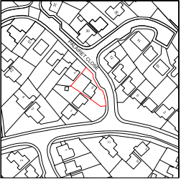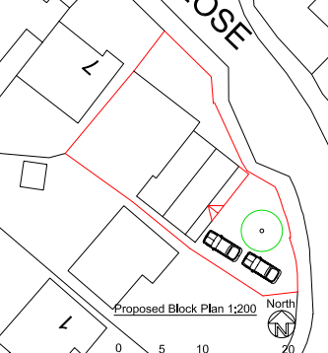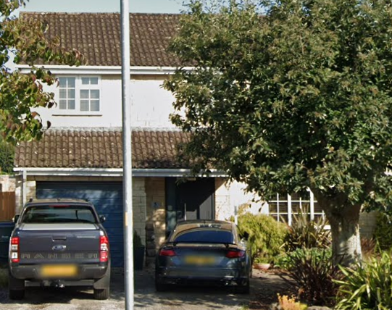
Location Plan Proposed Site Plan ‘Street View’ photograph of No.5.

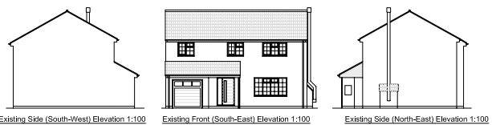
Existing front and two side elevations.

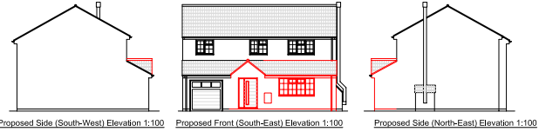
Proposed front and two side elevations.

The proposal would see the infill construction of a single storey front facing extension, it would serve to provide an enclosed porch area as well as an enlarged lounge area. The reconfigured porch would have a pitched gable feature set within shallow mono-pitched lean-to roof and would also have matching materials.

The proposed addition would be in keeping with and maintain the overall design and appearance of the front elevation; it would also be a subservient addition that would maintain and enhance the spatial flow of the host building without adverse impact on the character of the dwelling or its immediate surroundings. It is further noted that a nearby property within Palairet Close has constructed the same type of front extension.

Therefore, in summary, having regard to the above, the proposal complies with the design principles set out in Core Policy 57 of the Wiltshire Core Strategy and Appendix D of the Wiltshire Design Guide.

Amenity
Point vii of Core Policy 57 - Ensuring High Quality Design and Place Shaping of the Wiltshire Core Strategy seeks to ensure that developments do not adversely affect neighbouring properties. The National Planning Policy Framework (NPPF), particularly Paragraph 135(f), stresses that planning decisions should ensure developments provide a high standard of amenity for existing and future users.
The proposed extension would be a single storey addition that would look out onto and face its front garden area and also that of the main highway beyond. There are no immediate neighbours at the front aspect and the extension does not introduce any overlooking concerns.

Likewise, due to the location, scale and orientation of the proposal, there would be no overbearing, overshadowing or loss of light to the most immediate neighbour at No.3.

The proposal therefore accords with Core Policy 57 point vii. in respect of safeguarding residential amenity and Appendix D of the Wiltshire Design Guide.

Highway Matters.
Core Policy 57 (xiv) of the Wiltshire Core Strategy seeks to ensure that development must meet the requirements of Core Policy 61. This policy requires proposals to be capable of being served by safe access to the highway network. Core Policy 64 seeks to ensure compliance with parking standards set out in the Local Transport Plan.

The National Planning Policy Framework (NPPF), particularly Paragraph 115 and 116, requires that development proposals do not have an unacceptable impact on highway safety and that safe and suitable access to the site can be achieved for all users.

The proposed development would continue to use the established site access which would not be altered and would not result in the loss of the garage or existing parking spaces. Adequate parking provision is provided within the site and the existing access and parking arrangement remains acceptable with there not being any proposed increase in the number of bedrooms at the property.

The proposal does not have any adverse impact on highway safety and is therefore considered to comply with Core Policies 57 (xiv), 61 and 64 of the Wiltshire Core Strategy, the NPPF, and the Wiltshire Local Transport Plan.

Ecology Impact CP50 requires no net loss of biodiversity on site. The site is located within the Bath and Bradford on Avon Bat SAC. The proposed development because of its minor nature and urban location is considered unlikely to result in any risk of harm to bats or their habitat, however there is a minor alteration to the existing lean to roof and an informative is included in the event of any evidence of bats being found. There is no mechanism for significant effects from recreational pressure since it does not result in the creation of a new dwelling. Accordingly, the proposal is acceptable in this regard. As such, the development complies with Core Policy 50 of the Wiltshire Core Strategy and the relevant provisions of the NPPF.

Biodiversity Net Gain. This application is exempt from the requirement to deliver Biodiversity Net Gain under Schedule 7A, Section 4(2)(a) of the Town and Country Planning Act 1990, as inserted by the Environment Act 2021, because the proposal is a householder extension.

CONCLUSION
The proposed development is acceptable in terms of its design, scale, and relationship with the surrounding area. It would not result in any unacceptable harm to the character of the locality, the amenities of neighbouring occupiers, or the interests of highway safety or ecology.

The proposal is therefore considered to comply with the relevant policies of the Wiltshire Core Strategy, the Wiltshire Local Plan, and the National Planning Policy Framework. As such, the application is recommended for approval, subject to the conditions set out below.

RECOMMENDATION: Planning Permission be GRANTED subject to conditions.

