Wiltshire Council Planning Consultation Response

[Date]

Thursday, 18 June 2026

Application No: | PL/2026/02895
Site Address: | Land West of Marlborough Road

Please note the particulars in connection with the above planning application are available to view on the planning website http://www.wiltshire.gov.uk/planninganddevelopment.htm

I would welcome any comments that you have about this particular application by EARLIESTDECISIONDATE. If I do not receive your observations and comments by this date I will assume you have none. If you require an extension of time please contact the Planning Officer above who will do their best to accommodate this.

Recommendations:

No Comment
Support
Support subject to conditions (please set out below)

Object (for reasons set out below)
No objections

Matters Considered:

Provision of containers for waste and recycling:

The council requests s106 contributions towards the provision of waste and recycling containers for each residential unit, under policies CP3 and WCS6. The following estimated contribution is required for the proposed development:

Property type category | Contribution per house/per category | Quantity | Total
Individual house | £121.00 | 95 | £11,495
Flats 1-5 | £121.00
Bin store for block of 6-10 flats | £971.00
Bin store for block of 11-14 flats | £1,848.00
Bin store for block of 15-18 flats | £2725.00
 |  | Total | £11.495

Access to waste collection services:

I attach a guidance document setting out the council’s technical requirements to ensure that residents will be able to use the standard waste collection service. In general terms, following the attached guidance will allow the service to operate as intended and generally will mean that plans are acceptable to the waste management services team. The following paragraphs highlight some areas that would need to be addressed at the next stage of an application.

Vehicle access

If applicable Vehicle tracking is required to demonstrate that refuse collection vehicles (RCVs) can move through the development and turn at the ends of roads, especially taking account of cars parked in allocated spaces and at the roadside. Adequate turning room should be provided to take account of the restrictions on carry distances for residents set out in Part H of Building Regulations (25m), the limitations on carry distances for waste collection crews, where the vehicle should be able to stop within 10m of a collection point (see section 4.4 of the attached guidance) and due to the requirement to minimise reversing to meet the requirements of BS 5906:2005. Tracking on plans in future submissions should demonstrate the sufficiency of vehicle access.

The council requires an indemnity in order to operate on any roads that are not adopted, including during any period where the council needs to deliver waste collection services prior to adoption. The required arrangements are set out in section 5.8 of the attached guidance with a sample indemnity provided in Appendix C.

Tracking is shown on the plan.

Collection points

Each dwelling should have a collection point that is on level hardstanding off any roadway or footway at the curtilage of the property, as further described in section 5.2 of the waste SPD. Plans should identify these areas for each dwelling and demonstrate that they do not impact on space available on driveways and that soft landscaping won’t prevent or encumber the collection crew when emptying bins.

Issue:

Presentation point for muster points needs amending. (Screenshots below)
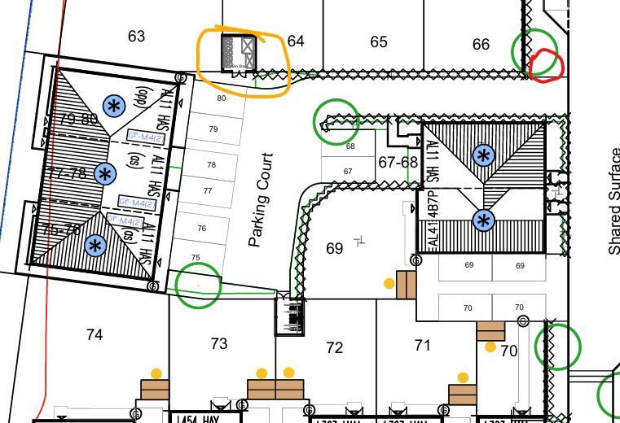
Unclear where muster point is intended or storage. If the structure highlighted in ornage is a bin store it would not be feasible for communal services without access to the highway. Current plan would not allow vehicle to manuovre this route.
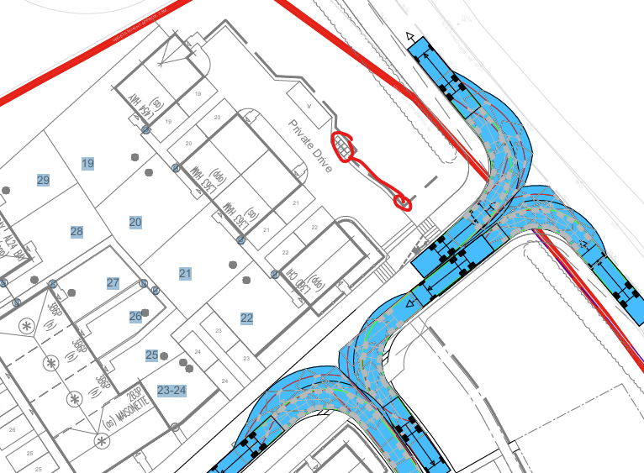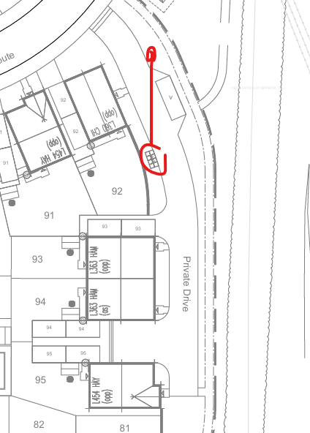
Muster points a 2 locations need to be closer to the access roads.
Storage points

In accordance with the guidance in section 5.4 of the waste SPD, plans in future submissions should demonstrate that each property has suitable storage space that takes account of the guidance. Showing containers to scale in situ will help to demonstrate compliance.
Note: Sufficient storage will be required for the introduction of new waste services which are planned for 2027, including food waste, and recycling of soft plastic/bags.

Issue: Confirmation needed to identify bin store for 75-80. Appears to be a bin store but not detailed.

Routes between storage and collection points

As noted in the ‘Vehicle access’ section above, residents should not have to carry their waste containers more than 25m from the storage point to the collection point. Plans should demonstrate that this is achievable for each dwelling, preferably with a supplementary table listing the carry distances per dwelling, for ease of reference. Section 5.3 of the waste SPD provides further details on matters to consider when designating these routes.

Conditions

In principal Waste Management Team support this application with the following conditions:

- Presentation point needs some adjustments.
- Guidance from the SPD
- Bin storage points for some houses need clarification. (No’s 75-80)
- Guidance notes regarding introduction of additional waste services planned for 2027 which will require additional space.

S106 contribution of £11,495 toward waste and recycling containers.

Waste Management Team

Supporting documents
Planning Layout PDF

