APPLICATION FOR HOUSEHOLDER PLANNING PERMISSION
DELEGATED REPORT

APPLICATION REFERENCE: | PL/2026/02102
APPLICATION TYPE: | Householder planning permission
SITE ADDRESS: | Bridgewalk House, Brixton Deverill, Warminster, BA12 7EJ
DEVELOPMENT DESCRIPTION: | Amendments to previously approved PL/2022/05624 & PL/2022/06725 - single storey extension of existing outbuilding to provide ancillary accommodation
RECOMMENDATION: | That Planning Permission be GRANTED

PROPOSAL

The proposal seeks planning permission for Amendments to previously approved PL/2022/05624 & PL/2022/06725 - single storey extension of existing outbuilding to provide ancillary accommodation at Bridgewalk House, Brixton Deverill, Warminster, BA12 7EJ.

Applications PL/2022/05624 & PL/2022/06725 were approved on 11 September 2024 and therefore remain extant permissions until 11 September 2027.

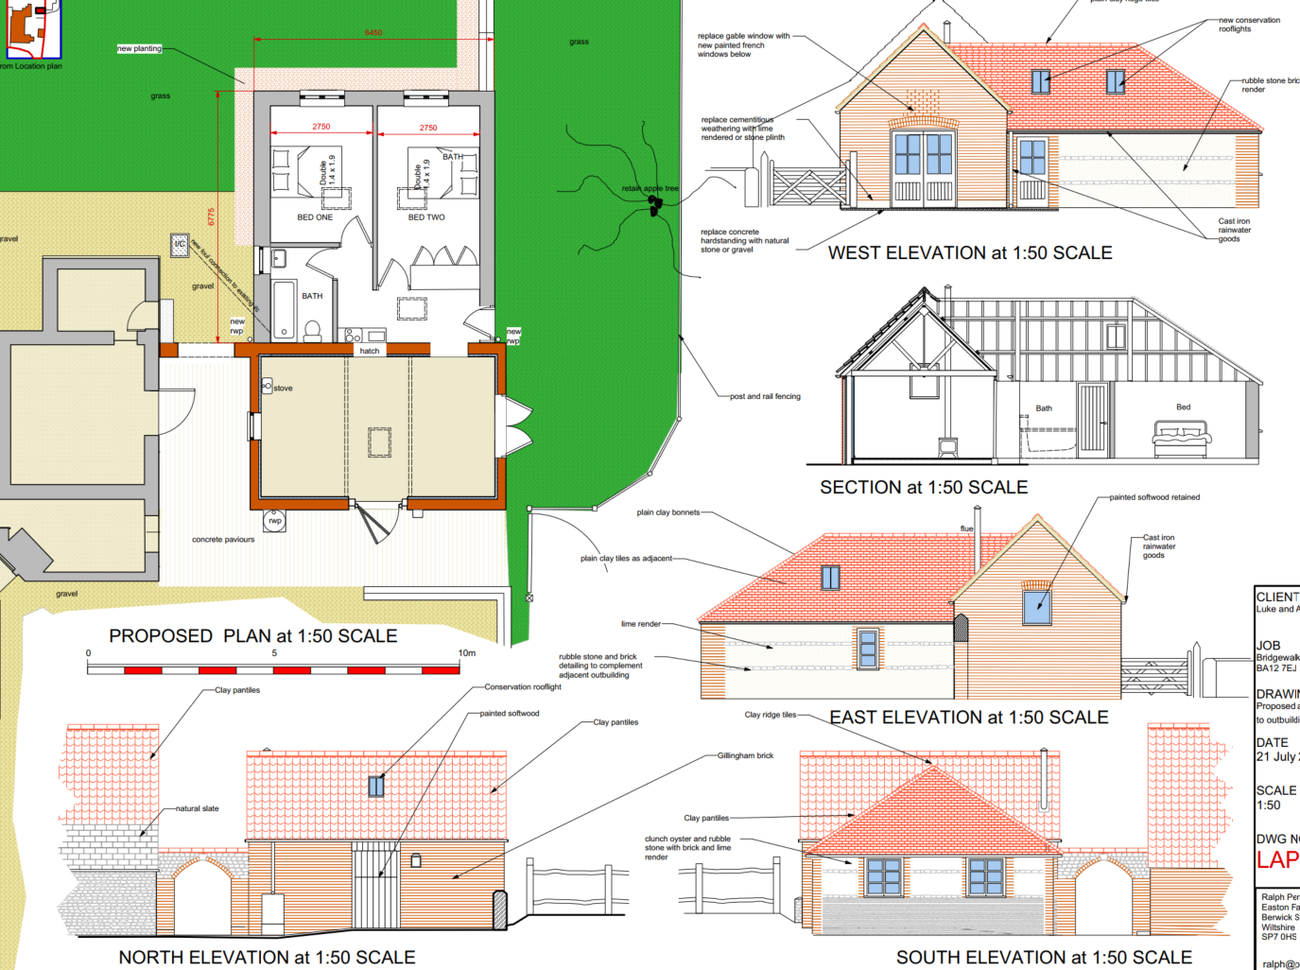

Approved Elevation and Floor Plans for PL/2022/05624 & PL/2022/06725

The approved 2022 extension to the existing outbuilding would have a footprint of c6.7m x 6.4m and would have had a large, hipped roof and would have been built using clay tiles with mostly lime rendered walls with two courses of rubble stone.

In these 2026 applications, the footprint is being extended slightly to 6.95m x 6.75m. The design is changing too by building a mirror image of the existing outbuilding via a small flat roofed link section. It would also have clay pantiles but would be finished with horizontal timber boarding panels. The flat roofed section would be pre-weathered zinc.

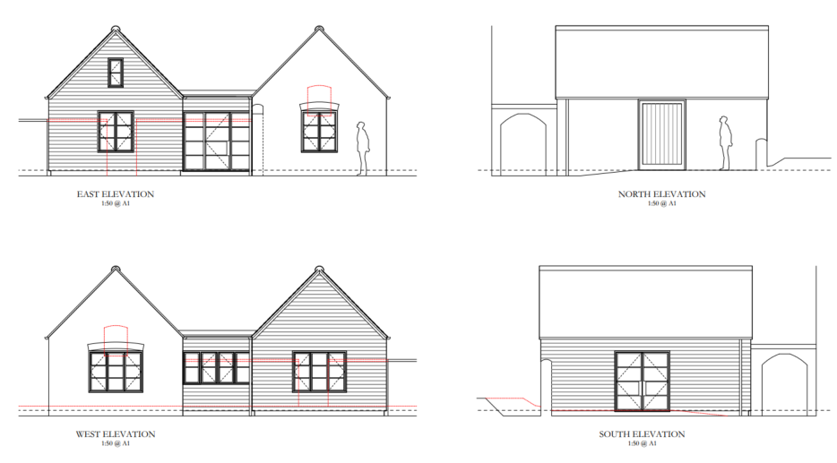

Proposed Elevations

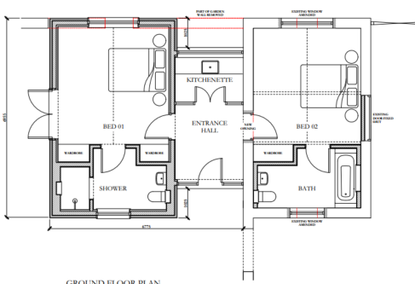

Proposed Floor Plan

The applicants have submitted the following documents in support of the application:

In the initial submission these documents were received on 30 March 2026

- Flood risk assessment (using the Council’s householder form)

- Design, Access and Heritage Statement (Ralph Perry Robinson)

- Results of archaeological trial trench evaluation (Simmonds and Hughes – dated July 2024)

On 1 May 2026 the applicants submitted an Archaeological Written Scheme of Investigation (Hughes – Dated April 2026) and a revised ground floor plan (25106 P 02 A).

On 1 June 2026, the applicants submitted the results of Archaeological Monitoring and Recording (Simmonds and Hughes – dated June 2026).

For the avoidance of any doubt, the Archaeological reports had also been sent separately to the Council’s Archaeology Officer who agreed and signed off the submissions. Whilst this should have been undertaken via a discharge of condition application for the PL/2022/06725 applications (condition 3 Archaeology), the documents were sent directly to Archaeology and agreed without this usual process.

SITE DESCRIPTION/CONTEXT

This is a Grade II listed building on the edge of Brixton Deverill set in spacious grounds. The building is a detached C18 – midC19 of rendered rubble stone construction.

The application site is subject to the following planning policy constraints:

- Grade II listed building
- Brixton Deverill Conservation Area
- Ground water levels are between 0/025-0.5m of the ground surface
- Cranborne Chase and West Wiltshire Downs National Landscape

PLANNING HISTORY

Proposal / Summary
13/04003/FUL - Full planning permission Decision - Approve with Conditions Date: 30/10/2013 – Works to form an additional bedroom and ensuite
13/04004/LBC - Listed building consent Decision - Approve with Conditions Date: 30/10/2013 – Works to form an additional bedroom and ensuite
PL/2022/05624 - Full planning permission Decision - Approve with Conditions Date: 11/9/2024 – Single storey extension of existing outbuilding to provide ancillary accommodation
PL/2022/06725 - Listed building consent (Alt/Ext) Decision - Approve with Conditions Date: 11/9/2024 – Single storey extension of existing outbuilding to provide ancillary accommodation
W/07/02266/LALBC - Listed building consent Decision - Approve with Conditions Date: 3/10/2007 – Reconstruction of damaged bridge

RELEVANT POLICIES AND GUIDANCE
Legislation:
From the point of view of the historic environment the main statutory tests are set out within the Planning (Listed Building and Conservation Areas) Act 1990.
Section 66 requires that special regard be given to the desirability of preserving listed buildings, their settings or any features of special architectural or historic interest which they possess
Section 72(1) of the Act requires the Council to pay special attention to the desirability of preserving or enhancing the character or appearance of designated Conservation Areas.

National Guidance:

The NPPF outlines government policy for planning. Chapter 16 of the NPPF 'Conserving and enhancing the historic environment' sets out the Government's high-level policies concerning heritage and sustainable development.

Local Context:

The development plan for Wiltshire comprises the Wiltshire Core Strategy (WCS) (adopted January 2015) and any made neighbourhood plans, which remains the principal statutory planning document guiding development across the county. In line with Section 38(6) of the Planning and Compulsory Purchase Act 2004, planning decisions must be made in accordance with the development plan unless material considerations indicate otherwise.

Though the development plan is considered as a whole, those parts deemed to be particularly relevant to this pre-application enquiry are listed below:

The adopted Wiltshire Core Strategy (WCS), with particular regard to:

- Core Policy 50 Biodiversity and Geodiversity;
- Core Policy 51 Landscape
- Core Policy 57 Ensuring High Quality Design and Place Shaping;
- Core Policy 58 Ensuring the Conservation of the Historic Environment;
The Council’s Core Strategy Policy CP58 ‘Ensuring the conservation of the historic environment’ requires that designated and non-designated heritage assets and their settings will be conserved, and where appropriate enhanced, in a manner appropriate to their significance and encourages proposals which improve the condition of heritage assets at risk.
The Council’s Core Strategy CP 57: Ensuring high quality design requires a high quality of design in all new developments. The policy requires applicants to “demonstrate how the proposal will make a positive contribution to the character of Wiltshire through (amongst other things) responding to the value of the natural and historic environment and being sympathetic to and conserving historic buildings and landscapes. Development is required to respond positively to the existing in terms of building layouts, built form, height, mass, scale, building line, plot size, elevational design, materials, streetscape and rooflines to effectively integrate the building into its setting.
Made Neighbourhood Plans:

Brixton Deverill does not have a neighbourhood plan

Supplementary Planning Document:

- Wiltshire Design Guide: Appendix D – Design Guidance for Householder extensions

CONSULTATION RESPONSES

Initial consultations were sent out on 9 April and following receipt of the WSI and revised ground floor plan again on 26 May 2026. Following receipt of the results report on 1 June, no further formal consultations were carried out other than via email with the Council’s Archaeology Officer.

Upper Deverills Parish Council: No comments received

Wiltshire Council Archaeology Officer: No objection

Wiltshire Council Ecology Officer: No objection subject to condition

Wiltshire Council Drainage Officer: No objection

Wiltshire Council Highways Officer: No objection

Wiltshire Council Conservation Officer: No objection

“We have already approved an extension to this outbuilding, which is considered to curtilage listed (hence the need for LBC as well as Planning Permission).

We have also had recent pre-application discussions (ENQ/2026/00143) about amending the design. The current application documentation reflects those discussions (i.e. a separate 'new' pitched element with a low-key link to the existing building). As such, I have no objection to the proposals which I consider will preserve the character of the original ancillary curtilage listed building as well as the setting of the house. As such, I consider the proposals would accord with Sections 16 and 66 of the Planning LBCA Act 1990, core policy 58 and Chapter 16 of the NPPF.”

Historic England: No objection

Environment Agency – No comments to make

REPRESENTATIONS

The application was advertised by site notice and 6 neighbour notification letters.

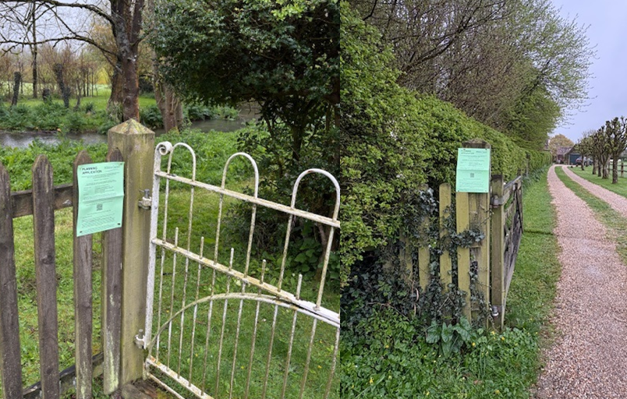

No comments were received.

ASSESSMENT

Section 38(6) of the Planning and Compulsory Purchase Act 2004 states:

"If regard is to be had to the development plan for the purposes of any determination to be made under the planning Acts, the determination must be made in accordance with the plan unless material considerations indicate otherwise."

In accordance with this statutory requirement, this application has been assessed against the relevant policies of the Development Plan, including the adopted Wiltshire Core Strategy (2015) and, where applicable, any made Neighbourhood Plans.

Principle of development

The extension would be used for incidental additional accommodation for the house (effectively an annexe) to which the applicants will be advised via informative that the extension must have and retain a dependency on the main house. As such there is no objection in principle to this proposed development.

Design and Impact upon the character and context of the area

Core Policy 57 - Ensuring High Quality Design and Place Shaping of the Wiltshire Core Strategy seeks to ensure that all new development is of high design quality, reflecting local context, character, and distinctiveness.

It is considered that the proposed extension, although slightly larger than the extant permission, represents a significant improvement. This is due to its respect for the simple built form and profile of the existing outbuilding, rather than introducing a large, hipped roof. The proposal is therefore viewed as being far more in keeping with the surrounding outbuildings and extensions, which are characterised by gable-ended forms.

While it is acknowledged that Bridgewalk House is finished in render and the outbuildings comprise a mix of brick and stone, no objection is raised to the introduction of timber cladding for the extension. Timber cladding offers a softer, more rural aesthetic—appropriate to the location—and helps to reduce the perceived bulk and mass of the development. Furthermore, it enables the extension to be read as a distinct addition, rather than attempting to replicate the existing structure or suggest that the outbuilding has always appeared in this form.

Having regard to the above, the proposal complies with the design principles set out in Core Policy 57 of the Wiltshire Core Strategy and Appendix D of the Wiltshire Design Guide.

Amenity

Point vii of Core Policy 57 - Ensuring High Quality Design and Place Shaping of the Wiltshire Core Strategy seeks to ensure that developments do not adversely affect neighbouring properties.

The National Planning Policy Framework (NPPF), particularly Paragraph 135(f), stresses that planning decisions should ensure developments provide a high standard of amenity for existing and future users.

The proposed development has been assessed in terms of its potential impact on the residential amenity of neighbouring properties, with particular regard to loss of light, overshadowing, loss of privacy, and overbearing effects.

The proposed extension would not be located close to any neighbouring boundary and is distant from the nearest neighbouring dwelling. Therefore, there would be no impact to neighbouring amenity.

The proposal therefore accords with Core Policy 57 point vii in respect of safeguarding residential amenity and Appendix D of the Wiltshire Design Guide.

Heritage Impact

Archaeology and Scheduled Monument:

Initial consultation was undertaken with the Council’s Conservation and Archaeology Officers, together with Historic England, on 9 April 2026. This was based on the submitted Heritage Statement and the 2024 archaeological trial trench evaluation. At that stage, Historic England raised concerns that:

“the proposal has the potential to impact on a number of heritage assets namely;

· Roman Villa at Brixton Deverill , scheduled monument (National Heritage List Entry No. 1448408)
· Bridgewalk House Grade II Listed Building (NHLE: 1364381)
· Brixton Deverill Conservation Area, including a number of Grade II Listed Buildings.

Significance of monument
The scheduled monument lies within a field to the south of the development.

The villa is a well preserved example of a large country house, with evidence of occupation from the 2nd century to the 4th century (1,800 to 1,600 years ago). There is also some evidence for later occupation and reuse of some of the buildings.

The villa has been identified through a series of archaeological investigations. These have shown that the Roman building is formed of three wings surrounding a large courtyard. The villa looks towards the east-south-east, across the valley bottom. This is similar to many of the modern houses, e.g. Bridgewalk House.

There are other buildings and associated structures to the east and south of the main villa. These have not been clearly identified so are not included within the scheduled area. There is the potential that there are other Roman remains associated with the villa close by, to the west and north.

Evaluation in 2023 on the proposed area of the extension uncovered some Roman remains. The remains included a stone wall 0.45m below the ground surface covered by Roman demolition deposits. These deposits were about 0.2m below ground level. These Roman deposits and structures will be of equivalent significance to the highly designated heritage asset.”

However, it is understood that the applicants had already submitted a written scheme of investigation (WSI) with the Council’s Archaeology Officer; and only formally submitted it as part of the planning application after it had been agreed. It is understood that the applicants then proceeded with the excavations in accordance with the WSI before the Council had opportunity to re-consult with Historic England over the WSI itself.

Nonetheless the Council’s Archaeology Officer commented:

“The excavation of the extension’s footprint was completed by AC Archaeology on 1st May 2026. They reported to me that the excavations had proceeded to a depth of 400mm below current ground level. Consequently, there was no exposure of the Roman wall (or other in situ pre-modern features) that was recorded at greater depth during the trial trenching. The strip exposed the modern concrete trough that was recorded previously.”

Therefore, it was confirmed that there was no need or requirement for the development works to go deeper to the actual Roman remains.

Historic England responded on 3 June 2026 (to the WSI and ground floor plan) to remove their objection stating “The revised plan now clearly shows the below ground impacts of the proposed new wall and how it will avoid the scheduled area. We can therefore confirm that scheduled monument consent will not be required for the works.”

Historic England did request minor amendments to the WSI; however, these comments were made without knowledge that the WSI had already been agreed with the Council’s Archaeology Officer and that the works had already been undertaken. Given that the excavation has been completed to the satisfaction of the Council’s Archaeology Officer, no further amendments are considered necessary.

The applicants then submitted the archaeological report of the works on 1 June, which was agreed by the Council’s Archaeology Officer on 3 June.

Conclusion:

Historic England has confirmed that Scheduled Monument Consent is not required, and the archaeological investigation has been carried out to the satisfaction of the Council’s Archaeology Officer. The proposed development therefore raises no outstanding archaeological concerns, and no further information or planning conditions are required in this respect.

Impact on the Conservation Area

The impact on the character of the Conservation Area would be negligible as the extension would not be readily visible from the public realm. Therefore, the character and appearance of the conservation area will be preserved and there would be no harm to its historic significance.

Impact on the setting, character and historic fabric of listed building

The impact on the setting and character of the listed building would be ultimately complimentary given the proposed design and use of materials and would be a significant betterment over the extant permission. The proposed extension would result in a straightforward and in-keeping extension that would not result in harm to the character of the listed building.

The significance of the building lies largely with its historic fabric and architecture - its form, layout and architectural expression/detailing and use of high-quality design materials which have significant aesthetic and architectural interest.

This scheme would extend a single storey outbuilding to the rear of the main house. The significance of the outbuilding is lower than that of the main listed building, being a vernacular simple structure. The loss of parts of the walling to accommodate the door opening on the south elevation would not result in such harm as to spoil the historic integrity of the listed building. Equally the loss of part of the garden wall, similarly of limited significance, would not require in overriding harm either.

Therefore, it is considered that the proposal, by virtue of its scale, design, and use of materials, is considered to preserve the character and appearance of the conservation area or the setting of the listed building. It would not result in harm to the significance of any heritage assets, and no objections have been raised by the Conservation Officer.

The development is therefore considered to comply with Core Policy 58 of the Wiltshire Core Strategy and Sections 66 and 72 of the Planning (Listed Buildings and Conservation Areas) Act 1990, as well as the relevant provisions of the NPPF.

Highway Safety and Parking

Core Policy 57 (xiv) of the Wiltshire Core Strategy seeks to ensure that development must meet the requirements of Core Policy 61. This policy requires proposals to be capable of being served by safe access to the highway network. Core Policy 64 seeks to ensure compliance with parking standards set out in the Local Transport Plan.

There would be no harm to highway safety as a result of the proposed development and as such would ocmnply with the relevant policies of the WCS.

Ecology Impact

Core Policy 50 of the Wiltshire Core Strategy seeks to protect and enhance biodiversity and geodiversity, including through ensuring that development avoids harm to protected species and habitats.

The National Planning Policy Framework (NPPF), in Paragraphs 193, requires that development minimises impacts on and provides net gains for biodiversity, including ensuring mitigation is secured where harm cannot be avoided.

The Council’s Ecology Officer comments:

River Avon Special Area of Conservation (SAC) Hampshire Catchment
This development falls within the catchment of the River Avon SAC and has potential to cause adverse effects alone or in combination with other developments through discharge of phosphorus in wastewater.

A test of likely significance has been carried out by the relevant Competent Authority (Wiltshire Council) as required by Regulation 63 of the Conservation of Habitats and Species Regulations 2017 (as amended). This concluded that since there is no proposal to create additional overnight accommodation, there would be no overall mechanism for adverse effect. The HRA has concluded that the application is not likely to have significant impacts on the SAC and subsequently the application is screened out of Appropriate Assessment.

Protected habitats and species
The building appears to be in a good condition, with no obvious gaps in the mortar, under tiles or brickwork. In any case, the roof will only be impacted at the eaves of the southwest elevation, where there are unlikely to be any significant roosting opportunities. The applicant should note that under the Conservation of Habitats and Species Regulations 2017 (as amended), it is an offence to harm or disturb bats or damage or destroy their roosts. In the unlikely event that bats are found, works should cease and advice from a professional ecologist must be sought.

It is possible that birds nest in or near to the outbuilding. The adults, young, eggs and nests of all species of birds are protected by the Wildlife and Countryside Act 1981 (as amended) while they are breeding. Please be advised that works should not take place that will harm nesting birds from March to August inclusive. The applicant is advised to check any structure or vegetation capable of supporting breeding birds and delay removing or altering such features until after young birds have fledged.

Part of the site crosses into the riparian zone of the River Wylye West to the south, which is a Priority Habitat and County Wildlife Site (CWS). However, the proposed works are restricted to the outbuilding which is ~45m north of the CWS. Whilst a Construction Method Statement was not conditioned previously, the applicant should be mindful of the risk of construction works and pollution to the CWS, and measures must be implemented to ensure the risk of, e.g., runoff and dust pollution, is minimised.

In line with NPPF and with CP50, gains for biodiversity would be welcomed – the applicant should consider adding an integrated bat or bird box to the proposed extension.

As such, the development complies with Core Policy 50 of the Wiltshire Core Strategy and the relevant provisions of the NPPF.

Officers have considered the request for the construction management plan but note that PL/2022/05624 is an extant permission (until 11 September 2027) without that condition. It is therefore considered to be unreasonable to require a pre-commencement condition to this effect and the matter can reasonably be addressed via informative. An informative will be added however to advise the application that bat and bird boxes should be considered.

National Landscape

Core Policy 51 of the Wiltshire Core Strategy requires all development to protect, conserve, and where possible enhance the character and quality of Wiltshire’s landscapes, giving particular weight to designated areas such as National Landscapes.

The National Planning Policy Framework (NPPF), in Paragraph 176, states that “great weight” should be given to conserving and enhancing landscape and scenic beauty in National Landscapes (formerly Areas of Outstanding Natural Beauty). Development within or affecting the setting of a National Landscape must demonstrate that it will not result in unacceptable harm to the special qualities of that area.

The proposal, by virtue of its scale, siting, and design, would not harm the special qualities or scenic character of the Cranborne Chase and West Wiltshire Downs National Landscape.

The development therefore complies with Core Policy 51 of the Wiltshire Core Strategy and Paragraph 176 of the NPPF in conserving and enhancing the National Landscape.

Drainage and Flood Risk

The southwestern corner of the application site (the part that is adjacent to the River Wylye) is within flood zones 2 and 3, but Bridgewalk House is approximately 11m outside of this zone; and therefore the proposed extension to the outbuilding is within flood zone 1. However, the site is within the second highest risk category of ground water flooding and in accordance with the Council’s 2019 and 2024 Strategic flood risk assessments (SFRA) the site cannot be considered to be at a low risk of flooding.

However, paragraph 176 of the NPPF states;

“Applications for some minor development and changes of use⁶² should also not be subject to the sequential test, nor the exception test set out below, but should still meet the requirements for site-specific flood risk assessments set out in footnote⁶³.

⁶² This includes householder development

⁶³ A site-specific flood risk assessment should be provided for all development in Flood Zones 2 and 3. In Flood Zone 1, an assessment should accompany all proposals involving: sites of 1 hectare or more; land which has been identified by the Environment Agency as having critical drainage problems; land identified in a strategic flood risk assessment as being at increased flood risk in future; or land that may be subject to other sources of flooding, where its development would introduce a more vulnerable use.”

This is a householder application and therefore footnote 62 applies (excluding the need for the sequential test). However, as the key part of the application site is within flood zone 1 and the SFRA shows this site to be in a high risk of ground water flooding, a site specific flood risk assessment is required.

The applicants have submitted the Council’s Flood Risk Assessment form indicating that ‘option 1’ is to be used – ensuring that ground levels of the extension will not be below existing ground level and that all electrical sockets will be 400mm above floor level and they will use flood resilient materials.

Officers consider that the submitted Flood Risk Assessment is sufficient and therefore the risk of ground water can be effectively managed.

Biodiversity Net Gain

Householder planning applications are exempt from the requirement to deliver Biodiversity Net Gain under Schedule 7A, Section 4(2)(a) of the Town and Country Planning Act 1990, as inserted by the Environment Act 2021.

CONCLUSION

The proposed development is considered to be acceptable in terms of its design, scale, and relationship with the surrounding area. It would not result in any unacceptable harm to the character of the locality, the amenities of neighbouring occupiers, or the interests of highway safety, heritage, or ecology.

The proposal is therefore considered to comply with the relevant policies of the Wiltshire Core Strategy, the Wiltshire Local Plan, and the National Planning Policy Framework. As such, the application is recommended for approval, subject to the conditions set out below.

RECOMMENDATION: That Planning Permission be GRANTED subject to conditions.

