APPLICATION FOR FULL-PLANNING PERMISSION
CASE OFFICER REPORT

APPLICATION REFERENCE: | PL/2026/01809
APPLICATION TYPE: | Full planning permission
SITE ADDRESS: | Melksham Football and Rugby Club, Eastern Way, Melksham, SN12 7GU
DEVELOPMENT DESCRIPTION: | To enable the area of land known as Melksham Rugby and Football clubs, to hold a Music Event and festival
RECOMMENDATION: | Refuse

SITE DESCRIPTION/CONTEXT

The site is located outside of the limits of development of Melksham, in what would be construed as countryside as defined within the Wiltshire Core Strategy (2015). There are no other special landscape designations associated with the site.

There are existing residential properties approximately 320m to the west of the site although residential uses arc around the site through north, west to south. To the east are predominantly open fields, although sporadic residential properties are located further afield to the east.

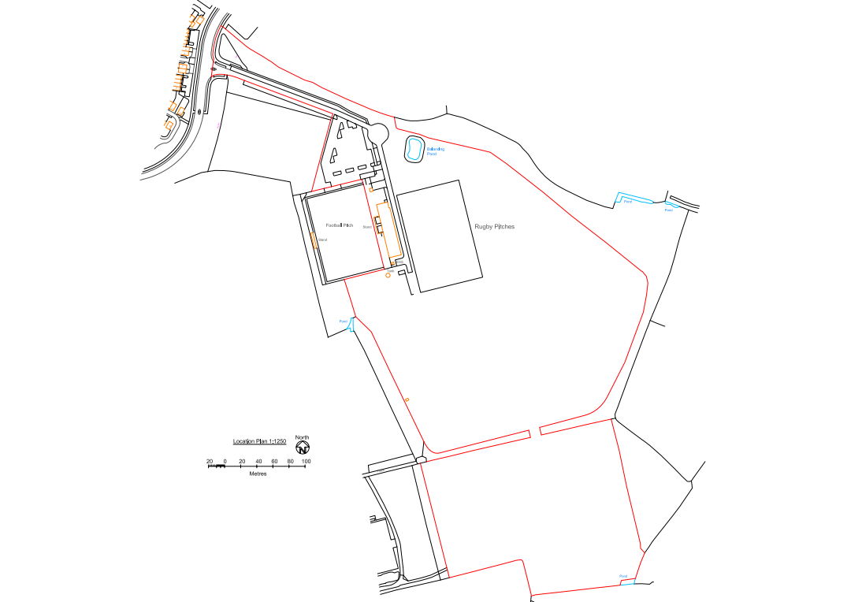
Site Layout

The land is generally level and contains the existing structures for Melksham Rugby Football Club and siting of sports pitches.

PROPOSAL

The application is to enable the area of land known as Melksham Rugby and Football clubs, to hold a Music Event and festival.

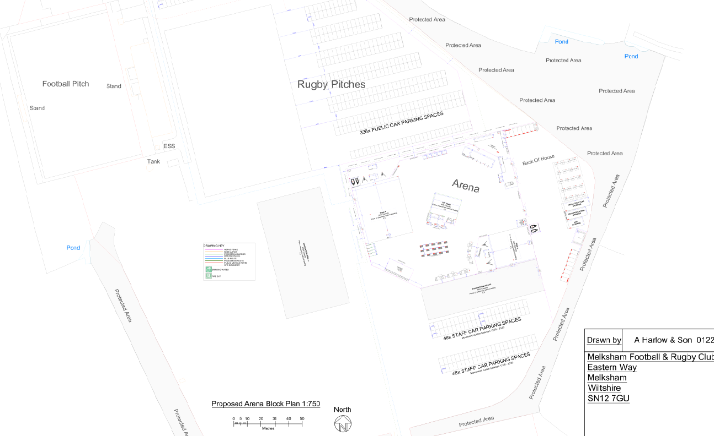
Proposed Arena Site Plan

This would be a temporary change of use to host a two-day outdoor music festival (Wiltshire Throwback Festival 2026), including the erection of temporary stages, marquees, bars, catering concessions, sanitation and welfare facilities, security infrastructure, lighting and fencing; together with associated access, traffic management and event operations (including live and recorded amplified music), with site set-up and dismantling.

There was some initial confusion over whether the application was for this event for 2026 or for multiple events. The applicant has confirmed that the application is for this event only in 2026.

PLANNING HISTORY

Proposal / Summary

PL/2025/04158 - To enable the area of land known as Melksham Rugby and Football club, to hold a temporary music event only for the 20th and 21st June 2025 with associated temporary structures built for the event – Refused
13/06739/FUL - Provision of new football and rugby facilities, including changing rooms, clubhouse and football stadium, together with 11 other football pitches, 4 rugby pitches, car parking, new access road and junction – Approved conditionally
Condition 5 of planning consent 13/06739/FUL, required the provision of an ecological management plan in the interests of ecology; and condition 7 and 9 were seeking landscape and landscape management plans, equally important in delivering the necessary green environmental corrdiors across and around the site.
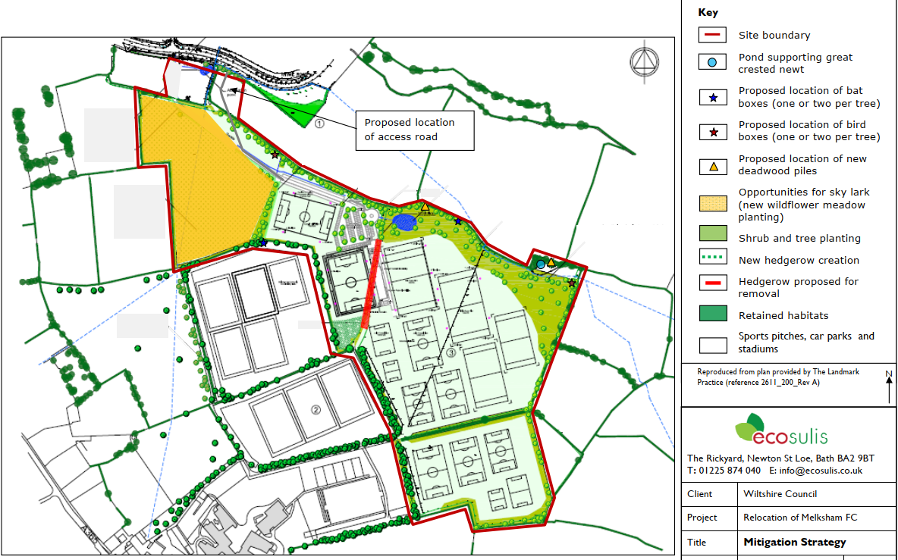
Mitigation Strategy

The mitigation and lighting strategy for the site provided a dark corridor along the northern boundary of the pitches. As set out within the approved ecological mitigation strategy the potential impacts of the proposals include direct habitat loss, fragmentation and increased disturbance.

RELEVANT LEGISLATION, POLICIES AND GUIDANCE

Statutory Legislation:

National Planning Policy:
- National Planning Policy Framework (NPPF)
- Planning Practice Guidance (PPG)
- National Design Guide
Development Plan:
The development plan for Wiltshire comprises the Wiltshire Core Strategy (WCS) (adopted January 2015) and any made neighbourhood plans, which remains the principal statutory planning document guiding development across the county. In line with Section 38(6) of the Planning and Compulsory Purchase Act 2004, planning decisions must be made in accordance with the development plan unless material considerations indicate otherwise.

Though the development plan is considered as a whole, those parts deemed to be particularly relevant to this application are listed below:

The adopted Wiltshire Core Strategy (WCS), with particular regard to:
- Core Policy 1 Settlement Strategy;
- Core Policy 2 Delivery Strategy;
- Core Policy 15 Spatial Strategy Melksham Community Area
- Core Policy 34 Additional Employment Land
- CP39 Tourist Development
- CP49 Protection of rural services and community facilities
- Core Policy 50 Biodiversity and Geodiversity;
- Core Policy 51 Landscape
- Core Policy 52 Green Infrastructure
- Core Policy 57 Ensuring High Quality Design and Place Shaping;
- Core Policy 60 Sustainable Transport;
- Core Policy 61 Transport & Development;
- Core Policy 62 Development Impacts on the Transport Network;
- Core Policy 64 Demand Management
- Core Policy 67 Flood Risk;

Draft Wiltshire Local Plan Policies
At Full Council on 19 May, the elected members of Wiltshire Council agreed to withdraw the emerging WLP. It will now be subject to a legal process to finalise its withdrawal – which is likely to happen in July or August (2026). The said Plan has no material weight for the purposes of the application.

Neighbourhood Plan:

Joint Melksham Neighbourhood Plan 2 2020-2038 (made August 2025, JMNP)
- Policy 1: Sustainable Design and Construction
- Policy 3: Flood Risk and Natural Flood Management
- Policy 4: Ultra Low Emission Vehicle Charging
- Policy 11: Sustainable Transport and Active Travel
- Policy 12: Green and Blue Infrastructure
- Policy 13: Biodiversity
- Policy 14: Open Spaces
- Policy 15: Community Facilities
- Policy 16: Local Green Spaces
- Policy 17: Trees and Hedgerows
- Policy 18: Landscape Character
- Policy 19: Separation of Settlements
- Policy 20: Locally Distinctive, High Quality Design
- Policy 21: Local Heritage
Supplementary Planning Documents and other Guidance:
- Wiltshire Design Guide (adopted April 2024)
- Wiltshire Local Transport Plan 2011-2026, adopted 2015 - including the Car Parking Strategy and Cycling Strategy, adopted 2015
- A Green & Blue Infrastructure Strategy for Wiltshire: Wiltshire’s Natural Environment Plan 2022-2030
- Wiltshire Local Cycling and Walking Infrastructure Plan (LCWIP)
- Active travel infrastructure design standards 2022
- Active travel parking standards and design guide 2022
- LTN1/20 – Cycle Infrastructure Design (July 2020)

ISSUES

The main issues that need to be addressed in this case include:
- Principle of development
- Noise and amenity impacts on nearby residents.
- Ecological sensitivity of the site and surrounding areas.
- Traffic and parking management.
- Visual Impact on the area.
- Other matters

CONSULTATION RESPONSES

WC Highways: No objection: Subject to appropriate parking control and continued liaison on traffic management, the Highway Authority raises no objection.

WC Rights of Way: No comment received

WC Public Protection: Objection on the following grounds: the submitted Noise Management Plan is insufficient to assess the likely impacts of noise on residential amenity. Note that the plan is limited to a single, defined event and does not adequately address a wider programme of events, cumulative impacts, or varying event scenarios. Concerns are raised regarding the limited identification of noise-sensitive receptors, the absence of baseline monitoring and predictive modelling, and the reliance on generic noise limits and reactive mitigation measures. As such, the proposal fails to demonstrate that unacceptable noise impacts can be avoided. Should the LPA be minded to approve, recommend securing a comprehensive acoustic assessment, clear limits on event frequency and duration, and a framework for event-specific noise management and enforceable controls.

WC Ecology: Objection on the following grounds: Insufficient information has been provided to demonstrate that the proposal would avoid significant harm to habitats and species. Further details are required, including confirmation of existing mitigation, a wildlife-sensitive lighting scheme and clear ecological protection measures, before the objection can be reviewed.

Sport England: No objection subject to condition: as it is considered to broadly meet exception 3 of our Playing Fields Policy and to accord with Paragraph 104 of the National Planning Policy Framework (NPPF), subject to condition.

Melksham Without Parish Council: Support: Welcome this application and reflected positively on the successful running of the previous event, noting effective crowd management, good security arrangements, minimal traffic issues and positive police feedback.

Melksham Town Council: Comment: notes the assurance that this is for a one off event but also notes that the application form itself has not been amended to say this. Melksham Town Council notes the concerns of the school about Friday hours and parking may affect the school and the pathway used by pupils. Melksham Town Council also notes that last years event could be heard some distance from the site. Melksham Town Council supports the application on the basis that it is a one off event only and granting permission does not establish a right for multiple events. To address the concerns Melksham Town Council asks that the applicants engage with the school regarding Friday event hours and that residents further afield be given contact details regarding possible noise issues.

REPRESENTATIONS
In accordance with the requirements of the Town and Country Planning (Development Management Procedure) (England) Order 2015 (as amended), the application was publicised by way of:
- Neighbour notification letters sent to adjoining and nearby properties
- A site notice displayed near the site
- An advertisement placed in the local press

These methods were used to inform interested parties and provide a period of 21 days for comments to be submitted.

Below is a summary of the representations received during the consultation period. Only material planning considerations have been taken into account in the assessment of this application. Non-material issues, such as property values or private legal disputes, cannot be considered in the determination process.

Summary
- Noise and disturbance
  - Significant concern regarding excessive noise, particularly low-frequency bass, affecting residential amenity and sleep.
  - Noise from the previous festival was clearly audible indoors, even with windows closed.
  - Evening operation until 23:00 considered harmful to residents, including families and those with early working hours.
- Frequency and principle of use
  - Strong concern about the precedent for multiple or regular events, rather than a single festival.
  - Many residents indicate that one event per year (at most) would be acceptable, but oppose a wider programme.
  - Perception that the proposal represents an intensified commercial use of a sports facility.
- Traffic, parking and highway impacts
  - Concerns over inadequate on-site parking, leading to overspill parking on nearby roads and estates.
  - Reports of dangerous or inconsiderate parking, verge damage, and increased traffic congestion.
  - Significant disturbance from traffic management measures during set-up and removal.
- General disturbance and behaviour
  - Anticipated impacts from crowd dispersal, shouting, anti-social behaviour, litter and broken glass.
  - Concerns about the suitability of a large-scale event in a residential, family-oriented area, including proximity to a school.
- Build, breakdown and ancillary impacts
  - Disturbance not limited to event days, but also from set-up and dismantling activities, generators and equipment.
- Scale and suitability of site
  - Event viewed as a large-scale festival operation (multiple stages, high attendance) inappropriate for the location.
  - Some consider the site unsuitable for festivals, given its proximity to housing.
- Impact on residential amenity
  - Repeated references to loss of peaceful enjoyment of homes and gardens.
  - Concerns that residents were not aware the site could be used for festivals when purchasing properties.
- Concerns regarding application process
  - Frustration that events have occurred or may proceed ahead of planning determination.
- Suggested controls (if approved)
  - Limit number of events per year.
  - Restrict hours and reduce finish times.
  - Impose strict noise limits (including bass control) and real-time monitoring.
  - Control sound checks and build/break periods.
  - Require robust traffic management and resident communication (e.g. hotline).
  - Post-event review and enforcement mechanisms.

ASSESSMENT
Section 38(6) of the Planning and Compulsory Purchase Act 2004 states:

"If regard is to be had to the development plan for the purposes of any determination to be made under the planning Acts, the determination must be made in accordance with the plan unless material considerations indicate otherwise."

In accordance with this statutory requirement, this application has been assessed against the relevant policies of the Development Plan, including the Wiltshire Core Strategy (2015) and, where applicable, any made Neighbourhood Plans. Consideration has also been given to the policies of the National Planning Policy Framework (NPPF) as a material consideration in the assessment.

Environmental Impact Assessment (EIA) Screening
In accordance with the Town and Country Planning (Environmental Impact Assessment) Regulations 2017 (as amended), the local planning authority has considered whether the proposed development constitutes EIA development.

No formal screening opinion was requested or issued. However, the local planning authority has considered the scale and nature of the development as part of the application process and is satisfied that it does not constitute EIA development under the 2017 Regulations.

Principle of Development
Policy Context
Core Policy 1 (Settlement Strategy) of the Wiltshire Core Strategy (WCS) establishes a hierarchy of settlements to guide the distribution of development. Whilst Market Towns, such as Melksham, are identified as suitable locations for sustainable growth, the policy makes clear that development should be directed to land within defined settlement boundaries, with more restrictive controls applied to land beyond.

Core Policy 2 (Delivery Strategy) reinforces this approach by requiring development to be plan-led and located in accordance with the settlement strategy. The policy confirms that development outside settlement boundaries will not normally be permitted, unless it meets specific exceptions set out within the WCS. In all cases, development must represent a sustainable form of development, supported by appropriate infrastructure and not resulting in unacceptable impacts.

In addition to the strategic policies governing the principle of development, other development plan policies are also relevant where they inform whether a proposal represents an acceptable form of development in principle, having regard to its nature and impacts. In this case, particular regard is had to:
- Core Policy 57 (Ensuring High Quality Design and Place Shaping), which seeks to ensure that development does not result in unacceptable impacts on the amenity of surrounding occupiers;
- Core Policy 50 (Biodiversity and Geodiversity), which requires the protection of ecological interests and avoidance of harm to habitats and species;
- Relevant policies within the Joint Melksham Neighbourhood Plan, including:
  - Policy 18 (High Quality Design), requiring development to respond positively to local character and protect amenity;
  - Policies 12 and 13 (Green Infrastructure and Biodiversity), which seek to safeguard ecological networks and ensure development does not adversely affect biodiversity; and
  - Policy 11 (Sustainable Transport and Active Travel), which requires development to be supported by appropriate access and movement arrangements.
Taken together, the development plan requires that proposals are not only located appropriately, but also represent a form of development that is compatible with its surroundings and does not give rise to unacceptable environmental or amenity impacts.

Assessment
The site lies outside the defined limits of development for Melksham, and therefore falls within the countryside for the purposes of the development plan. In such locations, Core Policies 1 and 2 establish a restrictive approach, whereby development will only be permitted where it accords with specific policy exceptions or can otherwise be justified as a sustainable form of development.

The proposal relates to the temporary change of use of land for a large-scale music festival, introducing intensified activity, noise, lighting and associated infrastructure into a location beyond the settlement boundary. Whilst it is acknowledged that the development is temporary in nature and utilises an existing recreational facility, it nevertheless represents a use that is materially different in character and intensity from the established use of the site.

In considering whether the proposal is acceptable in principle, it is necessary to have regard not only to its location, but also to whether it constitutes a sustainable and appropriate use of the land, having regard to its impacts. In this respect:
- The proposal gives rise to significant concerns in relation to residential amenity, particularly noise and disturbance, which are not demonstrated to be adequately mitigated. This conflicts with the requirements of Core Policy 57 and Policy 18 of the Neighbourhood Plan.
- The submitted information fails to demonstrate that the proposal would avoid harm to biodiversity and ecological receptors, contrary to Core Policy 50 and Policies 12 and 13 of the Neighbourhood Plan.
- The reliance on mitigation and management measures that are either reactive or insufficiently evidenced further undermines confidence that the development represents an acceptable form of use in this location.

In light of these factors, the proposal cannot be considered to represent a sustainable form of development, and does not fall within any recognised exception to the restrictive approach to development outside settlement boundaries.

Conclusion
The site lies outside the defined limits of development, where new development is strictly controlled under Core Policies 1 and 2 of the Wiltshire Core Strategy. Whilst the proposal is temporary in nature, it introduces a form of development that is not compatible with the character of the area and is not supported by any relevant policy exception.

Furthermore, when assessed against the wider development plan, the proposal fails to demonstrate that it would avoid unacceptable impacts on residential amenity and ecology, resulting in conflict with Core Policies 50 and 57 of the WCS and Policies 12, 13 and 18 of the Melksham Neighbourhood Plan.

Whilst the proposal relates to a temporary event and does not involve permanent built development, its acceptability is dependent on whether its impacts can be demonstrated to be acceptable. In this case, insufficient information has been provided to demonstrate that impacts in respect of residential amenity and ecology can be satisfactorily mitigated. As such, the proposal cannot be considered a sustainable form of development in this location.

Visual Impact on the Character and Appearance of the Area
Policy Context
Core Policy 57 of the Wiltshire Core Strategy (WCS) requires development to achieve a high standard of design, enhancing local character and responding positively to the natural, historic and built environment. Development should retain important features and be compatible with surrounding uses.

Core Policy 51 of the WCS seeks to protect, conserve and enhance landscape character and visual quality, requiring proposals to respect local distinctiveness, key views and visual receptors.

At the national level, Section 12 of the National Planning Policy Framework (NPPF) places great weight on achieving well-designed places, requiring development to be visually attractive and sympathetic to local character. The NPPF also recognises the importance of protecting the intrinsic character and beauty of the countryside.

Supplementary guidance, including the Wiltshire Design Guide SPD (2024), promotes a context-led approach to design that integrates development with landscape features and avoids visual intrusion. Similarly, the Building for a Healthy Life framework and the Wiltshire Green and Blue Infrastructure Strategy support development that responds positively to its landscape setting and reinforces green infrastructure.

Collectively, these policies require that development is appropriately designed and sited so as to avoid unacceptable visual harm, taking into account both its physical characteristics and duration.

Assessment
The proposal relates to a temporary two-day music festival, including the erection of stages, marquees, lighting and associated infrastructure, all of which would be installed for a short period and removed following the event.

The site is associated with an existing recreational use and is located adjacent to established built development. Whilst the introduction of temporary structures and lighting would result in a short-term and localised change in the appearance of the site, this must be considered in the context of:
- The limited duration of the event, including associated set-up and dismantling periods;
- The reversible nature of the development, with no permanent alteration to the landscape; and
- The relationship of the site to existing built form, which provides a degree of visual containment.

Given these factors, the development would not result in any lasting change to landscape character or visual amenity, and any visual effects would be transient and limited to the duration of the event.

Whilst temporary lighting and structures may be perceptible, particularly during evening periods, the short-term nature of these impacts carries significant weight. The proposal would not introduce permanent urbanising features, nor would it materially harm key views, landscape features or the wider character of the area.

Conclusion
Having regard to the temporary and reversible nature of the proposal, it is considered that the development would not result in significant adverse visual harm to the character and appearance of the area. The proposal is therefore considered to accord with Core Policies 51 and 57 of the Wiltshire Core Strategy, relevant guidance within the Wiltshire Design Guide, and the design objectives of the NPPF, and is acceptable in visual terms.

Amenity
Policy Context
Core Policy 57 (criterion vii) of the Wiltshire Core Strategy requires development to ensure that the amenity of existing occupiers is not adversely affected by reason of noise, disturbance, or other environmental impacts.

The National Planning Policy Framework (NPPF), at paragraph 135, similarly requires that development provides a high standard of amenity for existing and future users, and that proposals create places with a high standard of living conditions.

These policies establish that development must not give rise to unacceptable impacts on residential amenity, and that such impacts must be robustly assessed at the application stage.

Assessment
No concerns arise in relation to overlooking, loss of privacy, loss of light or overbearing impact, given the temporary nature of the proposal and absence of permanent built form. The primary issue in this case relates to noise and disturbance arising from the proposed festival use.

Numerous objections have been received from residents raising concerns at noise impacts from the proposed festival. A similar event weas held in 2025 where residents raised the same issues and concerns and maintain these concerns at this upcoming event.

Public Protection raise an objection on the basis that insufficient information has been provided to enable a robust assessment of noise impacts. The submitted Noise Management Plan is limited to a single event and does not consider a wider programme of events or cumulative effects. It fails to identify the full range of nearby noise-sensitive receptors and does not include baseline noise monitoring or predictive modelling. Instead, the assessment relies on generic limits and reactive mitigation measures, which do not demonstrate at the outset that noise impacts can be adequately controlled. Furthermore, the proposed noise limits are derived from assumptions about event frequency that may not align with the scope of the application.

Whilst it is acknowledged that noise management measures can, in principle, be secured by condition, the absence of baseline survey data and predictive modelling means that appropriate limits and mitigation cannot be clearly defined or secured at this stage. As such, a condition-based approach would not meet the tests of precision and enforceability.

In the absence of a comprehensive and robust noise assessment, the Local Planning Authority cannot be satisfied that the proposal would avoid unacceptable impacts on residential amenity, particularly having regard to the scale of the event and the use of amplified music in proximity to residential receptors.

Conclusion
Whilst no harm is identified in terms of overlooking, light or outlook, the proposal fails to demonstrate that it would not result in unacceptable noise disturbance to nearby residents. The application is therefore contrary to Core Policy 57 of the Wiltshire Core Strategy and the amenity objectives of the NPPF, and is unacceptable in amenity terms.

Highways Impacts and Parking
Policy Context
Core Policies 60–64 of the Wiltshire Core Strategy require development to provide safe and suitable access for all users, avoid severe impacts on the highway network, promote sustainable travel, and ensure adequate parking provision. These policies are supported by the Wiltshire Local Transport Plan and associated guidance, including the Local Cycling and Walking Infrastructure Plan and LTN 1/20, which seek to encourage active travel and reduce reliance on private vehicles.

Proposals must demonstrate that transport impacts are appropriately assessed and mitigated, with planning conditions or obligations used where necessary to secure suitable traffic management and parking controls.

Assessment
Local residents have raised concerns regarding potential traffic congestion, insufficient on-site parking, and the risk of overspill parking onto surrounding streets, together with disturbance associated with event setup and removal.

The application is supported by an Event Management Plan, incorporating a Traffic Management Plan. This is informed by evidence from the previous event, indicating that a majority of attendees travelled on foot, with relatively low levels of vehicular demand. Parking is to be controlled and monitored, including the provision of bookable parking and designated pick-up/drop-off (PUDO) arrangements to manage short-stay traffic. On event days, vehicle movements would be restricted and managed, with internal traffic controls in place, including speed limits, signage and stewarding. Traffic associated with build and break phases would include a range of vehicle types but is anticipated to be temporary and of limited duration.

The Local Highway Authority has been consulted and raises no objection to the proposal. It is noted that the previous event operated with minimal traffic impact relative to its scale, and that the proposed reduction in on-site parking is considered proportionate to observed demand. Notwithstanding this, the Authority advises that parking provision must be closely monitored to ensure no overspill onto the public highway, and that continued engagement with the Area Highways Team is required to agree appropriate traffic management and routing arrangements.

Having regard to the above, and in the absence of any technical objection from the Highway Authority, it is considered that the proposal would not result in a severe impact on the highway network, subject to appropriate traffic management and parking controls.

Conclusion
Subject to appropriate management of parking and continued liaison with the Highway Authority, the proposal is not considered to give rise to unacceptable highway safety or capacity impacts. The development is therefore acceptable in highways and parking terms and would not warrant refusal on this basis.

Ecology and Biodiversity
Policy Context
Core Policy 50 of the Wiltshire Core Strategy requires development to protect, conserve and enhance biodiversity, ensuring that adverse impacts on ecological receptors are avoided or adequately mitigated. Development must demonstrate that ecological features are retained, buffered and managed appropriately, and that disturbance to species and habitats is minimised throughout the lifetime of the development.

The National Planning Policy Framework (NPPF) requires that if significant harm to biodiversity cannot be avoided, adequately mitigated, or compensated, planning permission should be refused.

Assessment
The application is supported by an Ecological Impact Assessment and subsequent clarification and addendum notes. These documents confirm that the proposal relates to a temporary event confined to maintained grassland, with no permanent structures, no excavation, and no long-term habitat change.

The submitted information indicates that the main ecological sensitivities relate to boundary habitats and associated species, including bats and breeding birds, with impacts arising primarily from noise, lighting and activity disturbance rather than direct habitat loss.

Mitigation measures are proposed, including the use of rope and post demarcation, signage and stewarding to prevent encroachment into sensitive areas. The applicant also relies on the temporary and reversible nature of the development in concluding that no significant ecological effects would arise.

However, the Council’s Ecologist maintains a holding objection, advising that insufficient information has been provided to demonstrate that impacts to protected species and habitats would be adequately avoided or mitigated. In particular:
- The assessment does not provide sufficient confidence in respect of disturbance effects arising from noise, lighting and activity, particularly for bats and breeding birds;
- There is a lack of a robust and enforceable lighting strategy, including confirmation that previously secured dark corridors would be retained;
- Insufficient detail is provided regarding the protection and management of ecologically sensitive boundary habitats, including the adequacy of proposed mitigation measures; and
- Reliance on previous survey data and generalised assumptions limits confidence that the site-specific impacts of the current proposal have been properly assessed.

Whilst the applicant contends that impacts would be temporary and reversible, the development plan and national policy require that likely ecological impacts are clearly understood and demonstrably capable of being mitigated at the application stage. National policy is clear that where sufficient information is not provided to demonstrate that harm to biodiversity can be avoided or adequately mitigated, planning permission should be refused. In this case, the submitted information does not adequately demonstrate that disturbance effects on species and habitats would be avoided or reduced to an acceptable level.

The Local Planning Authority has not sought further ecological information in this instance. A previous application for a similar proposal was refused, in part, on ecological grounds. As such, the applicant was clearly aware of the need to address ecological impacts robustly as part of this submission.

Given this context, it is reasonable to expect that the application should have been supported by complete and sufficiently detailed ecological information at the outset. The failure to do so represents a fundamental shortcoming in the submission, rather than a matter that can be addressed through further negotiation or post-submission clarification.

Conclusion
In the absence of sufficient information to demonstrate that impacts on protected species and ecologically sensitive habitats can be satisfactorily avoided or mitigated—particularly in relation to disturbance from noise, lighting and activity—the proposal fails to comply with the requirements of Core Policy 50 of the Wiltshire Core Strategy and the National Planning Policy Framework.

The proposal is therefore unacceptable in ecological terms and warrants refusal on this basis.

Other Issues

Playing Fields and Community Facility
The application site forms part of an established outdoor sports facility comprising rugby and football pitches. Sport England has been consulted and raises no objection, subject to appropriate controls, noting that the proposal broadly accords with the exceptions set out in paragraph 104 of the National Planning Policy Framework. The proposed use would result in a temporary interruption to the availability of the playing fields and associated community facility during the event period, including set-up and dismantling. However, no permanent loss of playing field land would occur, and the site would be returned to its existing use following the event. Having regard to the temporary nature of the proposal and the absence of any lasting harm to the function of the facility, it is considered that the development would not conflict with policies seeking to protect community and recreational assets, and is therefore acceptable in this regard.

Flood Risk and Drainage
Core Policy 67 of the Wiltshire Core Strategy requires development to be located and designed so as to avoid increased flood risk. The proposal relates to a temporary event with no permanent built development, groundworks, or significant alteration to site levels. Whilst the event may give rise to short-term intensification of activity across the site, there is no evidence to indicate that this would materially affect surface water drainage or increase flood risk on or off site. The site would be restored to its original condition following the event. In the absence of any identified flood risk concerns and having regard to the temporary and reversible nature of the development, the proposal is considered to comply with Core Policy 67 and is acceptable in flood risk and drainage terms.

PLANNING BALANCE AND CONCLUSION

In accordance with Section 38(6) of the Planning and Compulsory Purchase Act 2004, the application must be determined in accordance with the development plan unless material considerations indicate otherwise. The relevant policies of the Wiltshire Core Strategy and the Melksham Neighbourhood Plan are considered to be up to date, and therefore the presumption in favour of sustainable development is not engaged in a way that would outweigh clear policy conflict.

Given the temporary nature of the proposal, any adverse effects would be time-limited. However, the development plan and national policy require that such impacts are properly understood and demonstrably acceptable at the decision-making stage. In this case, the absence of sufficient evidence in respect of noise and ecology means that the Local Planning Authority cannot be satisfied that unacceptable harm would be avoided. This uncertainty attracts significant weight.

The proposal would deliver limited socio‑economic and cultural benefits, including a short-term boost to the local economy and provision of a recreational event. These benefits carry moderate weight, recognising the temporary nature and limited duration of the development. Support from the Parish and Town Councils is noted and carries some weight; however, it does not outweigh the identified policy conflicts and evidential shortcomings.

However, these benefits must be weighed against the identified harms. The proposal fails to demonstrate that it would avoid unacceptable impacts on residential amenity, particularly in relation to noise and disturbance, and insufficient information has been provided to demonstrate that ecological impacts on protected species and sensitive habitats would be adequately avoided or mitigated. These matters attract significant weight, given the clear conflict with Core Policies 57 and 50 of the Wiltshire Core Strategy and the requirements of the National Planning Policy Framework.

Other matters, including highways, visual impact, flood risk and the temporary use of playing fields, are considered acceptable or neutral and do not weigh against the proposal.

Overall, the identified harms, particularly in relation to amenity and ecology, are not outweighed by the limited benefits of the scheme. The proposal therefore constitutes unsustainable development and conflicts with the development plan when read as a whole.

Accordingly, planning permission should be refused.

RECOMMENDATION: That Planning Permission be REFUSED.

Reasons for refusal:

