APPLICATION FOR LISTED BUILDING CONSENT
DELEGATED REPORT

APPLICATION REFERENCE: | PL/2026/02315
APPLICATION TYPE: | Listed Building Consent
SITE ADDRESS: | Bridgewalk House, Brixton Deverill, Warminster, BA12 7EJ
DEVELOPMENT DESCRIPTION: | Amendments to previously approved PL/2022/05624 & PL/2022/06725 - single storey extension of existing outbuilding to provide ancillary accommodation
RECOMMENDATION: | That Listed Building Consent be GRANTED

PROPOSAL

The proposal seeks listed building consent for Amendments to previously approved PL/2022/05624 & PL/2022/06725 - single storey extension of existing outbuilding to provide ancillary accommodation at Bridgewalk House, Brixton Deverill, Warminster, BA12 7EJ.

Applications PL/2022/05624 & PL/2022/06725 were approved on 11 September 2024 and therefore remain extant permissions until 11 September 2027.

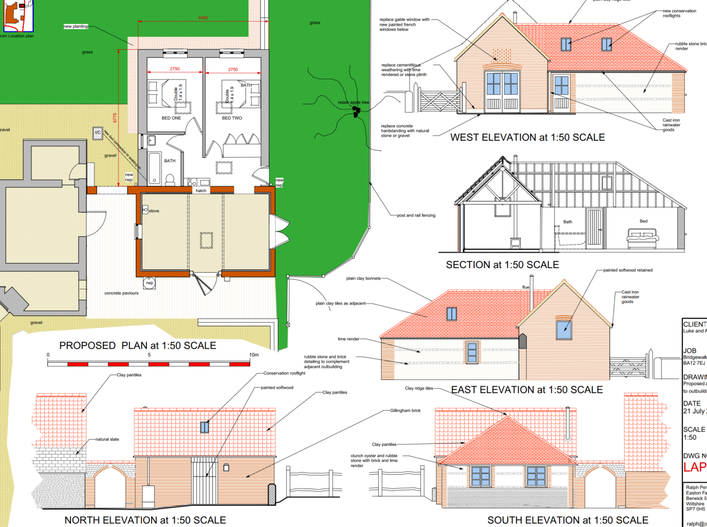

Approved Elevation and Floor Plans for PL/2022/05624 & PL/2022/06725

The approved 2022 extension to the existing outbuilding would have a footprint of c6.7m x 6.4m and would have had a large, hipped roof and would have been built using clay tiles with mostly lime rendered walls with two courses of rubble stone.

In these 2026 applications, the footprint is being extended slightly to 6.95m x 6.75m. The design is changing too by building a mirror image of the existing outbuilding via a small flat roofed link section. It would also have clay pantiles but would be finished with horizontal timber boarding panels. The flat roofed section would be pre-weathered zinc.

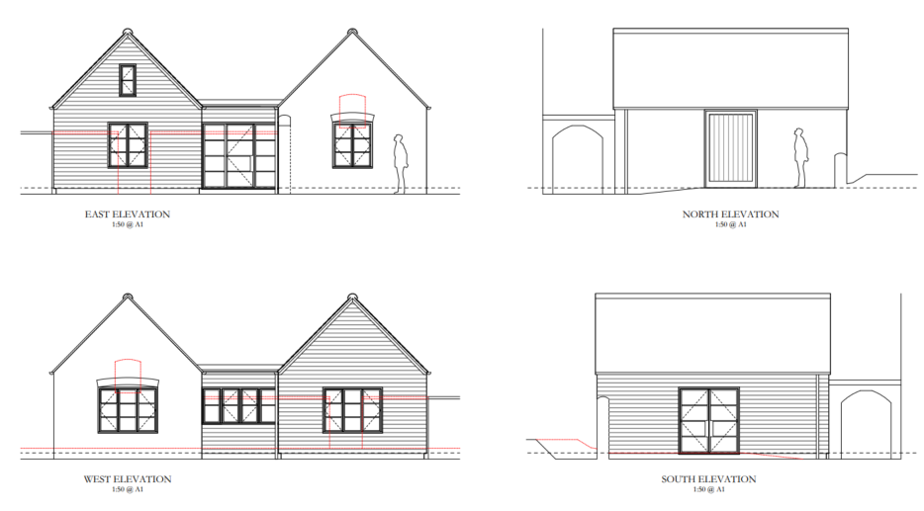

Proposed Elevations

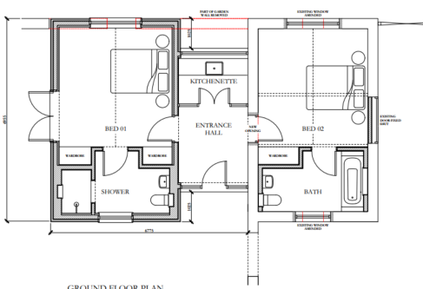

Proposed Floor Plan

The applicants have submitted the following documents in support of the application:

In the initial submission these documents were received on 30 March 2026

- Design, Access and Heritage Statement (Ralph Perry Robinson)

- Results of archaeological trial trench evaluation (Simmonds and Hughes – dated July 2024)

On 1 May 2026 the applicants submitted an Archaeological Written Scheme of Investigation (Hughes – Dated April 2026) and a revised ground floor plan (25106 P 02 A).

On 1 June 2026, the applicants submitted the results of Archaeological Monitoring and Recording (Simmonds and Hughes – dated June 2026).

For the avoidance of any doubt, the Archaeological reports had also been sent separately to the Council’s Archaeology Officer who agreed and signed off the submissions. Whilst this should have been undertaken via a discharge of condition application for the PL/2022/06725 applications (condition 3 Archaeology), the documents were sent directly to Archaeology and agreed without this usual process.

SITE DESCRIPTION/CONTEXT

This is a Grade II listed building on the edge of Brixton Deverill set in spacious grounds. The building is a detached C18 – midC19 of rendered rubble stone construction.

The application site is subject to the following planning policy constraints:

- Grade II listed building

The listed description reads:

Detached house. C18 and mid C19. Rendered rubble stone, Welsh slate roof, rendered brick stacks with toothed capping. Consists of C18 cottage to rear, enlarged by range to front and reroofed mid C19. Two-storey, 3-windowed front. Central 6-panelled double doors with margin-pane transom light and flat wooden hood, either side is flush 16-pane sash in moulded architrave with keystone. First floor has three flush 16-pane sashes in moulded architraves with keystones. Right return has 2-light casement to first floor, attached to left and right returns are single storey C19 additions with 16-pane sash. Rear has planked door to left of centre in gabled timber porch, 3-light casement to either side and 2-light casement to right, first floor has two 2-light casements. Interior has flagstone floors to rear range, front range has 6- panelled doors in moulded architraves, panelled shutters and reveals to windows, plain classical fireplaces. Attached outhouses to rear have pantiled roofs and planked doors.

PLANNING HISTORY

Proposal / Summary
13/04003/FUL - Full planning permission Decision - Approve with Conditions Date: 30/10/2013 – Works to form an additional bedroom and ensuite
13/04004/LBC - Listed building consent Decision - Approve with Conditions Date: 30/10/2013 – Works to form an additional bedroom and ensuite
PL/2022/05624 - Full planning permission Decision - Approve with Conditions Date: 11/9/2024 – Single storey extension of existing outbuilding to provide ancillary accommodation
PL/2022/06725 - Listed building consent (Alt/Ext) Decision - Approve with Conditions Date: 11/9/2024 – Single storey extension of existing outbuilding to provide ancillary accommodation
W/07/02266/LALBC - Listed building consent Decision - Approve with Conditions Date: 3/10/2007 – Reconstruction of damaged bridge

RELEVANT POLICIES AND GUIDANCE
Legislation:
From the point of view of the historic environment the main statutory tests are set out within the Planning (Listed Building and Conservation Areas) Act 1990.
Section 16 of the Planning (Listed Buildings and Conservation Areas) Act 1990 states that in considering whether to grant listed building consent for any works the local planning authority [or the Secretary of State] shall have special regard to the desirability of preserving the building or its setting or any features of special architectural or historic interest which it possesses.
Section 66 requires that special regard be given to the desirability of preserving listed buildings, their settings or any features of special architectural or historic interest which they possess
National Guidance:

The NPPF outlines government policy for planning. Chapter 16 of the NPPF 'Conserving and enhancing the historic environment' sets out the Government's high-level policies concerning heritage and sustainable development.

Local Context:

The development plan for Wiltshire comprises the Wiltshire Core Strategy (WCS) (adopted January 2015) and any made neighbourhood plans, which remains the principal statutory planning document guiding development across the county. In line with Section 38(6) of the Planning and Compulsory Purchase Act 2004, planning decisions must be made in accordance with the development plan unless material considerations indicate otherwise.

Though the development plan is considered as a whole, those parts deemed to be particularly relevant to this pre-application enquiry are listed below:

The adopted Wiltshire Core Strategy (WCS), with particular regard to:

- Core Policy 57 Ensuring High Quality Design and Place Shaping;
- Core Policy 58 Ensuring the Conservation of the Historic Environment;
The Council’s Core Strategy Policy CP58 ‘Ensuring the conservation of the historic environment’ requires that designated and non-designated heritage assets and their settings will be conserved, and where appropriate enhanced, in a manner appropriate to their significance and encourages proposals which improve the condition of heritage assets at risk.
Made Neighbourhood Plans:

Brixton Deverill does not have a neighbourhood plan

CONSULTATION RESPONSES

Initial consultations were sent out on 9 April and following receipt of the WSI and revised ground floor plan again on 26 May 2026. Following receipt of the results report on 1 June, no further formal consultations were carried out other than via email with the Council’s Archaeology Officer.

Upper Deverills Parish Council: No comments received

Wiltshire Council Archaeology Officer: No objection

Wiltshire Council Conservation Officer: No objection

“We have already approved an extension to this outbuilding, which is considered to curtilage listed (hence the need for LBC as well as Planning Permission).

We have also had recent pre-application discussions (ENQ/2026/00143) about amending the design. The current application documentation reflects those discussions (i.e. a separate 'new' pitched element with a low-key link to the existing building). As such, I have no objection to the proposals which I consider will preserve the character of the original ancillary curtilage listed building as well as the setting of the house. As such, I consider the proposals would accord with Sections 16 and 66 of the Planning LBCA Act 1990, core policy 58 and Chapter 16 of the NPPF.”

Historic England: No objection

REPRESENTATIONS

The application was advertised by site notice. No comments were received.

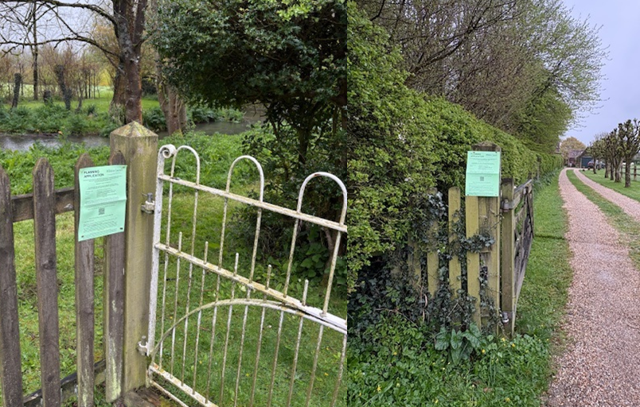
ASSESSMENT

Section 38(6) of the Planning and Compulsory Purchase Act 2004 states:

"If regard is to be had to the development plan for the purposes of any determination to be made under the planning Acts, the determination must be made in accordance with the plan unless material considerations indicate otherwise."

In accordance with this statutory requirement, this application has been assessed against the relevant policies of the Development Plan, including the adopted Wiltshire Core Strategy (2015) and, where applicable, any made Neighbourhood Plans.

Heritage Impact

Archaeology and Scheduled Monument:

Initial consultation was undertaken with the Council’s Conservation and Archaeology Officers, together with Historic England, on 9 April 2026. This was based on the submitted Heritage Statement and the 2024 archaeological trial trench evaluation. At that stage, Historic England raised concerns that the proposal had the potential to impact a number of designated heritage assets, namely:

“the proposal has the potential to impact on a number of heritage assets namely;

· Roman Villa at Brixton Deverill , scheduled monument (National Heritage List Entry No. 1448408)
· Bridgewalk House Grade II Listed Building (NHLE: 1364381)
· Brixton Deverill Conservation Area, including a number of Grade II Listed Buildings.

Significance of monument
The scheduled monument lies within a field to the south of the development.

The villa is a well preserved example of a large country house, with evidence of occupation from the 2nd century to the 4th century (1,800 to 1,600 years ago). There is also some evidence for later occupation and reuse of some of the buildings.

The villa has been identified through a series of archaeological investigations. These have shown that the Roman building is formed of three wings surrounding a large courtyard. The villa looks towards the east-south-east, across the valley bottom. This is similar to many of the modern houses, e.g. Bridgewalk House.

There are other buildings and associated structures to the east and south of the main villa. These have not been clearly identified so are not included within the scheduled area. There is the potential that there are other Roman remains associated with the villa close by, to the west and north.

Evaluation in 2023 on the proposed area of the extension uncovered some Roman remains. The remains included a stone wall 0.45m below the ground surface covered by Roman demolition deposits. These deposits were about 0.2m below ground level. These Roman deposits and structures will be of equivalent significance to the highly designated heritage asset.”

However, it is understood that the applicants had already submitted a written scheme of investigation (WSI) with the Council’s Archaeology Officer; and only formally submitted it as part of the planning application after it had been agreed. It is understood that the applicants then proceeded with the excavations in accordance with the WSI before the Council had opportunity to re-consult with Historic England over the WSI itself.

Nonetheless the Council’s Archaeology Officer commented:

“The excavation of the extension’s footprint was completed by AC Archaeology on 1st May 2026. They reported to me that the excavations had proceeded to a depth of 400mm below current ground level. Consequently, there was no exposure of the Roman wall (or other in situ pre-modern features) that was recorded at greater depth during the trial trenching. The strip exposed the modern concrete trough that was recorded previously.”

Therefore, it was confirmed that there was no need or requirement for the development works to go deeper to the actual Roman remains.

Historic England responded on 3 June 2026 (to the WSI and ground floor plan) to remove their objection stating “The revised plan now clearly shows the below ground impacts of the proposed new wall and how it will avoid the scheduled area. We can therefore confirm that scheduled monument consent will not be required for the works.”

Historic England did request minor amendments to the WSI; however, these comments were made without knowledge that the WSI had already been agreed with the Council’s Archaeology Officer and that the works had already been undertaken. Given that the excavation has been completed to the satisfaction of the Council’s Archaeology Officer, no further amendments are considered necessary.

The applicants then submitted the archaeological report of the works on 1 June, which was agreed by the Council’s Archaeology Officer on 3 June.

Conclusion:

Historic England has confirmed that Scheduled Monument Consent is not required, and the archaeological investigation has been carried out to the satisfaction of the Council’s Archaeology Officer. The proposed development therefore raises no outstanding archaeological concerns, and no further information or planning conditions are required in this respect.

Impact on the setting, character and historic fabric of listed building

The impact on the setting and character of the listed building would be ultimately complimentary given the proposed design and use of materials and would be a significant betterment over the extant permission. The proposed extension would result in a straightforward and in-keeping extension that would not result in harm to the character of the listed building.

The significance of the building lies largely with its historic fabric and architecture - its form, layout and architectural expression/detailing and use of high-quality design materials which have significant aesthetic and architectural interest.

This scheme would extend a single storey outbuilding to the rear of the main house. The significance of the outbuilding is lower than that of the main listed building, being a vernacular simple structure. The loss of parts of the walling to accommodate the door opening on the south elevation would not result in such harm as to spoil the historic integrity of the listed building. Equally the loss of part of the garden wall, similarly of limited significance, would not require in overriding harm either.

Therefore, it is considered that the proposal, by virtue of its scale, design, and use of materials, is considered to preserve the character and appearance of the conservation area or the setting of the listed building. It would not result in harm to the significance of any heritage assets, and no objections have been raised by the Conservation Officer.

The development is therefore considered to comply with Core Policy 58 of the Wiltshire Core Strategy and Sections 16 and 66 of the Planning (Listed Buildings and Conservation Areas) Act 1990, as well as the relevant provisions of the NPPF.

CONCLUSION

The proposed works have been carefully designed to respect the character, form, and significance of the Grade II listed building and its curtilage structures. The extension adopts a simple form, with a clear distinction between old and new, and utilises materials that are considered appropriate to the rural context.

The outbuilding to which the extension relates is of lesser significance than the principal listed building, and the limited alterations required to facilitate the development, including the formation of openings, would not result in harm to the building’s special architectural or historic interest.

Overall, the proposal would preserve both the character and setting of the listed building. In accordance with Sections 16 and 66 of the Planning (Listed Buildings and Conservation Areas) Act 1990, special regard has been given to the desirability of preserving the listed building, its setting, and its features of interest.

The development is therefore considered to accord with Core Policy 58 of the Wiltshire Core Strategy and the relevant provisions of the NPPF. Listed Building Consent is recommended for approval.

RECOMMENDATION: That Planning Permission be GRANTED subject to conditions.

