APPLICATION FOR HOUSEHOLDER PLANNING PERMISSION
DELEGATED REPORT

APPLICATION REFERENCE: | PL/2026/02653
APPLICATION TYPE: | Householder planning permission
SITE ADDRESS: | 115 Lacock Gardens, Hilperton, Trowbridge, BA14 7TG
DEVELOPMENT DESCRIPTION: | Single storey front dining room extension
RECOMMENDATION: | That Planning Permission be GRANTED

SITE DESCRIPTION/CONTEXT
The subject property is a detached, two-storey dwelling, in an area of shared modern late C20 design and materiality on modern road layouts. The side/south elevation abuts retained green space separating it from the highway Hilperton Way.

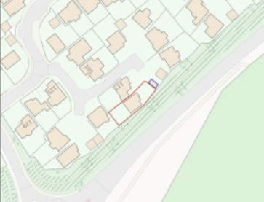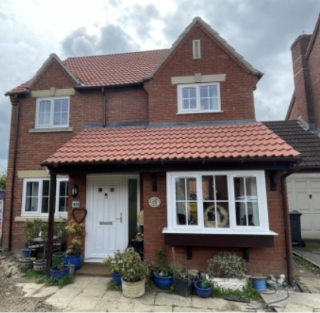

Location Plan and submitted site photo

The application site is within buffer zones of various bat roosts but not within any designated area.

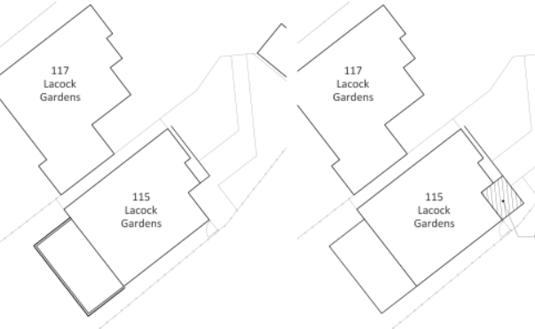

Existing and Proposed Block Plans

PROPOSAL

The proposal seeks planning permission for a single storey front extension to the existing dining room, projecting level to the existing study and front building line.

The proposal includes relocating a front and side window and the reduction of a first-floor window to enable the extension of the porch/study mono-pitch roof. Proposed materials include brick and roof tiles to match existing.

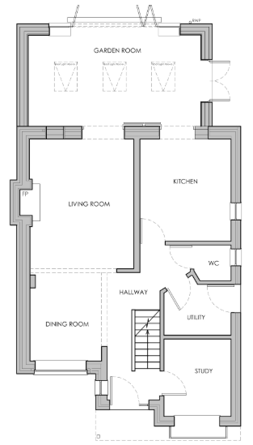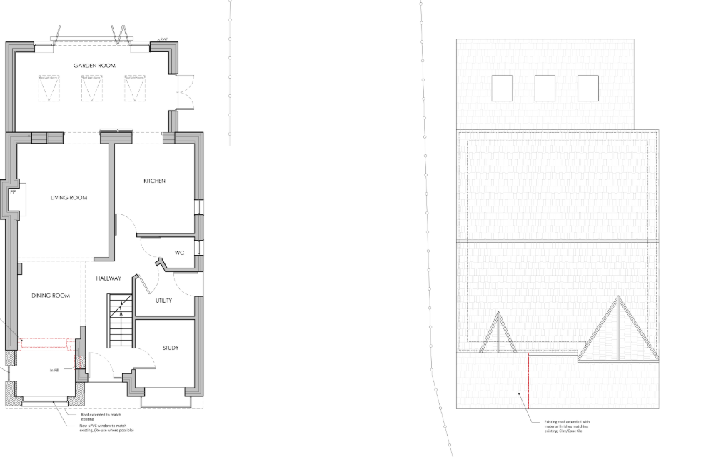

Existing and Proposed Ground Floor Plan

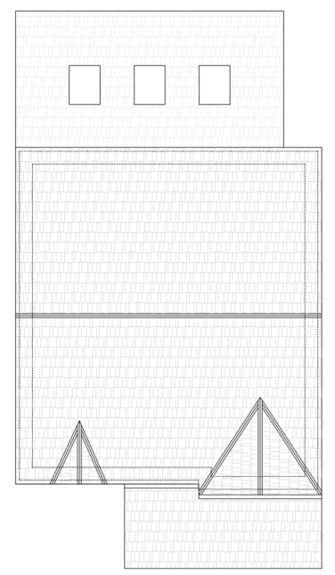

Existing and Proposed Roof Plan

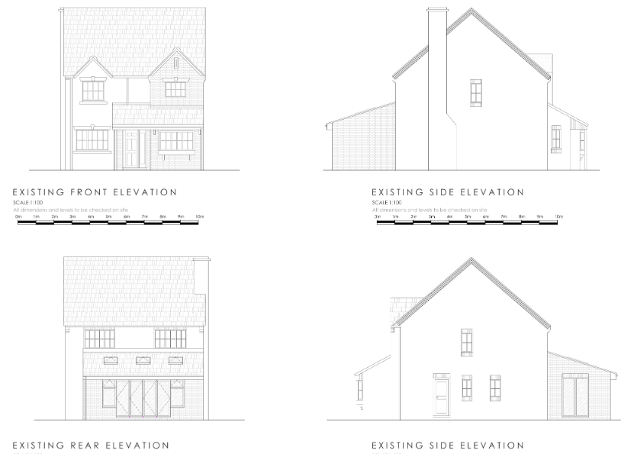

Existing Elevations

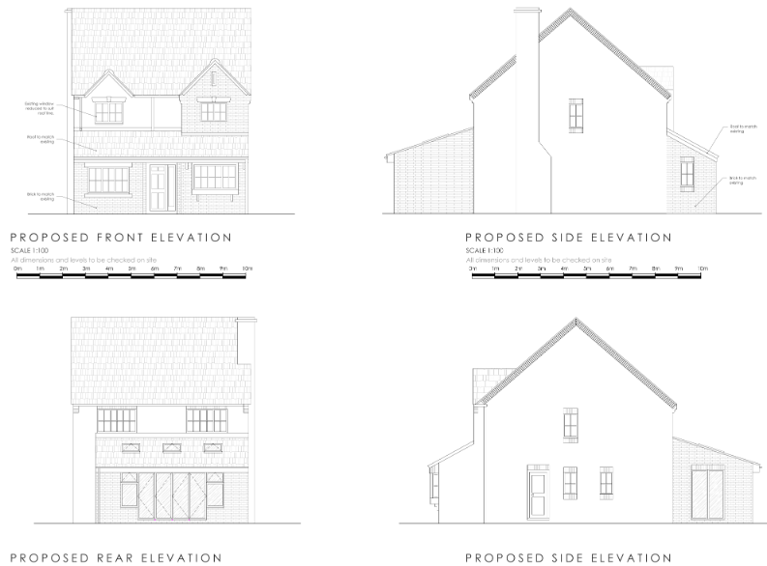

Proposed Elevations

PLANNING HISTORY
PL/2025/05795 - Certificate of lawfulness proposed for the erection of Single Storey Rear Extension – approved
15/02153/FUL – no.82 – front dining room extension and rear sunlounge extension – approve with conditions

RELEVANT POLICIES AND GUIDANCE
The National Planning Policy Framework (NPPF)
The Planning Practice Guidance
National Design Guide
Wiltshire Design Guide: Appendix D – Design Guidance for Householder extensions

Wiltshire Core Strategy:
- Core Policy 57 Ensuring High Quality Design and Place Shaping

Hilperton Neighbourhood Plan, made 2018.

CONSULTATION RESPONSES
Hilperton Parish Council: submitted a no comment.
Archaeology: no objection.

REPRESENTATIONS
No comments were received.

ASSESSMENT
Section 38(6) of the Planning and Compulsory Purchase Act 2004 states:

"If regard is to be had to the development plan for the purposes of any determination to be made under the planning Acts, the determination must be made in accordance with the plan unless material considerations indicate otherwise."

In accordance with this statutory requirement, this application has been assessed against the relevant policies of the Development Plan, including the adopted Wiltshire Core Strategy (2015) and, where applicable, any made Neighbourhood Plans.

Design and Impact upon the character and context of the area
Core Policy 57 - Ensuring High Quality Design and Place Shaping of the Wiltshire Core Strategy seeks to ensure that all new development is of high design quality, reflecting local context, character, and distinctiveness.

The proposed extension would involve a moderate increase of floorplan, increased front projection inline with the existing building line, all at a subservient single storey.

The scale, form and proposed materiality would enable successful integration with the host dwelling and reflects similar precedent local development.

Having regard to the above, the proposal complies with the design principles set out in Core Policy 57 of the Wiltshire Core Strategy and Appendix D of the Wiltshire Design Guide.

Amenity
Point vii of Core Policy 57 - Ensuring High Quality Design and Place Shaping of the Wiltshire Core Strategy seeks to ensure that developments do not adversely affect neighbouring properties.

The National Planning Policy Framework (NPPF), particularly Paragraph 135(f), stresses that planning decisions should ensure developments provide a high standard of amenity for existing and future users.

The proposed development has been assessed in terms of its potential impact on the residential amenity of neighbouring properties, with particular regard to loss of light, overshadowing, loss of privacy, and overbearing effects.

As a single storey extension, distanced beyond the front porch from the nearest neighbours, there are no concerns regarding overshadowing or overbearing. The proposed new window on the side elevation would face towards green space and so would not have a negative impact to neighbouring amenity.

The proposal therefore accords with Core Policy 57 point vii in respect of safeguarding residential amenity and Appendix D of the Wiltshire Design Guide.

Ecology Impact
Core Policy 50 of the Wiltshire Core Strategy seeks to protect and enhance biodiversity and geodiversity, including through ensuring that development avoids harm to protected species and habitats.

The National Planning Policy Framework (NPPF), in Paragraphs 193, requires that development minimises impacts on and provides net gains for biodiversity, including ensuring mitigation is secured where harm cannot be avoided.

The proposals pose no loss of biodiversity, and the application does not meet the threshold set out in legislation to demonstrate BNG.

All UK bat species are protected by European and UK legislation; the Conservation of Habitats and Species Regulations and the Wildlife and Countryside Act. Considering the scale and form of proposed development, as a single storey extension to an existing ground floor inhabitated modern dwelling, within a suburban area, no substanitave ecology impact is raised and as such does not meet the threshold for a habitat regulations assessment.

An informative is included as a precautionary measure, raising the profile of the Bat SAC, including that if any evidence of bat activity is detected, that the applicant should follow the advice of a professional ecologist or contact Natural England.

The applicant should note that under the terms of the Wildlife and Countryside Act (1981) and the Habitats Regulations (2010) it is an offence to disturb or harm any protected species, or to damage or disturb their habitat or resting place. Please note that this consent does not override the statutory protection afforded to any such species. In the event that your proposals could potentially affect a protected species you should seek the advice of a suitably qualified and experienced ecologist and consider the need for a licence from Natural England prior to commencing works. Please see Natural England’s website for further information on protected species.

As such, the development complies with Core Policy 50 of the Wiltshire Core Strategy and the relevant provisions of the NPPF.

CONCLUSION
The proposed development is considered to be acceptable in terms of its design, scale, and relationship with the surrounding area. It would not result in any unacceptable harm to the character of the locality, the amenities of neighbouring occupiers, or ecology.

The proposal is therefore considered to comply with the relevant policies of the Wiltshire Core Strategy, the Wiltshire Local Plan, and the National Planning Policy Framework. As such, the application is recommended for approval, subject to the conditions set out below.

RECOMMENDATION: That Planning Permission be GRANTED subject to conditions.

