APPLICATION FOR HOUSEHOLDER PLANNING PERMISSION
DELEGATED REPORT

APPLICATION REFERENCE: | PL/2026/02423
APPLICATION TYPE: | Householder planning permission
SITE ADDRESS: | 4 Sliver Street, Dilton Marsh, Westbury, BA13 4DQ
DEVELOPMENT DESCRIPTION: | Proposed Single Storey Rear Extensions
RECOMMENDATION: | That Planning Permission be GRANTED

SITE DESCRIPTION/CONTEXT
The subject property is a semi-detached, two-storey dwelling, with integrated garages between.

Silver Street lies at the edge of the historic core of Dilton Marsh, such that non-designated heritage assets line the opposite side of the lane, with modern dwellings with shared C20 design and materiality surrounding the proposal site’s side of the narrow lane.

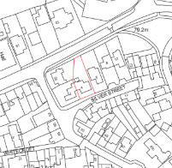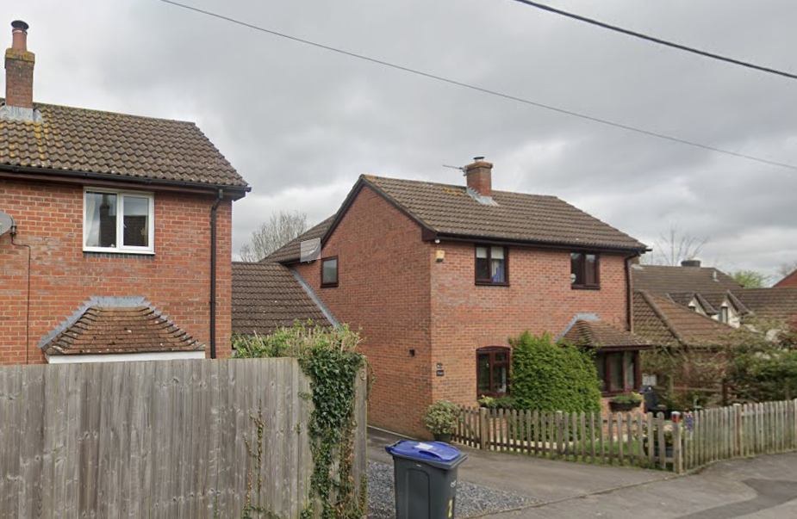

Location Plan and Google Earth Site Photo

The application site, whilst in Flood Zone 1, of lowest risk, also has slightly increased risk of ground water flooding.

The site also lies within the Bath and Bradford on Avon Bat SAC zones of impact.

PROPOSAL

The proposal seeks planning permission for single storey rear extensions:
- extension to the existing kitchen, with increased 1.5m side projection almost to the existing side building line, and 3.5m rear projection, with knocking through to create one large kitchen/dining space, with French doors, and two rooflights within a mono-pitch lean-to roof, with a side-facing window replacing the existing back door.
- Utility extension to the existing garage, with access from both the extended kitchen and garage, measuring 3.1m x 3.6m.

Proposed materials include brickwork and brown uPVC windows to match existing and a flat roof system, and profile roof tiles, against existing concrete profile tiles.

The location plan and aerial WCC mapping, shows a shed to the rear of the property which is the location of the proposed rear garage extension.

The proposal has no impact on the means of access to the dwelling or its current parking arrangement.

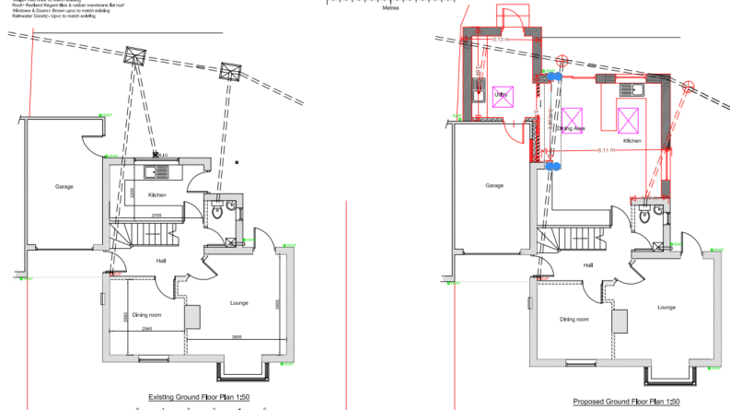

Existing and Proposed Ground Floor Plans

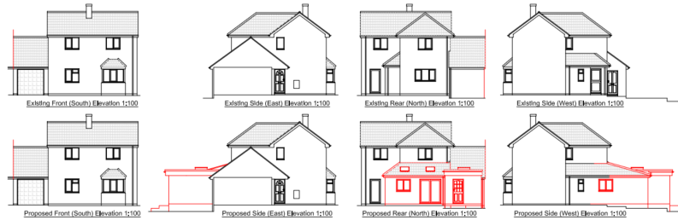

Existing Elevations

Proposed Elevations

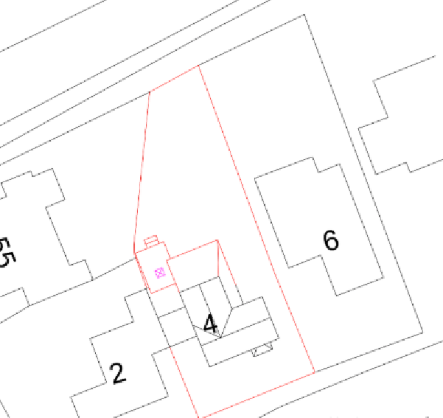

Proposed Block Plan

PLANNING HISTORY
W/81/00727/FUL - Full planning permission Decision - Approve with Conditions Date: 14/12/1981 – Erection of two pairs of semi-detached houses
W/83/00257/FUL - Full planning permission Decision - Approve with Conditions Date: 19/4/1983 – Four houses and garages
W/84/01456/FUL - Full planning permission Decision - Approved Date: 22/1/1985 – Extension

RELEVANT POLICIES AND GUIDANCE
The National Planning Policy Framework (NPPF)
The Planning Practice Guidance
National Design Guide
Wiltshire Design Guide: Appendix D – Design Guidance for Householder extensions

Wiltshire Core Strategy:
- Core Policy 57 Ensuring High Quality Design and Place Shaping
- Core Policy 67: Flood Risk

Dilton Marsh Neighbourhood Plan, made 2017.

CONSULTATION RESPONSES
Dilton Marsh Parish Council: No objection.

REPRESENTATIONS
No comments were received.

ASSESSMENT
Section 38(6) of the Planning and Compulsory Purchase Act 2004 states:

"If regard is to be had to the development plan for the purposes of any determination to be made under the planning Acts, the determination must be made in accordance with the plan unless material considerations indicate otherwise."

In accordance with this statutory requirement, this application has been assessed against the relevant policies of the Development Plan, including the adopted Wiltshire Core Strategy (2015) and, where applicable, any made Neighbourhood Plans.

Design and Impact upon the character and context of the area
Core Policy 57 - Ensuring High Quality Design and Place Shaping of the Wiltshire Core Strategy seeks to ensure that all new development is of high design quality, reflecting local context, character, and distinctiveness.

The proposal development would be restricted to the rear/side of the subject dwelling so as to not impact the streetscape.

The proposed side garage extension would be within the existing side building line established by the garage. The scale of the extensions would be moderate, whilst enabling improved functionality for modern living.

Neighbouring dwellings are not parallel but staggered, such that the proposed rear buildings line would project further than no.2 to the west, but less than no.6 to the east, but the scale of the development would remain commensurate to the host dwelling within its plot.

The proposed mono-pitch roof over the rear kitchen extension, would continue the existing pitched roof section. The junction between the proposed mono-pitch to the flat roof to the garage extension, whilst a little clunky, does continue to delineate between the extended garage form and host dwelling.

Proposed materials would enable the extensions to successfully integrate with the host dwelling.

Having regard to the above, the proposal complies with the design principles set out in Core Policy 57 of the Wiltshire Core Strategy and Appendix D of the Wiltshire Design Guide.

Amenity
Point vii of Core Policy 57 - Ensuring High Quality Design and Place Shaping of the Wiltshire Core Strategy seeks to ensure that developments do not adversely affect neighbouring properties.

The National Planning Policy Framework (NPPF), particularly Paragraph 135(f), stresses that planning decisions should ensure developments provide a high standard of amenity for existing and future users.

The proposed development has been assessed in terms of its potential impact on the residential amenity of neighbouring properties, with particular regard to loss of light, overshadowing, loss of privacy, and overbearing effects.

As previously noted, the neighbouring dwellings are staggered such that the proposed rear extensions would project beyond the rear building line of no.2. The intervening garages however, and single storey nature of the extensions, with a flat roof system to the immediate garage extension, and moderate scale of the extension, means there are no concerns regarding overbearing or overshadowing.

The proposal includes a reduction in openings to the side/east elevation facing no.6. As windows at ground floor level, any impact to neighbouring privacy can be managed by standard boundary treatments.

Proposed rooflights are at a height to raise no concerns to privacy.

The proposal therefore accords with Core Policy 57 point vii in respect of safeguarding residential amenity and Appendix D of the Wiltshire Design Guide.

Drainage and Flood Risk
Core Policy 67 of the Wiltshire Core Strategy and paragraph 181 of the NPPF requires that all new development avoids increasing flood risk on-site or elsewhere and, where appropriate, incorporates sustainable drainage measures. Development must also comply with national policy on flood risk management and drainage design. Paragraph 176 (via footnote 62) of the NPPF states that householder development should not be subject to the sequential test, nor the exception test.

The proposal site is within flood risk zone 1, with the additional risk of groundwater flooding.

Householder development is considered Minor Development, under the Flood Risk planning guidance, if “physical extensions to the existing dwelling itself,” and, barring a few exceptions not relevant here, “are unlikely to raise significant flood risk.” The proposal to remodel an existing property, is therefore deemed to not result in any loss of land prone to flood risk.

The existing drainage arrangements are unaltered by the proposals.

As such, the proposal is deemed to be safe for its users for the intended lifetime of the development with respect to the level and nature of the flood risk.

Biodiversity Net Gain
Householder planning applications are exempt from the requirement to deliver Biodiversity Net Gain under Schedule 7A, Section 4(2)(a) of the Town and Country Planning Act 1990, as inserted by the Environment Act 2021.

Ecology
Whilst being located within the zone of impact for the Bath and Bradford on Avon Bat SAC, the addition of single storey extensions which do not alter the roof of the existing buildings and which are set within the existing hard-landscaped garden area of the dwelling would not include works which would have potential to affect habitat and as such risks to protected species are minimal. The decision notice includes a standard informative as a precaution.

CONCLUSION
The proposed development is considered to be acceptable in terms of its design, scale, and relationship with the surrounding area. It would not result in any unacceptable harm to the character of the locality, the amenities of neighbouring occupiers, or the interests of drainage.

The proposal is therefore considered to comply with the relevant policies of the Wiltshire Core Strategy, the Wiltshire Local Plan, and the National Planning Policy Framework. As such, the application is recommended for approval, subject to the conditions set out below.

RECOMMENDATION: That Planning Permission be GRANTED subject to conditions.

