APPLICATION FOR HOUSEHOLDER PLANNING PERMISSION DELEGATED REPORT
APPLICATION REFERENCE: | PL/2026/02588
APPLICATION TYPE: | Householder planning permission
SITE ADDRESS: | 26 St Gregorys Avenue, Salisbury, SP2 7JP
DEVELOPMENT DESCRIPTION: | 2 storey side extension
RECOMMENDATION: | That Planning Permission be GRANTED

PROPOSAL

The proposal seeks planning permission for the erection of a two storey side extension to be constructed on the east side of the existing dwelling. The proposed extension will be constructed using materials to match the existing dwelling. Existing and proposed plans and elevations included below for comparison.

Site plan

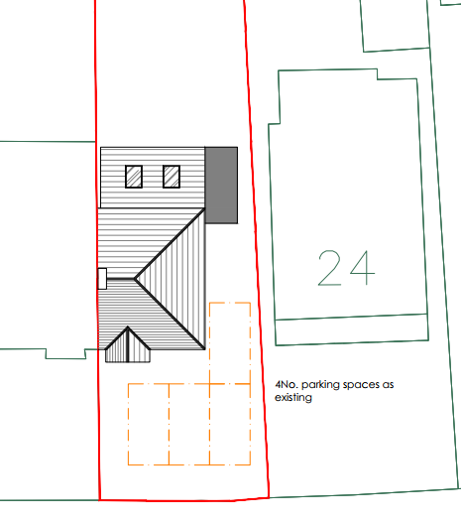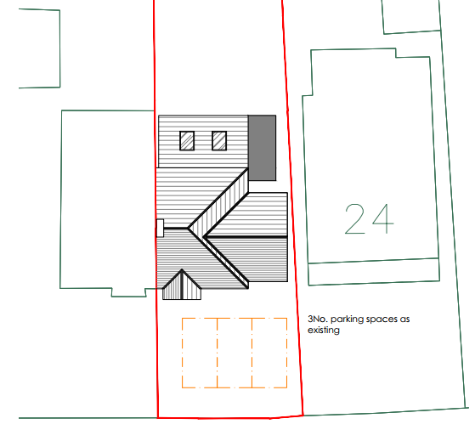

Elevations

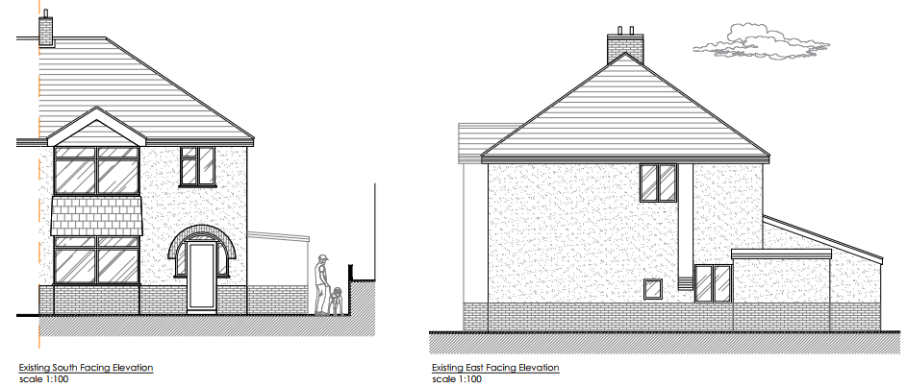

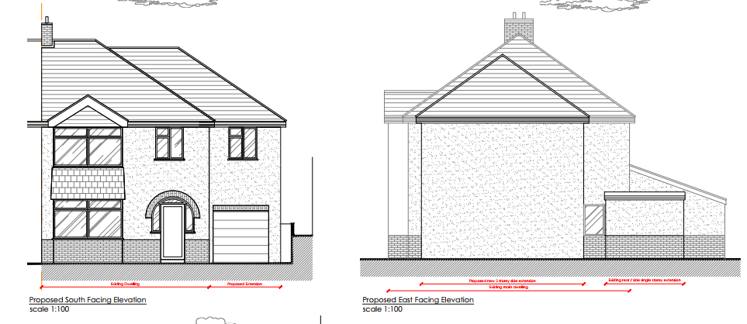

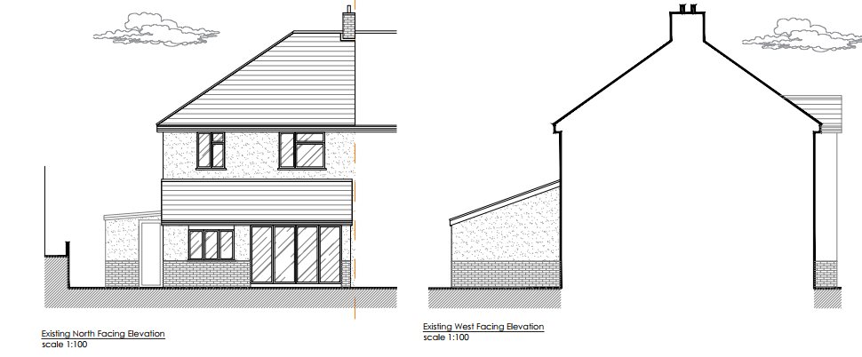

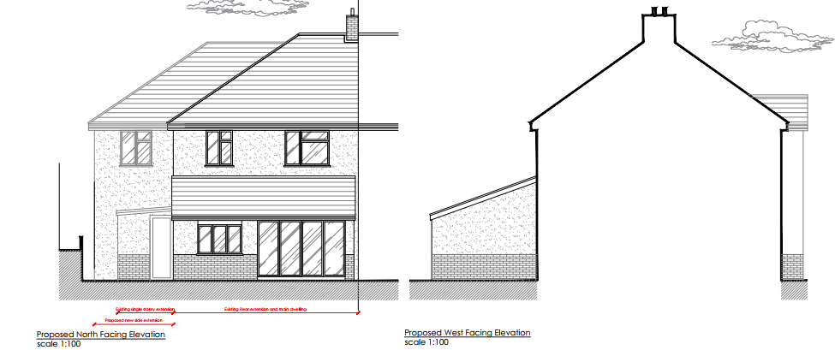

Floor plans

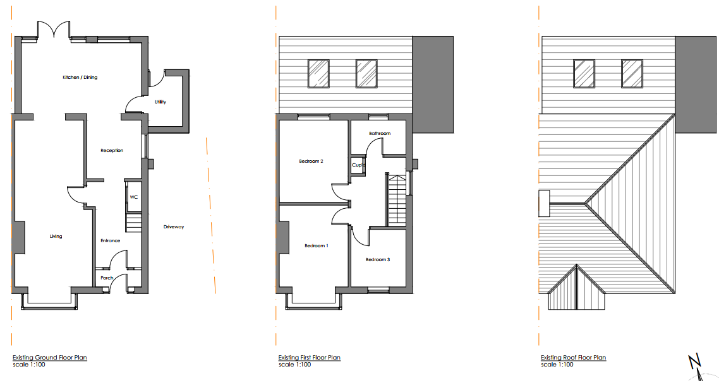

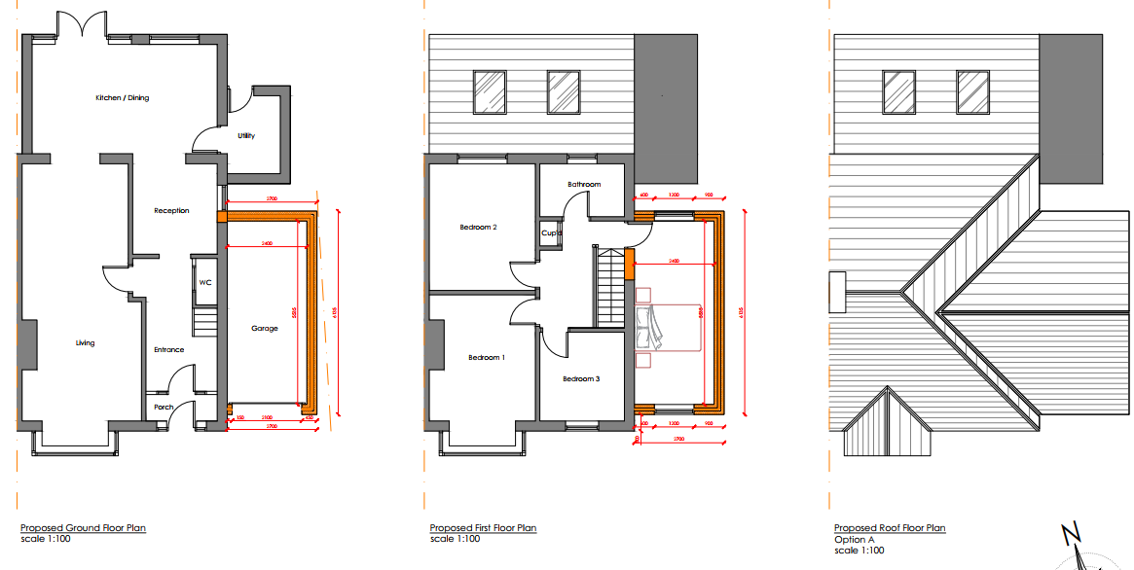

SITE DESCRIPTION/CONTEXT

The application site relates to a two storey detached residential dwelling located on the north side of St Gregorys Avenue. The application site is located within an established residential area and is within the defined settlement boundary of the City of Salisbury. Salisbury is defined as a Principal Settlement by Wiltshire Core Strategy (WCS) policies CP1 (Settlement Strategy), CP2 (Delivery Strategy) and CP20 (Salisbury Community Area).

Whilst the site is some distance from the river it is in Flood Zone 1; and is in an area that is at low risk of Ground Water flooding (Groundwater levels are at least 5 metres below the ground surface) , it is situated within the catchment of the River Avon Special Area for Conservation (SAC). The site also lies within the 13.8km zone of influence for the New Forest protected sites, which comprises the New Forest SPA, New Forest SAC and New Forest Ramsar site. As the proposed development relates to Householder extensions and not the creation of new separate overnight accommodation it is screened out of Appropriate Assessment and no further comments/assessment is needed with regard these ecological designations.

PLANNING HISTORY

None relevant

RELEVANT POLICIES AND GUIDANCE

Government Guidance

National Planning Policy Framework (NPPF)
National Planning Practice Guidance (NPPG)
National Design Guide

Wiltshire Core Strategy (WCS):

CP1 (Settlement Strategy)
CP2 (Delivery Strategy)
CP20 (Salisbury Community Area)
CP50 (Biodiversity and Geodiversity)
CP57 (Ensuring High Quality Design & Space Shaping)
CP60-64 (Transport)
CP69 (Protection of the River Avon SAC)

Supplementary Planning Documents:

Achieving Sustainable Development SPG (April 2005)
Wiltshire Local Transport Plan – Car Parking Strategy
Creating Places Design Guide
Wiltshire Design Guide

Salisbury Neighbourhood Plan

CONSULTATION RESPONSES

City Council: No comments

Highways: No objection subject to condition

REPRESENTATIONS

No comments were received.

ASSESSMENT

Section 38(6) of the Planning and Compulsory Purchase Act 2004 states:

"If regard is to be had to the development plan for the purposes of any determination to be made under the planning Acts, the determination must be made in accordance with the plan unless material considerations indicate otherwise."

In accordance with this statutory requirement, this application has been assessed against the relevant policies of the Development Plan, including the adopted Wiltshire Core Strategy (2015) and, where applicable, any made Neighbourhood Plans.

Design and Impact upon the character and context of the area

Core Policy 57 - Ensuring High Quality Design and Place Shaping of the Wiltshire Core Strategy seeks to ensure that all new development is of high design quality, reflecting local context, character, and distinctiveness.

The proposed two storey side extension is considered to be acceptable in terms of design and impact on the character of the host dwelling and wider street scene. The extension has been appropriately designed to appear subservient to the original dwelling, being set back from the principal elevation and with its ridge height set down, ensuring that it does not appear overly dominant or compete with the host property when seen from the public domain/front street scene. Furthermore, the use of materials to match the existing dwelling, including render, roof tiles and fenestration, will ensure a cohesive and sympathetic appearance.

The surrounding area is characterised by dwellings that have been extended and altered over time, and as such the proposal would be in keeping with the general character of the area and is appropriate in such an existing residential area. Overall, the scale, form and design of the extension are considered to respect the character and appearance of the site and its surroundings, in accordance with Core Policy CP57

Having regard to the above, the proposal complies with the design principles set out in Core Policy 57 of the Wiltshire Core Strategy and Appendix D of the Wiltshire Design Guide.

Amenity

Point vii of Core Policy 57 - Ensuring High Quality Design and Place Shaping of the Wiltshire Core Strategy seeks to ensure that developments do not adversely affect neighbouring properties.

The National Planning Policy Framework (NPPF), particularly Paragraph 135(f), stresses that planning decisions should ensure developments provide a high standard of amenity for existing and future users.

The proposed development has been carefully assessed in terms of its impact on neighbouring residential amenity. Overall, the extension is considered to be acceptable, with no unacceptable impacts arising in terms of overlooking, loss of privacy or overbearing impact.

However, some concern arises in relation to the two side elevation windows serving No. 24 St Gregory’s Avenue, which face into the site, as the proposed two-storey extension would extend closer to these windows and result in a degree of light loss. One of these windows is situated near the front elevation and is understood to serve the living room. This room also benefits from a bay window on the front elevation, which provides a good level of natural light and helps to offset any reduction in light to the side window.

The second neighbouring window is positioned further towards the rear of the side elevation; it is understood that this window serves a dining room which is also served by another source of light to the rear of the property. The extract below has been taken from a plan provided by the applicant to show the location of the neighbour’s window so the relationship with the proposed extension can be understood.
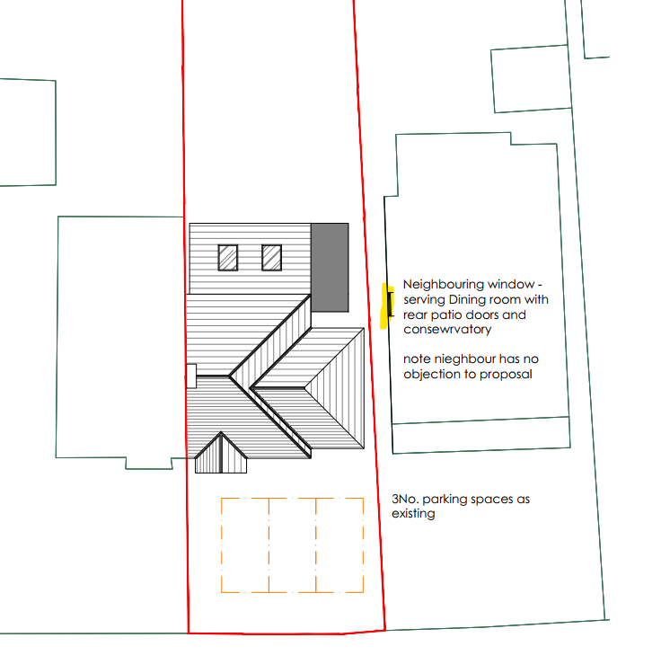
Photo below showing the above window, it can be seen in close proximity to, but a higher level than the flat roof single storey element on the application site.
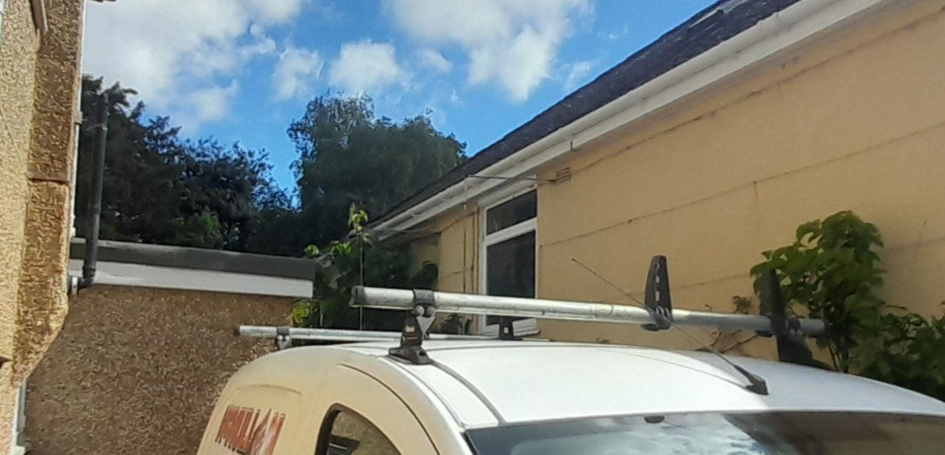

It can be seen that the window is located just to the rear of the proposed extension and therefore the potential impacts are less than originally thought. Had this window been directly alongside the proposed extension it is likely that the overbearing and overshadowing impacts would be significant enough to warrant a reason for refusal as the development would be contrary to CP57. However, the offset is on balance considered to be enough to alleviate Officers concerns, the window will not look directly out on to the flank wall of the proposed extension and will continue to look out over the existing flat roof addition, thus largely retaining their current views; natural light provision to this window will be retained to a degree.

Overall, the level of harm is not considered to be so significant as to warrant a reason for refusal of the application, and on balance, the impact is therefore considered acceptable, particularly as the windows affected are secondary sources of light and aspect from these neighbouring rooms.

Furthermore, as no windows are proposed on the flank wall of the proposed extension, there would be no overlooking impacts arising from the proposal, and any grant of permission would remove permitted development rights for additional openings in the side elevation facing No. 24, thereby ensuring that future impacts on neighbouring amenity are appropriately controlled.

The proposal therefore accords with Core Policy 57 point vii in respect of safeguarding residential amenity and Appendix D of the Wiltshire Design Guide.

Highways Impact

Core Policy 57 (xiv) of the Wiltshire Core Strategy seeks to ensure that development must meet the requirements of Core Policy 61. This policy requires proposals to be capable of being served by safe access to the highway network. Core Policy 64 seeks to ensure compliance with parking standards set out in the Local Transport Plan.

The National Planning Policy Framework (NPPF), particularly Paragraph 115 and 116, requires that development proposals do not have an unacceptable impact on highway safety and that safe and suitable access to the site can be achieved for all users.

The proposal will increase the property from a 3 to a 4 bed dwelling and as such 3 off street parking spaces are required to meet Wiltshire’s current parking standards. Three spaces are shown on the submitted plan, being in the same place as 3 of the existing spaces, however, parking is currently accessed through an opening in a front wall, rather than straight from the highway and as such, for the proposed parking arrangement to be acceptable, the dropped kerb across the site frontage will need to be extended.

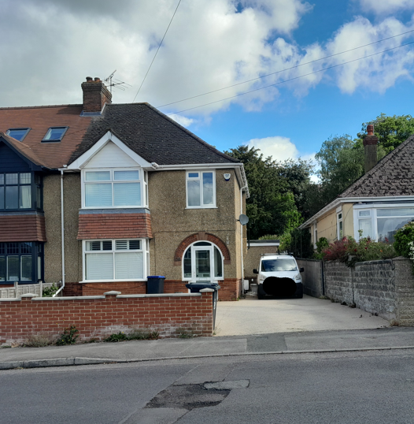

No highways objections are raised subject to conditions.
The proposal is therefore considered to comply with Core Policies 57 (xiv), 61 and 64 of the Wiltshire Core Strategy, the NPPF, and the Wiltshire Local Transport Plan.

Biodiversity Net Gain

Householder planning applications are exempt from the requirement to deliver Biodiversity Net Gain under Schedule 7A, Section 4(2)(a) of the Town and Country Planning Act 1990, as inserted by the Environment Act 2021.

CONCLUSION

The proposed development is considered to be acceptable in terms of its design, scale, and relationship with the surrounding area. It would not result in any unacceptable harm to the character of the locality, the amenities of neighbouring occupiers, or the interests of highway safety.

The proposal is therefore considered to comply with the relevant policies of the Wiltshire Core Strategy, the saved policies in the Salisbury District Local Plan; the Salisbury Neighbourhood Plan, and the National Planning Policy Framework. As such, the application is recommended for approval, subject to the conditions set out below.

RECOMMENDATION: That Planning Permission be GRANTED subject to conditions.

1. The development hereby permitted shall be begun before the expiration of three years from the date of this permission.
REASON: To comply with the provisions of Section 91 of the Town and Country Planning Act 1990 as amended by the Planning and Compulsory Purchase Act 2004.

2. The development hereby permitted shall be carried out in accordance with the following approved plans and documents.

Application form received 22/04/2026
Drg no 5008-PL000 Location plan received 22/04/2026
Drg no 5008-PL101 Proposed Floor Plans received 22/04/2026
Drg no 5008-PL102 Proposed Elevations received 22/04/2026
Drg no 5008-PL103 Rev B Proposed Block Plan received 12/06/2026

REASON: For the avoidance of doubt and in the interests of proper planning.

3. The materials to be used in the construction of the external surfaces of the development hereby permitted be in accordance with those stated on the approved plans and application form and shall match in material, colour and texture those used in the existing building.

REASON: In the interests of visual amenity and the character and appearance of the area.

4. Notwithstanding the provisions of the Town and Country Planning (General Permitted Development) (England) Order 2015 (or any Order revoking or reenacting or amending that Order with or without modification), no windows, doors or other form of openings other than those shown on the approved plans, shall be inserted in the east elevation of the development hereby permitted.

REASON: In the interests of residential amenity and privacy

5. The development hereby permitted shall not be first brought into use until the area between the back edge of the footway and a line drawn 2.4m parallel thereto over the entire site frontage has been cleared of any obstruction to visibility at and above a height of 600mm above the nearside carriageway level, and maintained as such thereafter.
REASON: In the interests of highway safety.
6. The development hereby permitted shall not be first brought into use until the first 5m of the access, measured from the edge of the carriageway, has been consolidated and surfaced (not loose stone or gravel). The access shall be maintained as such thereafter.
REASON: In the interests of highway safety.
7. The proposed development shall not be first brought into use until means/works have been implemented to avoid surface water from entering the highway.
REASON: To ensure that the highway is not inundated with surface water.
8. The vehicle access and parking spaces shall remain ungated.
REASON: In the interests of highway safety.
9. No part of the development hereby permitted shall be first brought into use until the access & parking spaces [3] have been completed in accordance with the details shown on the approved plans. The areas shall always be maintained for those purposes thereafter and maintained free from the storage of materials.
REASON: In the interests of highway safety.

INFORMATIVES

1. Highways

The application involves an extension to the existing vehicle access/dropped kerb. The consent hereby granted shall not be construed as authority to carry out works on the highway. The applicant is advised that a licence will be required from Wiltshire’s Highway Authority before any works are carried out on any footway, footpath, carriageway, verge or other land forming part of the highway. Please contact our Vehicle Crossing Team on vehicleaccess@wiltshire.gov.uk and/or 01225 713352 or visit their website at http://wiltshire.gov.uk/highways-streets to make an application.

2. Party Wall

The applicant is requested to note that this permission does not affect any private property rights and therefore does not authorise the carrying out of any work on land outside their control. If such works are required, it will be necessary for the applicant to obtain the landowners consent before such works commence. If you intend carrying out works in the vicinity of the site boundary, you are also advised that it may be expedient to seek your own advice with regard to the requirements of the Party Wall Act 1996.

3. Building Regulations

Any alterations to the approved plans, brought about by compliance with Building Regulations or any other reason must first be agreed in writing with the Local Planning Authority before commencement of work.

4. BNG not required

The effect of paragraph 13 of Schedule 7A to the Town and Country Planning Act 1990 is that planning permission granted for development of land in England is deemed to have been granted subject to the condition (biodiversity gain condition) that development may not begin unless:

(a) a Biodiversity Gain Plan has been submitted to the planning authority, and
(b) the planning authority has approved the plan.
The planning authority, for the purposes of determining whether to approve a Biodiversity Gain Plan, if one is required in respect of this permission would be Wiltshire Council.
There are statutory exemptions and transitional arrangements which mean that the biodiversity gain condition does not always apply. For further information on exempt developments please refer to:
https://www.gov.uk/guidance/biodiversity-net-gain-exempt-developments
Based on the information available this permission is considered to be one which will not require the approval of a biodiversity gain plan before development is begun because one or more of the statutory exemptions or transitional arrangements is considered to apply.

