CASE OFFICER'S REPORT

Application Reference: | PL/2026/00531
Application Type: | Outline planning permission: Some matters reserved
Consultation ends: | 12 May 2026
Case officer: | Steven Sims

Site Address: | Land to the East of Yarnbrook Road, West Ashton, Trowbridge, BA14 6AP
Proposal: | Outline planning application for development of 9no self build dwellings. All matters reserved except for Access and Layout.
Recommendation: | REFUSE

PROPOSAL AND SITE DESCRIPTION

The site

The site is very rural in nature and comprises approximately 0.47 hectares of agricultural land located to the east of Yarnbrook Road and to the south of West Ashton. Residential development is located beyond the northern and northwest boundaries of the site. There is a travellers site to the south and agricultural land further to the east.

A gravel track runs through the site west to east, which is bordered by mainly hedgerows and slopes down gently from east to west. The site is located within the Bath and Bradford on Avon Bat Special Area of Conservation (SAC), grey and yellow zone of the Trowbridge Westbury Bat Mitigation Strategy (TWBMS) and Salisbury Plain Special Protection Area (SPA).

The site is located within flood zone 1 and is not subject to groundwater flooding. The site is subject to surface water flooding at the access onto Yarnbrook Road.

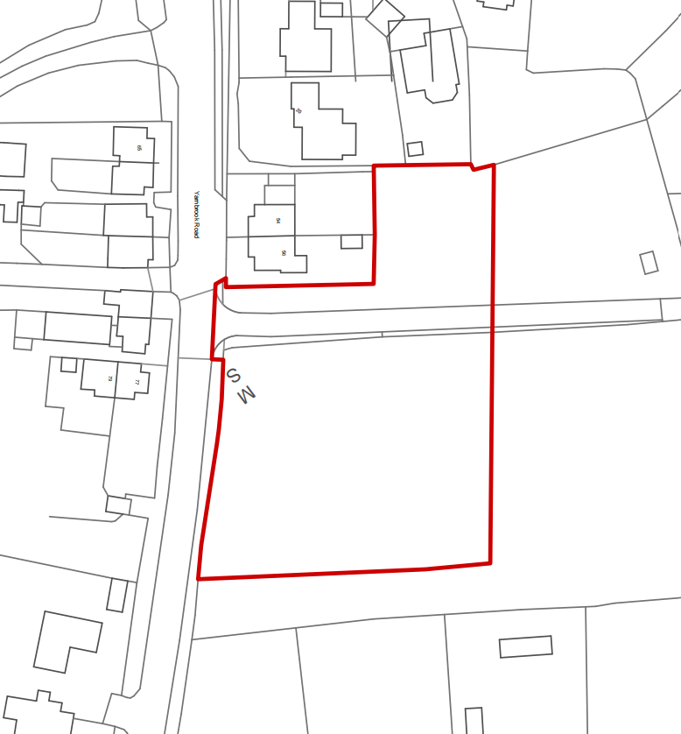
Location plan
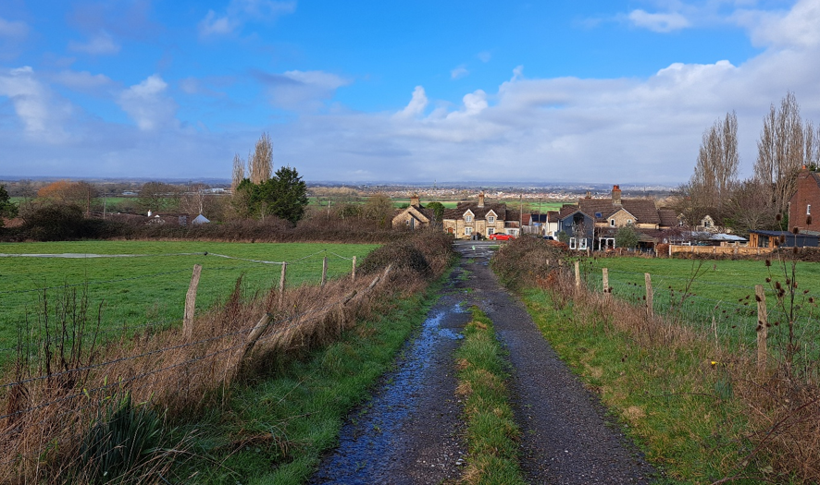
Application site viewed from the East looking towards Yarnbrook Road

The application

This is an outline planning application with all matters reserved except access and layout for the erection of 9 dwellings. Access to the site would be via the existing farm access off Yarnbrrok Road which would be upgraded to serve the new development.

The submitted layout plan indicates the provision of two parking spaces per dwelling. Paragraph 6.3 of the Design and Access Statement confirms that secure bicycle storage will be provided for each dwelling, along with visitor parking (although the visitor parking is not indicated on the layout plan). The development is proposed as self-build/custom build.

The proposed layout of the site is illustrated in the plan below:

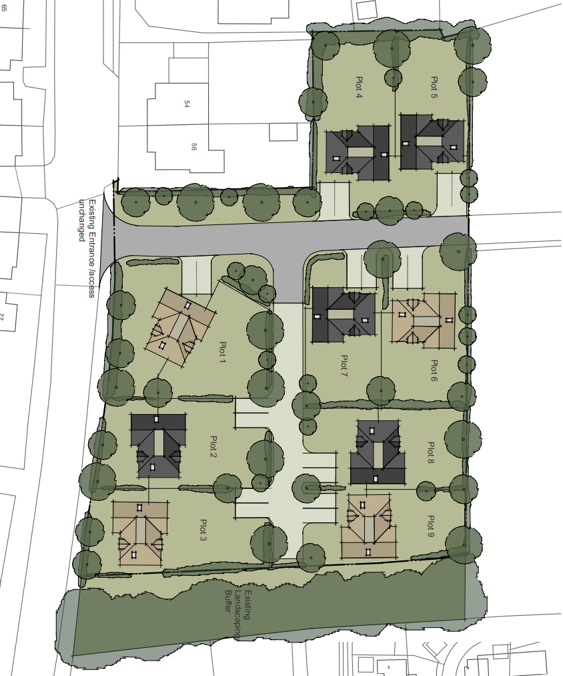
Proposed layout

POLICIES

Wiltshire Core Strategy (WCS) 2015
Core Policy 1: Settlement Strategy; Core Policy 2: Delivery Strategy; Core Policy 29: Spatial Strategy for the Trowbridge Community Area; Core Policy 41: Sustainable Construction and Low Carbon Energy; Core Policy 50: Biodiversity and Geodiversity; Core Policy 51: Landscape; Core Policy 57: Ensuring High Quality Design and Place Shaping; Core Policy 58: Ensuring the Conservation of the Historic Environment; Core Policy 60: Sustainable Transport; Core Policy 61: Transport and Development; Core Policy 62: Development Impacts on the Transport network; Core Policy 64: Demand management; Core Policy 67: Flood Risk

National Planning Policy Framework 2024 (the Framework) and Planning Practice Guidance (PPG)

Other
Wiltshire Local Transport Plan 2011 – 2026

Wiltshire Local Transport Plan 2025 – 2038 (endorsed at full council on 11 March 2025)
Wiltshire Local Transport Plan 2011 – 2026: Cycling Strategy

Wiltshire Design Guide SPD 2024
Trowbridge and Westbury Bat Mitigation Strategy (TWBMS) SPD July 2025
The 2025 Housing Land Supply Statement (base date April 2025)

Wiltshire Council’s Emerging Local Plan (WLP) 2020-2038

At Full Council on 19 May, the elected members of Wiltshire Council agreed to withdraw the emerging WLP. It will now be subject to a legal process to finalise its withdrawal - which is likely to happen in July or August (2026). The said Plan has no material weight for the purposes of the application.

PLANNING HISTORY

PL/2026/02193 – Demolition of an existing agricultural barn (which has prior approval for conversion to two dwellings under Class Q permitted development) and the erection of two detached self-build dwellings. – Under Consultation

PL/2025/08586 – Conversion of existing barn to two dwellings. The access track presently exists in serviceable order. – Prior Approval Granted

W/07/01375/FUL – Change of use from agriculture to mixed use of agriculture and livery/breeding of horses including the provision of a menage, the established barn and three mobile field shelters – Approved

W/05/01121/FUL – Change of use of land and buildings to mixed use of agriculture and equestrian (livery and breeding), together with provision of a menage – Withdrawn

W/01/01478/FUL – Erection of agricultural building for livestock shelter and storage – Approved

CONSULTATION RESPONSES

West Ashton Parish Council: Objects “to the above application on the grounds that it fails to provide adequate information for consideration and the information that has been supplied is both misleading and factually incorrect. The documentation provided appears to have drawn its assertions from online sources rather than knowledge of the village.
For example, using the clause references within the ‘Design and Access Statement’ accompanying the application:
2.1.1 It is incorrect to state that West Ashton has a Public House. The statement that the village has ‘excellent transport connections to larger settlements’ is refuted. (see qv)
2.1.2 The assertion that the site is ‘bounded by existing residential development to the East, South and West’ is disputed.
2.1.4 The statement of Local Services and Facilities for sustainable living is misleading as it:
i) repeats the inaccuracy regarding a Public House. There is a Longs Arms in Steeple Ashton (1.9 miles away).
ii) the statements regarding Local Shops and Healthcare concede that these are only available in Trowbridge but fail to acknowledge that these cannot be accessed without use of private car transport which, of itself, is contrary to Wiltshire Council’s policy for sustainable development.
2.1.5 Public Transport Links
This submission is wholly inaccurate.
There are no regular bus services available to West Ashton. There is no ‘car-free’ access to employment shopping or services.
There is no such railway station as Ashton Park. There is no railway station available to residents which has ‘direct pedestrian/cycle access’ and hence cannot be “supporting sustainable commuting patterns’
Trowbridge Railway station cannot be reached by bus as no such service is available.
The declaration that the above ‘fully satisfies (sic) the NPPF paragraph 110 requirement for developments to be located where they offer “genuine choice of transport modes” and support travel patterns’ is demonstrably incorrect.
2.2 We would appreciate clarification of the conditions that define suitable infill development.
2.3 Adjacent Barn Permission
The statement that the granting of ‘planning permission’ for the change of use of an agricultural barn designates the proposed site as being enclosed by residential development on all four sides is disingenuous. The granting of prior approval under Schedule 2 Part 3 Class Q of the General Permitted Development Order regulations does not constitute granting of planning permission.

Indeed the regulations declare that prior approval does not grant planning permission. It is a change of use, not development.
2.4 Housing Land Supply Context
The application does not specify the source of its information but it is presumed that this is the Housing Land Supply Statement issued in June 2025.This document does show the 2 year shortfall against the 5 year requirement of the National Planning Policy Framework but fails to disclose the excess of houses that will be provided within the County over the appropriate period.
3.1.4 Sustainable Transport not proven, see above.
5.3 Landscape and Biodiversity see comments below on the Ecology Assessment
5.4 Access and Movement.
The ability to connect to ‘existing footpath networks linking to local services and facilities’ is questioned. Detailed information on such existing footways is requested.
6.4 Pedestrian and Cycle Access
This repeats the erroneous and misleading information as shown above.
Preliminary Ecological Appraisal
It is appreciated that this submission is preliminary but its conclusions are most concerning. It is recommended that no phase 2 protected species surveys are necessary and declares that there are no bats present. This demonstrates inadequate research and appreciation of West Ashton’s ecology and Wiltshire Council’s and Trowbridge Town Council’s policies in that it does not mention the Trowbridge and Westbury Bat Mitigation Strategy. This initiative impacts directly on our community. The proposed site is designated as being within a ‘Yellow Area’ and consequently requires mitigation measures.
We do not believe that the applicant has demonstrated appropriate care and expertise in its submission and as such it should not be approved.’

Highways Officer: Objects

Ecology Officer: Objects. ‘Insufficient information has been submitted. In carrying out its statutory function, the LPA must be reasonably sure that the proposal will not result in significant adverse effects on protected habitats or species. The information outlined above must therefore be submitted and reviewed by the LPA’s ecology team prior to determination of the application. I therefore maintain a holding objection until all the issues listed above have been suitably addressed.’

Drainage Team: Holding objection. ‘In the previous response, the Lead Local Flood Authority (LLFA) raised an objection specifically requiring BRE 365 soakage testing to assess the feasibility of infiltration and to establish groundwater levels on site. These tests do not depend on the detailed design of the dwellings and can be undertaken independently at the current stage. Therefore, the applicant must submit the results of the soakage testing in order to address and remove the existing objection. The LLFA acknowledges that other detailed drainage information can be secured by condition and provided at a later stage, such as the pre-commencement or reserved matters stage, once the dwelling designs have been finalised.’

Archaeology Officer: Objects and pursuant to the agents response to consultees, “the site agent has challenged my previous advice in regard to this application when I advised that a geophysical survey of the site be carried out, followed by a trial trench evaluation, prior to the determination of the application. I must stress that this work will be required in order for me to fully assess the archaeological potential of the site, before advising on the likely impact of the proposals (as is required by NPPF Section 208, 2024 edition). I will not be changing my advice and I will maintain my objection to this application until the required work is carried out.’

REPRESENTATIONS

11 comments have been received which have been summarised as follows –

- Loss of privacy /overlooking/ loss of light to neighbouring properties
- Adverse impact from noise and other disruptions during construction works
- This site cannot surely be defined as ‘infill’
- It would further link West Ashton, a small village, to Yarnbrook
- Increased traffic onto the very busy A350 / highway safety issues / poor pedestrian links
- West Ashton does not have “excellent transport connections to larger settlements”
- Increase use of private car
- There is no ‘Ashton Park’ railway station/ there are no bus services to, or from, West Ashton, regular or otherwise / no ‘direct pedestrian/cycle access’ either
- Lack of local services/ no shop, public house or other amenities within the village
- Ecological issues including presence of bats on site
- Should the application be approved needs to be controlled by conditions
- Drainage issues, in particular groundwater
- There is a need for smaller affordable housing in the village
- Set a precedent for future development
- Air pollution issues
- Size, height, and/or design of the proposal is out of keeping with the character of the surrounding area
- Does not demonstrate adherence with relevant local planning policies
- Swift bricks should be installed in accordance with best-practice guidance

ASSESSMENT

Section 38(6) of the Planning and Compulsory Purchase Act 2004 states:

"If regard is to be had to the development plan for the purposes of any determination to be made under the planning Acts, the determination must be made in accordance with the plan unless material considerations indicate otherwise."

In accordance with this statutory requirement, this application has been assessed against the relevant policies of the Development Plan, including the adopted Wiltshire Core Strategy (2015) and, where applicable, any made Neighbourhood Plans.

Principle of development

Section 70(2) of the Town and Country Planning Act 1990 and section 38(6) of the Planning and Compulsory Purchase Act 2004 require that the determination of the application must be made in accordance with the Development Plan, unless material considerations indicate otherwise.

West Ashton is designated a Small Village (Core Policy 29) however it is considered the proposed development is located outside the village envelope and manifests as a speculative housing development within the open countryside.

Policy CP2 of the adopted WCS is clear that other than in "circumstances as permitted by other policies within this plan, identified in paragraph 4.25, development will not be permitted outside the limits of development, as defined on the policies map. The limits of development may only be altered through the identification of sites for development through subsequent Site Allocations Development Plan Documents and neighbourhood plans". This proposal therefore does not satisfy any of the 'exception policies' listed in paragraph 4.25.

Core Policy 2 is clear that only in certain circumstances would development be permitted in the open countryside (where an exception listed in paragraph 4.25 applies or other such policy exceptions exist), otherwise new housing should not be permitted outside settlement boundaries as a matter of principle.

Core Policies 60 and 61 of the WCS seek to promote sustainable development through the reduction on the reliance on private car use and encouraging the sustainable and safe movement of people within Wiltshire.

Although the village of West Ashton has a primary school and a town hall, local facilities are very limited. Public transport options are also very limited. The applicants Design and Access statement refers to ‘Regular bus routes connect West Ashton to Trowbridge, Bradford on Avon, and Bath…’ and the ‘Ashton Park Railway Station’. However, the nearest bus stop that serves West Ahston is located at Yarnbrook 1 km distant, resulting in very limited and indirect bus service provision requiring walking along substandard/unattractive route. There is also no Ashton Park rail station.

In addition, the pavement along the eastern side of Yarnbrook Road, which would serve as the main pedestrian link to West Ashton, is narrow in places and is considered substandard and inadequate to safely support the proposed development.

The proposed development would be poorly served by local services, facilities and amenities and future occupiers would be highly reliant on private motor vehicles to access the majority of local services including places of work, social, leisure, health and retail facilities.

In addition, with the identified poor pedestrian connectivity to the limited services of West Ashton and public transport, this would furthermore exacerbate the reliance on private motor vehicles, and future occupiers without their own private vehicle there would be a risk of social and economic seclusion and/or pedestrian access / highway conflicts in using the substandard pavement.

The application is therefore considered to be an inappropriate, unsustainable form of development. The development is located outside the limits of development and in the open countryside and as such is contrary to policies CP1, CP2, CP29, CP60 and CP61 of the WCS. The proposed scheme also needs to be assessed against the relevant policies of the local plan as detailed below.

5-Year Housing Land Supply

Following the Government’s December 2024 revisions to the NPPF, Wiltshire Council needs to provide a five-year Housing Land Supply (HLS). As a result of the December 2024 changes to the way housing need is calculated, introduced by government, the Council is unable to demonstrate a five-year supply of deliverable housing sites. Currently the Council can demonstrate 2.8-year housing land supply.

As a result of this housing land supply shortfall, NPPF paragraph 11 is engaged and local plan policies which seek to restrict the supply of housing whilst there is a supply deficit should be considered 'out-of-date' and full weight cannot be afforded to these policies.

However, as set out within the NPPF the presumption in favour of sustainable development (the 'tilted balance') set out in paragraph 11d) ii. is engaged whereby permission should be granted for new housing. unless any adverse impacts of doing so would "significantly and demonstrably outweigh the benefits" or the 'protection policies' detailed in Footnote 7 of the Framework apply” (officer emphasis added).

The implications of the current housing land supply position, and in particular the weight to be attributed to the development plan policies, must be taken into account when determining applications for new housing, including speculative non-plan led applications.

The weight to be attributed to such policies is a matter of judgment for the decision-maker. The weight to be afforded to the spatial strategy policies of the development plan is detailed in the section ‘Planning Balance’ later in this report.

Layout, Density, Design and Visual Impacts

Core Policy 51 of the WCS outlines that development should protect, conserve and where possible enhance landscape character and must not have a harmful impact upon landscape character. The policy requires applications to demonstrate how development proposals conserve and where possible enhance landscape character through sensitive design, landscape mitigation and enhancement measures. Core Policy 57 requires a high standard of design in all new developments and states that development should respond positively to the existing townscape and landscape.

Paragraph 131 of the Framework states "The creation of high quality, beautiful and sustainable buildings and places is fundamental to what the planning and development process should achieve".

Paragraph 135 of the Framework sets out a series of criteria which planning policies and decisions should ensure developments create, including being of high quality over the lifetime of the development, being visually attractive and sympathetic to the local character and history, creating a strong sense of place and creating places that are safe, inclusive and accessible and which promote health and well-being, with a high standard of amenity for existing and future users.

This application is seeking outline planning permission, with all matters reserved except for access and layout, for the construction of 9 dwellings. It should therefore be noted that appearance, landscaping and the scale of the development are matters reserved for a decision at a later date.

The outline application is accompanied by a layout plan that details the layout of the site including location and setting nine dwellings, access road, and accompanying parking.

The site is located within the open countryside and is readily visible from the adjacent highway and surrounding agricultural land. Whilst there are existing residential properties to the north and north-west, together with a traveller site to the south, the application site forms part of a wider expanse of undeveloped fields which provide a clear and defensible break between the built form of West Ashton and the surrounding rural landscape. As such, the site contributes positively to the prevailing open and rural character of the area.

The proposed development would materially change the rural landscape, resulting in an urbanising effect that would erode the existing character of the countryside. In addition to the dwellings themselves, the associated paraphernalia of residential occupation, including areas for parking, bin storage, and domestic garden features, would cumulatively domesticate the site. This would lead to a perceptible encroachment of built form and activity into the open landscape, diminishing its rural quality and edge of village character and undermining the site’s role as a transitional buffer between the existing dwellings to the north and the traveller site to the south.

It is therefore considered the residential development proposed, in this rural location, fails to protect, conserve or enhance landscape character and is contrary to local and national policy.

Amenity Effects

Core Policy 57 of the WCS requires in criteria vii for developments to have "regard to the compatibility of adjoining buildings and uses, the impact on the amenities of existing occupants, and ensuring that appropriate levels of amenity are achievable within the development itself, including the consideration of privacy, overshadowing, vibration, and pollution (e.g. light intrusion, noise, smoke, fumes, effluent, waste or litter)". Paragraph 135 of the Framework also requires planning policies and decisions to ensure developments have "a high standard of amenity for existing and future users".

This application seeks outline planning permission only at this stage. Although a layout plan has been submitted, no detailed design information for the proposed dwellings has been provided. Nevertheless, the layout plan demonstrates that the site could be potentially developed with appropriate separation distances and a clear approach to ensuring that the amenity of adjacent and future residents is not adversely affected.

Existing residential development lies immediately to the north of the site, with Plots 4 and 5 adjoining properties fronting Yarnbrook Road and Orchard Close. However, given the separation distances and the presence of intervening land, it is considered that a suitably designed scheme could be planned to avoid material harm to the amenities of these residents in terms of overlooking or loss of privacy.

Highway Impacts

Core Policy 57 (xiv) of the Wiltshire Core Strategy seeks to ensure that development must meet the requirements of Core Policy 61. This policy requires proposals to be capable of being served by safe access to the highway network. Core Policy 62 states new development should not be accessed directly from the national primary route network outside built-up areas, unless an over-riding need can be demonstrated. Core Policy 64 seeks to ensure compliance with parking standards set out in the Local Transport Plan.

Paragraph 116 of the NPPF states ‘Development should only be prevented or refused on highways grounds if there would be an unacceptable impact on highway safety, or the residual cumulative impacts on the road network, following mitigation, would be severe, taking into account all reasonable future scenarios.’

The application is accompanied by a site layout plan, revised access plan and a Design and Access Statement.

This outline application seeks permission for nine dwellings, with all matters being reserved except for access and site layout.

Two parking spaces are proposed for each dwelling. Vehicular access to the site would be taken from an existing access serving the stables and buildings at Lifely Farm, off the A350 Yarnbrook Road.

The A350 forms part of the Primary Route Network (PRN), which connects major towns within Wiltshire and is a heavily trafficked route.

Following the submission of revised access details, the Council’s highway team advised that the updated visibility splays, showing DMRB standards of 2.4m x 120m have demonstrate that such splays are possible within the extent of public highway. Providing these splays are maintained and regularly involve vegetation cutting to the north of the access, within the public highway, the access was not identified as a substantive ground for concern by the Council’s highways authority.

However, the Council’s highway team continue to raise the following objections to the scheme (set out in summary form):

the site is located in an unsustainable location, and the scheme is contrary to policy CP62 of the WCS since the development would access the PRN where there is poor pedestrian connectivity to West Ashton.

Core Policy 62 of the Wiltshire Core Strategy states that new development should not be accessed directly from the PRN unless an overriding need can be demonstrated. In this case, the proposed access to serve the nine-dwelling scheme would be taken from the A350 Yarnbrook Road, a principal route characterised by high traffic flows and vehicle speeds.

The introduction of a new junction at this location raises concerns regarding potential conflict between vehicles and the safe ingress and egress of residents. Furthermore, limited opportunities for pedestrian connectivity, together with substandard footway provision along this stretch of road, compound the identified highway / site sustainability concerns.

Whilst the applicants have attempted to address visibility splays, they have failed to address the substantive concerns relating to the site and wider sustainability principles, and as such, the proposal is considered to be contrary to the requirements of Core Policies 61 and 62 and the advice set out within the NPPF.

The applicant’s comments regarding the use of the existing access from the A350 to serve the development are noted. However, there is a significant difference between the approved use of the access for two dwellings at Lifely Farm, as permitted under a separate prior approval process, where the access already serves existing farm buildings and its farming operations, compared to the proposal to erect nine dwellings.

The latter would result in a substantial increase in traffic generation and a material intensification of the use of the access onto the busy A350/ PRN.

A recent dismissed appeal at land adjacent to A350, West Ashton Road, Yarnbrook (under application PL/2023/10654) is worthy of reporting here since it related to a proposal for the erection of 4 houses outside settlement limits where there was similar site sustainability arguments and for that appeal, the appointed inspector commented on the access to the PRN (A350) within paragraphs 13 and 14:

‘Finally, on the question of principle, one would consider CS CP62. This underlines that new development should not be accessed directly from the National Primary Route Network (NPRN) outside built-up areas, unless an over-riding need can be demonstrated. I note the Appellant’s argument that an old (now overgrown) field entrance exists but this would be very different from a significant access to 4 new dwellings being created at a point further along the frontage. I conclude that the scheme would fail to accord with CS CP62.’

and

‘I touch on CS CP62 above. The reasoning for the strict control over new development to the NPRN is to assist with traffic flow and reduce risk. Having observed the vehicular flows, speeds and make-up on this section of the A350, along with its alignment, lack of adequate footways, lighting or crossings, and having also personally gained access to the road from three existing nearby points, I would deem that new development served as planned would undoubtably hinder traffic flow and significantly increase risk. Whatever the details of the entrance design, I would say that this is not a suitable location for new housing to emerge onto the NPRN. The scheme would also fail to suitably provide for any meaningful pedestrian or cycle arrangements.’

Although the site referenced above is located to the northeast of Yarnbrook and approximately 760m from the current application site, the Inspector comments, regarding the heavily trafficked nature of the PRN, the vehicular flows and speeds, the substandard pavement/ footway provision, inadequacies over street lighting and safe road crossings, there would be a similar increased risk to highway safety for the 9-house proposal and the same reasons for dismissing the 4-house scheme apply here. The proposed development is therefore considered contrary to CP61 and CP62 of the WCS and paragraphs 115, 116 and 117 of the Framework.

Ecology Impacts

Core Policy 50 of the adopted Wiltshire Core Strategy seeks to protect and enhance biodiversity and geodiversity, as well as seeking to ensure that development avoids harm to protected species and habitats.

Paragraph 193 of the NPPF, requires that development minimises ecological impacts and provide net gain for biodiversity, including ensuring mitigation is secured where harm cannot be avoided.

The application is accompanied by a Preliminary Ecological Appraisal (PEA) produced by Arborweald dated November 2025 and a Design and Access statement supports the application.

The application site lies within the 6.4km zone of influence of the Salisbury Plain SPA and in light of the HRA for the Wiltshire Core Strategy and the HRA for the Wiltshire Housing Site Allocations Plan, the proposed development due to its location and proximity / and potential effects to ecology/protected species, it requires to have an Appropriate Assessment due to the potential impact of recreational pressures in combination with other plans and projects.
A strategic Appropriate Assessment (AA) has been prepared pertaining to development within the 6.4km zone of influence that could result in a likely significant effect on the SPA as a result of an increase in recreational / visitor pressure.

The AA reached the conclusion that there would be no likely adverse effects on the integrity of the SPA or its qualifying features provided that the Council’s mitigation strategy continues to be implemented.

Annual stone curlew monitoring and protection measures continue to be secured by the Council through appropriate mitigation. In January 2026 Natural England (NE) confirmed that the 2026 strategic AA for Salisbury Plain SPA continues to be supported by NE.

The application site is also located within the grey and yellow zones of the TWBMS, associated with the Bath & Bradford on Avon Bats SAC, and therefore the development of 9 houses has the potential to result in significant adverse impact on the special features of the SAC. The application must therefore be considered under the Habitats Regulations for the SAC as well as the SPA.

The grey medium risk zone represents an area where new residential development is likely to result in increased recreational use of important woodland bat sites.

In order to conclude an AA favourably, new residential development proposals for 49 dwellings or less within the grey hatched (recreational risk) zone will be expected to provide a financial contribution of £925 per dwelling towards the Council’s strategic recreational pressure mitigation scheme as detailed within section 9.2 of the 2025 adopted TWBMS.

This is required prior to commencement of development and must be secured via legal agreement. The applicants in their letter dated 26/4/26 have agreed to pay this sum but no mechanism has bene secured at this stage in the life of the application.

The yellow-coloured risk zone represents areas where habitat has been shown to be of particular importance, where development proposal are required to take into consideration the foraging areas and flightlines of horseshoe and Bechstein’s bats. In short, applications that would result in loss of potential habitat need to be properly surveyed and supported by on-site analysis and reporting.

It is nevertheless accepted that with proper surveying, some sites may be able to accommodate a suitable level of housing growth, but the key first test, is compliance with the requirements set by the adopted TWBMS.

Impacts will likely arise on individual sites and in-combination with other sites as a result of loss and/degradation of habitat of importance to the qualifying bats. In order to conclude the AA favourably, applications impacting greenfield land and bat habitat (such as the present application) are expected to provide a S106 contribution prior to commencement of £1,000 per dwelling (index linked from 2018) towards habitat mitigation detailed in Section 9.1 of the TWBMS. The applicants in their letter dated 26/4/26 have agreed to pay this sum, but there is no mechanism to secure this developer obligation at the time of determining the application.

As required by the Conservation of Habitats and Species Regulations 2017 (as amended) an Appropriate Assessment must be carried out by the LPA, and in this case, be tested against the TWBMS criteria (sections 6 and 8).
The submitted PEA states that the site contains grassland, scrub, hedgerow and a building. There are no potential roosting opportunities on-site. The report states that “the site provides limited opportunities for foraging and commuting bats”, although later considers the likelihood of presence as “moderate”.

No bat activity surveys have been undertaken despite the surrounding land being dominated by a mosaic of arable and pasture fields with connected hedgerow and patches of woodland. The site was previously grazed and possesses linear features that may be of some value to commuting bats. Moreover, there are multiple records of Bechstein’s bat roosts130m southwest, 200m southwest (maternity roost), and 400m northeast, and a Greater Horseshoe roost 260m northeast – all within relative close proximity to the site.

These records are not considered within the applicant’s ecology report – which is a material falling and given the absence of any bat survey data, it is considered that qualifying bat SAC species are likely using the application site to some extent for foraging and commuting purposes.

As required by paragraph 161 of the TWBMS an Ecological Parameters Plan (EPP) is necessary to support this type of application to clearly identify those areas of the site which are unconstrained, those areas where sensitive design or restrictions may be required (i.e., core habitat features), and any areas of the site which are to be retained, remain undeveloped, or be enhanced through developer mitigation.

In addition, an Ecological Mitigation Plan has not been provided as required (by paragraph 162 of the adopted TWBMS).

The layout plan implies the retention of the scrub border at the southwest boundary, which is welcomed. However, plans for the remaining scrub and hedgerow are unclear. At present, the habitat retention appears to be inadequate. The proposals would result in the significant urbanisation of the site, and the retention of the scrub at the southwest would be insufficient to demonstrate the site’s functionality to bats would not be adversely affected.

It is also not clear how the scrub would be managed/ secured away from the residential properties. In addition, there are no habitat buffers provided on any other boundary and the TWBMS makes clear that core habitat features should be expanded to 15m (Zone A), and then further buffered from development (as a dark buffer) by 15m (Zone B).

It is considered habitat mitigation has not been sufficiently demonstrated within the submission i.e. it is not clear what habitats would be lost, would be created, and which would be enhanced, etc.) and development in the yellow zone is expected to mitigate for habitat loss on site (see paragraph 146 of the TWBMS).

The submitted site plan does not sufficiently address this criterion of the TWBMS and given all the aforementioned failings of the submission, the only decision the Council can reach, is to refuse the application and conclude that the applicant has failed to satisfy the Council that the9-house proposals would not result in the loss of functionality of habitat potentially used by SAC bats.

Based on the above, the Council is not in a position to issue a favourable AA.

The Council’s ecologist furthermore raises concern regarding the impact of the development on Great Crested Newts (GCN) whereby the site may contain habitats suitable for use by GCN during their terrestrial phase (scrub and hedgerow) and further information would be required to adequately assess the impacts on GCN.

The Council’s ecologist welcomes the applicant’s commitment to use bird nest boxes, bee bricks and mammal gaps.

Insufficient information has however been submitted. In carrying out its statutory function, the LPA must be reasonably sure that the proposal will not result in significant adverse effects on protected habitats or species. The applicant has not demonstrated that the proposal would not, either alone, or in combination, with other development, likely result in significant adverse effects on the SAC and its qualifying features and for this reason, the application must be refused.

Drainage issues

Core Policy 67 of the adopted WCS states that all new development will include measures to reduce the rate of rainwater run-off and improve rainwater infiltration to soil and ground (sustainable urban drainage) unless site or environmental conditions make these measures unsuitable.

It is proposed that surface water drainage would be dealt with via soakaways and foul water drainage by existing mains sewer.

Concerns have been raised by the Council’s drainage team regarding lack of soakage testing to confirm the feasibility of infiltration and to establish groundwater levels on site. However as stated above the Council drainage mapping established the site is not subject to high levels of ground or surface water flooding (except at the access). Planning officers hold the view that surface water managed could be suitably controlled by a planning condition should an appeal be lodged and be successful against the LPAs decision.

Archaeology issues

Core Policy 58 of the WCS states development should protect, conserve and where possible enhance the historic environment and, designated heritage assets and their settings will be conserved, and where appropriate enhanced in a manner appropriate to their significance which include nationally significant archaeological remains.

Paragraph 207 of the NPPF states ‘…local planning authorities should require an applicant to describe the significance of any heritage assets affected, including any contribution made by their setting.’ The paragraph continues ‘Where a site on which development is proposed includes, or has the potential to include, heritage assets with archaeological interest, local planning authorities should require developers to submit an appropriate desk-based assessment and, where necessary, a field evaluation.’

The site of the proposed housing is located in an area mapped as having medieval and post-medieval archaeological interest along with evidence for isolated Romano-British settlement. It is possible that any groundworks associated with the construction of the proposed 9 houses could impact upon previously unrecorded archaeological features associated with this activity.
The Council’s archaeologist advises that the site / proposals should be the subject of a bespoke geophysical survey, followed by a trial trench evaluation in order to ground-truth the results of the remote sensing.

However, no evaluation has been submitted for this application, and the Council cannot adequately determine the impact of the development on underground historic features. In the absence of this information, the LPA is unable to properly assess the significance of any heritage assets with archaeological interest that may be present within the site, or to determine the potential impact of the proposed development upon them. As a result, the proposal does not demonstrate that the archaeological implications of the development have been fully understood or that harm can be avoided or mitigated. The development is therefore contrary to Core Policy 58 of the WCS, which requires that heritage assets and their settings are conserved in a manner appropriate to their significance. The proposal also conflicts with the principles of the NPPF (paragraph 207), which requires applicants to describe the significance of heritage assets affected and for local planning authorities to ensure that such information is provided to enable informed decision-making.

CONCLUSION (THE PLANNING BALANCE)

This proposal conflicts with the adopted Wiltshire Core Strategy and its strategic policy, which restrict new housing development outside the defined settlement boundaries in the open countryside, as detailed above.

The proposal would deliver a modest level of public benefit through the provision of nine new dwellings, contributing to the acknowledged shortfall in housing supply. In addition, some economic benefits would arise during the construction phase and through the subsequent occupation of the dwellings through local spend, including the potential support provided by new occupiers for local services and businesses.

The applicants advise that the development would be self/ custom build development, although there is no mechanism to secure this through a legal agreement at the time of the application being determined. Overall, these benefits can be given modest (future economic spend) to significant (housing delivery) weight in the planning balance.

The scheme would however result in the urbanisation of the open countryside with the loss of rural character and erosion of the landscape buffer that exists to the south of the existing village envelope, and the proposed development would neither protect, conserve or enhance landscape character. This harm merits significant weight in the planning balance.

The application site is located outside the defined limits of development and is poorly connected to West Ashton, with very limited access to public transport. The nearest bus stops are located some distance from the site and would be accessed via a narrow, intermittent and substandard pavement for pedestrians. These conditions are not considered to provide a safe, convenient or attractive walking environment, particularly for more vulnerable users and as such the site is not considered sustainable when tested against the NPPF as a whole.

Furthermore, the village of West Ashton offers only very limited day-to-day services and facilities, with the majority of employment, retail, healthcare and leisure opportunities located in Trowbridge or other towns. Access to these destinations on foot or by cycle would be heavily constrained by the nature of the surrounding highway network, including the dominance of the heavily trafficked A350 and the lack of continuous, high-quality pedestrian and cycle infrastructure, which furthermore materially reduces the site’s/proposal’s sustainability suitability.

Future occupiers of the development would likely have to rely heavily on private vehicles for the majority of trips, and offices bare not satisfied there are genuine, suitable and sage alternative choices of transport modes to support sustainable travel patterns, which is contrary to Core Policies 60 and 61 of the Wiltshire Core Strategy and the objectives of the National Planning Policy Framework.

The introduction of a new junction onto the PRN that would serve a material increase of traffic is also a significant concern pursuant to the potential conflicts between vehicles and the safe ingress and egress of residents. Furthermore, limited opportunities for pedestrian connectivity, together with substandard pavement provision along this stretch of highway, would result in significant identified highway safety concern to warrant a refusal.

The proposed development has not clearly demonstrated that it can achieve a safe and policy-compliant means of access without prejudicing the free flow of traffic along the A350 or compromising highway safety.

In addition, it has not been demonstrated that the development would not have, either alone, or in combination with other development, result in significant adverse effects on the SAC and its qualifying features.

Insufficient information has been submitted pursuant to bat and great crested newts. In carrying out its statutory function, the LPA must be reasonably sure that the proposal would not result in significant adverse effects on protected habitats or species. The applicant has not demonstrated that the proposal would not, either alone, or in combination, with other development, likely result in significant adverse effects on the SAC and its qualifying features and for this reason, the application must be refused.

The applicant has failed to provide an appropriate archaeological trial trench evaluation. In the absence of this information, the Local Planning Authority is unable to properly assess the significance of any heritage assets with archaeological interest that may be present within the site, or to determine the potential impact of the proposed development upon them. As a result, the proposal does not demonstrate that the archaeological implications of the development have been fully understood or that harm can be avoided or mitigated. The development is therefore contrary to Core Policy 58 of the Wiltshire Core Strategy, which requires that heritage assets and their settings are conserved in a manner appropriate to their significance. The proposal also conflicts with the principles of the Framework, paragraph 207, which requires applicants to describe the significance of heritage assets affected and for local planning authorities to ensure that such information is provided to enable informed decision-making.

Whilst the Council recognises the need to address its housing land supply, this does not override the need to demonstrate the development would not harm protected habitats sites, as defined in in Footnote 7 of the NPPF, and it is considered the tilted balance under paragraph 11(d) does not apply.

As such it is considered the development does not represent sustainable development being contrary to Core Policies 1, 2, 29, 50, 51, 58, 60 and 61 of the Wiltshire Core Strategy and the policies of the National Planning Policy Framework.

RECOMMENDATION: That Planning Permission be REFUSED

1. The site lies in the open countryside beyond the limits of development of any settlement identified for sustainable development in the settlement strategy of the Wiltshire Core Strategy. The proposal therefore conflicts with policies CP1 and CP2 of the Wiltshire Core Strategy (WCS) and does not meet the criteria for any of the exceptions to these policies set out in paragraph 4.25 of the WCS. Furthermore, the proposed development would be poorly served by local services, facilities and amenities such that the occupants of the dwellings would likely be heavily reliant on the use of private motor vehicles for the majority of routine journeys. The application is considered to be an inappropriate, unsustainable form of development which would significantly and demonstrably outweigh the benefit of providing nine additional dwellings in an open countryside location. As such the proposal, in the absence of an outweighing justification, is not considered to represent sustainable development being contrary to Core Policies 1, 2, 29, 60 and 61 of the Wiltshire Core Strategy and the policies of the National Planning Policy Framework taken as a whole.

2. The proposed development seeks to create a new access onto the A350, which forms part of the National Primary Route Network (NPRN), in a location outside of a built-up area. In the absence of any overriding justification, the proposal is contrary to Core Policy 62 of the Wiltshire Core Strategy, which resists new direct accesses onto the NPRN in such locations.

The proposed access arrangements, together with the expected intensification of use by motor vehicles and pedestrian movement interacting with the heavily trafficked PRN, would introduce material hazards and inconvenience to all users of the highway.

The development would result in increased pedestrian activity along a section of highway lacking adequate footways, lighting and safe crossing facilities, thereby exacerbating existing safety deficiencies.

As a result, the proposal would give rise to unacceptable impacts on highway safety and the free flow of traffic, contrary to Core Policy 57 (criteria ix and xiv), Core Policy 61 and Core Policy 62 of the Wiltshire Core Strategy and paragraphs 115, 116 and 117 of the of the National Planning Policy Framework.

3. The proposed development would result in the urbanisation of the open countryside with the subsequent erosion and loss of rural character being harmful. The Council is not satisfied the 9-house proposal would result in a scheme that would protect, conserve or enhance landscape character. The proposal is therefore contrary to Core Policies CP51 and CP57 of the Wiltshire Core Strategy and Paragraphs 135 and 187 of the National Planning Policy Framework.

4. The site is located within the Bradford on Avon Bat Special Area of Conservation (SAC) and grey and yellow zones of the Trowbridge Westbury Bat Mitigation Strategy and must, therefore, be considered under the Habitat Regulations. The SAC is recognised for its national and international importance for nature conservation. Its qualifying features are its protected priority habitats and species including important population of Bechstein Bats and Greater Horseshoe Bats. Insufficient information has been submitted to enable the Council to conclude a favourable Appropriate Assessment with respect of the Bath & Bradford-on-Avon Bat SAC. The Council is unable to conclude that there would be no adverse effects on the integrity of the Bath & Bradford-on-Avon Bat SAC. The proposed development is therefore contrary to Core Policy CP50 of the Wiltshire Core Strategy and paragraphs 187, 193, 194 and 195 of the National Planning Policy Framework.

5. The applicant has failed to provide an appropriate archaeological trial trench evaluation. In the absence of this information, the Local Planning Authority is unable to properly assess the significance of any heritage assets with archaeological interest that may be present within the site, or to determine the potential impact of the proposed development upon them. As a result, the proposal does not demonstrate that the archaeological implications of the development have been fully understood or that harm can be avoided or mitigated. The development is therefore contrary to Core Policy 58 of the Wiltshire Core Strategy, which requires that heritage assets and their settings are conserved in a manner appropriate to their significance. The proposal also conflicts with the principles of the Framework, paragraph 207, which requires applicants to describe the significance of heritage assets affected and for local planning authorities to ensure that such information is provided to enable informed decision-making.

6. In the absence of completed legal obligation at time of determination to secure the delivery and retention of the dwellings as self-build housing and to secure the necessary ecological mitigation measures, the proposed development fails to ensure appropriate mitigation of its impacts and compliance with relevant policy requirements. Without such secured mechanisms, the local planning authority cannot be satisfied that the development would deliver the self-build benefits or adequately mitigate its ecological impacts, resulting in an unacceptable form of development. The proposal is therefore contrary to Core Policies 3 and 50 of the Wiltshire Core Strategy and provisions of the National Planning Policy Framework.

INFORMATIVES TO APPLICANT

Please note that reason for refusal 6 cited above could be satisfactorily addressed via a s106 agreement.

