Re: The Cedars, Swindon Road, Malmesbury, SN16 9LU : PL/2026/03437
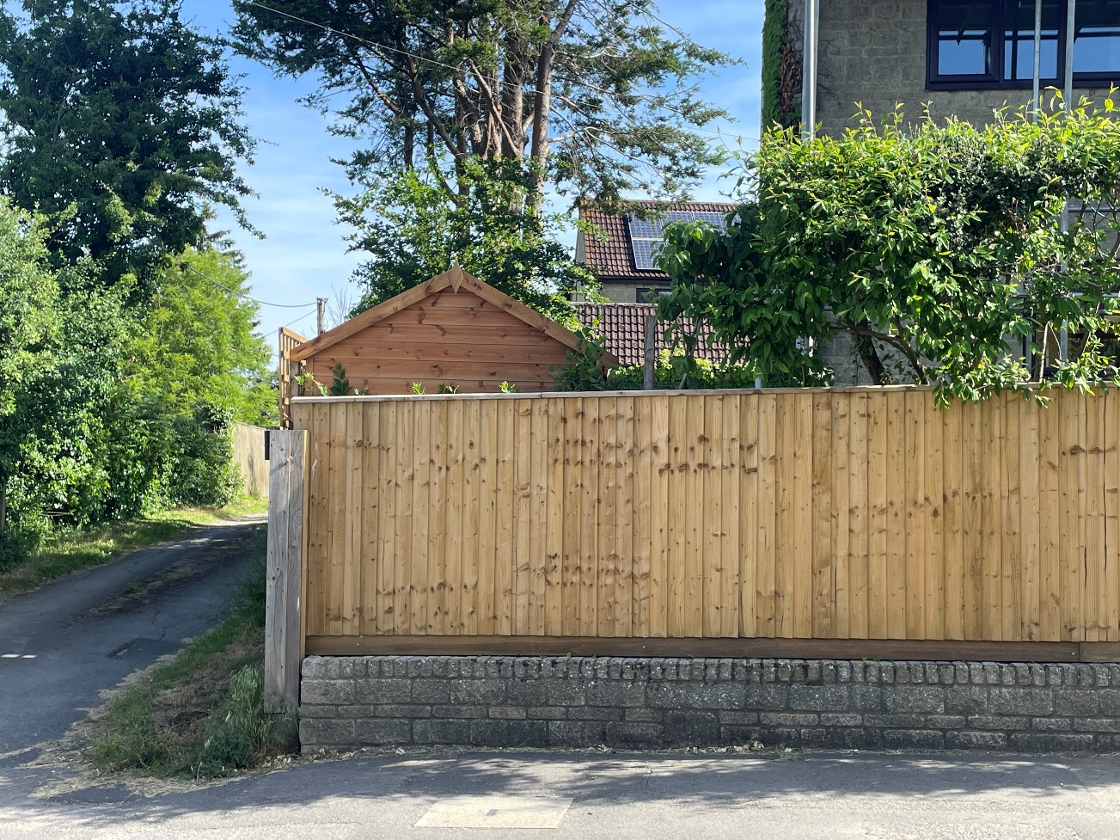
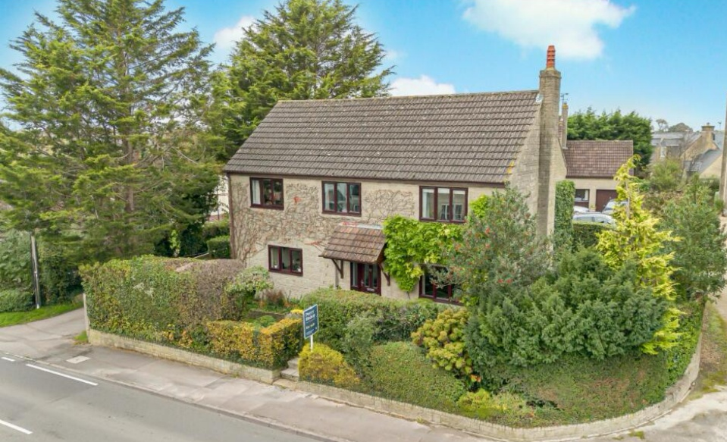
Roadside images – fence and shed

Property Image from Sale Details – Summer 24
Note roadside hedgerow, trimmed back to extent of exiting wall – circa 4.5m and large Cedar Tree in the corner of the property. This tree was removed for safety issues in late 24 early 25.

New Fence and Shed: - fencing set back some 7” from wall frontage.
Existing hedgerow cut back but retained and strengthened with supplementary planting. Note new growth emerging

