APPLICATION FOR FULL-PLANNING PERMISSION
CASE OFFICER REPORT

APPLICATION REFERENCE: | PL/2026/01793
APPLICATION TYPE: | Full planning permission
SITE ADDRESS: | Gul Riverside, Elston Lane, Shrewton , Salisbury, SP3 4HL
DEVELOPMENT DESCRIPTION: | Erection of timber stables and steel-frame open side barn
RECOMMENDATION: | Approve with Conditions

SITE DESCRIPTION/CONTEXT

Gul Riverside is a commercial stable located on Elston Lane, Shrewton. The current complex has two sets of stables, an office and a separate hay store and storage area. Originally a private stable, but in application 14/04077 a change of use to “outdoor and equine assisted therapy centre” was granted planning permission.

The site is not within a conservation area or a National Landscape and is not subject to any ground water or surface water flood risk. No public rights of way run through the site. The site is however within the Sailsbury Plain Special Protection Area 6.4km buffer area. There is also a grade II listed building opposite the site entrance. The site is adjacent to the River Till which is a SSSI.

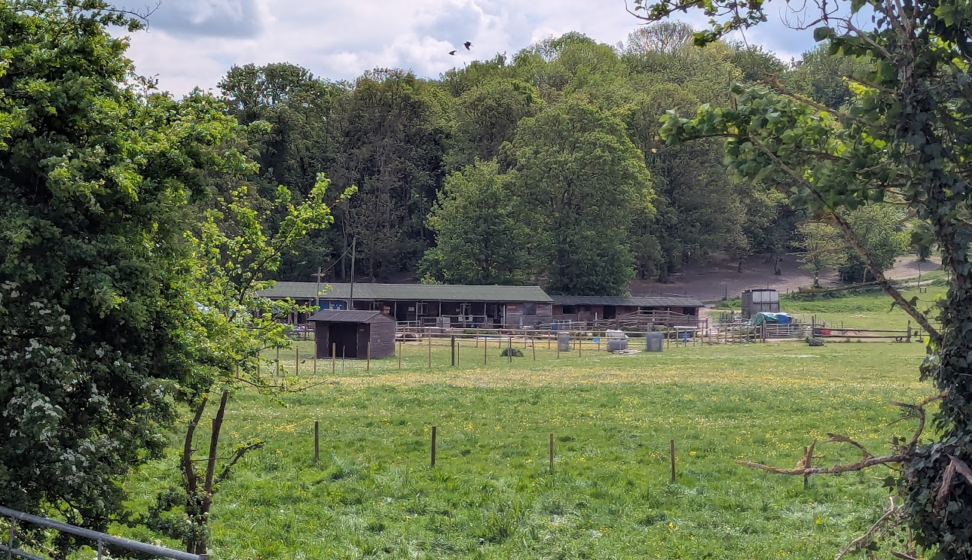

View through hedgerow gap on Elston Lane

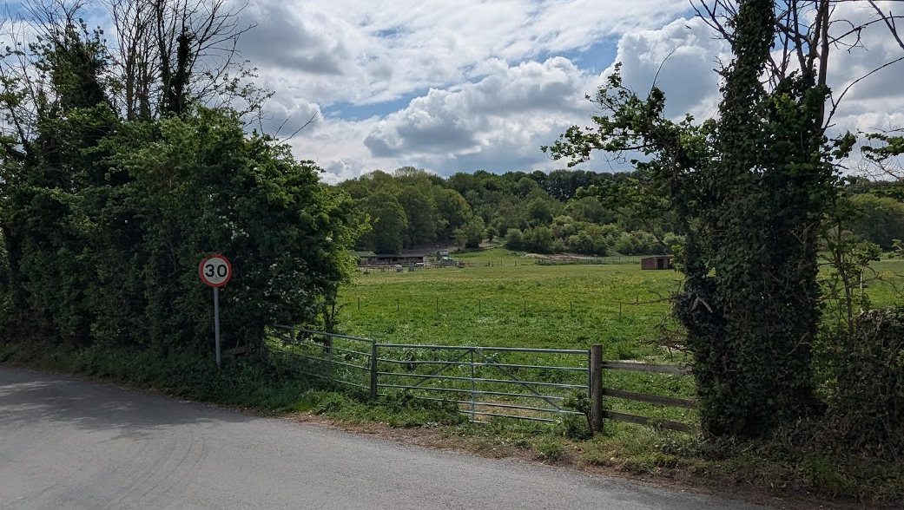

Wider view through same hedgerow gap on Elston Lane

PROPOSAL

The proposal seeks to erect another stable block of 2 stables and two storage rooms. In the resultant ‘L’ shaped layout of the stables, an open sided barn is proposed to allow for shelter.

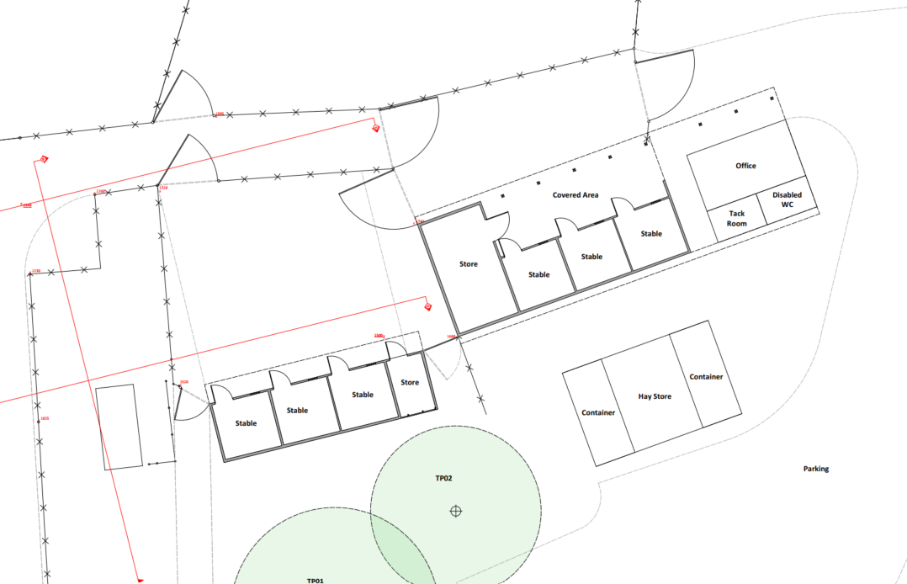

Existing Site Plan

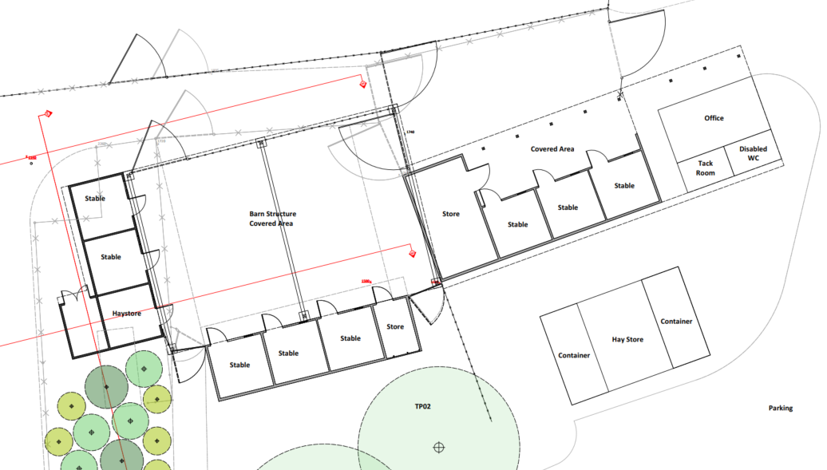

Proposed Site Plan

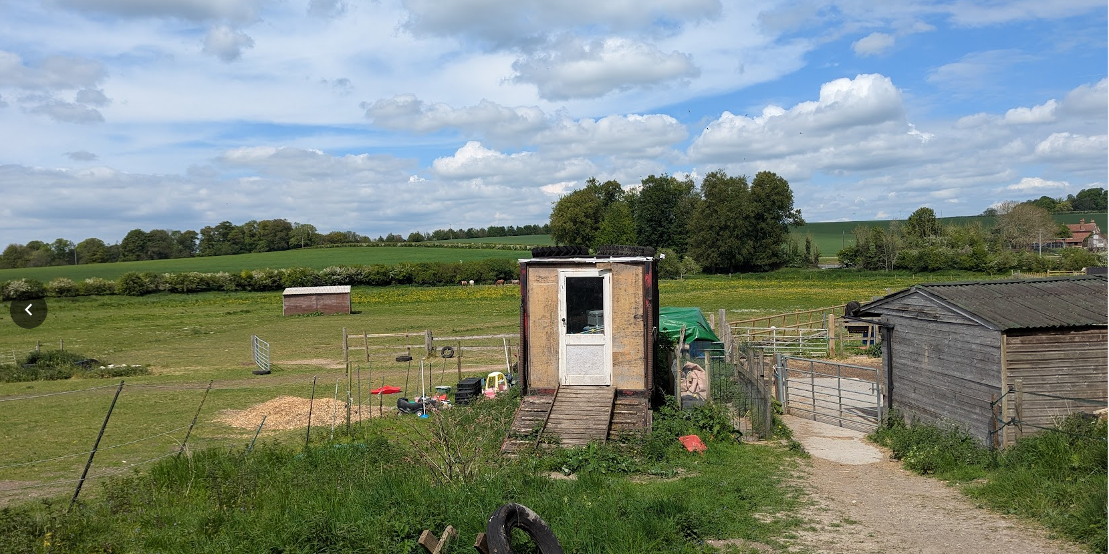

Photo of where the proposal would be located (no trees nearby)

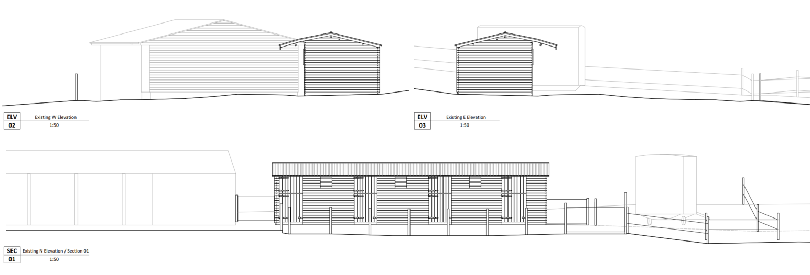
Existing Elevations

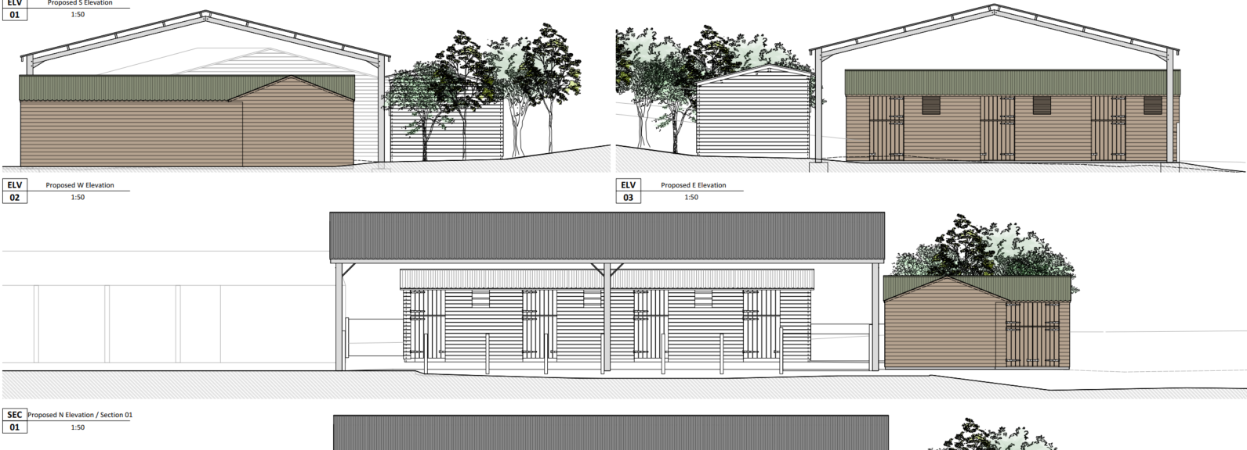

Proposed Elevations

In addition to the submitted plans the applicants have submitted the following documents with this application:

• Construction Management Statement. 21 May 2026. Paul Stevens Architecture Ltd. Job No. 1166;

• Preliminary Ecological Appraisal. 25 February 2026. Estate Land and Property Management Ltd. Ref. ELPM-ECO-001-PEA;

• Small Sites Metric (The Statutory Biodiversity Metric). 25 February 2026. Rev. 1

PLANNING HISTORY

Proposal / Summary
14/04077/FUL - Full planning permission Decision - Approve with Conditions Date: 28/1/2015 – Retrospective change of use of site to outdoor and equine assisted theropy centre including additional single storey stable block shelter and re roof existing cabin. Relocation of existing creation of new side yard,,and installation of disabled toilet and
S/1990/1629 - Full planning permission Decision - Approve with Conditions Date: 9/1/1991 – ERECTION OF STABLE BLOCK FOR PRIVATE USE

RELEVANT LEGISLATION, POLICIES AND GUIDANCE

From the point of view of the historic environment the main statutory tests are set out within the Planning (Listed Building and Conservation Areas) Act 1990.

Section 66 of the Planning (Listed Buildings and Conservation Areas) Act 1990 requires ‘special regard’ to be given to the desirability of preserving a listed building or its setting.

National Planning Policy:

The NPPF outlines government policy for planning. Chapter 16 of the NPPF 'Conserving and enhancing the historic environment' sets out the Government's high-level policies concerning heritage and sustainable development.

Planning Practice Guidance (PPG)
Development Plan:

The development plan for Wiltshire comprises the Wiltshire Core Strategy (WCS) (adopted January 2015) and any made neighbourhood plans, which remains the principal statutory planning document guiding development across the county. In line with Section 38(6) of the Planning and Compulsory Purchase Act 2004, planning decisions must be made in accordance with the development plan unless material considerations indicate otherwise.

Though the development plan is considered as a whole, those parts deemed to be particularly relevant to this application are listed below:

The adopted Wiltshire Core Strategy (WCS), with particular regard to:

- Core Policy 57 Ensuring High Quality Design and Place Shaping;
- Core Policy 58 Ensuring the Conservation of the Historic Environment

The Council’s Core Strategy Policy CP58 ‘Ensuring the conservation of the historic environment’ requires that designated and non-designated heritage assets and their settings will be conserved, and where appropriate enhanced, in a manner appropriate to their significance and encourages proposals which improve the condition of heritage assets at risk.

The Council’s Core Strategy CP 57: Ensuring high quality design requires a high quality of design in all new developments. The policy requires applicants to “demonstrate how the proposal will make a positive contribution to the character of Wiltshire through (amongst other things) responding to the value of the natural and historic environment and being sympathetic to and conserving historic buildings and landscapes. Development is required to respond positively to the existing in terms of building layouts, built form, height, mass, scale, building line, plot size, elevational design, materials, streetscape and rooflines to effectively integrate the building into its setting.”

Neighbourhood Plan: Orcheston does not have a Neighbourhood Plan or area designation

ISSUES

The main issues that need to be addressed in this case include:

- Whether the proposal constitutes EIA development
- Whether the scheme constitutes high quality design (CP 57)
- Whether the scheme would have an acceptable impact upon the reasonable living conditions of the adjoining users (CP 57)
- The impact on designated heritage assets

CONSULTATION RESPONSES

Orcheston Parish Council – No comments received

Wiltshire Council Highways Officer – No objection

Wiltshire Council Drainage Officer – No objection

Wiltshire Council Public Protection Officer – No comments received

Wiltshire Council Tree Officer - There is no Arb information on file to allow me to make an informed decision regarding impact on trees. Looking at ariel photography is seems unlikely that trees will be negatively impacted but I cannot be sure without a Tree Survey and Impact Assessment completed in accordance with BS5837:20212.

Wiltshire Council Ecology Officer – No objection subject to conditions

Natural England – No comment to make

REPRESENTATIONS

In accordance with the requirements of the Town and Country Planning (Development Management Procedure) (England) Order 2015 (as amended), the application was publicised by way of:

- Press Notice
- Neighbour notification letters sent to adjoining and nearby properties;
- A site notice displayed near the site;

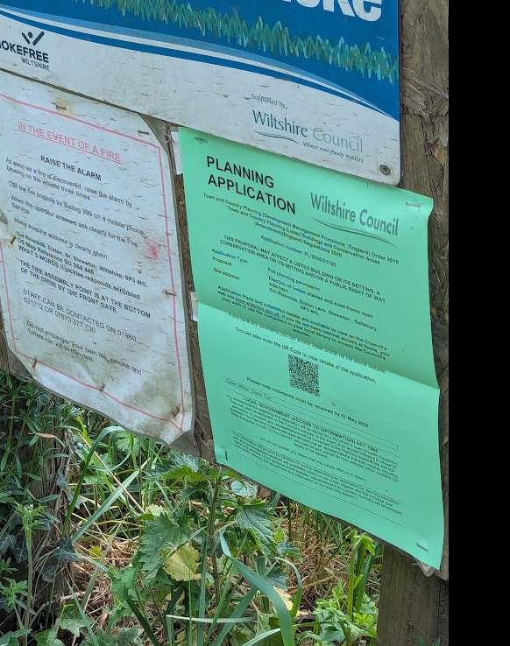

These methods were used to inform interested parties and provide a period of 21 days for comments to be submitted.

Below is a summary of the representations received during the consultation period. Only material planning considerations have been taken into account in the assessment of this application. Non-material issues, such as property values or private legal disputes, cannot be considered in the determination process.

No comments received

ASSESSMENT

Section 38(6) of the Planning and Compulsory Purchase Act 2004 states:

"If regard is to be had to the development plan for the purposes of any determination to be made under the planning Acts, the determination must be made in accordance with the plan unless material considerations indicate otherwise."

In accordance with this statutory requirement, this application has been assessed against the relevant policies of the Development Plan, including the Wiltshire Core Strategy (2015) and, where applicable, any made Neighbourhood Plans. Consideration has also been given to the policies of the National Planning Policy Framework (NPPF) as a material consideration in the assessment.

Environmental Impact Assessment (EIA) Screening

In accordance with the Town and Country Planning (Environmental Impact Assessment) Regulations 2017 (as amended), the local planning authority has considered whether the proposed development constitutes EIA development.

No Screening Opinion Issued
No formal screening opinion was requested or issued. However, the local planning authority has considered the scale and nature of the development as part of the application process and is satisfied that it does not constitute EIA development under the 2017 Regulations.

Principle of Development

The principle of development has already been established with the previous planning permission for the stable and its conversion into commercial use. Therefore, the additional stable and the erection of the barn, an effective shelter to allow for tacking up and general circulation and chores etc to be undertaken in dry conditions is supported in principle.

Design and Impact upon the character and context of the area

Core Policy 57 - Ensuring High Quality Design and Place Shaping of the Wiltshire Core Strategy seeks to ensure that all new development is of high design quality, reflecting local context, character, and distinctiveness.

The proposal would add a further stable block without significantly extending the existing complex of buildings. Both the stable and barn would also be located within existing circulation space, and would not involve or reduce the size the fields used as paddocks or horse training etc.

The existing (and extended) stable block has a low profile but fairly wide visual impact on the landscape. Depending on where you are stood on Elston Lane, the complex fills some of the gap views between the hedgerows. However, the introduction of the barn would add a new vertical empathise that needs careful consideration.

The barn would be approximately 18m long, 12m wide and 5.3m tall sloping to 3.6m at eaves. Whilst this is a fairly large footprint, 5.3m is not excessively tall when considering applications for agricultural buildings, to which this building would share that character. Furthermore, the ground to the south of the application site rises 22m (according to OS maps) and incorporates ‘The Cleeve’, a woodland area of approximately 2.8 hectares. The barn would be seen in this context and should assimilate into this tall, dark and rural backdrop.

The barn would have open sides under Onduline Roofing sheets, however no colour has been proposed. Research has found that this type of roofing has a matt finish (and not glossy) and therefore should not be reflective, which is an important benefit as to limit landscape harm. Given the rural backdrop, it is considered that matt anthracite or dark green colours would be the most appropriate colours and will be secured by condition.

Having regard to the above, the proposal complies with the design principles set out in Core Policy 57 of the Wiltshire Core Strategy.

Impact on Heritage Assets

The listed building description is as follows:

GATES AND GATE PIERS TO ELSTON HOUSE, ELSTON

ORCHESTON ELSTON SU 04 SE (north side) 3/169 Gates and gate piers to Elston House II Gates and gate piers. Circa 1860. Cast-iron. Gate piers consist of four attached shafts with filligree capitals and moulded finials, pair of gates have wrought-iron heads. Attached to either side are flint walls with pitched limestone coping and plain cast-iron railings. Elston House built c1860; not included in list. The entrance with decorative gates and gate piers, is particularly prominent on this road.

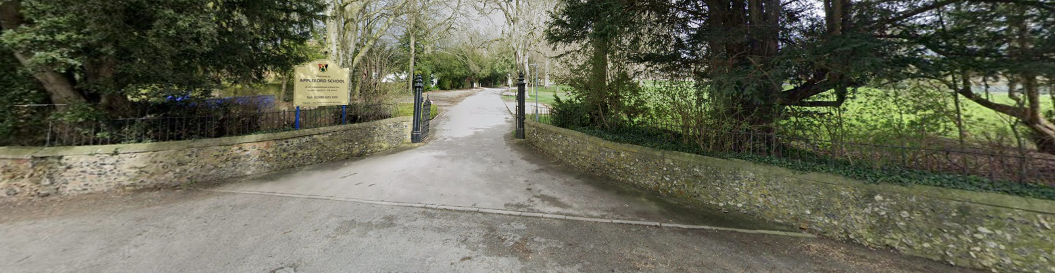

Photo of the Gates and Piers

The listed building would be approximately 150m away from the proposed development. However, the access into the application site is lined by a hedgerow on Elston Lane and from within the application site living the internal access. Therefore, the existing stable block cannot be seen from the listed building.

It is therefore considered that the setting of the listed building does not extend to where the proposed development would be located. Whilst the barn roof would likely be seen over the hedgerow, it is considered that there would be no impact on the setting of the listed building (and therefore would preserve its setting) and there would be no harm to its historic significance.

Therefore, the proposal is considered to be compliant with WCS Core Policies 57 and 58, the NPPF and section 66 of the Planning (Listed Buildings and Conservation Areas) Act 1990.

Amenity

Policy Context
Core Policy 57 (Point vii) of the Wiltshire Core Strategy requires development to respect the amenity of existing occupants and ensure appropriate amenity levels for future residents.

The National Planning Policy Framework (NPPF), particularly Paragraph 135, reinforces the need for development to provide a high standard of amenity for both existing and future users.

These policies guide the assessment of amenity impacts, which will be considered in detail under the below headings.

The proposal would only add two new stable blocks which would be approximately 190m away from the nearest residential dwelling. There should not therefore be any adverse effects by noise or smells. The barn would also not be of a size in which to cause any adverse harm to neighbouring buildings or uses and would be too far away from those boundaries.

Highways Impacts and Parking

Policy Context
Transport implications are a key factor in assessing planning applications, especially for larger developments. Proposals must demonstrate:
- Safe and suitable access for all users, including pedestrians, cyclists, and those with mobility impairments.
- No severe residual impacts on the surrounding highway network.
- Promotion of sustainable travel, reducing reliance on private vehicles.
- Adequate parking and cycle provision, in line with adopted standards.
- Protection and enhancement of public rights of way and active travel routes.

The application site is already served by an existing access. Whilst two additional stable blocks could increase the number of vehicular journeys by customers and clients, the increase in traffic using the access is not considered to be excessive. Additionally, Highways Officers have no objection to the proposal.

Ecology and Biodiversity

Policy Context
The ecological impact of development is a key planning consideration, especially for larger schemes. Proposals must assess and address potential effects on:

- Protected species
- Priority habitats
- Ecological networks
- Green and blue infrastructure

Core Policy 50 of the Wiltshire Core Strategy requires development to:

- Avoid harm to ecological assets.
- Deliver measurable Biodiversity Net Gain (BNG), in line with the Environment Act 2021.
- Support habitat restoration and connectivity.
- Integrate biodiversity into site design.

The Green & Blue Infrastructure Strategy (2022–2030) promotes nature recovery, ecosystem services, and habitat connectivity through development.

Unless exempt, National policy requires a minimum of 10% Biodiversity Net Gain (BNG) for major developments, demonstrated via:

- Biodiversity Metric calculations
- Ecological assessments (e.g. PEAs, Phase 1 surveys, protected species surveys)

The Council’s Ecology Officer has stated:

“Salisbury Plain Special Protection Area (SPA)
This application lies within the 6.4km zone of influence of the Salisbury Plain SPA and in light of the HRA for the Wiltshire Core Strategy and the HRA for the Wiltshire Housing Site Allocations Plan it is screened into Appropriate Assessment due to the potential impact of recreational pressure on stone curlew in combination with other plans and projects.
However, since this is an application for non-residential works, the above strategy does not apply.

Hampshire River Avon Special Area of Conservation (SAC) Catchment
This development falls within the catchment of the River Avon SAC and has potential to cause adverse effects alone or in combination with other developments through discharge of phosphorus in wastewater. Appropriate Assessment must be carried out by the relevant Competent Authority (the LPA) to determine the potential significant effects and the suitability of any measures proposed to avoid or mitigate those effects.

A test of likely significance has been conducted by the relevant Competent Authority (Wiltshire Council). This assessment determined that, due to the nature of the development, with no increase in dwelling and the lack of any increase in water supply, drainage installation within this development, there will be no mechanism for effect on the River Avon catchment. The Habitat Regulation Assessment (HRA) has concluded that the application is not likely to have significant impacts on the River Avon Catchment and the proposal is screened out of Appropriate Assessment.

River Avon SAC Core Policy 69
This development falls within 20m of the River Avon SAC and has the potential to cause likely significant effects (LSE’s) alone or in combination with other developments as a result of construction. An Appropriate Assessment (AA) under Section 63 of the Habitats Regulations must therefore be carried out by the Local Planning Authority to determine the potential significant effects and the suitability of any measures proposed to avoid or mitigate those effects, in line with Wiltshire Core Strategy Core Policy 69 (Protection of the River Avon SAC).
Core Policy 69 seeks to avoid and reduce environmental effects on the River Avon SAC during construction and operation to avoid and prevent pollution and mitigate disturbance effects.
In order to avoid and reduce potential environmental effects on the River Avon SAC, development will need to incorporate measures during construction and operation to avoid and prevent pollution and mitigate potential disturbance effects; appropriate measures may include consideration of suitable buffer zones along watercourses, habitat enhancements and river access management measures.

A Construction Method Statement (CMS) has been submitted and include measures to avoid and prevent direct damage, sedimentation, pollution, disturbance and/or changes to the hydrological regime. The CMS provides a marked-up plan showing the location of all pollution prevention measures, including: fencing protecting the edge of the riverbank, construction compound/location, storage area(s) for chemicals/toxic contaminants such as fuels. The CMS also details there will be no additional external lighting along the River Avon during construction works.

The LPA concludes that subject to the mitigation measures detailed in the Construction Method Statement, the Appropriate Assessment concludes no adverse effects on the integrity of the River Avon SAC during the Construction Phase.

River Till SSSI
The LPA have a duty to consult NE prior to determining a planning application that is in or likely to affect a SSSI (Schedule 4 (w) of The Town and Country Planning (Development Management Procedure) (England) Order 2015 and section 28i of The Wildlife and Countryside Act 1981).

This application lies within the River Till Site of Special Scientific Interest (SSSI). There is potential for the proposed development to have a harmful effect on this SSSI and those SACs, SPAs or Ramsar sites that they underpin. Consultation with NE is therefore required prior to determination of the application.

Natural England have been consulted on this application, their response is currently awaited. Given the statutory requirement to consult NE where development is within or likely to affect an SSSI, the application should not be determined until Natural England have provided their formal response.

The LPA must be reasonably sure that the proposal will not result in significant adverse effects on this protected site/these protected sites.

Priority Habitat Deciduous Woodland
Priority Habitat Deciduous Woodland lies within the south of the site. In accordance with Core Policy 50, development proposals must demonstrate how they protect features of nature conservation and geological value as part of the design rationale. There is an expectation that such features shall be retained, buffered, and managed favourably in order to maintain their ecological value, connectivity and functionality in the longterm. Where it has been demonstrated that such features cannot be retained, removal or damage shall only be acceptable in circumstances where the anticipated ecological impacts have been mitigated as far as possible and appropriate compensatory measures can be secured to ensure no net loss of the local biodiversity resource.

Protected Species
The Preliminary Ecological Appraisal identified the existing buildings as having negligible potential to support roosting bats. The site is assessed to offering suitability for foraging and commuting bats. The erection of timber stables and steel-frame open side barn will not require the removal of vegetation considered to be functionally important for bat foraging or commuting. Subject to retention of key boundary features and implementation of a sensitive lighting strategy, it is likely that the functionality of the habitats within the site and their availability to bats will not be adversely affected. Two trees have been identified as offering ‘moderate’ bat roost suitability; however, no trees with bat roost potential are proposed for removal under the current scheme. Should the proposals change such that trees with potential roosting features are affected, further survey work would be required and mitigation measures would need to be reviewed and updated accordingly.

The habitat within the proposed development site and the surrounding area is suitable for roosting, foraging and commuting bats. Any new lighting should be for the purposes for safe access and security and be in accordance with the appropriate Environmental Zone standards set out by the Institute of Lighting Engineers in their publication GN01:2021, ‘Guidance for the Reduction of Obtrusive Light’ (ILP, 2021), and Guidance note GN08/23 “Bats and artificial lighting at night”, issued by the Bat Conservation Trust and Institution of Lighting Professionals.

Where possible, vegetation removal should be scheduled outside the bird breeding season (1st March–31st August) to avoid potential disturbance. If removal during this period is unavoidable, a pre-works nesting bird inspection must be conducted no more than two weeks before tree felling begins. The applicant is advised to check any structure or vegetation capable of supporting breeding birds and delay removing or altering such features until after young birds have fledged. Damage to extensive areas that could contain nests/breeding birds should be undertaken outside the breeding season.

Biodiversity Net Gain
Under Schedule 7A of the Town and Country Planning Act 1990 (as inserted by Schedule 14 of the Environment Act 2021) this application is required to deliver 10% Biodiversity Net Gain (BNG). The Biodiversity Gain Plan condition will automatically apply if approval is forthcoming.
A completed statutory metric calculation (Small Sites Metric (The Statutory Biodiversity Metric. 25 February 2026. Rev. 1) confirming the baseline and predicted post- development biodiversity units of the site has been submitted (including the baseline habitat map).

Information in the completed on-site baseline habitat tabs is accepted as accurate based on the information submitted. The pre-development (baseline) situation is summarised below.

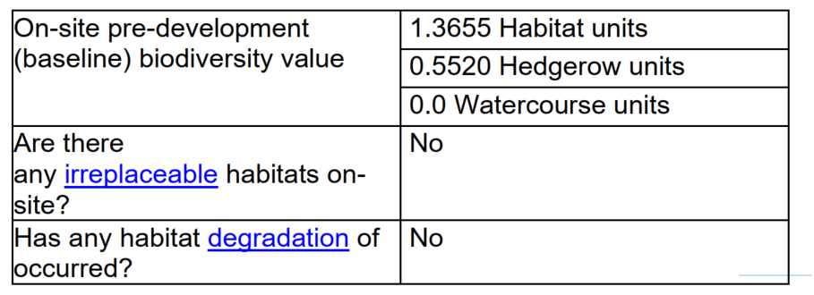

Core Policy 50 Core Policy 50 of the Wiltshire Core Strategy requires all development to demonstrate no net loss of biodiversity and to seek opportunities to enhance biodiversity. The NPPF also encourages applications to deliver measurable net gains (para 186 d). It is anticipated that all developments will deliver no net loss of biodiversity. For this application, biodiversity measures should focus on delivering continued ecological functionality for birds, bats and hedgehogs.

The Preliminary Ecological Appraisal recommends the inclusion of bird boxes. All details on exact locations and specifications must be added to all working plans (see condition below) and will become an enforceable part of the planning permission to avoid oversight and to ensure consistency and enforceability. Integrated features are generally maintenance-free and seek to benefit a target species/s or group/s and should demonstrate viability in terms of position on the building, location and clustering in accordance with relevant guidance and the additional features.”

Assessment:

Natural England have been consulted and for the avoidance of doubt have ‘no comment to make’ i.e. no objection in regard to potential impacts on the SSSI. The Ecology Officers concern for Natural England’s comments have therefore been addressed.

Having regard to Natural England’s response, the submitted ecological information, the scale and nature of the development, and the mitigation secured through conditions, the LPA is satisfied that the proposal will not result in adverse effects on the River Till SSSI and associated European sites.

The proposed stable and barn roof would be circa 120m away from the river at its closest point. Approximately half of the proposed site is already laid to hardstanding and therefore the amount of surface water runoff will not significantly increase. The applicants have also submitted a flood risk assessment which sets out that the development will use soakaway systems to promote natural infiltration, maintenance of permeable ground surfaces, retention of existing vegetation to assist with natural drainage and potential use of shallow swales or infiltration features if required. The FRA also includes a drainage strategy which will replicate greenfield runoff rates, prevent increased discharge to surrounding land and reduce the risk of surface water accumulation. The Council’s drainage officer has no objection to the proposal.

Therefore, it is considered that as surface water will be appropriately managed via the drainage strategy and in the absence of direct hydrological connectivity or pollutant pathways arising from the development, significant effects on the SSSI are not anticipated.

It is considered that the potential ecological impacts of the proposal have been appropriately assessed. The recommended planning conditions, including compliance with the Construction Management Statement and the provision of ecological enhancements and sensitive lighting, are necessary to secure mitigation and avoidance measures.

With these safeguards in place, the Local Planning Authority is satisfied that:

there will be no adverse effect on the integrity of the River Avon SAC, the proposal will not result in harm to the River Till SSSI or other designated sites, and the development will comply with Core Policy 50 and the relevant provisions of the NPPF.

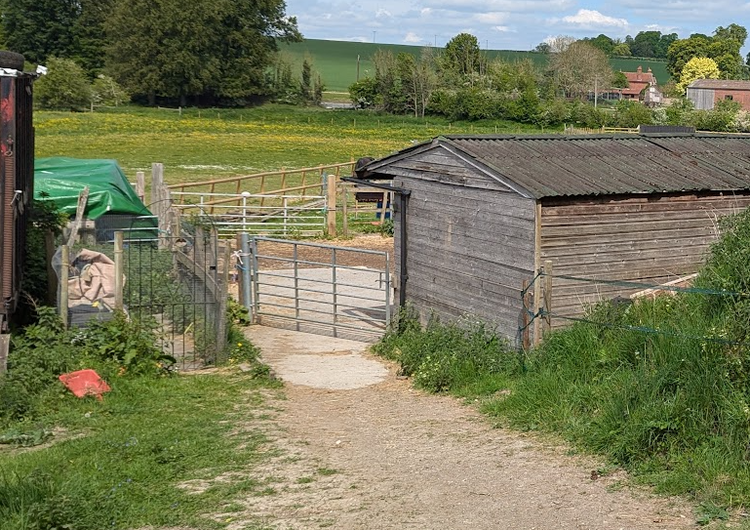

Photo of existing hardstanding

Flood Risk

Policy Context
Core Policy 67 of the Wiltshire Core Strategy and NPPF paragraphs 170–182 require:
• Avoidance of increased flood risk.
• Use of appropriate mitigation measures.
• Application of the sequential and exception tests for developments in Flood Zones 2 or 3.

Sustainable Drainage Systems (SuDS) are required for all major developments and must:
• Manage runoff near its source.
• Improve water quality.
• Support biodiversity and amenity.
• Be integrated into the site layout and green infrastructure.

The Council’s Drainage Officer has stated:

The application is minor in nature and involves only a minor increase in impermeable area. In
the absence of any existing flood risk on the site and with no nearby neighbouring properties,
it is not expected that the development would materially increase flood risk. It remains the applicant’s responsibility to ensure that the drainage design complies with CIRIA and Soakaway Guidance, so as to avoid any localised flooding or pooling within the site.

There is therefore no objection to the proposal on flood risk grounds.

PLANNING BALANCE AND CONCLUSION

In conclusion, the proposed development for the erection of additional timber stables and an open-sided barn at Gul Riverside represents a modest and logical extension to an established equine-based use. The principle of development is already well established through historic permissions, and the proposal has been carefully assessed against the relevant provisions of the Wiltshire Core Strategy and national planning policy.

The scheme is considered to be acceptable in design terms, maintaining a scale, form and appearance that reflects its rural context and existing building group, thereby complying with Core Policy 57. It would not result in harm to the setting or significance of nearby heritage assets, including the Grade II listed gates and piers to Elston House, in accordance with Core Policy 58 and statutory duties.

There are no adverse impacts identified in respect of residential amenity, highways safety, flood risk, or drainage. Ecological considerations, including impacts on designated sites and protected species, have been robustly assessed, and subject to appropriate mitigation and planning conditions, the development would avoid significant harm and deliver policy-compliant biodiversity outcomes.

Taking all material considerations into account, and having regard to the development plan as a whole, the proposal is considered to represent sustainable development. It accords with both local and national policy objectives and there are no overriding material considerations that would justify refusal. Accordingly, the application is recommended for approval, subject to appropriate planning conditions.

RECOMMENDATION:
That Planning Permission be GRANTED, subject to conditions

