APPLICATION FOR FULL-PLANNING PERMISSION
CASE OFFICER REPORT

APPLICATION REFERENCE: | PL/2026/00863
APPLICATION TYPE: | Full planning permission
SITE ADDRESS: | Albany House, 3-5 New Street, Salisbury, SP1 2PH
DEVELOPMENT DESCRIPTION: | Formalise the building’s use as two separate dwellings. The property has already been physically divided under PL/2022/06040. The proposal therefore concerns only the material change of use from one dwellinghouse to two under sections 55(1) and 55(3)(a) of the Town and Country Planning Act 1990
RECOMMENDATION: | Approve with Conditions

SITE DESCRIPTION/CONTEXT

The application site relates to a mid-terraced property located on the south side of New Street and is located within the settlement boundary of the principal settlement of Salisbury, as defined by Wiltshire Core Strategy (WCS) core policies 1 (Settlement Strategy), 2 (Delivery Strategy) and 20 (Spatial Strategy for the Salisbury Community Area). The application site is a grade 2 listed property and is also within the setting of a number of other listed buildings including grade 2, grade 2* and grade 1. The property is also located within the Salisbury City Conservation Area, the property is within flood zone 2, the Hampshire River Avon catchment area and the New Forest 13.8km Internationally protected sites zone of influence.

Extract below shows the application site and adjoining and nearby listed buildings hatched black.

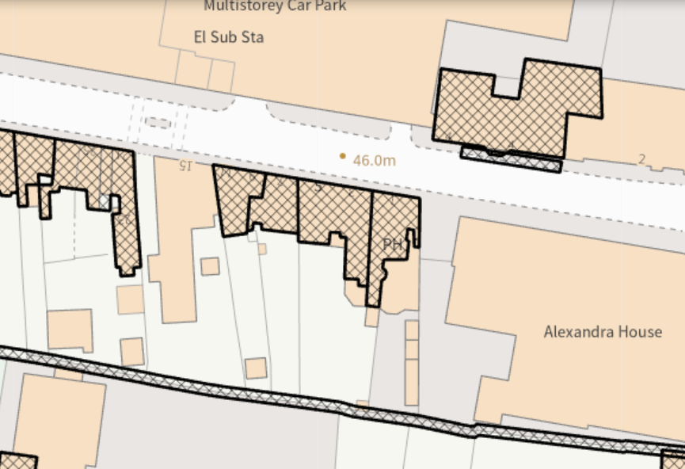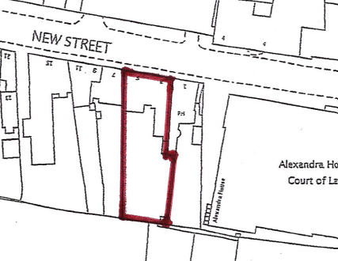

PROPOSAL

The application is seeking permission for the conversion of a single dwelling into two dwellings, no physical external or internal alterations or extensions are proposed, the development is solely a material change only/conversion.

Internal works were undertaken through listed building consent PL/2022/06040 which essentially provided the means for the property to be formally subdivided and used as two dwellings, hence why no physical works are now proposed.

This new application also follows two recent refused applications for full planning and listed building consent (PL/2024/02822 and PL/2024/08875) which were also both dismissed at appeal. These recent applications were for the subdivision of the property into three dwellings but also included extensions to the property. There were identified heritage harms which were unacceptable, there were also flood risk issues which had not been addressed. This new application has been submitted following feedback that the material change of use/conversion only would be the way forward.

PLANNING HISTORY

PL/2024/02822 - Proposed alterations to enable division of the existing dwelling into three separate dwellings. Refused and dismissed at appeal

PL/2024/08875 - Proposed alterations to enable division of the existing dwelling into three separate dwellings. Refused and dismissed at appeal

PL/2022/06040 - Internal alterations to ground floor – alterations to form under stair WC to hall and replacement floor tiles, close off doorway to rear room, fitting out existing rear extension to kitchen. Internal alterations to first floor – stud partition to rear bedroom to create en suite, close up existing doorway and creation of replacement plus stud partition for en suite to rear bedroom. Stud partition with doorway to front middle bedroom and fit out front west room to bathroom. External extraction for kitchen and bathroom. Approved.

20/07168/FUL - Change of use of building from Class B1 to Class C3 dwelling with no alterations. Approved

20/07788/LBC - Change of use of building from Class B1 to Class C3 dwelling with no alterations. Withdrawn

S/2005/0054 – Sign above entrance door, white metal (2-3mm thick) 36cm in height 78cm in length – approved

S/2004/1612 – Change of use from offices (B1) to alternative medicine, training and office use (D1) – approved

S/1985/1558 – Change of use of part of second floor from residential to office use – allowed on appeal

S/1984/0464 – Change of use of first floor and part of second floor to offices and retention of part second floor for residential – approved

RELEVANT LEGISLATION, POLICIES AND GUIDANCE

The National Planning Policy Framework (NPPF) (2024) confirms that planning law requires that applications for planning permission be determined in accordance with the development plan, unless material considerations indicate otherwise (Section 38(6) of the Planning and Compulsory Purchase Act 2004 and section 70(2) of the Town and Country Planning Act 1990); that the NPPF is a material consideration in planning decisions and planning policies and decisions must also reflect relevant international obligations and statutory requirements.

The proposals are therefore to be considered in the context of the National Planning Policy Framework (NPPF) and the development plan which comprises the adopted Wiltshire Core Strategy (WCS), which also includes some saved policies of the Salisbury District Local Plan (SDLP) and the Wiltshire Local Transport Plan.

The following policies are considered the most relevant to proposals:

National Planning Policy Framework (NPPF)
Planning Practice Guidance (PPG)
National Design Guide (NDG)

Wiltshire Core Strategy:

Core Policy 1 - Settlement Strategy
Core Policy 2 - Delivery Strategy
Core Policy 3 - Infrastructure Requirements
Core Policy 20 - Development in the Salisbury Community Area
Core Policy 41 - Energy Strategy
Core Policy 50 - Biodiversity and Geodiversity
Core Policy 51 - Landscape
Core Policy 52 - Green Infrastructure
Core Policy 55 - Air quality
Core Policy 57 - Design and amenity
Core Policy 58 - Ensuring the conservation of the historic environment
Core Policies 60 - 66 Transport and Development
Core Policy 67 - Drainage and flooding Core Policy 68 - Water resources
Core Policy 69 - Protection of River Avon SAC

Adopted Salisbury District Local Plan saved policies:

H8 - Housing Policy Boundary of Salisbury

Waste Core Strategy 2006-2026

Wiltshire Local Transport Plan 2011-2026
- Car Parking Strategy (Policy PS6 - Residential parking standards)
- Cycling Strategy Government Guidance:

Statutes:

Wildlife and Countryside Act 1981 as amended
Conservation of Habitats and Species Regulations 2017 (the ‘Habitats Regulations’)
Conservation of Habitats and Species (Amendment) (EU Exit) Regulations 2019

The Planning (Listed Buildings and Conservation Areas) Act 1990
• Section 16: Decision on application.
• Section 66: Special considerations affecting planning functions
• Section 72: General duty as respects conservation areas in exercise of planning functions

Ancient Monuments and Archaeological Areas Act (1979) amended by the National Heritage Act (1983) and the National Heritage Act (2002)
Environmental Protection Act, 1990
Environment Act 2021

Arrangements for Handling Heritage Applications – Notification to Historic England and National Amenity Societies and the Secretary of State (England) Direction 2021

Supplementary Planning Guidance:

Salisbury Central Area Framework - Wiltshire Council: • Adopted Salisbury City Central Area Framework 2020

Salisbury neighbourhood plan

Adopted 'Creating Places Design Guide’ Salisbury 2006
Wiltshire Design Guide

ISSUES

• Principle of development
• Flood risk
• Impact to the character and appearance of the area and significance of the designated Conservation Area/Listed building/settings/historic fabric
• Amenity considerations
• Highway considerations
• Ecological considerations: - Protected species - River Avon Special Area of Conservation - Phosphate Neutral Development - The New Forest Internationally protected sites

CONSULTATION RESPONSES

City Council - Support

Conservation - No objection

Public Protection – No observations

Highways – No objection subject to condition

Ecology - No objection subject to condition

Natural England – No objection subject to condition

Drainage – No objection

REPRESENTATIONS

In accordance with the requirements of the Town and Country Planning (Development Management Procedure) (England) Order 2015 (as amended), the application was publicised by way of:

- Neighbour notification letters sent to adjoining and nearby properties;
- A site notice displayed near the site;
- An advertisement placed in the local press

These methods were used to inform interested parties and provide a period of 21 days for comments to be submitted.

No representations have been received.

ASSESSMENT

Section 38(6) of the Planning and Compulsory Purchase Act 2004 states:

"If regard is to be had to the development plan for the purposes of any determination to be made under the planning Acts, the determination must be made in accordance with the plan unless material considerations indicate otherwise."

In accordance with this statutory requirement, this application has been assessed against the relevant policies of the Development Plan, including the Wiltshire Core Strategy (2015) and, where applicable, any made Neighbourhood Plans. Consideration has also been given to the policies of the National Planning Policy Framework (NPPF) as a material consideration in the assessment.

Principle of Development

At the heart of the NPPF is a presumption in favour of sustainable development and the Settlement and Delivery Strategies of the Core Strategy are designed to ensure new development fulfils the fundamental principles of sustainability. This means focusing growth around settlements with a range of facilities, where local housing, service and employment needs can be met in a sustainable manner. A hierarchy has been identified based on the size and function of settlements, which is the basis for setting out how the Spatial Strategy will deliver the levels of growth.

Core Policy 1 of the Wiltshire Core Strategy sets out the 'Settlement Strategy' for the county, and identifies four tiers of settlement - Principal Settlements, Market Towns, Local Service Centres, and Large and Small Villages. Only the Principal Settlements, Market Towns, Local Service Centres and Large Villages have defined limits of development/settlement boundaries.

Core Policy 2 of the Wiltshire Core Strategy sets out the 'Delivery Strategy'. It identifies the scale of growth appropriate within each settlement tier, stating that within the limits of development, as defined on the policies map, there is a presumption in favour of sustainable development at the Principal Settlements, Market Towns, Local Service Centres and Large Villages.

Salisbury is defined as a Principal Settlement, and the site lies within the defined settlement boundary of Salisbury and is also within the Salisbury Central Area. Residential development within the defined settlement boundary is acceptable in principle under saved policy H8 of the Salisbury District Local Plan and Core Policies 1 and 2 of the Wiltshire Core Strategy, although this is also subject to consideration against other relevant planning policies.

The principle of development is also subject to compliance with other relevant planning policies and the normal range of material considerations that have to be taken into account when determining a planning application and a judgement is necessary in terms of all the development impacts considered below. Particular constraints in developing this site are flood risk (including in relation to the principle of development discussed further below), heritage and amenity considerations.

5 Year Housing Land Supply

The Wiltshire Housing Land Supply Statement (June 2026) provides the latest position on the Council’s ability to demonstrate a five-year supply of deliverable housing land, which is a material consideration in the determination of planning applications.

The National Planning Policy Framework was revised in December 2024. This has reintroduced the requirement to meet five years’ worth of deliverable sites and a buffer to be applied to the five-year housing requirement in all circumstances and has revised the Local Housing Need calculation to establish the five-year housing requirement. These factors have resulted in a substantial increase in the five-year housing requirement to be met from the previous calculation. When this is assessed against the housing land supply which can be delivered within five years, the recalculation shows a significant reduction in the number of years supply. The resulting position shows that the Council can currently demonstrate a 2.8 years housing land supply of housing at a unitary authority level. This is considered to be a substantial shortfall.

The absence of a five-year housing land supply is a material consideration in the determination of this application. In accordance with Paragraphs 78 and 11(d) of the National Planning Policy Framework (NPPF), for applications involving the provision of housing, where there is a shortfall in the supply of deliverable housing sites, the most important policies for determining the application should be considered out of date. The current housing land supply shortfall is a factor that must be considered in the planning balance and in this case, as a five-year housing land supply cannot be demonstrated, the weight that can be applied to the most important policies for determining this application should be assessed and altered in the light of the shortage in housing land supply. The proposal must be assessed against the national policy context of the need to boost housing supply and the benefits of delivering new homes whilst having particular regard to the key policies set out in paragraph 11(d)(ii) and Footnote 9 of the NPPF.

In this instance, should significant harm such as heritage impacts or flooding issues be identified then it would be considered that the tilted balance of paragraph 11d of the NPPF is not triggered. Heritage and flooding issues are discussed below within this report.

Impact to the character and appearance of the area and significance of the designated Conservation Area/Listed building/settings/historic fabric

The site is also located within the designated Salisbury Conservation Area and is attached to
and within the setting of several listed buildings and New Street is identified as a positive frontage on the extract from the Salisbury Conservation Area Appraisal:

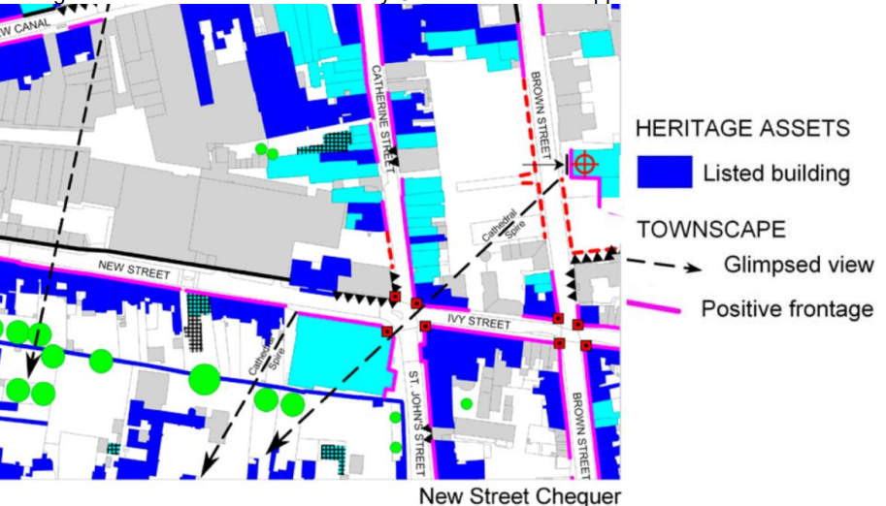
Extract from of Salisbury City Conservation Area Appraisal and Management Plan 2014 above.

The Planning (Listed Building and Conservation Areas) Act 1990 (sections 16 & 66) requires
proposals affecting listed buildings or their settings to seek to preserve the special interest of
the buildings and their settings. The principal considerations are to ensure that new development preserves the significance of listed buildings and their settings.

Section 72 of the Planning (Listed Buildings and Conservation Areas) Act 1990 states that in the exercise of any functions, with respect to any buildings or other land in a conservation area, under or by virtue of any of the provisions mentioned in this Section, special attention shall be paid to the desirability of preserving or enhancing the character or appearance of that
area.

In paying ‘special attention/regard’ to the Conservation Area and listed buildings and their settings, the NPPF requires an assessment as to whether the proposal causes ‘substantial harm’ or ‘less than substantial harm.

The NPPF outlines the government’s policy in respect of the historic environment (Section 16).

Paragraph 204 advises that when considering the impact of a proposed development on the
significance of a designated heritage asset, great weight should be given to the asset’s conservation. This is irrespective of whether any potential harm amounts to substantial harm,
total loss or less than substantial harm. Paragraph 213 emphasises that any harm to, or loss
of, the significance of a designated heritage asset, including from development within its setting, should require clear and convincing justification.

The NPPF defines the setting of a heritage asset as ‘The surroundings in which a heritage asset is experienced. Its extent is not fixed and may change as the asset and its surroundings evolve. Elements of a setting may make a positive or negative contribution to the significance of an asset, may affect the ability to appreciate that significance or may be neutral.’

The NPPF explains that where a proposed development will lead to substantial harm to or total loss of significance of a designated heritage asset, local planning authorities should refuse consent, unless it can be demonstrated that the substantial harm or loss is necessary to achieve substantial public benefits that outweigh that harm or loss and where a development proposal will lead to less than substantial harm to the significance of a designated heritage asset, this harm should be weighed against the public benefits of the proposal.

The PPG clarifies that public benefits might comprise anything that delivers economic, social
or environmental progress. Public benefits should flow from the proposed development. They
should be of a nature or scale to be of benefit to the public at large and should not just be a private benefit. However, benefits do not always have to be visible or accessible to the public
in order to be genuine public benefits.

Public benefits may include heritage benefits, such as:

• sustaining or enhancing the significance of a heritage asset and the contribution of its setting
• reducing or removing risks to a heritage asset
• securing the optimum viable use of a heritage asset in support of its long term conservation.

Core Policy 58 aims to ensure that Wiltshire’s important monuments, sites and landscapes and areas of historic and built heritage significance are protected and enhanced in order that
they continue to make an important contribution to Wiltshire’s environment and quality of life. The policy seeks to conserve designated heritage assets and their setting as well as non-designated heritage assets that contribute to a sense of local character and identity.

Core Policy 57 also requires a high standard of design in all new development which is expected to create a strong sense of place through drawing on the local context and ensure that valuable features and characteristics are protected and enhanced. Criteria (i), (iii) and (vi)
specifically refer to development making a positive contribution to the character of Wiltshire through:

i. ‘Enhancing local distinctiveness by responding to the value of the natural and historic environment, relating positively to its landscape setting and the exiting pattern of development
and responding to local topography by ensuring that important views into, within and out of the site are to be retained and enhanced.’
iii ‘Responding positively to the existing townscape and landscape features in terms of building
layouts, built form, height, mass, scale, building line, plot size, elevational design, materials streetscape and rooflines to effectively integrate the building into its setting.’
vi. ‘Making efficient use of land whilst taking account of the characteristics of the site and the
local context to deliver an appropriate development which relates effectively to the immediate
setting and to the wider character of the area.’

In terms of the impact on the heritage assets and character of the area, the proposals as previously stated relate solely to the material change created through the conversion of the existing dwelling into two dwellings but with no physical works. The property is currently solely in residential use as a C3 dwelling and will remain in residential C3 use but as two dwellings.

The Council’s conservation officer has been consulted and has stated –

“The building is grade II listed and in the Salisbury City CA, all the usual polices etc apply, and the application follows a previous scheme that was dismissed at appeal.
On the basis that the proposal involves no physical works and relies on a previous LBC for the separation, I see no cause for concerns whatsoever.”

The previous areas of concern and reason for refusal surrounding heritage impacts no longer stand through this new application. in terms of heritage impacts and impacts on the character and appearance of the area the proposals are considered to be comply to the NPPF, sections 16, 66 and 72 of The Act and core policies 57 and 58 of the Wiltshire Core Strategy.

Amenity

Core Policy 57 (Point vii) of the Wiltshire Core Strategy requires development to respect the amenity of existing occupants and ensure appropriate amenity levels for future residents.

The National Planning Policy Framework (NPPF), particularly Paragraph 135, reinforces the need for development to provide a high standard of amenity for both existing and future users.

The application site is currently a single residential property located adjacent to a public house and other residential and commercial buildings. The application has been submitted with a plan which shows that both properties will benefit from private rear amenity space, however overlooking from adjacent properties into the rear gardens and from rear gardens back at the rear elevations is likely to be possible. However, given the location of the property and existing situation regards overlooking and town centre noise and disturbance there are no objections raised. It is considered that future occupiers will be aware of the situation when buying/renting and will have chosen a city centre context. It is not considered that the subdivision of the property will have significant impacts on the amenity of future occupiers.

Again, given that the property is currently a C3 dwelling and will be retained in residential use but as two dwellings, there are not extensions or alterations which will detrimentally affect the existing relationship of the application site and neighbouring dwelling in terms of amenity impacts. There are therefore no significant concerns regarding amenity impacts to neighbouring properties.

Highways Impacts and Parking

Wiltshire Core Policy 60 seeks to help reduce the need to travel, particularly by car, and support and encourage the sustainable, safe and efficient movement of people and good within and through Wiltshire through a series of initiatives and together with Core Policy 62 seeks to mitigate any adverse impact on the transport network on transport users, local communities and the environment.

The proposals will see the increase in the number of separate residential units within the building. As existing there no associated parking spaces however, the property is located within the city centre, within easy walking or cycling distance of shops, facilities and amenities. The Highways Authority has been consulted and has raised no objections accordingly subject to a condition relating to the provision of cycle storage facilities.

Ecology and Biodiversity

Core Policy 50 of the Wiltshire Core Strategy seeks to protect and enhance biodiversity and geodiversity, including through ensuring that development avoids harm to protected species and habitats.

The National Planning Policy Framework (NPPF), in Paragraphs 193, requires that development minimises impacts on and provides net gains for biodiversity, including ensuring mitigation is secured where harm cannot be avoided.

The Council’s ecology team have been consulted and provided the following comments which raise no objection subject to condition/securing appropriate mitigation for phosphates and New Forest SAC.

New Forest Protected Sites

The proposed development site lies within the 13.8km zone of influence for the New Forest internationally protected sites, which comprises the New Forest SPA, New Forest SAC and New Forest Ramsar site. Therefore, the application is screened into appropriate assessment under the Conservation of Habitats and Species Regulations 2017 (as amended) on account of its potential to cause adverse effects on the New Forest protected sites through increased recreational pressure which may occur alone and in-combination with other plans and projects.

In line with the Councils Interim Mitigation Strategy, the applicant has agreed to pay the SAMM payment requirements of £612 per dwelling/tourism unit (plus legal fees). This will be secured via a S111 agreement at determination. Unilateral undertakings or s106 agreements are also available to ensure the necessary mitigation is secured.

This will enable the Council to conclude, subject to endorsement from Natural England, that the development proposed by means of this application will not lead to significant adverse effects on the New Forest protected sites alone or in-combination with other plans and projects. The cost of developer contributions to mitigate the burden would be £612 plus legal fees.

The applicant should be directed to the Guidance Note for Completing Agreements Under S111 of the Local Government Act 1972.

It is considered that this approach delivers the required level of certainty to secure effective mitigation for the recreational burdens of this planning application. There will be no in combination effects with other developments, therefore we can conclude that there would be no adverse effect on the integrity of the above European Sites as a result of the development.

Habitat Regulations Assessment: River Avon Special Area of Conservation (SAC) Hampshire Catchment.

This development falls within the catchment of the River Avon SAC and has potential to cause adverse effects alone or in combination with other developments through discharge of phosphorus in wastewater. Appropriate Assessment must be carried out by the relevant Competent Authority (the LPA) to determine the potential significant effects and the suitability of any measures proposed to avoid or mitigate those effects.

The submitted nutrient calculation (Natural England Nutrient Neutrality budget calculator for the River Avon SAC. 31.3.26 Nutrient Neutrality Assessment – Completed Nutrient Calculators for 3-5 New Street) calculated a total phosphorus budget of 0.11 kg TP/year pre 2030 and 0.2 kg TP/year post 2030. The budget has been approved by Wiltshire Council.

A Council-led scheme of phosphorus credits will be available for development which meets certain criteria at a fixed cost per kilogram of phosphorus, provided supply of mitigation is available. A completed Hampshire Avon Credit Screening Approval Certificate is required to apply for this scheme. The ecology section of this certificate has been completed by the Council’s ecology team for this application. This certificate can only be issued by the case officer if the application meets the two deliverability tests. Further details of the Council led scheme, including eligibility criteria, current cost to purchase credits, and details of how to apply, is available on our website Phosphorus and nitrogen mitigation - Wiltshire Council.

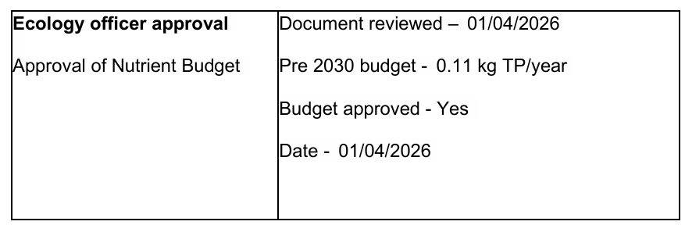
Council-issued phosphorus credits are expected to be available; to ensure that adequate mitigation is secured and deliverable for this development, it is advised that the necessary credits are secured as part of the permission. In the absence of a legal agreement the mitigation fee and administration charge for the scheme can be paid by a section 111. The administration fee should be paid on the granting of permission, and the mitigation fee is payable prior to commencement of development.

Where an applicant chooses to progress without securing mitigation at permission stage, nutrient neutrality must be secured, before any development can lawfully commence, via a planning obligation (Grampian condition or legal agreement). If the applicant elects to pursue this route, it should be noted that the planning permission will neither secure bespoke mitigation nor reserve any Council phosphorus credits. Consequently, there remains a risk that adequate mitigation may not be available, which could prevent the development from lawfully commencing.

A bespoke AA must be prepared and sent to NE, the application must not be determined until NE have endorsed the AA.

Biodiversity Net Gain From 12 February 2024 Biodiversity Net Gain (BNG) became mandatory under Schedule 7A of the Town and Country Planning Act 1990 (as inserted by Schedule 14 of the Environment Act 2021). Based on the information available the biodiversity gain planning condition is not considered to apply to this application as the development meets the following criteria and is therefore below the de minimis threshold, meaning the development:

• does not impact an onsite priority habitat (a habitat specified in a list published under section 41 of the Natural Environment and Rural Communities Act 2006); and
• impacts less than 25 square metres of onsite habitat that has biodiversity value greater than zero and less than 5 metres in length of onsite linear habitat (as defined in the statutory metric).

Natural England have been consulted and have confirmed no objections subject to mitigation as above.

The applicant has confirmed that they wish to secure credits and mitigation for River Avon SAC and New Forest SAC mitigation prior to determination rather than at a late date via Grampian condition. The applicant has agreed an extension of time of 5 days post completion of a S111 legal agreement to allow this process to be undertaken; only once the S111 agreement has been completed can an approval be issued.

NB – THE S111 AGREEMENT FOR BOTH THE NEW FOREST SAC AND RIVER AVON SAC HAS BEEN COMPLETED – 12/06/2026. This therefore allows the Council to confirm that apported mitigation has been secured for both of these SAC and an approval can now be issued.

Flood Risk and Drainage

Part of the site is identified on flood maps as being located in Flood Zone 2, see below map extract. However, the Environment Agency mapping data is indicative and is only an indication of the flood zones and does not account for the potential impact of Climate Change, including extreme weather events. Applying the cautionary principle to flood risk, the EA advise that flood risk to the site is likely to be over much more of the site than indicated, and the Council would consider the entire site to be within flood zone 2; unless it can be demonstrated using flood modelling via a site-specific flood risk assessment (FRA) that the site is/will remain in Flood Zone 1 with climate change.
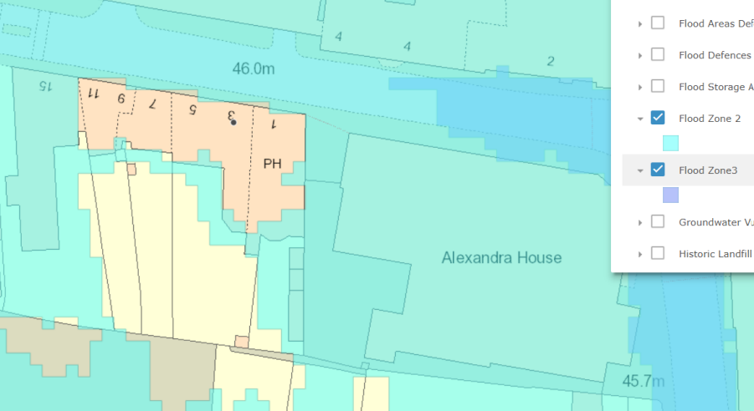

Therefore, with the site being located within flood zone 2 and the proposals being for additional residential units through the sub-division and extension of the existing building, a sequential test is required to be undertaken.

The NPPF para 172 states that

All plans should apply a sequential, risk-based approach to the location of development – taking into account all sources of flood risk and the current and future impacts of climate change – so as to avoid, where possible, flood risk to people and property. They should do this, and manage any residual risk, by:

a) applying the sequential test and then, if necessary, the exception test as set out below;
b) safeguarding land from development that is required, or likely to be required, for current or future flood management;
c) using opportunities provided by new development and improvements in green and other infrastructure to reduce the causes and impacts of flooding, (making as much use as possible of natural flood management techniques as part of an integrated approach to flood risk management); and
d) where climate change is expected to increase flood risk so that some existing development may not be sustainable in the long-term, seeking opportunities to relocate development, including housing, to more sustainable locations.

Para 174 of the NPPF 2024 is clear that development should be restricted in flood zones: -

The aim of the sequential test is to steer new development to areas with the lowest risk of flooding from any source. Development should not be allocated or permitted if there are reasonably available sites appropriate for the proposed development in areas with a lower risk of flooding.

Annex 3 of the NPPF provides the flood risk vulnerability classification. Dwellings are in the “More vulnerable” use.

The Planning Practice Guidance (PPG) explains that development should not be permitted if there are reasonably available sites appropriate for the proposed development in areas with a lower probability of flooding and that the NPPF sets these strict tests to protect people and property from flooding which all local planning authorities are expected to follow and where these tests are not met, national policy is clear that new development should not be allowed.

The sequential test is the first stage in addressing flood risk.

Any ‘Minor’ development proposals for residential development require a sequential test. This is because residential development other than change of use in flood zones 2/3 is unacceptable in principle unless there are no alternative sites available for development to meet the housing needs of the authority in flood zone 1.

The only exclusions (taken from Planning Practice Guidance- PPG) - are as follows:

A sequential test is also not needed if either of the following apply:

- the development is a minor development – but see below for definition of Minor in context of flooding:
- the development involves a change of use (e.g. from commercial to residential) unless your development is a caravan, camping chalet, mobile home or park home site

Minor development in the context of flood risk is:

- minor non-residential extensions: industrial/commercial/leisure etc. extensions with a footprint less than 250 square metres. alterations:
- development that does not increase the size of buildings e.g. alterations to external appearance.
- householder development: For example; sheds, garages, games rooms etc. within the curtilage of the existing dwelling, in addition to physical extensions to the existing dwelling itself. This definition excludes any proposed development that would create a separate dwelling within the curtilage of the existing dwelling e.g. subdivision of houses into flats The proposals include extensions to the building and as such are not exempt from needing to first pass a sequential test and are unacceptable in principle on flood risk grounds (regardless of any FRA/drainage strategy).

As the proposed development is for change of use/conversion from one to two dwellings only with no minor development/extensions a sequential test is not required. A site specific flood risk assessment has been provided which confirms that the property is not at risk of flooding and that the proposed development will not change the current situation. The Council’s drainage team have also provided comment and not objected to the development; their comments are included below.

Assessment

Although the site lies within Flood Zone 2, as is apparent from the survey, the height at pavement level outside each front door exceeds all of the EA modelled flood levels, so the site is above these levels. Additionally, the actual entrance levels are above pavement height and so further exceed the modelled levels. No alterations are proposed to existing arrangements for surface water management, which have always proved satisfactory

RECOMMENDATION No Objection for the following reasons: The proposed works are minor in nature and will not result in an increase in impermeable area or corresponding flood risk when compared to the existing scenario. As such, we have no objections to this application.

CIL

The proposed development may be liable for CIL as set out in the Wiltshire CIL Charging Schedule dated May 2015. This is a charge that local authorities can impose on new developments in their area. The money generated through the levy will contribute towards the funding of infrastructure to support growth and is payable upon commencement of development.

PLANNING BALANCE AND CONCLUSION

At the heart of the NPPF there is a presumption in favour of sustainable development requiring local planning authorities to approve development proposals that accord with an up-to-date development plan without delay; and where there are no relevant development plan policies, or the policies which are most important for determining the application are out-of-date, permission should be granted unless (taken from paragraph 11d of the NPPF):

- The application of policies in the NPPF that protect areas or assets of particular importance provides a clear reason for refusing development proposed; or
- any adverse impacts of doing so would significantly and demonstrably outweigh the benefits, when assessed against the policies in the NPPF taken as a whole;

The provision of additional housing in a city centre location is welcomed, and with due consideration to the Council’s current lack of 5 year housing land supply. There are no harms identified through the development in terms of heritage impacts, flood risk impacts amenity impacts or highway safety and subject to appropriate mitigation being secured through legal agreement for ecological matters such as River Avon SAC and New Forest SAC there are no ecology harms identified. The proposed development is not considered to have an adverse impact on the character and appearance of the area ad therefore accords with the above listed polices and guidance.

RECOMMENDATION: That Planning Permission be GRANTED, subject to conditions and subject to securing a S111 legal agreement for phosphate and new forest mitigation.

1. The development hereby permitted shall be begun before the expiration of three years from the date of this permission.

REASON: To comply with the provisions of Section 91 of the Town and Country Planning Act 1990 as amended by the Planning and Compulsory Purchase Act 2004.

2. The development hereby permitted shall be carried out in accordance with the following approved plans

Application form received 09/02/2026
Location plan received 17/2/2026
Proposed site plan B showing garden subdivision received 17/2/2026
Demarcation of dwellings plan C received 17/2/2026
Proposed site plan showing location of bin/cycle storage received 17/2/2026
Ground floor plan Drg no E1 Rev C received 09/02/2026
Ground floor plan Drg no E2 Rev C received 09/02/2026
First floor plan Drg no E4 Rev C received 09/02/2026
First floor plan Drg no E5 Rev C received 09/02/2026
Second floor plan Drg no E6 Rev C received 09/02/2026
Bin and bike store plans and elevations x 2 received 08/05/2026 and 12/05/2026

REASON: For the avoidance of doubt and in the interests of proper planning.

3. The development hereby permitted shall not be occupied, until covered cycle parking facilities of 6 spaces in total (dwelling 1=4 and dwelling 2=2) have been provided and made available for use. The cycle parking facilities shall be retained for use in accordance with the approved details at all times thereafter.
REASON: To ensure that satisfactory facilities for the parking of cycles are provided.

4. The overnight development hereby approved shall be designed to ensure it does not exceed 110 litres per person per day water consumption levels (which includes external water usage).

REASON: To ensure compliance with the prevailing mitigation strategy for nutrient neutrality in the water catchment within which this development is located.

INFORMATIVES

- BNG not required
The effect of paragraph 13 of Schedule 7A to the Town and Country Planning Act 1990 is that planning permission granted for development of land in England is deemed to have been granted subject to the condition (biodiversity gain condition) that development may not begin unless:

(a) a Biodiversity Gain Plan has been submitted to the planning authority, and
(b) the planning authority has approved the plan.

The planning authority, for the purposes of determining whether to approve a Biodiversity Gain Plan, if one is required in respect of this permission would be Wiltshire Council.

There are statutory exemptions and transitional arrangements which mean that the biodiversity gain condition does not always apply. For further information on exempt developments please refer to:
https://www.gov.uk/guidance/biodiversity-net-gain-exempt-developments
Based on the information available this permission is considered to be one which will not require the approval of a biodiversity gain plan before development is begun because one or more of the statutory exemptions or transitional arrangements is considered to apply.

- Bat Species - There is a low risk that bats may occur at the development site. Many species of bat depend on buildings for roosting, with each having its own preferred type of roost. Most species roost in crevices such as under ridge tiles, behind roofing felt or in cavity walls and are therefore not often seen in the roof space. Bat roosts are protected all times by the Conservation of Habitats and Species 2017 (as amended) even when bats are temporarily absent because, being creatures of habit, they usually return to the same roost site every year. Planning permission for development does not provide a defence against prosecution under this legislation or substitute for the need to obtain a bat licence if an offence is likely. If bats or evidence of bats is found during the works, the applicant is advised to stop work and follow advice from an independent ecologist or the applicant is advised to follow the advice of a professional ecologist or to contact Natural England’s Batline through the internet.

