APPLICATION FOR HOUSEHOLDER PLANNING PERMISSION
DELEGATED REPORT

APPLICATION REFERENCE: | PL/2026/02392
APPLICATION TYPE: | Householder Planning Permission
SITE ADDRESS: | 5 Leigh Park Road, Bradford On Avon, BA15 1TE
DEVELOPMENT DESCRIPTION: | Proposed Two Storey Side Extension, Front Porch & Landscaping
RECOMMENDATION: | That Planning Permission be GRANTED

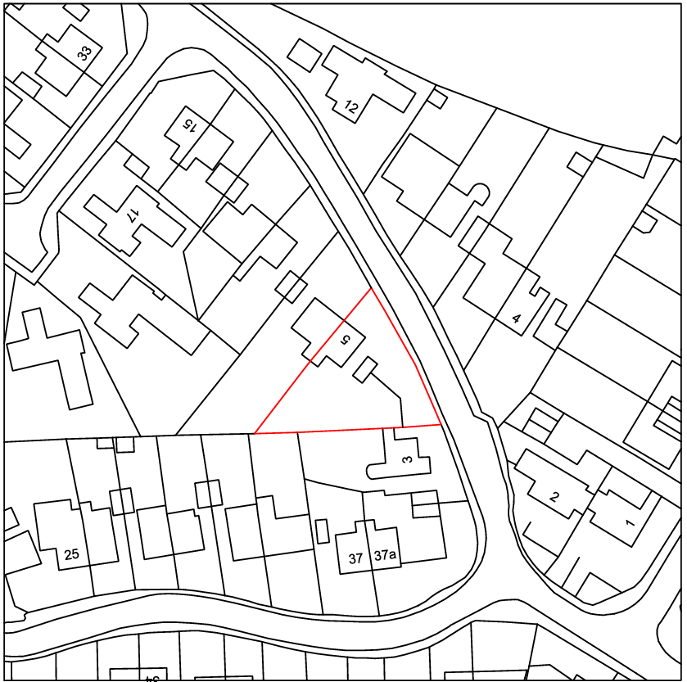

PROPOSAL

The application seeks planning permission for a two-storey side extension to replace an existing garage structure. At first floor level, the development would provide an additional bedroom and an ensuite, increasing the dwelling from a three-bedroom to a four-bedroom property. At ground floor level, the extension would facilitate an enlarged open-plan kitchen and living area, together with the provision of a small study. The proposal also includes the creation of a front parking area for the provision of three spaces and a front porch.

SITE DESCRIPTION / CONTEXT

The application site is located within a large residential estate characterised by a high degree of uniformity in design, with properties constructed in reconstituted buff stone, dark grey roof tiles, and white uPVC windows and doors. The prevailing built form comprises semi-detached and short terraced dwellings of a consistent style and scale. The area has an edge-of-settlement character, with glimpses of open countryside visible between buildings to the north, transitioning to higher density development towards the south. A number of similar properties within the estate have been extended with comparable two-storey side extensions, establishing a degree of precedent in the immediate area. The site lies within several ecological buffer zones and Flood Zone 1, with no groundwater flood risk identified, although there is a moderate surface water flood risk along the northeastern boundary adjacent to the highway.

PLANNING HISTORY

No relevant planning history has been identified for the site subject of this application.

RELEVANT LEGISLATION, POLICIES AND GUIDANCE

Wiltshire Core Strategy:

Core Policy 1 Settlement Strategy;
Core Policy 2 Delivery Strategy;
Core Policy 7 Spatial Strategy: Bradford on Avon Community Area;
Core Policy 50 Biodiversity and Geodiversity;
Core Policy 51 Landscape;
Core Policy 57 Ensuring High-Quality Design and Place Shaping;
Core Policy 60 Sustainable Transport;
Core Policy 61 Transport and Development;
Core Policy 64 Demand Management;
Core Policy 67 Flood Risk;

Bradford on Avon Neighbourhood Plan 2013-2026

The National Planning Policy Framework (NPPF)

The Planning Practice Guidance (PPG)

Wiltshire Design Guide - Appendix D – Design Guidance for Householder extensions

The Wiltshire Local Transport Plan 2011 – 2026: Car Parking Strategy (March 2015).

The Wiltshire Local Transport Plan 4 (LTP4) (March 2025)

Emerging Policy – Wiltshire Local Plan Review

At Full Council on 19 May, the elected members of Wiltshire Council agreed to withdraw the emerging WLP. It will now be subject to a legal process to finalise its withdrawal - which is likely to happen in July or August (2026). The said Plan has no material weight for the purposes of the application.

CONSULTATION RESPONSES

Bradford on Avon Town Council – No Objection

Local Highway Authority (Wiltshire Council) – No Objection
Highways raise no objection, confirming the driveway dimensions meet standards, though a nearby 20mph sign may need relocation to be agreed during the access application process. Approval is subject to standard conditions, including visibility splays, proper surfacing and drainage, ungated access, provision and retention of parking spaces, and obtaining a separate highways licence for any works to the dropped kerb.

REPRESENTATIONS

Four public consultation responses were received, comprising three objections and one general comment raising design considerations. The supportive/neutral comment suggests the extension be set back to improve its appearance and usability of the parking, while also noting potential constraints with the proposed parking arrangement.

The objections raise concerns regarding the scale and siting of the extension, citing loss of outlook, overbearing impact, overlooking, and harm to residential amenity. Additional concerns include impacts on the character of the area and street scene, loss of views of the surrounding countryside, potential loss of existing landscaping, and disturbance from construction activity.

ASSESSMENT

Section 38(6) of the Planning and Compulsory Purchase Act 2004 states:

"If regard is to be had to the development plan for the purposes of any determination to be made under the planning Acts, the determination must be made in accordance with the plan unless material considerations indicate otherwise."

In accordance with this statutory requirement, this application has been assessed against the relevant policies of the Development Plan, including the adopted Wiltshire Core Strategy (2015) and, where applicable, any made Neighbourhood Plans.

Householder extensions are generally acceptable in principle, as they typically fall within the established residential curtilage of a property and do not result in new residential development in the open countryside. In this case, the proposal also lies within the defined limits of development set out in the Core Strategy, further reinforcing its acceptability in principle.

Design and Impact the upon the character and context of the area

Core Policy 57 Ensuring High Quality Design and Place Shaping of the Wiltshire Core Strategy requires all new development to achieve a high standard of design that responds positively to its local context. Proposals must reinforce and enhance local character and distinctiveness, relate appropriately to the surrounding landscape, and demonstrate a thoughtful response to existing townscape features. This includes careful consideration of elements such as building height, scale, massing, building line, materials, and overall appearance, ensuring new development integrates harmoniously with its setting.

From a design perspective, the proposal is considered acceptable as it effectively replicates the form, materials and elevational composition of the existing dwelling, resulting in a cohesive and sympathetic addition. The extension adopts the same palette and architectural detailing, ensuring it integrates well with the host property and the wider uniform character of the estate. Importantly, the roofline has been set lower than that of the existing dwelling, allowing the extension to read as subordinate and maintaining the visual hierarchy of the original building and its attached neighbour. As such, the proposal is in keeping with the established design vernacular of the area and would not result in any adverse impact on the character or appearance of the street scene.

It is acknowledged that comments have been received suggesting the extension be set back from the principal elevation and raising concerns regarding the loss of front garden area to parking. With regard to the set-back, while this may offer some limited visual benefit, it is not considered necessary in this instance to render the proposal acceptable in design terms. The extension, as proposed, is consistent with the established character of the estate and reflects a number of similar approved and constructed side extensions in the immediate area where no such set-back has been required. As such, it would be difficult to reasonably justify a refusal on this basis.

In relation to the formation of parking to the front, concerns regarding the potential urbanising effect of replacing soft landscaping with hardstanding are noted. However, similar arrangements are evident locally, including along Christchurch Road and Berryfield Road, which establish a clear contextual precedent. During a visit to the site it was noted that the dwelling immediately opposite (6 Leigh Park Road) already has such a parking arrangement further reinforcing its local context. Furthermore, such works can often be carried out under permitted development rights (Schedule 2, Part 1, Class F), subject to appropriate surfacing conditions, demonstrating that this is a typical form of domestic alteration. On balance, whilst the visual change is recognised, it is not considered to result in harm sufficient to warrant refusal, particularly when viewed within the context of the surrounding area.

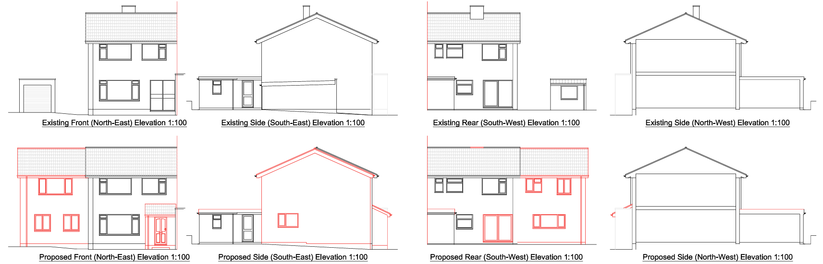
Exisiting and Proposed Elevations

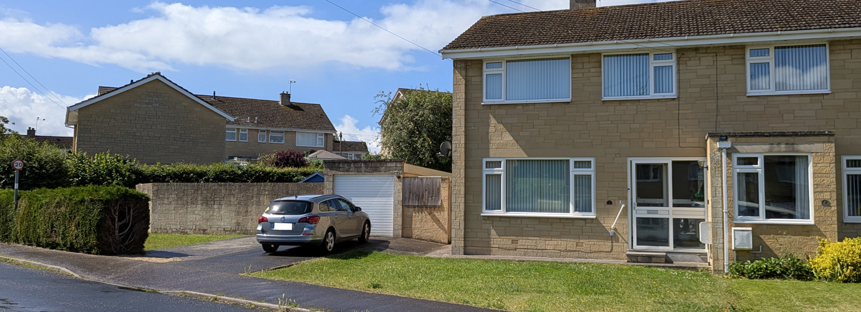
Site image
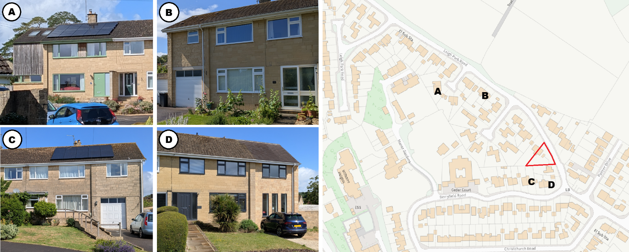
A: 47 Leigh Park Road (17/06466/FUL), B: 35 Leigh Park Road (W/99/00327/FUL), C: 35 Berryfield Road (W/83/00249/FUL), D: 37A Berryfield Road (PL/2023/08414)

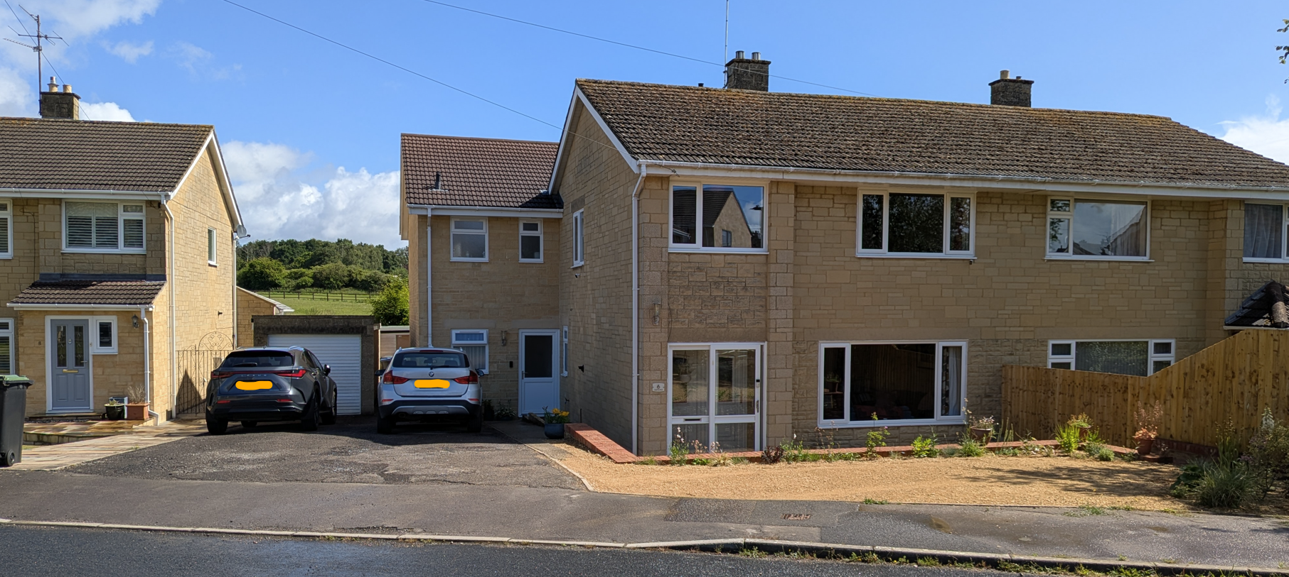
6 Leigh Park Road (immediately opposite site)

The proposed front porch would be sited alongside the existing porch on the attached dwelling and raises no concerns in relation to its appearance, siting and scale.

Having regard to the above, the proposal complies with the design principles set out in Core Policy 57 of the Wiltshire Core Strategy and Appendix D of the Wiltshire Design Guide.

Amenity

Core Policy 57 (criterion vii) of the Wiltshire Core Strategy seeks to ensure that development does not result in unacceptable impacts on the amenities of neighbouring properties. This is reinforced by Paragraph 135 of the National Planning Policy Framework, which requires that developments provide a high standard of amenity for existing and future users.

The proposed extension introduces additional first floor windows within the rear elevation and concerns have been raised regarding potential impacts on privacy. However, it is noted that the separation distance from the rear elevation to the site boundary is approximately 15m, with any intervisibility occurring at an oblique angle rather than direct window-to-window relationships. In this context, and given the edge-of-settlement location, this level of separation is considered sufficient to prevent harmful overlooking. Furthermore, the dwelling already benefits from first floor rear-facing windows, and the proposal would not materially alter the established relationship, with only a modest reduction in distance (approximately 3m at most).

In respect of overshadowing, the application site lies to the north of neighbouring properties on Berryfield Road, meaning the extension would not give rise to significant overshadowing to the rear due to the path of the sun. Any additional shadowing would be largely contained within the site and existing built form, and no harmful impact is anticipated to properties opposite the site. Similarly, given the separation distance to the boundary, the extension is not considered to result in an overbearing impact on neighbouring amenity spaces. Comments relating to the loss of private views towards adjacent agricultural land are noted; however, this is not a material planning consideration and cannot be afforded weight in the determination of the application.

Overall, the proposal is appropriately sited, designed and oriented such that it would not result in unacceptable harm to neighbouring residential amenity in terms of outlook, privacy, or light. The development therefore accords with Core Policy 57 (criterion vii) of the Wiltshire Core Strategy and the guidance set out within Appendix D of the Wiltshire Design Guide.

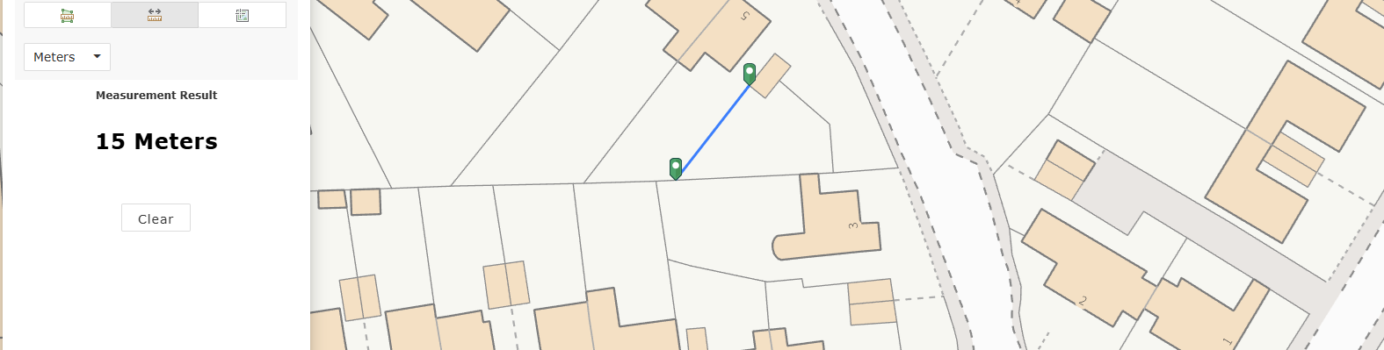
Distance to boundary

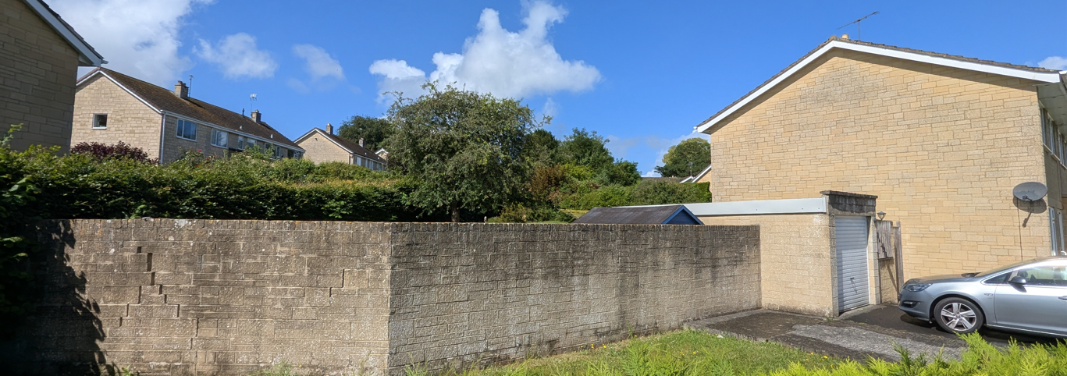
Site Photo

Transport and Highways

Core Policy 60 of the WCS states that Council will support and encourage safe and efficient movement of people and, where necessary, mitigate the impact of development on transport users and local communities. Core Policy 61 specifies that development should demonstrate that consideration has been given to a hierarchy of transport users and that proposals must, where relevant, serve as a safe access to the highway network. Paragraph 116 of the NPPF states that “Development should only be prevented or refused on highways grounds if there would be an unacceptable impact on highway safety, or the residual cumulative impacts on the road network, following mitigation, would be severe, taking into account all reasonable future scenarios”.

The WCS, through Core Policy 64, outlines the need for development to comply with a minimum level of parking standards. This is further discussed through the Wiltshire Local Transport Plan, and policy PS6 which identifies that new residential development is required to take account of dwelling size and the mix of associated parking function. The Car Parking Strategy further identifies that a minimum of three parking spaces should be provided for a four-bedroom dwelling. As the proposal would increase the property from a three to a four-bedroom dwelling, a requirement for three off-street parking spaces is applicable. The submitted layout demonstrates that three spaces can be accommodated within the site, and the Highway Authority has confirmed that the dimensions of the proposed parking area, including the minimum length of 4.8m, meet the necessary standards.

The Highway Authority raises no objection to the proposal subject to conditions. These include the provision and ongoing maintenance of adequate visibility splays at the site frontage, the surfacing and consolidation of the first 5m of access to prevent loose material migrating onto the highway, and the implementation of drainage measures to ensure that surface water does not discharge onto the public highway. Additional conditions require the access and parking areas to be completed prior to first use, retained for their intended purpose, and remain ungated in the interests of highway safety. It is also noted that a nearby 20mph repeater sign may require repositioning, which would be addressed through the separate vehicle access licensing process.

These conditions are necessary to ensure that the development provides a safe and suitable access, maintains adequate visibility for highway users, and avoids the creation of hazards such as loose materials or surface water on the highway. Subject to these controls, the proposal is considered to comply with Core Policies 60, 61, and 64 of the Wiltshire Core Strategy, Policy PS6 of the Local Transport Plan, and the guidance set out within the NPPF.

Ecology

Core Policy 50 of the Wiltshire Core Strategy seeks to ensure that development avoids and minimises impacts on biodiversity and protected species. Whilst Biodiversity Net Gain (BNG) is now a mandatory requirement under Schedule 7A of the Town and Country Planning Act 1990 (as amended), householder applications are exempt from this requirement.

The site lies within an SAC Parcel Buffer for Greater Horseshoe Bats, as well as Core Roost Buffers for Greater Horseshow and Lesser Horseshoe Bats. The proposal does not include new works to the existing roof structure, although the extension would connect to the side of the building under the fascia. The existing roof has the potential to support roosting bats, however the modern structure is such that opportunities for access into the loft space appear limited and therefore significant risk is not identified. In this context, it is appropriate to include an informative reminding the applicant of their legal obligations under the Wildlife and Countryside Act 1981 (as amended) and the need to cease works and seek appropriate advice should protected species be identified during construction.

Notwithstanding this, the application relates to a domestic property within an established residential area, and the works are confined to a managed garden environment with limited ecological value and a low likelihood of supporting sensitive habitats or species. As such, the proposal is not considered likely to give rise to harm to biodiversity interests. Subject to the inclusion of the informative, the development is considered to comply with Core Policy 50 of the Wiltshire Core Strategy.

Flooding and Drainage

Core Policy 67 of the Wiltshire Core Strategy requires development to minimise flood risk and ensure that surface water is managed appropriately without increasing runoff elsewhere. Paragraph 172 of the NPPF sets out the sequential approach to development, while paragraph 176 confirms that householder development of less than 250sqm is exempt from the application of the sequential and exception tests. As such, the principle of development in flood risk terms is acceptable.

The site is located within Flood Zone 1 and the Council’s Strategic Flood Risk Assessment identifies no groundwater flood risk. A band of surface water flood risk is present along the northeastern boundary adjacent to the highway, ranging from 0.1% AEP to 3.3% AEP. Whilst national guidance indicates that a site-specific Flood Risk Assessment may be required where there is evidence of other sources of flooding, the scale of development in this case is limited, comprising a net increase of approximately 25.1sqm of additional impermeable area, and not accounting for the fact that the space is largely comprised of exiting driveway hardstanding. Given the modest nature of the proposal, its location within an established residential curtilage, and the low level of identified constraints, it is considered that the submission of a formal FRA would be disproportionate.

The scheme does not give rise to any significant flood risk concerns and it is reasonable to conclude that surface water can be managed through standard domestic drainage arrangements. Furthermore, a condition recommended by the Highway Authority to prevent surface water from discharging onto the highway will ensure that the development does not adversely affect the surrounding highway network. On this basis, the proposal is considered to accord with Core Policy 67 of the Wiltshire Core Strategy and the relevant provisions of the NPPF.

CONCLUSION

The proposal is considered to be acceptable and in accordance with the relevant policies and guidance outlined above.

RECOMMENDATION: That Planning Permission be GRANTED subject to the following conditions:

1.
The development hereby permitted shall be begun before the expiration of three years from the date of this permission.
REASON: To comply with the provisions of Section 91 of the Town and Country Planning Act 1990 as amended by the Planning and Compulsory Purchase Act 2004.

2.
The development hereby permitted shall be carried out in accordance with the following approved plans and documents:

Exisiting and Proposed Elevations and Proposed Floor Plans AH2026/21 Rev A (Sheet 1 of 2)
Exisiting Floor Plans, Site Location and Proposed Block Plan AH2026/21 Rev A (Sheet 2 of 2)

REASON: For the avoidance of doubt and in the interests of proper planning.

3
The development hereby permitted shall not be first brought into use until the area between the back edge of the footway and a line drawn 2.4m parallel thereto over the entire site frontage has been cleared of any obstruction to visibility at and above a height of 600mm above the nearside carriageway level, and maintained as such thereafter.

REASON: In the interests of highway safety.

4.
The development hereby permitted shall not be first brought into use until the first 5m of the access, measured from the edge of the carriageway, has been consolidated and surfaced (not loose stone or gravel). The access shall be maintained as such thereafter.

REASON: In the interests of highway safety.

5.
The proposed development shall not be first brought into use until means/works have been implemented to avoid surface water from entering the highway.

REASON: To ensure that the highway is not inundated with surface water.

6.
The vehicle access and parking spaces shall remain ungated for the lifetime of the development.

REASON: In the interests of highway safety.

7.
No part of the development hereby permitted shall be first brought into use until the access & parking spaces [3] have been completed in accordance with the details shown on the approved plans. The areas shall always be maintained for those purposes thereafter and maintained free from the storage of materials.

REASON: In the interests of highway safety.

INFORMATIVE
The application involves an extension to the existing vehicle access/dropped kerb. The consent hereby granted shall not be construed as authority to carry out works on the highway. The applicant is advised that a licence will be required from Wiltshire’s Highway Authority before any works are carried out on any footway, footpath, carriageway, verge or other land forming part of the highway. Please contact our Vehicle Crossing Team on vehicleaccess@wiltshire.gov.uk and/or 01225 713352 or visit their website at http://wiltshire.gov.uk/highways-streets to make an application.

