

Arboricultural Methos Statement

For the construction of a two, timber built, stables and a tack room.
At North Lodge, Heytesbury Park, Heytesbury.

On behalf of:
Mr and Mrs Giessler
Prepared by:
Equestrian Blueprint
enquiries@equestrianblueprint.co.uk
https://equestrianblueprint.co.uk/
June 2026

Contents
Summary 3
Justification of RPAs 3
Existing Trees and Root Protection Areas 3
Pre-development Stage 4
Protective Fencing 4
Site Briefing 5
Development Stage 7
Working within RPAs 8
Avoiding damage 8
Accidental damage. 9
Post Development 9
Conclusion 9

Summary
This Arboricultural Method Statement (AMS) has been prepared in support of a planning application for the construction of stables, associated concrete yard areas, permeable access surfacing and a soakaway at East Hill Road.

Three trees adjacent to the proposed development area have been identified as potentially affected by the works. These are shown as T1, T2 and T3 on the submitted block plan.

The proposal has been designed to sit between the Root Protection Areas (RPAs) of the retained trees, making use of existing developed and disturbed ground where possible in order to minimise impacts upon the rooting environment.

Limited incursions into the outer extents of the RPAs of T1 and T2 are unavoidable due to the constrained nature of the site and the relationship with the existing stable yard. However, these areas are already influenced by existing hardstanding, compacted ground and historic disturbance.

The principal rooting area of T3 remains outside the development footprint and no significant excavation is proposed within its primary rooting environment.

This statement sets out the protective measures and construction methodologies that will be implemented to ensure the retained trees are adequately protected throughout the construction process.

Justification of RPAs
Tree | Diameter in mm | Equivalent single stem diameter | Root Protection Area to Annexe D
T1 Lime | 365 | 365 | 4.38m
T2 Lime | 250 | 250 | 3.0m
T3 Sycamore | 800 | 800 | 9.6m

Existing Trees and Root Protection Areas

T1 – Mature Lime (Tilia sp.)

T1 is a mature lime tree located adjacent to the existing concrete yard area. The tree appears in reasonable physiological condition with a broad crown and established rooting environment. Existing hardstanding already extends into part of the rooting area.

Stem diameter: 365mm

Calculated RPA radius: 4.38 metres

Approximate RPA area: 60sqm

T2 – Semi-Mature Lime (Tilia sp.)

T2 is a smaller semi-mature lime tree positioned adjacent to the eastern side of the proposed stable building. The tree has a smaller canopy spread and rooting area than T1.

Stem diameter: 250mm

Calculated RPA radius: 3.00 metres

Approximate RPA area: 28sqm

T3 – Mature Sycamore (Acer pseudoplatanus)

T3 is a substantial mature sycamore located to the east of the proposed development. The tree forms part of the wider tree group along the site boundary and has the largest RPA on site.

Although the RPA extends toward the proposed development area, the principal rooting environment and stem position remain well separated from the proposed works.

Stem diameter: 800mm

Calculated RPA radius: 9.60 metres

Approximate RPA area: 290sqm

Root Protection Areas

The RPAs shown indicatively on the submitted block plan have been calculated in accordance with BS5837:2012 “Trees in Relation to Design, Demolition and Construction – Recommendations”.

Pre-development Stage

Protective Fencing

Protective fencing shall be erected prior to any site clearance, excavation, delivery of materials or commencement of construction works.

The fencing shall:

Be installed in accordance with BS5837:2012;
Consist of weldmesh panels securely fixed to a scaffold framework or stabilised Heras-type fencing;
Remain in place for the full duration of the construction period.

None of the following shall take place within any protected area:

Storage of materials;
Parking of vehicles;
Fuel storage;
Cement mixing;
Fires;
Site compounds; or
Waste stockpiling

The fencing positions shall broadly follow the RPAs indicated on the submitted block plan.

Site Briefing

Prior to commencement of works all contractors and operatives shall be briefed regarding:

Tree protection requirements;
The location of RPAs;
Exclusion zones;
Approved working methodologies.

The applicant or designated site manager shall inspect all protection measures prior to commencement of development.

The annotated locations on Plan P3 will have a Herras type weld mesh fence erected for protection of the tree canopy, roots and trunk. This will be to BS 5837:2012 Chapter 6 figure 2 or 3. See Figures 2 and 3 below.

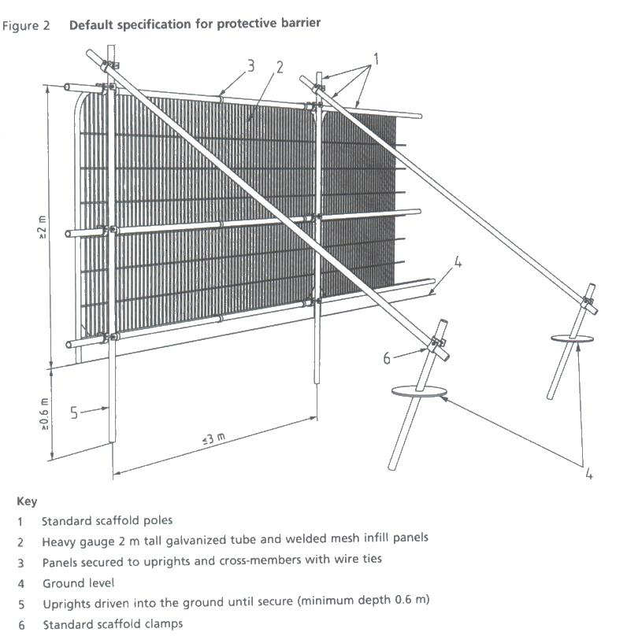

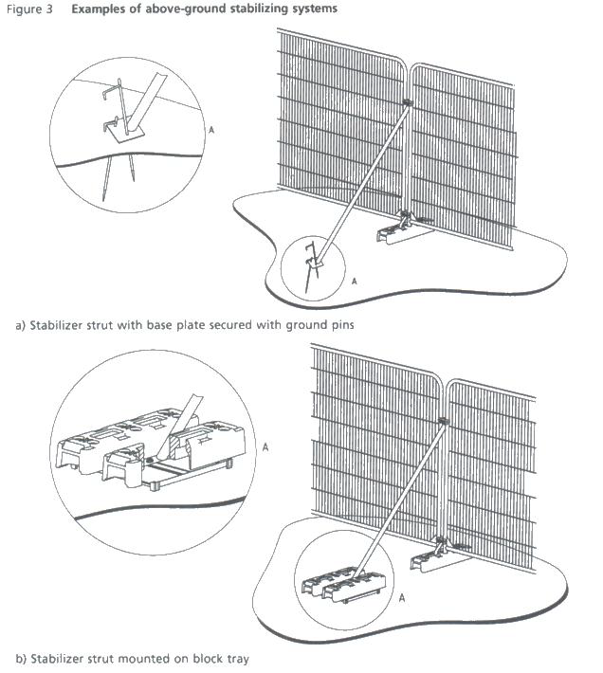

Site to be inspected by applicant or designated person before work commences person to ensure that the agreed protection measures are in place.

Development Stage
Daily visits by the applicant or designated person to ensure that the agreed protection measures are functional and correctly achieving their purpose.

Barriers should be fit for the purpose of excluding constructive activity, and appropriate to the degree and proximity of work taking place around the retained tree. Special attention should be paid to ensuring that barriers remain rigid and complete.

In order to prevent damage to any tree roots the surface will be removed as follows:
The excavation of material should ideally be carried out by hand, if not, in practical terms the bucket of the excavator must be used with the teeth horizontal, or a toothless bucket, so that any disturbance to the underlying soil is kept to a minimum. Where possible the excavation machinery should stand outside the RPA exclusion zone.

Digging should be done manually around any large surface roots. Rubble must not be stockpiled within the RPA’s and must be exported without crossing the RPA’s. Care should be taken to ensure that the excavator arm does not damage the crown of the tree. Subbase will only be removed to a depth to allow the installation of the new surfaces.

Any exposed tree roots will be covered in accordance with BS5837 7.2.2 and then roots smaller than 25mm will be pruned in accordance with BS5837 7.2.3, an arboriculturist will be informed if there are root clumps or roots larger than 25mm, and in turn the tree officer if necessary. In that case the roots will be covered to prevent desiccation, and the tree officer will be allowed to inspect the area.

Working within RPAs
All excavation will be carried out outside the areas protected by fencing, there will be no use of machinery within the protected areas.

Avoiding damage
Great care shall be exercised when working close to retained trees.

Plant and machinery with booms, jibs, counterweights or elevated loads shall be carefully controlled to prevent accidental contact with branches or stems.

The following restrictions shall apply throughout the development period:

No fires within 15 metres of retained trees;
No storage of concrete, oils, fuels or chemicals within RPAs;
No discharge of contaminated water within RPAs;
No raising or lowering of ground levels within protected areas;
No severance of major roots without arboricultural advice.

No access pruning is anticipated.

Accidental damage.
Where any accidental damage takes place the advice of a suitable competent arboriculturist will be sought. Measures will be taken to mitigate any harm caused and to negate future damage.

Post Development
Protective fencing shall remain in place until all heavy construction activity has ceased.

Upon completion of the works:

Temporary protection measures shall be carefully removed;
Any damaged ground shall be lightly cultivated and reinstated where necessary.

Any retained tree which dies, becomes seriously diseased or unstable within five years as a direct result of the development shall be replaced during the next planting season with a tree of similar size and species.

Conclusion
Subject to the implementation of the protective measures and construction methodologies detailed within this Arboricultural Method Statement, the proposed development can be undertaken without causing significant adverse impact to the long-term health or viability of the retained trees.
The proposal has been designed to:
- Utilise existing disturbed and previously developed areas where possible;
- Minimise incursions into RPAs;
- Retain the important landscape contribution of the existing lime and sycamore trees.
The retained trees are considered capable of tolerating the limited and carefully controlled construction activity proposed, subject to adherence with the protection measures contained within this Arboricultural Method Statement.

