

PLANNING, DESIGN, AND HERITAGE STATEMENT

For the construction of a two, timber built, stables and a tack room.
At North Lodge, Heytesbury Park, Heytesbury.
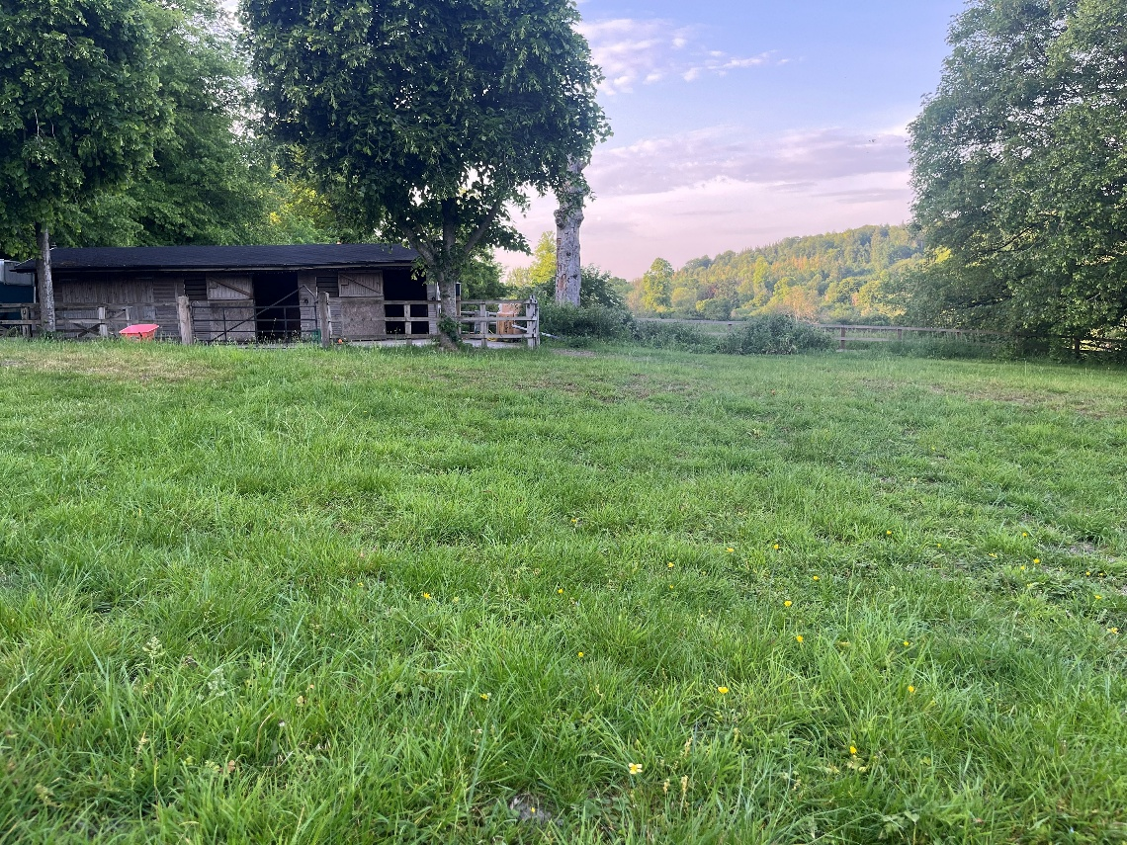
Prepared by:
Equestrian Blueprint
enquiries@equestrianblueprint.co.uk
https://equestrianblueprint.co.uk/

Contents
1. Introduction 3
2. Site Description 3
3. Proposed Development 4
4. Design and Layout 4
5. Landscape and Visual Impact 5
6. Trees and Arboricultural Considerations 5
7. Residential Amenity 6
8. Heritage Considerations 6
9. Ecology and Biodiversity 7
10. Access and Drainage 8
11. Manure disposal 8
12. Planning Policy Context 8
13. Conclusion 10

1. Introduction

This Planning, Design and Heritage Statement has been prepared in support of a planning application for the erection of a modest equestrian building at North Lodge, 19 Heytesbury Park, Heytesbury, Warminster, BA12 0HG.

The proposal comprises a traditional stable building containing two loose boxes and a tack room positioned adjacent to the existing, very similar, stable facilities within the holding.

The building is intended solely to support the private equestrian use of the property and wider landholding. No commercial equestrian activity, livery use, riding school operation or external training business is proposed.

2. Site Description

North Lodge comprises an established residential property with associated private equestrian facilities located within a rural setting on the eastern side of East Hill Road.

The application site occupies the north-western part of the holding where existing equestrian facilities are already present, including two stables, a tack room, a concrete yard and a permeable access track.

The proposed building would be located immediately east of the existing stable buildings and would therefore form a logical extension to an established stable group rather than an isolated development within open countryside.

The surrounding land is predominantly used for grazing and has an established equestrian character. The area immediately surrounding the proposed building comprises modified grassland maintained by regular grazing activity and consequently has a relatively domesticated appearance.

Additional grazing land is available to the west of East Hill Road, ensuring sufficient grazing provision remains available for horses associated with the holding.

The site is not prominently visible within the wider landscape and visibility from public viewpoints is limited due to the rural setting, topography, existing vegetation and relationship with existing equestrian buildings.

3. Proposed Development

The proposal seeks permission for the erection of a stable building comprising:

Two loose boxes;
One tack room;
Associated concrete base.

The building measures approximately 9.6 metres by 4.8 metres and adopts a traditional equestrian form with a simple dual-pitched roof and modest front overhang.

External materials have been selected to match the existing stable buildings on the site and comprise:

Timber shiplap wall cladding;
Felt shingle roof covering;
Traditional stable doors and detailing.

The proposal utilises the existing access arrangements serving the equestrian facilities and does not require any new access, parking provision or external lighting.

The building would support the ongoing private keeping of horses associated with the property.

4. Design and Layout

The design approach has been intentionally simple and reflects the established character of the existing equestrian buildings already present on the site.

The building has been positioned adjacent to the existing stable block in order to:

Consolidate existing equestrian development;
Minimise visual impacts;
Utilise established access arrangements;
Retain the open character of the wider grazing land;
Avoid impacts upon protected trees.

The proposal therefore represents a logical and well-considered extension to the existing stable facilities.

The scale of the building is modest and appropriate to its intended use. The ridge height remains low and the simple roof form ensures the structure remains visually recessive within its rural surroundings.

The use of matching materials further assists in integrating the development with the established stable group.

5. Landscape and Visual Impact

The proposal occupies a discreet position adjacent to existing equestrian buildings and would be viewed as part of an established stable group.

The site levels fall gradually across the application area and the proposed building sits comfortably within the existing topography. This assists in visually containing the development and reducing visibility from the wider landscape.

No trees, hedgerows or other landscape features would be removed as part of the development.

Whilst there is some limited intervisibility with neighbouring landholdings, the surrounding area already exhibits an established equestrian character including nearby stables and horse grazing.

The proposal is therefore considered to integrate appropriately within the landscape without causing unacceptable visual harm.

6. Trees and Arboricultural Considerations

The site lies within an Area Tree Preservation Order designation.

The proposal has been carefully positioned to avoid impacts upon protected trees and associated Root Protection Areas. The building footprint and associated concrete base are located outside identified RPAs and no protected trees or hedgerows would be removed as part of the development.

The proposal therefore preserves the character and appearance of the treed setting and avoids material arboricultural impacts.

7. Residential Amenity

The proposal represents a modest addition to an established private equestrian facility.

The nearest neighbouring property with potential visibility of the proposal lies approximately 80 metres south of the application site and already accommodates horses and stabling within its own landholding.

The proposal would not introduce an unfamiliar use into the locality and would not materially alter the established pattern of activity associated with the site.

No external lighting is proposed and no increase in vehicle movements would occur.

Given the separation distances involved, the established equestrian character of the area and the limited visibility of the building, the proposal is not considered to result in unacceptable impacts upon residential amenity.

8. Heritage Considerations

The site lies within the wider setting of several designated heritage assets associated with Heytesbury House, including:

Heytesbury House (Grade II*);
Stables at Heytesbury House (Grade II);
Coach House opposite the Stables at Heytesbury House (Grade II).

The application site itself does not contain listed buildings and North Lodge is not a listed building.

The proposed development has been designed as a modest and traditional equestrian structure visually associated with the existing stable buildings already present within the holding.

The proposal is limited in scale, adopts traditional materials and would be positioned within an existing area of equestrian activity rather than extending into undeveloped countryside.

Due to its modest scale, limited visibility and close association with existing stable buildings, the proposal would preserve the setting and significance of nearby heritage assets and would not result in harm to their significance.

The proposal therefore accords with the heritage objectives of the National Planning Policy Framework.

9. Ecology and Biodiversity

The proposal affects a limited area of modified grassland associated with the existing equestrian use of the site.

No trees, hedgerows, ponds or other notable habitat features would be removed or affected by the development.

No additional external lighting is proposed.

The proposal therefore results in very limited ecological impact and preserves the existing character of the site.

Given the limited scale of the proposal and the small area of modified grassland affected, the development gives rise to only limited biodiversity impacts. Any Biodiversity Net Gain requirements associated with the proposal would be satisfied through the provision of off-site biodiversity units and the application is therefore capable of achieving compliance with the statutory Biodiversity Net Gain requirements.

10. Access and Drainage

The proposal would utilise the existing established access arrangements already serving the equestrian facilities.

No changes to the access, parking or turning arrangements are proposed.

The development would not generate foul drainage.

Surface water runoff generated by the roof area would be disposed of within the site using a soakaway.

11. Manure disposal

Manure arising from the private equestrian use of the site is currently stored within an existing manure clamp located within the holding and collected periodically by a local contractor. This arrangement is well established and would continue as part of the proposed development.

The proposal would not materially alter the existing manure management arrangements associated with the site and the modest scale of the proposal is not considered likely to give rise to unacceptable environmental or residential amenity impacts

12. Planning Policy Context

Section 38(6) of the Planning and Compulsory Purchase Act 2004 requires planning applications to be determined in accordance with the Development Plan unless material considerations indicate otherwise.

The proposal has been assessed against the relevant policies of the Wiltshire Core Strategy together with the National Planning Policy Framework (NPPF).

The proposal is considered to accord with the overarching objectives of the NPPF which seek to support sustainable rural development whilst protecting the character of the countryside and the significance of heritage assets.

In particular, the proposal accords with:

Core Policy 51 – Landscape

Core Policy 51 seeks to protect, conserve and where possible enhance landscape character.

The proposal represents a modest extension to an existing stable grouping and would remain visually associated with established equestrian development already present on the site. The building adopts a traditional rural appearance, utilises appropriate materials and occupies a visually discreet position within the holding.

The proposal would not result in the loss of trees, hedgerows or important landscape features and would preserve the character of the surrounding rural landscape.

Core Policy 57 – Ensuring High Quality Design and Place Shaping

Core Policy 57 requires development to respond positively to local character and achieve appropriate standards of design.

The proposal adopts a simple and traditional equestrian design utilising timber shiplap cladding and felt shingle roofing to match the existing stable buildings already present on the site.

The scale, layout and appearance of the proposal are appropriate to the rural setting and the development has been carefully positioned to minimise visual impact and avoid impacts upon protected trees.

The proposal therefore represents a high quality and contextually appropriate form of development.

Core Policy 58 – Ensuring the Conservation of the Historic Environment

Core Policy 58 seeks to protect and conserve Wiltshire’s historic environment and heritage assets.

The proposal is modest in scale and positioned adjacent to existing stable buildings within an already established equestrian part of the holding. Due to the limited visibility of the development, its traditional rural appearance and its close association with existing equestrian structures, the proposal preserves the setting and significance of nearby listed buildings associated with Heytesbury House.

National Planning Policy Framework

The proposal is also consistent with the objectives of the National Planning Policy Framework, including:

Achieving well-designed places;
Supporting sustainable rural development;
Conserving and enhancing the natural environment;
Conserving and enhancing the historic environment.

Overall, the proposal represents an appropriate and proportionate form of development which responds positively to the site and surrounding rural context.

13. Conclusion

The proposal represents a modest and appropriate addition to an established private equestrian holding.

The development:

Supports an existing private equestrian use;
Consolidates development alongside existing stables;
Utilises existing access arrangements;
Avoids impacts upon protected trees;
Preserves neighbouring amenity;
Preserves the setting of nearby heritage assets;
Results in limited ecological impact;
Integrates successfully into the rural landscape.

The proposal therefore represents sustainable development for which planning permission should be granted

