54 Montgomery Gardens
View of trees from garden
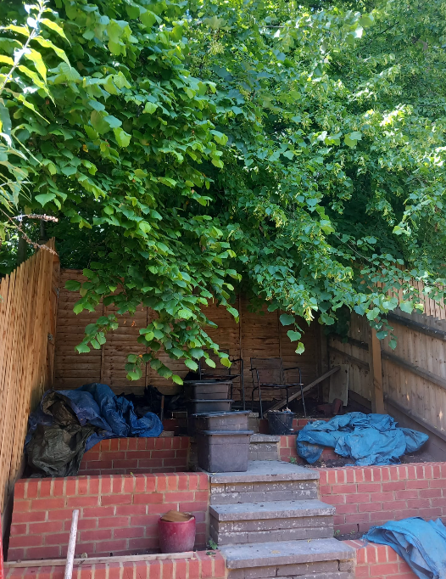

View from shelter belt side of fence
