APPLICATION FOR PRIOR NOTIFICATION – PART 3 CLASS Q CASE OFFICER REPORT

APPLICATION REFERENCE: | PL/2026/01941
APPLICATION TYPE: | Prior approval Part 3 Class Q: Agricultural buildings to dwellinghouses
SITE ADDRESS: | Barns at Middle Croft Farm, A360 / Maddington Street, Shrewton, SP3 4LA
DEVELOPMENT DESCRIPTION: | Demolition of Existing Dutch Barn and Change of Use of Existing Agricultural Building to Residential (Use Class C3) to form one single dwelling with rear extension of 4m.
RECOMMENDATION: | That Prior Approval is required and REFUSED

SITE DESCRIPTION/CONTEXT

The application site is located outside of and to the north east of the defined settlement boundary of the large village of Shrewton (settlement boundary defined by the thick black line on the map extract below) as defined by Wiltshire Core Strategy (WCS) policies CP1 (Settlement Strategy), CP2 (Delivery Strategy) and CP4 (Amesbury Community Area) and is therefore in policy terms considered to be in the open countryside.

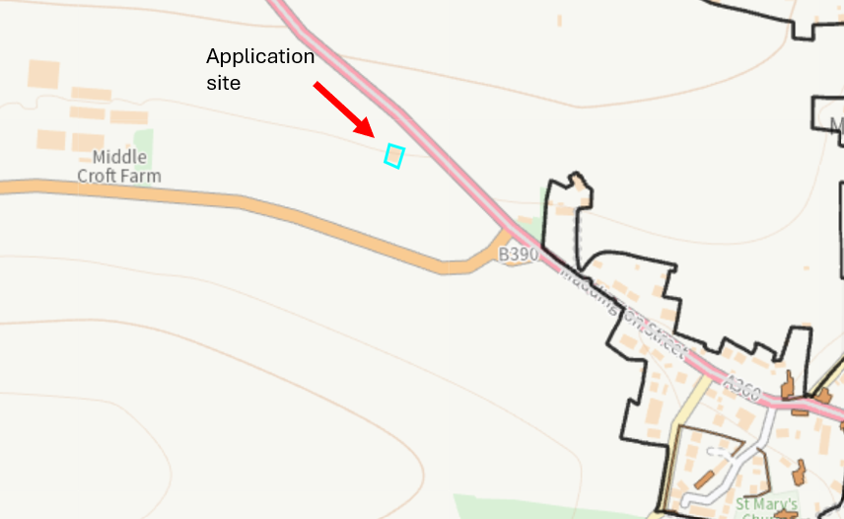

The site is located within a large agricultural field adjacent to and accessed via an existing vehicular access direct from the A360 (case officer photo).

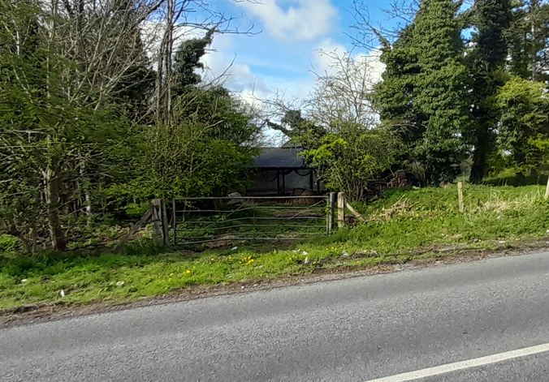
Further access (further to the south than the above access) is via an existing gateway just north of the junction of the B390 Chitterne Road with the A360 (Google maps image below).

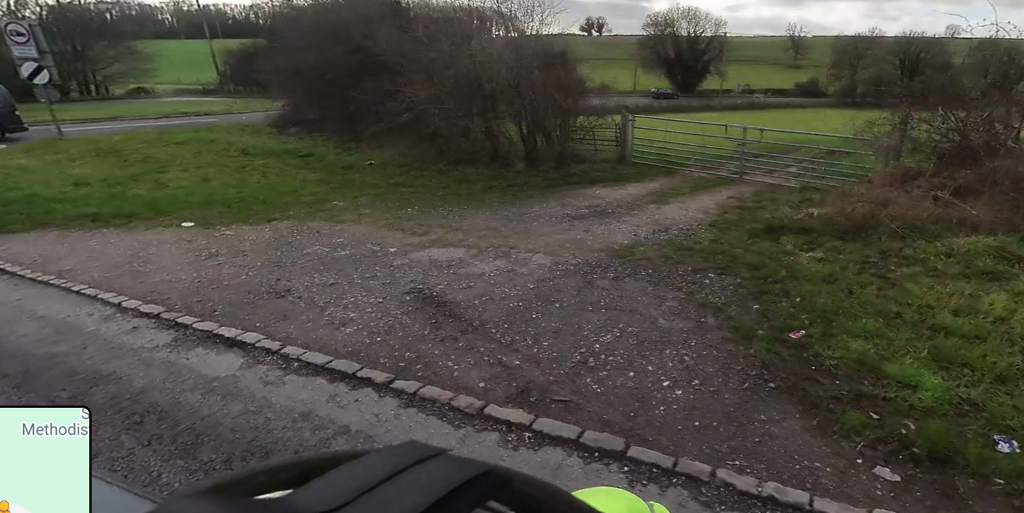

The site subject to this application is part of the wider pig farming enterprise associated with Middle Croft Farm, the main cluster of agricultural buildings located along the B390 Chitterne Road to the south west of the application site surrounded by associated agricultural fields.

The site is not located within a Conservation Area, is not listed or adjacent to any listed buildings; the site is located within the Special Landscape Area as defined by saved Salisbury District Local Plan (SDLP) policy C6. The site comprises a number of trees but none of the trees on the site are protected by virtue of a Tree Preservation Order (TPO).

There are no public rights of way across the site, the nearest rights of way are footpaths located to the east (SHREW24 and SHREW16) as marked with a purple line on the maps extract below.

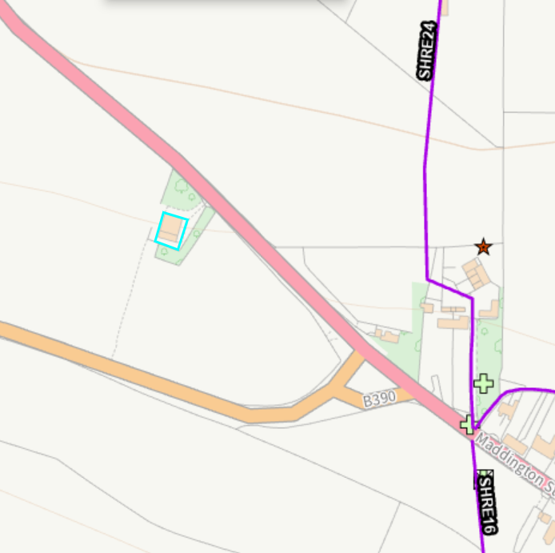

The site is located within Flood Zone 1, is not at risk of surface water flooding and at low risk of Groundwater flooding (Groundwater levels are between 0.5m and 5m below the ground surface. There is a risk of flooding to subsurface assets, but surface manifestation of groundwater is unlikely) but is some distance from the river, the site is also situated within the catchment of the River Avon Special Area for Conservation (SAC). The site is also located within the 6.4 kilometre recreational buffer of the Salisbury Plain SPA.

The agricultural buildings subject to this Class Q application for conversion to residential relate to a single storey, four bay mono-pitched, blockwork building and adjacent Dutch Barn, the two buildings can be seen in the case officer’s photos included below.
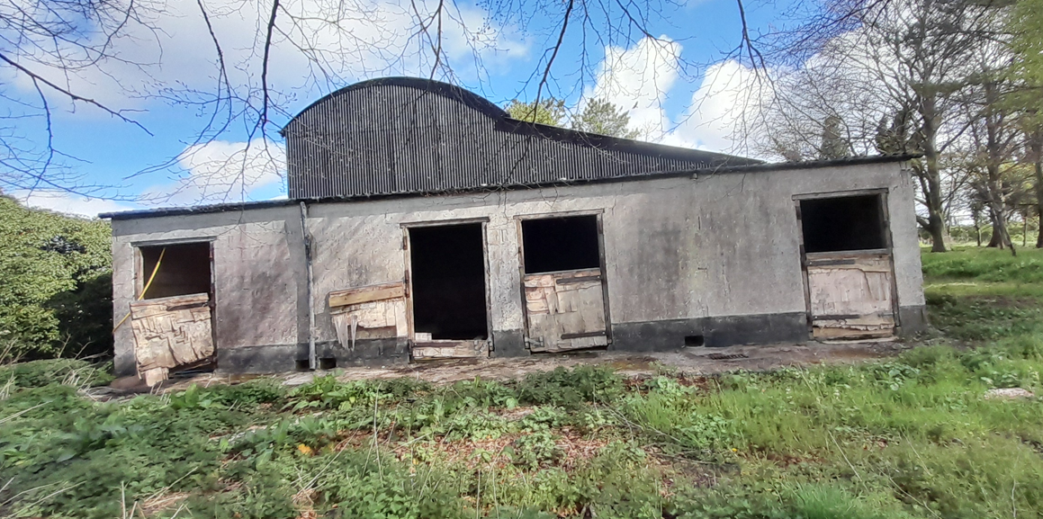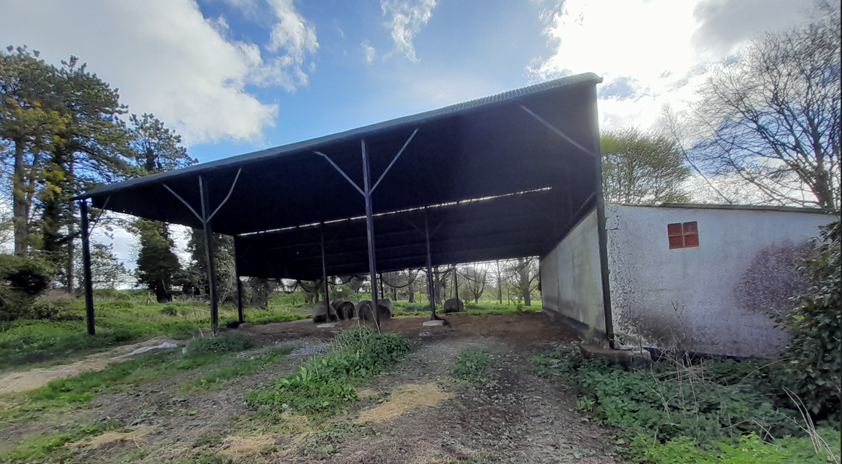

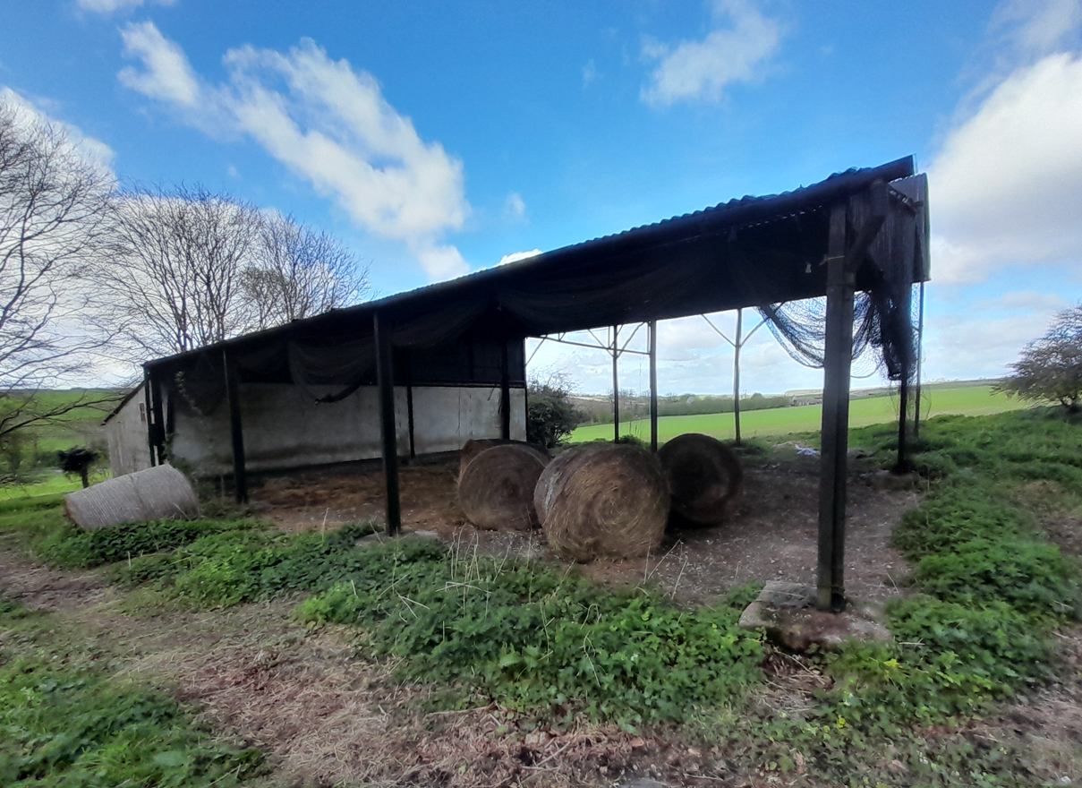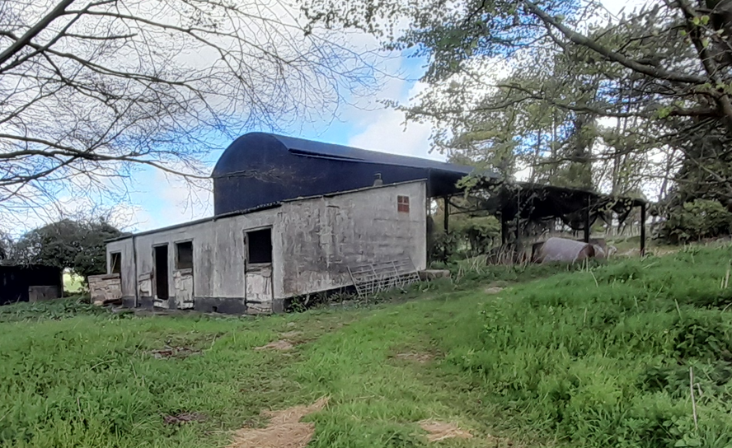

Internal photos
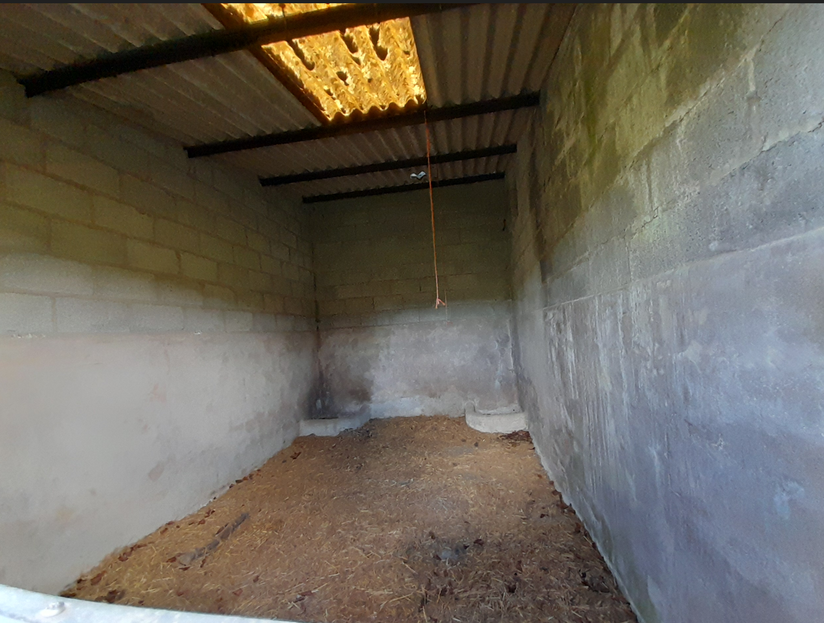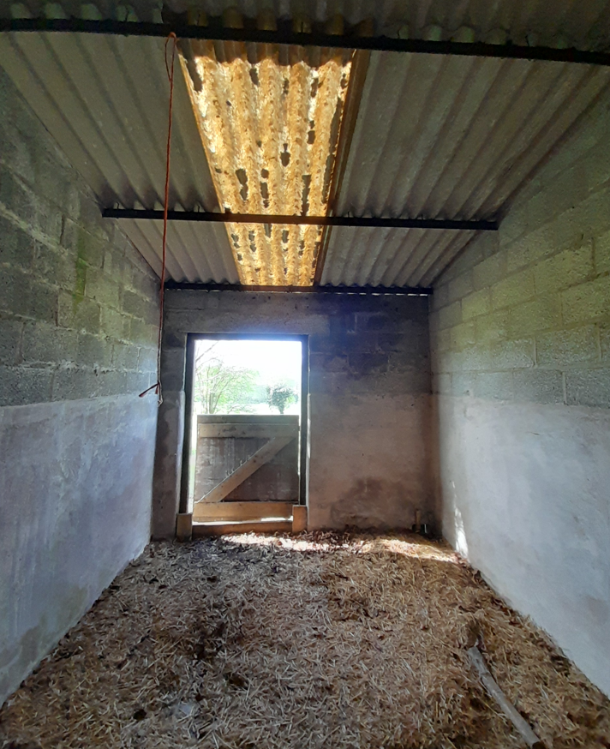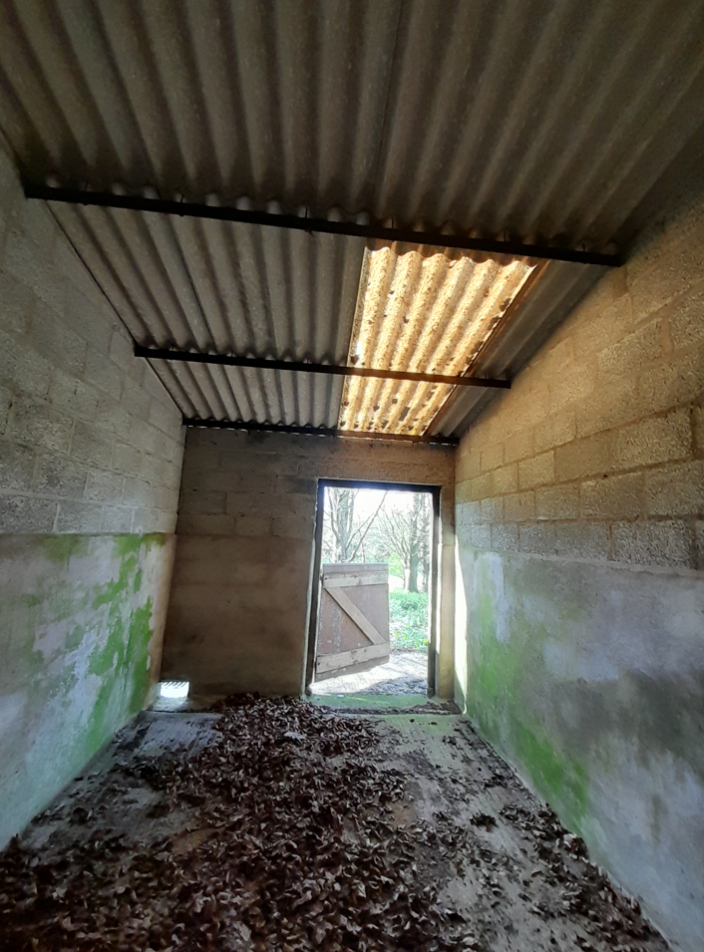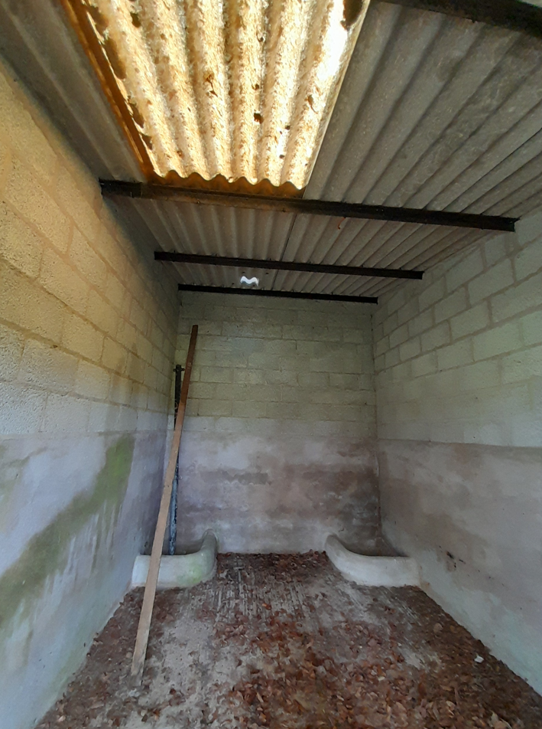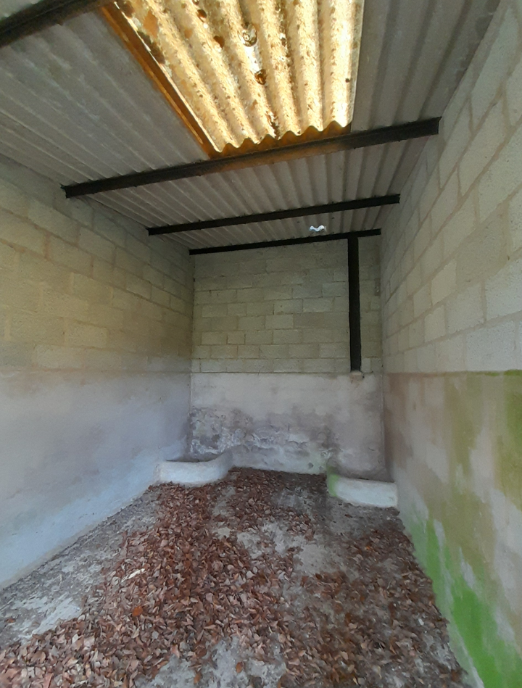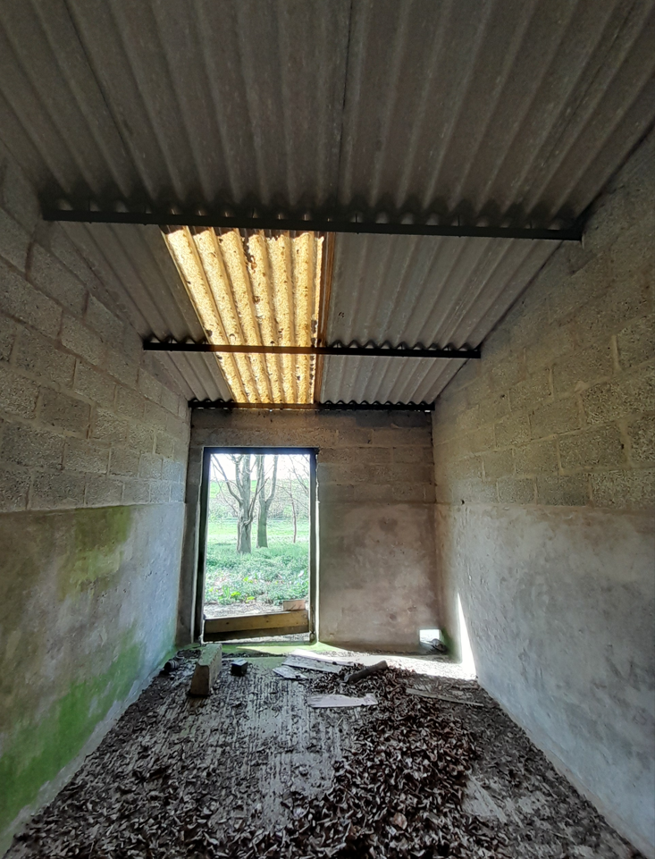

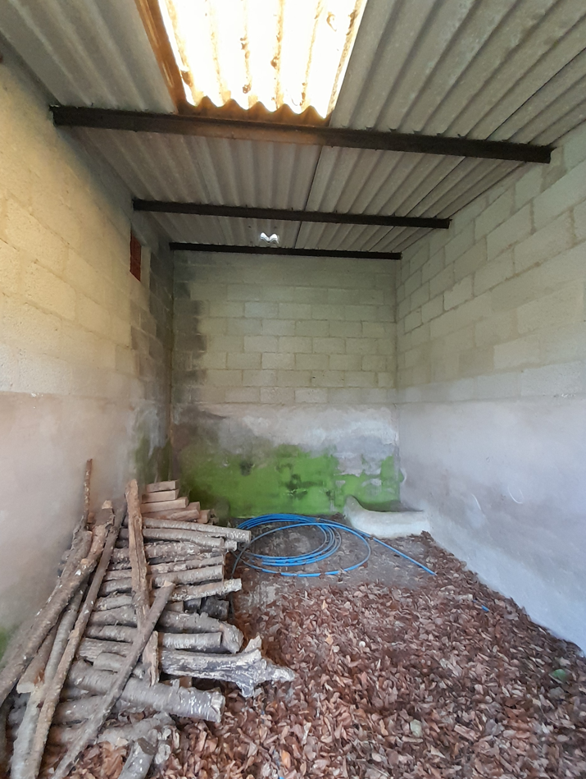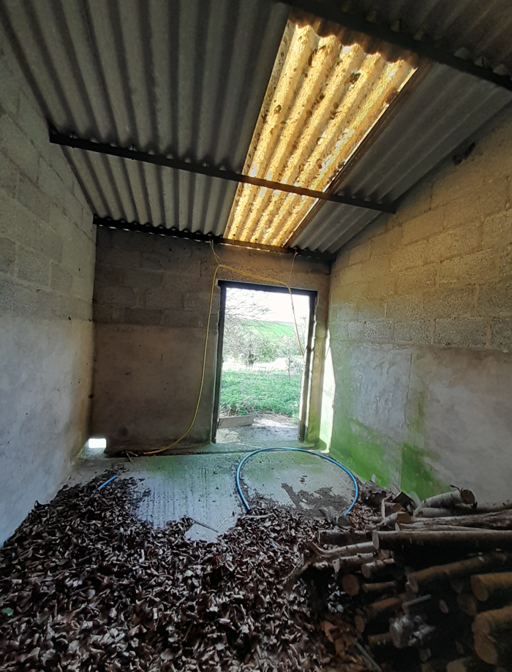
PROPOSAL

The application is notification for Prior Approval seeking to demonstrate that the proposal complies with all criteria within Schedule 2, Part 3, Class Q of the General Permitted Development Order 2015 (as amended) to allow prior approval to be granted for the demolition of the existing Dutch barn, change of use of the existing single storey four bay building to a C3 residential dwelling and the erection of a single storey 4m deep rear extension.

Existing floor plan
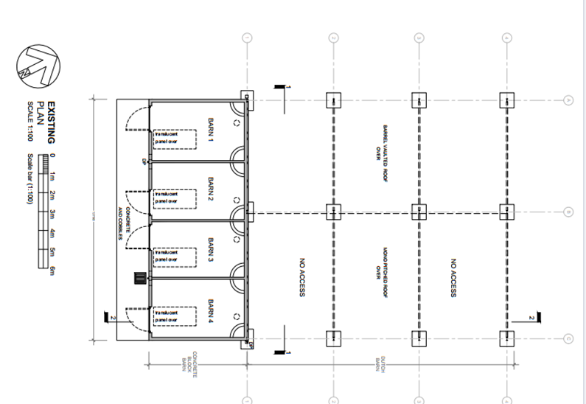
Proposed floor plan
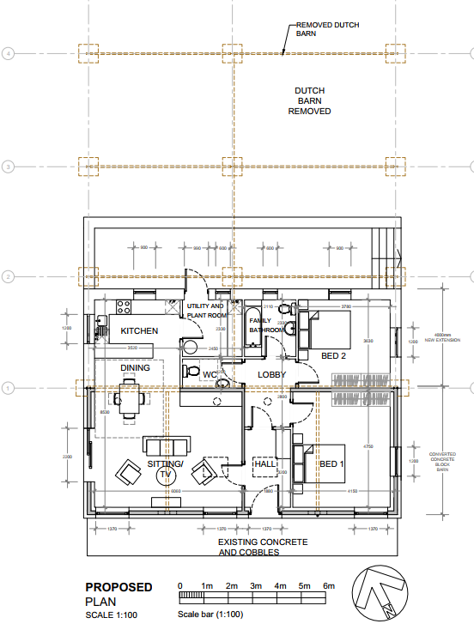
Existing elevations
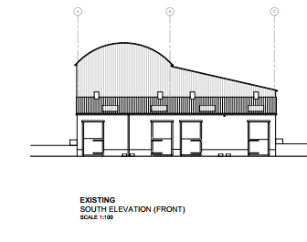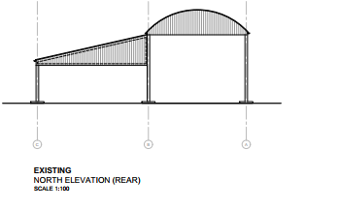
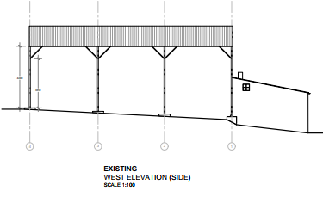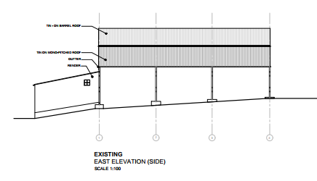

Proposed elevations
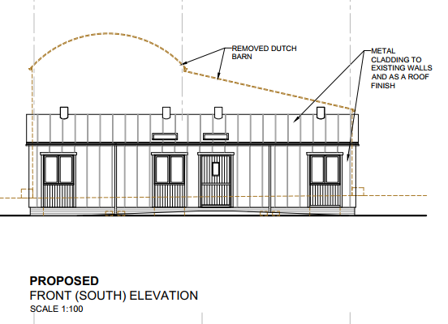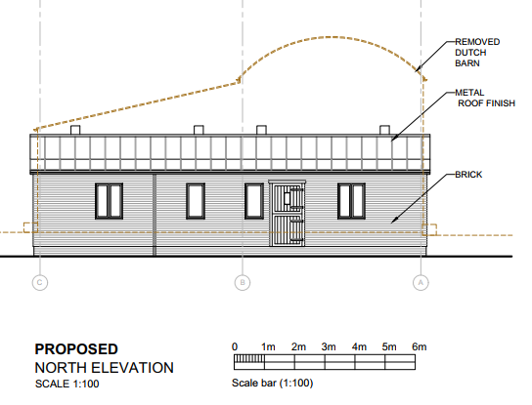

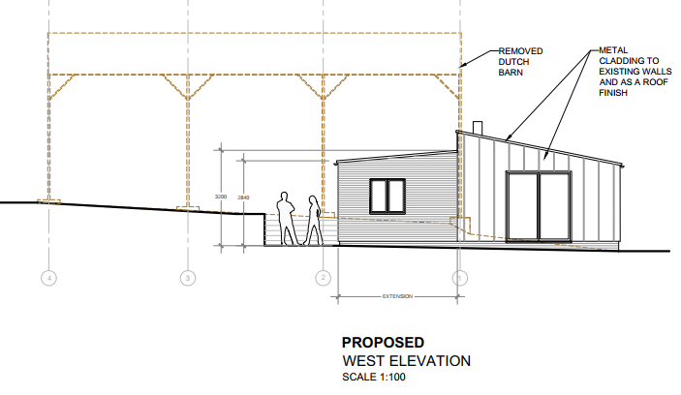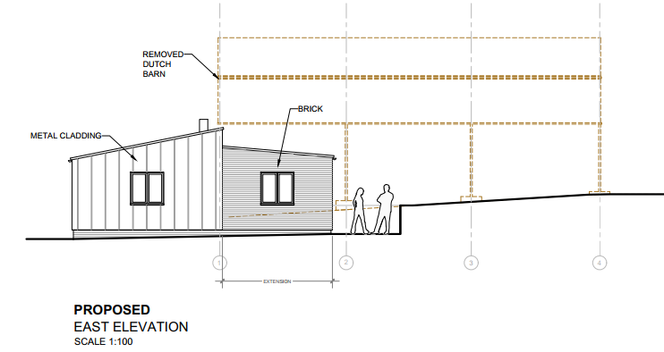

ISSUES

Whether the proposal constitutes Permitted Development under Class Q.
Whether the Prior Approval of the Local Planning Authority is required.

RELEVANT LEGISLATION, POLICY AND GUIDANCE

This application is assessed under Article 3 of the Town and Country Planning (General Permitted Development) (England) Order 2015 (as amended), which grants planning permission for certain types of development described in Schedule 2 of the Order. The grant of permission is subject to the limitations, conditions, and provisions set out within the relevant Classes of permitted development.

Under Schedule 2, Part 3, Class Q of the Town and Country Planning (General Permitted Development) (England) Order 2015 (as amended), certain changes of use and associated operations may be permitted subject to prior approval from the Local Planning Authority.

Conservation of Habitats and Species Regulations 2017 (as amended)

RELEVANT PLANNING HISTORY

None directly relevant to the buildings subject to this prior approval application.

There is however planning history for the wider farm –

14/03726/FUL - Erection of agricultural building for use as sow house. Approved
14/03727/FUL - Erection of pig finishing house. Approved
S/2011/1181 - Extension of existing barn to create new straw barn. Approved
S/2009/1026 - Demolition of 2 pig units. Erection of a 720-place pig finishing house. Alteration to ground slope and re-positioning of existing native species hedge. Approved
S/2001/0233 - Extension to bungalow to provide self-contained annex for disabled person.
S/1995/0886 - Construction of Livestock Building. Approved

CONSULTATIONS

Parish Council: No comment

Wiltshire Council Highways Officer: No objection subject to condition

The site is located outside of the built up area of the village of Shrewton, remote from the community services that occupiers of the dwelling would need. The site is served by the A360 and is within a 50mph speed limit and unlit. There is no safe pedestrian access to the village amenities from the site with there being no footway along the A360. The proposal would therefore usually attract an adverse highway recommendation on sustainability grounds, however, I am aware that this proposal is to be determined under the ‘Prior Notification’ procedure and I am not certain whether sustainability is a valid reason for refusal, I shall be guided by you on this matter.
Adequate visibility has been shown as being able to be provided. Sufficient parking provision along with turning is demonstrated on the submitted plans.
Therefore, should you be minded to support the development, I raise no highway objection subject to conditions.

No part of the development shall be occupied, until the visibility splays shown on the approved plans have been provided with no obstruction to visibility at or above a height of 900mm above the nearside carriageway level. The visibility splays shall always be maintained free of obstruction thereafter.
Reason: In the interests of highway safety.
The development hereby permitted shall not be occupied until the first 5m of the access, measured from the edge of the carriageway, has been consolidated and surfaced (not loose stone or gravel).

The access shall be maintained as such thereafter.
REASON: In the interests of highway safety.
The proposed development shall not be occupied until means/works have been implemented to avoid surface water from entering the highway.
REASON: To ensure that the highway is not inundated with surface water.
Any gates shall be set back 4.5m from the edge of the carriageway, such gates to open inwards only.
REASON: In the interests of highway safety.
No part of the development hereby permitted shall be occupied until the access, turning area & parking spaces [2] have been completed in accordance with the details shown on the approved plans. The areas shall always be maintained for those purposes thereafter and maintained free from the storage of materials.
REASON: In the interests of highway safety.
Informative
The application may involve an alteration to the existing vehicle access/dropped kerb. The consent hereby granted shall not be construed as authority to carry out works on the highway. The applicant is advised that a licence will be required from Wiltshire’s Highway Authority before any works are carried out on any footway, footpath, carriageway, verge or other land forming part of the highway. Please contact our Vehicle Crossing Team on vehicleaccess@wiltshire.gov.uk and/or 01225 713352 or visit their website at http://wiltshire.gov.uk/highways-streets to make an application.

Wiltshire Council Public Protection Officer: Objection

First comment received 27/04/2026

I have reviewed the submitted Supporting Statement – Application for Class Q Prior Approval for the change of use of an agricultural building to form a single dwelling, including the demolition of the existing Dutch barn and the construction of a rear extension.
The Supporting Statement asserts that “there are no harmful or objectionable activities taking place nearby to make the location undesirable” and concludes that the proposed dwelling would not suffer from adverse amenity impacts. However, no assessment or commentary has been provided in respect of the proximity of the proposed dwelling to adjoining land used for pig keeping, nor the potential impacts associated with that activity.
The keeping of pigs can give rise to significant odour, fly nuisance, and noise, which are inherent and lawful aspects of agricultural use. Given the immediate relationship between the proposed dwelling and the adjacent pig fields, there is a clear potential for future occupiers to experience adverse living conditions as a result of odour and pest impacts, particularly during warmer months and periods of intensive agricultural activity.
The Supporting Statement contains no information, assessment or mitigation proposals regarding:
• Potential odour impacts from pig keeping;
• Fly nuisance or other pest-related effects;
• The implications of introducing a noise and odour sensitive receptor in such close proximity to an established livestock use; or
• The risk of future land use conflict arising from complaints from residential occupiers.
In the context of the prior approval considerations under Class Q, insufficient information has been submitted to demonstrate that the location of the proposed dwelling would provide an acceptable standard of amenity for future occupants, or that it would not result in conflict with neighbouring agricultural activities.
On this basis, it is considered that the application fails to adequately address the impacts arising from nearby livestock operations, and further information would be required to demonstrate that the proposal is acceptable in amenity terms.

The applicant submitted further details in response to the above Public Protection comments and Public Protection were re-consulted, the following objections were made 05/06/2026.

Having reviewed the applicant’s supporting statement regarding the proximity of pig farming activities to the proposed residential conversion, Environmental Health Officers remain concerned about the potential impact on residential amenity.
While it is acknowledged that the nearest field is currently out of rotation for pig keeping, it is understood that this is part of a cyclical arrangement and is likely to be used again within approximately four years, potentially accommodating pigs for a period of up to two years. This field lies in very close proximity to the proposed dwelling.
Although the activity may not meet the threshold for intensive pig farming, it is nevertheless likely to give rise to impacts including odour, flies and other pests (potentially including rodents), and dust during dry periods. These impacts are inherent to the permitted agricultural use of the land.
The prevailing wind direction in this locality is from the south-west. As such, when pigs are present in the adjacent field, odour and dust emissions would be expected to be carried towards the proposed dwelling for a significant proportion of the time. Odours from the field currently in use would similarly be directed towards the barn. While these impacts may be less pronounced than those associated with intensive pig units, they are nonetheless likely to be noticeable and persistent. Experiencing such impacts within and around a dwelling on a regular basis would, in our view, constitute a significant adverse effect on residential amenity.
In addition, the farm benefits from Environment Agency permissions to burn bedding from pig huts when cleared. Although this activity is periodic, it is foreseeable that smoke arising from such burning, whether from currently utilised fields or those brought back into rotation, could result in amenity impacts and has the potential to give rise to statutory nuisance complaints.
It is recognised that there are existing dwellings in proximity to the pig-rearing land. However, these are long-established properties where occupants are likely to have accepted the agricultural impacts. Furthermore, f these dwellings are situated more favourably in relation to prevailing wind direction and are therefore less likely to experience the same level of impact.
While the long-term future of pig farming at this location may be uncertain, the assessment must be based on the lawful use of the land as it currently stands. There is also concern that prospective purchasers may not fully appreciate the cyclical nature of pig farming at the site. In particular, during periods when the adjacent field is not in use, the potential for its reintroduction, and the associated impacts, may not be readily apparent.
For these reasons, Environmental Health Officers maintain an objection to the proposal on the grounds of likely adverse impact on the amenity of future occupants.

REPRESENTATIONS

No third party representations have been received.

ASSESSMENT OF THE PROPOSAL

Class Q contains three principal provisions – Q(a), Q(b) and Q(c), as follows:

Permitted development

Q. Development consisting of—

(a)a change of use of—
(i)a building that is part of an established agricultural unit and any land within that building’s curtilage, or
(ii)a former agricultural building that was (but is no longer) part of an established agricultural unit and any land within that building’s curtilage, to a use falling within Class C3 (dwellinghouses) of Schedule 1 to the Use Classes Order,

(b)development referred to in sub-paragraph (a) together with the extension of the building referred to in sub-paragraph (a), or

(c)development referred to in sub-paragraph (a) together with building operations reasonably necessary to convert the building referred to in sub-paragraph (a) to a use falling within Class C3 (dwellinghouses) of that Schedule or to extend that building.

The application confirms that the building subject of this application was last lawfully used in connection with agricultural purposes/operations on the specified date

Under Class Q of Part 3 of the 2015 Order, it must be demonstrated that the building(s) was used solely for agriculture, as part of an established agricultural unit on 24th July 2023. The applicant states “The barn is part of an established agricultural unit and has solely been used for agricultural purposes since 24 July 2023. The Council have no evidence to the contrary to suggest that the building(s) was not used solely for agricultural purposes as part of an established agricultural unit on 24th July 2023. It is therefore considered that the building adheres to criterion (a) (i).

The proposals subject to this current application relate to a building that is a building that is part of an established agricultural unit, so Q (a) (i) is applicable to the determination of the proposal.

The proposals subject to this current application are also proposing to erect a 4m deep rear extension and are proposing building operations necessary to convert the building, therefore Q (b) and Q (c) are also applicable to the determination of the proposal.

Development not permitted

Q1. Development is not permitted by Class Q if—

(a)in the case of a site that is part of an established agricultural unit, the site was not part of the established agricultural unit—

(i)on 24th July 2023, or
(ii)where the site became part of the established agricultural unit after 24th July 2023, for a period of at least 10 years before the date development under Class Q begins,

(b)in the case of a site that was (but is no longer) part of an established agricultural unit—

(i)the site was part of an established agricultural unit on 24th July 2023,
(ii)where the site ceased to be part of an established agricultural unit after 24th July 2023, the site has not been part of the established agricultural unit for a period of at least 10 years before the date development under Class Q begins, or
(iii)since ceasing to be part of an established agricultural unit, the site has been used for any non-agricultural purpose,

It has been ascertained that the site was in use as part of an established unit on 24 July 2023 and therefore complies with this criterion.

(c)the floor space of any dwellinghouse developed under Class Q having a use falling within Class C3 (dwellinghouses) of Schedule 1 to the Use Classes Order exceeds 150 square metres,

The proposed dwellinghouse will not exceed 150 square metres. The dwellinghouse will have a floor space of 99.7 square metres. The criterion requirements have therefore been met.

(d)the development under Class Q, together with any previous development under Class Q, within the original limits of an established agricultural unit (see paragraph Q.3(2) of this Part) would result in—

(i)the cumulative number of separate dwellinghouses having a use falling within Class C3 (dwellinghouses) of Schedule 1 to the Use Classes Order exceeding 10, or
(ii)the cumulative floor space of dwellinghouses having a use falling within Class C3 (dwellinghouses) of Schedule 1 to the Use Classes Order exceeding 1,000 square metres.

There has been no previous application submitted under Class Q, the proposals therefore comply with this criterion.

(e)the site is occupied under an agricultural tenancy, unless the express consent of both the landlord and the tenant has been obtained

The application has confirmed that the site is not occupied by a tenancy and that the Applicant is the freeholder. Therefore, the proposals comply with this criterion.

(f)less than 1 year before the date development begins—

(i)an agricultural tenancy over the site has been terminated, and
(ii)the termination was for the purpose of carrying out development under Class Q,
unless both the landlord and the tenant have agreed in writing that the site is no longer required for agricultural use,

The application has confirmed that the site is not occupied by a tenancy and that the Applicant is the freeholder. Therefore, the proposals comply with this criterion.

(g)development under Class A(a) or Class B(a) of Part 6 of this Schedule (agricultural buildings and operations) has been carried out on the established agricultural unit during the period which is 10 years before the date development under Class Q begins.

There has been no development under Class A (a) or Class B (b) on the established agricultural unit during the period which is 10 years before the date development under Class Q begins. Therefore, the proposals comply with this criterion.

(h)the development would result in the external dimensions of the building extending beyond the external dimensions of the existing building at any given point, other than—

(i)extension of the building allowed by paragraph Q.1(i);
(ii)protrusions of up to 0.2 metres to accommodate building operations allowed by paragraph Q.1(j)(i)

The proposal includes extension within these parameters allowed by paragraph Q.1(i).

There will be no protrusions of more than 0.2m. Therefore, the proposals comply with this criterion.

(i)the development under Class Q(b) would result in an extension that—

(i)has more than one storey,
(ii)is sited anywhere other than to the rear of the existing building,
(iii)extends beyond the rear wall of the existing building by more than 4 metres,
(iv)has eaves the height of which exceed the height of the eaves of the existing building,
(v)is higher than whichever is the lower of—
(aa)the highest part of the roof of the existing building, or
(bb)a height of 4 metres above the ground,
(vi)extends beyond a wall that forms a side or principal elevation of the existing building, or
(vii)would be sited on land that, before the development under Class Q(b), is not covered by a hard surface that was provided on the land by virtue of any development, and—
(aa)the hard surface was not provided on the land on or before 24th July 2023, or
(bb)where the hard surface was provided on the land after 24th July 2023, the hard surface has not been situated on the land for a period of at least 10 years before the date development under Class Q(b) begins,

The application submission confirms that
- The extension is single storey
- The existing south elevation is the principal elevation. This elevation faces onto a concrete yard area and includes the barn doors that access the building. The existing Dutch barn that is located to the rear of the building proposed for conversion, enclosing the north-facing elevation, is proposed to be demolished. The extension will be sited to the rear of the barn in its place.
- The extension is no more than 4m beyond the rear wall of the barn.
- The eaves height is lower than the eaves of the existing barn.
- The highest part of the extension roof sits below the existing barn.
- The extension extends to the rear of the barn. It will replace the existing Dutch barn, which will be demolished.
- The floor of the Dutch barn is comprised of a hard surface. This is where the extension will be sited.
- The hard surfaces on the site were in place before 24th July 2023.

Therefore, the requirements of this criterion have been met.

(j)the development under Class Q(c) would consist of building operations other than—
(i)the installation or replacement of—
(aa)windows, doors, roofs, or exterior walls, or
(bb)water, drainage, electricity, gas or other services,
to the extent reasonably necessary for the building to function as a dwellinghouse, and
(ii)partial demolition to the extent reasonably necessary to carry out building operations allowed by paragraph Q.1(j)(i),

The application submission has confirmed that

- The proposal will install new windows and doors and that the existing walls will be retained with metal cladding provided to the front elevation. A brick finish is proposed around the existing walls on the east, west and north elevations
- All necessary services are reasonable and easily introduced.
- Demolition of the attached Dutch barn is proposed to enable the proposed development.

Therefore, the requirements of this criterion have been met.

(k)the site is on article 2(3) land,

The site is not on article 2(3) land. This criterion is therefore met.

(l)the site is, or forms part of—
(i)a site of special scientific interest;
(ii)a safety hazard area;
(iii)a military explosives storage area,

The site is not in any of these areas. This criterion is therefore met.

(m)the site is, or contains, a scheduled monument,

The site is not and does not contain a schedule monument. This criterion is therefore met.

(n)the building is a listed building,

The building which is proposed for conversion is not listed. Therefore, this criterion is met.

(o)the existing building, excluding any proposed extension under Class Q(b) but including any proposed building operations under Class Q(c), would not be capable of complying with the nationally described space standard issued by the Department for Communities and Local Government on 27th March 2015 as read with the notes dated 19th May 2016 which apply to it, or

It is considered that the conversion (with the erection of the 4 metres deep rear extension) to create a single storey two bedroom dwellinghouse complies with nationally described space standards – see submitted areas provided with the application submission included below, and therefore, this criterion requirement is met.

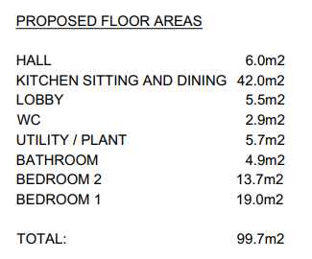
(p)the building does not have suitable existing access to a public highway.

The existing agricultural buildings and land are served by an existing established but apparently little used (based on Google maps images) access off the A360 road to the north east. The Council’s Highways Officer has assessed this proposal and has no objection to the conversion of the building from a highway safety perspective subject to a number of conditions which relate to visibility splays, surface water drainage, consolidated surface, siting of gates and completion of parking/turning before occupation of the new dwelling. Whilst the Highway Officers suggested conditions are noted, these requirements do not form part of the Class Q process and are not things that can be requested due to the way the legislation is set out. In addition, the red line does not include the access, but this is within the blue outlined land and withing the ownership of the applicant.

Therefore, with the access being established and existing, this criterion requirement is met.

Can the building be “converted”?

Building operations are permitted under Class Q including the replacement or installation of exterior walls, roofs, doors and windows, but recent appeal decisions states that it is not the intention of the permitted development right to allow rebuilding work which would go beyond what is reasonably necessary for the conversion of the building to residential use. It is only where the existing building is already suitable for conversion that it would be considered to have the permitted development right.

The National Planning Policy Guidance provides some further explanation as to what the Government perceives as permitted building works able to be carried out as part of this permitted development route. Recent case law and appeals are also referenced in the section below. The NPPG comments the “The permitted development right under Class Q assumes that the agricultural building is capable of functioning as a dwelling”. To establish if indeed the agricultural building, is capable of functioning as a dwelling, the application is accompanied by a set of proposed drawings that include elevations, floor, and roof plans.

Once the existing Dutch barn has been removed, the remaining existing building to be converted is a single storey structure measuring approximately 13 metres along the north and south elevations and approximately 5.25 metres along the east and west elevations.

The existing barn is a concrete block work structure set upon a concrete base; cement render provides the external finish. The building comprises a shallow mono pitch roof with what appears to be corrugated fibre cement roof sheets. The existing concrete block work building includes four doors along the south elevation, no openings in the north elevation and a small high level opening on both the east and west elevations with ventilation slats covering the openings.

The application is also accompanied by a current structural condition report undertaken by W P Drewett MRICS Chartered Building Surveyor on 19th March 2026 that confirms that the building is sound and stable and capable of conversion and states -

2.5 The existing structural elements of the building to the converted has been surveyed and is considered to be in good condition and suitable to be utilised for the conversion of the building for residential use.

Therefore, as per the details within the application submission it appears that the existing concrete blockwork building is structurally capable of conversion.

Para Q(j) makes provision for building operations reasonably necessary to CONVERT the building.

(j)the development under Class Q(c) would consist of building operations other than—
(i)the installation or replacement of—
(aa)windows, doors, roofs, or exterior walls, or
(bb)water, drainage, electricity, gas or other services,
to the extent reasonably necessary for the building to function as a dwellinghouse, and
(ii)partial demolition to the extent reasonably necessary to carry out building operations allowed by paragraph Q.1(j)(i),

The proposed works aim to retain the existing concrete block work frame and roof frame; the following text is taken from the Building Survey Report and Structural Analysis which has been submitted to support the application.

3.1 The proposed drawings indicate the roof being reclad with metal cladding upon the existing structure. This can be achieved by applying plywood sheeting upon the existing purlins, followed by membrane and metal sheeting. Insulation can be applied on the underside, secured to a false, non-structural ceiling.
3.2 The existing concrete block walls are to be clad with metal sheeting. This is reasonable and practically carried out. Internally, insulation backed plaster board or linings can be provided for thermal improvements, to meet Building Regulations.
3.3 Windows and door openings are to be amended, as permitted. The amendments are recommended to be carried out in the same materials as the existing building (i.e. concrete block).
3.4 The existing concrete slab can be retained with a regulating layer of concrete applied to provide a level floor (currently its laid to falls, for housing animals). Upon the regulated level slab, membrane, insulation and screed can be applied followed by floor finishes.
3.5 Adaptation of internal partitions can reasonably be carried out together with extension ‘’knock though’’. Introduction of concrete lintels to support loads will need to be provided, as common practice when converting or adapting masonry buildings.
3.6 The proposed designs clearly retain all the existing structures for conversion with minimal alterations, consisting of only cladding (walls and roof) and adapting openings, otherwise the works consists of internal alterations and the permitted extension.
3.7 The extension, as compliant with the Permitted Development criteria dimension restrictions, is recommended to be constructed in a traditional manner with concrete trench fill foundations, cavity masonry walls and mono pitch rafter roof structure.

The scope of proposed works and retention of the existing concrete block frame, floor and openings with proposed works for the additional of metal sheeting to the external walls, replacement metal sheeting to the roof, and addition of insulation fall within the realm as building operations reasonably necessary for the conversion as per the parameters of para Q (j)(i). The proposals as shown are considered to be conversion with reasonable works and not a rebuild, noting the works required to the existing building to knock through part of the rear wall to connect through to the proposed extension. The proposed demolition of the Dutch barn is considered reasonably necessary to facilitate the extension of and conversion of the existing concrete block single storey building. It is considered that the building is capable of conversion with the structure able to support the proposed changes and new roofing materials and that the agricultural building would be capable of functioning as a dwelling.

Paragraph Q.2 Prior Approval criteria:

Conditions

Once it has been established that the proposals satisfy the criteria set out in Paragraph Q.1;
Paragraph Q.2 of Class Q of the Town and Country Planning (General Permitted Development) Order 2015 states that the conversion of an agricultural building to residential, is considered permitted development subject to the condition that before beginning the development, the developer shall apply to the local planning authority for a determination as to whether the prior approval of the authority will be required as to—

(1) (a) transport and highway impacts of the development,
(b) noise impacts of the development,
(c) contamination risks on the site,
(d) flooding risks on the site, or
(e) whether the location or siting of the building makes it otherwise impractical or undesirable for the building to change from agricultural use to a use falling within Class C3 (dwellinghouses) of the Schedule to the Use Classes Order; and
f) the design and external appearance
g) the provision of adequate natural light in all habitable rooms of the dwellinghouses

(2) Where the development proposed is development under Class Q(a) only, development is permitted subject to the condition that before beginning the development, the developer must apply to the local planning authority for a determination as to whether the prior approval of the authority will be required as to the items referred to in sub-paragraphs (1)(a) to (e) and (g), and the provisions of paragraph W (prior approval) of this Part apply in relation to that application.

(3) Where the development proposed includes development under Class Q(b), the developer must also apply, as part of the application under sub-paragraph (1) or (2) (as the case may be), for a determination as to whether the prior approval of the authority will be required as to the impact of the proposed extension on the amenity of any adjoining premises.

(4) Development under Class Q is permitted subject to the condition that development under Class Q(a), and under Class Q(b) or (c), if any, must be completed within a period of 3 years starting with the prior approval date.

(a) Transport and Highways

Paragraph 115 of the National Planning Policy Framework (NPPF) emphasises the importance of promoting sustainable transport modes, ensuring safe and suitable access for all users, and designing development in accordance with national guidance. It also requires that any significant impacts on the transport network—whether in terms of capacity, congestion, or highway safety—can be mitigated in a cost-effective manner.

Paragraph 116 of the NPPF further clarifies that development should only be refused on highways grounds where there would be an unacceptable impact on highway safety, or where the residual cumulative impacts on the road network, following mitigation, would be severe.

In terms of locational sustainability, the Local Planning Authority (LPA) is not able to assess whether the site’s location in open countryside is sustainable in relation to access to services, employment, or facilities. This is not a consideration under the relevant prior approval provisions. Accordingly, the key matter for assessment is the impact of the proposal on highway safety, particularly in relation to the site access and the surrounding local highway network.

The PPG has clarified that the sustainability of a building’s location is not a test that applies to this permitted development right. The site is served off a classified “A” road but is located outside the settlement boundary of the large village of Shrewton and for the purposes of the local plan, the site is therefore situated within the open countryside.

The Council’s Highways Team have commented on this application and whilst raising concerns regarding the sustainability of the site being located outside of any settlement boundary, do not raise any highway objection to this proposal. The proposal therefore satisfies this part of the prior approval assessment.

(b) Noise Impacts of the development

Paragraph 187(e) of the National Planning Policy Framework (NPPF) requires that planning decisions contribute to and enhance the natural and local environment by ensuring that new and existing development does not contribute to, or is not exposed to, unacceptable levels of noise pollution. This includes preventing development from being put at risk or adversely affected by such impacts.

Further to this, Paragraph 198(a) advises that new development should be appropriate for its location, taking into account the likely effects, including cumulative impacts, of pollution on health, living conditions, and the natural environment. It emphasises the need to mitigate potential adverse impacts arising from noise and to avoid noise that could result in significant harm to health or quality of life.

In the context of this proposal, the key consideration is whether the development would result in, or be exposed to, unacceptable levels of noise, and whether any such impacts can be appropriately mitigated to ensure a suitable living environment.

The Public Protection officer has raised objections regarding the noise impacts from the associated pig farming enterprise on land adjacent to the application site.

Core Policy 57 requires that proposals have regard to appropriate levels of noise (and amenity) and achievable within the development itself. Given the proximity of this adjoining use, it is not considered that appropriate noise (and amenity) levels will be achievable from the change of use of the building to a dwelling.

(c) Contamination Risks
Paragraph 196 of the National Planning Policy Framework (NPPF) sets out the expectations for planning decisions in relation to land quality and safety. It states that:

- Sites must be suitable for their proposed use, taking into account ground conditions and any risks arising from land instability or contamination. This includes risks from natural hazards or former activities such as mining, and any proposed mitigation measures, including land remediation and its potential environmental impacts.
- Following any necessary remediation, land should not be capable of being determined as contaminated under Part IIA of the Environmental Protection Act 1990.
- Adequate site investigation information, prepared by a competent person, must be available to inform the assessment of these risks.

No comments have been received from Public Protection in relation to contamination. Given the previous use of the agricultural barns for agricultural purposes for which the history of use is unknown, there is potential for some land contamination but it is considered that in the absence of a consultee objection in this regard, such a matter could be dealt with by a condition on any decision (if prior approval were to be granted for the development). It is therefore clear that any potential contamination risk would be managed by condition and the proposals therefore satisfy this part of the prior approval assessment and would not form an additional reason for refusal of this scheme in this instance.

(d) Flooding Risks

The NPPF makes clear that inappropriate development in areas at risk of flooding should be avoided by steering development towards areas with the lowest risk, whether that risk is current or future. Where development is necessary in areas at risk, it must be demonstrated that the development can be made safe for its lifetime without increasing flood risk elsewhere.

The site is located in Flood Zone 1 with no other sources of flood risk identified and is not over a hectare in size. There are no concerns regarding flood risk, therefore the proposal satisfies this part of the prior approval assessment.

(e) Whether the location or siting of the building makes it otherwise impractical or
Undesirable

The site is situated in the countryside. However, the NPPG confirms that the permitted development right deliberately does not apply a test in relation to the sustainability of the location.

The PPG states the following: “The permitted development right does not apply a test in relation to sustainability of location. This is deliberate as the right recognises that many agricultural buildings will not be in village settlements and may not be able to rely on public transport for their daily needs. Instead, the local planning authority can consider whether the location and siting of the building would make it impractical or undesirable to change use to a house”. Impractical or undesirable are not defined in the regulations.

The NPPG confirms that ‘Impractical reflects that the location and siting would “not be sensible or realistic”, and undesirable reflects that it would be “harmful or objectionable”. When considering whether it is appropriate for the change of use to take place in a particular location, the NPPG also confirms that the ‘…local planning authority should start from the premise that the permitted development rights grants planning permission, subject to the prior approval requirements. That an agricultural building is in a location where the local planning authority
would not normally grant planning permission for a new dwelling is not a sufficient reason for refusing prior approval’.

‘Impractical or undesirable’ are not specifically defined and are a matter of planning judgement.

Subsection iv of Core Policy CP57 of the WCS states that applications will have:
“… regard to the compatibility of adjoining buildings and uses, the impact on the amenities of existing occupants, and ensuring that appropriate levels of amenity are achievable within the development itself, including the consideration of privacy, overshadowing, vibration, and pollution (e.g. light intrusion, noise, smoke, fumes, effluent, waste or litter)…”

Under Class Q 2(e), prior approval is required to assess whether the location or siting of the building makes the proposed change of use impractical or undesirable.

The application site lies in very close proximity to land in active agricultural use for pig keeping. Upon consultation, the Council’s Environmental Health (Public Protection) officers confirms that this use is lawful and likely to give rise to environmental impacts including odour, noise, flies, and other pests, as well as dust during dry periods and smoke associated with the periodic burning of pig bedding. These impacts are inherent to pig farming and cannot reasonably be mitigated at source.

In addition, Environmental Heath has also commented that prevailing south-westerly winds would frequently carry odour and other emissions towards the application site, such that future occupiers would experience these impacts on a regular and ongoing basis which would further diminish living conditions. Taken together, these factors would result in a poor standard of amenity for future occupiers.

Whilst the applicant’s supporting statement and discussion during the application process states that there are no harmful or objectionable activities nearby and that pigs do not smell, have flies or cause the impacts stated by the Council’s Environmental Health Officer. They consider that particularly pigs that are outdoors do not cause any concerns in this regard, it is however considered that the applicant has not fully assessed or addressed the implications of the adjacent pig farming operations. Environmental Health officers have sustained objections, noting that the proximity of the proposed dwelling to the pig-rearing land would likely result in significant adverse effects on residential amenity. In particular, the cyclical nature of pig farming at the site means that adjacent fields, including those currently out of use, are likely to be brought back into rotation, resulting in periods of intensified impact over time.

In addition, the introduction of a new sensitive residential use in such close proximity to an established agricultural use gives rise to a high risk of land use conflict, with the potential for future complaints that could unreasonably constrain the ongoing operation of the farm.

The presence of other nearby dwellings does not outweigh this harm, as these are long-established properties whose occupants are likely to have accepted the impacts of the surrounding agricultural environment, and in any event are more favourably located in relation to prevailing wind direction.

The applicant has sought to address the concerns raised by Public Protection by suggesting a number of potential mitigation measures, including the use of a Unilateral Undertaking to restrict pig keeping on adjacent land, the imposition of an agricultural occupancy restriction, and the installation of mechanical ventilation with filtration. These options have been carefully considered.

In respect of the proposed Unilateral Undertaking, whilst this could theoretically restrict the use of adjoining land within the applicant’s control, it is not considered to provide a reasonable solution in this instance. The agricultural use of the land for pig keeping is lawful and long established, and it would be unreasonable to rely on a planning obligation to restrict or sterilise agricultural land in order to facilitate a residential conversion under permitted development. Furthermore, such an approach would conflict with the underlying intent of Class Q, which is not to introduce development that would undermine the continued function of an agricultural unit.

The suggestion of an agricultural occupancy restriction is also not considered appropriate in this context. Class Q provides for a change of use to a dwellinghouse (Use Class C3), and the imposition of an occupancy restriction would alter the nature of that use and would not overcome the fundamental issue that the site is subject to environmental conditions that would result in poor amenity for any occupant, regardless of their occupation.

It is also noted that the suggestion of an agricultural occupancy restriction has only been raised at a late stage in the determination process, following officer indication that the application was unlikely to be supported. No information has been submitted alongside the application to demonstrate any functional or financial need for an agricultural worker to reside at the site. Furthermore, when officers advised that a separate application for an agricultural worker’s dwelling may be more appropriate if such a need existed, it was confirmed by the agent that there is no requirement for the dwelling to be occupied by an agricultural worker. It was also indicated that the applicant intends to retire in the near future and that the farm may be sold. In this context, the proposed occupancy restriction appears to be a reactive measure to address the identified concerns rather than a genuine reflection of an operational need, and as such is not considered to be appropriate .

In terms of mechanical ventilation and filtration, whilst such measures may assist in reducing the need to open windows, they would not address the wider amenity impacts associated with the site, including outdoor amenity space, odour, and fly nuisance. Future occupants would still be exposed to these impacts when accessing and using the external environment around the dwelling, and reliance on such systems would not be a reasonable or satisfactory means of mitigation in this rural context.

Overall, it is not considered that the suggested mitigation measures would overcome the identified harm or alter the conclusion that the location and siting of the building make the proposed residential use impractical and undesirable.

Taking all of the above into account, it is concluded that the location and siting of the building, in such close proximity to an active pig farming operation, would make the proposed residential use impractical and undesirable. The proposal therefore fails to comply with Class Q2(e) of Schedule 2, Part 3 of the Town and Country Planning (General Permitted Development) (England) Order 2015 (as amended).

Part X of part 3 the Class Q legislation is relevant to this application, particularly in respect of the red line and curtilage where Part X describes the curtilage as –

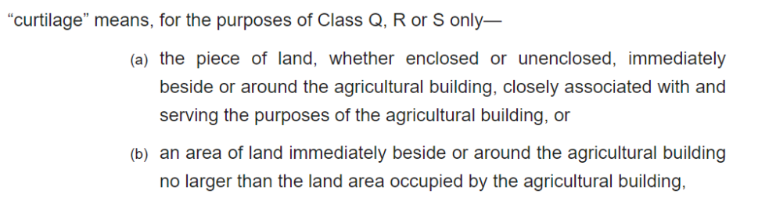

The red line has been fairly tightly drawn around the existing building(s) – both Dutch barn and the concrete block work building and includes an L-shaped area of land immediately around the buildings to the east and south as amenity space, the parking spaces are to be within the former footprint of the Dutch barn as per (b) above, with a total area of 401 sqm. The site area does not exceed the land immediately around the building, which is laid to grass, and is no larger than the area of land occupied by the building (242 sqm externally), so it is considered that the curtilage complies with Part X and comprises the lesser of the two available options.
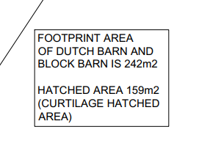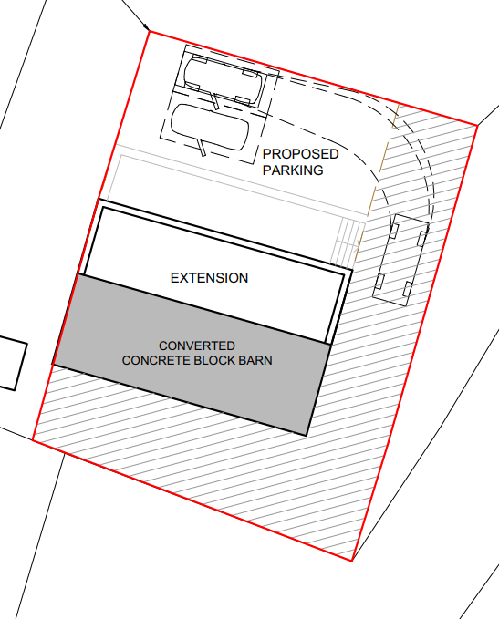

(f) The design or external appearance of the building

Paragraph 131 of the National Planning Policy Framework (NPPF) highlights that good design is a fundamental aspect of sustainable development, helping to create better places in which people live and work, and making development more acceptable to communities.

Relevant to this application type, Paragraph 135 sets out key principles to ensure that new development:

- Functions well and contributes positively to the overall quality of the area, not just in the short term but over the lifetime of the development;
- Is visually attractive through high-quality architecture, thoughtful layout, and effective landscaping;
- Is sympathetic to local character and history, including the surrounding built environment and landscape setting;
- Creates places that are safe, inclusive, and accessible, promoting health and well-being and providing a high standard of amenity for both existing and future users.

The NPPF also encourages Local Planning Authorities to make appropriate use of design tools and processes to assess and improve the quality of development proposals. This includes reference to national guidance such as the National Design Guide and assessment frameworks like Building for a Healthy Life, which support the delivery of well-designed, contextually appropriate development.

Criterion Q2,1(f) of Class Q of Part 3 of Schedule 2 of the Town & Country Planning (General Permitted Development) (England) Order 2015, relates to the external appearance of the building.

Notwithstanding the works required to extend and convert the building as previously outlined, and following the demolition of the Dutch barn, the appearance of the building will be that of a single storey mono pitched building, the extension being subservient in scale to the existing building but reflecting the character of this existing building but in mirror image form. External materials will be metal sheet cladding often seen on agricultural buildings to maintain the agrarian character of building in this rural location. The site is located in a prominent location with views of the site from the A360 and also the B390 Chitterne Road. The building is however currently screened by surrounding trees. The low profile of the proposed dwelling helps to minimise the impacts of the development. Furthermore, the removal of the Dutch barn is considered to be a visual improvement on the locality. Overall, it is considered that the design and appearance of the building would be acceptable in prior approval terms.

(g) The provision of adequate natural light in all habitable rooms of the dwellinghouse(s)

The prior approval matter to be assessed under para. Q.2(1)(g) relates to the provision of natural light into habitable rooms of the proposed dwelling.

For the purposes of the Part 3 (change of use) PD rights, para. X of the GPDO defines “habitable rooms” as:

...any rooms used or intended to be used for sleeping or living which are not solely used for cooking purposes, but does not include bath or toilet facilities, service rooms, corridors, laundry rooms, hallways or utility rooms.

The proposals show that all habitable rooms are to be served by windows and in some cases, glazed doors too to enable natural light to enter the building. It is therefore considered that the proposal makes provision for adequate natural light in all habitable rooms and thus satisfies this requirement of the prior approval assessment.

(2) Where the development proposed is development under Class Q(a) only, development is permitted subject to the condition that before beginning the development, the developer must apply to the local planning authority for a determination as to whether the prior approval of the authority will be required as to the items referred to in sub-paragraphs (1)(a) to (e) and (g), and the provisions of paragraph W (prior approval) of this Part apply in relation to that application.

(3) Where the development proposed includes development under Class Q(b), the developer must also apply, as part of the application under sub-paragraph (1) or (2) (as the case may be), for a determination as to whether the prior approval of the authority will be required as to the impact of the proposed extension on the amenity of any adjoining premises.

As the proposals includes an alterations and extension under Class Q(b) and Class Q (c) an assessment on these matters is needed

The proposal comprises the demolition of the existing Dutch barn, the conversion of the remaining agricultural structure, and the erection of a single-storey rear extension projecting up to 4 metres. The demolition of the Dutch barn is considered acceptable as it does not form part of the building proposed for conversion and its removal would not undermine the building’s ability to function as a qualifying structure under Class Q. The proposed works and extension accord with the amended provisions of Class Q, which allow for necessary alterations to facilitate the conversion and also allows limited rear extensions, and by reason of its scale, siting, and single-storey form, is considered subservient to the host building. The extent of works is therefore regarded as reasonably necessary to facilitate the conversion. In terms of amenity impacts, there are no nearby properties that will be affected by the development. The proposals are therefore considered to be compliant with Class Q(b) and Class Q (c).

Other matters

WCS policy CP50 (Biodiversity and Geodiversity) and the NPPF requires the Local Planning Authority to ensure protection of important habitats and species in relation to development and seeks enhancement for the benefit of biodiversity through the planning system.

The site it is situated within the River Avon Special Area of Conservation (SAC) catchment area. The SAC is designated for several species of wildlife that depend on pristine water quality that is typical of chalk rivers such as the Avon. It is part of a network of sites across Europe designated in order to protect these and other species vulnerable to man-induced habitat change. This SAC is particularly vulnerable to the effects of pollutants including phosphate and nitrogen which may enter the river for example at sewage treatment works or from fertilizers applied to farmland throughout the catchment. Residential development within these catchments has the potential, either alone or in combination with other plans or projects, to give rise to likely significant effects on the SAC through increased nutrient loading associated with foul drainage.

The application site lies within the Zone of Influence of the Salisbury Plain SAC / SPA, which supports a range of internationally important habitats and species, including the stone curlew.

The creation of a new residential dwelling in this area has potential to increase pressure on these designations. The provisions of the Conservation of Habitats and Species Regulations 2017 (as amended) (Habitat Regs) are therefore relevant to the development. Whilst the matters of ecology and protected species are not issues that are identified in the Class Q criteria for consideration as part of the prior approval process, the procedural notes of the GPDO makes it clear that permitted development rights do not override the requirements of the Habitats Regs and that Regulations 75-78 still apply.

The Habitats Regs address the requirements for protecting sites that are internationally important for threatened habitats and species (for example, as is relevant in this instance, SACs and SPAs (often referred to as European Sites)). This includes a requirement for assessment of ‘plans and projects’ by ‘the competent authority’ (e.g., the Local Planning Authority) which are likely to have a significant effect on the sites. A separate application under the Regulation 75 and 77 of the Habitat Regs would therefore be necessary for any scheme found to be acceptable within the permitted development provisions of the GPDO.

In this instance however, the prior approval is to be refused due to the potential noise impacts and the undesirable/impractical siting and location. This matter is not therefore considered to be relevant in this instance.

CONCLUSION

For the reasons as outlined within this report, the proposed development is considered not to comply with all of the criteria set out in Class Q, paragraph 1 of the GPDO thereby making it development that does not benefit from permitted development rights. Therefore, it is considered that the proposal does not satisfy the requirements of Class Q, paragraph 2 (1) of
the GPDO thereby confirming that prior approval of the Local Planning Authority is required and is subsequently, refused.

PRIOR APPROVAL IS REQUIRED AND REFUSED FOR THE FOLLOWING REASON(S):

The prior approval of the Local Planning Authority is required under Class Q part 2(e) as to whether the location or siting of the building makes it otherwise impractical or undesirable for the building to change from agricultural use to a use falling within Class C3 (dwellinghouses) of the Schedule to the Use Classes Order.

The Local Planning Authority considers that the proposed change of use would introduce a residential dwelling in very close proximity to an established and lawful pig farming operation. The agricultural use is likely to generate adverse impacts including odour, noise, disturbance, flies, dust and other associated effects, which are inherent to such activities and cannot reasonably be mitigated.

By reason of this relationship, future occupiers of the dwelling would be subject to a poor standard of residential amenity on a regular and ongoing basis. Furthermore, introducing a residential use in this location would give rise to the potential for land use conflict, which could place undue pressure on the continued operation of the adjoining agricultural use.

As such, the Local Planning Authority considers that the location and siting of the building make the proposed development impractical and undesirable for residential use. The proposal therefore fails to comply with Schedule 2, Part 3, Class Q.2(1), in particular criteria (b) and (e), and the provisions of Paragraph W (prior approval) of the Town and Country Planning (General Permitted Development) (England) Order 2015 (as amended).

INFORMATIVE TO APPLICANT(S):

- The applicant(s) should be reminded of their obligations to comply with Article 3 - (1) of the Town and Country Planning (General Permitted Development) (England) Order 2015 (as amended) to ensure that the development complies with regulations 75 to 78 of the Conservation of Habitats and Species regulations 2017. Failure to do so may result in the development not being Permitted Development.

- The following plans and documents submitted by the applicant which form the application have been used to assess the proposals and reach this decision.

Application form received 23/03/2026
Location plan and existing block plan Drg no 4392-01 Rev C received 23/03/2026
Building Survey Report and Structural Analysis report received 23/03/2026
Biodiversity survey/report received 23/03/2026 received 23/03/2026
Visibility site plan and cars turning site plan Drg no 4392-04 received 23/03/2026
Existing plans and elevations Drg no 4392-02 Rev A received 23/03/2026
Proposed plans and elevations Drg no 4392-03 Rev B received 07/04/2026
Planning statement received 23/03/2026
Agents response to Environmental Health objections received 12/05/2026

