APPLICATION FOR HOUSEHOLDER PLANNING PERMISSION
DELEGATED REPORT

APPLICATION REFERENCE: | PL/2026/00762
APPLICATION TYPE: | Householder planning permission
SITE ADDRESS: | 57, Upper South Wraxall, Bradford on Avon, BA15 2SE
DEVELOPMENT DESCRIPTION: | Demolition of existing extensions, outbuildings and 20th Century garage structure. Construction of two storey extension to south-east of original cottage, works to historic cottage to address structural and fabric failings. Relocation of existing swimming pool. Extension to existing boundary wall to Upper South Wraxall following removal of structures and construction of new boundary wall to western boundary.
RECOMMENDATION: | That Planning Permission be GRANTED

PROPOSAL
This householder proposal seeks planning permission for the removal of a number of ad hoc extensions and to erect a contemporary two-storey wraparound extension to the side and rear of the host dwelling, in addition to upgrading the dwelling.

The existing swimming pool set within the rear curtilage would be relocated closer to the host dwelling and the existing boundary wall extended (following the removal of some external structures) and a new boundary wall would be constructed on the western boundary. The existing garage building with store would be replaced with a single storey garage set further into the driveway area.

The scheme has been subject to revised plans following objections to the scheme in regard to the proposed remodelling of the original façade of the host dwelling. The original scheme was called into committee by the local ward member but following the submission of revised plans the call in was rescinded. The revised plans were received 25.03.2026 and consulted on for a 21-day period.

SITE DESCRIPTION/CONTEXT
The host dwelling is Random Forge, at No. 57 Upper South Wraxall, a two-storey detached dwelling accessed by a single-track road to the north of the village located in the conservation area and within the West Wiltshire Green Belt. The host dwelling is believed to date from the 17th Century and is considered to be a non-designated heritage asset. The surrounding area character is heavily informed by its rural location.

The proposal sits within the recreational impact zone of the Bath and Bradford on Avon Special Area of Conservation for bats and is a site that is mapped as having some surface water flood risk.

PLANNING HISTORY
W/79/01149/HIS - Historic apps 1974 to 1983 Decision - Approved with Conditions
Date: 6/11/1979 – Extension to provide utility, with dressing room and bathroom over
W/81/00456/HIS - Historic apps 1974 to 1983 Decision - Approved Date: 12/5/1981 –
Double garage and workshop
ENQ/2025/01680 Pre application advice - Proposals to remodel and extend the existing house to improve upon previous extension and adaptation works that have rendered the house currently unfit for occupation – Dated 15/12/2025

RELEVANT POLICIES AND GUIDANCE
The adopted Wiltshire Core Strategy (WCS), with particular regard to
- Core Policy 2 Delivery Strategy
- Core Policy 50 Biodiversity and Geodiversity
- Core Policy 51 Landscape
- Core Policy 57 Ensuring High Quality Design and Place Shaping
- Core Policy 58 Ensuring the Conservation of the Historic Environment
- Core Policy 60 Sustainable Transport
- Core Policy 61 Transport & Development
- Core Policy 64 Demand Management
- Core Policy 67 Flood Risk
Emerging Policy – Wiltshire Local Plan Review
At Full Council on 19 May, the elected members of Wiltshire Council agreed to withdraw the emerging WLP. It will now be subject to a legal process to finalise its withdrawal - which is likely to happen in July or August (2026). The said Plan has no material weight for the purposes of the application.
South/Lower South Wraxall Conservation Area Statement
Bath and Bradford on Avon Bat SAC Guidance September 2015
Wiltshire Design Guide: Appendix D – Design Guidance for Householder extensions
The National Planning Policy Framework (NPPF) and Planning Practice Guidance
Planning (Listed Buildings and Conservation Areas) Act 1990
National Design Guide

CONSULTATION RESPONSES

South Wraxall Parish Council: No objection (following submission of the revised plans)
Wiltshire Council Conservation: No objection
Wiltshire Council Drainage: No objection
Wiltshire Council Arboricultural Officer: No objection
Wiltshire Council Ecology: No Objection

REPRESENTATIONS
A number of objections were received on the original plans, and the proposal was called into committee by the local ward member. Revised plans were submitted and consulted on for the requisite period. Following the revisions, the call in to committee was rescinded.

One objection was maintained/received on the revised plans, the points raised are fully appraised within the officer report below.

ASSESSMENT
Section 38(6) of the Planning and Compulsory Purchase Act 2004 states:

"If regard is to be had to the development plan for the purposes of any determination to be made under the planning Acts, the determination must be made in accordance with the plan unless material considerations indicate otherwise."

In accordance with this statutory requirement, this application has been assessed against the relevant policies of the Development Plan, including the adopted Wiltshire Core Strategy (2015) and, where applicable, any made Neighbourhood Plans.

Principle of Development in the Green Belt
The 2024 NPPF regards the construction of new buildings in the Green Belt as ‘inappropriate development’, unless the proposal falls within the criteria set out in paragraph 154. Within this list of exceptions, extensions or alterations to existing buildings may be acceptable if they do not result in “disproportionate additions over and above the size of the original building”.

Paragraph 153 of the 2024 NPPF states that
“…when considering any planning application, local planning authorities should ensure that substantial weight is given to any harm to the Green Belt, including harm to its openness. Inappropriate development is, by definition, harmful to the Green Belt and should not be approved except in very special circumstances. ‘Very special circumstances’ will not exist unless the potential harm to the Green Belt by reason of inappropriateness, and any other harm resulting from the proposal, is clearly outweighed by other considerations”.
The NPPF does not quantify what disproportionate constitutes and the Council does not prescribe a volumetric /percentage maximum, so a planning judgement must be made in each case and be assessed on its own individual merits.
The NPPF does however define ‘original building’ as “a building as it existed on 1 July 1948 or, if constructed after 1 July 1948, as it was originally built.”
Planning history and the historic mapping for the property reveals that the host dwelling has been extended since it was originally built. The records show that permission was granted in 1979 (W/79/01149/HIS) for the extension on the south elevation with the garage building granted permission in 1981 (W/81/00456/HIS). However other extensions have been added that do not register on the Council’s planning history database.
The Planning Statement calculates that the volume of the original building (with the forge outbuilding located to the southwest of the property) sat at 691m3 and the existing built form on site is in the region of 974m3, and officers have calculated similar volume calculations.
With the removal of the identified non original extensions and the proposed erection of the two-storey extension and replacement garage, the submitted planning statement estimates that if approved and implemented, the volume would change to 967m3.
Original volume= 691m3
Existing built volume = 974m3 (40% above original)
Total volume (including removal of existing structures and erection of proposed structures) - once implemented) = 967m3 (39% above original)
Officers have calculated the proposal would equate to a 39% volume increase from the original volume, and when compared to the post 1947 development that would be demolished as part of this application proposal, the recalculated final volume would be less than what currently exists. On this basis, when applying the NPPF green belt test, the proposal would be proportionate to the original built volume and is therefore acceptable.
The proposal would remove existing structures that are of poor quality in terms of their relationship with the main original dwelling, and some of the extensions have quite significantly diminished the original form and character of the dwelling, and planning and conservation officers consider the new extension would be much more in keeping.
Officers have analysed the proposal and the site and have concluded that the proposed development would not result in material harm to the openness of the Green Belt given the proposed development would be of limited development within the confines of the application site. As such, Paragraph 153 of the NPPF would be satisfied.
Design and Impact on Character and Appearance of the Non-Designated Heritage Asset
The Council’s Core Strategy Policy CP58 ‘Ensuring the conservation of the historic environment’ requires that designated and non-designated heritage assets and their settings will be conserved, and where appropriate enhanced, in a manner appropriate to their significance and encourages proposals which improve the condition of heritage assets at risk.
The Council’s Core Strategy CP 57: Ensuring high quality design requires a high quality of design in all new developments. The policy requires applicants to “demonstrate how the proposal will make a positive contribution to the character of Wiltshire through (amongst other things) responding to the value of the natural and historic environment and being sympathetic to and conserving historic buildings and landscapes”.

Development is required to respond positively to the existing in terms of building layouts, built form, height, mass, scale, building line, plot size, elevational design, materials, streetscape and rooflines to effectively integrate the building into its setting.

The proposal seeks householder planning permission for the removal of a number of ad hoc extensions that have been added to the original dwelling over a number of years and seeks to erect a contemporary two-storey wraparound extension to the side and rear of the host dwelling, alongside general upgrading to the original dwelling, which is noted to be in state of some disrepair.

The existing swimming pool set within the rear curtilage would be relocated closer to the host dwelling and the existing boundary wall would be extended (following the removal of some external structures) and a new boundary wall would be constructed on the western boundary.

The existing garage building with store would be replaced with a single storey garage set further into the driveway area.

The original cottage is understood to be of ‘solid rubble stone construction with subsequent application of consolidating cementitious renders, slurry wash and waterproofing paints over. Later 19th century structures are thought to be of an uninsulated cavity construction with cementitious render and paint finishes over. Later 1970s extensions are of concrete block construction, with render finishes over and hung tile cladding to the first floor. The house is fitted with double glazed uPVC windows installed at an undermined time’
The host dwelling not only has a number of non-original additions, of varying quality, there are also a number of outbuildings within the residential curtilage.
The original dwelling is believed to date from the 1700’s and has a simple two storey form, that at some point had loft rooms created. The original dwelling is in need of repair, with areas of damp within several of the living rooms and bedrooms.
Extensions have been added to the north, east and south elevations that provide a rather hotchpotch series of rooms, and the extensions themselves, are of limited architectural merit and there is no officer opposition to the identified extent of demolition.
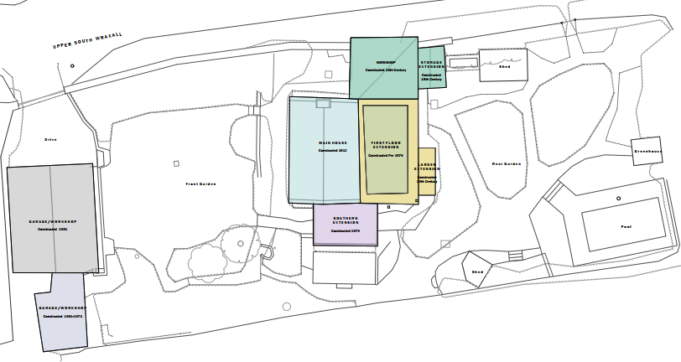
Existing Site Plan
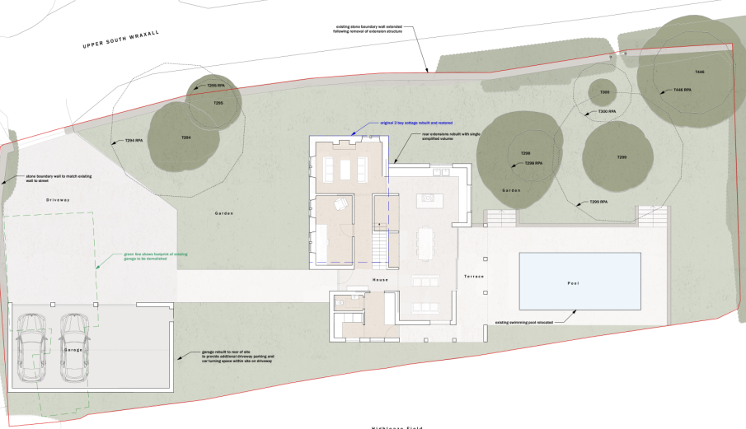
Proposed Site Plan
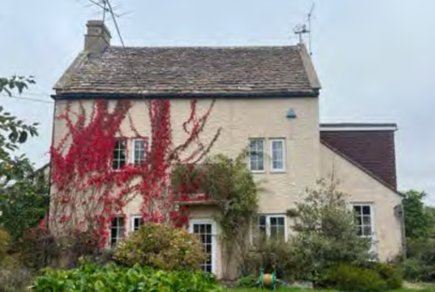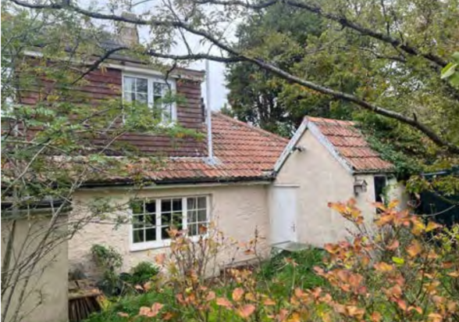
Existing front (left) and rear (right) elevation.
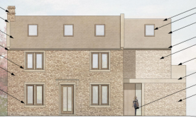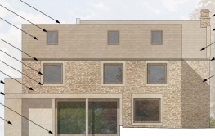
Proposed front (left) and rear (right) elevation.
The proposal seeks to remove all the non-original extensions and some of the outbuildings to the rear of the host dwelling and to erect a two-storey rear extension that would in part extend from the south side extension of the original dwelling. The ridge height of the extension would sit down from the ridge height of the original dwelling to identify it as a subordinate addition. The extension would consist of a pitched roof with a projection on the south elevation consisting of ground floor accommodation only.
Objections were received to the originally submitted scheme that raised concerns that the original property would be demolished and rebuilt, however the applicant has always maintained that the original dwelling would be preserved. Objections were also based on the extent to which the front façade of the original dwelling would be altered.
The revised plans received 25.03.2026 sought to reintroduce the doorway at ground floor, retain the door hood and make further adjustments to the window proportions on the western elevation. Following the revisions only one objection was received citing concerns of the ‘creation of a building of modern appearance while mimicking some features of the original cottage’. The interested party objected to the need to demolish and rebuild the original cottage, however as previously stated the original cottage is to be preserved.
The objection cites examples of cottages within the village that have been extended without altering the appearance of the original cottage. However as previously stated the scheme seeks to retain the original facade of the cottage as closely as possible and extend the accommodation with a contemporary style extension with materials sympathetic to the host dwelling.
The applicant seeks to utilise matching sustainable materials, with coursed Wiltshire stone rubble elevations with lime mortar joints, coursed stone slate roofs and stained hardwood fenestration. The architectural detail relates to a contemporary appearance, and whilst the Council is supportive of innovative modern design and would not seek to impose a pastiche approach to any design, given the property’s history and location within the conservation area, the design is subject to scrutiny of its architectural merit.
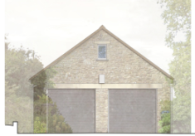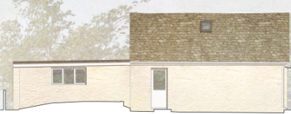
Front and East side elevation of the existing garage building
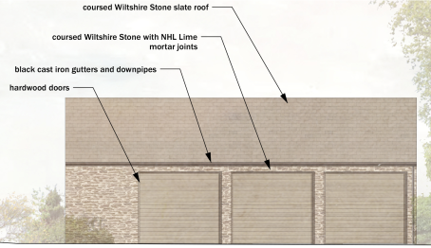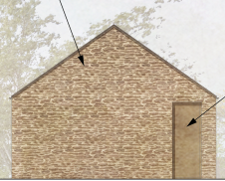
Front and East side elevation of the proposed garage building
Through positive engagement with the applicant and the submission of revised plans officers are satisfied that the original features of the non-designated heritage asset would be retained as much as possible. The restoration of the original host dwelling, and the retention of the original façade is supported.
The use of good quality sustainable materials is supported, given the materials are local to the area and are the predominate materials within architecture in Bradford on Avon and Bath which are within short driving distances of the application site.
The Local Authority Conservation officer was consulted on the proposal and offered the following comments firstly as part of the initial consultation on the original submission:
Original Scheme
“The proposals appear to be well considered and born of a thorough and robust analysis of the site and its immediate context.
The additions to be removed are of limited value, the proposed form of the replacement structure appears appropriate and would have a traditional appearance that appears a more logical evolution of the original cottage”
The conservation officer was then reconsulted following the submission of revised plans and advised as follows:
Revised Scheme
“As per my original comments the removal of the existing modern additions to this cottage is welcomed. I've noted the additional information supporting the proposal and clarifying the extent of the proposed works. The additional information is as previously discussed with the agent and case officer and addresses the issues discussed in my previous emails”
The proposal seeks to upgrade the existing dwelling and would provide a replacement extension and garage building that would be read as a more coherent design, replacing a number of existing ad hoc extensions that do not benefit the architectural context as a whole.
It is considered that the extensions would by virtue of their height, scale and design constitute complementary additions to the host dwelling that would appear commensurate to the size of the property and plot. Having regard to the above, the proposal complies with the design principles set out in Core Policy 57 and Core Policy 58 of the Wiltshire Core Strategy and Appendix D of the Wiltshire Design Guide.

Heritage Impact
From the point of view of the historic environment the main statutory tests are set out within the Planning (Listed Building and Conservation Areas) Act 1990.

Section 72(1) of the Act requires the Council to pay special attention to the desirability of preserving or enhancing the character or appearance of designated Conservation Areas.

The NPPF outlines government policy for planning. Chapter 16 of the NPPF 'Conserving and enhancing the historic environment' sets out the Government's high-level policies concerning heritage and sustainable development.

As the application site is located within the South Wraxall Conservation Area views into and out of the application site need to be appraised with any potential negative impact of any future development assessed.
It is observed that the works would be utilised with materials to match existing and the proposed elevations would utilise natural sustainable materials, which would help them blend into the existing environment. The appraisal of the design and visual impact set out within this report, is supportive of the proposed architectural proportions of the extension and garage building and is supported by the Conservation officer.
The remodelling of the boundary walls and relocation of the swimming pool would be carried out with limited disruption to the existing environs and would be in keeping with the character and appearance of the area. The development would be contained within the built envelope of the application site, with limited views across to the proposed extension from the public realm. Officers consider that the proposal by virtue of its scale, design, and use of materials, would preserve the character and appearance of the conservation area.
The development is therefore considered to comply with Core Policy 58 of the Wiltshire Core Strategy and Sections 66 and 72 of the Planning (Listed Buildings and Conservation Areas) Act 1990, as well as the relevant provisions of the NPPF.

Amenity
Point vii of Core Policy 57 - Ensuring High Quality Design and Place Shaping of the Wiltshire Core Strategy seeks to ensure that developments do not adversely affect neighbouring properties.

The National Planning Policy Framework (NPPF), particularly Paragraph 135(f), stresses that planning decisions should ensure developments provide a high standard of amenity for existing and future users.

The proposed development has been assessed in terms of its potential impact on the residential amenity of neighbouring properties, with particular regard to loss of light, overshadowing, loss of privacy, and overbearing effects.

The host dwelling occupies a large residential plot with an extended residential curtilage and the proposed works to the dwelling would maintain extended separation distances to any immediate neighbours. Given the detached nature of the host dwelling and nature of the works, no adverse overlooking overshadowing or overbearing impacts would likely occur to neighbouring occupiers.
The proposal therefore accords with Core Policy 57 point vii in respect of safeguarding residential amenity and Appendix D of the Wiltshire Design Guide.

Highways Impact
Core Policy 57 (xiv) of the Wiltshire Core Strategy seeks to ensure that development must meet the requirements of Core Policy 61. This policy requires proposals to be capable of being served by safe access to the highway network. Core Policy 64 seeks to ensure compliance with parking standards set out in the Local Transport Plan.

The National Planning Policy Framework (NPPF), particularly Paragraph 115 and 116, requires that development proposals do not have an unacceptable impact on highway safety and that safe and suitable access to the site can be achieved for all users.

Impact on parking provision – Core Policy 64 (Demand Management) seeks to manage the demand for vehicle parking and confirms that residential parking standards are to be based on minimum parking standards.
In order to comply with the Wiltshire Local Transport Plan 2011 – 2026: Car Parking Strategy (March 2015) three on-site car parking spaces would be required for a 4+ bed dwelling (standard min. size 2.4m x 4.8m).
The proposal seeks to replace the existing garage building with a single storey triple garage. This and the enlarged driveway area would adequately provide enough off-road parking for several vehicles, as illustrated by the site plan below.
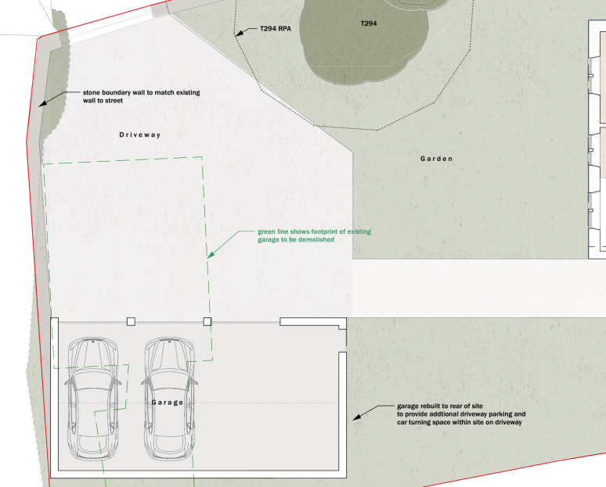

The existing off road parking arrangement does not allow an adequate turning facility, therefore vehicles have to either reverse into or out of the site from the public highway, therefore the enlarged driveway provides a betterment to the site, and the proposed development would not result in any adverse impact on highway safety. Adequate parking and turning provision is provided in accordance with Wiltshire’s adopted parking standards, and access arrangements are acceptable.
The proposal is therefore considered to comply with Core Policies 57 (xiv), 61 and 64 of the Wiltshire Core Strategy, the NPPF, and the Wiltshire Local Transport Plan.
Ecology Impact
Core Policy 50 of the Wiltshire Core Strategy seeks to protect and enhance biodiversity and geodiversity, including through ensuring that development avoids harm to protected species and habitats.

The National Planning Policy Framework (NPPF), in Paragraphs 193, requires that development minimises impacts on and provides net gains for biodiversity, including ensuring mitigation is secured where harm cannot be avoided.

The site lies within a consultation zone for Greater Horseshoe bats associated within the Bath and Bradford-on-Avon Bats SAC and therefore has potential to result in significant adverse impact on the special features of that site.
The scheme was subject to consultation with the Local Authority ecologist who submitted the following response:
‘Habitat Regulations Assessment (HRA)
Bath & Bradford on Avon Bats Special Area of Conservation (SAC)
A test of likely significance has been carried out by the relevant Competent Authority (Wiltshire Council) as required by Regulation 63 of the Conservation of Habitats and Species Regulations 2017 (as amended). No bat species associated with the SAC were recorded during surveys, and no evidence of their presence was identified on site. As such, the development will not affect the integrity or conservation objectives of the SAC.
The HRA has concluded that the application is not likely to have significant impacts on the SAC and subsequently the application is screened out of Appropriate Assessment.
Protected Species
Great Crested Newts
There is a residual risk that great crested newts / reptiles could occur on the application site. These species are legally protected, and planning permission does not provide a defence against prosecution. In order to minimise the risk of these species occurring on the site, the developer is advised to clear vegetation during the winter, remove all waste arising from such clearance and maintain vegetation as short as possible. If these species are found during the works, the applicant is advised to stop work and follow advice from an independent ecologist or the Council Landscape and Design Team (ecologyconsultations@wiltshire.gov.uk).
Bats
The survey results (Bat Survey: Random Forge, South Wraxall by Crossman Associates REF: J1133.009) indicate that, although the building is situated within suitable bat habitat and contains a number of minor potential roosting features, no evidence of roosting bats was identified during the daytime inspection or emergence surveys. However, common pipistrelle, soprano pipistrelle, and noctule bats were recorded foraging within the garden and surrounding area, demonstrating that non-SAC bat species utilise the site as part of the local foraging resource. Overall, the level of survey effort undertaken is considered appropriate, and the findings are sufficient to support the conclusion that the development is unlikely to impact roosting bats’
The ecologist has requested that the development is carried out in strict accordance with the approved Bat Survey, and a condition would be added to ensure this. As such, the development complies with Core Policy 50 of the Wiltshire Core Strategy and the relevant provisions of the NPPF.

Drainage and Flood Risk
Core Policy 67 of the Wiltshire Core Strategy and paragraph 181 of the NPPF requires that all new development avoids increasing flood risk on-site or elsewhere and, where appropriate, incorporates sustainable drainage measures. Development must also comply with national policy on flood risk management and drainage design. Paragraph 176 (via footnote 62) of the NPPF states that householder development should not be subject to the sequential test, nor the exception test.

The site lies within Flood Zone 1 however there is evidence on the Council's SFRA that the site is subject to surface water flooding as illustrated on the map insert below.
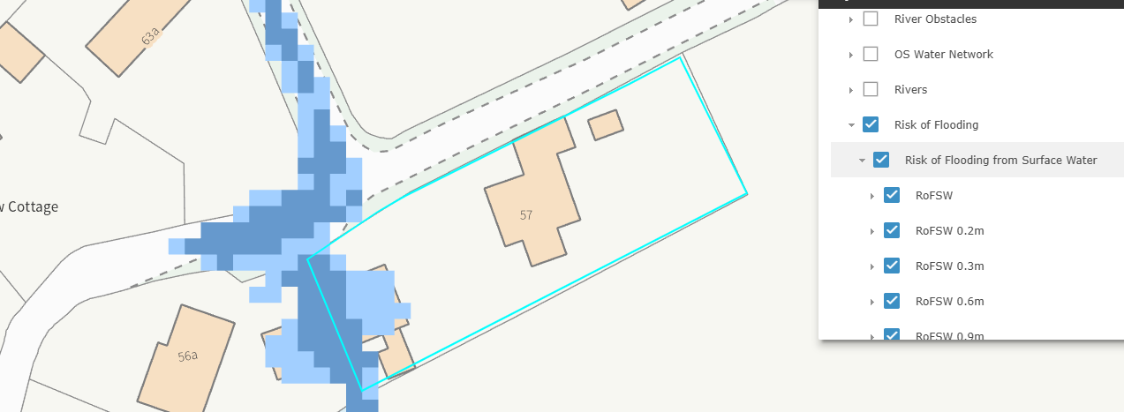
As the proposed works would involve excavation of the site due consideration has to be given to the provision of suitable water drainage system, as the proposed development is likely to increase the risk of flooding on site or elsewhere.
The Local Authority Drainage team were consulted on the proposal and offered the following comments
‘The applicant notes that the site is located within Flood Zone 1, indicating a low probability of fluvial flooding, and therefore a Flood Risk Assessment is not required at the planning stage.
Local evidence and Wiltshire Council’s SFRA mapping show a 1 in 1000-year surface-water flood risk affecting the existing driveway and garage area, with occasional ponding reported during heavy rainfall when the adjacent road gully becomes blocked.
The proposed works address this by relocating the garage outside the mapped surface-water risk area, incorporating flood-resilient construction measures, and implementing a SuDS-based drainage strategy—including a porous driveway, threshold drain, and new soakaway system— to ensure that surface water is managed on-site without increasing runoff to the public highway’
The set of revisions that were sent through did not address any drainage concerns therefore the Drainage team recommended that prior to any development taking place that a surface water drainage strategy be submitted, and a condition would be added to ensure this.

The proposal therefore complies with Core Policy 67 of the Wiltshire Core Strategy and the policy in the NPPF, ensuring that flood risk is not increased and that surface water drainage is appropriately managed.

Land Stability
There is no specific policy in the WCS that addresses land stability specifically however the NPPF states at paragraph 187 (e) that planning decisions should contribute to and enhance the natural environment by preventing new and existing development from contributing to, being put at unacceptable risk from, or being adversely affected by, unacceptable levels of soil, air, water or noise pollution or land instability.

Paragraph 196 (a) states that planning decisions should ensure that a site is suitable for its proposed use taking account of ground conditions and any risks arising from land instability and 189 (c) says adequate site investigation information, prepared by a competent person, is available to inform these assessments.

Paragraph 197 of the NPPF states where a site is affected by ... land stability issues, responsibility for securing a safe development rest with the developer and/or landowner.

It is acknowledged that the groundworks necessary for the pool would involve excavation of the site which could lead to erosion of the landscape. However, as the NPPF states, land stability issues are the responsibility for the landowner and developer and statutory Building Regulations will be reviewing the proposal in terms of its foundations and stability both at the start, during and post-construction. Officers are therefore satisfied that the proposed landscaping works are deemed sufficient to avoid land instability.

Trees
The application site lies within a conservation area, therefore if any scheme seeks to remove existing trees, permission would be required from the Local Planning Authority. A report was included within the submission documents detailing the proposed works on site.
The Local Authority Arboricultural officer was consulted on the proposal and offered no objection subject to the submission of an Arboricultural Impact Assessment and Tree Protection Plan being submitted prior to the commencement of any works.
In the event of any formal approval a condition would be added to ensure that the necessary documentation is submitted. Therefore, officers raise no objections in regard to any adverse Arboricultural impacts.

Biodiversity Net Gain
Householder planning applications are exempt from the requirement to deliver Biodiversity Net Gain under Schedule 7A, Section 4(2)(a) of the Town and Country Planning Act 1990, as inserted by the Environment Act 2021.

CONCLUSION
The proposed development is considered to be acceptable in terms of its design, scale, and relationship with the surrounding area. It would not result in any unacceptable harm to the character of the locality, the amenities of neighbouring occupiers, or the interests of highway safety, heritage, or ecology.

The proposal is therefore considered to comply with the relevant policies of the Wiltshire Core Strategy, the Wiltshire Local Plan, and the National Planning Policy Framework. As such, the application is recommended for approval, subject to the conditions set out below.

RECOMMENDATION: That Planning Permission be GRANTED subject to conditions.

Conditions
1.The development hereby permitted shall be begun before the expiration of three years from the date of this permission.
REASON: To comply with the provisions of Section 91 of the Town and Country Planning Act 1990 as amended by the Planning and Compulsory Purchase Act 2004.

2. The development hereby permitted shall be carried out in accordance with the following approved plans and documents:
Location Plan DWG No 156_P_000_B - Received 11.02.2026
Existing Site Plan DWG No 156_P_001 - Received 03.02.2026
Removals Plan DWG No 156_P_002 - Received 03.02.2026
Existing Ground Floor Plans DWG No 156_P_010 - Received 03.02.2026
Existing First and Second Floor Plans DWG No 156_P_011 - Received 03.02.2026
Existing Roof Plan DWG No 156_P_012 - Received 03.02.2026
Existing Garage Floor and Roof Plans DWG No 156_P_013 - Received 03.02.2026
Existing Elevations DWG No 156_P_030 - Received 03.02.2026
Existing Garage Elevations DWG No 156_P_035 - Received 11.02.2026
Existing Chronology Plan DWG No 156_P_100 - Received 03.02.2026
Proposed Site Plan DWG No 156_P_102A - Received 27.02.2026
Proposed Ground Floor Plans DWG No 156_P_110 B PROP - Received 25.03.2026
Proposed First Floor Plan DWG No 156_P_111A - Received 27.02.2026
Proposed Roof Plan DWG No 156_P_112A - Received 27.02.2026
Proposed Elevations DWG No 156_P_301B - Received 25.03.2026
Proposed Garage Elevations and Floor Plans DWG No 156_P_302 - Received 11.02.2026
Existing House Elevations - Demolitions DWG No 156_P_500A-DEM0 - Received 25.03.2026
Existing Plans - Demolition DWG No 156_P_501DEMO - Received 10.03.2026

REASON: For the avoidance of doubt and in the interests of proper planning.

3. The development will be carried out in strict accordance with the following documents:

Bat Survey: Random Forge, South Wraxall by Crossman Associates REF: J1133.009 Section Recommendations

REASON: For the avoidance of doubt and for the protection, mitigation and enhancement of biodiversity

4. No development shall commence on site until a scheme for the discharge of surface water from the site incorporating sustainable drainage details, has been submitted to and approved in writing by the Local Planning Authority. The development shall not be first brought into use until surface water drainage has been constructed in accordance with the approved scheme.

REASON: To ensure that the development can be adequately drained.

5. No demolition, site clearance or development shall commence on site, and; no equipment, machinery or materials shall be brought on to site for the purpose of development, until a comprehensive Arboricultural Method Statement and Tree Protection Plan showing the exact position of each tree/s and their protective fencing, in accordance with British Standard 5837: 2012: “Trees in Relation to Design, Demolition and Construction - Recommendations”; has been submitted to and approved in writing by the Local Planning Authority, and;
The protective fencing shall be erected in accordance with the approved details. The protective fencing shall remain in place for the entire development phase and until all equipment, machinery and surplus materials have been removed from the site. Such fencing shall not be removed or breached during construction operations.
No retained trees shall be cut down, uprooted or destroyed, nor shall any retained tree/s be topped or lopped other than in accordance with the approved plans and particulars. Any topping or lopping approval shall be carried out in accordance British Standard 3998: 2010 “Tree Work – Recommendations” or Arboricultural techniques where it can be demonstrated to be in the interest of good Arboricultural practice.
If any retained tree is removed, uprooted, destroyed or dies, another tree shall be planted at the same place, at a size and species and planted at such time, that must be agreed in writing with the Local Planning Authority.
No fires shall be lit within 15 metres of the furthest extent of the canopy of any retained trees or hedgerows or adjoining land and no concrete, oil, cement, bitumen or other chemicals shall be mixed or stored within 10 metres of the trunk of any tree or group of trees to be retained on the site or adjoining land.
[In this condition “retained tree” means an existing tree which is to be retained in accordance with the approved plans and particulars; and paragraphs above shall have effect until the expiration of ten years from the first occupation or the completion of the development, whichever is the later].
REASON: The application contained insufficient information to enable this matter to be considered prior to granting planning permission and the matter is required to be agreed with the Local Planning Authority before development commences in order that the development is undertaken in an acceptable manner, to enable the Local Planning Authority to ensure the retention of trees on the site in the interests of visual amenity.
Informatives
Drainage
The EA’s standing advice for minor extensions will apply.
• All new drainage will need to comply fully with Building Regulations Part H (and they should
engage with the building control department in order to ensure this).
• In line with the NPPF and National Standards for SuDS, the applicant should seek to use
SuDS wherever practicable as part of the surface water drainage strategy.
• Any soakaways should be designed and constructed in accordance with CIRIA C574 and
the Wiltshire Guidance.

