APPLICATION FOR HOUSEHOLDER PLANNING PERMISSION
DELEGATED REPORT

APPLICATION REFERENCE: | PL/2026/02786
APPLICATION TYPE: | Householder planning permission
SITE ADDRESS: | 7 Church Street, Longbridge Deverill, Warminster, BA12 7DJ
DEVELOPMENT DESCRIPTION: | Single storey rear extension
RECOMMENDATION: | That Planning Permission be GRANTED

PROPOSAL

The proposal seeks planning permission for Single storey rear extension at 7 Church Street, Longbridge Deverill. The extension would be a small extension to square off the ground floor footprint of the host building built with matching brickwork under a flat roof.

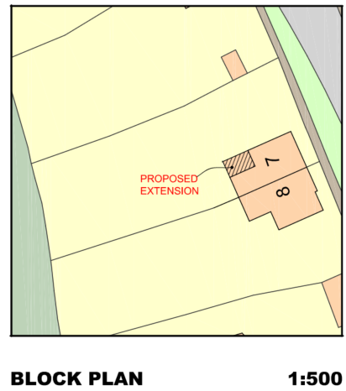

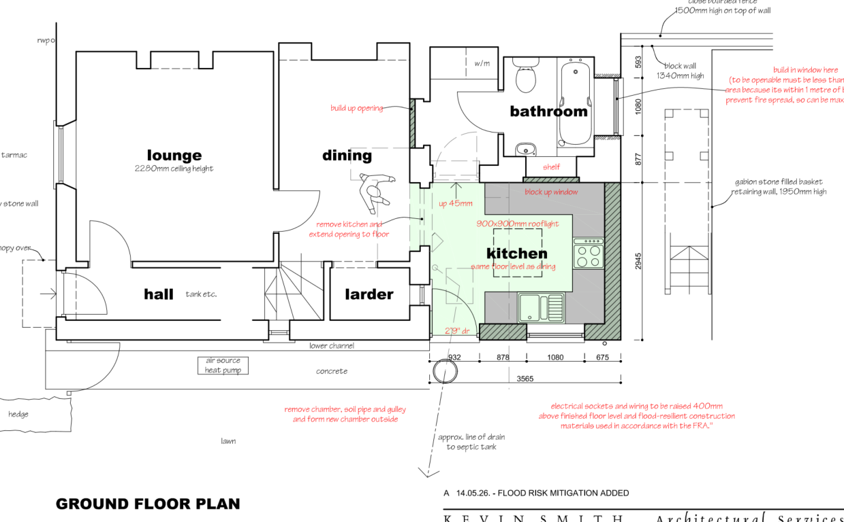

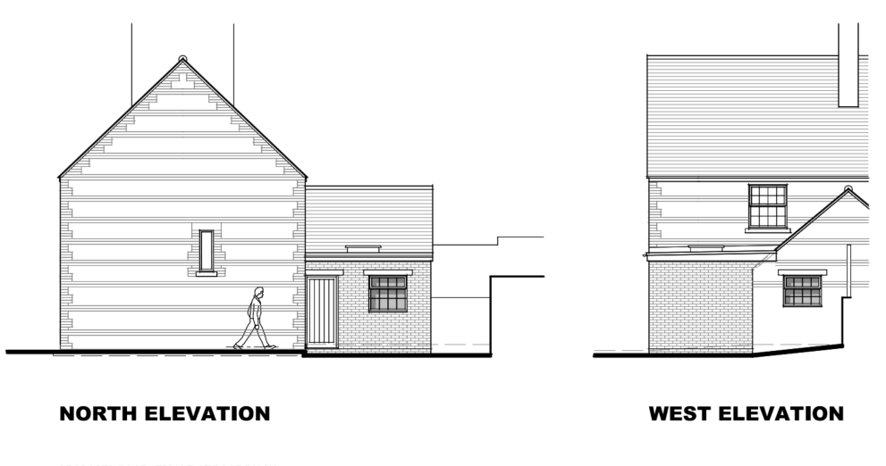

Proposed Side (North) and West (rear) elevations

SITE DESCRIPTION/CONTEXT

No 7 is a two-storey semi-detached dwelling located on Church Street which is at the northern end of the built form of this small village. The semi-detached pair along with its neighbouring semi-detached pair are visually striking properties with a mixture of stone and brick horizontal courses and a visually prominent central chimney that extends high above the ridge.

Despite the visual attractiveness of the semi-detached pairs, they are not listed, within a conservation area and are also not considered to be non-designated heritage assets.

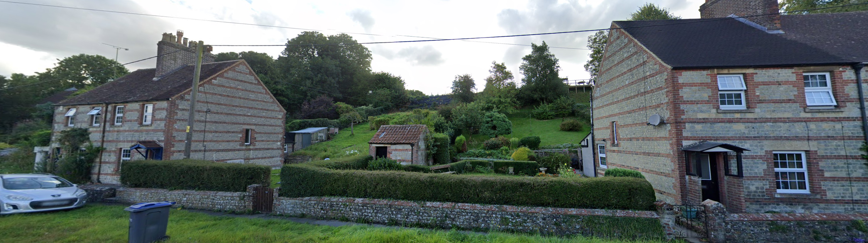

The application site is subject to the following planning policy constraints:

- Cranborne Chase and West Wiltshire Downs National Landscape
- Salisbury Plain Special Protection Area 6.4km buffer
- Ground water within 0.025-0.5m of the surface

PLANNING HISTORY

Proposal / Summary
PL/2026/02724 - Prior approval Part 1 Class A.1(ea): Larger home extension Decision - Prior Approval Refused Date: 28/4/2026 – Prior approval under Part 1 Class A.1(ea) for a single storey rear extension.

RELEVANT POLICIES AND GUIDANCE

National Context:

The National Planning Policy Framework (NPPF)

The Planning Practice Guidance

Local Context:

Wiltshire Core Strategy:

- Core Policy 50: Biodiversity and Geodiversity
- Core Policy 51: Landscape
- Core Policy 57 Ensuring High Quality Design and Place Shaping
- Core Policy 61: Transport and New Development
- Core Policy 67: Flood Risk

Longbridge Deverill does not have a Neighbourhood Plan or Area Designation

Wiltshire Design Guide: Appendix D – Design Guidance for Householder extensions

CONSULTATION RESPONSES

Longbridge Deverill Parish Council: No comments received

REPRESENTATIONS

No comments were received.

ASSESSMENT

Section 38(6) of the Planning and Compulsory Purchase Act 2004 states:

"If regard is to be had to the development plan for the purposes of any determination to be made under the planning Acts, the determination must be made in accordance with the plan unless material considerations indicate otherwise."

In accordance with this statutory requirement, this application has been assessed against the relevant policies of the Development Plan, including the adopted Wiltshire Core Strategy (2015) and, where applicable, any made Neighbourhood Plans.

Design and Impact upon the character and context of the area

Core Policy 57 - Ensuring High Quality Design and Place Shaping of the Wiltshire Core Strategy seeks to ensure that all new development is of high design quality, reflecting local context, character, and distinctiveness.

Although flat roofs are generally discouraged, the proposed development would form a modest, straightforward, and suitable addition to the host property. It would not result in any harm to the character or appearance of the dwelling (the semi-detached pair) or the wider street scene. The use of matching brickwork would further assist in integrating the extension with the existing building.

Having regard to the above, the proposal complies with the design principles set out in Core Policy 57 of the Wiltshire Core Strategy and Appendix D of the Wiltshire Design Guide.

Amenity

Point vii of Core Policy 57 - Ensuring High Quality Design and Place Shaping of the Wiltshire Core Strategy seeks to ensure that developments do not adversely affect neighbouring properties.

The National Planning Policy Framework (NPPF), particularly Paragraph 135(f), stresses that planning decisions should ensure developments provide a high standard of amenity for existing and future users.

The proposed development has been assessed in terms of its potential impact on the residential amenity of neighbouring properties, with particular regard to loss of light, overshadowing, loss of privacy, and overbearing effects.

The proposed extension would be small and well away from both neighbours. There would be no overlooking, overbearing or harmful effects from the proposal.

The proposal therefore accords with Core Policy 57 point vii in respect of safeguarding residential amenity and Appendix D of the Wiltshire Design Guide.

Ecology Impact

Core Policy 50 of the Wiltshire Core Strategy seeks to protect and enhance biodiversity and geodiversity, including through ensuring that development avoids harm to protected species and habitats.

The National Planning Policy Framework (NPPF), in Paragraphs 193, requires that development minimises impacts on and provides net gains for biodiversity, including ensuring mitigation is secured where harm cannot be avoided.

The Council’s Ecology Officer has not been consulted on this application, but the application site is within the 6.4km zone of influence of the Salisbury Plain SPA and in light of the HRA for the Wiltshire Core Strategy and the HRA for the Wiltshire Housing Site Allocations Plan it is screened into Appropriate Assessment due to the potential impact of recreational pressure on stone curlew in combination with other plans and projects.

A strategic Appropriate Assessment (AA) has been prepared pertaining to development within the 6.4 km zone of influence that could result in a likely significant effect on the SPA as a result of an increase in recreational / visitor pressure. The AA reached a conclusion of no adverse effects on the integrity of the SPA or its qualifying features provided that the council’s mitigation strategy continues to be implemented. Annual stone curlew monitoring and protection measures continue to be secured by the Council.

In January 2026 Natural England (NE) confirmed that the 2025 strategic AA for Salisbury Plain SPA continues to be supported by NE.

National Landscape

Core Policy 51 of the Wiltshire Core Strategy requires all development to protect, conserve, and where possible enhance the character and quality of Wiltshire’s landscapes, giving particular weight to designated areas such as National Landscapes.

The National Planning Policy Framework (NPPF), in Paragraph 176, states that “great weight” should be given to conserving and enhancing landscape and scenic beauty in National Landscapes (formerly Areas of Outstanding Natural Beauty). Development within or affecting the setting of a National Landscape must demonstrate that it will not result in unacceptable harm to the special qualities of that area.

The proposal, by virtue of its scale, siting, and design, would not harm the special qualities or scenic character of the Cranborne and Chase and West Wiltshire Downs National Landscape.

The development therefore complies with Core Policy 51 of the Wiltshire Core Strategy and Paragraph 176 of the NPPF in conserving and enhancing the National Landscape.

Drainage and Flood Risk

The application site is within flood zone 1 but is within the second highest risk category of ground water flooding and in accordance with the Council’s 2019 and 2024 Strategic flood risk assessments (SFRA) the site cannot be considered to be at a low risk of flooding.

However, paragraph 176 of the NPPF states;

“Applications for some minor development and changes of use⁶² should also not be subject to the sequential test, nor the exception test set out below, but should still meet the requirements for site-specific flood risk assessments set out in footnote⁶³.

⁶² This includes householder development

⁶³ A site-specific flood risk assessment should be provided for all development in Flood Zones 2 and 3. In Flood Zone 1, an assessment should accompany all proposals involving: sites of 1 hectare or more; land which has been identified by the Environment Agency as having critical drainage problems; land identified in a strategic flood risk assessment as being at increased flood risk in future; or land that may be subject to other sources of flooding, where its development would introduce a more vulnerable use.”

This is a householder application and therefore footnote ⁶² applies (excluding the need for the sequential test) and the site is not within flood zone 2 and 3. However, as the site is within flood zone 1 and the SFRA shows this site to be in a high risk of ground water flooding, a site specific flood risk assessment is required.

The applicants have submitted the Council’s Flood Risk Assessment form indicating that ‘option 1’ is to be used – ensuring that ground levels of the extension will not be below existing ground level and that all electrical sockets will be 400mm above floor level and they will use flood resilient materials.

Officers consider that the submitted Flood Risk Assessment is sufficient and therefore the risk of ground water can be effectively managed.

Biodiversity Net Gain

Householder planning applications are exempt from the requirement to deliver Biodiversity Net Gain under Schedule 7A, Section 4(2)(a) of the Town and Country Planning Act 1990, as inserted by the Environment Act 2021.

CONCLUSION

The proposed development is considered to be acceptable in terms of its design, scale, and relationship with the surrounding area. It would not result in any unacceptable harm to the character of the locality, the amenities of neighbouring occupiers, or the interests of highway safety, heritage, or ecology.

The proposal is therefore considered to comply with the relevant policies of the Wiltshire Core Strategy, the Wiltshire Local Plan, and the National Planning Policy Framework. As such, the application is recommended for approval, subject to the conditions set out below.

RECOMMENDATION: That Planning Permission be GRANTED subject to conditions.

