APPLICATION FOR FULL-PLANNING PERMISSION
CASE OFFICER REPORT

APPLICATION REFERENCE: | PL/2026/00617
APPLICATION TYPE: | Full planning permission
SITE ADDRESS: | Land off junction of Salisbury and Lynchets Roads, Amesbury, SP4 7JA
DEVELOPMENT DESCRIPTION: | Creation of a permanent layby, bollards and a temporary compound access off Salisbury Road, Amesbury to enable construction and future operation of a below ground stormwater storage tank.
RECOMMENDATION: | Approve with Conditions

SITE DESCRIPTION/CONTEXT

The site relates to a triangular piece of land located towards the southern edge of the settlement boundary of Amesbury. Amesbury is defined as a Market Town by Wiltshire Core Strategy (WCS) policies CP1 (Settlement Strategy), CP2 (Delivery Strategy) and CP4 (Amesbury Community Area). The site itself is outside of the settlement boundary. The site is an area of unused land which is predominantly grass with shrubs and trees. The site is of archaeological significance with a barrow and lynchets known on the site. Immediately to the south is a scheduled monument which relates to the lynchets.

The site is surrounded by residential properties to the north, east and west. A public right of way – byway AMES 20 runs to the east with the A345 to the west.
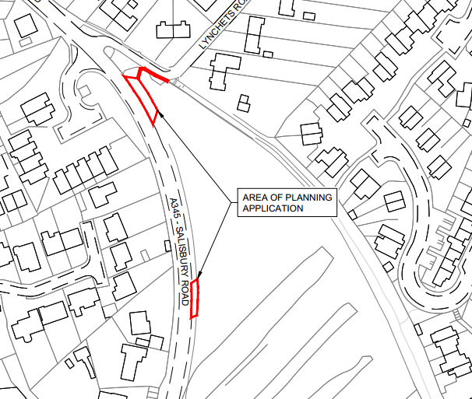
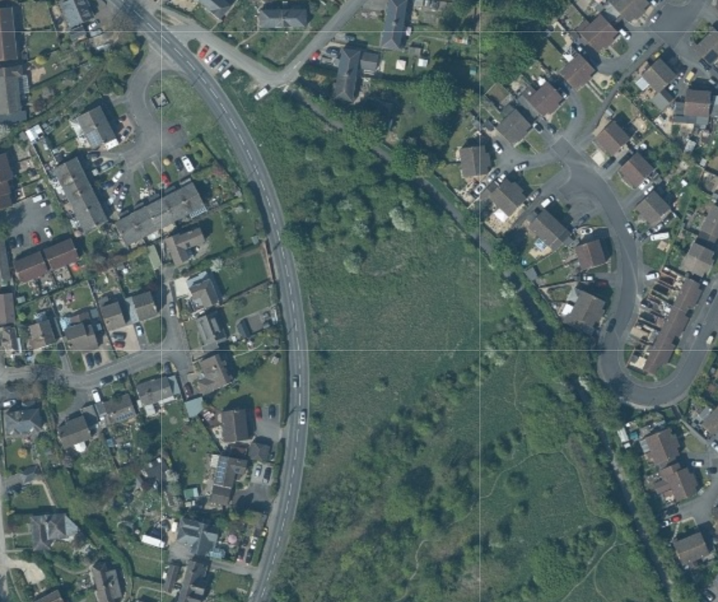
Whilst the site is some distance from the river it is in Flood Zone 1; and is in an area that is at low risk of Ground Water flooding (Groundwater levels are between 0.5m and 5m below the ground surface, there is a risk of flooding to subsurface assets, but surface manifestation of groundwater is unlikely), it is situated within the catchment of the River Avon Special Area for Conservation (SAC). The site is not located within a conservation and there are no listed buildings on or immediately adjacent to the site, the site is also just outside of the boundary of the Special Landscape Area (saved policy C6 of the Salisbury District Council).

PROPOSAL

The proposal seeks permission for the construction of a permanent layby off the A345 Salisbury Road, Amesbury, together with associated bollards and a temporary construction compound and vehicular access. The development is required to facilitate the installation and future maintenance of a below-ground stormwater storage tank, intended to attenuate increased combined rain and foul water flows arising from new residential development. While the storage tank, associated below-ground infrastructure, and roadside control kiosk constitute permitted development, the proposed layby will provide necessary long-term access for maintenance tankers, and the temporary access will enable construction. The works are required to reduce the risk of sewer flooding and environmental spills.

Proposed site plan included below

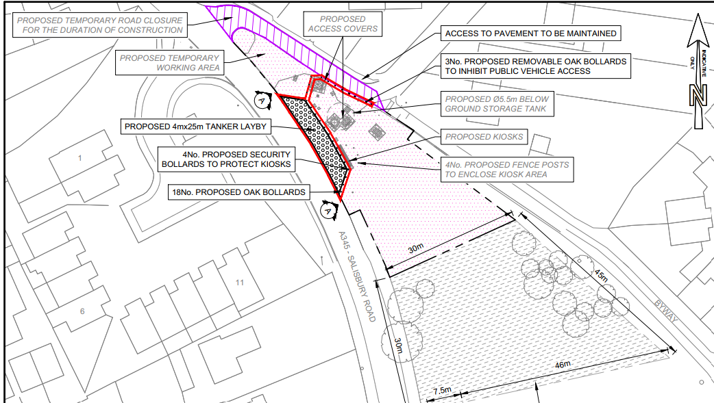
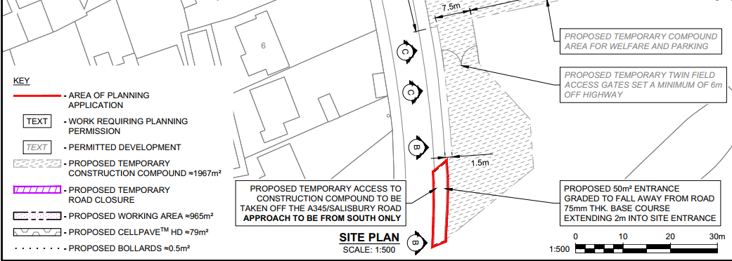

Amended plans and additional information were submitted during the application process and re-consultation undertaken as appropriate, the amendments predominantly related to highway issues.

PLANNING HISTORY

None

RELEVANT LEGISLATION, POLICIES AND GUIDANCE

Statutory Legislation:

National Planning Policy:
- National Planning Policy Framework (NPPF)
- Planning Practice Guidance (PPG)
- National Design Guide

Development Plan:

The development plan for Wiltshire comprises the Wiltshire Core Strategy (WCS) (adopted January 2015) and any made neighbourhood plans, which remains the principal statutory planning document guiding development across the county. In line with Section 38(6) of the Planning and Compulsory Purchase Act 2004, planning decisions must be made in accordance with the development plan unless material considerations indicate otherwise.

Though the development plan is considered as a whole, those parts deemed to be particularly relevant to this application are listed below:

The adopted Wiltshire Core Strategy (WCS), with particular regard to:

Core Policy 1: Settlement Strategy
Core Policy 2: Delivery Strategy
Core Policy 4: Spatial Strategy: Amesbury Community Area
Core Policy 48: Supporting Rural Life
Core Policy 50: Biodiversity
Core Policy 51: Landscape
Core Policy 57: Ensuring high quality design and place shaping
Core Policy 58: Ensuring the conservation of the historic environment
Core Policy 60-64 Highways
Core Policy 69: River Avon SAC

Saved policies of the Salisbury District Local Plan
C6 Special Landscape Area

Supplementary Planning Documents:

Achieving Sustainable Development SPG (April 2005)
Wiltshire Local Transport Plan – Car Parking Strategy
Wiltshire Design Guide
Creating Places Design Guide

ISSUES

- Principle
- Visual Impacts
- Archaeology/heritage
- Amenity
- Highways
- Rights of Way
- Ecology
- Trees

CONSULTATION RESPONSES

Town Council - Amesbury Town Council object to the closure of Lynchets Road as this is a narrow one way road and is not suitable for 2 way traffic.

Town Council – second response following amended plans and re-consultation - Amesbury Town Council support this change to the initial application

Historic England – no comment

Highways – no objection subject to condition

Archaeology – no objection subject to condition

Public protection – no objection subject to condition

Trees – not clear what if any trees are affected, a Tree Survey, Constraints Plan and Impact Assessment will be needed if the development will impact trees.

Rights of Way – no comments received.

REPRESENTATIONS
In accordance with the requirements of the Town and Country Planning (Development Management Procedure) (England) Order 2015 (as amended), the application was publicised by way of:

- Neighbour notification letters sent to adjoining and nearby properties;
- A site notice displayed near the site; [

These methods were used to inform interested parties and provide a period of 21 days for comments to be submitted.

Below is a summary of the representations received during the consultation period. Only material planning considerations have been taken into account in the assessment of this application. Non-material issues, such as property values or private legal disputes, cannot be considered in the determination process.

10 third party representations have been received and are included in full below.

- Can you assure us in Avonstoke Close (just opposite the proposed layby)that these tankers will not use our Close as a turning point. We constantly get vehicles turning around causing much damage to the road surface which is finally being repaired this month. Perhaps a "NO TURNING" sign would be considered for our Close.

- I'm not against this, but my only concern is how long will this go on for as the only parking I have for my cars is in the proposed place for works vehicles and unlike everyone else, I don't have a driveway or parking around the back off my house.

- Object - Blocking off Lynchets Road at the junction to the A345 is unworkable.
Lynchets Road is a very narrow ONE-WAY road.
Blocking off Lynchets Road at the junction with the A345 (Salisbury Road) is not a feasible, as Lynchet Road is not capable of being a 2-way road, and therefore 2-way traffic for cars and delivery vans is not possible.
Lynchfield Road is also a ONE-WAY lane leading to Lynchets Road, and is not capable of being turned into a 2-way road for an exit onto Highfield Road.

- I am a resident of Avonstoke Close in Amesbury.
This email is regarding the planning application PL/2026/00617 which proposes the creation of a permanent layby, bollards and a temporary compound access off Salisbury Road, Amesbury to enable construction and future operation of a below ground stormwater storage tank.
Whilst I am not opposed to the creation of a stormwater storage tank at that location, I am opposed to your suggested blocking of Lynchets Road during the construction phase.
Lynchets Road is a narrow one-way road, entering at a junction on Parsonage Road, and exiting onto the A345 (Salisbury Road). Lynchets Road is too narrow to allow 2-way traffic, and blocking the exit would create carnage for cars, and delivery vans. Lynchfield Road is also a narrow one-way lane so cannot be reasonably used as an exit route onto Highfield Road.
Please reconsider blocking the exit of Lynchets Road onto the A345.
- Whilst not opposed to the work, I don't believe we can cope with the closure of the end of Lynchetts Road. That would mean making a narrow one way road two way, it simply isn't feasible. Parsonage Road could not cope with more traffic turning onto it.
Also, the loss of the parking area by our homes would cause significant disruption for all. Even for deliveries, they would then block a lane of the A345. Let's hope nobody wants a visitor during that time or a tradesperson with a vehicle!

- Aside from the obvious traffic issues etc. as raised by others here, I would like to voice my concerns regarding the potential removal of any trees during these works. Although I cannot find any written details of the likelihood of this occurring, several local residents are under the impression that at least one tree is to be removed. I would like some reassurance that this is not going to be the case.

- This seems completely ridiculous, the land is part of the lynchets and is protected. Last year a huge team of volunteers spent ages cleaning up the area and site. I would also like to say how disappointing it is that hardly anyone on lynchets road has been contacted in regard to this. I would like to raise the following:

- The land is part of a historic site which should be protected.
2. This is incredibly dangerous and the proposed plans for the closure is impossible. Lynchets rd is a 1 way street how are residents supposed to get out/in especially given how close it is to a nearby school, it's seems incredibly silly, dangerous and not thought through.
3. The planned kiosk and layby is off the Salisbury road which sees Cars doing way in excess of 30 mph most often. Furthermore it also has the potential to cause issues for those living on Salisbury road, with getting in /out of their drives which given the nature of the rd is already difficult.

- Serious concerns as to how people are going to get to/from work or how rubbish collection/deliveries will take place. A lot of residents are reliant on deliveries in the area.
It's also disappointing to see that this is so close to the lynchets protected area, this shout stay protected otherwise what is the point!

- I Just heard from My neighbour end of Lynchets road gone a lay-by and Wessex water working for 6 months so that road is shut and one-way was planning for use two way that not a good idea because road was really narrow, and big vehicles also coming frequently like delivery vans and parked vehicles. And we not been even notified for this work, this work is effects us so we should notify by someone.

- I just wanted to say how incredibly frustrated I am with the above ref.
This is a situation which affects the whole of lynchets road, Highfield, lynchfield road and parsonage road, yet hardly any residents have been contacted about the proposed works/planning.
To give some context, lynchets road is incredibly narrow, we have a lot of elderly residents with care needs which means a lot of cars and traffic daily. If the works are given the go ahead, I have serious concerns about how residents are going to access their homes, without it becoming a danger and a serious hazard.
Furthermore, the roads off of lynchets (lynchfield and highfield) are also very narrow leading to parsonage road, which with the school traffic and many blindspots getting in/out of the junctions it is going to be a complete nightmare which risks the safety of residents and potentially school children!

Moving on to the proposed works, this is protected historic land. I and many others are in complete and utter disbelief that it is merely even being suggested.
A year or so ago many many volunteers cleared the lynchets area, they did an incredible job and worked hard to protect the area showcasing the lynchets hill area.
The area is also full of wildlife: owls, deer, hedgehogs etc, which we should be protecting and supporting in the local area.
To close, the a345 leading out of Amesbury is an awful road I feel the kiosk and layby area would only worsen that and potentially have a knock on affect on Salisbury rd residents as well.
I hope that this is given a serious look into, as I said myself and my other residents are incredibly frustrated and are hoping that Wiltshire council does the right thing here.

The applicant provided the following comment in direct response to the above third party comments –

We note local resident’s comments on the planning application in the main relate to the construction traffic management scheme.

The proposal provides additional foul sewerage capacity to support new development. Without
providing capacity there is a risk of sewer flooding at this location and increased sewer overflow spills at Amesbury water recycling centre.

An excavated below ground tank negates the need for upsizing considerable lengths of sewers, with associated road closures, as an alternative. We have sought to locate the tank and ancillary items in an area with least environmental and operational impact.

We appreciate there will be some disruption while the proposal is constructed. The working area within the road closure (bottom of Lynchetts Road) is required to provide the space necessary to undertake construction and protect the public and our workforce. The closure and traffic diversion has been discussed and agreed with Wiltshire Council Highways Team. A letter will be sent to affected residents shortly with full details. Our Construction Traffic Management Plan is attached containing further detail.

We can confirm tankers will not use Avonstoke Close as a turning point.

Once constructed planned visits by our operational team will be minimal (estimated 2 planned
visits per year). Availability of the proposed layby is crucial at all times for any unplanned emergency works to ensure the safety of our operational colleagues and the safe operation of the sewer network. Signage will be erected to confirm usage by Wessex Water only.

The entrance to the temporary construction compound is the closest point to the scheduled monument “Lynchetts at Southmill Hill”, some 300 metres distance with the permanent features being approximately 700m distance. We have worked with the county archaeologist to agree a mitigation plan, please refer to the submitted “Project Design for archaeological monitoring and recording” for further details.

The scheme is spilt into elements requiring planning permission (layby, bollards and temporary
compound access) and those Wessex Water is able to construct under permitted development
rights (underground tank and kiosk). The BNG metric has been submitted for the planning elements of the scheme. Unfortunately, a tree had to be felled to enable the permitted development aspects of the scheme to progress. A minimum one tree will be replanted in accordance with Wessex Water’s environmental no net loss commitment in addition to commitments under the BNG metric.

ASSESSMENT

Section 38(6) of the Planning and Compulsory Purchase Act 2004 states:

"If regard is to be had to the development plan for the purposes of any determination to be made under the planning Acts, the determination must be made in accordance with the plan unless material considerations indicate otherwise."

In accordance with this statutory requirement, this application has been assessed against the relevant policies of the Development Plan, including the Wiltshire Core Strategy (2015) and, where applicable, any made Neighbourhood Plans. Consideration has also been given to the policies of the National Planning Policy Framework (NPPF) as a material consideration in the assessment.

Principle of Development

The proposed development is considered to be acceptable in principle as it is required to enable Wessex Water, as a statutory undertaker, to fulfil its duty to provide and maintain essential drainage infrastructure. The works support the installation/delivery and ongoing maintenance of a below-ground stormwater storage tank necessary to manage increased flows arising from planned development and to mitigate the risk of sewer flooding and environmental harm. The provision of a permanent layby and associated infrastructure is therefore justified to ensure safe and practical access for maintenance, and is supported in principle subject to detailed assessment of amenity, design, highways, ecological, and archaeological impacts

Many of the works including the below ground stormwater storage tank, associated below ground pipework, new access covers and a roadside control kiosk, with demarcation fence posts and chain will be constructed under Permitted Development Rights, as detailed in Parts 2, 4 & 13 of Schedule 2 to The Town and Country Planning (General Permitted Development) Order 2015.

Visual Impact

Core Policy 57 states that new development is expected to create a strong sense of place through drawing on the local context and being complementary to the locality.

The application site lies in a prominent position alongside the A345 when traveling south – see Google maps image below. The site is also visible from the public right of way to the east of the site and also when traveling north along the A345 into Amesbury. Any works to the application site will inevitably have visual impacts on the locality.

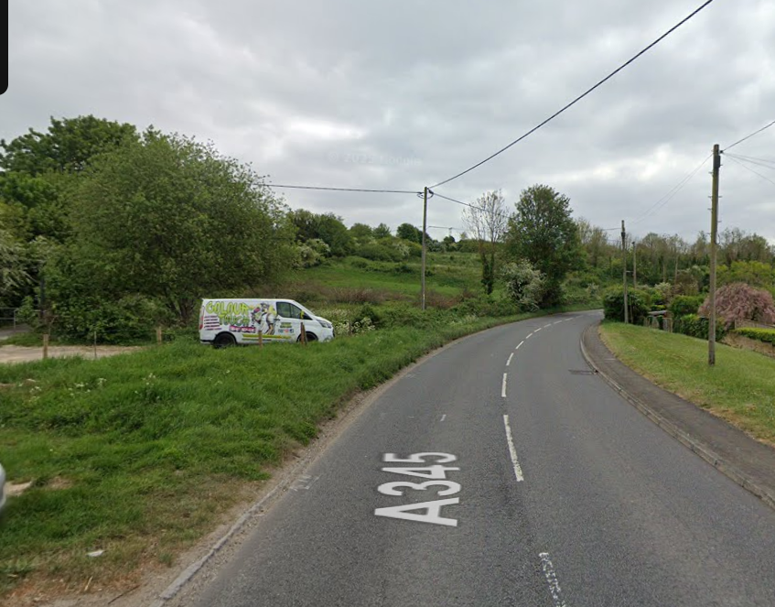

Many of the proposed works can be undertaken under permitted development such as the underground tank with associated pipes/cables and the above ground kiosks. The temporary works compound and access are also permitted development. There will be temporary harmful visual impacts caused during the construction phase for these elements but once the works have been completed, it is essentially only the kiosks that will remain visible as structures above ground, these are considered to be modest structures, again, Officers cannot object to these given that they do not need planning permission.

The proposed permanent layby with associated bollards will be the main element of the proposed works that will cause be visible upon completion of the development. Whilst the change in character of the section of land from green to a vehicle layby will be distinctly different, it is not considered that the visual impacts of the proposed layby are significant or harmful in this location alongside the A345.

Archaeology/ Heritage

The Council’s Core Strategy Policy CP58 ‘Ensuring the conservation of the historic environment’ requires that designated and non-designated heritage assets and their settings will be conserved, and where appropriate enhanced, in a manner appropriate to their significance and encourages proposals which improve the condition of heritage assets at risk.

The Council’s Core Strategy CP 57: Ensuring high quality design requires a high quality of design in all new developments. The policy requires applicants to “demonstrate how the proposal will make a positive contribution to the character of Wiltshire through (amongst other things) responding to the value of the natural and historic environment and being sympathetic to and conserving historic buildings and landscapes. Development is required to respond positively to the existing in terms of building layouts, built form, height, mass, scale, building line, plot size, elevational design, materials, streetscape and rooflines to effectively integrate the building into its setting.

The application site and siting of the proposed works are in a sensitive archaeological location with some impressive medieval lynchets (probably the best preserved in Wiltshire) immediately to the south of the site that are designated as a Scheduled Monument. Wiltshire’s Historic Environment Record (HER) also shows a cropmark ring ditch closer to the proposed works. This feature has been interpreted as indicating the location of a Bronze Age barrow, although other interpretations are possible. There were also traces of other possible barrows and an ancient field system on the north-facing slope to the east of the site that have since been lost under the 20th-century housing estate.
Wessex Water has previously been in contact with the Archaeology Service at Wiltshire Council about the permitted development elements of this scheme and, as noted in the submitted planning statement, the Council’s archaeologist has previously advised that the groundworks are subject to archaeological monitoring.
It can be noted that the temporary compound, which as is not part of this application due to falling within permitted development, lies close to the cropmark ring ditch to the south. The method of construction of the temporary compound is not included in this application but should seek to impact minimally on below ground deposits.
It is also noted in the planning statement that Historic England has been consulted by Wessex Water. Historic England have also been consulted as part of the application process due to the proximity of the Scheduled Monument to the south but have raised no objections and indeed have made a “no comment” response to the proposals.
Initially, the Council’s archaeologist requested the following condition be added to any permission given -
The programme of archaeological monitoring and recording can be secured by the following condition:
No development shall commence within the area indicated by the red line boundary on Wessex Water’s Location Plan, dated April 2025, until:
a) A written programme of archaeological investigation, which should include on-site work and off-site work such as the analysis, publishing and archiving of the results, has been submitted to and approved in writing by the Local Planning Authority; and
b) The approved programme of archaeological work has been carried out in accordance with the approved details.
REASON: In order to record and advance understanding of the significance of any heritage assets to be lost in a manner proportionate to their importance and to make this evidence and any archive generated publicly accessible in accordance with Paragraph 218 of the NPPF.
The programme of archaeological work should comprise the archaeological monitoring of any ground works that have the potential to impact on buried archaeological remains. The programme of archaeological work will conclude with the preparation of a report on the results commensurate with their significance.

The applicant however given the requirement for amendments due to highway related issues took the opportunity to provide the above requested written programme of archaeological investigation for agreement as part of the live application to avoid the need to discharge the condition at a later date.

The document was assessed and considered acceptable, see comments below from the Council’s archaeologist, a condition will be added to any permission to ensure the works are carried out in accordance with the agreed 'Project Design for Archaeological Monitoring & Recording.’

I would draw your attention to the file entitled 'Project Design for Archaeological Monitoring & Recording' that has been included among the supporting documentation attached to the above application on the planning portal. I would commend this document to you

Amenity

Core Policy 57 (Point vii) of the Wiltshire Core Strategy requires development to respect the amenity of existing occupants and ensure appropriate amenity levels for future residents. The National Planning Policy Framework (NPPF), particularly Paragraph 135, reinforces the need for development to provide a high standard of amenity for both existing and future users.

The application site is located close to a large number of residential properties, the nature of the proposed development once completed is unlikely to have an adverse impact on the amenity of these nearby residential dwellings.

There will be inevitable amenity impacts during construction works caused by noise and disturbance. There are also identified impacts in relation to the road closures that will be in place associated with the proposed development.

The amenity impacts associated with the proposal are acknowledged and, while unfortunate, are considered necessary to enable the construction of essential infrastructure. The associated road closure works are not part of the primary development itself but arise as a consequence of it, facilitating the delivery and ongoing maintenance of essential drainage infrastructure, the majority of which constitutes permitted development. Temporary disruption will occur due to road closures and construction activities; however, the working area is required to ensure safe delivery of the works, with traffic management arrangements agreed with the Highway Authority and advance notification to affected residents to minimise inconvenience.

Therefore, on balance it is considered that the works to enable the proposed development will cause a short term inconvenience to residents on the roads affected such as Lynchets Road and immediate surrounded roads as a result of diversions however, in amenity terms relating to the actual development it is not considered that these are significant enough to warrant a refusal.

A condition will be added to any permission relating to the hours of construction works.

Highways Impacts and Parking

Transport implications are a key factor in assessing planning applications, especially for larger developments. Proposals must demonstrate:

- Safe and suitable access for all users, including pedestrians, cyclists, and those with mobility impairments.
- No severe residual impacts on the surrounding highway network.
- Promotion of sustainable travel, reducing reliance on private vehicles.
- Adequate parking and cycle provision, in line with adopted standards.
- Protection and enhancement of public rights of way and active travel routes.

Relevant policies include Core Policies 60–64 of the Wiltshire Core Strategy, supported by the Wiltshire Local Transport Plan, Car Parking Strategy, and Cycling Strategy. The Local Cycling and Walking Infrastructure Plan (LCWIP) and LTN 1/20 (DfT) provide further design guidance for active travel infrastructure.

Where necessary, Transport Assessments or Statements should be submitted to evaluate impacts and identify mitigation. Planning conditions or legal agreements may be used to secure off-site improvements, travel plans, or contributions to sustainable transport infrastructure.

One of the key considerations for the proposed development subject to this planning application relates to highway impacts as the works are located alongside a very busy “A” road, on a bed adjacent to other roads. The applicant sought preapplication advice from the Council to gauge initial views on the proposals. The preapplication response raised highway safety concerns and the applicant had subsequent discussion with the Council’s highways team prior to submitting the formal planning application. During the course of the application further amendments were required to enable a no objection from the Council’s highways officer. The highways officer’s comments are included in full below which demonstrate a clear assessment of the issues and changes made to the scheme to allow permission to be granted. No objections are therefore raised regarding highway safety matters subject to conditions, the applicant will also need to enter a S278 agreement with the Council but this is undertaken outside of the planning permission process under separate legislation.

1st response - 25/02/2026

Access and parking

The agreement to the principle of the proposal had been the subject of a pre-application submission, with a proposed temporary access located approximately 70 metres southeast of the junction of the A345 with Lynchets Road.

The submitted plans with the current planning application now indicate the proposed temporary access to be located much further south, approximately 130 metres from the junction with Lynchets Road. This location indicates an access which would require vehicles to make a 180-degree turn into the site to access the compound, resulting in unacceptable manoeuvring on the A345. An access which is formed perpendicular to the A345 carriageway would be required, which should include the required 2.4m by 43m visibility splays.

The submitted plans do not provide any detail of the size of vehicles required to access the compound, and it should be demonstrated with swept path analysis that such an access can adequately accommodate the required manoeuvres of the largest vehicle that would need to access the compound.

There should also be details of the number of contractors/vehicles that would be on site and the associated materials deliveries, together with a plan indicating how such vehicles can be accommodated within the compound. A programme for the works should also be provided detailing the number of vehicles that would be generated and the management of deliveries.
Also, details of the closure of the temporary access and the reinstatement of the verge and hedge following the completion of the works will need to be provided.

With regard to the proposed permanent layby, there is insufficient detail of the kerbing to the layby, with Drawing No. C00520-WWSL-XX-XX-D-T-7204 Rev C01 referring to lorry kerbs, but with no detail of such kerbs provided. However, it has previously been advised that kerbs with a 25mm upstand should be provided which would provide ease of access for a tanker, and therefore revised, and additional detailed, plans are therefore required. See detail below
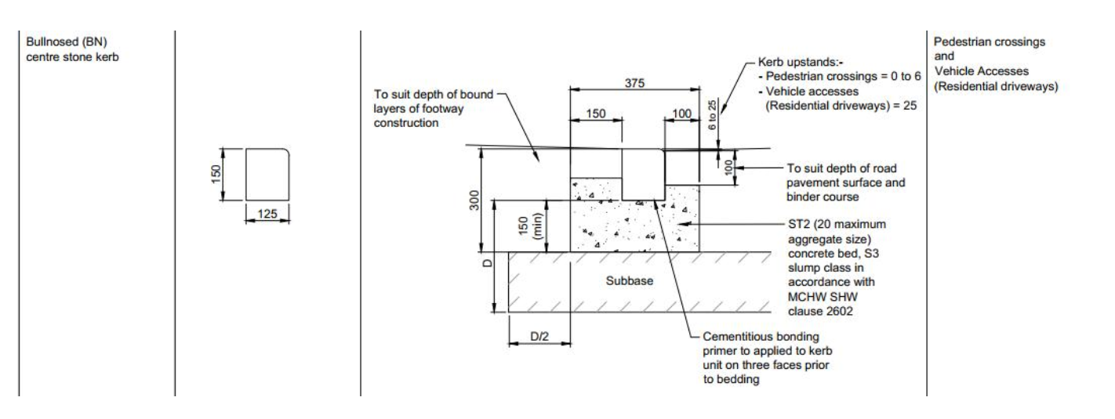
A sign was also recommended to be added (preferably on the fence behind the layby on private land) along the lines of ‘layby to be kept clear at all times for Wessex Water tanker parking’.

Whilst there was concern that the layby could be used by the public for parking, the surface of the layby is proposed as a Cellpave HD paving which would allow grass to grow through the paving thus making the layby a less obvious parking area. A detail of the proposed Cellpave will need to be provided as part of the submission.

The proposed bollards are required to protect the equipment and would mainly be located within private land. However, it is noted that the last two southwestern bollards would be located within land forming part of the public highway and as such are not acceptable, particularly having regard to the closeness to the carriageway. All bollards need to be a minimum of 500mm from the edge of the public highway. See extract below showing the extent of public highway hatched in red.

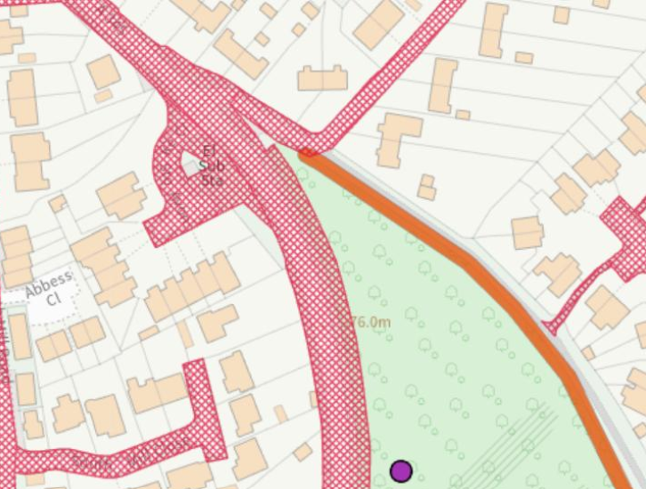
As previously advised, the works would need to be the subject of a Short Form Section 278 Agreement for which approval of detailed drawings will be required. No works can commence on the highway until such approval is in place.

Summary and Recommendations

Having regard to the above, whilst the principle of the proposed temporary access and permanent layby are considered acceptable, the detail of the temporary access is not considered appropriate due to its orientation, and a revised arrangement is required.

Amended details of the layby are also required, as referred to above.

I therefore raise a holding objection and seek the submission of further and amended details.

2nd response received 28/04/2026

Proposal

The proposal involves the creation of a permanent layby off the A345 Salisbury Road to accommodate tankers required for maintaining a below ground foul sewerage storage tank.

The proposed new access to serve a temporary construction compound has been amended to increase the width of the access from the A345, together with increasing the initial dept of the access route into the compound to facilitate HGV movements out of the access enabling them to exit perpendicular to the A345 carriageway.

The red line boundary has been extended to reflect the increased size of the access. Given that the site compound is also required to serve the construction of the development, it is considered that the compound area should also be included within the application site boundary.

Roadside control kiosks are also required to be installed which are proposed to be protected with bollards surrounding it.

Access, Parking and Manoeuvring

The proposed temporary construction access has been amended to provide for HGVs to enter and leave in a forward gear, with appropriate visibility splays of 2.4m x 43 m in each direction.
The temporary access is required to serve a compound area which would accommodate delivery vehicles, materials storage and contractor parking. Gates are proposed to be set back approximately 20m from the A345 carriageway edge to enclose the compound, which would be sufficient to ensure a vehicle can pull clear of the highway in advance of the gates.

The extent of the access surfacing between the gates and A345 carriageway has been increased to ensure an exiting vehicle can approach perpendicular to the carriageway, thus ensuring appropriate visibility without the need for drivers to look over their shoulder with a more acute angle of exit, as previously proposed.

The compound area is proposed to accommodate delivery vehicles, contractor parking, onsite manoeuvring and materials/plant storage.

The submitted Traffic Management Plan indicates the areas proposed to accommodate the vehicles and turning areas, together with the storage areas and welfare facilities. It is noted that the plan is not to scale and there are no dimensions or swept path analysis to confirm that the proposed areas are sufficient for the intended purposes. A scaled compound plan should therefore be provided which provides details of the following.

• Dimensions of contractor car parking spaces
• Swept path analysis for rigid and articulated vehicles within the compound

It is also noted that the largest vehicle requiring to be accommodated within the compound is an articulated lorry, however, the submitted swept path analysis for the temporary access only indicates the movements for an 8.5m long tanker. Details of the swept path movements for all vehicles should be submitted to demonstrate the impact of such vehicles accessing and exiting the A345 temporary access. This should also demonstrate that such vehicles can be adequately accommodated within the compound area also.

The Traffic Management Plan has provided details of the estimated number of vehicles during the 6-month construction period, advising up to a maximum of 10no. site staff, 10no. 8-wheeled rigid lorries and 3no. articulated or rigid lorries for deliveries and removal of plant, equipment and materials.

It is noted that a one-way system will operate within the compound to control the movement of vehicles, with vehicle movements being supervised.

The numbers and frequency of HGVs to and from the site would need to be carefully managed to ensure that there would be no conflict of arrivals/departures and the number of HGVs that can be accommodated within the confines of the compound.

Drawing No. C00520-WWSL-XX-XX-D-T-7206 Rev C03 indicates details of the reinstatement of the fence and hedge following the completion of the works and removal of the temporary access. These works will form part of the S278 Highway works.

With regard to the proposed permanent layby for the tanker, the layby would be constructed on land forming part of the existing public highway and would be 25m long and 4m deep. The layby detail has been amended to indicate a construction in a Heavy Duty Cellpave with a 25mm upstand kerb to provide ease of access for a tanker. The general construction shown on submitted Drawing No. C00520-WWSL-XX-XX-D-T-7208 Rev C01 is considered acceptable for this purpose.

The construction of the layby will, however, require more detailed engineering drawings of the construction, including a tie-in detail for the A345 carriageway construction to enable the kerbing works to be undertaken. Details of the construction of the temporary access will also be required. These details will need to be submitted and approved as part of a Section 278 Agreement.

A sign to restrict the access to and the use of the layby will also be required (preferably on the fence behind the layby on private land) which should read ‘layby to be kept clear at all times for Wessex Water tanker parking’.

As previously advised, the works would need to be the subject of a Short Form Section 278 Agreement for which approval of detailed drawings will be required. No works can commence on the highway until such approval is in place.

Summary and Recommendations

Having regard to the above, the revised detail for the tanker layby is considered acceptable, in planning terms. Further details of the construction will be subject to a S278 Agreement.
With regard to the proposed temporary access to serve the compound, the applicant has not provided sufficient detail of the swept path analysis for the largest vehicles that will need to be accommodated within the site in order to demonstrate how they can both access and exit the A345 access, and also manoeuvre within the compound. A scaled plan should be included within the Traffic Management Plan of the compound to confirm that the proposed parking areas and turning areas would be appropriately dimensioned and fit for purpose.

It is therefore recommended that further details are provided.

Subject to the satisfactory receipt of the additional information and confirmation that parking and manoeuvring can be adequately accommodated, together with the extension of the red line boundary to include the site compound, subject to recommended conditions.

The applicant will be expected to enter into a S278 Agreement with the Highway Authority before commencement of works hereby approved

3rd response received 26/05/2026

Application Site

The red line application boundary does not include the compound area, with the applicant advising that “under Part 4A of the GPDO temporary structures and uses are permitted development provided they are on adjoining land. The temporary compound is on adjoining land and need not be included in the redline boundary.” It is a matter for the case officer to determine if the red line boundary is appropriate.

Traffic Management Plan

The revised Traffic Management Plan indicates the areas proposed to accommodate the vehicles and turning areas, together with the storage areas and welfare facilities. Appropriate wheel wash facilities will also be required to ensure mud and loose material are not tracked out onto the highway.

The Overall Plan within the Traffic Management Plan is now shown to scale and confirms that the largest vehicle requiring access can be appropriately accommodated. It also satisfactorily indicates parking for contractors and visitors.

The swept path analysis drawings SK05, SK06 and SK07 indicate that the largest vehicle can access and exit the site compound access appropriately in a forward gear.

The numbers and frequency of HGVs to and from the site would need to be carefully managed to ensure that there would be no conflict of arrivals/departures and the number of HGVs that can be accommodated within the confines of the compound.

As previously advised, the works would need to be the subject of a Short Form Section 278 Agreement for which approval of detailed drawings will be required. No works can commence on the highway until such approval is in place.

Summary and Recommendations

The applicant has now provided sufficient detail of the swept path analysis for the largest vehicles that will need to be accommodated within the site, and it is now shown that vehicles could access and exit the A345 access, and also manoeuvre within the compound.

It is therefore recommended that no highway objection is raised subject to conditions being attached to any permission granted.

Rights of Way

Public right of way AMES 20 is located to the eastern side of the application site; it is understood that the proposed works will not impact this public right of way and it will remain open. The Council’s rights of way team have been consulted but have not provided any comments. An informative will be added to any permission to advise that it is an offence to block a public right of way, furthermore, rights of way have separate legislation should any issues arise during the construction phase of development.

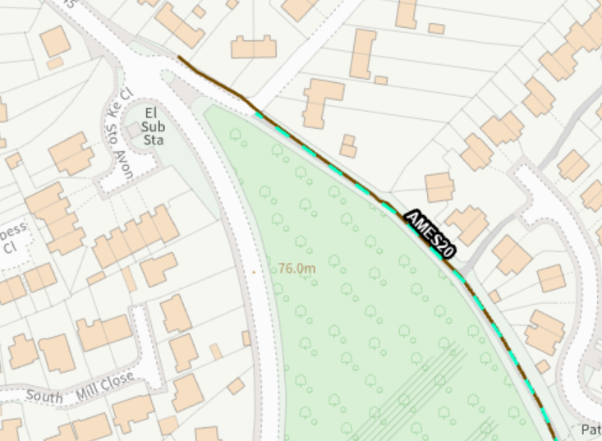

Ecology and Biodiversity

The ecological impact of development is a key planning consideration, especially for larger schemes. Proposals must assess and address potential effects on:

- Protected species
- Priority habitats
- Ecological networks

Core Policy 50 of the Wiltshire Core Strategy requires development to:

- Avoid harm to ecological assets.
- Deliver measurable Biodiversity Net Gain (BNG), in line with the Environment Act 2021.
- Support habitat restoration and connectivity.
- Integrate biodiversity into site design.

The Green & Blue Infrastructure Strategy (2022–2030) promotes nature recovery, ecosystem services, and habitat connectivity through development.

Unless exempt, National policy requires a minimum of 10% Biodiversity Net Gain (BNG) for major developments, demonstrated via:

- Biodiversity Metric calculations
- Ecological assessments (e.g. PEAs, Phase 1 surveys, protected species surveys)

The Council’s ecology team have been consulted and have provide the following comments raising no objection subject to conditions. Their comments are include in full below.

Protected and Notable Species/Habitats

Reptiles

The application site was assessed as providing suitable habitat to support reptiles in the form of scrub and tussocky grassland. Common lizard were subsequently recorded on site during the 2025 surveys in low numbers. The proposal will lead to the loss of suitable reptile habitat and mitigation in the form of phased vegetation clearance has been proposed which will allow reptiles on site to disperse into the surrounding habitat.

Due to the scale of the works and suitable adjacent habitat, the approach is accepted in this instance. The proposed phased working methods must be included within a construction environment management plan (CEMP) which could be secured by condition.

No other protected or notable species or habitats were recorded on site however; a number of reasonable avoidance measures and precautionary working practices were outlined within the ecologist report which must be implemented within the CEMP which can be secured by condition.

It is noted that a tree will be removed as part of the permitted development works. Please note that bats roost in trees and bats and their roosts afforded stringent protection under the Conservation of Habitats and Species Regulations 2017 (as amended). Prior to works being undertaken to this tree we would advise that you seek advice from your ecologists.

Salisbury Plain Special Protection Area (SPA) 6.4km

This application lies within the 6.4km zone of influence of the Salisbury Plain SPA
A test of likely significance has been carried out by the relevant Competent Authority (Wiltshire Council) as required by Regulation 63 of the Conservation of Habitats and Species Regulations 2017 (as amended). This concluded that given the scale and nature of the development there is no mechanism for adverse effect. The HRA has concluded that the application is not likely to have significant impacts on the SAC and subsequently the application is screened out of Appropriate Assessment.

Habitat Regulations Assessment: River Avon Special Area of Conservation (SAC)Hampshire Catchment

This development falls within the catchment of the River Avon SAC and has potential to cause adverse effects alone or in combination with other developments through discharge of phosphorus in wastewater.

A test of likely significance has been carried out by the relevant Competent Authority (Wiltshire Council) as required by Regulation 63 of the Conservation of Habitats and Species Regulations 2017 (as amended). This concluded that given the scale and nature of the development there is no mechanism for adverse effect. The HRA has concluded that the application is not likely to have significant impacts on the SAC and subsequently the application is screened out of Appropriate Assessment

Biodiversity Net Gain

Under Schedule 7A of the Town and Country Planning Act 1990 (as inserted by Schedule 14 of the Environment Act 2021) this application is required to deliver 10% Biodiversity Net Gain (BNG). The Biodiversity Gain Plan condition will automatically apply if approval is forthcoming.

A completed statutory metric calculation confirming the baseline and predicted post-development biodiversity units of the site has been submitted.

Information in the completed on-site baseline habitat tabs is accepted as accurate based on the information submitted. The pre-development (baseline) situation is summarised below.

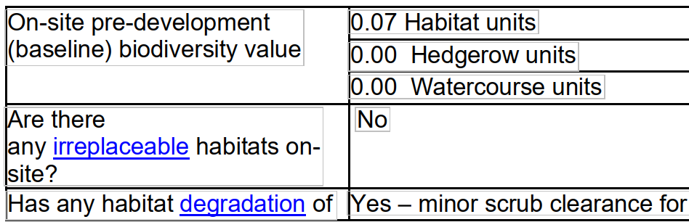

The submitted metric indicates 0.25 biodiversity units or less will be required to meet the 10%BNG requirement and that on-site BNG is not achievable. In these circumstances statutory credits can be bought without providing evidence that insufficient off-site options are available in England. For further information please refer to guidance on Statutory Biodiversity Credits on the GOV.UK website Statutory biodiversity credits - GOV.UK. under ‘How to prove statutory credits are needed’

Trees

There has been some confusion relating to whether any trees on or surrounding the application site will be affected or removed as part of the proposed development. The applicant has confirmed that -

No trees will be impacted by works within the redline boundary as there are no trees within the redline boundary, nor does it overlap with root protection zones of any nearby trees. The layout of the scheme has been designed so as to minimise impact on trees and vegetation. Outside of the redline boundary, it was required that one tree was felled to enable the permitted development aspects of the scheme to progress. The loss of this tree will be compensated for in accordance with Wessex Water’s environmental no net loss commitment, in addition to commitments under the BNG metric associated with planning. Additional trees within the permitted development area are also visible on satellite imagery, however, these trees have since been felled by the landowner for reasons unrelated to Wessex Water's development. Temporary plant and equipment will be sited outside of root protection areas in accordance with our standard Construction and Environmental Third Party Management Plan for the site (forming part of Wessex Water’s ISO 14001 Environment Management System accreditation). the shaft location (PD Rights) is also located outside of root protection areas.

Therefore, given that the application site is not within a conservation area and there are no tree preservation order protecting trees on the site, trees can be removed without prior consent. One tree has been removed as part of the works carried out under permitted development which is unfortunate but not something the Council can control; the applicant has confirmed that a new tree will be planted to replace the tree that has been removed.

Other

The concerns raised by third parties relating to the closure of nearby roads during the construction phase are acknowledged and understood that there will be a temporary inconvenience caused by the need for Wessex Water to do this to facilitate safe construction of the proposed development. It is understood that the road closures and diversions have been agreed with Wiltshire Highways (outside of the planning process) and that appropriate signage and notification to all properties affected will be undertaken. Unfortunately to enable development such measures are necessary but do not need planning permission in themselves.
Regarding notification of local residents, whilst only the immediate neighbouring dwellings were consulted, site notices were put up in the locality for anyone to view and be able to comment on the application.

PLANNING BALANCE AND CONCLUSION

At the heart of the NPPF there is a presumption in favour of sustainable development requiring local planning authorities to approve development proposals that accord with an up-to-date development plan without delay; and where there are no relevant development plan policies, or the policies which are most important for determining the application are out-of-date, permission should be granted unless (taken from paragraph 11d of the NPPF):

- The application of policies in the NPPF that protect areas or assets of particular importance provides a clear reason for refusing development proposed; or
- any adverse impacts of doing so would significantly and demonstrably outweigh the benefits, when assessed against the policies in the NPPF taken as a whole;

On balance, the proposed development is considered acceptable having regard to the Development Plan as a whole and all other material considerations.

The scheme facilitates essential drainage infrastructure required to mitigate sewer flooding risk and potential environmental harm, and is therefore supported in principle. While there will be some localised and temporary impacts during construction, particularly in relation to amenity and traffic management, these have been appropriately considered and can be mitigated through condition and agreed management measures. The permanent visual and environmental impacts of the layby are relatively modest and not considered to result in significant harm to the character of the area or nearby heritage assets.

No objections have been raised by statutory consultees subject to conditions, and the proposal is considered to comply with relevant policies of the Wiltshire Core Strategy. Accordingly, planning permission is recommended, subject to appropriate conditions.

RECOMMENDATION:
That Planning Permission be GRANTED, subject to conditions

1. The development hereby permitted shall be begun before the expiration of three years from the date of this permission.
REASON: To comply with the provisions of Section 91 of the Town and Country Planning Act 1990 as amended by the Planning and Compulsory Purchase Act 2004

2. The development hereby permitted shall be carried out in accordance with the following approved plans and documents.

Application form received 29/01/2026
Proposed layby plan Drg no C00520-WWSL-XX-XX-D-T-7204 Rev C02 received 16/04/2026
Elevation A-A Drg no C00520-WWSL-XX-XX-D-T-7205 Rev C03 received 16/04/2026
Elevation B-B Drg no C00520-WWSL-XX-XX-D-T-7206 Rev C03 received 16/04/2026
Elevation C-C Drg no C00520-WWSL-XX-XX-D-T-7207 Rev C01 received 16/04/2026
Proposed site plan Drg no C00520-WWSL-XX-XX-D-T-7202 Rev C02 received 16/04/2026
Temporary access route visibility splay Drg no C00520-WWSL-XX-XX-D-T-7203 Rev C02 received 16/04/2026
Location plan Drg no C00520-WWSL-XX-XX-D-T-7200 Rev C02 received 16/04/2026
Vehicle path analysis Scania P370 tanker compound access entry Drg no C00520-WWSL-XX-XX-D-T-SK03 Rev C01 received 16/04/2026
Vehicle path analysis Scania P370 Tanker Lay-by Exit Drg no C00520-WWSL-XX-XX-D-T-SK02 Rev C02 received 16/04/2026
Vehicle Path Analysis Scania P370 Tanker Compound Access Exit Drg no C00520-WWSL-XX-XX-D-T-SK04 Rev C01 received 16/04/2026
Vehicle Path Analysis Scania P370 Tanker Lay-by Entry Drg no C00520-WWSL-XX-XX-D-T-SK01 Rev C02 received 16/04/2026
Cellpave HD & Kerb Detail Drg no C00520-WWSL-XX-XX-D-T-7208 Rev C02 received 10/06/2026
Traffic management plan received 08/05/2026
Vehicle path analysis FTA design articulated (2016) turning within compound Drg no C00520-WWSL-XX-XX-D-T-SK06 Rev C01 received 08/05/2026
Vehicle path analysis FTA design articulated (2016) Compound access exit Drg no C00520-WWSL-XX-XX-D-T-SK07 Rev C01 received 08/05/2026
Vehicle path analysis FTA design articulated (2016) compound access entry Drg no C00520-WWSL-XX-XX-D-T-SK05 Rev C01 received 08/05/2026
Ecological Impact Assessment. April 2026. Wessex Water received 16/04/2026
Biodiversity Net Gain Statement. March 2026. Wessex Water received 16/04/2026
Statutory Biodiversity Metric. March 2026. Alice Orpin/Mark Doughty received 16/04/2026

REASON: For the avoidance of doubt and in the interests of proper planning.

3. The materials to be used in the construction of the development hereby permitted be in accordance with those stated on the approved plans and application form.

REASON: In the interests of visual amenity and the character and appearance of the area.

4. The development will only be undertaken in strict accordance with the Project Design for Archaeological Monitoring & Recording Document number ACA0531_1_1 by AC Archaeology dated March 2026 received 16/04/2026 unless otherwise agreed in writing with the Local Planning Authority.

The Project Design requires the archaeological monitoring and recording of any ground works that have the potential to impact on buried archaeological remains. The programme of archaeological work will conclude with the preparation of a report on the results of the exercise. A report on the results of the archaeological monitoring and recording will be submitted to the local planning authority within six months of the completion of archaeological monitoring on site.

REASON: To enable the recording of any matters of archaeological interest.

5. No construction or demolition work shall take place on Sundays or Public Holidays or outside the hours of 0800 to 18:00 Monday to Friday and 08:00 to 13:00 on Saturdays.
Reason: Core policy 57, Ensuring high design and place shaping such that appropriate levels of amenity are achievable.

6. The temporary construction access hereby approved shall not be first brought into use until the visibility splays shown on the approved plans have been provided with no obstruction to visibility at or above a height of 900mm above the nearside carriageway level. The visibility splays shall always be maintained free of obstruction thereafter for the duration of the site works.

Reason: In the interests of highway safety

7. The development shall be carried out in accordance with the Traffic Management Plan received on 8th May 2026, including the site compound plan numbered C00520-WWSL-XXXX-D-T-SK06 Rev C01.

Reason: In the interests of highway safety.

8. The temporary construction access hereby approved to the A345 Salisbury Road shall be reinstated and the verge and hedgerows fully reinstated by the applicant as detailed within the application documents, in a manner to be agreed in writing with the Local Planning Authority and within 1 month of completion of the site works.

Reason: In the interests of highway safety and amenity

9. Prior to the commencement of works, including demolition, ground works/excavation, site clearance, vegetation clearance and boundary treatment works, a Construction Environmental Management Plan (CEMP) shall be submitted to the local planning authority for approval in writing. The Plan shall provide details of the avoidance, mitigation and protective measures to be implemented before and during the construction phase, including but not necessarily limited to the following:

Identification of ecological protection areas/buffer zones and tree root protection areas and details of physical means of protection, e.g. exclusion fencing.

Working method statements for protected/priority species, such as nesting birds and reptiles.

Work schedules for activities with specific timing requirements in order to avoid/reduce potential harm to ecological receptors; including details of when a licensed ecologist and/or ecological clerk of works (ECoW) shall be present on site.

Development shall be carried out in strict accordance with the approved CEMP.

REASON: To ensure adequate protection and mitigation for ecological receptors prior to and during construction, and that works are undertaken in line with current best practice and industry standards and are supervised by a suitably licensed and competent professional ecological consultant where applicable

INFORMATIVES

1. BNG required - The effect of paragraph 13 of Schedule 7A to the Town and Country Planning Act 1990 is that planning permission granted for the development of land in England is deemed to have been granted subject to the condition “(the biodiversity gain condition”) that development may not begin unless:
(a) a Biodiversity Gain Plan has been submitted to the planning authority, and
(b) the planning authority has approved the plan.

The planning authority, for the purposes of determining whether to approve a Biodiversity Gain Plan if one is required in respect of this permission would be Wiltshire Council. There are statutory exemptions and transitional arrangements which mean that the biodiversity gain condition does not always apply. For further information on exempt developments please refer to: https://www.gov.uk/guidance/biodiversity-net-gain-exemptdevelopments.

Based on the information available this permission is considered to be one which will require the approval of a biodiversity gain plan before development is begun because none of the statutory exemptions or transitional arrangements are considered to apply.

Irreplaceable habitat If the onsite habitat includes irreplaceable habitat (within the meaning of the Biodiversity Gain Requirements (Irreplaceable Habitat) Regulations 2024) there are additional requirements for the content and approval of Biodiversity Gain Plans.

The Biodiversity Gain Plan must include, in addition to information about steps taken or to be taken to minimise any adverse effect of the development on the habitat, information on arrangements for compensation for any impact the development has on the biodiversity of the irreplaceable habitat.

The planning authority can only approve a Biodiversity Gain Plan if satisfied that the adverse effect of the development on the biodiversity of the irreplaceable habitat is minimised and appropriate arrangements have been made for the purpose of compensating for any impact which do not include the use of biodiversity credits.

2. The applicant will be expected to enter into a S278 Agreement with the Highway Authority before commencement of works hereby approved.

3. Nesting Birds - All British birds, their nests and eggs are protected under Section 1 of the Wildlife and Countryside Act 1981 (as amended) and the Countryside and Rights of Way Act 2000 while birds are nesting, building nests and sitting on eggs. The applicant is advised to check any structure or vegetation capable of supporting breeding birds and delay removing or altering such features until after young birds have fledged. Damage to extensive areas that could contain nests/breeding birds should be undertaken outside the breeding season. This season is usually taken to be the period between 1st March and 31st August, but some species are known to breed outside these limits.

4. Any alterations to the approved plans, brought about by compliance with Building Regulations or any other reason must first be agreed in writing with the Local Planning Authority before commencement of work.

5. The applicant is requested to note that this permission does not affect any private property rights and therefore does not authorise the carrying out of any work on land outside their control. If such works are required, it will be necessary for the applicant to obtain the landowners consent before such works commence. If you intend carrying out works in the vicinity of the site boundary, you are also advised that it may be expedient to seek your own advice with regard to the requirements of the Party Wall Act 1996.

6.The applicant should note that it is a criminal offence to obstruct a public right of way under section 137 of the Highways Act 1980 and therefore no materials, plant, temporary structures or excavations of any kind should be deposited / undertaken which obstruct or adversely affect the public right of way WSLO26 whilst development takes place, without prior consultation with, and the further permission of, the highways authority at Wiltshire council.
7. The applicant should note that under the terms of the Wildlife and Countryside Act (1981) and the Conservation of Habitats and Species Regulations 2017 (as amended) it is an offence to disturb or harm any protected species including for example, breeding birds and reptiles. The protection offered to some species such as bats, extends beyond the individual animals to the places they use for shelter or resting. Please note that this consent does not override the statutory protection afforded to any such species. In the event that your proposals could potentially affect a protected species you should seek the advice of a suitably qualified and experienced ecologist and consider the need for a licence from Natural England prior to commencing works. Please see Natural England’s website for further information on protected species.

