HOUSEHOLDER PLANNING APPLICATION.
CASE OFFICER REPORT

APPLICATION REFERENCE: | PL/2026/02071
APPLICATION TYPE: | Householder
SITE ADDRESS: | 75 Fell Road, Westbury, BA13 2GG.
DEVELOPMENT DESCRIPTION: | Retrospective application for removal of conservatory and replacement with single storey extension.
RECOMMENDATION: | Approve with Conditions.

PROPOSAL
The proposal seeks retrospective permission for the removal of an aged conservatory and for its replacement with a single storey extension in the same location and on the same footprint.

SITE DESCRIPTION/CONTEXT
The site is a two-storey semi-detached/link attached dwelling located with the market town of Westbury. The site is located within an established residential housing estate and is also located within the Salisbury Plain SPA 6400m buffer zone, the ‘Grey’ zone of the adopted Trowbridge Westbury Bat Mitigation Strategy (TWBMS) and also the Bath & Braford on Avon Bat SAC.

RELEVANT PLANNING HISTORY
Proposal / Summary
N/A

RELEVANT POLICIES AND GUIDANCE

Wiltshire Core Strategy:

- Core Policy 29 Spatial Strategy for Westbury
- Core Policy 57 Ensuring High Quality Design and Place Shaping
- Core Policy 50: Biodiversity and Geodiversity
- Core Policy 51: Landscape
- Core Policy 58: Ensuring the Conservation of the Historic Environment
- Core Policy 61: Transport and New Development
- Core Policy 64: Demand Management
- Core Policy 67: Flood Risk

Westbury ‘Made’ Neighbourhood Plan

Wiltshire Design Guide: Appendix D – Design Guidance for Householder extensions

The National Planning Policy Framework (NPPF)

The Planning Practice Guidance

National Design Guide

Emerging Wiltshire Local Plan:
At Full Council on 19 May 2026, the elected members of Wiltshire Council agreed to withdraw the emerging Wiltshire Local Plan. It will now be subject to a legal process to finalise its withdrawal - which is likely to happen in July or August (2026). The said Plan has no material weight for the purposes of this application.

CONSULTATION RESPONSES
Westbury Town Council: No objections.

Drainage: No comment.

REPRESENTATIONS
One email of objection was received raising the following points:

-Size and design of the extension is too large and represents overdevelopment.
-Loss of light & over shadowing.
-Constructed prior to receiving planning permission, with work continuing once reported.
-Summer house also constructed without planning permission and has applicant’s son living within it.
-Drainage system installed for summer house, drainage problems with neighbouring houses.
-Neighbour at No.73 not neighbour consulted.

PRINCIPLE OF THE PROPOSAL.
The principle of the proposed scheme is considered to be acceptable for the reasons as discussed below.

ASSESSMENT
Section 38(6) of the Planning and Compulsory Purchase Act 2004 states:

"If regard is to be had to the development plan for the purposes of any determination to be made under the planning Acts, the determination must be made in accordance with the plan unless material considerations indicate otherwise."

In accordance with this statutory requirement, this application has been assessed against the relevant policies of the Development Plan, including the adopted Wiltshire Core Strategy (2015) and the Westbury ‘Made’ Neighbourhood Plan.

Design and Impact upon the upon the character and context of the area

Core Policy 57 - Ensuring High Quality Design and Place Shaping of the Wiltshire Core Strategy seeks to ensure that all new development is of high design quality, reflecting local context, character, and distinctiveness.

The proposal can be viewed within the plan snippets taken from the submitted plans:

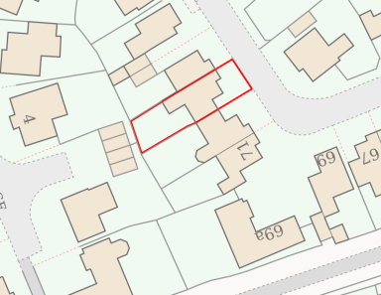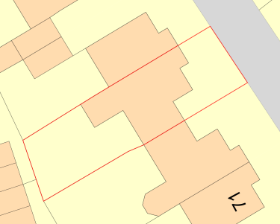
Location Plan Site Plan

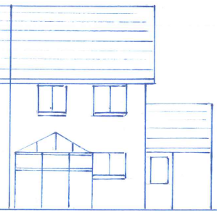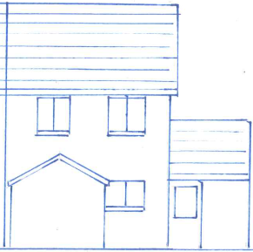
Existing & Proposed West Rear Elevations.

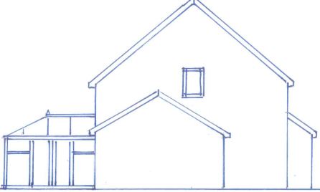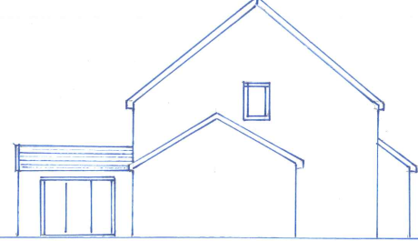
Existing & Proposed North Side Elevations.

The proposal has seen the removal of a conservatory to the rear of the building and for its replacement with a single storey extension, which has a shallow pitched roof, which serves to provide a dining room. The scheme has bifold doors leading out on the site’s private residential garden area.

The proposal utilises the footprint of the former conservatory. The extension has also utilised the existing brick constructed boundary wall facing onto the neighbouring boundary fence with No.77, with the two outer side walls being timber clad. The roof height of the proposal would remain the same at 3m, as that of the former conservatory, as would its length and width measurements at 3.7m and 3m. In essence, a same sized extension has been constructed as that of the former conservatory.

The proposal is an upgraded extension that has thermal heat retention efficiency, which is a contrast to the previous inefficient conservatory. The scale and design of the extension is appraised as being entirely appropriate and sympathetic to the host dwelling.

Therefore, in summary, having regard to the above, the proposal complies with the design principles set out in Core Policy 57 of the Wiltshire Core Strategy and Appendix D of the Wiltshire Design Guide.

Amenity
Point vii of Core Policy 57 - Ensuring High Quality Design and Place Shaping of the Wiltshire Core Strategy seeks to ensure that developments do not adversely affect neighbouring properties. The National Planning Policy Framework (NPPF), particularly Paragraph 135(f), stresses that planning decisions should ensure developments provide a high standard of amenity for existing and future users.
The extension is single storey whose measurements match those of the previous conservatory and is in effect a swap for the old conservatory. The extension has utilised the existing footprint of the conservatory, as well as the north facing former brick constructed boundary wall of the previous conservatory, which is adjacent to the existing high level boundary fence between the host dwelling and the neighbour at No.77.

Whilst the extension does not have the glass transparency of its roof of the previous conservatory, the eaves height would be 2.1 metre with a roof ridge height of just under 3 metres, this being as shown below in the scaled plan snippet:

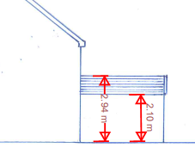

Therefore, taking into account the height of the 1.8 metre boundary fence, the eaves height is 30cm above the fenceline, with the roof sloping away from the boundary. There are no side facing windows so there is no overlooking of the neighbour at No.77.

For the reasons set out above, and given location and orientation of the extension, there would be no significant overshadowing or loss of light to the nearest neighbour at No. 77. The replacement extension would be of limited height and mass (as discussed above) and is not considered to constitute overdevelopment. Similarly, the separation distance and orientation between the single-storey extension and No. 73 are such that no unacceptable loss of light or overshadowing would occur.

The proposal therefore accords with Core Policy 57 point vii. in respect of safeguarding residential amenity and Appendix D of the Wiltshire Design Guide.

Ecology Impact CP50 requires no net loss of biodiversity on site. The site is located within an established residential housing estate and is also located within the Salisbury Plain SPA 6400m buffer zone, the ‘Grey’ zone of the adopted Trowbridge Westbury Bat Mitigation Strategy (TWBMS) and also the Bath & Braford on Avon Bat SAC. The development has taken place and because of its minor nature and urban location is considered unlikely to have resulted in ecological harm during the dismantling of the conservatory.

There is no mechanism for significant effects from recreational pressure since it does not result in the creation of a new dwelling. Accordingly, the proposal is acceptable in this regard. As such, the development complies with Core Policy 50 of the Wiltshire Core Strategy and the relevant provisions of the NPPF.

Biodiversity Net Gain. This application is exempt from the requirement to deliver Biodiversity Net Gain under Schedule 7A, Section 4(2)(a) of the Town and Country Planning Act 1990, as inserted by the Environment Act 2021, because the proposal is a householder extension.

Flood Risk Assessment.
A flood risk assessment has been included with the application as the site is within flood zone 2 in the main and very partially flood zone 3 to the northern aspect of the site. The submitted information indicates that flood mitigation measures would be undertaken in regard to raising the electrical sockets a minimum of 400mm off the ground level, which is considered to be wholly appropriate.

Other Matters.
The neighbour at No.73 has written in with several points of concern; with those relating to design, size and overshadowing having already been addressed. Concerns regarding the planning application having been submitted retrospectively are acknowledged, however, the planning legislation is not punitive for such late submissions and officers are only able to examine the planning merits of the scheme, as has been done throughout. Comments have also been received in regard to the construction of a summer house in the rear garden, whose footprint is shown in the block plans. The summer house is not the subject of the current application and so it is not possible to comment on its design or use.

Concern has also been expressed in regard to drainage matters; the council’s drainage section has been consulted on this application, who have not raised any comments.

The neighbour at No.73 has complained that they were not notified about the application and did not receive a neighbour notification letter. The council records show a letter as having been sent out to the neighbour, if the letter was not delivered, this is something outside of the council’s control. In addition comments on the scheme have been received from this neighbour.

As the application is retrospective, there is no requirement to apply the 3 year commencement condition.

CONCLUSION
The extension is acceptable in terms of its design, scale, and relationship with the surrounding area. It would not result in any unacceptable harm to the character of the locality, the amenities of neighbouring occupiers, or the interests of highway safety or ecology.

The proposal is therefore considered to comply with the relevant policies of the Wiltshire Core Strategy, the Wiltshire Local Plan, and the National Planning Policy Framework. As such, the application is recommended for approval, subject to the conditions set out below.

RECOMMENDATION: Planning Permission be GRANTED subject to conditions.

