APPLICATION FOR FULL PLANNING PERMISSION
DELEGATED REPORT

APPLICATION REFERENCE: | PL/2026/02194
APPLICATION TYPE: | Full Planning Permission
SITE ADDRESS: | 3 Church Lane, Limpley Stoke, Bath, BA2 7GH
DEVELOPMENT DESCRIPTION: | Retrospective temporary change of use of existing annexe to self-contained dwelling for a period of 2 years
RECOMMENDATION: | That Planning Permission be GRANTED

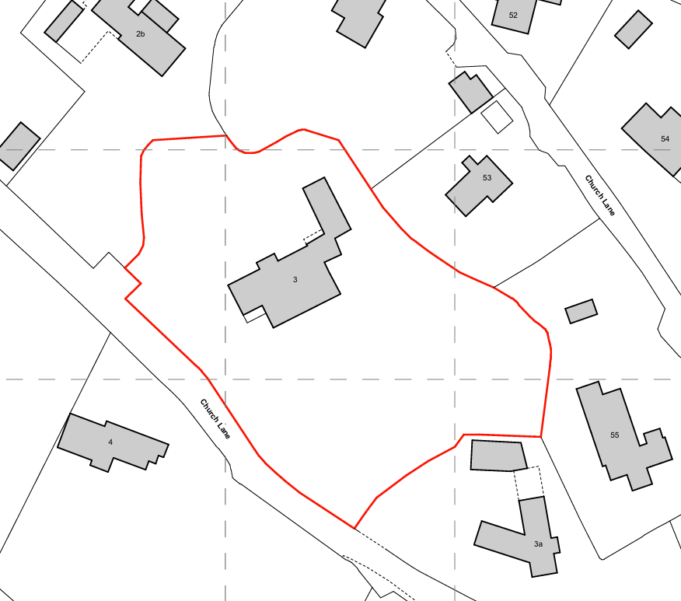

PROPOSAL

The application seeks temporary planning permission for the change of use of an existing residential annexe to a self-contained one-bedroom dwelling for a 2-year period. The annexe is located above an existing garage and was used as ancillary accommodation to the host dwelling. No operational development, external alterations or extensions are proposed as part of the application, and the building would remain physically and functionally linked to the main house. The proposal is intended to be temporary in nature, due to a change in the applicant’s family circumstances with the accommodation being capable of reverting to its ancillary use at the end of the stated 2-year period without requiring any operational development.

SITE DESCRIPTION / CONTEXT

The application site relates to a detached dwelling at 3 Church Lane, Limpley Stoke, occupying a generous residential plot within the small village. The property includes an L-shaped dwelling with the annexe provided above the garage, which is served by a shared driveway providing on-site parking and turning. The site lies within the West Wiltshire Green Belt and the Cotswolds National Landscape (formerly AONB), as well as a designated Special Landscape Area, reflecting the high quality and sensitivity of the surrounding rural landscape. The site is located within Flood Zone 1 and is not subject to significant flood risk constraints, although it falls within a number of ecological buffer zones associated with SAC designations. The immediate character of the area is predominantly residential with a strong rural setting defined by spacious plots, landscaping and low-density development

PLANNING HISTORY

Reference No. | Proposal / Summary | Decision
W/76/00324/HIS | Swimming pool annexe | Approved
W/92/00952/FUL | First floor extension over garage | Approved
W/96/00578/FUL | Granny flat over existing garage / workshop | Approved
W/01/01116/FUL | Granny annexe | Approved
18/12089/FUL | Full refurbishment and small extension to existing dwelling | Approved

RELEVANT LEGISLATION, POLICIES AND GUIDANCE

Wiltshire Core Strategy:

Core Policy 1 Settlement Strategy;
Core Policy 2 Delivery Strategy;
Core Policy 7 Spatial Strategy: Bradford on Avon Community Area;
Core Policy 45 Meeting Wiltshire’s Housing Needs;
Core Policy 50 Biodiversity and Geodiversity;
Core Policy 51 Landscape;
Core Policy 57 Ensuring High-Quality Design and Place Shaping;
Core Policy 60 Sustainable Transport;
Core Policy 61 Transport and Development;
Core Policy 62 Development Impacts on the Transport Network;
Core Policy 64 Demand Management;
Core Policy 67 Flood Risk;

Freshford & Limpley Stoke made Neighbourhood Plan 2014-2039

The National Planning Policy Framework (NPPF) and Planning Practice Guidance (PPG)

Wiltshire Design Guide

The Wiltshire Local Transport Plan 2011 – 2026: Car Parking Strategy (March 2015).

The Wiltshire Local Transport Plan 4 (LTP4) (March 2025)

West Wiltshire Local Plan Saved Policies
C3 Special Landscape Area: SLA 7 The southern fringes of The Cotswolds, not covered by designation as an AONB.

Emerging Policy – Wiltshire Local Plan Review

At Full Council on 19 May, the elected members of Wiltshire Council agreed to withdraw the emerging WLP. It will now be subject to a legal process to finalise its withdrawal - which is likely to happen in the autumn of 2026. The said Plan has no material weight for the purposes of the application.

CONSULTATION RESPONSES

Limpley Stoke Parish Council – Supportive

Local Highway Authority (Wiltshire Council) – No Objection

REPRESENTATIONS

No third-party comments were received.

ASSESSMENT

Section 38(6) of the Planning and Compulsory Purchase Act 2004 states:

"If regard is to be had to the development plan for the purposes of any determination to be made under the planning Acts, the determination must be made in accordance with the plan unless material considerations indicate otherwise".

In accordance with this statutory requirement, this application has been assessed against the relevant policies of the Development Plan, including the adopted Wiltshire Core Strategy (2015) and, where applicable, any made Neighbourhood Plans.

Principle of Development

The application site lies within the village of Limpley Stoke, identified as a Small Village within the Wiltshire Core Strategy. The proposal seeks the temporary use of an existing annexe as a self-contained dwelling. Notwithstanding its temporary nature, the proposal must be considered as the creation of an additional dwelling for the purposes of policy assessment.

Core Policy 1 sets out that development within Small Villages will be limited to that which helps to meet the housing needs of the settlement, or supports employment opportunities, services and facilities. In this instance, whilst the proposal would contribute modestly to the Council’s housing supply through the provision of a one-bedroom unit, there is limited evidence to demonstrate that it would directly meet an identified local housing need. However, it is acknowledged that the unit has been used on an unauthorised basis for separate residential accommodation and has been occupied on that basis, with the application seeking to regularise and temporarily retain this use.

WCS Core Policy 2 further states that, outside defined settlement boundaries, development at Small Villages will be limited to infill within the existing built area and will be supported where it meets housing needs and satisfies criteria relating to character, settlement form and landscape impact. In this case, the annexe is located within the established residential curtilage of an existing dwelling, within the built-up part of the village, and does not represent new or encroaching built development. The proposal does not involve any operational development, and therefore fully respects the existing character and form of the settlement. It would not result in elongation of the village or the consolidation of sporadic or loose-knit development, nor would it introduce development into a sensitive or undeveloped landscape. As such, criteria i), ii) and iii) of Core Policy 2 are satisfied. The proposal has also been considered against the Freshford and Limpley Stoke Neighbourhood Plan and is not considered to conflict with its relevant policies.

Notwithstanding the above, the site is located within the Green Belt, where national policy requires that substantial weight is given to any harm. As set out above, the proposal involves no increase in built form and would preserve the spatial openness of the Green Belt. Any limited impact arising from a modest intensification of use, such as additional vehicle movements or parking, is considered minor and is further tempered by the temporary and reversible nature of the proposal.

Overall, the proposal represents the temporary reuse of existing accommodation within the built area of the village, without physical expansion or harm to settlement form or landscape character. When combined with the limited Green Belt impacts and the reversible nature of the development, the proposal is considered acceptable in principle, subject to the imposition of a condition restricting the use to a temporary period.

Greenbelt

The site lies within the West Wiltshire Green Belt, where national policy set out in the NPPF establishes a presumption against inappropriate development. Paragraph 153 confirms that inappropriate development is, by definition, harmful to the Green Belt and should not be approved except in very special circumstances, while paragraph 154 provides limited exceptions, including the re-use of buildings where openness is preserved.

The proposal relates solely to the temporary change of use of an existing annexe and does not involve any operational development, extensions, or external alterations. As such, there would be no increase in built form, and the physical openness of the Green Belt would be preserved. The building is of permanent and substantial construction and already forms part of the established residential curtilage. In this respect, the proposal aligns with the exceptions set out in paragraph 154 of the NPPF.

It is acknowledged that the use of the annexe as a separate dwelling could result in a modest increase in activity on site, including the potential for an additional parked vehicle. As identified at pre-application stage, this has the potential to give rise to a limited impact on the openness of the Green Belt in terms of activity. However, the parking area already exists, no additional hardstanding is proposed, and it has been demonstrated that adequate parking can be provided within the site. The consequential impacts are therefore considered to be minimal.

Furthermore, as clarified through the follow-up pre-application response, the proposal is explicitly temporary in nature and fully reversible, and the absence of operational development is a significant material consideration. The Planning Practice Guidance advises that the assessment of openness is a matter of planning judgement, including consideration of duration and the ability to restore the site. In this case, the temporary nature of the proposal and the lack of any permanent physical change weigh in favour of the development.

Taking all of the above into account, it is considered that the proposal would preserve the openness of the Green Belt and would not conflict with its purposes. The limited additional activity associated with the use would not amount to material harm, particularly when balanced against the temporary and reversible nature of the development. The proposal is therefore considered acceptable in Green Belt terms, subject to a condition limiting the permission to a defined period.

Design and impact the upon the character and context of the area

Core Policy 57 Ensuring High Quality Design and Place Shaping of the Wiltshire Core Strategy requires all new development to achieve a high standard of design that responds positively to its local context. Proposals must reinforce and enhance local character and distinctiveness, relate appropriately to the surrounding landscape, and demonstrate a thoughtful response to existing townscape features. This includes careful consideration of elements such as building height, scale, massing, building line, materials, and overall appearance, ensuring new development integrates harmoniously with its setting.

Core Policy 51 of the WCS states that development should conserve and protect existing landscape character. It additionally states that local features such as hedgerows and watercourses must be considered as part of any analysis, as well as other matters which relate to the overall distinctive quality of the specific locality in question. Given the absence of external alterations, the proposal is considered to conserve the scenic beauty of the National Landscape.

The proposal relates to the change of use of an existing annexe and does not involve any external alterations, extensions or operational development. As such, the form, scale, materials and overall appearance of the building would remain unchanged. The proposal would therefore not give rise to harm in design terms and would preserve the character and appearance of both the host dwelling and the wider area, in accordance with Core Policies 51 and 57 of the Wiltshire Core Strategy. The development therefore respects the established residential character of the site and its surroundings.

Having regard to the above, the proposal complies with the design principles set out in Core Policy 57 of the Wiltshire Core Strategy and Appendix D of the Wiltshire Design Guide.

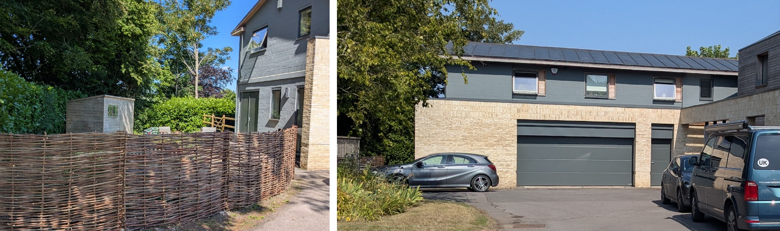
Private amenity space and front elevation

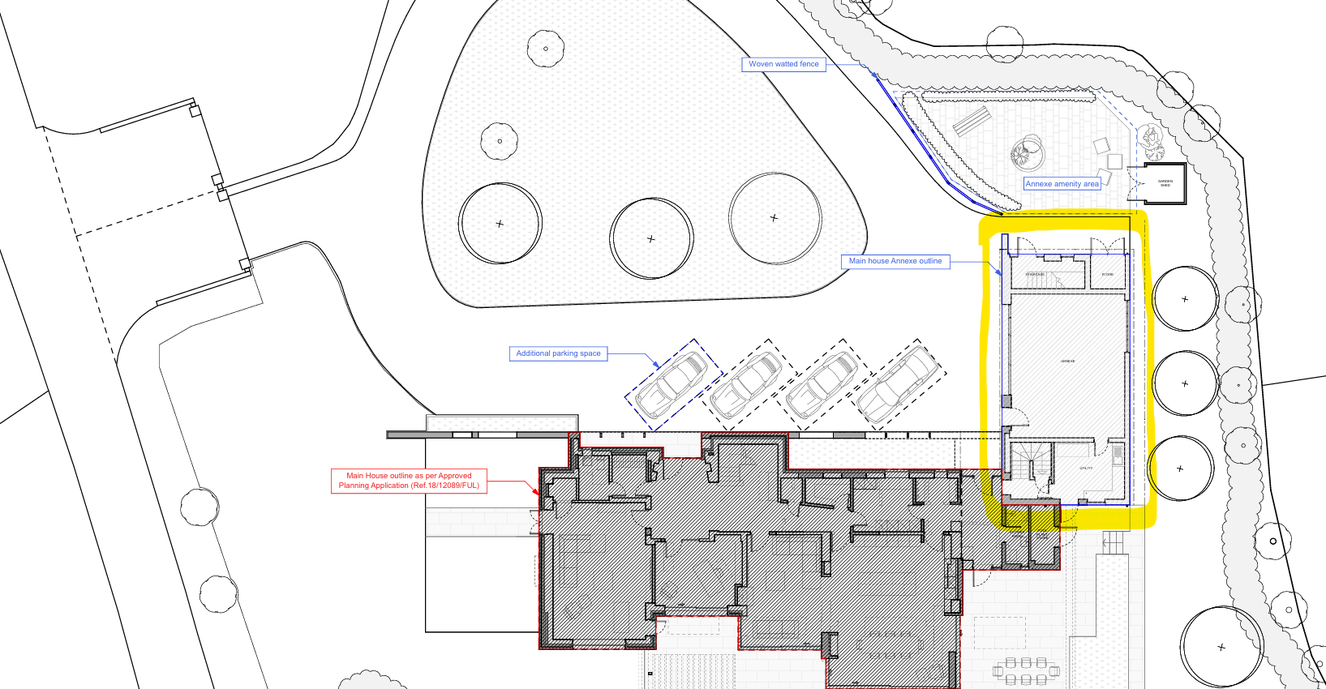
Block Plan (Annexe highlighted yellow)

Amenity

Point vii of Core Policy 57 Ensuring High Quality Design and Place Shaping of the Wiltshire Core Strategy seeks to ensure that developments do not adversely affect neighbouring properties.

The National Planning Policy Framework (NPPF), particularly Paragraph 135, stresses that planning decisions should ensure developments provide a high standard of amenity for existing and future users.

The proposed use of the annexe as a one-bedroom dwelling is not considered to give rise to unacceptable impacts on the amenity of neighbouring occupiers. The accommodation is modest in scale and the level of activity associated with its occupation would be comparable to that which could reasonably occur through incidental or ancillary use of the annexe. The site occupies a relatively large residential curtilage, with separation from neighbouring properties and the benefit of established boundary treatments which provide a degree of screening. As such, the proposal would not result in material overlooking, loss of privacy, noise, or disturbance.

In terms of the living conditions of future occupiers, the annexe provides a suitable standard of internal accommodation and benefits from access to a defined area of private outdoor space. This external amenity area is proportionate to the size of the unit and provides adequate space for sitting out, drying clothes and general day-to-day use. Overall, the proposal is considered to provide an acceptable standard of residential amenity for both existing and future occupants, in accordance with Core Policy 57 of the Wiltshire Core Strategy.

The proposal is appropriately sited, designed, and oriented to ensure that it would not result in unacceptable impact upon/to the amenities or living conditions of neighbouring residential occupiers, particularly in terms of outlook, privacy, or access to natural light.

The proposal therefore accords with Core Policy 57 point vii in respect of safeguarding residential amenity and Appendix D of the Wiltshire Design Guide.

Transport and Highways

Core Policy 60 of the Wiltshire Core Strategy seeks to support safe and efficient movement of people and mitigate the transport impacts of development, whilst Core Policy 61 requires development to provide safe access to the highway network. Paragraph 116 of the NPPF advises that development should only be refused on highways grounds where there would be an unacceptable impact on highway safety or where the residual cumulative impacts on the road network would be severe.

The proposal would utilise the existing access, driveway and parking arrangements associated with the host dwelling, with no alterations to the highway or access arrangements proposed. The Local Highway Authority has raised no objection to the development, and there is no evidence to suggest that the modest intensification associated with a one-bedroom unit would give rise to material highway safety concerns.

Core Policy 64 requires development to comply with adopted parking standards, as set out within the Wiltshire Local Transport Plan and Car Parking Strategy. In this case, a one-bedroom dwelling would require a minimum of one parking space. The site benefits from an established parking area with capacity for multiple vehicles, and it has been demonstrated that sufficient space is available to accommodate the needs of both the host dwelling and the proposed unit. Subject to the identification and retention of a dedicated parking space for the annexe, the proposal is considered to accord with adopted parking standards and would not result in unacceptable pressure on the surrounding highway network.

Ecology

Core Policy 50 of the Wiltshire Core Strategy seeks to ensure that development avoids adverse impacts on biodiversity and, where possible, enhances ecological value. The proposal relates solely to the change of use of an existing building and does not involve any external alterations, land take, or works to the fabric of the building that would be likely to affect habitats or protected species.

The site is located within a number of ecological buffer zones associated with SAC designations; however, given the absence of operational development and the modest scale of the proposal, it is not considered that the development would give rise to harm to designated sites or protected species. The use of the building would remain residential in nature, and no intensification is proposed that would materially affect ecological interests.

In addition, the proposal falls within the category of development that is exempt from the requirement to deliver Biodiversity Net Gain, as it does not constitute operational development.

Accordingly, the proposal is considered to comply with Core Policy 50 of the Wiltshire Core Strategy, with no adverse ecological impacts identified.

Flooding and Drainage
Core Policy 67 of the Wiltshire Core Strategy requires development to be located and designed to minimise vulnerability to flooding and to ensure it does not increase flood risk elsewhere. The application site is located within Flood Zone 1, which represents the lowest probability of flooding, and there is no evidence to suggest that the site is affected by surface water or groundwater flooding to a degree that would constrain the proposed development.
The proposal relates solely to the change of use of an existing building and does not involve any operational development or alterations to the site’s drainage arrangements. As such, it would continue to utilise the existing drainage infrastructure, which is considered to be functioning adequately. There is therefore no requirement for the introduction of sustainable drainage systems or further technical assessment in this instance.
Having regard to the scale and nature of the proposal, and the fact that no built development is proposed, the development is considered acceptable in relation to flood risk and drainage, in accordance with Core Policy 67 of the Wiltshire Core Strategy and the relevant provisions of the NPPF.

Planning Balance

The Local Planning Authority is currently unable to demonstrate a five-year supply of deliverable housing sites, with a supply position of approximately 2.8 years. This represents a significant material consideration and renders the most important policies for determining the application out of date. In accordance with paragraph 11(d) of the NPPF, permission should therefore be granted unless the application of policies in the Framework that protect areas or assets of particular importance provides a clear reason for refusing the development, or any adverse impacts would significantly and demonstrably outweigh the benefits.
The site lies within the Green Belt, which is identified within footnote 7 of the NPPF. However, as set out in the assessment above, the proposal would preserve the openness of the Green Belt and would not conflict with its purposes. The limited additional activity associated with the use would not amount to material harm, particularly when taking into account the temporary and reversible nature of the proposal. As such, Green Belt policy does not provide a strong reason for refusal in this instance, and the tilted balance is engaged.
In applying paragraph 11(d)(ii), it is acknowledged that the proposal gives rise to a limited degree of policy conflict, including with Core Policy 1, and the potential for minor non-spatial impacts on openness arising from the additional residential activity. However, these harms are afforded limited weight given the modest scale of the development, the absence of operational development, and the temporary nature of the proposal.
Against this, the proposal would deliver a modest but nevertheless valuable contribution to housing supply in the context of a significant shortfall, making effective use of an existing residential building without the need for new construction. The proposal would not give rise to adverse impacts in respect of design, residential amenity, highways, ecology or flood risk.
Taking all matters into account, the adverse impacts of the proposal would not significantly and demonstrably outweigh its benefits. The proposal is therefore considered to represent sustainable development and is acceptable in accordance with the National Planning Policy Framework.

CONCLUSION

The proposal gives rise to a limited degree of policy conflict, particularly in respect of Core Policy 1 and the location of a new dwelling within the Green Belt. However, these harms are afforded limited weight, having regard to the absence of operational development, the modest scale of the unit, and the temporary and reversible nature of the proposal. When taken together with the benefits of providing additional housing and making effective use of an existing building and having regard to the tilted balance set out in the NPPF, the proposal is considered to be acceptable. Planning permission is therefore recommended for approval.

RECOMMENDATION: That Planning Permission be GRANTED subject to the following conditions:

1.The development hereby permitted is based on the following approved plans and documents:

Proposed First Floor Plan PL-GA-101 A
Proposed East and West Elevations PL-GA-301 A
Proposed Block Plan PL-GA-003 A
Site Location Map PL-EX-001 A
Proposed Ground Floor Plan PL-GA-100 A
Proposed North and South Elevations PL-EX-300 A
Proposed Roof Level Plan PL-GA-102 A

REASON: For the avoidance of doubt and in the interests of proper planning.

2.The hereby approved use of the annexe as a self-contained dwelling shall only enure for a temporary period and shall cease 2 years from date of this decision at which point the accommodation shall revert to being used only for ancillary purposes associated to the main dwelling at 3 Church Lane, Limpley Stoke, Bath, BA2 7GH.

REASON: To define the terms of the development and to establish the temporary, flexible change of use. The condition is required to ensure that the use is not used as a separate residential unit unless future planning permission is sought and obtained in the future (subject to a full justification and policy assessment).

3.The parking space shown on the approved plans for the self-contained dwelling hereby permitted shall be kept available for that purpose at all times and shall not be used for any other purpose.

REASON: To ensure the retention of adequate on-site parking provision in the interests of highway safety and to accord with Core Policy 64 of the Wiltshire Core Strategy

