Diagram showing proposed location of dormer window in relation to neighbouring properties
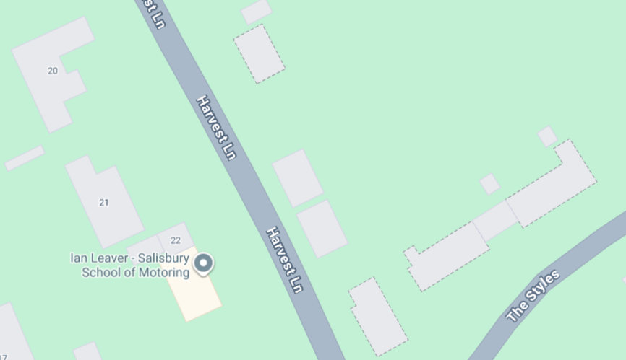

Satellite image showing topography of surrounding area and proposed dormer.
