APPLICATION FOR HOUSEHOLDER PLANNING PERMISSION
DELEGATED REPORT

APPLICATION REFERENCE: | PL/2026/02662
APPLICATION TYPE: | Householder planning permission
SITE ADDRESS: | Great Crabtree, 45 Chitterne Road, Codford, Warminster, BA12 0PG
DEVELOPMENT DESCRIPTION: | Garage conversion and front extension, new front porch extension.
RECOMMENDATION: | That Planning Permission be GRANTED

PROPOSAL

The proposal seeks planning permission for “Garage conversion and front extension, new front porch extension” at Great Crabtree, 45 Chitterne Road, Codford.

The garage is located on the side elevation of the host building and is enclosed by a boundary wall that lines a driveway with No’s 39, 49 and 44 Granary Close. The proposal would convert the garage and extend it forwards to the front corner of the host building. A small porch extension would also be built as seen below.

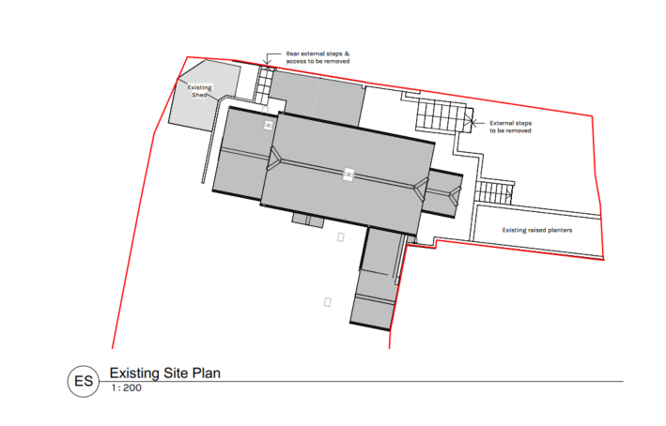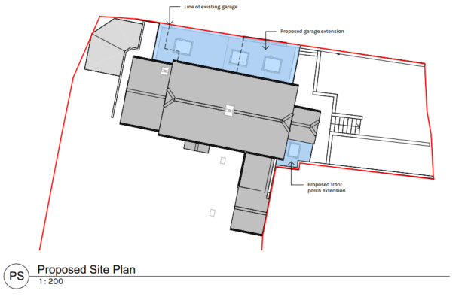

Existing Site Plan Proposed Site Plan

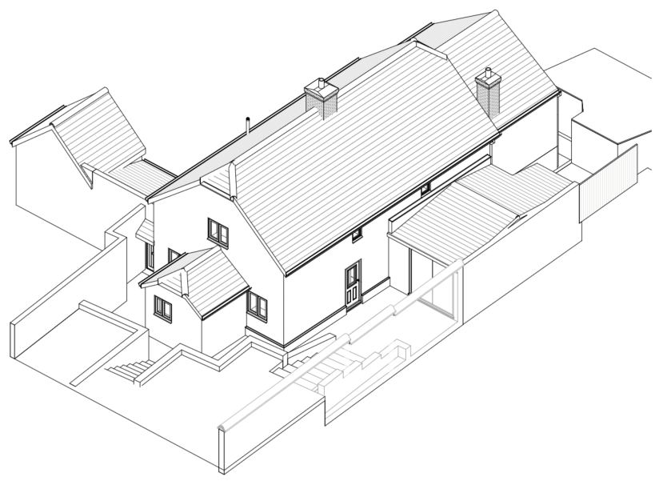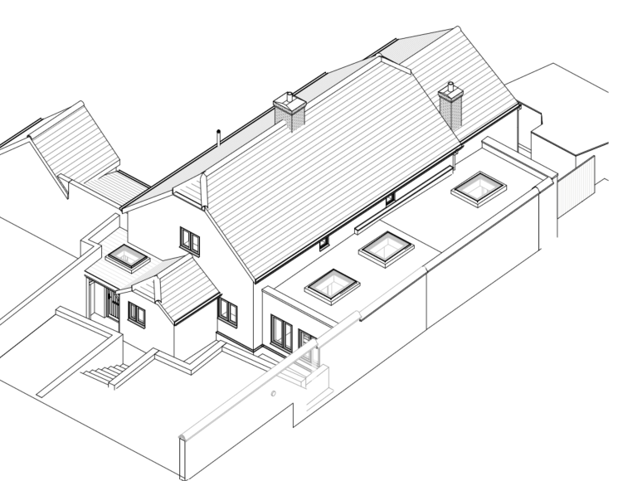

Existing 3D View Proposed 3D View

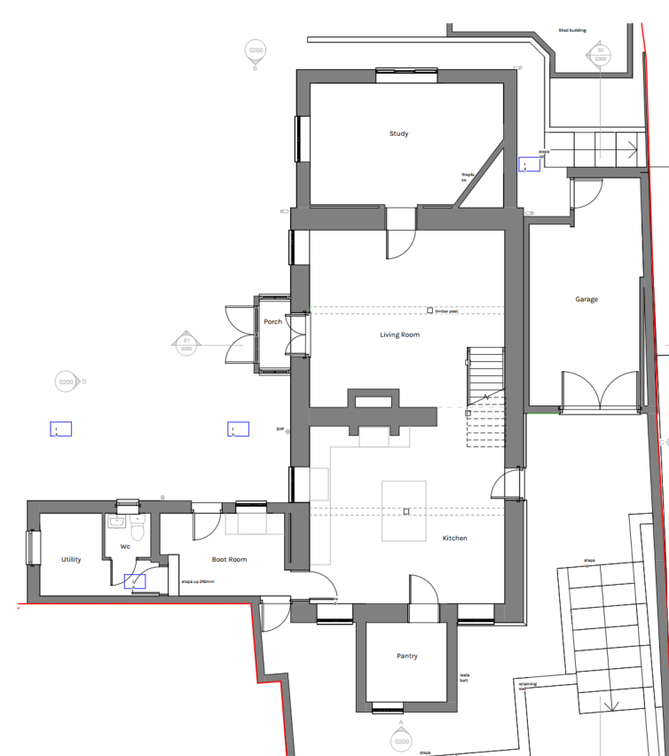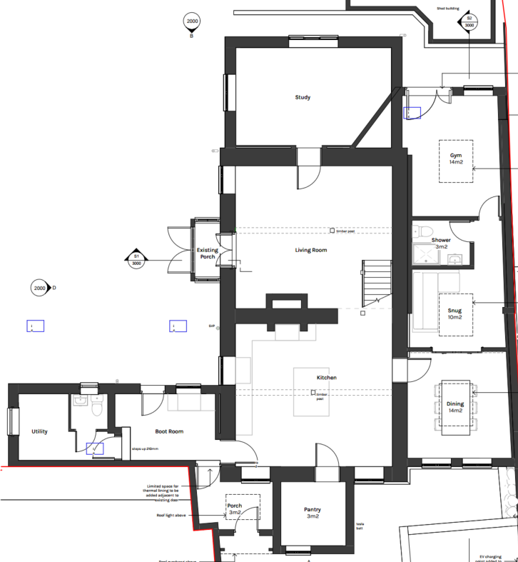

Existing Floor Plan Proposed Floor Plan

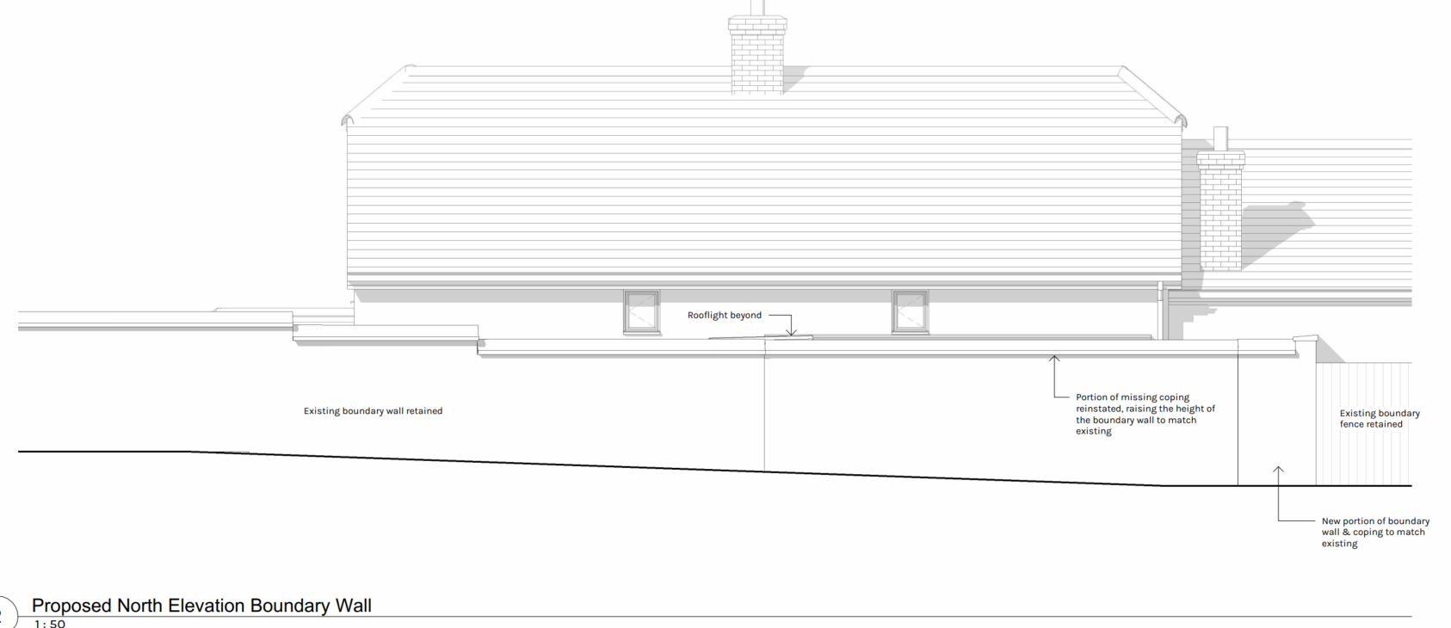

Proposed North Elevation Boundary Wall Plan

The applicant’s agent has confirmed that:

“The existing boundary wall will be retained. However, should any sections be found to be structurally unstable during the works, those portions will be replaced on a like-for-like basis. Due to the change in levels across the site, the existing boundary wall will fully enclose the extension.”

The applicants have also submitted revised plans to accurately show the steps in the boundary wall adjacent to Granary Close. The superseded plans showed only one drop in the wall when there are two. This has now been amended and clarified.

SITE DESCRIPTION/CONTEXT

The application site is within the limits of development of Codford which is defined in the Wiltshire Core Strategy as being a large village.

Great Crabtree is a detached 2 storey dwelling that is ‘side on’ to the main road. The level of the dwelling is also set down into the plot and requires steps down from the recently re-profiled main driveway (google street view images from May 2023) which removed the slope to the garage and installed a retaining wall. The boundary is also largely defined by stone and brick walls, to which the proposed extensions would be built against (as illustrated by the 3D views).

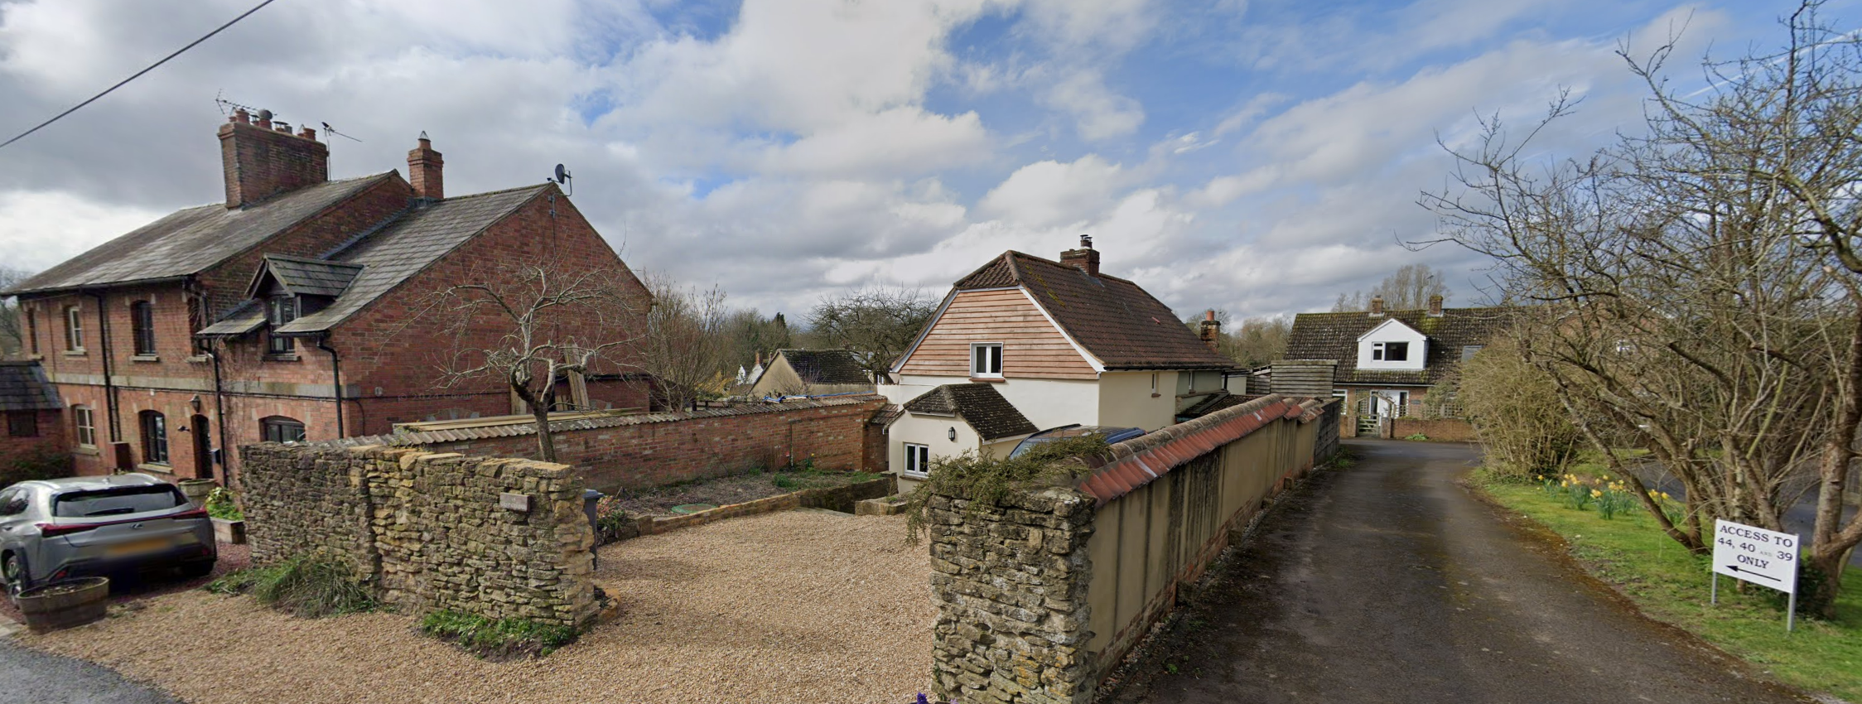

Google March 2024 Street view image of application site (No 2 Dairy Cottage to the left)

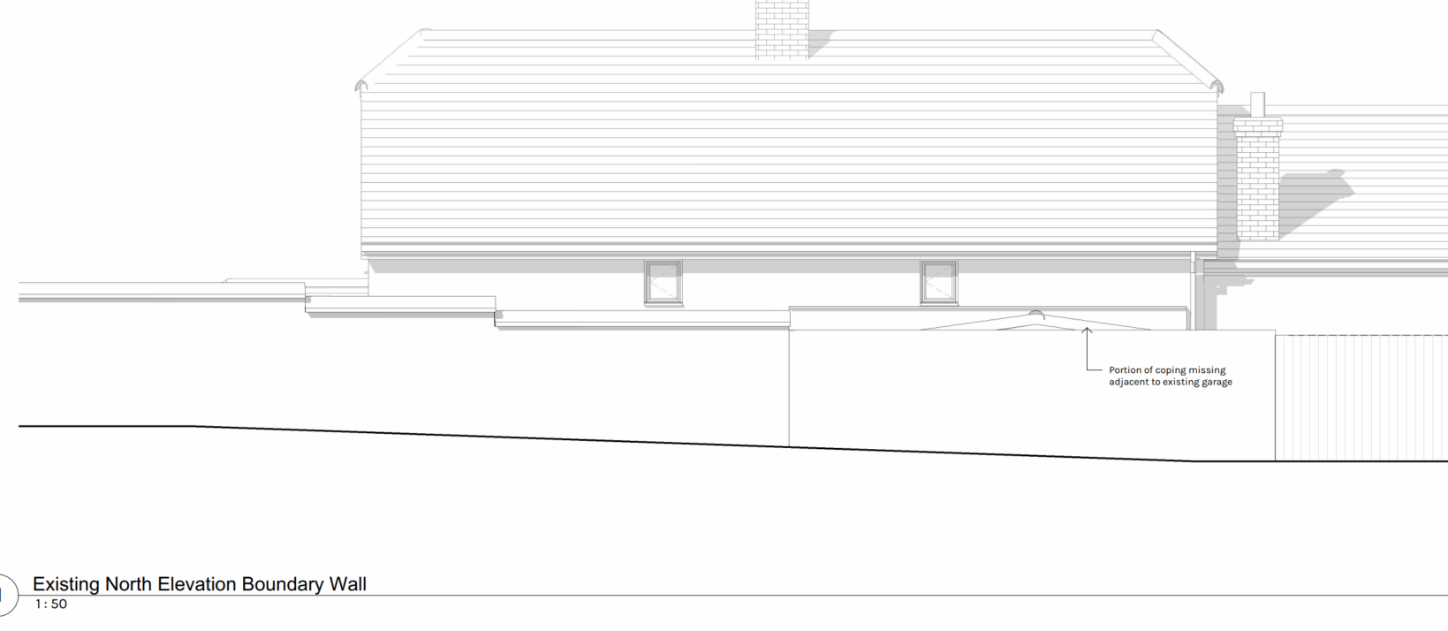

Existing North Elevation Boundary Wall plan

The application site is subject to the following planning policy constraints:

- 6.4km buffer zone of the Salisbury Plain Special Protection Area
- Cranbourne Chase and West Wiltshire Downs National Landscape

There is no ground or surface water flood risk.

PLANNING HISTORY

Proposal / Summary
W/93/01111/FUL - Full planning permission Decision - Approve with Conditions Date: 21/10/1993 – Demolition of store and construction of two storey extension
W/94/01532/FUL - Full planning permission Decision - Approved Date: 9/2/1995 – construction of single storey family room
W/98/01162/FUL - Full planning permission Decision - Approve with Conditions Date: 14/9/1998 – First floor extension
W/02/00058/FUL - Full planning permission Decision - Approve with Conditions Date: 9/4/2002 – Two storey extension

RELEVANT POLICIES AND GUIDANCE

National Context:

The National Planning Policy Framework (NPPF)

The Planning Practice Guidance

Local Context:

Wiltshire Core Strategy:

- Core Policy 50: Biodiversity and Geodiversity
- Core Policy 51: Landscape
- Core Policy 57 Ensuring High Quality Design and Place Shaping
- Core Policy 61: Transport and New Development
- Core Policy 64: Demand Management
- Core Policy 67: Flood Risk

Codford does not have a Neighbourhood Plan or area designation.

Wiltshire Design Guide: Appendix D – Design Guidance for Householder extensions

CONSULTATION RESPONSES

Codford Parish Council: No objection

Wiltshire Council Highways Officer: No objection

REPRESENTATIONS

The application was advertised by 9 neighbour notification letters allowing for 21 days of public consultation.

Two comments received

- I think it is very important to retain the original wall around proposed extension which adjoins the private drive of neighbours. It is of the local style, which is historically desirable. If possible the section of the wall which had been previously replaced by some breeze blocks should be restored. The proposed new building should not exceed present height of garage. The garage should have no access on to the neighbours’ private drive as is the case now.

- The applicant has no right of access to the driveway adjacent to the side of the proposed development which leads to 39,40 and 44 Chitterne Road which requires access (both pedestrian and vehicular) at all times. Any damage to the driveway (owned by Meadow Cottage, 40 Chitterne Road) caused by vehicles associated with this construction must be made good. It is hoped that the boundary wall along the side of the proposed development will be finished in keeping with rest of the property.

For the avoidance of doubt the revised plans have not been sent for public consultation because they have not changed the proposal and have only clarified the true extent of the existing boundary wall that will be retained in the proposal. The plans also clarify that the wall is to be restored to its previous appearance, thereby addressing the request of one of the representation letters.

ASSESSMENT

Section 38(6) of the Planning and Compulsory Purchase Act 2004 states:

"If regard is to be had to the development plan for the purposes of any determination to be made under the planning Acts, the determination must be made in accordance with the plan unless material considerations indicate otherwise."

In accordance with this statutory requirement, this application has been assessed against the relevant policies of the Development Plan, including the adopted Wiltshire Core Strategy (2015) and, where applicable, any made Neighbourhood Plans.

Design and Impact upon the character and context of the area

Core Policy 57 - Ensuring High Quality Design and Place Shaping of the Wiltshire Core Strategy seeks to ensure that all new development is of high design quality, reflecting local context, character, and distinctiveness.

The proposed garage conversion and extension would be undertaken within the existing boundary wall that runs along Granary Close. The extensions, including the porch element which would sit adjacent to and below the boundary walls, would not be readily visible from the public realm and would therefore not result in harm to the host building or the wider street scene.

Officers noted that the boundary wall steps down in two locations, whereas the applicant’s original elevation and 3D drawings showed only a single step. This has now been addressed through revised plans, which confirm that the extensions would largely remain below the height of the existing wall.

While the roof of the extension may be partially visible from Chitterne Road due to the higher ground levels, this limited visibility would not give rise to harm to the host building or the character of the street scene. The porch extension is similarly considered acceptable and would not result in any adverse impacts.

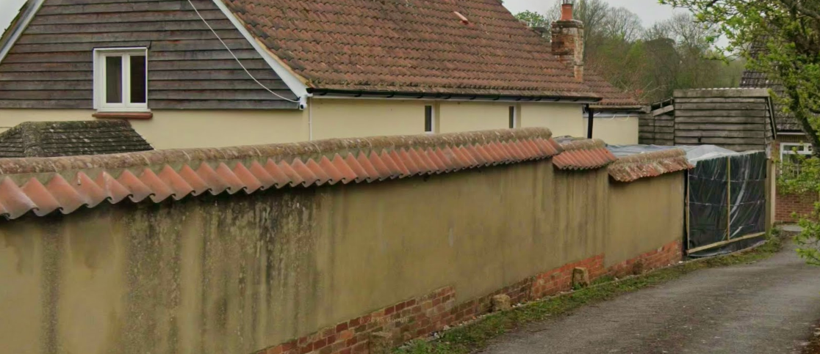

A prior occupation condition will be added to ensure that the wall is restored in full as shown on the boundary elevation plan before the extensions are occupied or first brought into use.

Having regard to the above, the proposal complies with the design principles set out in Core Policy 57 of the Wiltshire Core Strategy and Appendix D of the Wiltshire Design Guide.

Amenity

Point vii of Core Policy 57 - Ensuring High Quality Design and Place Shaping of the Wiltshire Core Strategy seeks to ensure that developments do not adversely affect neighbouring properties.

The National Planning Policy Framework (NPPF), particularly Paragraph 135(f), stresses that planning decisions should ensure developments provide a high standard of amenity for existing and future users.

The proposed development has been assessed in terms of its potential impact on the residential amenity of neighbouring properties, with particular regard to loss of light, overshadowing, loss of privacy, and overbearing effects.

The extensions would be built within the confines of the existing boundary walls and therefore would cause no harm to neighbouring amenity by reason of overshadowing or overlooking.

The proposal therefore accords with Core Policy 57 point vii in respect of safeguarding residential amenity and Appendix D of the Wiltshire Design Guide.

Highways Impact

Core Policy 57 (xiv) of the Wiltshire Core Strategy seeks to ensure that development must meet the requirements of Core Policy 61. This policy requires proposals to be capable of being served by safe access to the highway network. Core Policy 64 seeks to ensure compliance with parking standards set out in the Local Transport Plan.

The National Planning Policy Framework (NPPF), particularly Paragraph 115 and 116, requires that development proposals do not have an unacceptable impact on highway safety and that safe and suitable access to the site can be achieved for all users.

The proposed development would not result in any adverse impact on highway safety. Adequate parking and turning provision are provided on the existing driveway in accordance with Wiltshire’s adopted parking standards, and access arrangements are acceptable. The garage would have not been the required minimum internal dimensions (6x3m) to qualify as a parking space. Therefore, there is no objection to its removal.

The proposal is therefore considered to comply with Core Policies 57 (xiv), 61 and 64 of the Wiltshire Core Strategy, the NPPF, and the Wiltshire Local Transport Plan.

Ecology Impact

Core Policy 50 of the Wiltshire Core Strategy seeks to protect and enhance biodiversity and geodiversity, including through ensuring that development avoids harm to protected species and habitats.

The National Planning Policy Framework (NPPF), in Paragraphs 193, requires that development minimises impacts on and provides net gains for biodiversity, including ensuring mitigation is secured where harm cannot be avoided.

The Council’s Ecology Officer has not been consulted on this application, but the application site is within the 6.4km zone of influence of the Salisbury Plain SPA and in light of the HRA for the Wiltshire Core Strategy and the HRA for the Wiltshire Housing Site Allocations Plan it is screened into Appropriate Assessment due to the potential impact of recreational pressure on stone curlew in combination with other plans and projects.

A strategic Appropriate Assessment (AA) has been prepared pertaining to development within the 6.4 km zone of influence that could result in a likely significant effect on the SPA as a result of an increase in recreational / visitor pressure. The AA reached a conclusion of no adverse effects on the integrity of the SPA or its qualifying features provided that the council’s mitigation strategy continues to be implemented. Annual stone curlew monitoring and protection measures continue to be secured by the Council.

In January 2026 Natural England (NE) confirmed that the 2025 strategic AA for Salisbury Plain SPA continues to be supported by NE.

National Landscape

Core Policy 51 of the Wiltshire Core Strategy requires all development to protect, conserve, and where possible enhance the character and quality of Wiltshire’s landscapes, giving particular weight to designated areas such as National Landscapes.

The National Planning Policy Framework (NPPF), in Paragraph 176, states that “great weight” should be given to conserving and enhancing landscape and scenic beauty in National Landscapes (formerly Areas of Outstanding Natural Beauty). Development within or affecting the setting of a National Landscape must demonstrate that it will not result in unacceptable harm to the special qualities of that area.

The proposal, by virtue of its scale, siting, and design, would not harm the special qualities or scenic character of the Cranborne and Chase and West Wiltshire Downs National Landscape.

The development therefore complies with Core Policy 51 of the Wiltshire Core Strategy and Paragraph 176 of the NPPF in conserving and enhancing the National Landscape.

Biodiversity Net Gain

Householder planning applications are exempt from the requirement to deliver Biodiversity Net Gain under Schedule 7A, Section 4(2)(a) of the Town and Country Planning Act 1990, as inserted by the Environment Act 2021.

Other issues

The neighbour consultation raised issue over potential construction works damaging a private driveway and that the applicants have no access rights over the driveway. These are civil matters between the affected parties and are outside of the Council’s control.

CONCLUSION

The proposed development is considered to be acceptable in terms of its design, scale, and relationship with the surrounding area. It would not result in any unacceptable harm to the character of the locality, the amenities of neighbouring occupiers, or the interests of highway safety, heritage, or ecology.

The proposal is therefore considered to comply with the relevant policies of the Wiltshire Core Strategy, the Wiltshire Local Plan, and the National Planning Policy Framework. As such, the application is recommended for approval, subject to the conditions set out below.

RECOMMENDATION: That Planning Permission be GRANTED subject to conditions.

