APPLICATION FOR FULL-PLANNING PERMISSION
CASE OFFICER REPORT

APPLICATION REFERENCE: | PL/2026/01074
APPLICATION TYPE: | Full planning permission
SITE ADDRESS: | Roche Old Court, East Winterslow, Salisbury, SP5 1BG
DEVELOPMENT DESCRIPTION: | Installation of ground mounted solar panels with ancillary structures and associated landscaping to be used in association with the residential dwelling known as Roche Old Court.
RECOMMENDATION: | Approve with Conditions

SITE DESCRIPTION/CONTEXT

The application site relates to a large grade 2* listed tithe barn with several attached, Grade II listed outbuildings laid out in an ‘L’ shape, along with a Grade II listed Shepherd’s Cottage; the buildings front onto a central courtyard and the associated land, listed buildings are marked with black hatching on the map extract below. The site in particular relates to an agricultural field located immediately to the south west of the main group of buildings. The site is surrounded by fields, with the west boundary of site defined by the C335 Pincroft Lane.

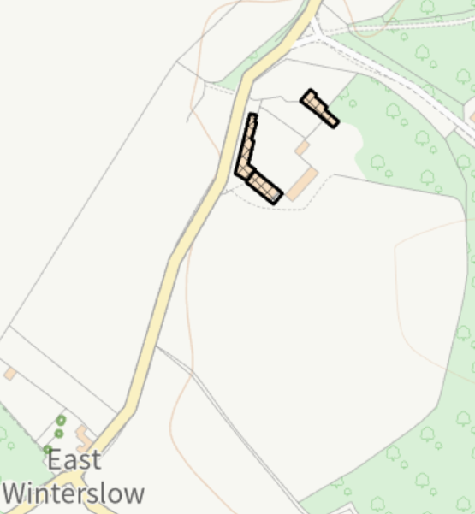

The site is located outside of any settlement boundary as defined by Wiltshire Core Strategy (WCS) policies CP1, CP2 and CP23, therefore outside of the defined limits of development as defined by the relevant policies of the adopted Wiltshire Core Strategy (WCS) and as such is considered to be within the countryside for the purposes of the local plan.

The site is located in Flood Zone 1 and not at risk of groundwater flooding. It is within the special landscape area as per saved policy C6 and within the New Forest Protected sites 13.8 km recreation zone of influence and the River Test catchment (SAC, SPA and SSSI).

A public footpath with reference WSL026 runs across the site, just outside of the red line, but within the blue line boundary of the site. Further public footpaths WSL014, WSL023 and WSL028 are located to the west and south west of the site.

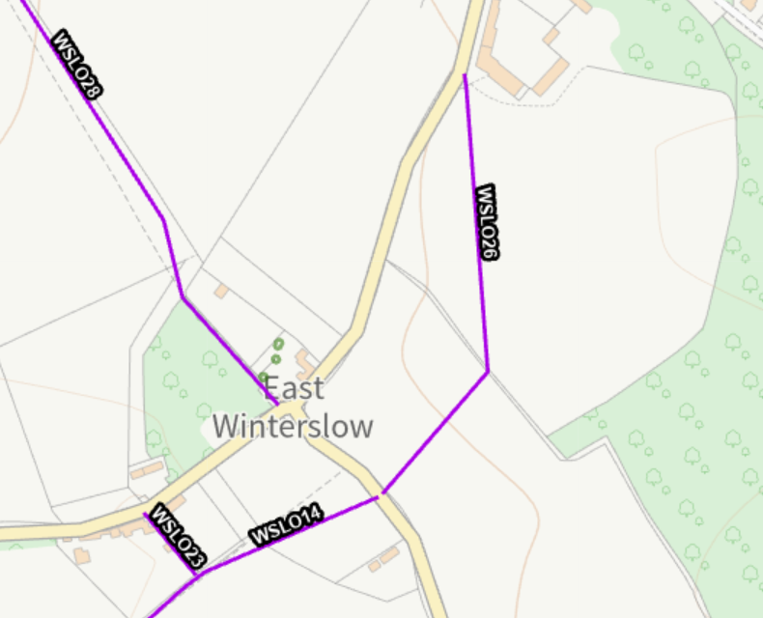

An area to the east of the proposed development lies deciduous woodland categorised under a priority habitat inventory.

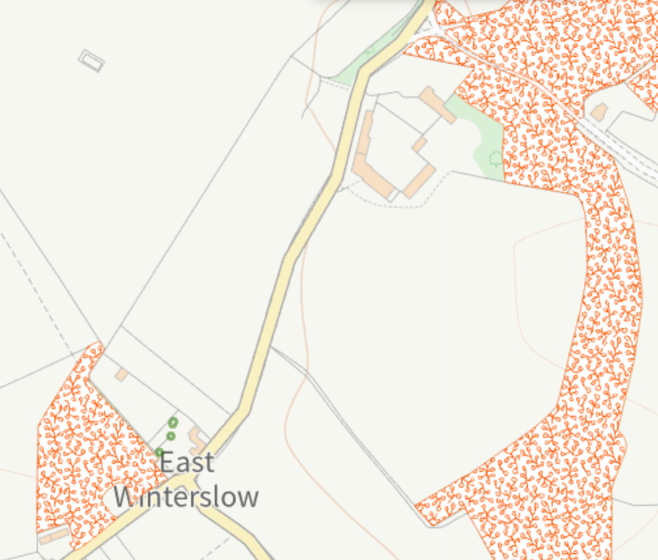

The site lies just outside of the ancient woodland 15 m buffer; this buffer is marked with dark green on the map extract below.

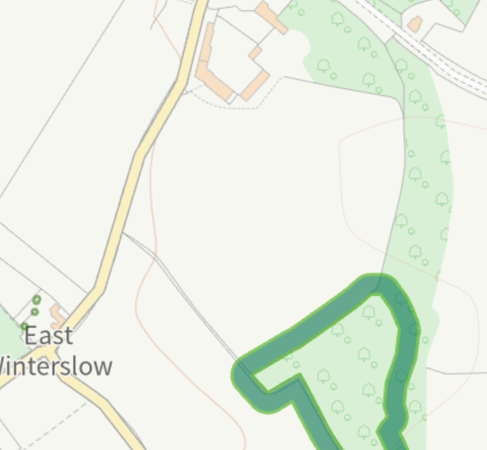

PROPOSAL

The application is seeking consent for the installation of ground mounted solar panels with ancillary structures and associated landscaping to be used in association with the residential dwelling known as Roche Old Court.
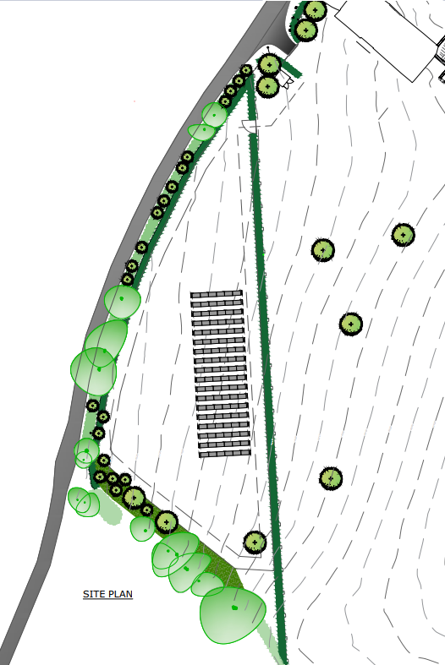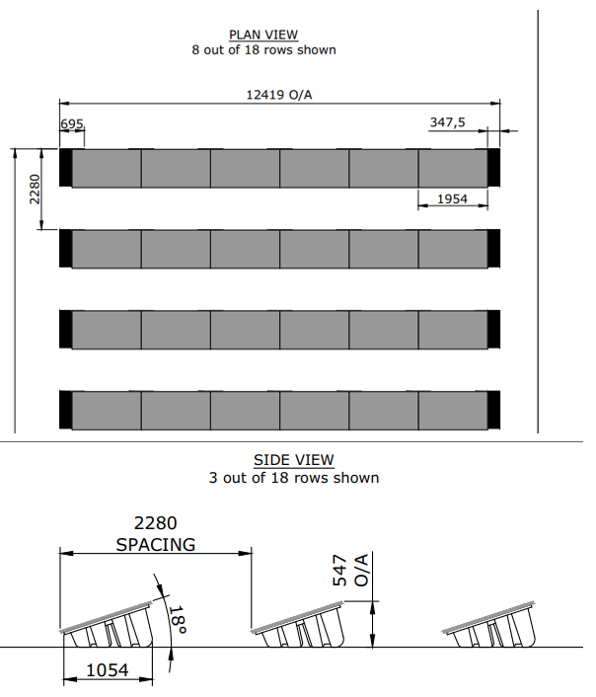
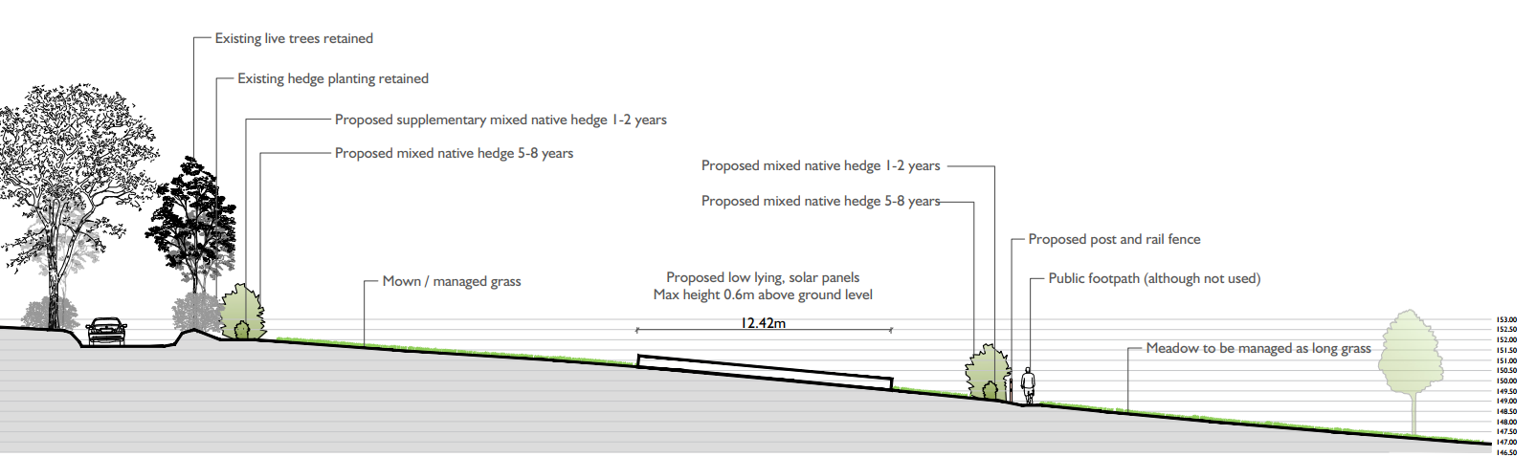

The solar panels will comprise 18 rows of 6 panels with a total of 108 panels to be installed.

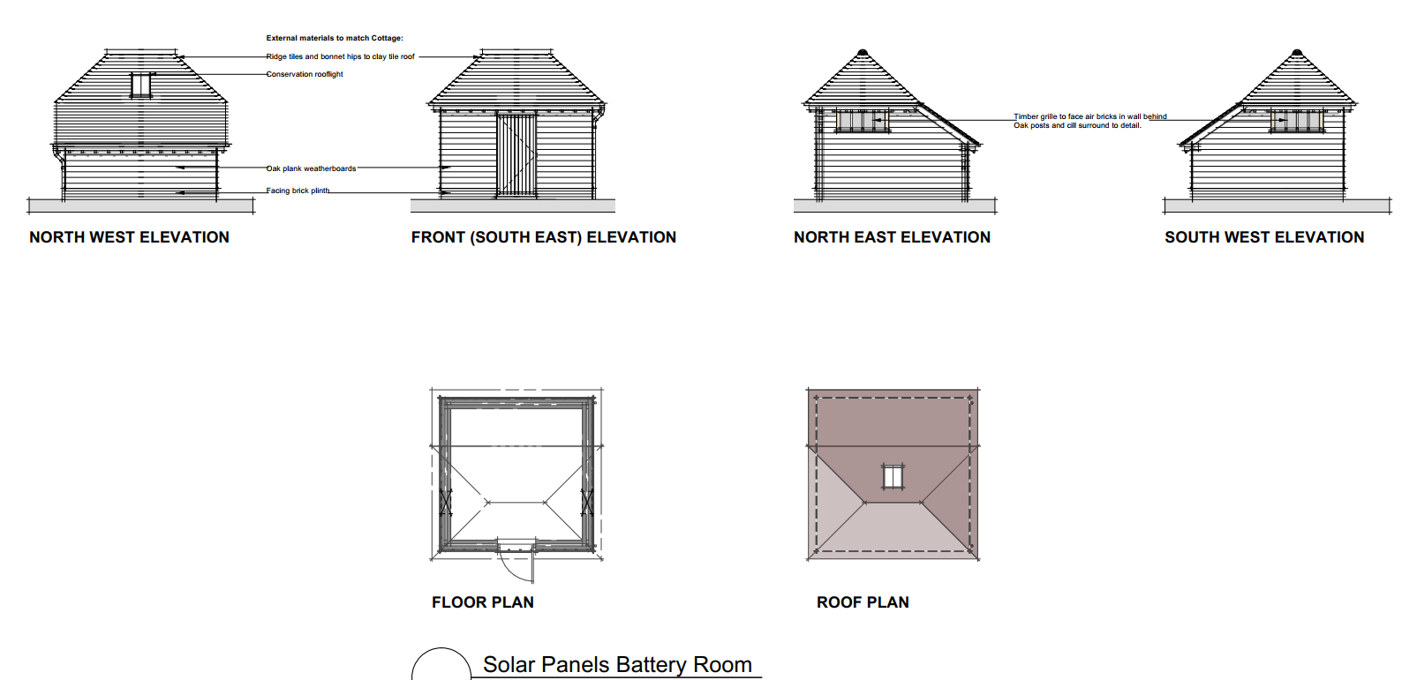

PLANNING HISTORY

The site at Roche Old Court has an extensive planning history relating to the buildings themselves which are listed below, there is however no previous planning history for the field associated with this current application for the proposed solar panels.

Proposal / Summary
PL/2022/07336 - Approval of details reserved by a condition Decision - Approve Date: 4/10/2022 – Discharge of condition 4a on PL/2022/04872 (Replacement of existing structure know as Former Farm Manager's House)
PL/2023/00841 - Listed Building Discharge of Condition Decision - Approve Date: – Discharge of Condition 3 of PL/2022/05188
PL/2024/07690 - Householder planning permission Decision - Approve with Conditions Date: 22/11/2024 – Outdoor swimming pool and pool house and associated works
PL/2024/09199 - Householder planning permission Decision - Approve with Conditions Date: 19/3/2025 – Refurbishment of the existing Cartshed, workshop and storage buildings to ancillary accommodation, including reconstruction of the roof incorporating reusable historic elements
PL/2024/09438 - Listed building consent (Alt/Ext) Decision - Approve with Conditions Date: 19/3/2025 – Refurbishment of the existing Cartshed, workshop and storage buildings to ancillary accommodation, including reconstruction of the roof incorporating reusable historic elements
PL/2024/11183 - Approval of details reserved by a condition Decision - Approve Date: 30/1/2025 – Discharge of details for condition 3 (a) Archaeological investigation of planning application PL/2023/02063 (Single storey extension to the main house at Old Roche Court and associate works for repairing and making habitable the existing house including w
PL/2024/11421 - Approval of details reserved by a condition Decision - Partial Discharge of Condition(s) Date: 3/3/2025 – Discharge of LBC conditions 3, photographic record 6, photographic record of the existing wall 7, photographic record of the existing brick & 11, record of the repairs on listed building application PL/2023/02464 (Single storey extension to the main house
PL/2025/03171 - Listed building consent (Alt/Ext) Decision - Withdrawn by Applicant Date: 8/5/2025 – Remedial works and installation of lining to basement walls against water ingress
PL/2025/03947 - Approval of details reserved by a condition Decision - Approve Date: 3/7/2025 – Discharge of Conditions 4a (written programme of archaeological investigation), 5 (Details of materials to be used for the roof of the pool house) and 6 (detailed planting specification) of PL/2024/07690
PL/2025/04003 - Listed Building Discharge of Condition Decision - Refuse Date: – Discharge of Condition 13 (Panelling Paint Analysis) of PL/2023/02464
PL/2025/05147 - Approval of details reserved by a condition Decision - Approve Date: 5/8/2025 – Discharge of Conditions 4 schedule and specification of works, 5 method statement, 6 samples of the materials, 7 details of the proposed corrugated roofing , 8 joinery , 9 proposed horizontal timber, 10 details of the natural stone , 11 rainwater goods an
PL/2025/05188 - Approval of details reserved by a condition Decision - Approve Date: 5/8/2025 – Discharge of Conditions 3 schedule and specification of works, 4 method statement, 5 materials, 6 corrugated roofing, 7 joinery, 8 timber cladding, 9 natural stone, 10 rainwater goods, & 11 brick sample of planning application PL/2024/09438 (Refurbishment
PL/2025/05818 - Listed building consent (Alt/Ext) Decision - Approve with Conditions Date: 9/10/2025 – Application of basement water control lining
PL/2025/06329 - Householder planning permission Decision - Approve with Conditions Date: 16/9/2025 – Demolition and reconstruction of unsafe external walls of the existing workshop (building 4) and storage (building 5) and works to the party wall between Cartshed (building 3) and workshop (building 4)
PL/2025/06561 - Listed building consent (Alt/Ext) Decision - Approve with Conditions Date: 16/9/2025 – Demolition and reconstruction of unsafe external walls of the existing workshop (building 4) and storage (building 5) and works to the party wall between Cartshed (building 3) and workshop (building 4)

RELEVANT LEGISLATION, POLICIES AND GUIDANCE

Statutory Legislation:

Section 66 of the Planning (Listed Buildings and Conservation Areas) Act 1990

National Planning Policy:
- National Planning Policy Framework (NPPF)
- Planning Practice Guidance (PPG)
- National Design Guide

Development Plan:

The development plan for Wiltshire comprises the Wiltshire Core Strategy (WCS) (adopted January 2015) and any made neighbourhood plans, which remains the principal statutory planning document guiding development across the county. In line with Section 38(6) of the Planning and Compulsory Purchase Act 2004, planning decisions must be made in accordance with the development plan unless material considerations indicate otherwise.

Though the development plan is considered as a whole, those parts deemed to be particularly relevant to this application are listed below:

The adopted Wiltshire Core Strategy (WCS), with particular regard to:

Core Policy 1: Settlement Strategy
Core Policy 2: Delivery Strategy
Core Policy 23: Spatial Strategy: South Wiltshire Community Area
Core Policy 41: Sustainable construction and low carbon energy
Core Policy 42: Standalone Renewable Energy Installations
Core Policy 48: Supporting Rural Life
Core Policy 50: Biodiversity and Geodiversity
Core Policy 51: Landscape
Core Policy 52: Green Infrastructure
Core Policy 57: Ensuring High Quality Design and Place Shaping
Core Policy 58: Ensuring conservation of the historic environment

Saved Policy C6: Special Landscape Area (Annexe D of WCS)

Supplementary Planning Documents and other Guidance:

Wiltshire Design Guide (adopted April 2024)
Wiltshire Local Transport Plan 2011-2026,
Creating Places Design Guide
Wiltshire Biodiversity Action Plan (2008) (BAP)
Wiltshire Infrastructure Delivery Plan 3 (2011-2026)
Wiltshire Climate Strategy (2022-2027)

ISSUES

- Principle of the Development (Best and Most Versatile (BMV) Agricultural Land)
Assessment against national and local policy support for renewable energy, including CP42 of the Wiltshire Core Strategy and the NPPF. Consideration of the site’s Agricultural Land Classification and the implications of using Grades 1, 2, or 3a land, in accordance with the NPPF and Written Ministerial Statements.
- Landscape and Visual Impact and Impact on Heritage Assets
Assessment of effects on landscape character and views, including cumulative impacts with other nearby solar developments. Consideration of direct or indirect effects on listed buildings, conservation areas, and their settings, in line with Section 66 of the Planning (Listed Buildings and Conservation Areas) Act 1990.
- Archaeology
Assessment of the potential for archaeological interest on the site and the need for mitigation or further investigation, in consultation with the Council’s archaeology team.
- Neighbour Amenity
Consideration of potential impacts on residential amenity, including outlook, noise, glint and glare.
- Highway Safety
- Ecology and Biodiversity
Assessment of submitted ecological surveys, biodiversity net gain, and mitigation/enhancement measures in accordance with Policy CP50 and the Environment Act 2021.

CONSULTATION RESPONSES

Parish Council – No objections

Conservation – No objections

Archaeology – No objections subject to condition

Landscape – No objection

Ecology – No objection subject to condition

Rights of Way – No objection

REPRESENTATIONS

No comments have been received.

ASSESSMENT

Solar farms form part of the UK’s strategy to reduce carbon emissions and transition towards cleaner, more sustainable sources of energy. As the impacts of climate change become more pressing, renewable energy developments like solar farms play an increasingly important role in helping to meet national and local carbon reduction targets. Wiltshire Council has committed to becoming carbon neutral by 2030, and national planning policy encourages local authorities to support renewable energy projects where the impacts are, or can be made, acceptable. However, the need for clean energy must be balanced with other important considerations such as protecting landscape character, heritage assets, local amenity, agricultural land, and biodiversity. This section of the report provides a detailed assessment of the relevant planning issues, including how the proposed solar farm aligns with local and national policy objectives, and whether its impacts are acceptable when weighed against the wider environmental benefits of the scheme.

Section 38(6) of the Planning and Compulsory Purchase Act 2004 states:

"If regard is to be had to the development plan for the purposes of any determination to be made under the planning Acts, the determination must be made in accordance with the plan unless material considerations indicate otherwise."

In accordance with this statutory requirement, this application has been assessed against the relevant policies of the Development Plan, including the Wiltshire Core Strategy (2015) and, where applicable, any made Neighbourhood Plans. Consideration has also been given to the policies of the National Planning Policy Framework (NPPF) as a material consideration in the assessment.

Principle of Development

Paragraph 165 of the National Planning Policy Framework (NPPF) encourages local plans to support the increase in the use and supply of renewable and low-carbon energy, while ensuring that any adverse impacts are appropriately addressed.

Paragraph 168 of the NPPF confirms that applicants are not required to demonstrate the overall need for renewable or low-carbon energy. Instead, local planning authorities are expected to approve such schemes if their impacts are (or can be made) acceptable, in accordance with national policy.

In line with this national direction, Wiltshire Council has committed to becoming carbon neutral by 2030. This ambition is embedded within the Wiltshire Climate Strategy, which identifies renewable energy generation as a key priority for the efficient and environmentally responsible use of land, in support of a growing population and biodiversity.

At the local level, Core Policies CP1 and CP2 of the Wiltshire Core Strategy (WCS) set out the spatial strategy for sustainable development in the county. While the proposal does not directly deliver housing or employment development, it represents a form of sustainable development, supporting Wiltshire's transition to a low-carbon economy. The development may also deliver short-term employment opportunities during the construction phase.

Core Policy 42 of the WCS provides specific policy support for standalone renewable energy schemes, stating that such proposals will be supported where it is demonstrated that individual and cumulative impacts have been satisfactorily addressed. The policy identifies the following considerations as particularly relevant (in the context of this proposal):

i. landscape
iv. biodiversity
v. historic environment
vi. use of the local transport network
vii. residential amenity, including noise, odour, visual amenity and safety
viii. best and most versatile agricultural

Whilst in this instance the proposals relate to the installation of ground mounted solar panels to serve a residential property and associated buildings and is not a large scale solar farm, in principle, the use of solar panels can be supported in principle subject to the application demonstrating that the proposal will not result in unacceptable impacts, or that any identified impacts can be suitably mitigated. A detailed assessment of the proposal against the relevant criteria of CP42—including landscape, heritage, biodiversity, residential amenity, transport, and agricultural land quality—is provided in the following sections of this report.

Agricultural land classification - Best and most versatile agricultural Land

The National Policy Statement (NPS) for Energy, published in January 2024, is a material consideration in the determination of planning applications under the Town and Country Planning Act 1990. The NPS is relevant to both nationally significant infrastructure projects (NSIPs) and smaller-scale renewable energy proposals considered at the local level.

In May 2024, a Written Ministerial Statement (WMS) by the Secretary of State for Energy Security and Net Zero provided further guidance on balancing national priorities for energy security and food production. The WMS states:

“Due weight needs to be given to the proposed use of Best and Most Versatile land when considering whether planning consent should be granted for solar developments. For all applicants the highest quality agricultural land is least appropriate for solar development and as the land grade increases, there is a greater onus on developers to show that the use of higher quality land is necessary.”

Both the NPPF and the NPS define Best and Most Versatile (BMV) agricultural land as land falling within Grades 1, 2, and 3a of the Agricultural Land Classification.

Footnote 65 of the NPPF reinforces this approach, stating:

“Where significant development of agricultural land is demonstrated to be necessary, areas of poorer quality land should be preferred to those of a higher quality.”

Further guidance is provided in the Planning Practice Guidance (PPG), Paragraph 013 (ID: 5-013-20150327), which advises that:

- Local planning authorities should encourage the use of previously developed and non-agricultural land for large-scale solar farms.
- Solar farms are typically temporary structures, and planning conditions can be used to secure the removal of infrastructure once it is no longer in use and restoration of the land to its previous condition.

At the local level, Core Policy 42 (criterion viii) of the Wiltshire Core Strategy requires that proposals for standalone renewable energy schemes demonstrate that the impact on Best and Most Versatile agricultural land has been satisfactorily considered.

In addition, the Wiltshire Climate Strategy (2022–2027) identifies as a key objective:

“The efficient and environmentally sensitive use of land, providing for the needs of an increasing population and nature; food production, renewable energy generation, housing and transport, alongside woodland creation and nature recovery.”

Agricultural Land Classification strategic maps show the likelihood of BMV land and identify the site as likely to have an ALC of Grade 2, however, Natural England’s explanatory note on ALC strategic scale maps is clear that the gradings are predictions and that the map is “intended for strategic planning purposes only, is not suitable for use below scale 1:250,000 or for the definitive classification of any local area of site.”

In line with national planning guidance, the use of previously developed land and non-agricultural land should be prioritised for the development of ground-mounted solar farms. However, it is recognised that across Wiltshire, there is a limited supply of previously developed or non-agricultural land of sufficient scale that is not already in active alternative use and capable of accommodating large-scale solar installations.

The Land Use Framework for England (2026) is now a material consideration an establishes a strategic, data-led approach to the long-term management of land, seeking to align competing demands for development, food production, infrastructure and environmental enhancement within a single overarching framework. It is however not a direct policy tool but is more of a guide for the decision maker to try to direct the right uses to the right place to make the best use of the land putting emphasis on food security.

The application site comprises Grade 2 agricultural land and is therefore identified as Best and Most Versatile (BMV), a finite and valuable resource to which weight must be afforded in decision-making. Policy and emerging guidance, including the Land Use Framework, reinforce the expectation that higher quality land should be safeguarded, with development directed towards land of lower agricultural value wherever possible. However, it is noted that the Framework is primarily forward-looking and intended to inform future policy revisions, and while it is a material consideration, its weight is currently limited.

In this case, the proposal is relatively modest in scale, extending to less than 0.2 hectares, and would not result in the permanent loss of the land’s agricultural function. The scheme would allow for continued low-intensity agricultural use, such as sheep grazing between panel arrays, and there is potential for soil quality to recover over the operational lifetime due to reduced intensive cultivation.

Set against this is the strong national and local support for renewable energy generation, the Government’s commitment to achieving net zero, and the Council’s declaration of a climate emergency. Solar development is a key contributor to meeting these objectives.

On balance, whilst the temporary use of this Grade 2 BMV land weighs against the proposal, this harm is limited and reversible, and it is considered to be outweighed by the wider public benefits of renewable energy generation in responding to the current climate emergency.

Subject to conditions securing the removal of the solar infrastructure upon cessation of use, and restoration of the land to its original agricultural condition, the development is considered to comply with the aims of the NPPF, guidance in the Planning Practice Guidance, and Core Policy 42 (criterion viii) of the Wiltshire Core Strategy and is acceptable in principle.

Cumulative Impact

In addition to providing updated guidance on the use of best and most versatile agricultural land, the Written Ministerial Statement (WMS) issued in May 2024 also provides direction on the need to assess cumulative impacts of solar energy developments. It states:

“[…] we are increasingly seeing geographical clustering of proposed solar developments in some rural areas. […] When considering whether planning consent should be granted for solar development it is important to consider not just the impacts of individual proposals, but also whether there are cumulative impacts where several proposals come forward in the same locality.”

This reflects a growing national and local concern about the spatial concentration of solar farms and associated infrastructure in certain rural areas.
At its Full Council meeting on 21 May 2024 Wiltshire Council supported a motion (Motion No. 2024-03 – Solar Farms) calling for greater clarity on national policy regarding the distribution and cumulative assessment of solar development. The motion stated:

“[…] this Council is increasingly concerned at the concentration of solar farms, battery storage and associated infrastructure in Wiltshire. Some villages are now completely surrounded by solar farms, and their continued concentration represents a significant cumulative impact and industrialisation of the countryside.
Wiltshire Council therefore calls on the Secretary of State for the Department of Levelling Up, Housing and Communities to define more closely what is meant by ‘cumulative impact’ regarding solar farms and to take clear steps to ensure that solar developments are more evenly spread across the UK […]”

While no further central government guidance has yet been issued in response to this motion, and although the WMS stops short of defining cumulative impact in detail, national planning policy continues to emphasise the importance of balancing the need for clean energy investment with appropriate environmental and spatial safeguards. The Autumn Budget (30 October 2024) also reiterated the Government’s commitment to supporting clean energy technologies, which remains an important material consideration.

Within this context, officers have considered the potential cumulative landscape and visual effects of this proposal, including its relationship with other solar and battery storage developments in the surrounding area.

Policy CP42 of the Wiltshire Core Strategy explicitly requires consideration of cumulative effects when determining proposals for standalone renewable energy installations.

The Planning Practice Guidance (PPG) provides additional context, stating:

- Cumulative landscape impacts refer to the effects on the character, fabric, and quality of the landscape, and whether the proposed development would become a dominant or defining feature.
- Cumulative visual impacts relate to the degree to which the development would be seen from the same viewpoints or along the same journey as other installations, and the resulting effect on visual amenity for those experiencing the landscape.

Although the term “locality” as used in the Written Ministerial Statement (WMS) is not formally defined, Wiltshire Council’s motion of 21 May 2024 highlights that multiple solar farm proposals within or surrounding the same village can collectively alter the local character and setting. This interpretation supports a more nuanced and locally responsive assessment of cumulative impact.

There are no known immediate solar arrays in the vicinity of the application site, therefore it is considered that the cumulative impacts in this instance will not to harm the local character and setting.

Landscape and Visual Impact and Impact on Heritage Assets

Criteria (i) of Policy CP42 of the WCS requires standalone renewable energy installations to
take into account the landscape, particularly in and around National Landscapes.

Policy CP51 of the WCS expresses that proposals should be informed by and sympathetic to the distinctive character areas and further expresses that development must not have a harmful impact upon landscape character. If there are negative impacts, they must be mitigated as far as possible through sensitive design and landscape measures. CP51 requires development proposals to demonstrate that identified aspects of landscape character have been protected, conserved and where possible enhanced, which includes the following summarised aspects which are relevant for assessment of the scheme:

(i) The locally distinctive pattern and species composition of natural features such as trees, hedgerows, woodland, field boundaries, watercourses and waterbodies
(ii) The locally distinctive character of settlements and their landscape settings
(iii) The separate identity of settlements
(v) Landscape features of cultural, historic or heritage value
(vii) Tranquillity and the need to protect against intrusion from light pollution, noise and
motion
(viii) Landscape functions

Saved policy C6 states - Within the Special Landscape Area, proposals for development in the countryside will be considered having particular regard to the high quality of the landscape. Where proposals which would not have an adverse effect on the quality on the landscape are acceptable, they will be subject to the following criteria;

(i) the siting and scale of development to be sympathetic with the landscape; and
(ii) high standards of landscaping and design, using materials which are appropriate to the locality and reflect the character of the area.

Policy CP57 of the WCS requires high quality design and place shaping for all new development and includes the expectation that proposals should make a positive contribution to the character of Wiltshire. Proposals should demonstrate how the development meets the expectations of criteria of CP57 which includes the following summarised points which are relevant for assessment of the scheme on landscape matters:

(i) Enhancing local distinctiveness by responding to the value of the natural and historic environment, relating positively to its landscape setting and the existing pattern of development and responding to local topography by ensuring that important views into, within and out of the site are to be retained and enhanced.
(ii) The retention and enhancement of important landscaping and natural features.
(vi) making efficient use of land whilst taking account of the characteristics of the site and the local context
(xii) The use of high standards of building materials, finishes and landscaping

Wiltshire’s Climate Strategy further refers to the Councils GBI which sets out a long-term vision, strategic goals and principles for delivering green and blue infrastructure across Wiltshire.

Section 66(1) of the Planning (Listed Buildings and Conservation Areas) Act 1990 places a statutory duty on decision-makers to have special regard to the desirability of preserving a listed building or its setting, or any features of special architectural or historic interest which it possesses.

Relevant national policy is set out in Chapter 16 of the National Planning Policy Framework (NPPF), which provides guidance on conserving and enhancing the historic environment. Paragraphs 212 to 221 specifically address how local planning authorities should assess and balance the potential impacts of development on heritage assets, including their settings.

At the local level, Policy CP42 (v) of the Wiltshire Core Strategy (WCS) requires standalone renewable energy proposals to demonstrate that impacts on the historic environment, including the setting of heritage assets, have been appropriately considered. In addition:

- Policy CP57 promotes high-quality design and place-shaping for all new development, with criterion (iv) requiring proposals to be sympathetic to and to conserve historic buildings and historic landscapes.
- Policy CP58 provides further protection, requiring development to protect, conserve, and where possible enhance the historic environment of Wiltshire.

These combined national and local requirements form a robust framework for ensuring that solar farm developments are appropriately assessed in terms of their potential impact on the historic environment.

The proposed solar development has been designed to minimise landscape and visual impacts through careful siting, low-profile design, and enhanced landscaping. The ground-mounted panels, positioned on a gently sloping field away from Pincroft Lane, would have a maximum height of approximately 600mm, reducing their visibility from surrounding viewpoints. The proposed building to be used for battery storage is a modest structure to be constructed in materials to complement the associated buildings at Roche Old Court. There are no particular concerns regards the scale, design or siting of this associated building.

Potential visual impacts are limited to glimpsed views from along Pincroft Lane and probably the most direct views from the nearby footpath; however, these would be mitigated through the retention and reinforcement of existing hedgerows, supplemented by new native planting to create more robust boundary screening. Additional measures, including new hedgerow planting along the footpath and infilling of boundary vegetation, would further integrate the development into the landscape. Overall, subject to the proposed mitigation, the scheme is considered to result in limited and acceptable landscape and visual impacts.

The Council’s Landscape Officer was consulted and has raised no objections stating -

I note from the Landscape Assessment that the site is well contained by existing vegetation and local topography. The proposed panels are low level and while they would be seen in proximity from the existing footpath the proposed hedgerow will in time close this view down. Landscape mitigation including gapping up the boundary hedgerows will have an overall beneficial landscape effect. I also note that the Conservation Officer has no concerns with regards to the landscape setting of the barn/courtyard. I therefore conclude that the proposal is a low impact development with minimal and localised landscape and visual effects.

In terms of heritage impacts to the nearby listed buildings, the solar panels are separate to these listed buildings, the low profile and angle of the solar panels help to minimise impacts on these heritage assets. The Council’s conservation officer has been consulted and has raised no objections in terms of heritage impacts, stating –

I have no objection to the proposed solar panels. I do not consider they would have an adverse impact on the setting of the barn/courtyard in view of their proposed location. I note the intention to plant a mixed native hedgerow to provide additional screening.

Overall, it is not considered that the proposed development will result in significant visual, landscape or heritage assets.

Archaeology

The Council’s archaeologist has been consulted and has provided the following comments -

The site of the proposed development is located immediately to the south of a Scheduled Monument (No: 1002995, Tithe Barn, Roche Old Court) located in Roche Court Farm, which is a settlement with medieval origins. The installation of the solar panels and the construction of the battery room would impact upon any as yet unrecorded sub-surface archaeological features from earlier phases of the medieval settlement that may survive in the field to the south of the farm. It is also possible that the landscaping referred to in the supporting documentation may also have an impact, although the precise nature of this landscaping is unclear at this time.
I would therefore advise that the development footprint is made the subject of a geophysical survey and that a report on the results of this work is submitted to Wiltshire Council Archaeology Service (WCAS) for review and approval prior to the determination of this application. I will then be in a position to offer you an opinion on the need (or not) for any further investigated work, depending on the results of the remote sensing.
I would therefore advise the applicant to engage the services of an archaeological contractor in order to carry out this survey at the earliest available opportunity.

The applicant asked if it was possible for a pre-commencement condition to be added to any permission requiring the submission of a written scheme of investigation to be provided relating to a watching brief of the site during construction works rather than a geophysics survey up front.

The Council’s archaeologist confirmed that the request for the geophysics route was potentially a cheaper option for the applicant as this would confirm if a watching brief was required or not.

However, the Council’s archaeologist is content if the applicant would prefer to have the usual pre-commencement condition to provide a WSI prior to commencement and then have a watching brief undertaken in accordance with the agreed WSI to cover the works when carried out. The applicant confirmed that this was their preferred route.

Therefore, subject to an appropriate condition to secure a written scheme of investigation for a watching brief there are no concerns relating to impacts on archaeology.

Amenity Impacts

Core Policy 57 (Point vii) of the Wiltshire Core Strategy requires development to respect the amenity of existing occupants and ensure appropriate amenity levels for future residents. The National Planning Policy Framework (NPPF), particularly Paragraph 135, reinforces the need for development to provide a high standard of amenity for both existing and future users.

The application site is not immediately adjacent to any residential dwellings; the nearest residential dwelling is located to the west approx. 100 metres from the siting of the solar panels and approx. 170metres from the new building to be used as battery storage. This separation distance is considered to be sufficient to alleviate any amenity concerns to the nearest neighbouring residential property.

In terms of impacts on the amenity of occupiers or Roche Old Court itself the battery store is screened from the main residential buildings by an existing barn; the siting of the solar panels further to the west provides a good separation distance from the associated residential uses.

As such, it is considered that the application conforms with CP57 of the WCS, and NPPF para
135, with no measurable impact on amenity for surrounding dwellings.

Highways Impacts and Parking

Criteria (vi) of Policy CP42 requires proposals to take into account the use of the local transport network.

Criteria (ix) of Policy CP57 of the WCS requires development to ensure the public realm, including new roads and other rights of way, are designed to create places of character which are legible, safe and accessible.

Policy CP60 of the WCS expresses the Councils support and encouragement of sustainable, safe and efficient movement of people and goods within and through Wiltshire. Expressing under part CP60(vi) that there should be assessment and, where necessary, mitigation of the impact of development on transport users, local communities and the environment.

Criteria (ii) of Policy CP61 of the WCS requires proposals to be capable of being served by safe access to the highway network. CP61 further expresses that, where appropriate, contributions will be sought towards sustainable transport improvements.

In this impact, the application site is located in a rural area, the roads leading to the site are narrow and for the main part single lane. The application site has been subject to a huge project to refurbish the existing dwelling and associated buildings and courtyard. The addition of the solar panels is another phase for these works. Given the scale of the solar installation, it is not considered that these works are significant to cause additional undue highway safety issues given the scale of the current works on the site. Any impacts will be for a short period of time given the scale of the development.

In addition, the Councils rights of way officer has provided the following comments in relation to the nearby rights of way.

Public footpath WSLO26 runs through the field to the west of the proposed panels. The proposed battery storage building is positioned alongside the public footpath.
The path currently enters the field at an existing kissing gate. This looks to be located between the proposed hedge and the battery storage building. The application does not state there will be any changes to the location of the path on the ground so the path should remain available on the existing line through the site. The path is not shown fenced in on the east side on the site plan.
If the applicant proposes to make any changes not detailed on the site plan to the surface and boundary features of the path, they should contact the Countryside Access Officer (rightsofway@wiltshire.gov.uk) to discuss and agree any works prior to commencement.
I have no objection subject to the following informatives:
The applicant should note that it is a criminal offence to obstruct a public right of way under section 137 of the Highways Act 1980 and therefore no materials, plant, temporary structures or excavations of any kind should be deposited / undertaken which obstruct or adversely affect the public right of way WSLO26 whilst development takes place, without prior consultation with, and the further permission of, the highways authority at Wiltshire council.
The applicant should note that no gates or stiles should be erected across the public right of way without prior consultation and approval from the Countryside Access Officer (contact rightsofway@wiltshire.gov.uk). Unauthorised structures across a right of way are an obstruction and gates may only be authorised for the control of stock under section 147 of the Highways Act 1980.

Ecology and Biodiversity

Paragraph 192 of the National Planning Policy Framework (NPPF) sets out the expectation that planning should protect and enhance biodiversity and geodiversity. In exercising its statutory functions, the local planning authority must ensure that it has sufficient information to assess whether the proposal is likely to result in harm to protected habitats or species.

Schedule 14 of the Environment Act 2021 introduces a requirement that all planning permissions granted in England are subject to a condition preventing development from commencing until a Biodiversity Gain Plan (BGP) demonstrating at least a 10% net gain in biodiversity has been submitted to and approved by the local planning authority.

At a local level, Core Policy 50 (CP50) of the Wiltshire Core Strategy requires development to protect Wiltshire’s natural environment, including features that perform ecological functions for wildlife. Proposals must demonstrate how they have considered features of nature conservation and geological value in their design. CP50 also expects all development to seek opportunities to enhance biodiversity, with enhancement measures contributing to the aims of the Wiltshire Biodiversity Action Plan (BAP).

The application has been supported by appropriate biodiversity documents and the Council’s ecologist has raised no objection to the proposed development subject to conditions.

New Forest Protected Sites - The proposed development site lies within the 13.8km zone of influence for the New Forest internationally protected sites, which comprises the New Forest SPA, New Forest SAC and New Forest Ramsar site.

Therefore, the application is screened into appropriate assessment under the Conservation of Habitats and Species Regulations 2017 (as amended) on account of its potential to cause adverse effects on the New Forest protected sites through increased recreational pressure which may occur alone and in-combination with other plans and projects.

A test of likely significance has been carried out by the relevant Competent Authority (Wiltshire Council). This concluded that given the nature of the development and the absence of any increase in overnight accommodation, there would be no recreational impact on the New Forest, therefore there is no mechanism for adverse effect. The Habitat Regulation Assessment (HRA) has concluded that the application is not likely to have significant impacts on the New Forest SPA, New Forest SAC and New Forest Ramsar site and the proposal is screened out of Appropriate Assessment.

River Test Catchment - Solent Maritime Special Area of Conservation (SAC), Chichester and Langstone Harbours Special Protection Area (SPA) and Ramsar site, Portsmouth Harbour SPA and Ramsar site, Solent and Southampton Water SPA and Ramsar site.

This development falls within the catchment of the River Test which drains into the Solent Protected Sites and has potential to cause adverse effects alone or in combination with other developments through discharge of nitrogen in wastewater. Appropriate Assessment must be carried out by the relevant Competent Authority (the LPA) to determine the potential significant effects and the suitability of any measures proposed to avoid or mitigate those effects.

A test of likely significance has been conducted by the relevant Competent Authority (Wiltshire Council). This assessment determined that, due to the nature of the development, with no increase in dwelling and the lack of any increase in water supply, drainage installation within this development, there will be no mechanism for effect on the River Test catchment. The Habitat Regulation Assessment (HRA) has concluded that the application is not likely to have significant impacts on the River Test Catchment, and the proposal is screened out of Appropriate Assessment.

Protected Species - Where possible, vegetation removal should be scheduled outside the bird breeding season (1st March–31st August) to avoid potential disturbance. If removal during this period is unavoidable, a pre-works nesting bird inspection must be conducted no more than two weeks before tree felling begins. The applicant is advised to check any structure or vegetation capable of supporting breeding birds and delay removing or altering such features until after young birds have fledged. Damage to extensive areas that could contain nests/breeding birds should be undertaken outside the breeding season.

Biodiversity Net Gain - Under Schedule 7A of the Town and Country Planning Act 1990 (as inserted by Schedule 14 of the Environment Act 2021) this application is required to deliver 10% Biodiversity Net Gain (BNG). The Biodiversity Gain Plan condition will automatically apply if approval is forthcoming.

A completed statutory metric calculation (20 March 2026) confirming the baseline and predicted post-development biodiversity units of the site has been submitted (including the condition assessment sheets and maps).

Information in the completed on-site baseline habitat tabs is accepted as accurate based on the information submitted. The pre-development (baseline) situation is summarised below.
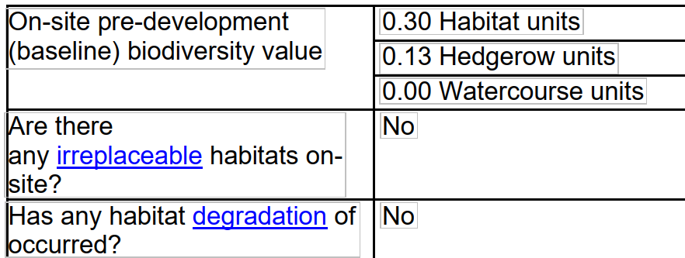

Figure 4. Post-development design plan (Biodiversity Net Gain Plan. 20 March 2026.

Wessex Ecology. Version No. 5986.1) identifies the areas of habitat creation and enhancement which contributes to the applications proposed BNG, however detail on the plan is limited. Confirmation of how the development will achieve BNG is a post-determination matter however consideration should be given to how any proposed BNG will be secured.

Off-site Biodiversity Gain Site - It is intended that an area of land in Figure 4. Post-development design plan (Biodiversity Net Gain Plan. 20 March 2026. Wessex Ecology. Version No. 5986.1) would be enhanced to achieve a 10% gain.

All land located outside the redline application boundary of the development site is considered off-site (refer to information here Make off-site biodiversity gains as a developer - GOV.UK.

All off-site biodiversity gains sites must be registered on the national biodiversity gains site register. Guidance on how to register a biodiversity gains site including a list of items required to apply can be found here - Register a biodiversity gain site - GOV.UK. In order for the Biodiversity Gain Plan condition to be discharged all off-site gains must be shown on the Biodiversity Gain Plan as allocated to this development on the national biodiversity gains site register.

Off-site gains must be secured via a legal agreement for at least 30 years. This must be a planning obligation (Section 106 agreement) or conservation covenant. Wiltshire Council will not enter into a Section 106 agreement for off-site gains unless the off-site gain site has been verified. Contact ecologychargeableservice@wiltshire.gov.uk to request further information on site verification.

Core Policy 50 of the Wiltshire Core Strategy requires all development to demonstrate no net loss of biodiversity and to seek opportunities to enhance biodiversity. The NPPF also encourages applications to deliver measurable net gains (para 186 d). It is anticipated that all developments will deliver no net loss of biodiversity.

PLANNING BALANCE AND CONCLUSION

At the heart of the NPPF there is a presumption in favour of sustainable development requiring local planning authorities to approve development proposals that accord with an up-to-date development plan without delay; and where there are no relevant development plan policies, or the policies which are most important for determining the application are out-of-date, permission should be granted unless (taken from paragraph 11d of the NPPF):

- The application of policies in the NPPF that protect areas or assets of particular importance provides a clear reason for refusing development proposed; or
- any adverse impacts of doing so would significantly and demonstrably outweigh the benefits, when assessed against the policies in the NPPF taken as a whole;

The proposed development is for the installation of a renewable led energy scheme comprising ground mounted photovoltaic solar arrays together with ancillary infrastructure. The proposed development is sustainable development that will make a contribution to the supply of renewable energy helping to reduce carbon emissions required to meet the Climate Change Act 2050 net zero.

On balance, whilst the proposal would result in the loss of Best and Most Versatile (BMV) Grade 2 agricultural land, this impact would be limited in nature. The land would not be irreversibly lost and could continue to support agricultural use, such as sheep grazing, alongside the solar arrays, with the potential for full restoration at the end of the development’s operational life. As such, the weight attributed to this harm is reduced. The scheme would deliver clear benefits through the generation of renewable energy, making a contribution towards reducing carbon emissions and supporting the transition to a low-carbon energy supply. These benefits attract substantial weight.

In terms of landscape and visual impacts, and any potential effects on heritage assets, these have been carefully assessed and are considered to be acceptable, particularly in light of the proposed mitigation and landscaping measures which would soften views and minimise the impacts of the development into the rural landscape.

Having regard to all material considerations, it is concluded that the limited harm identified is outweighed by the significant environmental benefits of the proposal, and the development is therefore acceptable on balance.

RECOMMENDATION:
That Planning Permission be GRANTED, subject to conditions

1. The development hereby permitted shall be begun before the expiration of three
years from the date of this permission.

REASON: To comply with the provisions of Section 91 of the Town and Country Planning Act 1990 as amended by the Planning and Compulsory Purchase Act 2004.

2. The development hereby permitted shall be carried out in accordance with the
following approved plans and documents:

Application form received 12/03/2026
Location plan Drg no SA-01 Rev A received 20/03/2026
Typical section Drg no 1078-SE-08 Rev A received 25/03/2026
Proposed plans/PV layout plan Drg no 4813-45694-500-000 Rev A received 16/02/2026
Landscape Statement received 16/02/2026
Proposed site plan/landscape masterplan Drg no 1078-MP-03 Rev A received 25/03/2026
Solar Array Battery Room Plans + Elevations Drg no SA 02 Rev # received 16/02/2026

REASON: For the avoidance of doubt and in the interests of proper planning

3. The materials to be used in the construction of the external surfaces of the development hereby permitted shall match those detailed on the application form and approved plans

REASON: For the avoidance of doubt and in the interests of character, design, appearance and setting of heritage assets

4. No development shall commence within the area indicated by the red line boundary on Location Plan Drg on SA 01 Rev A dated February 2026 until:
a) A written programme of archaeological investigation, which should include on-site work and off-site work such as the analysis, publishing and archiving of the results, has been submitted to and approved in writing by the Local Planning Authority; and
b) The approved programme of archaeological work has been carried out in accordance with the approved details.
REASON: In order to record and advance understanding of the significance of any heritage assets to be lost in a manner proportionate to their importance and to make this evidence and any archive generated publicly accessible in accordance with Paragraph 218 of the NPPF.
The programme of archaeological work should comprise the archaeological monitoring of any ground works that have the potential to impact on buried archaeological remains. The programme of archaeological work will conclude with the preparation of a report on the results commensurate with their significance.

5. The development shall be carried out in strict accordance with the approved landscaping details and shall be retained for the lifetime of the development.

All soft landscaping comprised in the approved details of landscaping shall be carried out in the first planting and seeding season following the first use of or the completion of the development hereby permitted whichever is the sooner; All shrubs, trees and hedge planting shall be maintained free from weeds and shall be protected from damage by vermin and stock. Any trees or plants which, within a period of five years, die, are removed, or become seriously damaged or diseased shall be replaced in the next planting season with others of a similar size and species, unless otherwise agreed in writing by the local planning authority.

REASON: To ensure a satisfactory landscaped setting for the development and the protection of existing important landscape features

6. Upon the development ceasing to be utilised to generate electricity, the panels and other associated infrastructure shall be removed from the site.

REASON: In order that the land is restored to its original condition following its cessation for use for the generation of electricity in the interests of the visual and landscape character of the area

7. All lighting provided on site shall be in accordance with the appropriate Environmental Zone standards set out by the Institute of Lighting Engineers in their publication GN01:2021, ‘Guidance for the Reduction of Obtrusive Light’ (ILP, 2021), and Guidance note GN08/23 “Bats and artificial lighting at night”, issued by the Bat Conservation Trust and Institution of Lighting Professionals.

REASON: In the interests of the amenities of the area and to minimize impacts on biodiversity caused by light spillage to areas above and outside the development site.

8. The development will be carried out in strict accordance with the following documents:

• Biodiversity Net Gain Plan. 20 March 2026. Wessex Ecology. Version No. 5986.1;
• The Statutory Biodiversity Metric. 20 March 2026;
• The Statutory Biodiversity Metric -Technical Annex 1: Condition Assessment Sheets and
Methodology. 27 February 2026.

REASON: For the avoidance of doubt and for the protection, mitigation and enhancement of biodiversity.

9. No construction (including demolition) shall take place on Sundays or Public Holidays or outside the hours of 08:00 to 18:00 Monday to Friday and 08:00 to 13:00 on Saturdays.

REASON: To minimise disturbance to nearby residents during the construction

INFORMATIVES

1. BNG required - The effect of paragraph 13 of Schedule 7A to the Town and Country Planning Act 1990 is that planning permission granted for the development of land in England is deemed to have been granted subject to the condition “(the biodiversity gain condition”) that development may not begin unless:

(a) a Biodiversity Gain Plan has been submitted to the planning authority, and
(b) the planning authority has approved the plan.

The planning authority, for the purposes of determining whether to approve a Biodiversity Gain Plan if one is required in respect of this permission would be Wiltshire Council. There are statutory exemptions and transitional arrangements which mean that the biodiversity gain condition does not always apply. For further information on exempt developments please refer to: https://www.gov.uk/guidance/biodiversity-net-gain-exempt-developments

Based on the information available this permission is considered to be one which will require the approval of a biodiversity gain plan before development is begun because none of the statutory exemptions or transitional arrangements are considered to apply. Irreplaceable habitat If the onsite habitat includes irreplaceable habitat (within the meaning of the Biodiversity Gain Requirements (Irreplaceable Habitat) Regulations 2024) there are additional requirements for the content and approval of Biodiversity Gain Plans.

The Biodiversity Gain Plan must include, in addition to information about steps taken or to be taken to minimise any adverse effect of the development on the habitat, information on arrangements for compensation for any impact the development has on the biodiversity of the irreplaceable habitat.

The planning authority can only approve a Biodiversity Gain Plan if satisfied that the adverse effect of the development on the biodiversity of the irreplaceable habitat is minimised and appropriate arrangements have been made for the purpose of compensating for any impact which do not include the use of biodiversity credits.

2. Any alterations to the approved plans, brought about by compliance with Building Regulations or any other reason must first be agreed in writing with the Local Planning Authority before commencement of work.

3. The applicant should note that it is a criminal offence to obstruct a public right of way under section 137 of the Highways Act 1980 and therefore no materials, plant, temporary structures or excavations of any kind should be deposited / undertaken which obstruct or adversely affect the public right of way WSLO26 whilst development takes place, without prior consultation with, and the further permission of, the highways authority at Wiltshire council.
4. The applicant should note that no gates or stiles should be erected across the public right of way without prior consultation and approval from the Countryside Access Officer (contact rightsofway@wiltshire.gov.uk). Unauthorised structures across a right of way are an obstruction and gates may only be authorised for the control of stock under section 147 of the Highways Act 1980.

5. The applicant should note that under the terms of the Wildlife and Countryside Act (1981) and the Conservation of Habitats and Species Regulations 2017 (as amended) it is an offence to disturb or harm any protected species including for example, breeding birds and reptiles. The protection offered to some species such as bats, extends beyond the individual animals to the places they use for shelter or resting. Please note that this consent does not override the statutory protection afforded to any such species. In the event that your proposals could potentially affect a protected species you should seek the advice of a suitably qualified and experienced ecologist and consider the need for a licence from Natural England prior to commencing works. Please see Natural England’s website for further information on protected species.

