APPLICATION FOR HOUSEHOLDER PLANNING PERMISSION
DELEGATED REPORT

APPLICATION REFERENCE: | PL/2026/02121
APPLICATION TYPE: | Householder Planning Permission
SITE ADDRESS: | Applecroft, 69 Lane End, Corsley, Warminster, BA12 7PG
DEVELOPMENT DESCRIPTION: | 2nd storey extension
RECOMMENDATION: | That Planning Permission be GRANTED

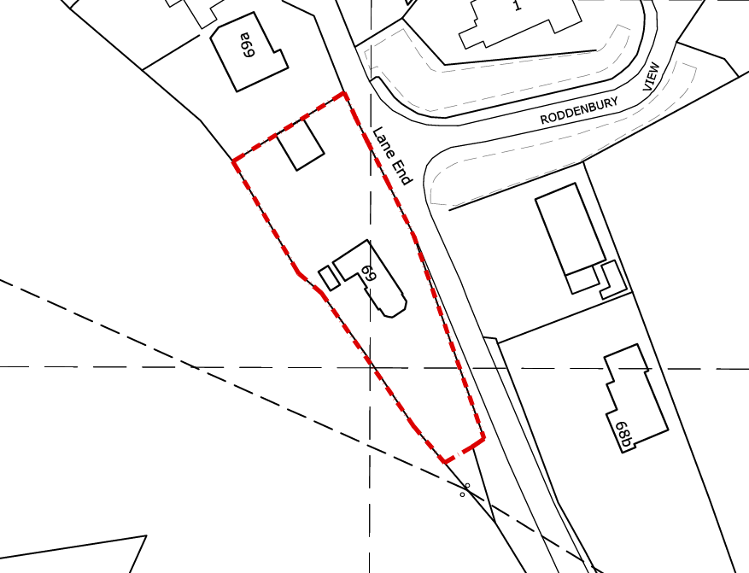

PROPOSAL

The application seeks planning permission for the conversion and extension of the existing rear projection to form a new two-storey rear extension. At ground floor level, the development would create a larger open-plan kitchen and dining area, replacing the current smaller kitchen, utility room, and office space to provide improved internal living accommodation. At first floor level, the proposals include the addition of a new bedroom with an associated en-suite, alongside the reconfiguration of the existing layout. This reconfiguration involves the removal of one existing bedroom to facilitate a larger family bathroom, ensuring that the property would remain as a three-bedroom dwelling overall despite the internal alterations.

SITE DESCRIPTION / CONTEXT

The application site relates to a detached dwelling located within a rural village context, characterised by a mix of external materials, although the host property itself is constructed of red brick with a tiled roof. The surrounding area exhibits a typical countryside character, with established greenery forming boundary treatments and expansive views of adjacent open farmland and mature trees. The property benefits from a substantial garden and is situated off a quiet country lane, with a large detached ancillary garage structure located within the curtilage. The site lies within Flood Zone 1, with the Council’s Strategic Flood Risk Assessment indicating potential groundwater flood risk, and is also positioned within the Cranborne Chase and West Wiltshire Downs National Landscape.

PLANNING HISTORY

Reference No. | Proposal / Summary | Decision
W/01/00114/FUL | Replacement double garage and store | Approved
14/03800/FUL | Single storey rear extension | Approved

RELEVANT LEGISLATION, POLICIES AND GUIDANCE

Wiltshire Core Strategy:

Core Policy 1 Settlement Strategy;
Core Policy 2 Delivery Strategy;
Core Policy 31 Spatial Strategy: Warminster Community Area;
Core Policy 50 Biodiversity and Geodiversity;
Core Policy 51 Landscape;
Core Policy 57 Ensuring High-Quality Design and Place Shaping;
Core Policy 60 Sustainable Transport;
Core Policy 61 Transport and Development;
Core Policy 64 Demand Management;
Core Policy 67 Flood Risk;

The National Planning Policy Framework (NPPF)

The Planning Practice Guidance (PPG)

Wiltshire Design Guide - Appendix D – Design Guidance for Householder extensions

The Wiltshire Local Transport Plan 2011 – 2026: Car Parking Strategy (March 2015).

The Wiltshire Local Transport Plan 4 (LTP4) (March 2025)

Emerging Policy – Wiltshire Local Plan Review

At Full Council on 19 May, the elected members of Wiltshire Council agreed to withdraw the emerging WLP. It will now be subject to a legal process to finalise its withdrawal - which is likely to happen in July or August (2026). The said Plan has no material weight for the purposes of the application.

CONSULTATION RESPONSES

Corsley Parish Council – No Comment Received

REPRESENTATIONS

No comments received.

ASSESSMENT

Section 38(6) of the Planning and Compulsory Purchase Act 2004 states:

"If regard is to be had to the development plan for the purposes of any determination to be made under the planning Acts, the determination must be made in accordance with the plan unless material considerations indicate otherwise."

In accordance with this statutory requirement, this application has been assessed against the relevant policies of the Development Plan, including the adopted Wiltshire Core Strategy (2015) and, where applicable, any made Neighbourhood Plans.

Householder extensions are generally acceptable in principle, as they typically fall within the established residential curtilage of a property and do not result in new residential development in the open countryside.

Design and Impact the upon the character and context of the area

Core Policy 57 Ensuring High Quality Design and Place Shaping of the Wiltshire Core Strategy requires all new development to achieve a high standard of design that responds positively to its local context. Proposals must reinforce and enhance local character and distinctiveness, relate appropriately to the surrounding landscape, and demonstrate a thoughtful response to existing townscape features. This includes careful consideration of elements such as building height, scale, massing, building line, materials, and overall appearance, ensuring new development integrates harmoniously with its setting.

The proposed development would retain the existing single-storey rear extension, which is constructed of natural stone with a pitched roof, and extend upwards to create a two-storey addition. The first-floor element would be finished in timber cladding, with a roof of concrete tiles to match the host dwelling. The extension has been designed with a roof pitch that remains below the height of the main house, ensuring it appears subservient and maintains a clear visual hierarchy with the original dwelling. To the rear, the proposal includes a balcony area serving the new bedroom, set within a gable feature incorporating large-scale glazing extending up to the roof apex. Whilst this introduces a more contemporary element, the use of timber cladding reflects materials already present within the locality and would not appear incongruous. Furthermore, due to its position at the rear, the extension would face away from neighbouring dwellings and would be largely screened from wider public vantage points, with only limited glimpses possible from across the adjacent field. Overall, the proposal respects the established form and footprint of the dwelling, representing an upward extension rather than a significant increase in site coverage, and uses materials that are consistent with the surrounding vernacular.

The site lies within the Cranborne Chase and West Wiltshire Downs National Landscape, where great weight must be afforded to conserving and enhancing landscape character in accordance with Core Policy 51. In this instance, the proposal is considered to represent a modest and proportionate extension to the existing dwelling, which would not result in any significant encroachment into the open countryside or alter the established spatial arrangement of built form within the site. The extension is contained within the existing curtilage and, being located to the rear, would not appear prominent in wider landscape views. The choice of materials, including timber cladding and tiles to match the host dwelling, ensures that the development would assimilate appropriately with both the property and the wider rural context. As such, the proposal would not give rise to any demonstrable harm to the character or scenic qualities of the National Landscape and is therefore considered to comply with the aims of Core Policy 51.

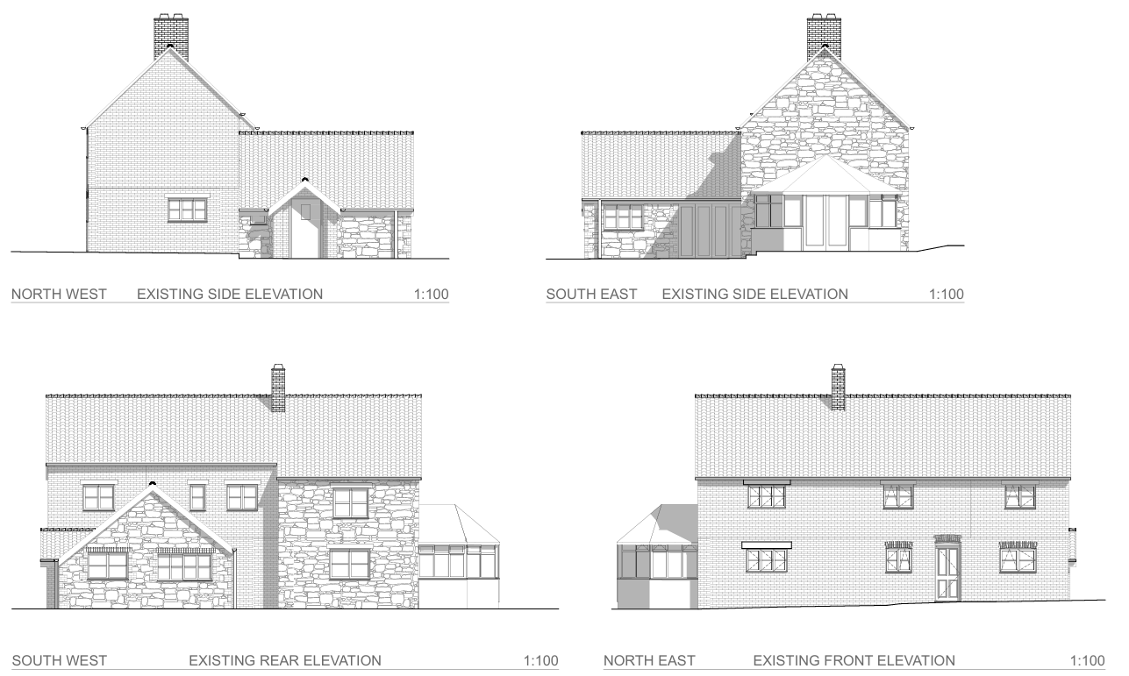
Exisiting Elevations

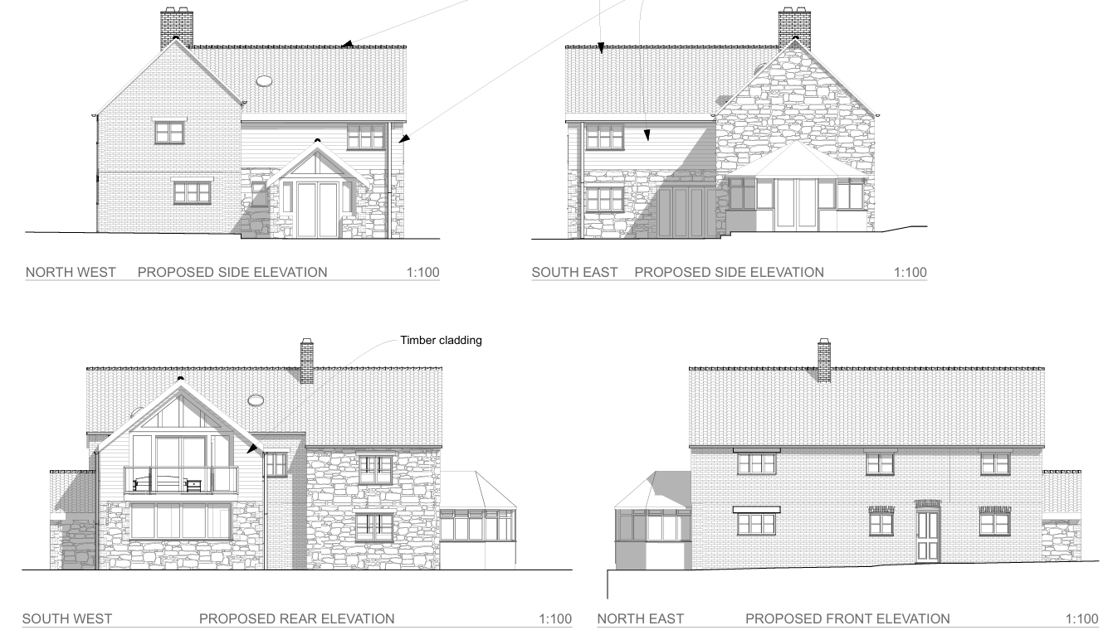
Proposed Elevations

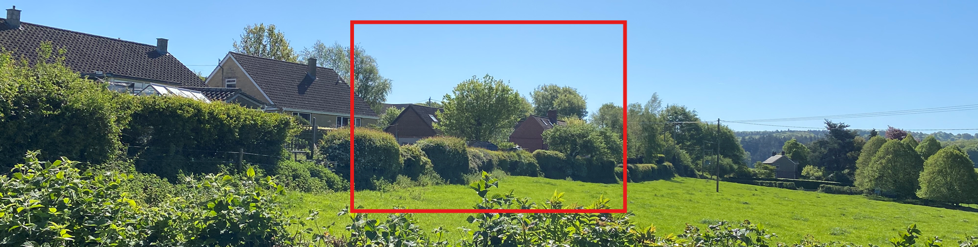
Site from across adjacent field

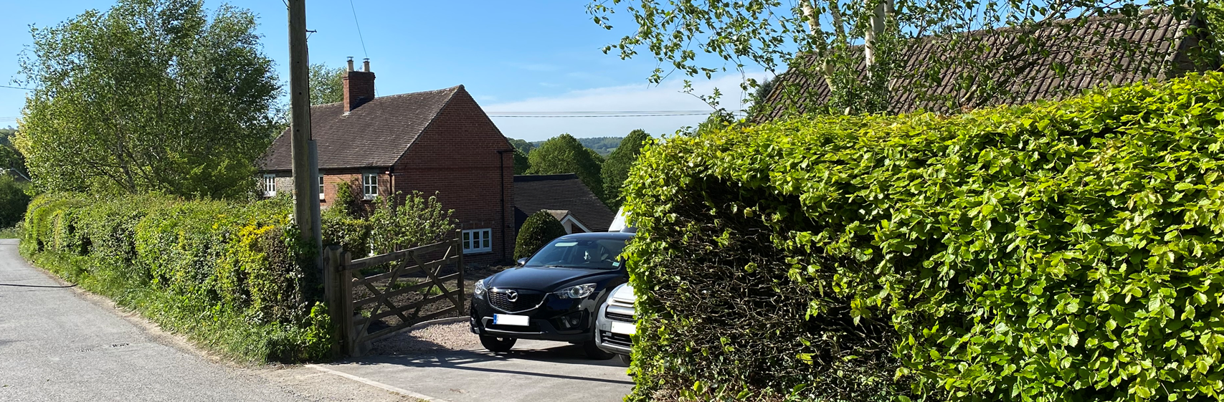
Site from Lane End

Having regard to the above, the proposal complies with the design principles set out in Core Policy 57 of the Wiltshire Core Strategy and Appendix D of the Wiltshire Design Guide.

Amenity

Point vii of Core Policy 57 Ensuring High Quality Design and Place Shaping of the Wiltshire Core Strategy seeks to ensure that developments do not adversely affect neighbouring properties.

The National Planning Policy Framework (NPPF), particularly Paragraph 135, stresses that planning decisions should ensure developments provide a high standard of amenity for existing and future users.

The proposed development is considered acceptable in terms of its impact on neighbouring residential amenity. The host dwelling is positioned at a substantial distance from adjacent properties, with approximately 36 metres separation, ensuring there would be no adverse impacts in terms of overbearing presence, overshadowing, or loss of light. Although new windows are proposed within the north-west and south-east elevations, the significant separation distance ensures that there would be no harmful overlooking or loss of privacy to neighbouring occupiers. Furthermore, the proposed rear-facing balcony would be oriented towards open farmland, where there are no nearby residential receptors requiring protection. As such, the development would not give rise to any unacceptable impacts on neighbouring amenity and is therefore considered to comply with relevant planning policy.

The proposal is appropriately sited, designed, and oriented to ensure that it would not result in unacceptable impact upon/to the amenities or living conditions of neighbouring residential occupiers, particularly in terms of outlook, privacy, or access to natural light.

The proposal therefore accords with Core Policy 57 point vii in respect of safeguarding residential amenity and Appendix D of the Wiltshire Design Guide.

Other Issues

Core Policy 50 of the Wiltshire Core Strategy requires development to protect and, where possible, enhance biodiversity interests. In this case, the proposal relates to householder development and is therefore exempt from the requirement to deliver Biodiversity Net Gain under Schedule 7A, Section 4(2)(a) of the Town and Country Planning Act 1990 (as amended). The works are confined to the existing residential curtilage and do not give rise to any identified ecological constraints or impacts on designated sites, protected habitats, or species. As such, the proposal is considered acceptable in ecological terms and compliant with the requirements of Core Policy 50.

The proposal includes internal reconfiguration at first floor level, resulting in the creation of a new bedroom alongside the removal of an existing bedroom to accommodate a larger bathroom. As such, the overall number of bedrooms within the dwelling would remain unchanged. Additionally, the proposal does not include any alteration to the existing parking and access arrangements. It is therefore considered that there is no highway or transportation concerns present with the proposal, and it is otherwise considered acceptable.

The application site lies within Flood Zone 1, where the risk of fluvial flooding is considered low; however, the Council’s Strategic Flood Risk Assessment highlights the potential for groundwater flood risk in the area. In line with paragraph 176 of the NPPF, the proposal, as minor householder development under 250m², is exempt from the sequential and exception tests. While national policy advises that site-specific flood risk assessments may still be required in areas affected by other sources of flooding, it is considered that, given the limited scale and nature of the proposed works—primarily an extension to an existing dwelling within an established residential curtilage—the submission of a detailed flood risk assessment would not be necessary in this instance. The development would not significantly increase impermeable surfacing or alter ground conditions to a degree that would exacerbate flood risk, and it is reasonable to expect that surface water can be appropriately managed through standard drainage measures in accordance with Core Policy 67. As such, the proposal is considered acceptable in terms of drainage and flood risk.

CONCLUSION

The proposal is considered to be acceptable and in accordance with the relevant policies and guidance outlined above.

RECOMMENDATION: That Planning Permission be GRANTED subject to the following conditions:

1.
The development hereby permitted shall be begun before the expiration of three years from the date of this permission.
REASON: To comply with the provisions of Section 91 of the Town and Country Planning Act 1990 as amended by the Planning and Compulsory Purchase Act 2004.

2.
The development hereby permitted shall be carried out in accordance with the following approved plans and documents:

Proposed Plans 2603 AP.11 (30 March 2026)
Location Plan and Site Plan 2603 S.01 (30 March 2026)
Proposed Elevations 2603 AP.12 (30 March 2026)
Proposed Site and Roof Plans 2603 AP.13 (12 April 2026)

REASON: For the avoidance of doubt and in the interests of proper planning.

