APPLICATION FOR HOUSEHOLDER PLANNING PERMISSION
DELEGATED REPORT

APPLICATION REFERENCE: | PL/2026/02433
APPLICATION TYPE: | Householder planning permission
SITE ADDRESS: | 84 The Green, Great Cheverell. Devizes, SN10 5UY
DEVELOPMENT DESCRIPTION: | Removal of existing attached outbuilding with proposed single storey front/side extension, proposed oak framed open porch and proposed garden room.
RECOMMENDATION: | That Planning Permission be GRANTED

PROPOSAL

The proposal seeks planning permission for the demolition of an existing attached outbuilding and the construction of a single-storey front/side extension, oak framed open porch and detached garden room.

The existing and proposed plans are shown below:

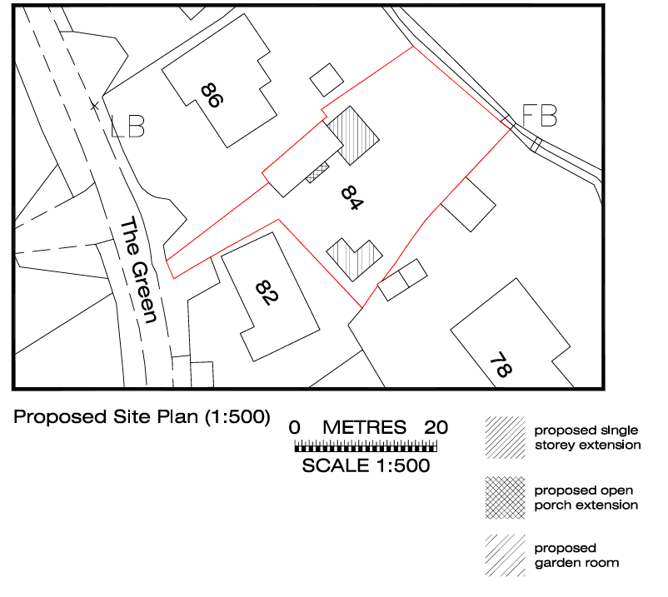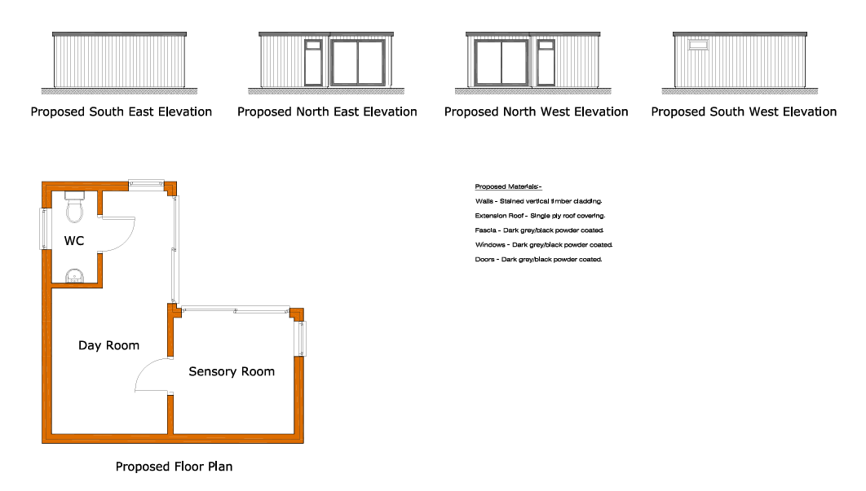

Proposed site plan Proposed outbuilding

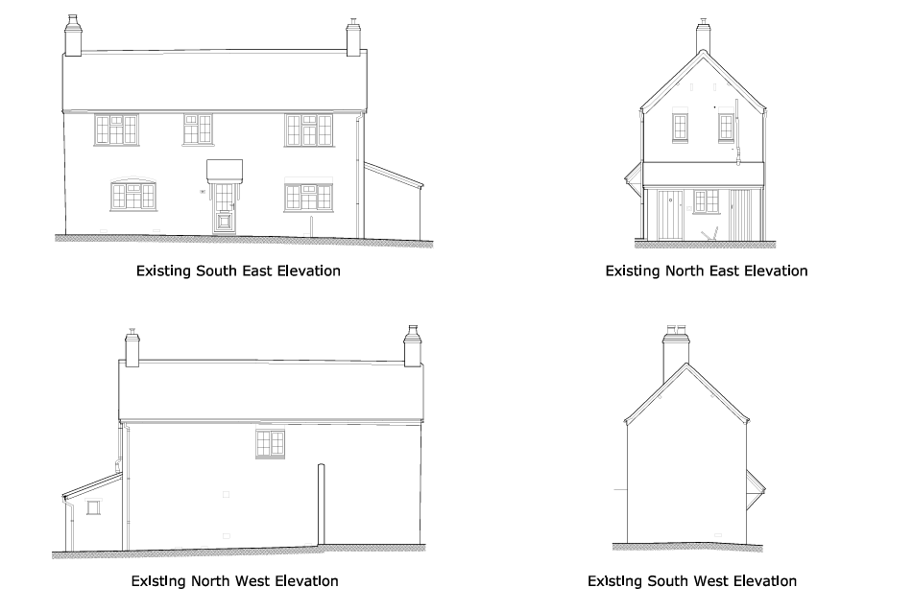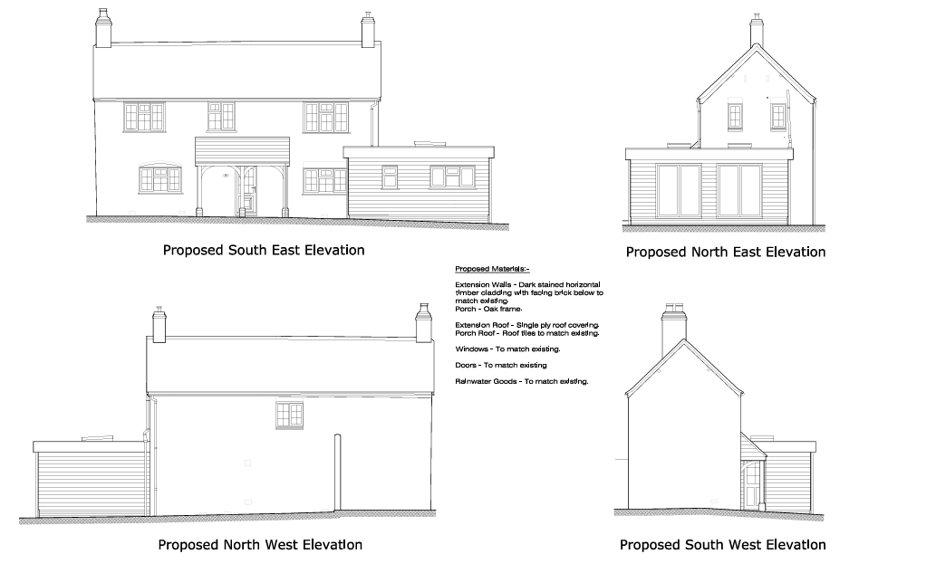

Existing and proposed elevations (dwelling)

SITE DESCRIPTION/CONTEXT

The application site relates to No.84 The Green, a detached two-storey dwelling, with a single-storey attached outbuilding to the north-east of the property. The dwelling is constructed of facing brick, with a tiled pitched roof over the two storey main property and a tiled lean-to roof over the single-storey outbuilding. The dwelling is positioned side on to the street, with its principal elevation facing into the site. The dwelling is set back from the highway by approximately 18m and accessed from The Green via a private driveway.

There is a stream to the north-east of the site with open countryside beyond. The site itself lies within Flood Zone 1, whilst the stream lies within Flood Zones 2 and 3 as confirmed in the submitted Floor Risk Assessment.

There are no other notable site constraints – the site does not lie within a Conservation Area or National Landscape and the building is not a listed building.

PLANNING HISTORY

No relevant planning history

RELEVANT POLICIES AND GUIDANCE

Wiltshire Core Strategy:

- Core Policy 50: Biodiversity and Geodiversity
- Core Policy 57 Ensuring High Quality Design and Place Shaping
- Core Policy 61: Transport and New Development
- Core Policy 64: Demand Management
- Core Policy 67: Flood Risk

Wiltshire Design Guide: Appendix D – Design Guidance for Householder extensions

The National Planning Policy Framework (NPPF)

The Planning Practice Guidance

National Design Guide

CONSULTATION RESPONSES

Cheverell Magna Parish Council: No objection

WC Drainage Engineer: commented “The proposed extension will be within FZ1, therefore no consultation required.”

WC Highways Officer: No objection

REPRESENTATIONS

No comments were received at the time of writing.

ASSESSMENT

Section 38(6) of the Planning and Compulsory Purchase Act 2004 states:

"If regard is to be had to the development plan for the purposes of any determination to be made under the planning Acts, the determination must be made in accordance with the plan unless material considerations indicate otherwise."

In accordance with this statutory requirement, this application has been assessed against the relevant policies of the Development Plan, including the adopted Wiltshire Core Strategy (2015) and, where applicable, any made Neighbourhood Plans (in this instance the area is designated but no neighbourhood plan has been made).

Design and Impact upon the character and context of the area

Core Policy 57 - Ensuring High Quality Design and Place Shaping of the Wiltshire Core Strategy seeks to ensure that all new development is of high design quality, reflecting local context, character, and distinctiveness.

The proposal involves three key elements, construction of a single-storey front/side extension construction and an oak framed open porch and the construction of a detached outbuilding.

The existing single-storey lean-to extension will be demolished to facilitate the construction of the front/side extension.

The proposed extension would be constructed of horizontal timber cladding above facing brick to match existing, single-ply roof covering, and windows and doors to match existing.

Whilst the flat‑roofed form and forward projection depart from the preferred design principles set out in Appendix D of the Wiltshire Design Guide, in this particular case the harm is limited by the dwelling’s orientation, substantial setback from the highway, and the presence of existing built form within the street scene, including the neighbouring flat-roofed garage (as evidenced in the images below:

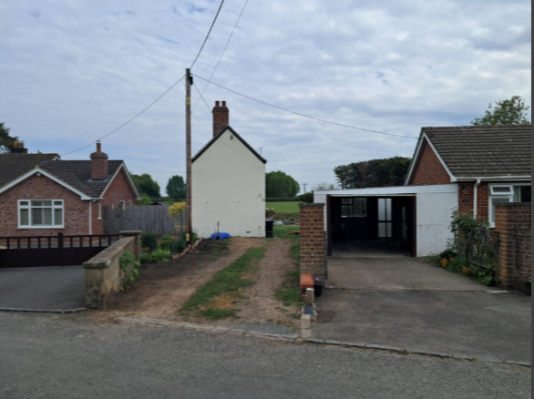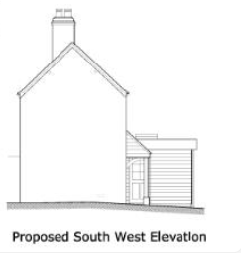

Case Officer’s site visit photo Proposed side elevation facing the highway
The proposal would therefore not result in demonstrable harm to the character or appearance of the area.

The proposed porch would be a modest addition to the dwelling and read in context with the proposed extension.

The proposed outbuilding would be sited in the southern corner of the site adjacent to neighbouring properties (No.s 78 and 82 The Green) and established trees/vegetation. The proposed outbuilding would be constructed to an appropriate scale, design and materials (stained vertical timber cladding, single-ply roof covering, dark grey/black powder coated windows and doors) and would be in keeping with the proposed house extension. The proposed outbuilding would be positioned such that it would not readily visible from public vantage points. In light of the above, the proposed outbuilding is considered to be an acceptable addition. Given its scale, siting and relationship with the host dwelling, the outbuilding is considered to be incidental to the enjoyment of the dwellinghouse, and as such a condition will be included on the approval to ensure that it is retained for such purposes.

The application site is a generous sized plot, which can easily accommodate the proposed development, without constituting overdevelopment. The proposed extension, porch and outbuilding are considered acceptable additions, which would not result in such a detrimental impact upon the character and appearance of the area to warrant a reason for refusal in this instance.

Having regard to the above, the proposal complies with the design principles set out in Core Policy 57 of the Wiltshire Core Strategy and Appendix D of the Wiltshire Design Guide.

Amenity

Point vii of Core Policy 57 - Ensuring High Quality Design and Place Shaping of the Wiltshire Core Strategy seeks to ensure that developments do not adversely affect neighbouring properties.

The National Planning Policy Framework (NPPF), particularly Paragraph 135(f), stresses that planning decisions should ensure developments provide a high standard of amenity for existing and future users.

The proposed development has been assessed in terms of its potential impact on the residential amenity of neighbouring properties, with particular regard to loss of light, overshadowing, loss of privacy, and overbearing effects.

The siting of the proposed extension, porch and outbuilding can be seen in the image below:

Proposed site plan

As can be seen in the image above, the proposed extension would be constructed to the side and project forward of the principal elevation, facing into the application site. The extension would be set in by approximately 1 to 2m from the shared boundary with the neighbouring property to the north-west (No.86). Given the single-storey nature of the proposals and the separation distances that exist between the extension and neighbouring properties, it is considered that the proposal will not materially impact upon the occupiers as a consequence of overbearing impact, overshadowing or loss of privacy.

The proposed porch would be a modest addition to the dwelling, facing into the application site and not towards any neighbouring properties. It is therefore considered that the porch would not impact upon the amenity of neighbouring occupiers.

The proposed outbuilding would be sited in the southern corner of the site, adjacent to the shared boundaries with No.s 78 and 82 The Green. As can be seen in the image below, this corner of the site is relatively well screened from neighbouring properties by existing trees:

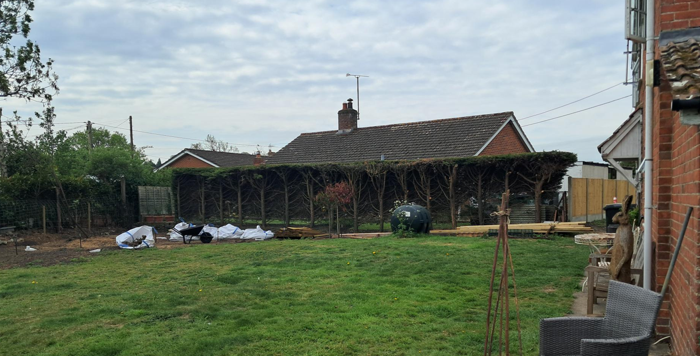

Case Officer’s site visit photo
The proposed outbuilding would be set in from the shared boundaries with the neighbouring properties by at least 1.75m. Given the siting, the single-storey nature of the building and the existing boundary treatments, it is considered that the proposed outbuilding would not adversely impact upon the neighbouring occupiers as a consequence of overbearing impact, overshadowing or loss of privacy.

The proposal therefore accords with Core Policy 57 point vii in respect of safeguarding residential amenity and Appendix D of the Wiltshire Design Guide.

Highways Impact
Core Policy 57 (xiv) of the Wiltshire Core Strategy seeks to ensure that development must meet the requirements of Core Policy 61. This policy requires proposals to be capable of being served by safe access to the highway network. Core Policy 64 seeks to ensure compliance with parking standards set out in the Local Transport Plan.

The National Planning Policy Framework (NPPF), particularly Paragraph 115 and 116, requires that development proposals do not have an unacceptable impact on highway safety and that safe and suitable access to the site can be achieved for all users.

The proposals comprise a single-storey extension, porch and detached outbuilding. There would be no increase in the number of bedrooms as a result of the proposed development. Furthermore, there would be no change to the existing access, driveway, and parking provision.

In consideration of the proposed development, the council’s Highways Officer has raised no objection, commenting as follows:

“I refer to the above planning application for the removal of the existing attached outbuilding with proposed single storey front/side extension, proposed oak framed open porch and proposed garden room.

The proposal will not alter the number of bedrooms in the property or the parking provision or vehicle access and is therefore considered not to be detrimental to highway safety.”

The proposed development would not result in any adverse impact on highway safety. Adequate parking and turning provision is provided in accordance with Wiltshire’s adopted parking standards, and access arrangements are acceptable.

The proposal is therefore considered to comply with Core Policies 57 (xiv), 61 and 64 of the Wiltshire Core Strategy, the NPPF, and the Wiltshire Local Transport Plan.

Drainage and Flood Risk
Core Policy 67 of the Wiltshire Core Strategy and paragraph 181 of the NPPF requires that all new development avoids increasing flood risk on-site or elsewhere and, where appropriate, incorporates sustainable drainage measures. Development must also comply with national policy on flood risk management and drainage design. Paragraph 176 (via footnote 62) of the NPPF states that householder development should not be subject to the sequential test, nor the exception test.

The majority of the application site lies within Flood Zone 1, with only the very edge of the north-eastern side of the site falling within Flood Zones 2 and 3. The stream to the north-east of the site also lies within Flood Zones 2 and 3 (as evidenced in the Flood Map for Planning below):

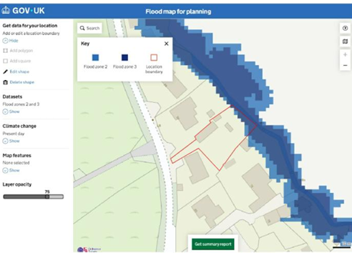

The application site slopes down towards the stream. The proposed extension would be constructed approximately 13.5m from the stream and the proposed outbuilding would be sited approximately 25.5m. The submitted Design and Access Statement (Flood Risk Assessment section) confirms that the finished floor levels would be in the region of 1m above the water level. Whilst the proposed extension and outbuilding lie wholly within Flood Zone 1 and therefore do not require any flood mitigation measures, the proposed extension and outbuilding will be constructed with slabs to match the slab level of the existing property as stated in the submitted Design and Access Statement (Flood Risk Assessment section).

As the proposed development lies within Flood Zone 1 and the slab levels will match the slab level of the existing property, the proposals do not give rise to any significant concerns in terms of flood risk.

The proposal therefore complies with Core Policy 67 of the Wiltshire Core Strategy and the policy in the NPPF, ensuring that flood risk is not increased and that surface water drainage is appropriately managed.

Biodiversity Net Gain

Householder planning applications are exempt from the requirement to deliver Biodiversity Net Gain under Schedule 7A, Section 4(2)(a) of the Town and Country Planning Act 1990, as inserted by the Environment Act 2021.

CONCLUSION

In undertaking the planning balance, the proposal gives rise to a limited degree of design harm, which attracts moderate weight. However, this is outweighed by the absence of harm in respect of neighbour amenity, highway safety and flood risk, and the overall compliance with the development plan when read as a whole.

As such, the proposal is considered to comply with the relevant policies of the Wiltshire Core Strategy, the Wiltshire Local Plan, and the National Planning Policy Framework. As such, the application is recommended for approval, subject to the conditions set out below.

RECOMMENDATION: That Planning Permission be GRANTED subject to conditions.

