APPLICATION FOR FULL PLANNING PERMISSION DELEGATED REPORT

APPLICATION REFERENCE: | PL/2026/02163
APPLICATION TYPE: | Full planning permission
SITE ADDRESS: | Boyes Transport Yard, Longcross, Near Zeals, Warminster, BA12 6LL
DEVELOPMENT DESCRIPTION: | Retrospective planning application for retention of welfare facilities and revisions to workshop building permitted by planning permission PL/2022/01499.
RECOMMENDATION: | That Planning Permission be REFUSED

PROPOSAL

The proposal seeks planning permission for the retention of welfare facilities which include a portacabin and separate toilet block; the application is also seeking consent for the retention of revisions to the design of the workshop building which was approved but not built in accordance with the details submitted under planning permission PL/2022/01499.

Welfare portacabin Toilet block

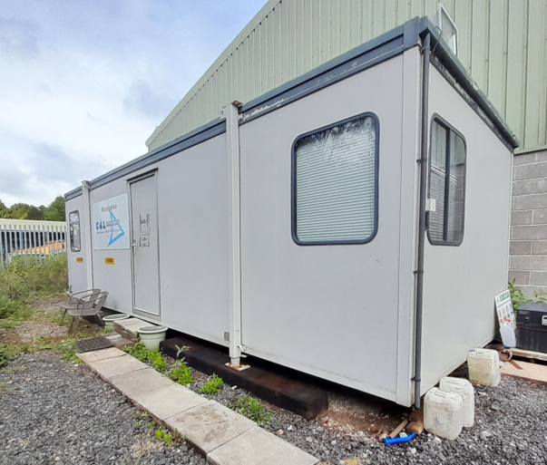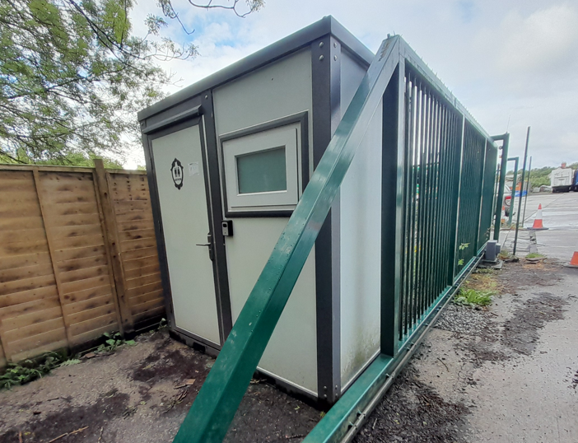

Warehouse

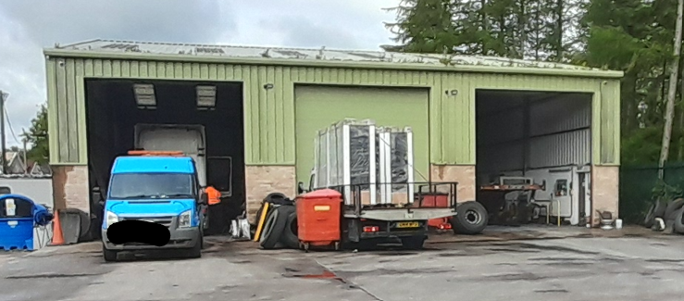

SITE DESCRIPTION/CONTEXT

The application site relates to Boyes Transport; an existing established commercial site used as a haulage site for parking of HGVs with an associated workshop and area of hardstanding. The site is located outside of any settlement boundary to the north east of the small village of Zeals, not far from the County border with Dorset. The site is located to the north of the A303 accessed from the northern side of Portnells Lane.

The site is bounded by Leaping Frogs nursery school to the east; an area of woodland to the north; C&G Surfacing Ltd, a commercial company providing tarmac/other surfacing immediately to the west with residential properties to the west of C&G Surfacing Ltd. To the south of the application site on the opposite side of Portnells Lane are fields and a residential dwelling known as Cornerways Cottage.

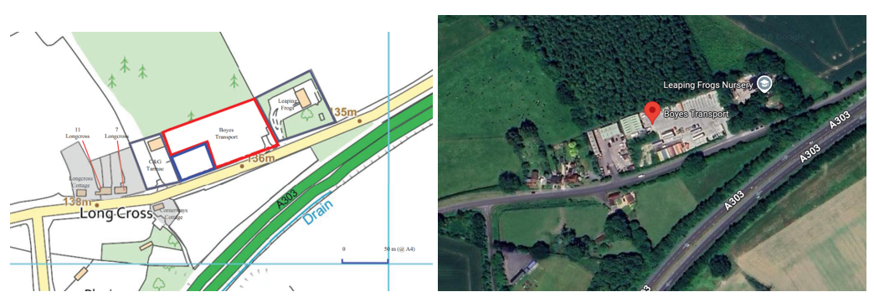

The site is not located within a conservation area and there are no listed buildings on or immediately adjacent to the site, but the site is located within the Cranborne Chase National Landscape (Formerly AONB).

PLANNING HISTORY

The application site has an extensive site history as listed below.

PL/2023/07051 - Full planning permission Decision - Refuse Date: 20/2/2024 – Siting of 7 No. shipping containers to provide storage for existing transport yard

PL/2023/04127 - Removal/variation of conditions Decision - Withdrawn by Applicant Date: 2/8/2023 – Variation of conditions 2 and 10 of PL/2022/01499 to allow the siting of 7 shipping containers to be used for storage

PL/2022/01499 - Full planning permission Decision - Approve with Conditions Date: 28/11/2022 – Proposed 0.13 ha extension to existing 0.52 ha Boyes Transport Yard for use as a 60ft x 70ft (18.29m x 21.34m x 7.1m (h)) HGV and trailer workshop, new concrete yard, oil interceptor and landscaping, retaining max 15 car parking spaces and max 15 lorry and trailer parking spaces

20/04569/FUL - Full planning permission Decision - Approve with Conditions Date: 3/11/2021 – Continued use of Boyes existing Transport Yard (0.5 ha) for HGV tractor and trailer parking and soft landscaping (revised scheme).

20/04355/CLE - Lawful development: Existing use Decision - Approved Date: 10/9/2020 – Coverage of 5,598 sqm of the 8,000 sqm site with hardcore in the summer of 2015 to create firm hardstanding for Boyes Transport (BT) and Grandstands Worldwide Ltd (GWL)

19/08011/FUL - Full planning permission Decision - Approve with Conditions Date: 8/10/2019 – Erection of a New Unit for Machinery Storage

16/05242/FUL - Full planning permission Decision - Approve with Conditions Date: 25/7/2016 – Demolition of the 2 existing buildings and the erection of a replacement building (amendment to the development granted by Planning Permission 15/12787/FUL)

15/12707/FUL - Full planning permission Decision - Approve with Conditions Date: 11/4/2016 – Demolition of the 2 existing buildings and the erection of a replacement building

13/05423/FUL - Full planning permission Decision - Approve with Conditions Date: 18/5/2015 – Change of use to HGV Trailer Storage, form new vehicular and pedestrian access

S/2009/0014 - Full planning permission Decision - Refused Date: 30/6/2009 – change use of land from agricultural to hgv trailer storage and new vehicular access and relocation of layby

S/2008/0341 - Full planning permission Decision - Refused Date: 11/4/2008 – a concrete pad for agricultural use two tanks to be placed on pad one for liquid fertiliser the other for water access off old a303 (retrospective)

S/2007/1961 - Full planning permission Decision - Withdrawn Date: 16/11/2007 – change of use for hgc trailer storage and provision of new access and laying out of 15 trailer spaces and new permeable surface and fencing

S/2001/2305 - Full planning permission Decision - Refused Date: 14/2/2002 – parking for 6 lorries mainly at weekends and light storage

PL/2023/00587 - Approval of details reserved by a condition Decision - Approve Date: 4/4/2023 – Discharge of Condition No 6 on PL/2022/01499 (Proposed 0.13 ha extension to existing 0.52 ha Boyes Transport Yard for use as a 60ft x 70ft (18.29m x 21.34m7.1m (h)) HGV and trailer workshop, new concrete yard, oil interceptor and landscaping, retaining max 15 car parking spaces and max 15 lorry and trailer parking spaces.

RELEVANT POLICIES AND GUIDANCE

- National Planning Policy Framework (NPPF)
- Planning Practice Guidance (PPG)
- National Design Guide

Wiltshire Core Strategy:

CP1 Settlement Strategy
CP2 Delivery Strategy
CP17 Spatial Strategy: Mere Community Area
CP35 Existing employment sites
CP50 Biodiversity
CP51 Landscape
CP57 Ensuring High Quality Design and Place Shaping
CP60-64 Highways
CP65 Movement of goods

Salisbury District Saved local plan policy E19

National Landscape Management Plan
Wiltshire Design Guide
Creating Places Design Guide

CONSULTATION RESPONSES

Parish Council: Objection

Zeals Parish Council have objected to this retrospective planning application in two parts
1) The welfare unit - the planning application states it is unknown how foul sewage is disposed of and it is unknown if it will be connected to the existing drainage system. Concern was expressed to the effect it would have on an AONB, especially as the planning application suggests proposed employment will increase, putting further strain on any currant ‘drainage system’.
2) The workshop building – the building that is on site at the moment is taller than the original planning application allowed. It can be seen that the eaves height is the same as the building adjacent to it, on a neighbouring companies land, but the actual roof is much higher. Over height buildings can spoil an AONB, in which this building is sited and conditions on the original planning application seem to have been blatantly ignored.

Public Protection: On review of the application, it is noted that the site boundary is approximately 47 metres from Leaping Frogs Day Nursery and 60 metres from the nearest residential property. To ensure that these noise-sensitive receptors are adequately protected from potential adverse effects, it is recommended that conditions 5, 9, 11, and 12 attached to planning permission PL/2022/01499 are re-attached to any subsequent planning approval.
In addition, it is recommended that condition 14 of planning permission PL/2022/01499 is also re-attached.

Archaeology: No comment

Highways: I note the submission seek permission for the retention of the existing workshop and welfare facilities. I am aware that the workshop building previously received consent under application PL/2022/01499, however, was not constructed in accordance with that previous approval. The workshop and welfare units as existing do not have a material impact to highway matters and therefore, I recommend that no Highway objection is raised.

National Landscape: No formal comments have been received due to the National Landscape awaiting the LVIA the Agent stated had been commissioned which has not been provided at the time of writing this report 2 days before the expiry of the 8 week determination date. Informally the National Landscape had expressed concerns in relation to the development.

REPRESENTATIONS

Two letters of support have been received and included in full below.

- I am writing in support of the application, we can only really see the building which materially would make no difference if it was slightly lower as you would still see it, and a small view of the yard through the gateway. You can see buildings and vehicles in both C&G and Leaping frogs sites the same. It's a perfect place for a business and obviously it helps the economy both locally and nationally. The applicants have caused me no harm and I wish them well.

- Without wishing to go over old support, I drive the road daily and I have seen the site improve over the years, out of the 3 sites along that stretch road this site appears to be less conspicuous than the others and the hedging has all but shielded the whole site. From talking to a few people it is my understanding that the previous company dealing with the application made an error and this application is to rectify that, in the years that the building has been there to me it has never stood out as being overly high and does look similar to a barn found on a farm. Nobody has ever mentioned to me that it looked excessively high and I believe it is a legal requirement for a toilet to be on site for staff to use.

Two letters of objection have been received from the same third party and included in full below.

First letter of objection

- 1. Landscaping Objection: The application appears to rely on the deep roadside landscape screen along the Old A303 frontage, but the enclosed Highway Land Ownership and Topographic Boundary Plan from 2020 indicates that important parts of that verge and screening are outside the applicant's ownership/control. See Appendices 1 and 2.

Landscape screening which the applicant did not own or control could in 2022 and cannot today (because it is Highway Land owned by Wiltshire Council) cannot be treated as secure, permanent mitigation for an intrusive industrial building and shipping containers in the Cranborne Chase National Landscape.

The Council should not now accept the taller as-built workshop, and unauthorised welfare buildings, containers, yard parking or lighting on the false premise that the roadside vegetation is secure landscape mitigation.

- 2. Height Objection: In accordance with the Case Planning Officer’s (Lynda King) fixed position; her original planning judgment under PL/2022/01499 was to restrict the ridge height to about 7.1m, broadly comparable with the neighbouring C&G building (C&G eaves height is 143.63m and 144.30m to ridge – see Appendices 1 and 2) and in the context of landownership and landscaping. In any event, a materially taller workshop was not needed by the applicant in 2022. Further, the Applicant willingly accepted the restriction to 7.1m after several years of a planning saga.

- 3. No need for greater workshop height: The claimed operational justification for the higher workshop also needs scrutiny. The as-built eaves are lower than the approved eaves. The as-built eaves are even lower than the adjacent C&G building, too. The assertion that the increased ridge was necessary for HGV clearance is questionable. The applicant should provide accurate approved/as-built comparative drawings showing eaves, ridge, door openings, roof pitch and internal clearances – compared also to the C&G workshop.

- 4. Incomplete retrospective planning application: The application is not a minor tidying-up exercise. It is a retrospective attempt to regularise all the development already carried out, since the workshop was started on 1 July 2022. The Council must therefore assess the whole development as built and the use as operating, not merely the applicant's narrow description.

- 5. Faulty red line: The red line and description appear inadequate. The application refers to welfare facilities and revisions to the workshop, but the site raises wider issues: the full operational yard, shipping containers, HGV/trailer and car parking, possible intensification, external lighting, oil storage, washdown, trade waste, drainage, office/welfare accommodation, annexed land without permission for commercial use and the relationship with the wider planning unit. A retrospective application cannot regularise selected parts while leaving obviously identified – see photographs by the applicant – and connected operational development - outside the red line and unexplained.

- 6. Planning Conditions and the S106: The Council should require a comparison against PL/2022/01499 and a compliance schedule for all conditions and obligations, including any section 106 requirements.

- 7. National Landscape: The application is also deficient on environmental and National Landscape matters. An open B2 workshop is not benign. Servicing, MOT work, oil storage, contaminated washdown water, trade waste, foul drainage from showers/WCs and external lighting all require proper control. The site lies within the Cranborne Chase National Landscape, where landscape and scenic beauty have the highest national protection. The Council should require proper landscape/visual, drainage, lighting, ecology/BNG and operational-use information before any decision is made.

- 8. In short, the Council is being asked to approve a larger and taller (to ridge only) and different workshop, wholly new welfare/office accommodation, more containers (than dismissed at appeal on adverse impact on the National Landscape grounds), more parking (than approved in 2022), more lighting and yard operations without defining the planning unit, ownership, mitigation, environmental controls or compliance with the 2022 permission.

- 9. I respectfully request that the Council either requires the submission of a comprehensive application addressing the whole site and all development/use, or refuses permission because the application is materially incomplete and has not demonstrated compliance with the development plan, national policy or the previous controls attached to PL/2022/01499.

- 10. If approval is contemplated, further information must first be required and the Parish Council, consultees and neighbours re-consulted

Appendix 1 - Wiltshire Council Highways Plan dated 30 November 2020
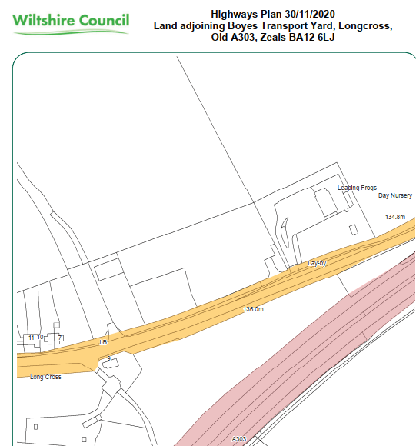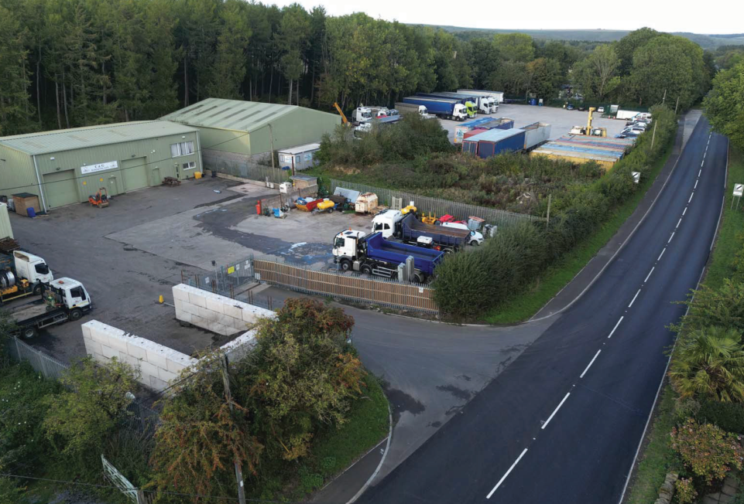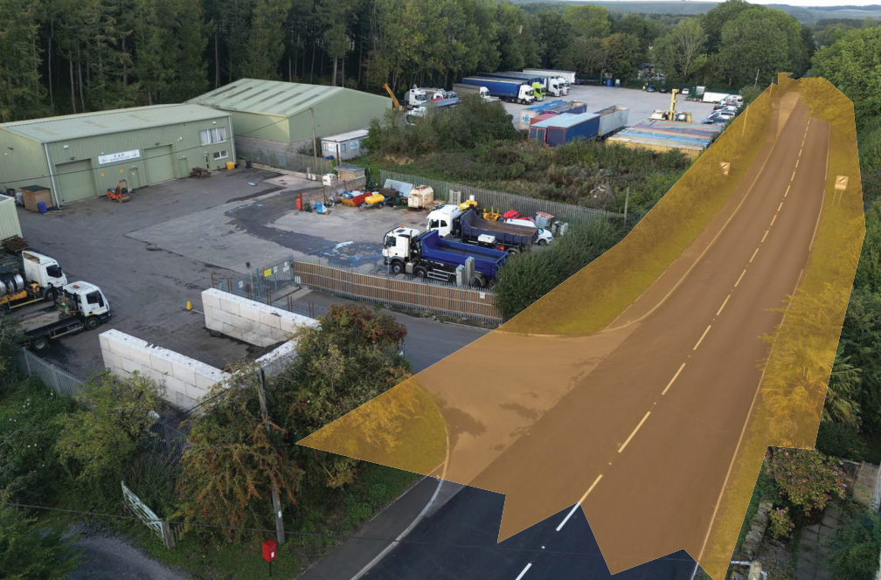
Appendix 2 - Boyes Transport topographic survey / Land Registry boundary overlay dated November 2020
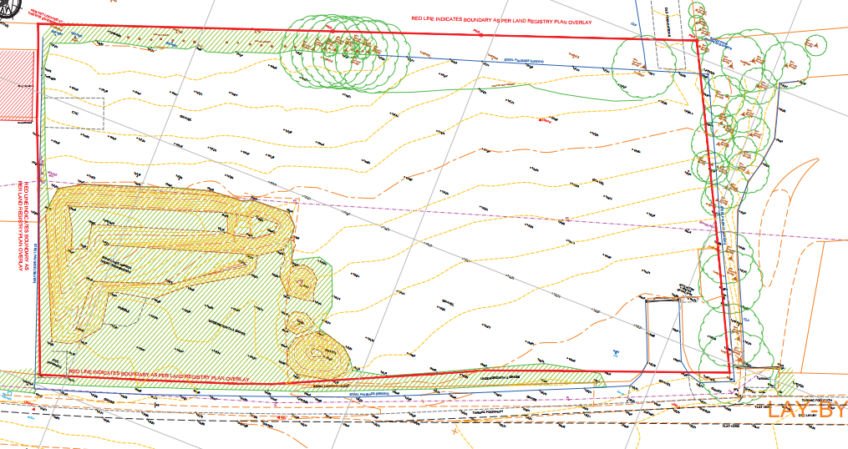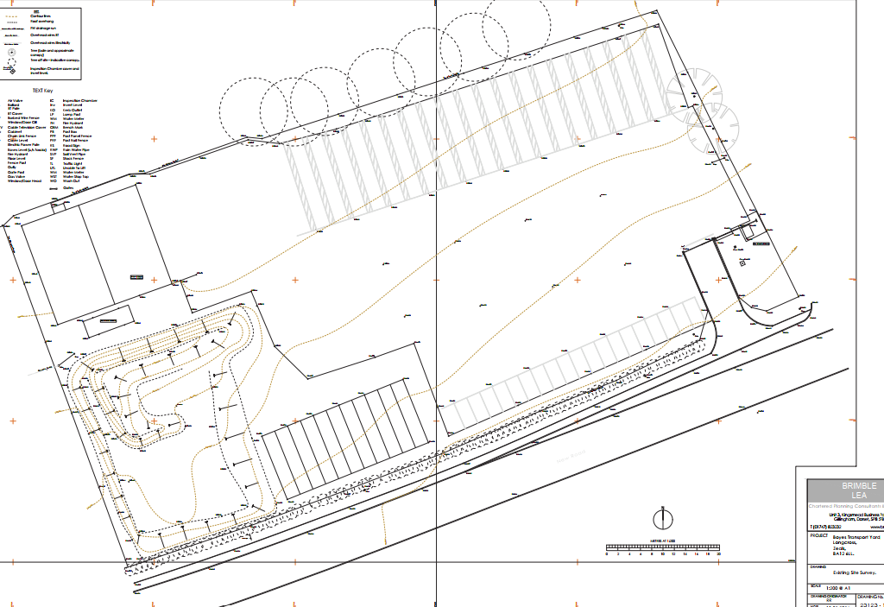

Second letter of objection following the applicant’s rebuttal to the first objection above.

- Benchmark has reviewed the applicant’s rebuttal, uploaded to the Council’s planning register on or about 12 May 2026.
- 2. The rebuttal does not alter Benchmark’s objection to the retrospective planning application.
- 3. The applicant states: “as far as we are aware we own the land that the hedging is on”. That is not legal title evidence. No Land Registry title plan, conveyance, transfer, highway authority confirmation, or other legal evidence has been provided to displace the Council’s own highway land ownership plan or Benchmark’s submitted boundary analysis.
- 4. The Council should therefore proceed on the basis that the applicant has not demonstrated ownership or secure control of the roadside landscape screening relied upon as mitigation.
- 5. Unsupported belief of ownership is insufficient where the application relies upon that screening to mitigate the visual impact of a larger/different industrial building and associated operational development in the Cranborne Chase National Landscape.
- 6. The applicant’s rebuttal appears to be a personal response from the applicant, not a professional planning, landscape, highways, legal, drainage, lighting, ecology or operational-use assessment. The Council should attach limited weight to unsupported assertions where proper technical evidence is required.
- 7. The rebuttal also misunderstands Benchmark’s reference to the C&G building. The cited eaves and ridge figures are datum levels taken from the topographic survey, not an assertion that the neighbouring building is 143m high.
- 8. The rebuttal does not answer Benchmark’s point that the retrospective application appears to show the as-built workshop is not taller at eaves level than the approved scheme, and is lower at eaves level than the C&G building next door. That is directly relevant to the applicant’s claimed functional need for the taller ridge.
- 9. Nor does the rebuttal address the wider planning deficiencies identified in Benchmark’s objection, including the adequacy of the red line, the full operational yard, welfare/office accommodation, shipping containers, HGV/trailer and car parking, lighting, drainage, waste, oil storage, National Landscape impacts, and compliance with the 2022 permission, conditions and any section 106 obligations.
- 10. Benchmark therefore maintains that the Council should either require a comprehensive, properly evidenced application addressing the whole as-built development and operational use of the site, or refuse the present retrospective application because the applicant has not demonstrated that the development is acceptable in planning terms.

Applicants’ response to the first letter of objection from the third party, included in full below.

- 1. With regards to landscaping nothing has altered since the approved application, which was implemented as approved at the time, if anything was wrong at the time Benchmark should have highlighted the issue. As far as we are aware we own the land that the hedging is on and the fence and hedging both follow the same line that it did when we first purchased the land.
- 2. Firstly, we believe Benchmark may yet again have made another error reference the height of buildings as we believe C&G tarmac eaves height is definitely nowhere near 143m and the ridge is also definitely not exceeding 144m. for him to get such get such a simple measurement so drastically wrong in his letter of objection, clarifies the simple error on the original application regarding the ridge height and roof pitch of our building.
- 3. The eaves height is 100mm (4 inches) different to the application which is due to the floor screed during construction, the doorway is as was always required and the only reason there is a problem with the overall height is due to the plans being unworkable. The building was constructed with a 12.5-degree pitch as per plans, obviously Richard put a 7 instead of an 8 on the plans which has led us to be in this predicament now.
- 4. Redacted as not appropriate
- 5. Obviously, we are not planning experts and are just normal people trying to make a living, but we have used Brimble Lea on many occasions over the last 30 years and have found them professional and trust that they know how to deal with an application. In our experience they have not made any basic errors.
- 6. We are sure that if the council require anything regarding a section 106, they are quite capable of liaising with our planning agent.
- 7. The ridge height alters absolutely nothing regarding used oil (which is deposed of by a licenced firm) and any trade waste etc.
- 8. The only reason we have had to reapply as stated by Richard for a different ridge height, is because the only measurements (the ridge height and degrees) left to Benchmark planning to calculate and submit were wrong.

ASSESSMENT

Section 38(6) of the Planning and Compulsory Purchase Act 2004 states:

"If regard is to be had to the development plan for the purposes of any determination to be made under the planning Acts, the determination must be made in accordance with the plan unless material considerations indicate otherwise."

In accordance with this statutory requirement, this application has been assessed against the relevant policies of the Development Plan, including the adopted Wiltshire Core Strategy (2015) and, where applicable, any made Neighbourhood Plans.

Principle, Design and Impact upon the upon the character and context of the area (including impact on National Landscape)

The application site relates to an existing commercial/employment site in the countryside and therefore saved Policy E19 is relevant. This states that proposals to redevelop or enlarge existing employment sites in the countryside will be permitted where the proposed development would take place within the existing boundaries of the site. Proposals involving land outside established boundaries will be considered if:

• The proposal would result in improved local employment opportunities
• The proposal will improve the operational efficiency of the enterprise
• There is no suitable alternative building in the immediate locality
• There is no adverse impact on the character of the surrounding landscape or biodiversity
• There is no unacceptable increase in vehicular traffic or additional reliance on the private
care
• The environment of any nearby dwellings will not be adversely affected

Core Policy 51 of the Wiltshire Core Strategy requires all development to protect, conserve, and where possible enhance the character and quality of Wiltshire’s landscapes, giving particular weight to designated areas such as National Landscapes.

The National Planning Policy Framework (NPPF), in Paragraph 189, states that “great weight” should be given to conserving and enhancing landscape and scenic beauty in National Landscapes (formerly Areas of Outstanding Natural Beauty). Development within or affecting the setting of a National Landscape must demonstrate that it will not result in unacceptable harm to the special qualities of that area.

Under Section 245 of the Levelling-Up and Regeneration Act 2023, the Council must now ‘seek to further’ the purposes of the National Landscapes in its decision making. This legislative change strengthens the duty under Section 85 of the Countryside and Rights of Way Act 2000, which originally required that authorities ‘have regard to’ their conservation purpose. In assessing this proposal, the Council has actively considered how it will conserve and enhance the natural beauty of the National Landscape, in line with national legislation and the area's Management Plan.

Core Policy 57 - Ensuring High Quality Design and Place Shaping of the Wiltshire Core Strategy seeks to ensure that all new development is of high design quality, reflecting local context, character, and distinctiveness.

Following a site meeting with the case officer and agent who were briefly joined by the applicant, combined with a careful review of the submitted plans and documents for the current application, site history and third party comments, it has been established that the site as viewed on the ground does not match the submitted plans and is at odds with the previously approved plans and conditions. Some such concerns were raised with the agent during the site visit, explicitly the layout of the lorry and car parking spaces and conditions relating to the number of vehicles (lorry and cars) that can be parked on the site. The following email highlighting the discrepancies was sent to the agent.

“As submitted the application is incomplete and contains inaccurate and incomplete detail, this application should therefore be withdrawn.

During our recent site meeting, I raised a number of concerns/issues relating to other unauthorised works that had taken place and had not been identified on the plans submitted with this application rendering the current submission inaccurate. I mentioned that I would not be able to approve the plans as submitted given that they contained incorrect information at odds with the current permission and conditions for the site.

You confirmed that you were not aware of these other inconsistencies with the previously approved applications on the site as you were not the agent for these and had only become involved now following the applicants request for you to submit this current application. You stated you would need to look into the site history and what has been given consent and what conditions currently apply. I will highlight the issues below, noting this may not be 100% comprehensive but does seriously highlight the inadequacy of the current submission.

- Condition 9 of application PL/2022/0149 states
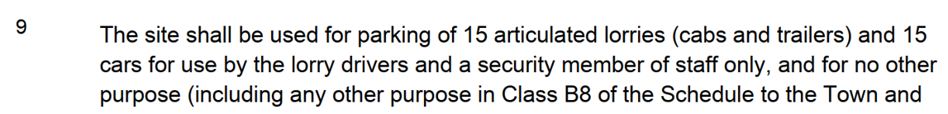
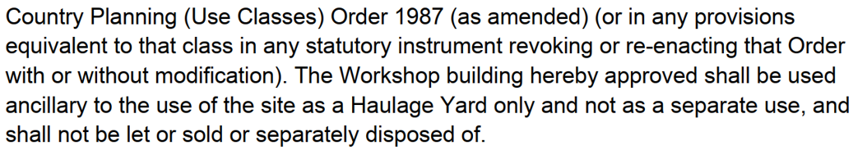

There are clearly more than 15 lorry spaces provided within the site. The approved plan shows 15 lorry space along the northern edge of the site. The submitted plan shows 20 lorry parking spaces marked in this position which were also noted on site (we counted these together during our site meeting). Lorries were also parked in other locations within the site, outside of this line of 20 spaces (only 15 are permitted).

- Similarly, 15 car parking spaces were approved under PL/2022/0149, there are more than these provided on site, the location of these also differs from the approved plans. On site these are located along the south boundary rather than the western side as per the approved plan , the approval also splits the approved 15 car parking spaces into 2 groups, one of 10 spaces, the other of 5 spaces.

- The submitted plans include the storage containers that are unauthorised, their retention refused and dismissed at appeal. You stated that you were preparing a separate application for these storage containers to be submitted in the near future. However, we cannot approve a plan (if we are minded to approve, this has not yet reached this stage) for this current application with these unauthorised containers shown. Ideally these would form part of one application to regularise all the various unauthorised works or at the very last be submitted at the same time as another application so they can run concurrently.

- Condition 10 of PL/2022/0149 states no storage etc, yet there were tyres stacked outside, as well as machinery and ither items, again in breach of condition.

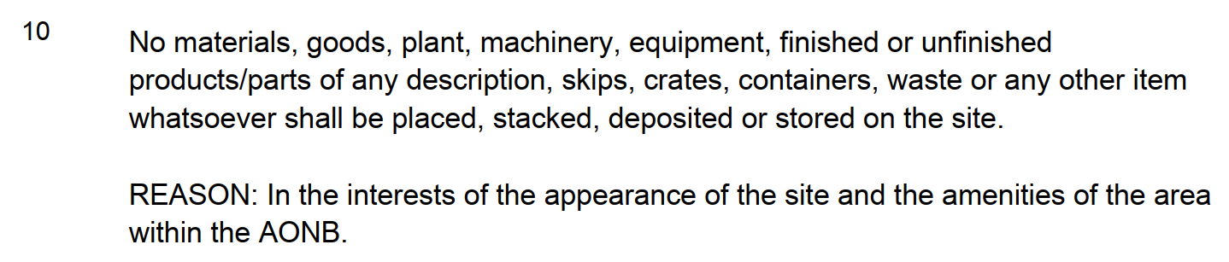

- I also consider the red/blue lines are incorrect. The siting of the storage containers appears to be within part of the blue line, to me the red line needs to be extended and does not currently include all land where works have been undertaken.

- It appears that the approved landscaping has not been completed in accordance with the details agreed for PL/2022/0149

- Condition 14 relates to no lighting be installed within first agreeing details with the LPA, lighting was seen during the site visit and I can find no details in our system relating to these.

- You also confirmed during our site meeting that you were awaiting an LVI to be completed to support the current application, this has not yet been received. This would need to take into account all the other various unauthorised works.

- The applicant mentioned when we met on site that they have another part of the business in Dorset (sorry I can’t remember if he said Wincanton or Gillingham) and that his intention was to bring some of that business to the Zeals site. This in itself is a concern as it would represent an intensification of the business at the Zeals site for which we have no information.

- I am sure you are aware of the concerns from the National Landscape (Richard Burden) about the portacabin and whether it is really appropriate for this location. Linked to this are the requirement for details relating to the disposal of the foul waste.

- There are also the comments from Mr Greenwood raising potential issues with the submission. Their various points need to be addressed formally although some of these points relate to matters detailed above.

Therefore, given the large amount of issues raised above, and given that the 8 week date is next week, the application as submitted cannot be approved due to the inaccuracies and omissions. This current application should therefore be withdrawn and resubmitted when a comprehensive application has been compiled to address all the issues. It is not considered appropriate to extend the time for this current application to add in the other bits and pieces as realistically this results in a new proposal and therefore a new fresh application.

Some site photos included below taken by the case officer during the site meeting with the agent and site plan approved for application PL/2022/0149 and the site plan submitted for approval with this current application included below for ease of comparison.

Approved PL/2022/0149 as below.
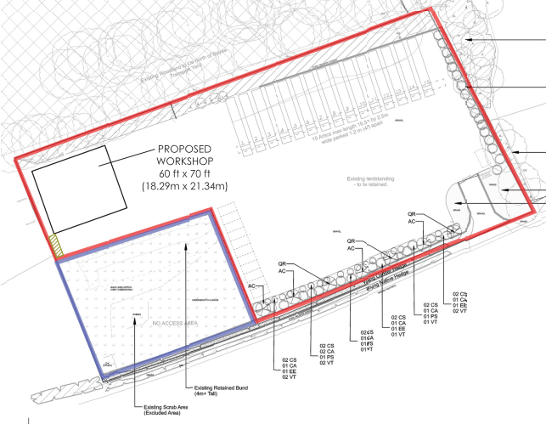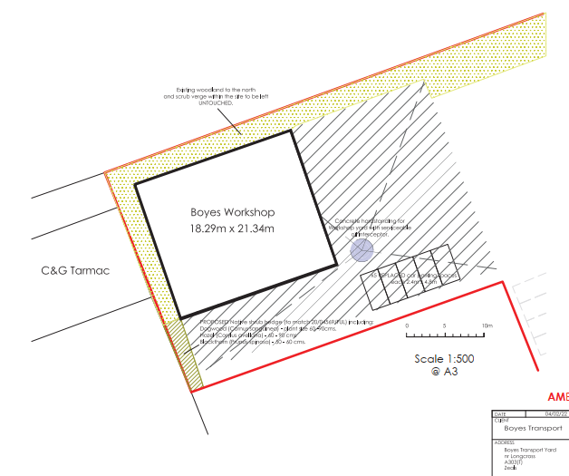
Seeking approval as below.

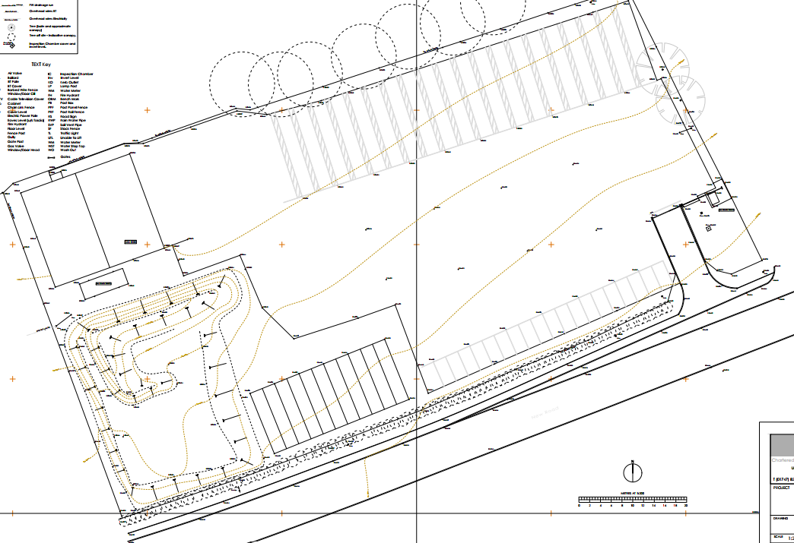

Photo below taken towards the east boundary, car parking for more than 15 cars shown along the south boundary which is not the approved location for the car parking and exceeds permitted numbers. Storage containers can be seen at the far end of the parked cars. Lorries parked in the yard not within the parking spaces along the north boundary.
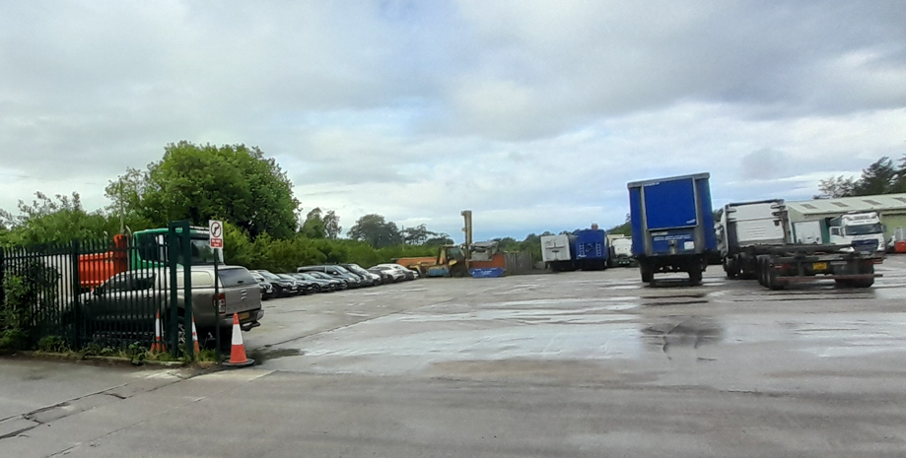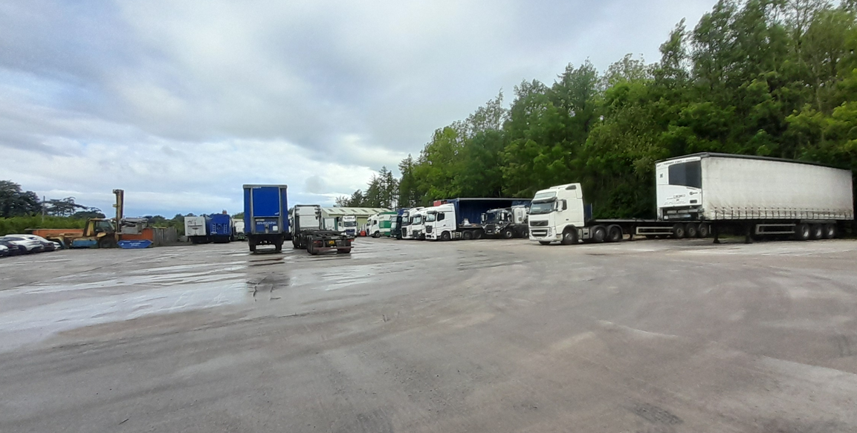

Lorry parking spaces at odds with the approved plan
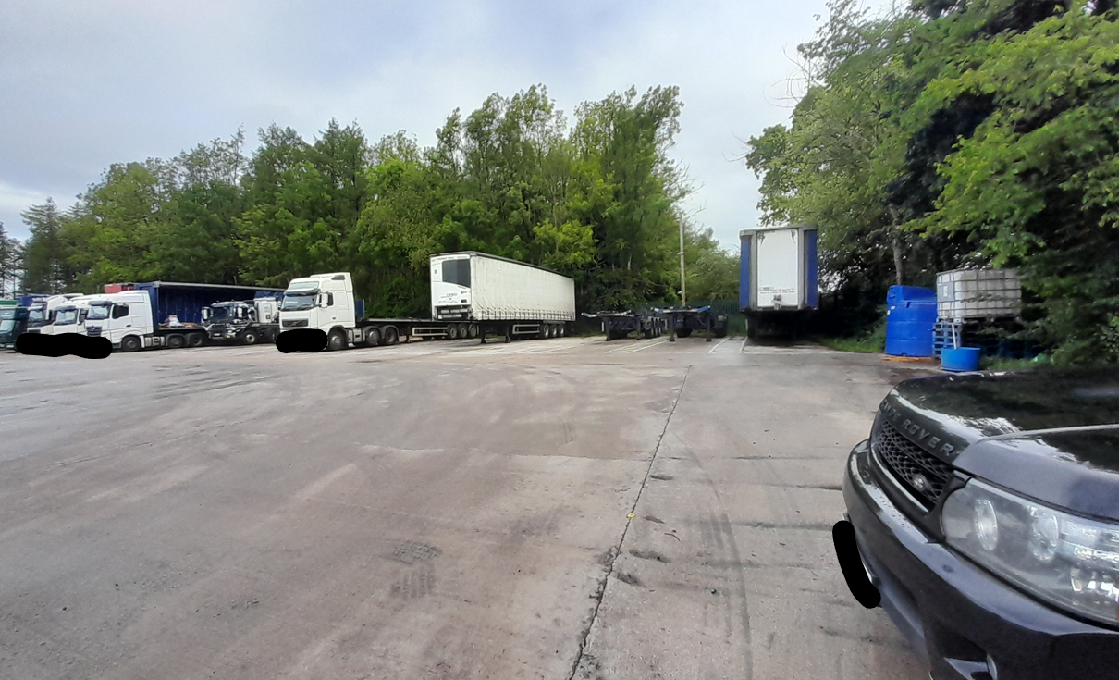

Items stored outside
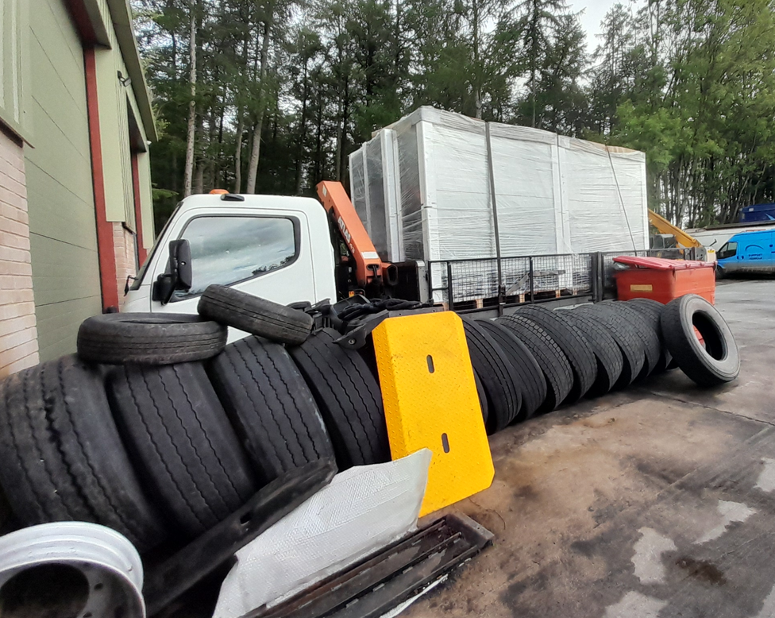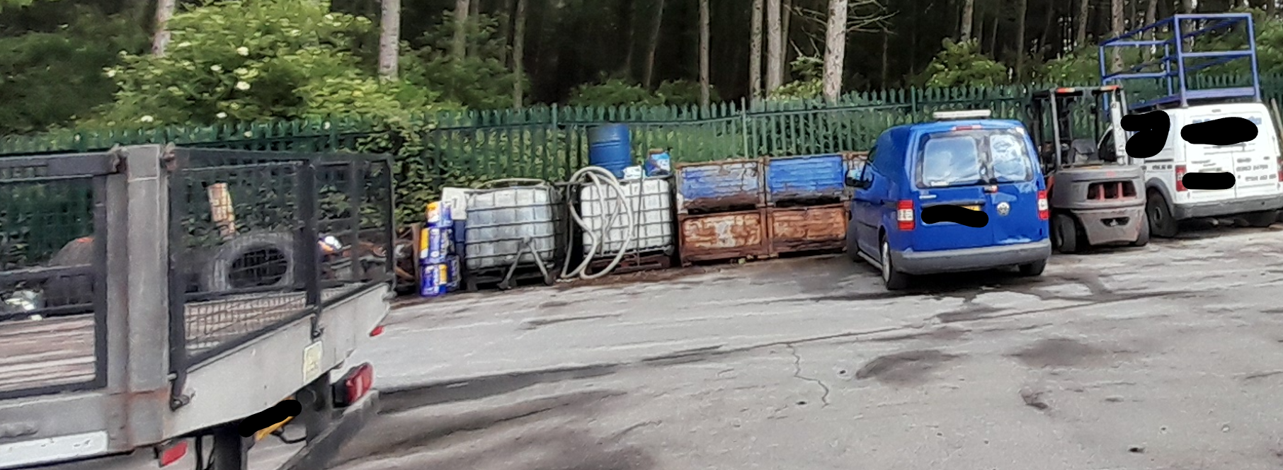

In addition to the above, no formal comments have been received by the Principal Landscape & Planning Officer for the Cranborne Chase National Landscape who contacted the case officer and the agent wanting to discuss with the proposals with the applicant/agent prior to submitting their formal comments due to their concerns and lack of information submitted with the application. Following the National Landscape representative contacting the Agent, the Agent advised that

“Our client has commissioned a Landscape Visual Appraisal (LVA), which is being prepared by Vince Steele of Steele Landscape Design (copied in).

Once the LVA has been submitted to the Planning Case Officer (Hayley Clark), we will be agreeing to an extension of the public consultation period accordingly, to give people a chance to review the report and provide their comments.

Perhaps you could provide a holding comment for now please, to say that you will await receipt of the LVA before providing your full comments.”

National Landscape representative provided informal comments and responded to the above comments from the Agent as follows:

“I have some queries about the location and style of the welfare facilities and toilet. I note concerns from the Parish which appear to question disposal arrangements, and I am mindful of NPPF 187 and 189 together with NPPG on quality of development within NLs; ‘All development in National Parks, the Broads and Areas of Outstanding Beauty will need to be located and designed in a way that reflects their status as landscapes of the highest quality’. The fact that the welfare facilities and toilet appear to be afterthoughts is concerning.”

In this instance, whilst the application as submitted is on the surface applying to regularise the toilet block, welfare portacabin and design of the warehouse, Officers consider that there are so many omissions and inaccuracies with the current application which combined with the clear no compliance of the overall site with previously approved plans/documents and conditions that fundamentally the appearance and operation of the site is considered to have no overall compliant planning permission.

Therefore, whilst the site relates to an existing employment site, given the apparent multiple breaches identified above including excessive vehicle parking, unauthorised storage containers, non-compliant storage activities, unapproved lighting, and failure to implement agreed landscaping, the submitted plans are inaccurate and include changes made on site which have not been regularised or previously picked up by the applicant, agent or Council. The plans also include the storage containers for which a planning application has been refused with a subsequent appeal dismissed. The Council are concerned that there may be potential for inadvertently permitting changes through the inaccurate plans and must show due diligence in insisting all errors are addressed.

It is considered that there is insufficient supporting information, including the absence of a Landscape Visual Appraisal, and unresolved concerns from the National Landscape regarding the siting and design of welfare facilities and their impact on the character of the area. The extent of unauthorised development and lack of compliance with existing permissions raises concerns that the site, as it currently operates, does not benefit from a coherent or lawful planning permission.

Officers do not consider it possible or appropriate to fully assess the development currently submitted as it is essentially part and parcel of the overall business, use and operations of the Boyes Transport site. Therefore given the scale of inaccuracies, omissions, and policy conflicts, the Council must err on the side of caution and must conclude that the proposed development and submitted application cannot be supported in its current form will cause harm to the character and appearance of the area and importantly to the National Landscape and is contrary to the relevant policies in the Development Plan, notably CP57 and CP51 and the relevant provisions in the NPPF. The Council can also not confirm that the proposals comply with saved policy E19 which specifically relates to the employment use of the site and is a key policy for consideration regards the principle acceptable of further development on the site.

It is strongly recommended that the whole of the site at Boyes Transport is assessed in detail in terms of what has and hasn’t been carried out in accordance (or not) with previous consents and conditions. Only when a full assessment has been undertaken and a full understanding has been reached can a formal application be submitted, supported with appropriate plans and documents to allow the Council, consultees and third parties the opportunity to assess the impacts of the development when they are able to fully understand the site and operations and potential impacts.

Amenity
Point vii of Core Policy 57 - Ensuring High Quality Design and Place Shaping of the Wiltshire Core Strategy seeks to ensure that developments do not adversely affect neighbouring properties.

The National Planning Policy Framework (NPPF), particularly Paragraph 135(f), stresses that planning decisions should ensure developments provide a high standard of amenity for existing and future users.

The previous consent PL/2022/01499 included a number of conditions relating directly or indirectly to amenity impacts, these include condition 5 - No processes, plant or machinery shall be carried out/installed outside the building on the site; condition 9 restricting number of lorries and cars stored/parked on to 15 of each, restricting the use of the site including ancillary use or the workshop building in association with the haulage yard; condition 11 restricting hours for manoeuvring of articulated lorries; condition 12 restricting house of use for the workshop building and condition 14 no external lighting. The Public Protection Officer has requested these conditions be reapplied to any future forthcoming permission to protect amenity of nearby properties.

Again, as per the above, Officers do not consider it possible or appropriate to fully assess the development currently submitted in terms of impact on amenity, given the scale of inaccuracies, omissions, and policy conflicts, many of these relating specifically to areas with direct potential amenity impacts. Therefore, the Council can only conclude based on the paucity of the submitted information that the proposals will have an adverse amenity impact on nearby properties contrary to CP51 and para 135 of the NPPF.

Highways Impact

Core Policy 57 (xiv) of the Wiltshire Core Strategy seeks to ensure that development must meet the requirements of Core Policy 61. This policy requires proposals to be capable of being served by safe access to the highway network. Core Policy 64 seeks to ensure compliance with parking standards set out in the Local Transport Plan.

The National Planning Policy Framework (NPPF), particularly Paragraph 115 and 116, requires that development proposals do not have an unacceptable impact on highway safety and that safe and suitable access to the site can be achieved for all users.

The Highway Authority has been consulted on the submission and has raised no objection to the welfare portacabin, toilet block and amended design for the warehouse in terms of highway safety. However, Highway Authority due to the lack of information submitted with this application have not been made aware of the inaccuracies, omissions and breaches of planning that have occurred on site. No assessment has been made regards the excess number of lorries and cars parked/stored on the site over the permitted 15 lorries and 15 cars; nor have they assessed the amended layout and associated potential intensification of the use of the site particularly given the applicants stated intention to bring part of their business from Dorset to the Zeals site.

Given that the plans as submitted in terms of the parking provision for lorries and cars in terms of number of spaces and siting, Officers do not consider it possible to provide a fully informed balance assessment of highway safety impacts for the whole site given the scale of inaccuracies, omissions, and policy conflicts. Again, the Council must err on the side of caution and must conclude that the proposed development and submitted application cannot be supported in its current form in terms of highway safety impacts, as submission, the lack of information and poor submission is contrary to Core Policies 57 (criterion xiv), 61, and 64 of the Wiltshire Core Strategy, the relevant provisions of the National Planning Policy Framework, and the objectives of the Wiltshire Local Transport Plan.

Ecology Impact

Core Policy 50 of the Wiltshire Core Strategy seeks to protect and enhance biodiversity and geodiversity, including through ensuring that development avoids harm to protected species and habitats.

The National Planning Policy Framework (NPPF), in Paragraphs 193, requires that development minimises impacts on and provides net gains for biodiversity, including ensuring mitigation is secured where harm cannot be avoided.

BNG - From 12 February 2024 Biodiversity Net Gain (BNG) became mandatory under Schedule 7A of the Town and Country Planning Act 1990 (as inserted by Schedule 14 of the Environment Act 2021). Given that the development is retrospective, the works are exempt from the statutory Biodiversity Net Gain (BNG) in Schedule 7A of the Town & Country Planning Act 1990 (inserted by the Environment Act 2021).

No other ecological information has been provided with the application other than a paragraph within the submitted planning statement which states -

The industrial nature of the existing site with associated activity does not provide a suitable habitat for any protected species and the proposal will therefore have a neutral impact on biodiversity in accordance with Core Strategy Policy 50 and Chapter 15 of the NPPF.

Whilst the above statement may be correct, there are concerns that the landscaping previously approved has not been implemented in accordance with the approved details. The landscaping was also a means for ecological gain. Therefore, any submission must include confirmation of appropriate landscaping and enhancement measures. The Council do however accept that ecological enhancement measures these can be secured by condition.

However, it does appear from looking at the site history that the site has a past record of not complying with conditions or approved details, therefore any future conditions relating to ecological matters would need to be very strictly controlled in order that any permitted amendments to the current permission at the Boyes Transport site complies with CP50 and the relevant provisions within the NPPF.

S106

It is understood that previous permitted applications have been subject to a S106 agreement, the most recent for application PL/2022/01499; the Agreement made under Section 106 of the Town and Country Planning Act, 1990 was dated the 25th November 2022 between Wiltshire Council and Stephen Boyes and Sarah Boyes. The S106 agreement was required to cover signage from the site and the use of best endeavours to ensure that vehicles did not travel through the village of Zeals to reach the site.

No mention of this has been included with the current application. Whilst not a reason to refuse and application in this instance, Officers note that a deed of variation must be secured as part of any future application should permission be granted.

CONCLUSION

In considering the application submission and weighing up the submitted information, comments received, site history, constraints and other materials consideration to reach a planning decision, it is acknowledged that the site forms part of an established employment use with the established haulage use of the site and the permitted associated workshop.

However, in this instance, it is considered that this carries limited weight given the significant shortcomings associated with the current submission. As mentioned above, the Council consider it is not possible to positively determine the application due to the scale of inaccuracies, omissions and identified breaches of both the approved plans and planning conditions, which result in a fundamentally flawed and unreliable application. In the absence of accurate plans, comprehensive supporting information, and a clear understanding of the full extent of development and operations on site, the Local Planning Authority cannot properly assess the impacts of the proposal. Consequently, and having regard to the site’s sensitive location within the Cranborne Chase National Landscape, the Council must err on the side of caution.

On the basis of the information available, it can only reasonably conclude that the development results in harm to the character and appearance of the area and fails to demonstrate compliance with the Development Plan. The proposal is therefore considered to conflict with CP51, CP57, CP61 of the Wiltshire Core Strategy, saved Policy E19, and the relevant provisions of the NPPF, and in the absence of overriding material considerations, planning permission should be refused.

RECOMMENDATION: That Planning Permission be REFUSED.

Following a detailed site visit and an assessment of the submitted plans and the detailed planning history and the stipulations of the various planning consents related to the site, it is considered that the submitted plans are inaccurate and incomplete, with the omission of key elements of development already carried out on site, and there also being clear evidence of non-compliance with previously approved plans and planning conditions under permission PL/2022/01499. The application fails to provide a comprehensive and reliable description of the development and its associated operations, including but not limited to, parking provision, storage, lighting, landscaping, and the extent of operational activities.

As a result, in the absence of sufficient and accurate supporting information, including a Landscape Visual Appraisal, and given the statutory duty to seek to further the purposes of the National Landscape, and the great weight afforded to conserving and enhancing landscape and scenic beauty, on the basis of the information submitted, the proposal fails to demonstrate that it would not result in adverse harm to the character and appearance of the area or that it complies with the Development Plan. The development would therefore be contrary to Core Policies CP51, CP57 and CP61 of the Wiltshire Core Strategy, saved Policy E19 of the Salisbury District Local Plan, and the relevant provisions of the National Planning Policy Framework.

