APPLICATION FOR HOUSEHOLDER PLANNING PERMISSION
DELEGATED REPORT

APPLICATION REFERENCE: | PL/2026/01859
APPLICATION TYPE: | Householder planning permission
SITE ADDRESS: | 41 Queesway, Melksham, SN12 7LB
DEVELOPMENT DESCRIPTION: | Formation of a vehicular access including dropped kerb and construction of a permeable gravel hardstanding to the front of the property.
RECOMMENDATION: | That Planning Permission be GRANTED

SITE DESCRIPTION/CONTEXT
The subject property is a mid-terrace, two-storey C20 modern dwelling, in an area of shared design and materiality, south east of Melksham’s town centre on the classified Road Queensway, C398.

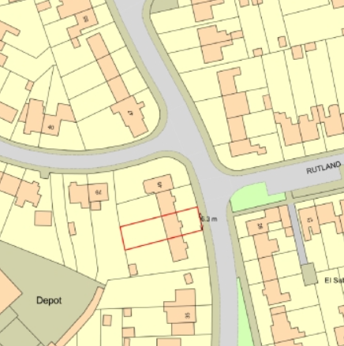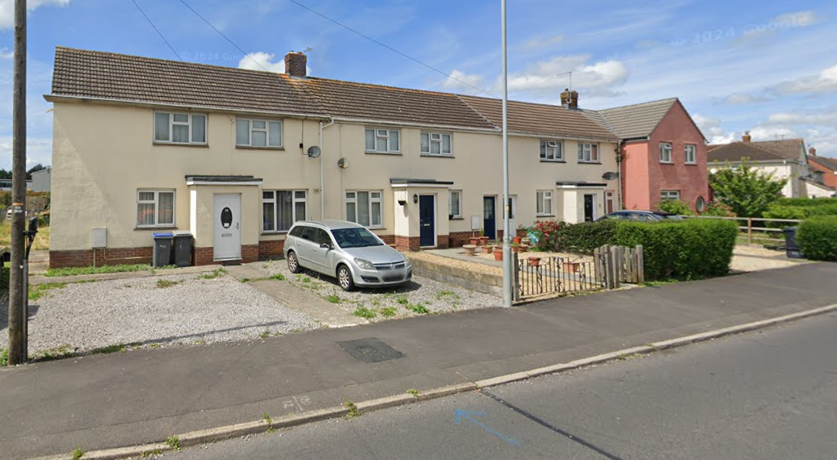

Location Plan and Google Earth Site Photo

The application site, whilst within Flood Zone 1, of lowest risk, there is also an increased risk of ground water flooding.

PROPOSAL

The proposal seeks planning permission for the formation of a vehicular access across the pedestrian footpath, measuring 5m x 3m, to the front garden, and creation of hardstanding for off-street parking. Kerb edging is included to retain loose material on site

Proposed materials include gravel and a kerb edging, as existing. All as per the sketch below:

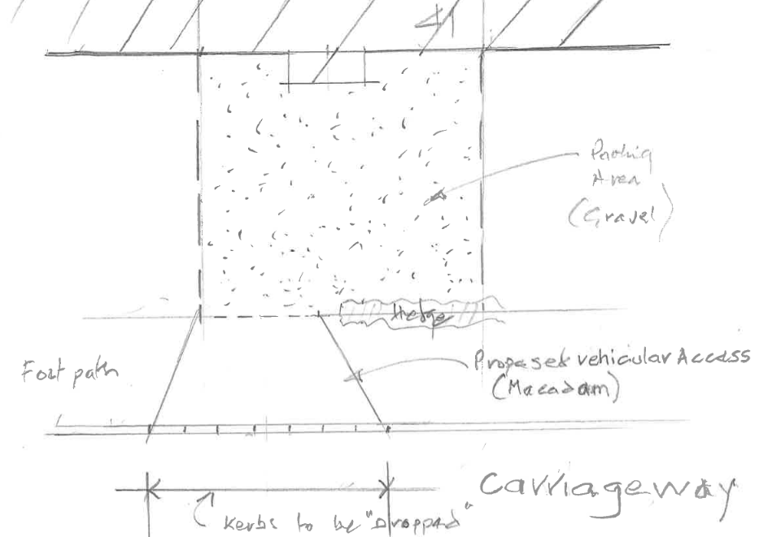

Proposed Block Plan

PLANNING HISTORY

It is noted, that whilst both no. 43 and 39 have parking full width across the front garden, neither have planning permission.

RELEVANT POLICIES AND GUIDANCE
The National Planning Policy Framework (NPPF)
The Planning Practice Guidance
National Design Guide
Wiltshire Design Guide: Appendix D – Design Guidance for Householder extensions

Wiltshire Core Strategy:
- Core Policy 57 Ensuring High Quality Design and Place Shaping
- Core Policy 61: Transport and New Development
- Core Policy 64: Demand Management
- Core Policy 67: Flood Risk

Melksham Neighbourhood Plan, made 2021.

CONSULTATION RESPONSES
Melksham Town Council: No objection.
Highways: No objection, subject to conditions.

REPRESENTATIONS
No comments were received.

ASSESSMENT
Section 38(6) of the Planning and Compulsory Purchase Act 2004 states:

"If regard is to be had to the development plan for the purposes of any determination to be made under the planning Acts, the determination must be made in accordance with the plan unless material considerations indicate otherwise."

In accordance with this statutory requirement, this application has been assessed against the relevant policies of the Development Plan, including the adopted Wiltshire Core Strategy (2015) and, where applicable, any made Neighbourhood Plans.

Design and Impact upon the character and context of the area
Core Policy 57 - Ensuring High Quality Design and Place Shaping of the Wiltshire Core Strategy seeks to ensure that all new development is of high design quality, reflecting local context, character, and distinctiveness.

The proposed driveway is of a scale, design and materials to harmonise with the host dwelling, wider area and similar neighbouring development.

Having regard to the above, the proposal complies with the design principles set out in Core Policy 57 of the Wiltshire Core Strategy and Appendix D of the Wiltshire Design Guide.

Amenity
Point vii of Core Policy 57 - Ensuring High Quality Design and Place Shaping of the Wiltshire Core Strategy seeks to ensure that developments do not adversely affect neighbouring properties.

The National Planning Policy Framework (NPPF), particularly Paragraph 135(f), stresses that planning decisions should ensure developments provide a high standard of amenity for existing and future users.

As a driveway, there are no concerns with loss of light or privacy.

The proposal, and necessary conditions ensure highway and pedestrian safety is managed.

The proposal therefore accords with Core Policy 57 point vii in respect of safeguarding residential amenity and Appendix D of the Wiltshire Design Guide.

Highways Impact
Core Policy 57 (xiv) of the Wiltshire Core Strategy seeks to ensure that development must meet the requirements of Core Policy 61. This policy requires proposals to be capable of being served by safe access to the highway network. Core Policy 64 seeks to ensure compliance with parking standards set out in the Local Transport Plan.

The National Planning Policy Framework (NPPF), particularly Paragraph 115 and 116, requires that development proposals do not have an unacceptable impact on highway safety and that safe and suitable access to the site can be achieved for all users.

The proposed access would be onto a classified road. There are no objections from the Highways Officer subject to conditions to manage visibility and consolidated surface.

The proposed development would not result in any adverse impact on highway safety. Adequate parking and turning provision is provided in accordance with Wiltshire’s adopted parking standards, and access arrangements are acceptable.

The proposal is therefore considered to comply with Core Policies 57 (xiv), 61 and 64 of the Wiltshire Core Strategy, the NPPF, and the Wiltshire Local Transport Plan.

Drainage and Flood Risk
Core Policy 67 of the Wiltshire Core Strategy and paragraph 181 of the NPPF requires that all new development avoids increasing flood risk on-site or elsewhere and, where appropriate, incorporates sustainable drainage measures. Development must also comply with national policy on flood risk management and drainage design. Paragraph 176 (via footnote 62) of the NPPF states that householder development should not be subject to the sequential test, nor the exception test.

Householder development is considered Minor Development, under the Flood Risk planning guidance. The proposal includes SuDS-appropriate permeable gravel effectively managing on site flood risk.

The proposal therefore complies with Core Policy 67 of the Wiltshire Core Strategy and the policy in the NPPF, ensuring that flood risk is not increased and that surface water drainage is appropriately managed.

Biodiversity Net Gain
Householder planning applications are exempt from the requirement to deliver Biodiversity Net Gain under Schedule 7A, Section 4(2)(a) of the Town and Country Planning Act 1990, as inserted by the Environment Act 2021.

CONCLUSION
The proposed development is considered to be acceptable in terms of its design, scale, and relationship with the surrounding area. It would not result in any unacceptable harm to the character of the locality, the amenities of neighbouring occupiers, or the interests of highway safety.

The proposal is therefore considered to comply with the relevant policies of the Wiltshire Core Strategy, the Wiltshire Local Plan, and the National Planning Policy Framework. As such, the application is recommended for approval, subject to the conditions set out below.

RECOMMENDATION: That Planning Permission be GRANTED subject to conditions.

