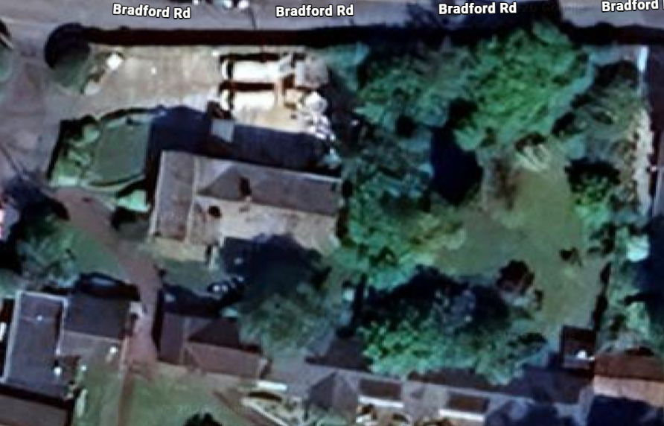
Apples x 2, Magnolia and holly
Liquidambar
Macrocarpa and spruce

