APPLICATION FOR HOUSEHOLDER PLANNING PERMISSION
DELEGATED REPORT

APPLICATION REFERENCE: | PL/2026/01693
APPLICATION TYPE: | Householder planning permission
SITE ADDRESS: | 110A The Midlands, Holt, Trowbridge, BA14 6RG
DEVELOPMENT DESCRIPTION: | Demolish existing lean-to laundry and erection of a single storey extension. New covered Entry porch, provide 2 No. Bay windows/doors to Living Room, and to Bedroom 2, re-configure interior to contain new Utility Room. Convert existing stone garage into an annex for a flexible space (Bedroom/study/workshop)
RECOMMENDATION: | That Planning Permission be GRANTED

PROPOSAL

The proposal seeks planning permission to demolish an existing lean-to laundry on the northeast elevation of the host dwelling and erect a single storey extension, with covered entrance porch over the footprint of the laundry room. Two existing windows on the front and rear elevations would be replaced with bay windows. The existing detached garage would also be converted to an annex building.

SITE DESCRIPTION/CONTEXT
This application relates to a detached bungalow, 110A The Midlands, located within an established residential area in Holt. The host dwelling benefits from an off-road parking area to the front elevation and a detached garage. The general area comprises of a mixture of housing types and styles of different periods.

The application site is located within the Holt Conservation Area, and a Grade II listed building is positioned to the north of the host dwelling,

PLANNING HISTORY
N/A

RELEVANT POLICIES AND GUIDANCE

Wiltshire Core Strategy:
The Wiltshire Core Strategy (WCS) 2015
Core Policy 2 Delivery Strategy
Core Policy 29 – Spatial Strategy for the Trowbridge Community Area
Core Policy 57 - Ensuring High Quality Design and Place Shaping
Core Policy 58 - Ensuring the Conservation of the Historic Environment
Core Policy 60 – Sustainable Transport
Core Policy 61 – Transport and Development
Core Policy 64 – Demand Management
Emerging Policy – Wiltshire Local Plan Review
At Full Council on 19 May, the elected members of Wiltshire Council agreed to withdraw the emerging WLP. It will now be subject to a legal process to finalise its withdrawal - which is likely to happen in July or August (2026). The said Plan has no material weight for the purposes of the application.
Holt Neighbourhood Plan 2016-2026 Made January 2017

Wiltshire Design Guide: Appendix D – Design Guidance for Householder extensions
The National Planning Policy Framework (NPPF)
The Planning Practice Guidance
National Design Guide

CONSULTATION RESPONSES
Holt Parish Council: No comment
Wiltshire Council Highways: No objection

REPRESENTATIONS
No comments were received.

ASSESSMENT
Section 38(6) of the Planning and Compulsory Purchase Act 2004 states:

"If regard is to be had to the development plan for the purposes of any determination to be made under the planning Acts, the determination must be made in accordance with the plan unless material considerations indicate otherwise."

In accordance with this statutory requirement, this application has been assessed against the relevant policies of the Development Plan, including the adopted Wiltshire Core Strategy (2015) and, where applicable, any made Neighbourhood Plans.

Heritage, Design and Impact upon the character and context of the area
From the point of view of the historic environment the main statutory tests are set out within the Planning (Listed Building and Conservation Areas) Act 1990.

Section 72(1) of the Act requires the Council to pay special attention to the desirability of preserving or enhancing the character or appearance of designated Conservation Areas.
The Council’s Core Strategy Policy CP58 ‘Ensuring the conservation of the historic environment’ requires that designated and non-designated heritage assets and their settings will be conserved, and where appropriate enhanced, in a manner appropriate to their significance and encourages proposals which improve the condition of heritage assets at risk.

The Council’s Core Strategy CP 57: Ensuring high quality design requires a high quality of design in all new developments. The policy requires applicants to “demonstrate how the proposal will make a positive contribution to the character of Wiltshire through (amongst other things) responding to the value of the natural and historic environment and being sympathetic to and conserving historic buildings and landscapes. Development is required to respond positively to the existing in terms of building layouts, built form, height, mass, scale, building line, plot size, elevational design, materials, streetscape and rooflines to effectively integrate the building into its setting.

The NPPF outlines government policy for planning. Chapter 16 of the NPPF 'Conserving and enhancing the historic environment' sets out the Government's high-level policies concerning heritage and sustainable development.

The application site is located within the Holt Conservation Area, which covers the historic core of the village, and a Grade II listed building is positioned to the north of the host dwelling, therefore, any works to the host dwelling have to be appraised in relation to any impact upon the immediate setting of these heritage assets. The conservation area is shown shaded green on the map insert below and the listed building is illustrated by the black hatching.
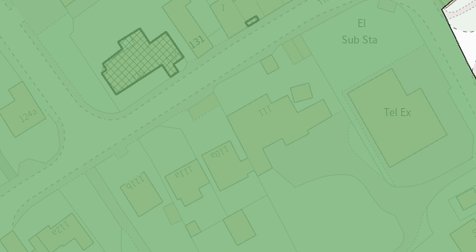
The applicant seeks to demolish an existing lean-to laundry room on the northeast elevation of the host dwelling and erect a single storey extension, with covered entrance porch, over the footprint of the laundry room. Two existing windows on the front and rear elevations would be replaced with bay windows.

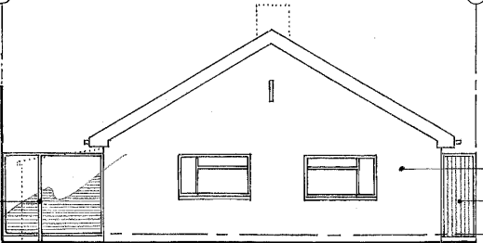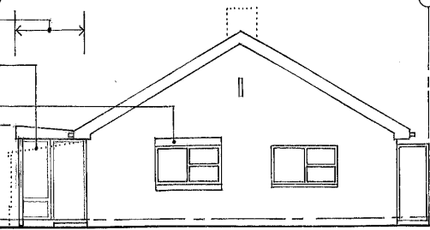
Existing and proposed front elevation of the host dwelling
The materials would consist of a painted finish to the render blockwork to match the existing, with a zinc roof flat roof over the extension and all fenestration both existing and proposed would consist of powder coated aluminium frames.
The existing garage building would remain as existing with the garage door replaced with natural ashlar stone infill with aluminium windows within the existing doorframe. A window would be inserted on the southeast elevation facing the driveway with three aluminium framed roof lights inserted in the existing roof to illuminate the internal space.
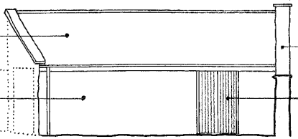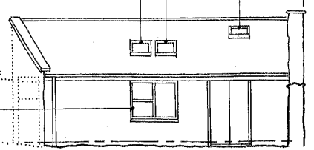
Existing and proposed front elevation of the converted garage

The proposed annex comprises a single room with kitchenette and shower room and can be seen in relation to the accommodation within the main dwelling in the plan extract below:

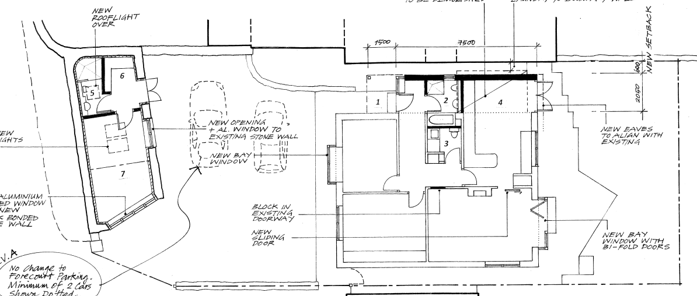
Proposed floor plans

The proposal would relate to small scale additions and alterations, with the extension replacing existing built form of a similar footprint and a small annex clearly forming ancillary accommodation to the main dwelling. The use of matching materials would ensure the proposal would integrate into the surrounding setting and existing street scene. It is considered that the works would by virtue of their height, scale and design constitute complementary additions to the host dwelling that would appear commensurate to the size of the property and plot.

Given the limited works proposed, that would be set within the built envelope of the application site, it is considered that there would be no harm to the site or its surroundings. The proposal, by virtue of its scale, design, and use of materials, is considered to preserve the character and appearance of the conservation area and the setting of the listed buildings nearby.

The development is therefore considered to comply with Core Policy 57 and 58 of the Wiltshire Core Strategy and Section 72 of the Planning (Listed Buildings and Conservation Areas) Act 1990, as well as the relevant provisions of the NPPF and the Wiltshire Design Guide.

Amenity
Point vii of Core Policy 57 - Ensuring High Quality Design and Place Shaping of the Wiltshire Core Strategy seeks to ensure that developments do not adversely affect neighbouring properties.

The National Planning Policy Framework (NPPF), particularly Paragraph 135(f), stresses that planning decisions should ensure developments provide a high standard of amenity for existing and future users.

The proposed development has been assessed in terms of its potential impact on the residential amenity of neighbouring properties, with particular regard to loss of light, overshadowing, loss of privacy, and overbearing effects.

All windows proposed would be inserted at ground floor level and would overlook the applicant’s private residential curtilage, therefore no overlooking concerns are raised.

The proposal relates to single storey additions to a single storey dwelling that sits centrally within its detached plot. Therefore, due to the nature of the proposal officers raise no concerns in regard to any adverse overbearing, or overshadowing impacts or loss of light to neighbouring properties.

This application seeks to utilise the existing garage building as ancillary accommodation, and a condition would be applied on any planning permission granted to ensure that the accommodation shall remain as ancillary to the host property and not as separate independent accommodation.

The proposal therefore accords with Core Policy 57 point vii in respect of safeguarding residential amenity and Appendix D of the Wiltshire Design Guide.

Highways Impact
Core Policy 57 (xiv) of the Wiltshire Core Strategy seeks to ensure that development must meet the requirements of Core Policy 61. This policy requires proposals to be capable of being served by safe access to the highway network. Core Policy 64 seeks to ensure compliance with parking standards set out in the Local Transport Plan.

The National Planning Policy Framework (NPPF), particularly Paragraph 115 and 116, requires that development proposals do not have an unacceptable impact on highway safety and that safe and suitable access to the site can be achieved for all users.

The host dwelling currently benefits from two bedrooms and the conversion of the garage building to habitable accommodation would introduce a third bedroom. In order to comply with the Wiltshire Local Transport Plan 2011 – 2026: Car Parking Strategy (March 2015) two on-site car parking spaces would be required for a 3-bed dwelling (standard min. size 2.4m x 4.8m), which is the same criteria for a two bedroomed dwelling.

The host dwelling benefits from a generous driveway to the front elevation that could easily accommodate several vehicles. Therefore, the proposed development would not result in any adverse impact on highway safety. The Local Authority Highways team were consulted on the proposal and offered no objections.

Adequate parking and turning provision is provided in accordance with Wiltshire’s adopted parking standards, and access arrangements are acceptable.

The proposal is therefore considered to comply with Core Policies 57 (xiv), 61 and 64 of the Wiltshire Core Strategy, the NPPF, and the Wiltshire Local Transport Plan.

Biodiversity Net Gain
Householder planning applications are exempt from the requirement to deliver Biodiversity Net Gain under Schedule 7A, Section 4(2)(a) of the Town and Country Planning Act 1990, as inserted by the Environment Act 2021.

CONCLUSION

The proposed development is considered to be acceptable in terms of its design, scale, and relationship with the surrounding area. It would not result in any unacceptable harm to the character of the locality, the amenities of neighbouring occupiers, or the interests of highway safety, heritage.

The proposal is therefore considered to comply with the relevant policies of the Wiltshire Core Strategy, the Wiltshire Local Plan, and the National Planning Policy Framework. As such, the application is recommended for approval, subject to the conditions set out below.

RECOMMENDATION: That Planning Permission be GRANTED subject to conditions.

Conditions

- The development hereby permitted shall be begun before the expiration of three years from the date of this permission.
REASON: To comply with the provisions of Section 91 of the Town and Country Planning Act 1990 as amended by the Planning and Compulsory Purchase Act 2004.

- The development hereby permitted shall be carried out in accordance with the following approved plans and documents:
Location Plan DWG No PA-01 - Received 12.03.2026
Existing & Proposed Site Plan DWG No PA-02 - Received 12.03.2026
Existing Ground Floor Plan Including Parking DWG No PA-03 A - Received 26.03.2026
Existing Elevations DWG No PA-04 - Received 12.03.2026
Proposed Ground Floor Plan Including Parking DWG No PA-05 A - Received 26.03.2026
Proposed Elevations DWG No PA-06 - Received 12.03.2026
REASON: For the avoidance of doubt and in the interests of proper planning.

- The accommodation hereby permitted shall not be occupied at any time other than for purposes ancillary to the residential use of the main dwelling, known as 110A The Midlands, Holt, and it shall remain within the same planning unit as the main dwelling.

REASON: The additional accommodation is sited in a position where the Local Planning Authority, having regard to the reasonable standards of residential amenity, access, and planning policies pertaining to the area, would not permit a wholly separate dwelling.

