HOUSEHOLDER PLANNING APPLICATION.
CASE OFFICER REPORT
APPLICATION REFERENCE: | PL/2026/02146
APPLICATION TYPE: | Householder
SITE ADDRESS: | 45 Lower Westwood, Bradford on Avon, BA15 2AW.
DEVELOPMENT DESCRIPTION: | Proposed single rear extension, two storey side extensions and associated works.
RECOMMENDATION: | Approve with Conditions.

PROPOSAL
The proposal seeks planning permission for the construction of a single storey rear extension and a two-storey side extension.

SITE DESCRIPTION/CONTEXT
The property is a two-storey semi-detached building, constructed from reconstituted stone with clay rooftiles and located within the Large Village of Westwood. The site is located within a Conservation Area and Green Belt land. The site is also within the Bath and Bradford on Avon Bat SAC.

RELEVANT PLANNING HISTORY
Proposal / Summary
N/A

RELEVANT POLICIES AND GUIDANCE

Wiltshire Core Strategy:

- Core Policy 57 Ensuring High Quality Design and Place Shaping
- Core Policy 58 Ensuring Conservation of the historic environment
- Core Policy 50: Biodiversity and Geodiversity
- Core Policy 51: Landscape
- Core Policy 58: Ensuring the Conservation of the Historic Environment
- Core Policy 61: Transport and New Development
- Core Policy 64: Demand Management
- Core Policy 67: Flood Risk

Westwood emerging Neighbourhood Plan (Designation of Westwood Neighbourhood Area).

Wiltshire Design Guide: Appendix D – Design Guidance for Householder extensions

The National Planning Policy Framework (NPPF)

The Planning Practice Guidance

National Design Guide

Emerging Wiltshire Local Plan:
At Full Council on 19 May 2026, the elected members of Wiltshire Council agreed to withdraw the emerging Wiltshire Local Plan. It will now be subject to a legal process to finalise its withdrawal - which is likely to happen in July or August (2026). The said Plan has no material weight for the purposes of this application.

CONSULTATION RESPONSES
Westwood Parish Council: No objections.

Highways: No objections.

REPRESENTATIONS
No comments were received.

PRINCIPLE OF THE PROPOSAL.
The principle of the proposed scheme is considered to be acceptable for the reasons as discussed below.

ASSESSMENT
Section 38(6) of the Planning and Compulsory Purchase Act 2004 states:

"If regard is to be had to the development plan for the purposes of any determination to be made under the planning Acts, the determination must be made in accordance with the plan unless material considerations indicate otherwise."

In accordance with this statutory requirement, this application has been assessed against the relevant policies of the Development Plan, including the adopted Wiltshire Core Strategy (2015) and the emerging Neighbourhood Plan for Westwood.

Design and Impact upon the upon the character and context of the area

Core Policy 57 - Ensuring High Quality Design and Place Shaping of the Wiltshire Core Strategy seeks to ensure that all new development is of high design quality, reflecting local context, character, and distinctiveness.

The proposals can be viewed within the plan snippets taken from the submitted plans:

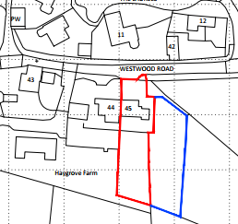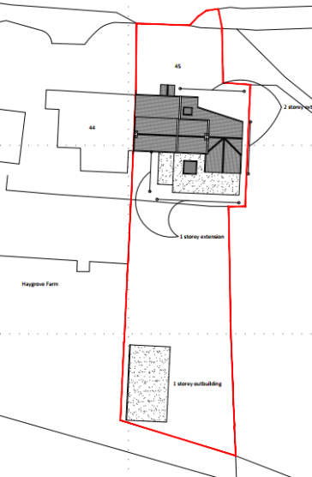

Location Plan Proposed Site Plan
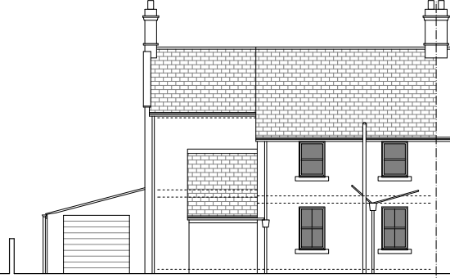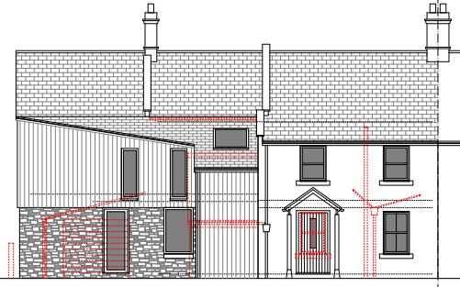
Existing & Proposed North Front Elevations.

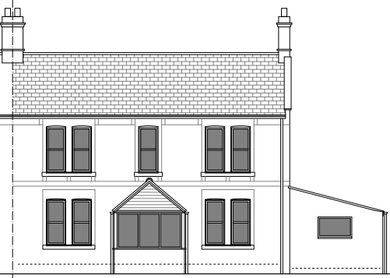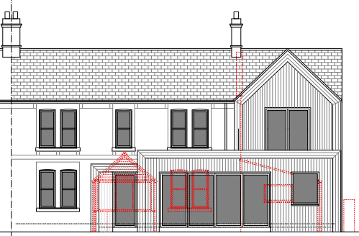
Existing & Proposed South Rear Elevations.

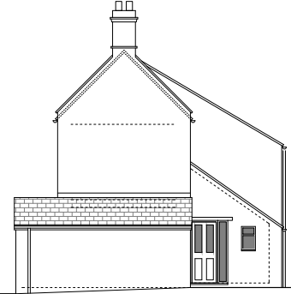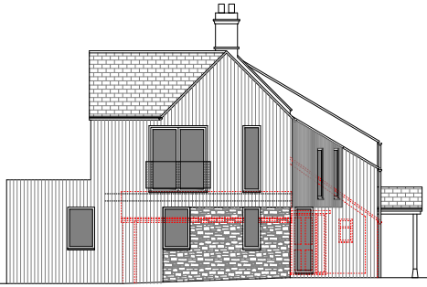
Existing & Proposed East Side Elevation.

The scheme proposes the construction of a two-storey side extension and a single storey rear extension, which would include a separate rear entry and extended living accommodation. The scheme would provide a positive connection with the site’s rear garden area.

It is recognised that the site is within Green Belt land and so to facilitate the proposals the overall scheme would involve the demolition of the existing garage and rear porch to accommodate the proposals. In addition, the scheme also proposes the demolition of the existing unsympathetic front extension to allow for its replacement with a partial two storey extension, to provide new stair
access to its first floor.

The scheme would alter the existing front elevation to provide a new front door entrance and would therefore provide a more in keeping public frontage. The scheme would also provide internal alterations that are not the subject of planning approval, as the building is not listed.

The scheme would introduce a pitched gable rear two storey extension, which when combined with the proposed flat roof extension, would both be clad in natural timber, offering a contemporary designed scheme. This theme is carried to the front of the property which would serve to improve its current arguably awkward presence.

It is noted that the neighbouring property has been considerably extended and so the proposed extension would serve to visually balance the overall length and appearance of the building, with its relocated front door entrance adding a visual focal point.

A new outbuilding is also proposed to be constructed at the rear of the site’s long linear garden; it would be an ancillary building that would be used as a combined home gym and office. It would have a mono-pitch roof and finished in matching timber cladding to compliment the main host building.

Therefore, in summary, having regard to the above, the proposal complies with the design principles set out in Core Policy 57 of the Wiltshire Core Strategy and Appendix D of the Wiltshire Design Guide.

Amenity
Point vii of Core Policy 57 - Ensuring High Quality Design and Place Shaping of the Wiltshire Core Strategy seeks to ensure that developments do not adversely affect neighbouring properties. The National Planning Policy Framework (NPPF), particularly Paragraph 135(f), stresses that planning decisions should ensure developments provide a high standard of amenity for existing and future users.
The proposed two storey extension would look out onto and face its front and rear garden areas; the building is located in a developed residential area where the principle of high-level mutual overlooking is an established principal. In this instance however, due to the established fenestration within the building, there would not be the introduction of new overlooking, with the outlook from the high-level windows remaining the same.

The proposed east side facing elevation would include a Juliet balcony, which would look onto open land and so would not overlook neighbours.

The single storey rear extension would look onto the site’s private rear garden area and again would not harmfully impact on neighbouring amenity.

The proposed ancillary outbuilding at the rear of the garden would be at a lower land level and at a distance of 26 metres from the main house, this would not harmfully impact on neighbouring amenity.

The proposal therefore accords with Core Policy 57 point vii. in respect of safeguarding residential amenity and Appendix D of the Wiltshire Design Guide.

Green Belt.
The site lies within Green Belt land and there is no relevant WCS development plan policies relating to the Green Belt, therefore the NPPF provides the policy direction. The NPPF sets out within paragraph 142 that “The Government attaches great importance to Green Belts. The fundamental aim of Green Belt policy is to prevent urban sprawl by keeping land permanently open; the essential characteristics of Green Belts are their openness and their permanence”.
Openness is the absence of development and Paragraph 143 the NPPF sets out five key purposes of the Green Belt with one being to safeguard the open countryside from encroachment. The NPPF also explains how to treat proposals within the Green Belt.

Paragraph 153 of the NPPF states inappropriate development is, by definition, harmful to the Green Belt and should not be approved except in very special circumstances. The two key characteristics of the Green Belt are its openness and its permanence.

Paragraph 154 sets out the categories of development which may be regarded as being ‘appropriate’ or exceptions in the Green Belt, such that in this instance sub-paragraph C allows for extensions as an exception. In this instance the extension consists of an area of infill within the main build of the side and rear of the dwelling, that would be set back from the public realm by 15 metres, therefore in accordance with the policy, the works would not result in a disproportionate addition.

In this case, it is noted that there would be demolitions taking place to part accommodate the proposals, in regard to the demolition of the existing garage, part front aspect and rear porch. Whilst useful as an indicator, existing volume calculations have been submitted which also consider works that could be undertaken within permitted development rights. However, the key aspect for consideration is the openness and permanence of the Green Belt.

In terms of the openness of the Green Belt, the two-storey side element of the proposal would replace the existing garage and would utilise and slightly extend its existing footprint, with the limited development being attached to the side and rear of the house. This and the low level flat roofed single storey rear extension would maintain the openness of the Green Belt, with such works taking place within the strict confines of the established residential curtilage of the principal building; the surrounding open views of the countryside and also to the east of the site, would be unaffected and permanently retained. In addition, and in support of the proposals, Paragraph 154 (C) of the NPPF allows for domestic extensions to take place.

In regard to the proposed residential garden outbuilding that would be sited within the rear garden, this would be used for recreational sport purposes, in the form of a home gym, Paragraph 154(B) of the NPPF allows for the provision of such recreational facilities. The openness of the land would be maintained, as the outbuilding would be sited within the natural contours of the garden land, with the building being of a simple mono pitch roof design and being timber clad. The following two snippets taken from the plans serve to show this:

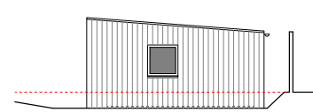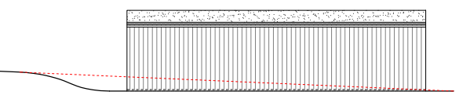

Therefore, for the above stated reasons and because the site is not readily open or isolated due to the surrounding existing built form, the scheme serves to contribute to the character of the site. To ensure the proportionality of the extensions, fits in and adheres within the context of the surrounding Green Belt.

Conservation Area.
The NPPF, Section 72 of the Planning (Listed Building and Conservation Area) Act 1990 and Core Policy 58 of the Council’s adopted Core Strategy highlights the fact that the Local Planning Authority has a duty to pay special attention to the preservation and enhancement of the character and appearance of the Conservation Area.

The site is located within the Westwood Conservation Area which is characterised by relatively modest individual dwellings and structures in a loose and low-density pattern along the main highway. There is no overarching style or configuration save for the use of similar local vernacular materials and forms. Whilst the existing building has some architectural merit, it makes a limited contribution to the build quality of the Conservation Area. Overall, it is appraised that the extension improves the appearance of the building through use of improved quality materials to the front aspect, whilst proposing a modest reconfiguration and improvements to form a more positive frontage to the public realm. Therefore, careful consideration has been given to CP 58 of the Core Strategy, the NPPF and Section 72 of the Planning (Listed Building and Conservation Area) Act 1990, whereby it is appraised for these reasons as discussed, the proposed works would cause no harm to the character of the Conservation Area.

Highway Matters.
Core Policy 57 (xiv) of the Wiltshire Core Strategy seeks to ensure that development must meet the requirements of Core Policy 61. This policy requires proposals to be capable of being served by safe access to the highway network. Core Policy 64 seeks to ensure compliance with parking standards set out in the Local Transport Plan.

The National Planning Policy Framework (NPPF), particularly Paragraph 115 and 116, requires that development proposals do not have an unacceptable impact on highway safety and that safe and suitable access to the site can be achieved for all users.

The proposed development would continue to use the established site access which would not be altered and would not have any adverse impact on highway safety. Adequate parking and turning provision is provided within the site and such access arrangements are acceptable. The council’s highways officer has been consulted who has not raised any objections.

The proposal is therefore considered to comply with Core Policies 57 (xiv), 61 and 64 of the Wiltshire Core Strategy, the NPPF, and the Wiltshire Local Transport Plan.

Ecology Impact CP50 requires no net loss of biodiversity on site. The site is located within the Bath and Bradford on Avon Bat SAC. The proposed development because of its minor nature and residential/urban location is considered unlikely to result in harm to bats or their habitat. There is no mechanism for significant effects from recreational pressure since it does not result in the creation of a new dwelling. Accordingly, the proposal is acceptable in this regard. As such, the development complies with Core Policy 50 of the Wiltshire Core Strategy and the relevant provisions of the NPPF. A standard ecology informative has been attached to make the applicant aware.

Biodiversity Net Gain. This application is exempt from the requirement to deliver Biodiversity Net Gain under Schedule 7A, Section 4(2)(a) of the Town and Country Planning Act 1990, as inserted by the Environment Act 2021, because the proposal is a householder extension.

CONCLUSION
The proposed development is acceptable in terms of its design, scale, and relationship with the surrounding area. It would not result in any unacceptable harm to the character of the locality, the amenities of neighbouring occupiers, or the interests of highway safety, heritage, or ecology.

The proposal is therefore considered to comply with the relevant policies of the Wiltshire Core Strategy, the Wiltshire Local Plan, and the National Planning Policy Framework. As such, the application is recommended for approval, subject to the conditions set out below.

RECOMMENDATION: Planning Permission be GRANTED subject to conditions.

