PL/2026/02443 - Land at White Street, West Lavington, Wiltshire, SN10 4HR
Formal Objection
West Lavington Parish Council objects to the proposed development of 47 dwellings off White Street. The proposal is contrary to Wiltshire Core Strategy and the Made West Lavington Neighbourhood Plan and is inconsistent with the National Planning Policy Framework (NPPF). The cumulative impacts on highway safety, local congestion, flood risk, residential amenity, biodiversity, agricultural land and village capacity are not capable of being adequately mitigated.

Principle of Development & Location
The Council’s written pre-application response (ENQ/2025/00848) makes clear that the proposal was considered unacceptable in principle at that stage. Officers explicitly stated that the development lies outside the defined Limits of Development for West Lavington and therefore within open countryside, where residential development is strictly controlled and only permitted in exceptional circumstances. An open market led proposal for up to 47 dwellings was found not to meet any of the exception criteria set out in paragraph 4.25 of the Wiltshire Core Strategy. This weighs significantly against the proposal and confirms that it conflicts with the adopted spatial strategy. (https://www.wiltshire.gov.uk/media/372/Wiltshire-Core-Strategy-adopted-2015/pdf/Wiltshire_Core_Strategy_2015.pdf?m=1735555642237)
The pre-application response repeatedly emphasises the importance of avoiding harsh or abrupt urban edges, minimising suburban design influences, and ensuring a soft and verdant transition to the countryside. Officers advised that only a well-designed, low-density and landscape-led scheme could potentially reflect the character of this location. A 47-dwelling estate significantly exceeds what could reasonably be described as low-density within this sensitive rural edge context and therefore conflicts with this advice.
The Council’s landscape advice also confirms that the site may qualify as a ‘valued landscape’ in NPPF terms due to its contribution to local character, community value, important views, and the setting of the Conservation Area. Even if this threshold were debated, the inherent beauty of the countryside and the contribution of the site to the village’s rural setting attracts strong policy protection.

Heritage and Historic Importance
The West Lavington and Littleton Panell Conservation Area is defined by the survival of a historic linear settlement pattern running along the High Street. This reflects the gradual growth of the villages from the medieval period onwards. The linear layout follows the natural topography, with the main street tracing the contour of the east‑facing valley slope beneath the Salisbury Plain escarpment and overlooking the Semington Brook valley. This relationship with the landscape creates a distinctive pattern of roadside buildings, enclosed plots, and outward views across the valley. The villages still clearly express their historic development, with later infill generally respecting the established linear form.
The character of the Conservation Area arises from the close interplay between buildings, landform, and landscape. Development is concentrated along the High Street and punctuated by historic farmsteads, manor houses, boundary walls, and mature planting. Most buildings are domestic in scale and vernacular in style, typically two storeys and built from brick, Greensand stone, render, or painted brickwork, with clay tile, slate, or occasional thatch. This consistency of scale and materials creates a strong sense of cohesion, reinforced by surviving historic plot boundaries, enclosed yards, and ancillary outbuildings.
In West Lavington specifically, the southern part of the Conservation Area contains a particularly rich concentration of designated heritage assets. These include West Lavington Manor, Home Farm, Hooks Court, and the Parish Church of All Saints, along with their associated walls, gardens, and agricultural buildings. Together, they form a sequence of historic structures and spaces of high architectural and historic value, strongly contributing to the area’s special interest and preserving the village’s manorial and agricultural character. The survival of historic boundary walls, enclosed farmyards, and mature planting plays a significant role in maintaining the sense of enclosure and the clear historic structure of this part of the village.
Development within the curtilage of these listed structures and any modifications to White Street or its junction with the A360 will cause substantial harm to this historic area.

Highways Safety
The proposed access strategy is unacceptable. White Street is a narrow rural lane and the junction with the A360 has known visibility constraints. The West Lavington Neighbourhood Plan site-selection evidence specifically identified that this site (Site 3, “Behind High Street/Orchard Place/White Street”), had “limited visibility” at the junction and that White Street was a “narrow lane” which may be inadequate to support new dwellings. It also recorded that “any substantial increase in development” would require the junction issue to be solved before development could proceed. (https://www.westlavington.org.uk/documents/documents-2018/np-2018/West Lavington NDP Housing Site Selection Methodology.pdf)
The NPPF requires development impacts on highway safety and congestion to be capable of being mitigated to an acceptable degree, and states that development may be refused where there would be an unacceptable highway-safety impact or severe residual cumulative impacts on the road network. (https://assets.publishing.service.gov.uk/media/67aafe8f3b41f783cca46251/NPPF_December_2024.pdf)
Wiltshire Core Strategy Core Policies 60 and 61 require new development to reduce the need to travel by private car, support safe and efficient movement, and demonstrate through transport assessment that all transport users have been properly considered. (https://www.wiltshire.gov.uk/media/372/Wiltshire-Core-Strategy-adopted-2015/pdf/Wiltshire_Core_Strategy_2015.pdf?m=1735555642237)
A 47-dwelling estate would materially intensify use of a constrained lane and junction already identified by the Neighbourhood Plan evidence as problematic. The application should therefore be refused unless and until the applicant demonstrates, with robust junction modelling, visibility surveys, swept-path analysis and cumulative traffic assessment, that safe access can be achieved without harming the rural character of White Street or displacing risk elsewhere – both of which are at risk as vehicles are encouraged to use Rickbarton, All Saints Road Church Lane and Church Street to overcome visibility issues.
White Street, All Saints Road, Church Lane and Rickbarton are single-vehicle-width lanes with no meaningful public passing places. Reliance on private driveways as informal passing bays is not a planning solution. It creates conflict between residents, pedestrians, cyclists, horse riders, delivery vehicles, emergency vehicles, refuse vehicles and construction traffic.
The NPPF requires applications to create places that are safe, secure and attractive and to prioritise pedestrian and cycle movements. This proposal would do the opposite by adding daily vehicle movements to a network of lanes that cannot accommodate two-way traffic safely or efficiently. (https://assets.publishing.service.gov.uk/media/67aafe8f3b41f783cca46251/NPPF_December_2024.pdf)
The resulting congestion would not be an abstract inconvenience. It would affect highway safety, emergency access, pedestrian safety, residential amenity and the functioning of the village. This is inconsistent with Wiltshire Core Strategy Core Policy 61 on transport and new development, and with Core Policy 57, which requires high-quality design and place-shaping that responds positively to local context and protects the amenity of existing residents. (https://www.wiltshire.gov.uk/media/372/Wiltshire-Core-Strategy-adopted-2015/pdf/Wiltshire_Core_Strategy_2015.pdf?m=1735555642237)
Wiltshire Council’s Highways pre-application advice expressly warned that any significant increase in traffic movements at the White Street / Church Street / A360 junction may be considered unacceptable and could form a reason for refusal. This concern arises from restricted visibility and the constrained geometry of the junction. This aligns precisely with the Neighbourhood Plan site assessment and reinforces the conclusion that the access arrangements represent a fundamental constraint rather than a matter of detailed mitigation.
The officer advice further demonstrates that the acceptability of the proposal is contingent on extensive third-party highway works, monitoring, surfacing, path widening, travel planning and behavioural interventions. Reliance on such a scale of mitigation is indicative of a site that is not inherently suitable for development of this scale and nature.
The parish council is actively working with Highways to find a solution to traffic congestion, speeding and pedestrian safety in this immediate vicinity. The stretch of the A360 at White Street running south to the junction with Rickbarton is a key focus because of significant issues each day. A development this large will only exacerbate problems here but because our work is with the LHFIG it is possible that Highways’ understanding of the issues have not made its way into the pre-app response.

Highways Related Issues
The proposal is likely to generate rat-running through All Saints Road, Church Lane and Rickbarton as drivers seek alternatives to White Street and the A360 junction. These lanes are not designed to function as distributor roads. They are narrow residential lanes with poor visibility, limited pedestrian refuge, constrained junctions and no safe passing infrastructure.
This raises a cumulative highway issue. The NPPF requires the decision-maker to consider cumulative impacts on the road network, not merely the technical capacity of the immediate site access. A transport assessment that focuses only on peak-hour trip rates at the site access would fail to assess the real-world operation of the local network and therefore is not supported by the NPPF. (https://assets.publishing.service.gov.uk/media/67aafe8f3b41f783cca46251/NPPF_December_2024.pdf)
The application should be refused unless the applicant can demonstrate, through a full area-wide transport assessment, that the development would not cause unsafe or severe cumulative impacts on White Street, All Saints Road, Church Lane, Rickbarton and their junctions with the A360. Anecdotal evidence from occasions when the A360 has been closed to traffic shows the real-world impact this development would have on Rickbarton in particular. Cars meeting each other halfway with one needing to either reverse back onto a busy A-road or the other reversing 200m up a steep hill were a common occurrence, as was damage to banking and driveways.

Flooding and Surface-Water Drainage
West Lavington and Littleton Panell experience flood risk from four interacting sources: fluvial flooding from Semington Brook, surface water runoff from steep chalk slopes, groundwater emergence during prolonged wet periods, and occasional sewer surcharge when the foul network is overwhelmed. While major historical flooding has been limited, recent years have seen more frequent flood alerts, saturated ground conditions and several near-miss events, indicating an increasing level of risk.
The villages lie at the transition between permeable Chalk and less permeable Greensand and Clay. This geography provides excellent infiltration during average conditions but produces rapid runoff and rising groundwater when the aquifer is saturated.
Infrastructure improvements remain important. Some road drains and gulleys—particularly along the A360, Duck Street and outside Dial House—require maintenance or small-scale upgrades. The proposal does not address remaining infiltration issues and surface water separation. Protecting the Semington Brook floodplain as open space remains essential to allow safe temporary storage during high flows.
The most effective natural defence against fluvial flooding is to keep the Semington Brook floodplain open and functional. The current land use already supports this: the most vulnerable parts of the floodplain are primarily pasture and undeveloped green space55. Local planning policy (e.g. the Neighbourhood Plan) has recognised this by steering development away from high-risk zones. Maintaining these areas as flood-compatible land uses (e.g. grazing, recreation, or deliberately managed wetland meadows) ensures that when floods do occur, water can safely spread out without damaging property. The development will remove a proportion of this protection. SuDS calculations based on the development area alone misses the larger impact of losing green space within the wider village. Given local flooding experience, including the level of run off flooding at Dauntsey School and the recent expansion of their attenuation pond illustrates the importance of this site to attenuate and store large scale surface water run off. Orchard Place, White Street and Sunnyside have all been impacted by close calls in the last 3 years. The risk and the experience of flooding in this area of the village is an annual event and not the once in 100-year event maintained by the applicant.
The proposal is unacceptable in flood-risk terms. Existing local evidence shows repeated flooding at the A360 bend opposite Duck Street and at Duck Street, where water is forced up through drains and floods roads and properties. This is not a remote or theoretical “1 in 100 year” concern. Local residents report repeated flooding in each of the last three years and on many previous occasions with properties damaged. The photos below demonstrate the issue with flooding of Duck Street in heavy rain, these issues have been experienced repeatedly over the last few years despite vacuuming of the drainage runs. There is simply not enough capacity in the infrastructure for existing rainwater, let along additional water generated by the collection of run-off from 47 roofs, driveways and roads.
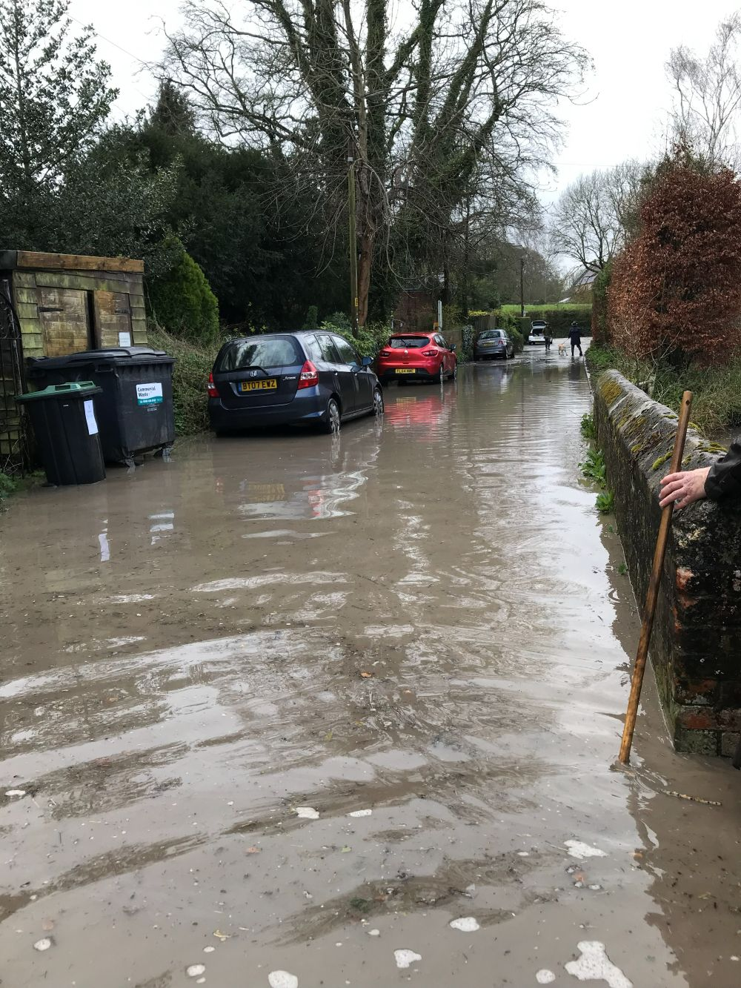Duck Street looking west towards the A360
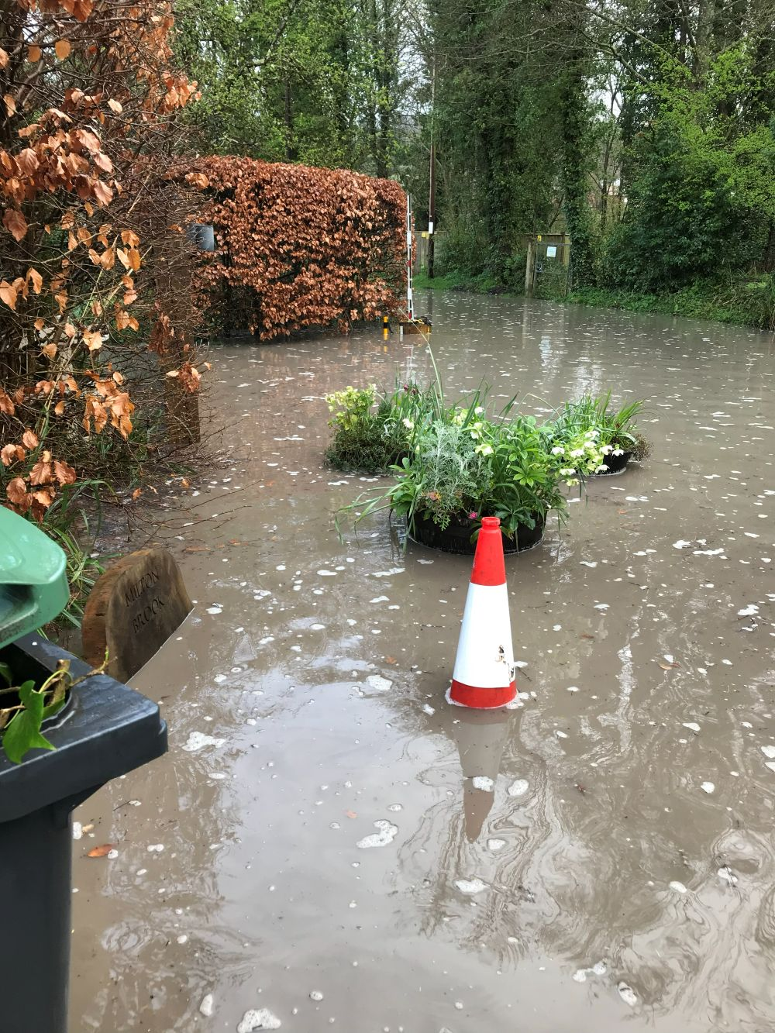Duck Street flooded halfway along east of the bridge
Water being forced up through the drain covers due to the weight of water coming down from White Street and under the A360
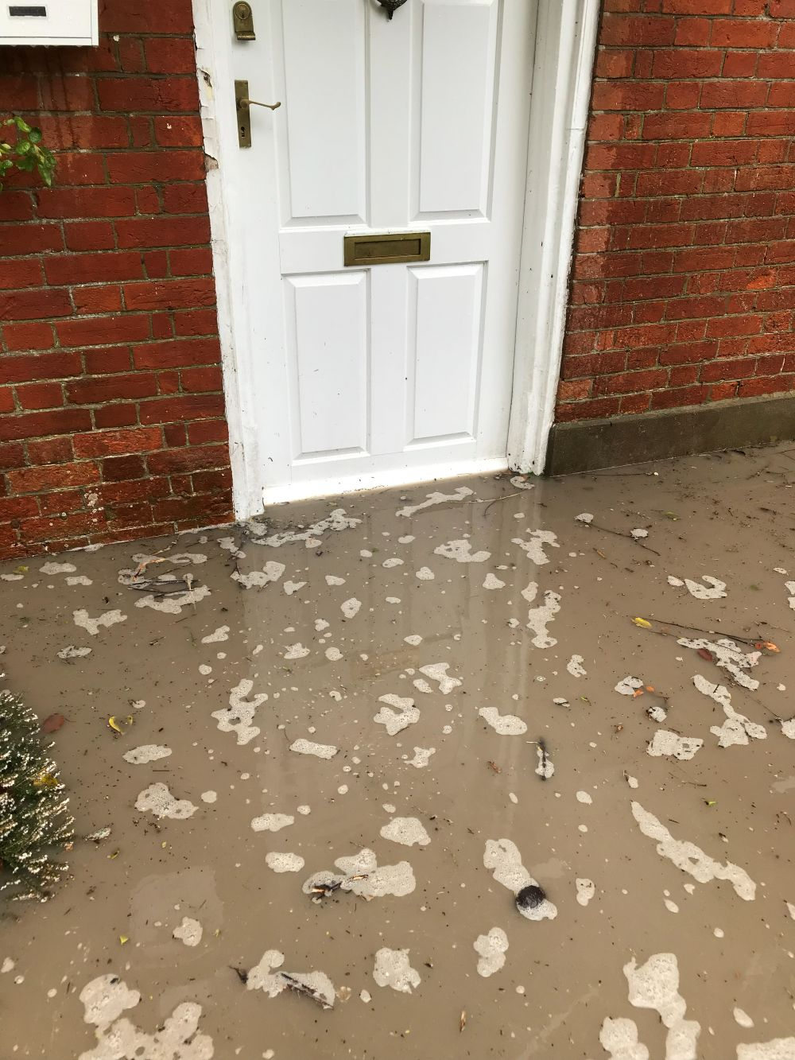Flood water entering a residential property – An annual risk now

The NPPF is clear that inappropriate development in areas at risk of flooding should be avoided, that development must be safe for its lifetime without increasing flood risk elsewhere, and that planning authorities must consider all sources of flood risk, including surface water and climate change. It also requires planning authorities to ensure that flood risk is not increased elsewhere which would be the case even if the water was held onsite and attenuated before releasing it into the network. (https://assets.publishing.service.gov.uk/media/67aafe8f3b41f783cca46251/NPPF_December_2024.pdf)
The current field allows rainfall to permeate naturally. Replacing it with roads, roofs, driveways and compacted gardens will inevitably alter the hydrology. Attenuation may slow discharge, but it does not remove the additional burden on a drainage network that local evidence shows is already overwhelmed. The relevant test is not whether the applicant can calculate a theoretical discharge rate on paper; it is whether the development will avoid increasing flood risk elsewhere in the real drainage catchment. On the evidence of repeated flooding downstream, that test is not met.
The West Lavington site-selection evidence also recorded public concern about surface-water flooding “particularly in view of the previous problems in this part of the village”. (https://www.westlavington.org.uk/documents/documents-2018/np-2018/West Lavington NDP Housing Site Selection Methodology.pdf)
Permission should be refused unless the Lead Local Flood Authority is satisfied, using up-to-date local flood-history evidence and climate-change allowances, that the proposal would not worsen flooding at the A360, Duck Street or surrounding properties. Planning officers should also seek recent flooding evidence from the parish council showing real-world impact of hydrology issues surrounding the site and not simply rely on hypothetical modelling.

Density, Overlooking and Loss of Privacy
The proposed two-storey dwellings behind High Street and Orchard Place would result in unacceptable overlooking and loss of privacy, particularly for Orchard Place, which is a cul-de-sac of bungalows. The change in scale and relationship would be harmful to existing residential amenity.
The NPPF requires planning decisions to create high-quality, beautiful and sustainable places and to secure a high standard of amenity for existing and future users. Wiltshire Core Strategy Core Policy 57 similarly seeks high-quality design and place-shaping, including protection of residential amenity and positive response to the existing townscape, landscape and local character. (https://www.wiltshire.gov.uk/media/372/Wiltshire-Core-Strategy-adopted-2015/pdf/Wiltshire_Core_Strategy_2015.pdf?m=1735555642237)
The Neighbourhood Plan evidence already identified overlooking concerns from nearby residents in respect of this site. (https://www.westlavington.org.uk/documents/documents-2018/np-2018/West Lavington NDP Housing Site Selection Methodology.pdf)
The proposal would introduce an estate scale development into a sensitive location where the relationship with existing bungalows, rear gardens and open countryside has not been shown to be acceptable.

Neighbourhood Plan Conflict
The applicant’s claim that the proposal accords with the Neighbourhood Plan is misleading. The site was considered in the Neighbourhood Plan evidence base but was not allocated. The site-selection document identified this site (Site 3) as “Behind High Street/Orchard Place/White Street” and expressly concluded that it was “Not recommended for allocation”.
The reasons were directly relevant to this application: inadequate access, harm from widening White Street, limited visibility, harm to the Conservation Area setting, biodiversity value, and demonstrable harm outweighing benefits. The same evidence also recorded that Wiltshire Council officers had concerns about limited visibility at the A360 junction and the inadequacy of White Street to support a number of new dwellings.
The extract of the Site Selection Methodology that scores this site is included in Appendix 2. Particular attention is highlighted to pages 36 and 46, 47 and 48 of the Site Selection Methodology.
(https://www.westlavington.org.uk/documents/documents-2018/np-2018/West Lavington NDP Housing Site Selection Methodology.pdf)
The NPPF presumption in favour of sustainable development supports proposals that accord with an up-to-date development plan; it does not support proposals that mischaracterise a rejected site as if it were an allocation.
(https://assets.publishing.service.gov.uk/media/67aafe8f3b41f783cca46251/NPPF_December_2024.pdf)
The pre-application advice confirms that there are no policies within the Made West Lavington Neighbourhood Plan that support development of this scale or in this location. This directly contradicts any assertion by the applicant that the proposal aligns with, or is supported by, the Neighbourhood Plan. The site’s omission from allocation was a conscious and evidence-led decision, and that evidence remains a highly material consideration.
This proposal is contrary to the plan-led approach and should be refused.

Loss of Agricultural Land
The site is productive agricultural land. If it comprises best and most versatile agricultural land, namely Grade 2, the NPPF requires decision-makers to recognise its economic and other benefits. The NPPF also states that where significant development of agricultural land is necessary, poorer-quality land should be preferred to higher-quality land. In this case, given recent development in West Lavington, this development cannot be deemed necessary. (https://assets.publishing.service.gov.uk/media/67aafe8f3b41f783cca46251/NPPF_December_2024.pdf)
The pre-application response confirms that the site comprises Grade 2 agricultural land, which constitutes Best and Most Versatile land. National policy requires substantial weight to be given to the protection of such land, particularly where the development is not necessary and where alternative locations exist. In the absence of exceptional justification, the permanent loss of high-quality agricultural land weighs against the proposal.

Biodiversity Loss
The site has local biodiversity value. The Neighbourhood Plan site-selection evidence described the field as “undisturbed” and “harbouring a variety of biodiversity value”. Local residents also report bats, reptiles and other wildlife using the site. (https://www.westlavington.org.uk/documents/documents-2018/np-2018/West Lavington NDP Housing Site Selection Methodology.pdf)
The NPPF requires planning decisions to minimise impacts on biodiversity, provide net gains, protect ecological networks and support priority or threatened species such as bats and hedgehogs. It further states that if significant harm to biodiversity cannot be avoided, mitigated or compensated, planning permission should be refused. (https://assets.publishing.service.gov.uk/media/67aafe8f3b41f783cca46251/NPPF_December_2024.pdf)
Wiltshire Core Strategy Core Policy 50 requires development proposals to demonstrate how features of nature-conservation value will be protected, retained, buffered and managed, and how unavoidable impacts will be mitigated and compensated. Residents are not satisfied that the development has undertaken this work. (https://www.wiltshire.gov.uk/media/372/Wiltshire-Core-Strategy-adopted-2015/pdf/Wiltshire_Core_Strategy_2015.pdf?m=1735555642237)
The reported cutting back of the field shortly before surveys, and alleged disturbance or movement of reptile mats, casts doubt on whether the ecological baseline is reliable. Planning officers should require independent ecological review and, if necessary, repeat surveys at the correct time of year and under appropriate site conditions. A biodiversity net gain calculation based on a degraded or artificially suppressed baseline should be given little weight.
The applicants Ecological Impact Statement regarding bats looks at overfly but does not consider roosting outside of development area. We know from a survey carried out in 2022 in All Saints Church by Mr Gareth Harris, County Recorder, Wiltshire Mammal Group & Wiltshire Bat Group. That the species of bat roosting and night roosting for hunting are:
Greater horseshoe
Lesser horseshoe
Serotine
Noctule
Common Pipistrelle
Soprano Pipistrelle
Brown long-eared bat.

It is clear from the report that All Saints Church is an important place for hunting and roosting bats, therefore the surrounding area including the applicant’s site must be considered as important. The applicants study downplays the likelihood and importance of local roosting sites. Mr Harris’ email to the church is included as Appendix 1.

There is also evidence from householders that Serotine bats roost and raise pups in the roof of 46 High St. and that they come each year to do so. This has also been confirmed and recorded by Mr Harris.

There is insufficient mitigation and allowance in the application to reduce the risk to our bat communities.

Overdevelopment
West Lavington has already absorbed substantial recent growth, including developments of 50 homes and 19 homes elsewhere in the village. A further 47 dwellings would mean over 100 new homes in a very short period, imposing cumulative pressure on roads, drainage, local services, landscape character and community infrastructure.
The NPPF requires sustainable development to align growth and infrastructure, reflect local circumstances, and take account of the character, needs and opportunities of each area. (https://assets.publishing.service.gov.uk/media/67aafe8f3b41f783cca46251/NPPF_December_2024.pdf)
Wiltshire Core Strategy Core Policy 3 concerns infrastructure requirements, and Core Policy 48 supports rural life by improving access to services and infrastructure rather than overwhelming rural communities. (https://www.wiltshire.gov.uk/media/372/Wiltshire-Core-Strategy-adopted-2015/pdf/Wiltshire_Core_Strategy_2015.pdf?m=1735555642237)
The issue is not opposition to housing in principle. It is that this particular site was assessed through the Neighbourhood Plan process and rejected for sound planning reasons. Those reasons remain valid: poor access, flood risk, harm to character, residential amenity concerns and ecological value. The cumulative burden of yet another large development on a small rural community weighs strongly against permission.

Consultation
The applicant states in The Statement of Community Engagement, Section 2.3 that the public consultation was in keeping with the requirements of:
“National policy and guidance introduced in the Localism Act and the National Planning Policy Framework (NPPF).
Wiltshire Council’s consultation requirements, specifically Statement of Community Involvement for Planning 2020.
The spirit of through and meaningful consultation.”
The Parish Council acknowledges that a community engagement event was held on 9th July and the opportunity to provide feedback was given. However, prior to the event and subsequent to the event there has been no engagement with the community until the planning application was submitted. The invitation to the event stated that “CG Fry and Sons are preparing an outline planning application”. A full planning application was submitted.
Consultation has been at the absolute minimum and has not kept to the spirit of the NPPF or Wiltshire’s SCI.

Conclusion
For the reasons above, the application conflicts with the NPPF, Wiltshire Core Strategy Core Policies 3, 50, 57, 60, 61, 67 and 68, and the made West Lavington Neighbourhood Plan evidence base. The proposal would cause unacceptable harm through highway danger, congestion, rat-running, increased flood risk, loss of amenity, loss of agricultural land, biodiversity harm and overdevelopment.
Taken cumulatively, the pre-application advice reinforces and corroborates the objections set out above. The Council’s own officers identified fundamental conflicts with the settlement strategy, open countryside protection, highways safety, landscape character, conservation area setting, agricultural land protection and design expectations. These are not minor or technical shortcomings; they go to the heart of whether the proposal represents sustainable development. It is clear that the harms arising from this proposal significantly and demonstrably outweigh its benefits, even having regard to the current housing land supply position.
West Lavington Parish Council met to discuss this application on Thursday 7th May 2026. Approximately sixty members of the public were present along with the applicant and their agent. The Parish Council voted unanimously to object to the proposal for the reasons above. The Parish Council also requested that the local member (Cllr Dominic Muns) submits a call-in if the officer is minded to approve the application.
Planning permission should be refused.
Appendix 1. Report on Bats at All Saints Church
From: Gareth Harris
Date: Thu, 13 Oct 2022 at 16:19
Subject: All Saint's Church, West Lavington
Afternoon All,
Mark kindly met me this morning to retrieve the two bat detectors that I left in the church. The results are pretty interesting….
Firstly – I left a detector on one of the central pillars in the nave, roughly pointing towards the piano (where there were some accumulated bat droppings).
The detector recorded 7 nights of activity before the batteries ran out. The numbers in the following table relate to “bat passes” i.e. the number of times the detector was triggered by that species. So the numbers don’t relate to numbers of bats, but they are a proxy for activity levels.
This largely confirms what we suspected, that pipistrelle bats, long-eared bats and Lesser horseshoe were present.
This shows that Lesser horseshoes are indeed flying around the inside of the church and they are typically doing so in the middle of the night – the fact that they aren’t recorded at dusk or dawn, suggests they aren’t day roosting here, but somewhere else, and come here only in the middle of the night. This is characteristic of what’s called “night roosting” behaviour. This is a good definition of a night roost: “a sheltered area where the bats can hang up, groom, and digest their food between foraging bouts. These are particularly important for heavily pregnant females and for bats foraging at a distance from their normal day roost. Many night roosts are structures which would be too light and exposed to the elements to be suitable as day roosts, but during darkness provide the bat with sufficient shelter and security against inclement weather and/or predators. Examples of these include church porches, derelict old-fashioned outside toilets, or open sided sheds.”
Basically, the day roost is somewhere else and the bat (its likely an individual) comes here only in the middle of the night. The places where the droppings are found are well-lit locations too, so this fits nicely.
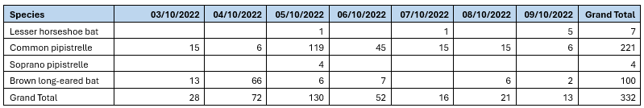
Similarly, the decent number of Brown long-eared bat passes, indicate that a roost is present, and that they were warming up inside the church before leaving the church to forage in the wider landscape. Additionally, the time of year, and the types of calls that were recorded indicate that they were also courting and displaying too – we often record this type of behaviour in September and October inside large buildings such as churches, cathedrals, barns and large houses. Again, this fits with what we know – we suspect the roost closest to the main door is long-eared bat.
Common pipistrelle were also very vocal – and the calls recorded also relate to courting bats. All British bats mate and court in the autumn months.
Secondly – we left a detector in the outbuilding where we suspected the Greater horseshoe.
Here we recorded 10 nights of data.
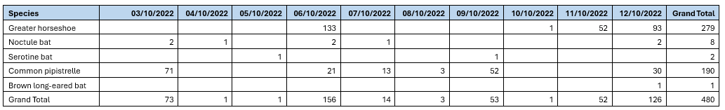
Astonishingly, we recorded 279 passes of Greater horseshoe bat – so they are clearly using it. Not every night and sometimes not very much – but other nights, they used it a lot (e.g. the 6th).
In the following graph, I’ve plotted the number of passes recorded for each hour (1800hrs, 1900hrs, 2000hrs etc). This highlights where the main activity is. During the 3rd to the 12th October, sunset was between 1838 and 1821…….and sunrise was 0710-0725.
We don’t think the Greater horseshoe bat is day roosting in the outbuilding (because we’ve never seen it there – and it’s a big bat, you’d have noticed it!). And our data shows it is using the outbuilding through the night……but the timings of the recordings show the bat is using the site a lot shortly after sunset and an hour before sunrise……in fact, some of the passes are within minutes of sunset. Which means that the Greater horseshoe bat is roosting somewhere VERY close by. Its perhaps worth canvassing nearby residents to see if anyone has outbuildings, stables, cellars etc that it could be using for day roosting.

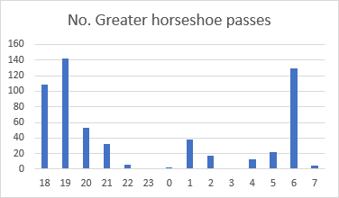
I also suspect, judging by the numbers of calls and of the constant echolocation calls, that this bat was actually perched and was warbling at the same time – i.e. it may have been singing to attract females. (I’ve seen them do this in the entrances to roosts before). And if that’s the case, I wonder if it was successful!?
Jane – feel free to use any of this to feed into your response to BCT.
Mark & Anne – this confirms the species list for the church is currently:
Greater horseshoe
Lesser horseshoe
Serotine
Noctule
Common pip
Soprano pip
Brown long-eared bat.
And I bet we can add to that next year!
Cheers for now
Regards Gareth Harris
County Recorder – Wiltshire Mammal Group & Wiltshire Bat Group
Email: wiltsbatrecords@gmail.com

Appendix 2.
