APPLICATION FOR HOUSEHOLDER PLANNING PERMISSION
DELEGATED REPORT

APPLICATION REFERENCE: | PL/2026/02488
APPLICATION TYPE: | Householder planning permission
SITE ADDRESS: | 118 Clay Street, Crockerton, Warminster, BA12 8AG
DEVELOPMENT DESCRIPTION: | Proposed Extension and Alterations
RECOMMENDATION: | That Planning Permission be GRANTED

PROPOSAL

The proposal seeks planning permission for Proposed Extension and Alterations at 118 Clay Street, Crockerton, Warminster.

The extension would have matching render walls and matching planning roof tiles but would also introduce timber cladding on the first-floor section of the extension on each of its three elevations. Revised plans have been received which have changed the timber cladding from ‘dark’ stained to unstained and left to naturally fade to silver.

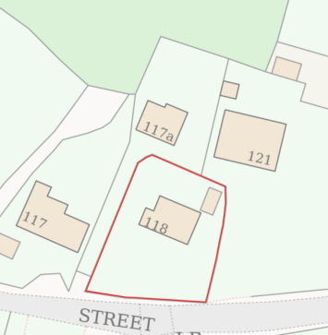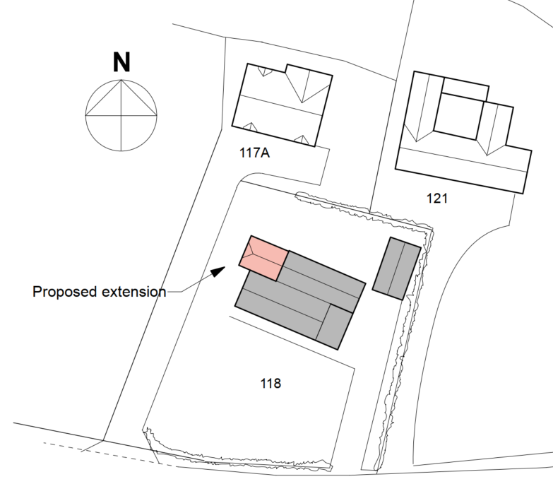

Site Location Plan and Proposed Block Plan

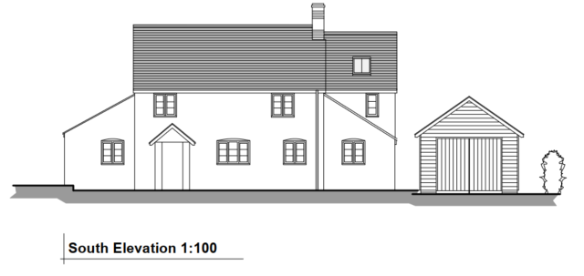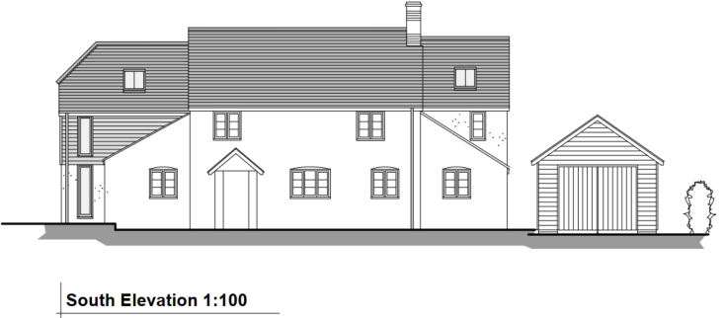

Existing and Proposed South (front) Elevations

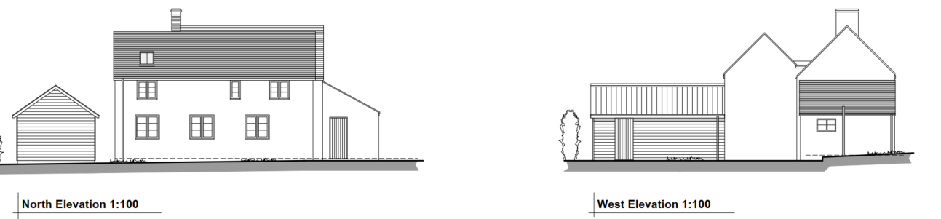

Existing North and West Elevations

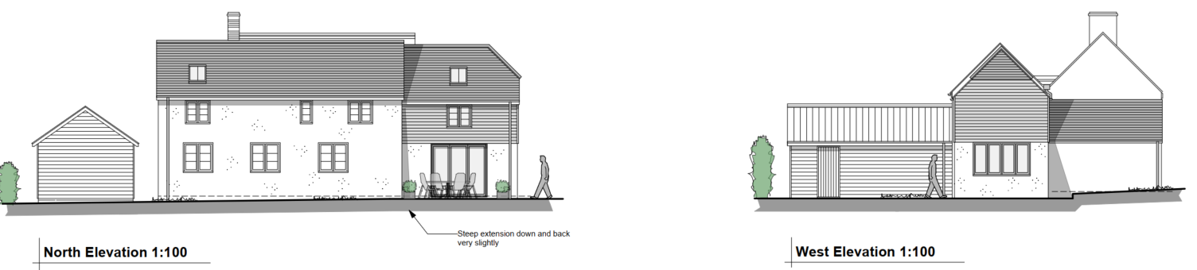

Proposed North and West Elevations

SITE DESCRIPTION/CONTEXT

No 118 is a detached two storey dwelling that along with its immediate neighbours on the north side of Clay Street are all generously set back from the road by circa 16m. Additionally the sloping ground of Crockerton (with the south side of Clay Street being on higher ground) means that the built form of No 118 (and its neighbours) have less of an impact on the street scene.

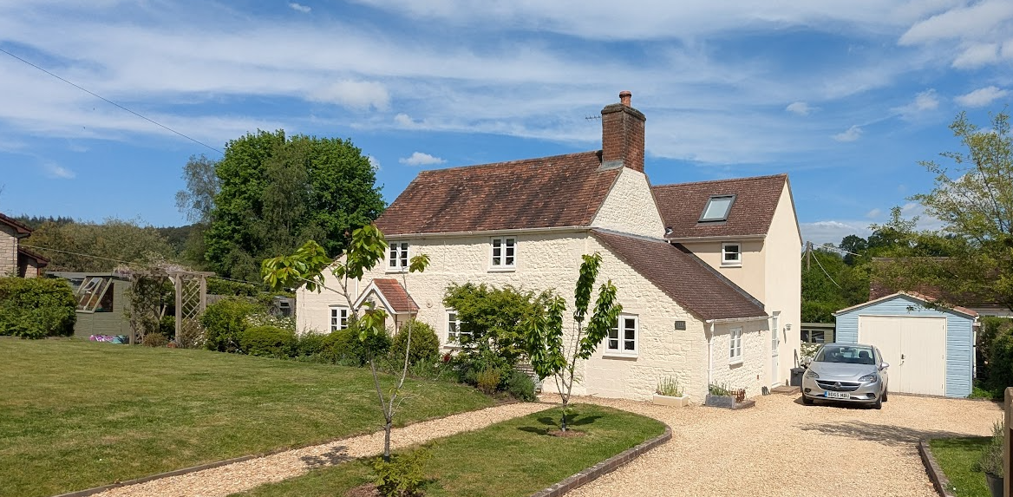

No 118 (with 2016 extension visible on the right side)

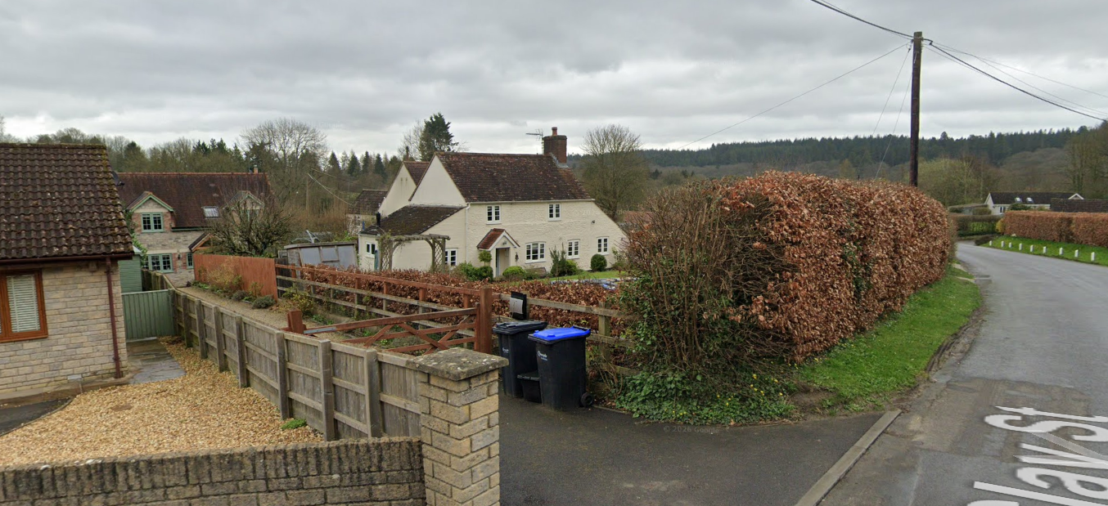

March 2024 Google Street View image of No 118 with No 117a behind (left)

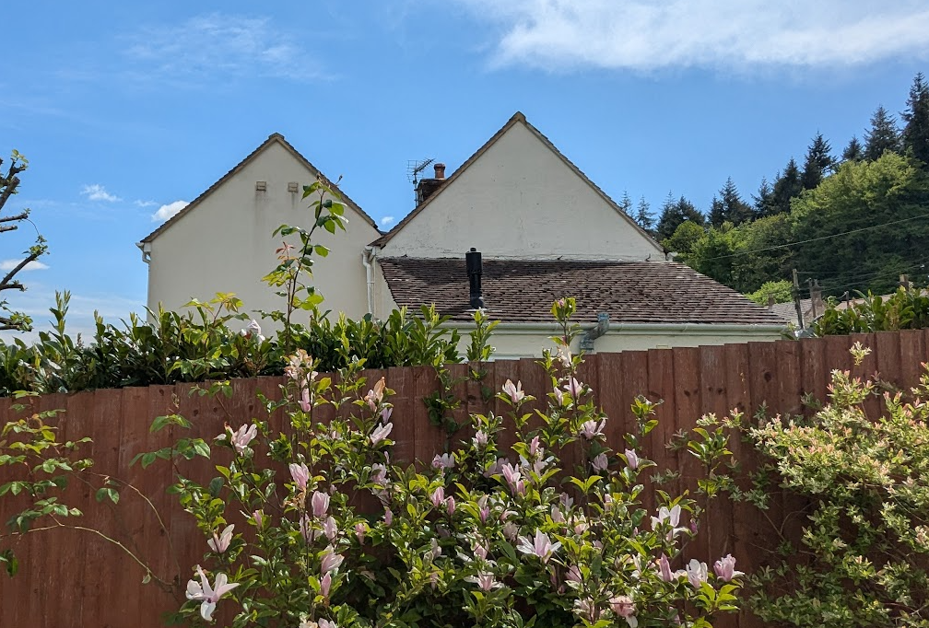

View of No 118 from driveway leading to No 117a

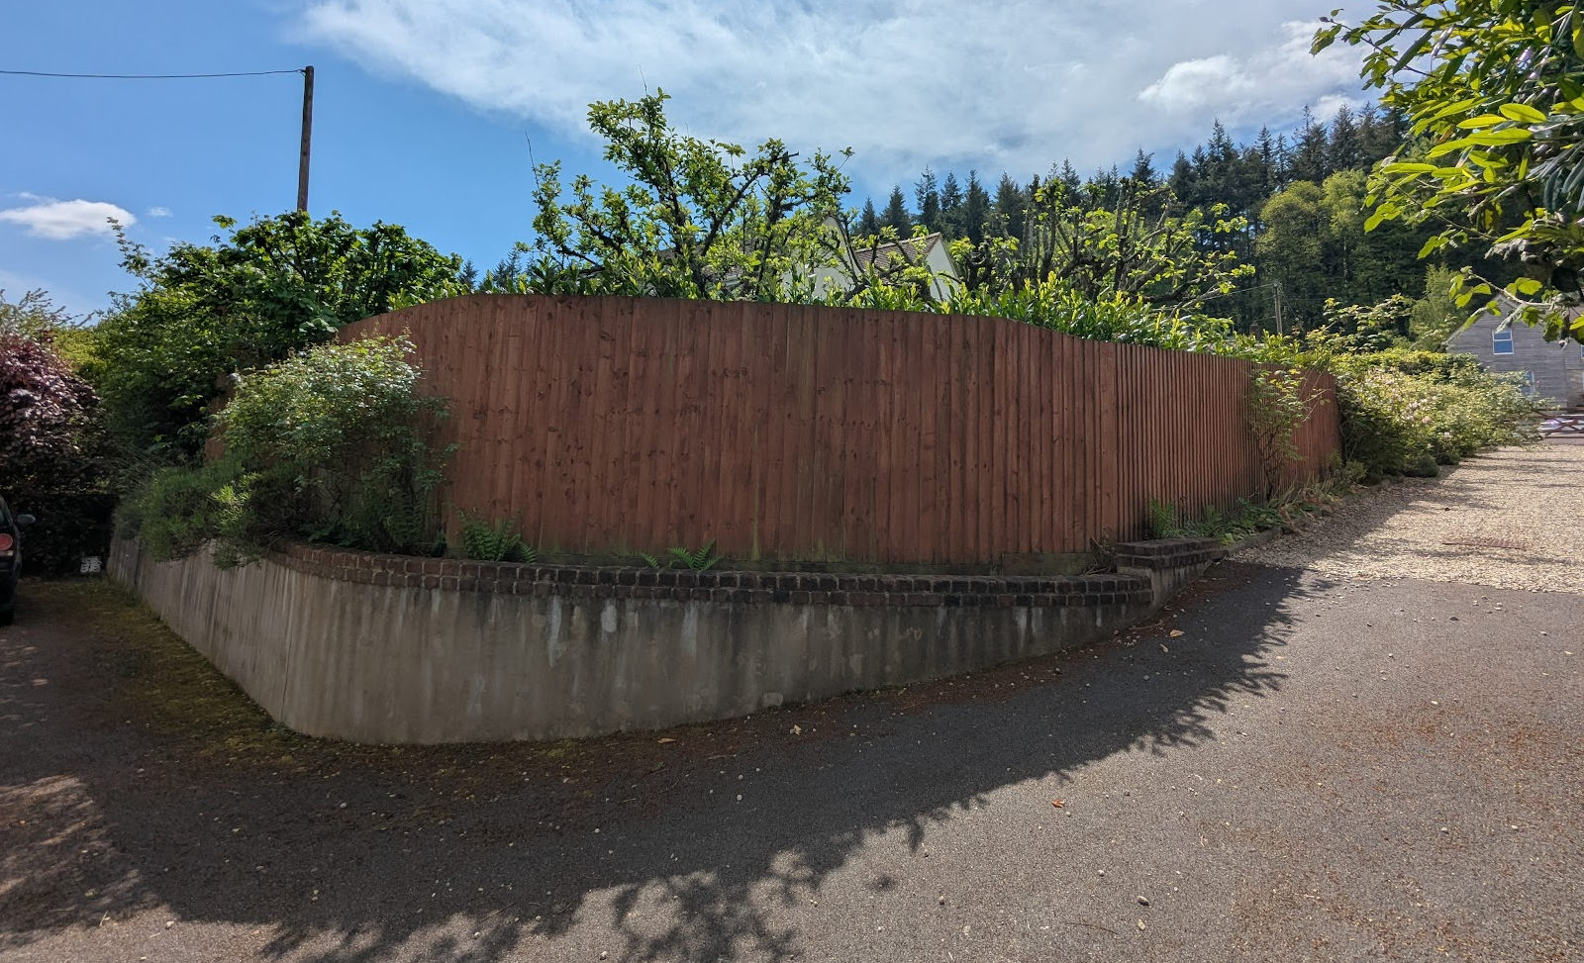

View from front elevation of No 118 (ridge of 2016 extension visible)

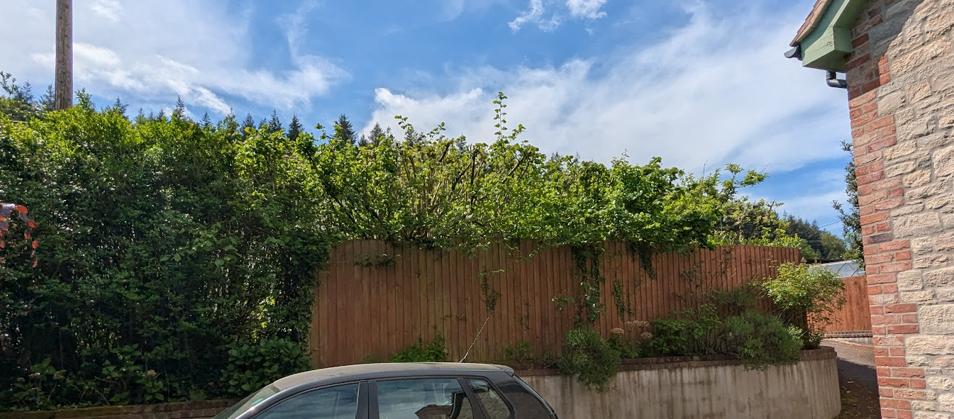

View from side elevation of No 118

No 118 has had a recent two storey extension on the rear elevation (16/02066/FUL) which introduced the second ridgeline and gable ends. This application also included a ground floor family room extension, which has not been built (and is where the proposed two storey extension in this application is proposed).

The application site is not within a conservation area. The Bath Arms Public House is a grade II listed building and is circa 60m from the application site (and on the opposite side of the proposed extension).

The application site is also within the Cranborne Chase and West Wiltshire Downs National Landscape and is also within the 6.4km buffer zone of the Sailsbury Plain Special Protection Area.

The site is subject to ground water flood risk where it is understood to be within 0.025m-0.5m of the surface. The site is not subject to any surface water flood risk. The applicant has submitted the Council’s flood risk assessment form.

PLANNING HISTORY

Proposal / Summary
16/02066/FUL - Full planning permission Decision - Approve with Conditions Date: 26/4/2016 – Proposed first floor extension, single storey garden room and replacement garage.

RELEVANT POLICIES AND GUIDANCE

National Context:

The National Planning Policy Framework (NPPF)

The Planning Practice Guidance

From the point of view of the historic environment the main statutory tests are set out within the Planning (Listed Building and Conservation Areas) Act 1990.

Section 66 requires that special regard be given to the desirability of preserving listed buildings, their settings or any features of special architectural or historic interest which they possess.

Local Context:

Wiltshire Core Strategy:

- Core Policy 50: Biodiversity and Geodiversity
- Core Policy 51: Landscape
- Core Policy 57 Ensuring High Quality Design and Place Shaping
- Core Policy 58: Ensuring the Conservation of the Historic Environment
- Core Policy 67: Flood Risk

Wiltshire Design Guide: Appendix D – Design Guidance for Householder extensions
Witlshire Strategic Flood Risk Assessments 2019 and 2024

Longbridge Deverill does not have a neighbourhood plan or area designation.

CONSULTATION RESPONSES

Longbridge Deverill Parish Council: No objection.

REPRESENTATIONS

8 neighbour notification letters were sent out on 29 April 2026 and additional 14-day re-consultation letters were sent on 18 May 2026 following receipt of revised plans.

No comments were received.

Further revised plans were received on 4 June to increase the width of the proposed bedroom window on the south elevation by 50mm to make it building control compliant to be used as an escape window. The first floor level was also shown on the elevation plans. It is considered that it is not necessary to re-consult on this very minor change, especially in the context that there have been no objections to the proposal.

ASSESSMENT

Section 38(6) of the Planning and Compulsory Purchase Act 2004 states:

"If regard is to be had to the development plan for the purposes of any determination to be made under the planning Acts, the determination must be made in accordance with the plan unless material considerations indicate otherwise."

In accordance with this statutory requirement, this application has been assessed against the relevant policies of the Development Plan, including the adopted Wiltshire Core Strategy (2015) and, where applicable, any made Neighbourhood Plans.

Design and Impact upon the character and context of the area

Core Policy 57 - Ensuring High Quality Design and Place Shaping of the Wiltshire Core Strategy seeks to ensure that all new development is of high design quality, reflecting local context, character, and distinctiveness.

No. 118 originated as a traditional cottage, later altered through the addition of two substantial single-storey side extensions with lean-to roofs (constructed prior to the availability of Council records). Although these extensions were similar in scale and design, they disrupted the building’s original appearance, balance, and symmetry.

In 2016, a two-storey rear extension was added. This addition was well designed and generally sympathetic, reflecting the form of the original cottage. However, it extended in line with one of the side lean-to structures rather than the original rear wall, resulting in increased visual bulk and mass. Despite this, its rearward position and the site’s gradual change in ground levels mean it appears somewhat subordinate to the original building.

As a result of these cumulative alterations, No. 118 now presents an irregular and somewhat ad hoc appearance. Accordingly, careful consideration must be given to the impact of the proposed further extension.

The current proposal seeks to construct an additional two-storey rear extension, extending beyond both the original cottage’s side wall and the existing lean-to extension. It would also introduce a half-hipped roof form and first-floor timber cladding as a new external material.

While the proposed scale, roof design, and materials would add to the building’s existing asymmetry and further dilute the original cottage form, there are material considerations that weigh against refusal. The introduction of first-floor timber cladding, although differing from the original cottage materials, is not considered inappropriate within the local context. There are examples in the immediate vicinity, including No. 123 opposite, which features similar timber cladding, as well as the detached timber double garage serving No. 105. These examples demonstrate that timber cladding is an established and acceptable material within the street scene.

Similarly, the proposed modern fenestration within the extension would not directly reflect the traditional window proportions and detailing of the original cottage. However, given its location to the rear, its limited visibility within the wider street scene, and the already evolved and mixed character of the host building, it is not considered to result in unacceptable harm to the overall appearance of the property.

The extension would be located to the rear of the property, which itself is set approximately 16 metres back from the main road. It would not be visible from the east along Clay Street, as it would be screened by the original cottage. Additionally, boundary treatment has evolved over time; although the front hedge was historically maintained at around 1 metre in height (as evidenced by Google Street View imagery between 2009–2011), it has since been allowed to grow to over 2 metres (since at least 2023), providing further screening. While such features cannot be relied upon permanently, they do offer current visual mitigation.

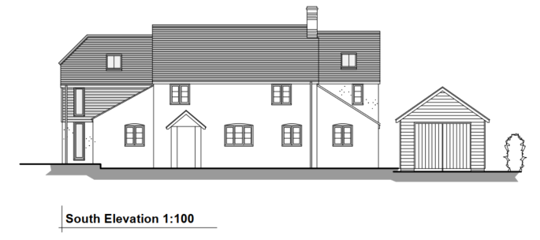

Proposed South Elevation

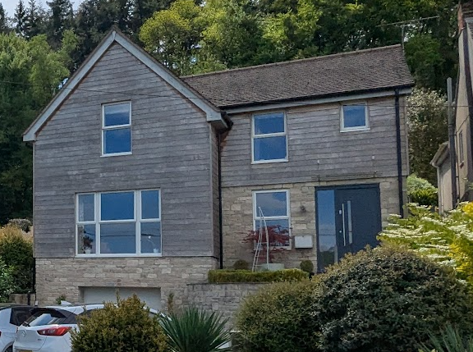

Example of timber cladding opposite at No 123

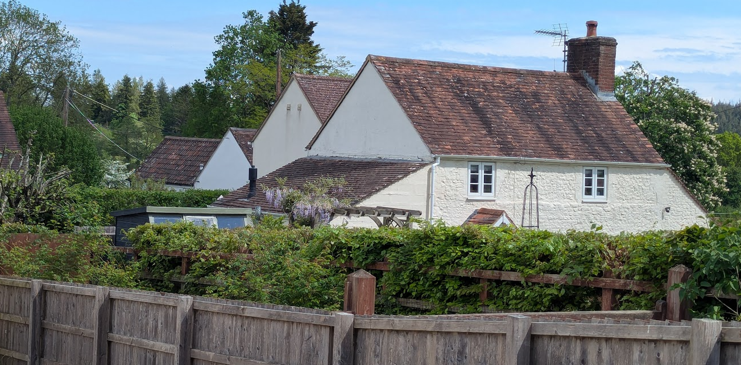

View of key elevations from Clay Street (from in front of No 117)

Consequently, views of the proposed extension would be limited, with only partial visibility from the southwest (in the vicinity of No. 117). Although the cumulative impact of the extensions contributes to the building’s asymmetry, the set-back from the road and the site’s sloping topography reduce its prominence within the wider street scene. As with the 2016 extension, the proposed roof would appear subordinate and would not dominate the original cottage.

Officers have also considered whether a gabled roof form would provide greater visual continuity with the existing structure. However, the applicant has justified the half-hipped design on the basis of reducing potential impacts on neighbouring amenity, an issue addressed separately within this report. Given the building’s already irregular form, it is considered that while the half-hipped roof introduces a degree of additional visual discord and departs from the predominantly gabled character of the street, this harm is not sufficient to warrant refusal.

Having regard to the above, the proposal complies with the design principles set out in Core Policy 57 of the Wiltshire Core Strategy and Appendix D of the Wiltshire Design Guide.
Amenity

Point vii of Core Policy 57 - Ensuring High Quality Design and Place Shaping of the Wiltshire Core Strategy seeks to ensure that developments do not adversely affect neighbouring properties.

The National Planning Policy Framework (NPPF), particularly Paragraph 135(f), stresses that planning decisions should ensure developments provide a high standard of amenity for existing and future users.

The proposed development has been assessed in terms of its potential impact on the residential amenity of neighbouring properties, with particular regard to loss of light, overshadowing, loss of privacy, and overbearing effects.
Overshadowing and natural daylight

The site is situated on land that slopes downward to the rear, resulting in the neighbouring property to the north (No. 117a) having a finished floor level approximately 1.5–2 metres lower than that of No. 118. Consequently, the ridge of the existing 2016 rear extension is visible from the driveway at No. 117a, and the proposed extension would also be partially apparent from this vantage point.

No. 117a represents the neighbouring property most likely to be affected by overshadowing. The proposed two-storey extension would be positioned approximately 8.6 metres from the shared boundary and around 12.8 metres from the front elevation of No. 117a.

The proposed development would introduce some additional overshadowing. However, it is important to note that the existing dwelling and boundary treatments already give rise to similar impacts. As shown in the photographs within the introduction, the existing boundary fence already casts a degree of shadow comparable in nature to that created by No. 118 itself. The proposed extension would increase this effect, but not to a materially greater degree.

This can be indicatively evidenced using sun path modelling (e.g. Suncalc), which indicates that, on 21 December, the existing building casts a ground level shadow of approximately 24 metres by late morning. The proposed extension would increase the width of this shadow at this time of year. This analysis is indicative only and intended to assist in understanding the likely seasonal pattern of shadowing, rather than constituting a precise technical assessment.

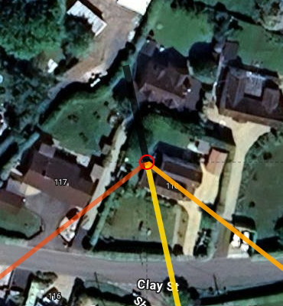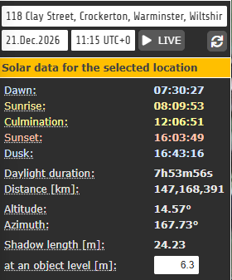

Extract from www.suncalc.org – 21 December 2026

However, analysis indicates that overshadowing sufficient to reach the built form of No. 117a is largely limited to the period between late October and late February (as ground shadow lengths for a 6.3m high structure would only project circa 12.8m), with any impact on windows likely restricted to a short period around the winter solstice. For the remainder of the year, shadows would fall primarily across the applications site’s own rear garden and No 117a’s driveway.

The inclusion of a half-hipped roof form reduces the overall bulk and mass of the extension when compared to a full gable, allowing marginally greater penetration of daylight. While modest, this design feature weighs in favour of the proposal.

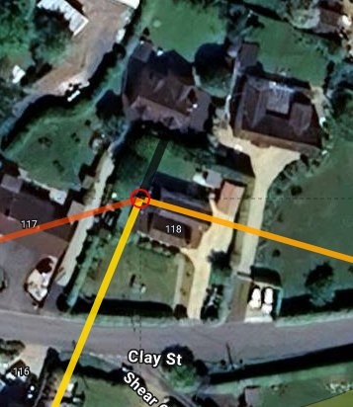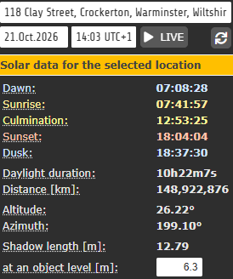

Extract from www.suncalc.org – 21 October 2026

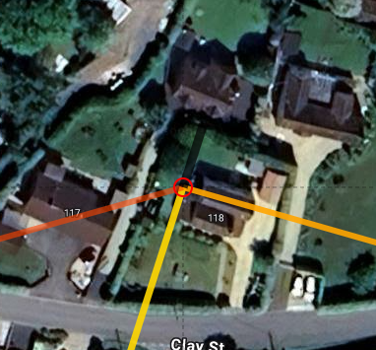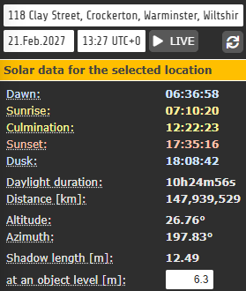

Extract from www.suncalc.org – 21 February 2027

With regard to No. 117 (to the west), the impact would be more limited. The extension would be approximately 7.5 metres from the boundary, and any overshadowing would largely affect the far (northern) end of the rear garden during morning hours only. The main amenity areas, including the immediate patio, would remain unaffected. Any impact would again be most pronounced during the winter months.

While it is acknowledged that there would be some additional overshadowing and reduction in natural light, particularly during the winter, this is not considered to result in unacceptable harm sufficient to warrant refusal. Existing boundary treatments and the current built form already give rise to comparable effects.

Loss of Privacy

The proposal includes a first-floor bedroom window in the rear elevation facing towards No. 117a at a distance of approximately 12.8 metres. This falls below the 20-metre guideline for window-to-window separation distances set out in the Wiltshire Design Guide. In addition, the window would be positioned approximately 0.5–1 metre higher than the corresponding first-floor windows at No. 117a due to the difference in ground levels.

To mitigate potential overlooking, the applicant proposes that this window be obscure glazed. It is also considered reasonable and necessary to secure, by condition, that the window is fixed shut.

While it is generally undesirable to restrict outlook from a principal habitable room, the internal layout has been designed to ensure the bedroom benefits from adequate alternative sources of natural light and outlook (and means of escape). These include two rooflights and a front-facing window. The rooflights are positioned approximately 1.9 metres above floor level, preventing direct views towards neighbouring properties and limiting views to the sky only.

A further condition can reasonably be imposed requiring that, should the position of the rear rooflight be altered, it is installed with a minimum cill height of 1.7 metres above floor level to safeguard against overlooking.

Subject to these conditions, the proposal would not result in unacceptable loss of privacy.

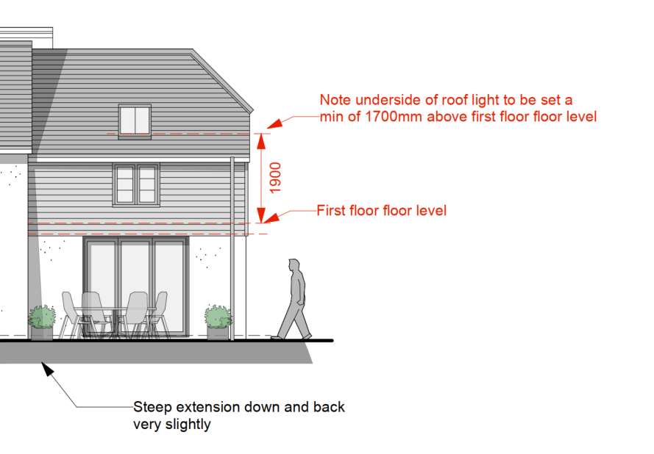

Detailed North (rear elevation plan) confirming height of velux above floor level

Overbearing Impact

Notwithstanding the two-storey scale of the extension and the site’s topography, there remains a sufficient degree of separation between the proposed development and neighbouring properties. The extension would not appear unduly dominant or overbearing when viewed from adjoining sites.

Conclusion on amenity

Overall, while a degree of impact on neighbouring amenity has been identified—particularly in terms of winter overshadowing—this is not considered to be so significant as to warrant refusal. Subject to appropriate conditions, the proposal is considered to accord with Core Policy 57 (criterion vii) of the Wiltshire Core Strategy and the guidance set out in Appendix D of the Wiltshire Design Guide.

Highways Impact

Core Policy 57 (xiv) of the Wiltshire Core Strategy seeks to ensure that development must meet the requirements of Core Policy 61. This policy requires proposals to be capable of being served by safe access to the highway network. Core Policy 64 seeks to ensure compliance with parking standards set out in the Local Transport Plan.

The National Planning Policy Framework (NPPF), particularly Paragraph 115 and 116, requires that development proposals do not have an unacceptable impact on highway safety and that safe and suitable access to the site can be achieved for all users.

The proposed development would not result in any adverse impact on highway safety. Adequate parking and turning provision is provided in accordance with Wiltshire’s adopted parking standards, and access arrangements are acceptable.

The proposal is therefore considered to comply with Core Policies 57 (xiv), 61 and 64 of the Wiltshire Core Strategy, the NPPF, and the Wiltshire Local Transport Plan.

Heritage Impact

The NPPF outlines government policy for planning. Chapter 16 of the NPPF 'Conserving and enhancing the historic environment' sets out the Government's high-level policies concerning heritage and sustainable development.

The Bath Arms is a Grade II listed building; however, it is considered that its setting does not extend to the part of the site affected by this proposal (due to the distance and the proposal being on the opposite side to the listed building). As such, the development would preserve the setting of the listed building and would not result in harm to its historic significance.

The development is therefore considered to comply with Core Policy 58 of the Wiltshire Core Strategy and Section 66 of the Planning (Listed Buildings and Conservation Areas) Act 1990, as well as the relevant provisions of the NPPF.

Ecology Impact

Core Policy 50 of the Wiltshire Core Strategy seeks to protect and enhance biodiversity and geodiversity, including through ensuring that development avoids harm to protected species and habitats.

The National Planning Policy Framework (NPPF), in Paragraphs 193, requires that development minimises impacts on and provides net gains for biodiversity, including ensuring mitigation is secured where harm cannot be avoided.

The Council’s Ecology Officer has not been consulted on this application, but the application site is within the 6.4km zone of influence of the Salisbury Plain SPA and in light of the HRA for the Wiltshire Core Strategy and the HRA for the Wiltshire Housing Site Allocations Plan it is screened into Appropriate Assessment due to the potential impact of recreational pressure on stone curlew in combination with other plans and projects.

A strategic Appropriate Assessment (AA) has been prepared pertaining to development within the 6.4 km zone of influence that could result in a likely significant effect on the SPA as a result of an increase in recreational / visitor pressure. The AA reached a conclusion of no adverse effects on the integrity of the SPA or its qualifying features provided that the council’s mitigation strategy continues to be implemented. Annual stone curlew monitoring and protection measures continue to be secured by the Council.

In January 2026 Natural England (NE) confirmed that the 2025 strategic AA for Salisbury Plain SPA continues to be supported by NE.

Having undertaken an Appropriate Assessment as the competent authority, and having regard to the Council’s adopted mitigation strategy, the Local Planning Authority is satisfied that the proposal, alone and in combination with other plans and projects, would not result in an adverse effect on the integrity of the Salisbury Plain Special Protection Area.

National Landscape

Core Policy 51 of the Wiltshire Core Strategy requires all development to protect, conserve, and where possible enhance the character and quality of Wiltshire’s landscapes, giving particular weight to designated areas such as National Landscapes.

The National Planning Policy Framework (NPPF), in Paragraph 176, states that “great weight” should be given to conserving and enhancing landscape and scenic beauty in National Landscapes (formerly Areas of Outstanding Natural Beauty). Development within or affecting the setting of a National Landscape must demonstrate that it will not result in unacceptable harm to the special qualities of that area.

The proposal, by virtue of its scale, siting, and design, would not harm the special qualities or scenic character of the Cranborne and Chase and West Wiltshire Downs National Landscape.

The development therefore complies with Core Policy 51 of the Wiltshire Core Strategy and Paragraph 176 of the NPPF in conserving and enhancing the National Landscape.

Drainage and Flood Risk

The application site is within flood zone 1 but is within the second highest risk category of ground water flooding and in accordance with the Council’s 2019 and 2024 Strategic flood risk assessments (SFRA) the site cannot be considered to be at a low risk of flooding.

However, paragraph 176 of the NPPF states;

“Applications for some minor development and changes of use⁶² should also not be subject to the sequential test, nor the exception test set out below, but should still meet the requirements for site-specific flood risk assessments set out in footnote⁶³.

⁶² This includes householder development

⁶³ A site-specific flood risk assessment should be provided for all development in Flood Zones 2 and 3. In Flood Zone 1, an assessment should accompany all proposals involving: sites of 1 hectare or more; land which has been identified by the Environment Agency as having critical drainage problems; land identified in a strategic flood risk assessment as being at increased flood risk in future; or land that may be subject to other sources of flooding, where its development would introduce a more vulnerable use.”

This is a householder application and therefore footnote 62 applies (excluding the need for the sequential test) and the site is not within flood zone 2 and 3. However, as the site is within flood zone 1 and the SFRA shows this site to be in a high risk of ground water flooding, a site specific flood risk assessment is required.

The applicants have submitted the Council’s Flood Risk Assessment form indicating that ‘option 1’ is to be used – ensuring that ground levels of the extension will not be below existing ground level and that all electrical sockets will be 400mm above floor level and they will use flood resilient materials.

Officers consider that the submitted Flood Risk Assessment is sufficient and therefore the risk of ground water can be effectively managed.

Biodiversity Net Gain

Householder planning applications are exempt from the requirement to deliver Biodiversity Net Gain under Schedule 7A, Section 4(2)(a) of the Town and Country Planning Act 1990, as inserted by the Environment Act 2021.

CONCLUSION

In undertaking the planning balance, it is acknowledged that the proposal would result in some harm, notably through the further erosion of the building’s original form and a degree of additional overshadowing to neighbouring properties during winter months. However, these impacts are limited in extent, mitigated by design measures and site context, and do not give rise to unacceptable harm. These factors are weighed against the acceptable design response in a constrained and already altered context, the limited visual impact within the wider street scene, and the absence of harm in respect of highways, heritage, ecology and landscape. On balance, the proposal is considered acceptable.

The proposed development is considered to be acceptable in terms of its design, scale, and relationship with the surrounding area. It would not result in any unacceptable harm to the character of the locality, the amenities of neighbouring occupiers, or the interests of highway safety, heritage, or ecology.

The proposal is therefore considered to comply with the relevant policies of the Wiltshire Core Strategy, the Wiltshire Local Plan, and the National Planning Policy Framework. As such, the application is recommended for approval, subject to the conditions set out below.

RECOMMENDATION: That Planning Permission be GRANTED subject to conditions.

