CASE OFFICER'S REPORT

Application Reference: | PL/2026/01665
Application Type: | Removal/variation of conditions
Consultation ends: | 17 April 2026
Case officer: | Steven Sims

Site Address: | Rose Villa, 79 High Street, Dilton Marsh, Westbury, BA13 4DP
Proposal: | Vary Condition 2 and 4 on PL/2024/10578 - Single-storey utility room addition, a two-storey eastern extension with living and dining rooms, a kitchen/breakfast room, a master bedroom with en-suite, and a single-storey kitchen extension. Additionally, a double garage will be constructed on the western edge of the property
Recommendation: | Approve with Conditions

SITE DESCRIPTION/CONTEXT

The main property is a detached 2 storey dwelling located within the settlement limits of Dilton Marsh. Existing residential development is located to the east, south and west. Residential garden and open fields lie to the north. The site is bordered by fencing and hedgerows.

The adjacent residential property to the northeast (73 and 75, St Marys Lane) is a grade II listed building. The site is located within the Salisbury Plain Special Protection Area (SPA) and within the Bath & Bradford on Avon Special Area of Conservation (SAC). The yellow zone (medium risk for habitat loss) of the Trowbridge Westbury Bat Mitigation Strategy (TWBMS) is located directly to the north of the application site. The site is located in flood zone 1 and is not subject to high levels of surface water or groundwater flooding.

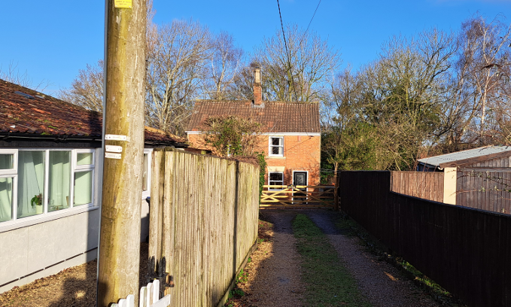
Existing dwelling and access drive off High Street

PROPOSAL

This application seeks amendments to approved scheme PL/2024/10578 for extensions to 79 High Street and erection of a garage. Proposed alterations to the approved scheme include –
- Marginal increase (approx. 2 metres) in the length of the proposed ground floor rear/ side extension to provide additional breakfast room, kitchen and utility room space
- Additon of a first floor window to serve bedroom 1 in the east elevation (to be obscurely glazed)
- Addition of ground floor side elevation windows to the living/ dining rooms
- Rooflights to the ground floor rear extension
- Change of material finish to the single storey extension including the use of standing seam metal roofing and timber cladding

Revised plans submitted have reverted the garage design to that previously approved under application PL/2024/10578.

The addition of the cat slide roof to the rear/ side ground floor extension will result in removal of the rear balcony off bedroom 1 approved under PL/2024/10578.

As detailed in the following plans.

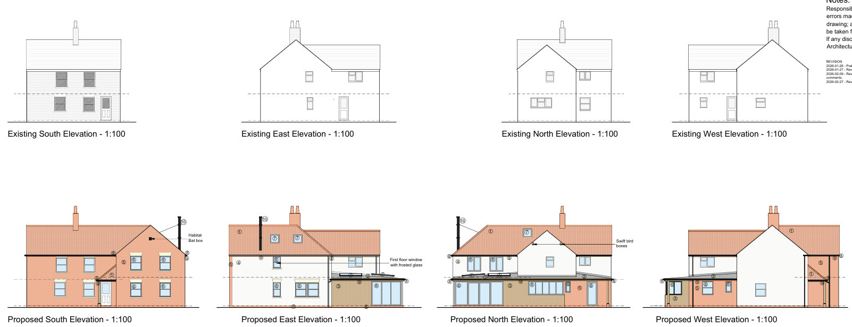

Existing/ proposed elevations

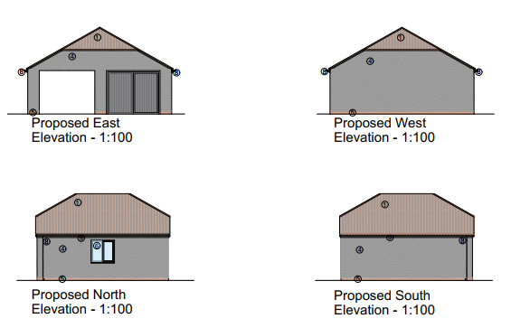

Proposed garage

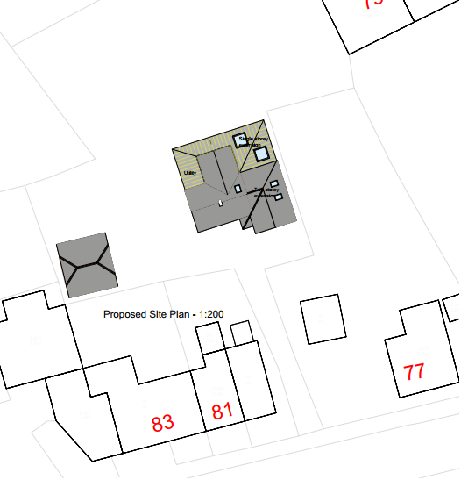
Proposed site plan

PLANNING HISTORY

PL/2024/10578 – Single-storey utility room addition, a two-storey eastern extension with living and dining rooms, a kitchen/breakfast room, a master bedroom with en-suite, and a single-storey kitchen extension. Additionally, a double garage will be constructed on the western edge of the property. – Approved

W/83/00872/FUL – Two storey extension – Approved

RELEVANT POLICIES AND GUIDANCE

Wiltshire Core Strategy (WCS):
- Core Policy 50: Biodiversity and Geodiversity
- Core Policy 51: Landscape
- Core Policy 57: Ensuring High Quality Design and Place Shaping
- Core Policy 58: Ensuring the Conservation of the Historic Environment
- Core Policy 61: Transport and New Development
- Core Policy 64: Demand Management

Dilton Marsh Neighbourhood Plan 2020-2038 (made Sept 2025)
Wiltshire Design Guide: Appendix D – Design Guidance for Householder extensions
The National Planning Policy Framework (NPPF)
The Planning Practice Guidance
National Design Guide

CONSULTATION RESPONSES

Dilton Marsh Parish Council: No objection

Highways Team: No objection

Drainage Team: No objection

REPRESENTATIONS

None received

ASSESSMENT

Section 38(6) of the Planning and Compulsory Purchase Act 2004 states:

"If regard is to be had to the development plan for the purposes of any determination to be made under the planning Acts, the determination must be made in accordance with the plan unless material considerations indicate otherwise."

In accordance with this statutory requirement, this application has been assessed against the relevant policies of the Development Plan, including the adopted Wiltshire Core Strategy (2015) and, where applicable, any made Neighbourhood Plans.

Principle of development

The principle of development of the site and extending the existing dwelling and erecting the garage was established under application PL/2024/10578.

Design and Impact upon the upon the character and context of the area

Core Policy 57 - Ensuring High Quality Design and Place Shaping of the Wiltshire Core Strategy seeks to ensure that all new development is of high design quality, reflecting local context, character, and distinctiveness.

The application site is located within a mainly residential area of Dilton Marsh. Residential development in the area is characterised by terraced, semi-detached and detached 2 storey dwellings of a variety of design and styles with varying garden sizes.

The site is set back from the highway with access via a private driveway. As such much the proposed 2 storey side extension and ground floor extensions and double garage would not be visible from the highway.

The proposed design of the extensions and garage are considered acceptable. External materials proposed (red brick, white render, timber cladding and clay tiles) are also acceptable in this in this location.

The footprint to the dwelling would be doubled by the addition of extensions. However, the application site is extensive as detailed in the block plan above and as such the development would not result in a scheme that is considered overdevelopment of the site.

Officers therefore have no concerns about the design of the proposed extensions and garage and have concluded that the development would assimilate well within the site and its surroundings, and would have no adverse impact on the character of the area.

Having regard to the above, the proposed revision to the original scheme comply with the design principles set out in Core Policy 57 of the Wiltshire Core Strategy and Appendix D of the Wiltshire Design Guide.

Amenity

Point vii of Core Policy 57 - Ensuring High Quality Design and Place Shaping of the Wiltshire Core Strategy seeks to ensure that developments do not adversely affect neighbouring properties.

The National Planning Policy Framework (NPPF), particularly Paragraph 135(f), stresses that planning decisions should ensure developments provide a high standard of amenity for existing and future users.

The proposed development has been assessed in terms of its potential impact on the residential amenity of neighbouring properties, with particular regard to loss of light, overshadowing, loss of privacy, and overbearing effects.

Due to the separation distance between the application site and neighbouring dwellings the development, and in particular the 2 storey extension, would not result in harmful loss of light / overshadowing impacts on neighbouring residents.

It is recognised that the erection of the 2 storey extension would result in some loss of light/ overshadowing impacts on a section of the rear garden of No. 77 High Street, in particular during the later part of the day as the Sun moves east to west, however it is considered this impact would not be sufficiently harmful to warrant a recommendation for refusal.

Although the proposed 2 storey extension would be located relatively close to the boundary of No. 77 High Street, and the scheme would have some overbearing impact on part of the rear garden area of No. 77, due to the limited area of garden the development would impact, it is not considered the extension would cause the level of harm sufficient to warrant a recommendation for refusal.

A condition will be imposed, requiring the proposed first floor east elevation window that serves bedroom 1 to be obscurely glazed.

The proposed additional ground floor east elevation windows will not result in additional overlooking/ loss of privacy to neighbouring residents, in particular residents at No. 77, because of the existing boundary treatment that consists of a 6ft high fence and hedge.

It should be noted the rear garden of No. 77 is already overlooked to some degree by existing first floor side windows, as such the development would not result in additional overlooking/ loss of privacy towards residents of No. 77 High Street.

The proposed 2 storey side extension would sit further forward of the existing front elevation of the dwelling by approx. 3 metres, however this would mainly result in additional overlooking of the side garden/ garage/ driveway of No. 77 High Street, and as such would not result in additional harm to the living conditions of occupants of No. 77. In addition, due to the oblique angle of views from the first floor south facing windows of the extension, the development would not result in additional harmful overlooking of the rear garden area of No. 81 High Street.

The addition of the ground floor extensions and erection of the garage, due to their location, would have no adverse impact on the amenity of adjacent residents in terms of overlooking/ loss of privacy and loss of light/ overshadowing impacts.

The proposed amendments therefore accord with Core Policy 57 point vii in respect of safeguarding residential amenity and Appendix D of the Wiltshire Design Guide.

Highways Impact

Core Policy 57 (xiv) of the Wiltshire Core Strategy seeks to ensure that development must meet the requirements of Core Policy 61. This policy requires proposals to be capable of being served by safe access to the highway network. Core Policy 64 seeks to ensure compliance with parking standards set out in the Local Transport Plan.

The National Planning Policy Framework (NPPF), particularly Paragraph 115 and 116, requires that development proposals do not have an unacceptable impact on highway safety and that safe and suitable access to the site can be achieved for all users.

The proposed revised scheme would result in the formation of a 4 bed property as per approved application PL/2024/10578 and the need for 3 off road parking spaces remains. It is considered that adequate car parking and turning provision is available within the site and there are no objections to the development from the council’s highways officer.

The proposed development would not result in any adverse impact on highway safety. Adequate parking and turning provision is provided in accordance with Wiltshire’s adopted parking standards, and access arrangements are acceptable. The proposal is therefore considered to comply with Core Policies 57 (xiv), 61 and 64 of the Wiltshire Core Strategy, the NPPF, and the Wiltshire Local Transport Plan.

Heritage Impact

From the point of view of the historic environment the main statutory tests are set out within the Planning (Listed Building and Conservation Areas) Act 1990. Section 66 requires that special regard be given to the desirability of preserving listed buildings, their settings or any features of special architectural or historic interest which they possess.

The Council’s Core Strategy Policy CP58 ‘Ensuring the conservation of the historic environment’ requires that designated and non-designated heritage assets and their settings will be conserved, and where appropriate enhanced.

The NPPF outlines government policy for planning. Chapter 16 of the NPPF 'Conserving and enhancing the historic environment' sets out the Government's high-level policies concerning heritage and sustainable development.

The grade II listed 73 and 75, St Marys Lane is located approx. 20 metres to the northeast of the existing dwelling. Although the listed building is located in close proximity to the development and the 2 storey side extension would bring the building closer to the listed building, the design of the extension is considered acceptable and as such it is considered the development would cause no harm to the setting of the listed asset.

The proposal, by virtue of its scale, design, and use of materials, is considered to preserve the setting of the listed building and it would not result in harm to the significance of any heritage assets. The development is therefore considered to comply with Core Policy 58 of the Wiltshire Core Strategy and Sections 66 and 72 of the Planning (Listed Buildings and Conservation Areas) Act 1990, as well as the relevant provisions of the NPPF.

Ecology Impact

Core Policy 50 of the Wiltshire Core Strategy seeks to protect and enhance biodiversity and geodiversity, including through ensuring that development avoids harm to protected species and habitats.

The National Planning Policy Framework (NPPF), in Paragraphs 193, requires that development minimises impacts on and provides net gains for biodiversity, including ensuring mitigation is secured where harm cannot be avoided.

Application PL/2024/10578 was accompanied by a Preliminary Bat Roost Assessment dated March 2025 and a Bat Survey dated July 2025. Although no further assessment has been provided with the current scheme, it is considered the July 2025 assessment is still relevant in this case.

The application site is located within a 4km Core Roost Buffer consultation zone for greater horseshoe bats associated with the Bath & Bradford on Avon Bats Special Area of Conservation (SAC) and therefore has potential to result in significant adverse impact on the special features of that site. Appropriate Assessment (AA) under Section 63 of the Conservation of Habitats and Species Regulations 2017 (as amended) must be carried out by the relevant Competent Authority (the LPA) to determine the potential significant effects and the suitability of any measures proposed to avoid or mitigate those effects.

The Preliminary Bat Roost Assessment (March 2025) submitted under application PL/2024/10578 reports that although part of the roof space in the dwelling was inaccessible, there is no direct flight access into the roof spaces for greater horseshoe bats. Therefore, any impact on this SAC feature is unlikely.

A test of likely significance has been carried out by the relevant Competent Authority (Wiltshire Council) as required by Regulation 63 of the Conservation of Habitats and Species Regulations 2017 (as amended). This concluded that given the scale and nature of the development, there is no mechanism for adverse effect. The HRA has concluded that the application is not likely to have significant impacts on the SAC and subsequently the application is screened out of Appropriate Assessment.

Based on the information available the biodiversity gain planning condition is not considered to apply to this application as the application is for development which is subject of a householder application within the meaning of article 2(1) of the Town and Country Planning (Development Management Procedure) (England) Order 2015.

As such, the development complies with Core Policy 50 of the Wiltshire Core Strategy and the relevant provisions of the NPPF.

Conditions

Condition 1 is to be revised accordingly to reference the starting date.

Condition 2 (plans) will be amended accordingly.

Condition 3 (materials to match) is not considered necessary as the plans to be approved detail proposed materials.

Condition 4, requiring details of a balcony screen, will be removed as it is no longer considered necessary.

Conditions 5 and 6 will remain.

A new condition will be imposed, requiring the proposed first floor east elevation window that serves bedroom 1 to be obscurely glazed.

CONCLUSION

The proposed development is considered to be acceptable in terms of its design, scale, and relationship with the surrounding area. It would not result in any unacceptable harm to the character of the locality, the amenities of neighbouring occupiers, or the interests of highway safety, heritage, or ecology.

The proposal is therefore considered to comply with the relevant policies of the Wiltshire Core Strategy, the Wiltshire Local Plan, and the National Planning Policy Framework. As such, the application is recommended for approval, subject to the conditions set out below.

RECOMMENDATION: That Planning Permission be GRANTED subject to conditions

