Design and Access Statement
1.0 Description of development
The replacement of an existing non-mains sewerage system with a small sewage treatment plant (STP), with a treatment efficiency for Total Phosphorus removal of at least 5 mg/l without chemical dosing, including the installation of associated pipes, cables, vents, ducts, manholes or kiosks, and alongside ancillary engineering operations.
Location – 1 & 2 Field Cottages
Location and site plans are included in the submission.

2.0 Need
Nutrient pollution is a big environmental issue for many of our most important places for nature in England. In rivers and estuaries, increased levels of nutrients (especially nitrogen and phosphorus) can harm wildlife. These nutrients are affecting the condition of internationally protected rivers, such as the River Avon Special Area of Conservation (SAC).
The River Avon has been identified as a phosphorus sensitive catchment. The Secretary of State, in accordance with the power in Section 96C of the Water Industry Act 1991 to designate catchment areas as sensitive for phosphorus or nitrogen where a habitats site is wholly or partly in England is considered in an unfavourable condition by virtue of pollution from nutrients in water from one or both of those nutrients.
A Local Development Order - Upgrading septic tanks and small treatment plants in the River Avon catchment has been adopted to help expedite the roll-out of nutrient mitigation schemes including non-mains drainage improvements in the River Avon catchment (Figure 1).
The Local Development Order (LDO) grants planning permission for the replacement of septic tanks and small sewage treatment plants on individual properties with more efficient systems small sewage treatment systems. The adopted Local Development Order is included as Appendix 1.
Some projects fall outside of the scope of the Local Development Order because of constraints with the site location (Figure 2). A separate planning application is required to ensure further consideration of the constraints and this is the case with this application.
This project is being delivered as part of the nutrient mitigation scheme for the River Avon catchment and the conditions and informatives included in Figure 3 are relevant in this case.

Figure 1 – Map of Local Development Order Area
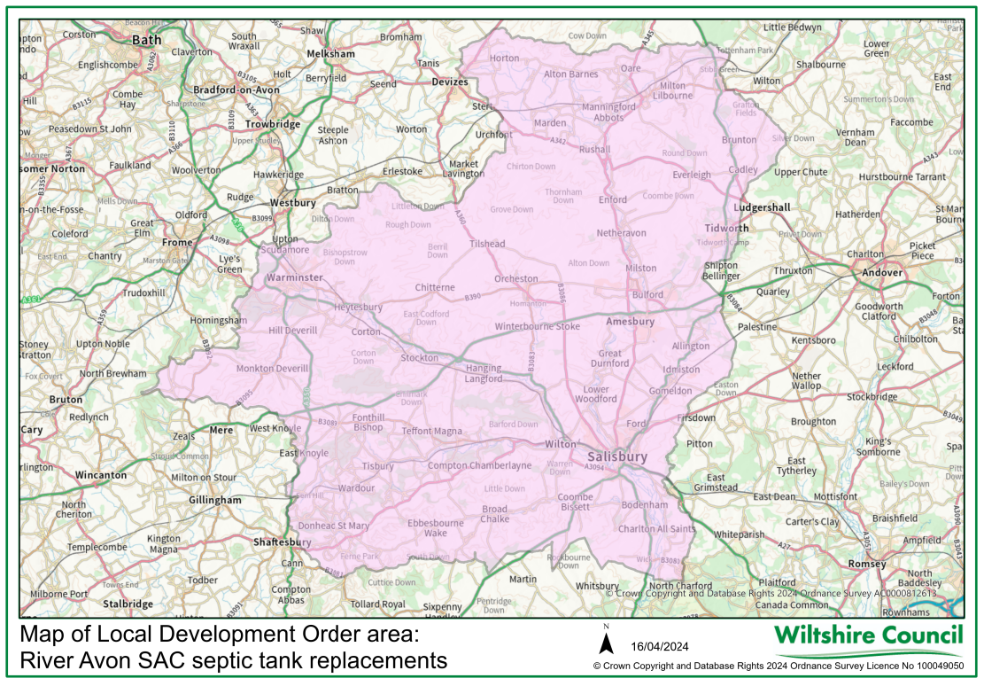
Figure 2 – LDO Constraints
Constraints - Development not permitted if:
- The boundary of the premises that the system serves is within 30 metres of a public foul sewer.
- Is in a European protected site or affects functionally linked habitat.
- Is in a site of special scientific interest (SSSI)
- The development is in or likely to affect groundwater in source protection zones 1 and 1c
- Any part of the development would be within 20m of a main river.
- Any part of the development would be within flood zone 2, 3 or 3b or requires a flood risk assessment in line with the requirements of the National Planning Policy Framework and with reference to the Council’s Level 1 Strategic Flood Risk Assessment.
- The development would be situated within the curtilage of a listed building.
- The development would be situated within an area of high archaeological and heritage sensitivity.
- The development includes land potentially affected by contamination from a previous activity or pollution incident.
- The development is within 5m of the strategic highway boundary.

Figure 3 Local Development Order Conditions and Informatives
For information the following conditions and informatives are secured to the Local Development Order and should be considered in this case to ensure consistency. Conditions 2 and 3 are essential conditions to ensure that nutrient treatment standards are secured into the future.
Conditions
The following conditions apply to all small sewage treatment plants permitted under but not limited to this LDO:
- Proposals are only be deemed LDO compliant subject to the submission and subsequent local planning authority approval of the details in writing.
- The plan must show the proposed location of the small sewage treatment plant in relation to the site boundaries, other existing buildings or constraints on the site.
- The plan must show the location of the discharge point or drainage field
- The model of the small sewage treatment plant installed
- The British Water, or equivalent, accreditation certificate for the system
- The small sewage treatment plant and drainage field shall be installed, maintained and operated without chemical dosing in accordance with the submitted specification and details hereby approved.
- Future replacements of the system shall have an equivalent treatment efficiency of at least 5 mg/l for Total Phosphorus removal, and must meet requirements of relevant planning and environmental legislation.
- Should the treatment system no longer be required or becomes obsolete, it must be removed within 6 calendar months unless otherwise agreed with local planning authority.
- Any land affected by the works must be reinstated to its previous condition, as far as reasonably possible, unless written confirmation to the contrary is provided by the Local Planning Authority.
- Within 30 days of the development being completed, the developer or land owner must provide written notification to the LPA, this must include photographic evidence of the completed works and development site.
Reason
To ensure the protection and improvement of the phosphorus sensitive catchment

Informatives
The following informatives apply to all proposals permitted under the LDO:
- The planning permission under this Order is based on the information submitted with the application. If this information is found to be incorrect, the proposal would no longer be permitted under the LDO and any approval given would be null and void. A full planning application would then be required to regularise the development.
- Non Mains Drainage: Primary responsibility for ensuring sewage systems for new developments are adequate lies with the Building Control Department.
- Consent under the Building Regulations is likely to be required in most cases. Further details on the Building Regulations can be obtained from the Wiltshire Council Building Control Service.
- An installation of a package treatment plant (PTP) needs to meet the requirements of the General Binding Rules, or if an environmental permit is required, ensure it is in line with any approved permit
- Other environmental permissions may be required.
- Applicants should understand whether they could form part of a sewerage undertaker’s legal duty (Wessex Water in this instance) to build and pay for a new sewer to connect a number of neighbouring properties (known as first time sewerage).
- An asset register will be used to record installations in the catchment.
- Before carrying out any tree work you must check if a tree is covered by a Tree Preservation Order (TPO), Conservation Area, or through another form of protection and appropriate action taken accordingly.
- Any outfall to the Kennet & Avon Canal, regardless of the need for planning permission or otherwise, will require a licence from the Canal & River Trust as well as the Environment Agency.
- Pollution Prevention During Construction Safeguards should be implemented during the construction phase to minimise the risks of pollution from the development. Such safeguards should cover: • the use of plant and machinery • oils/chemicals and materials • the use and routing of heavy plant and vehicles • the location and form of work and storage areas and compounds • the control and removal of spoil and waste
- The Environmental Permitting (England & Wales) Regulations 2016 make it an offence to cause or knowingly permit a groundwater activity unless authorised by an environmental permit which the Environment Agency will issue. A groundwater activity includes any discharge that will result in the input of pollutants to groundwater.
- The discharge of domestic sewage associated with a development may require an environmental permit under the Environmental Permitting (England & Wales) Regulations 2016, from the Environment Agency, unless an exemption applies. The End 2 applicant is advised to contact the Environment Agency on 03708 506 506 for further advice and to discuss the issues likely to be raised. You should be aware that there is no guarantee that a permit will be granted. Additional ‘Environmental Permitting Guidance’ can be found at: https://www.gov.uk/environmental-permit-check-if-you-need-one.
- The discharge of domestic sewage associated with a development may be subject to General Binding Rules under the Environmental Permitting (England & Wales) Regulations 2016 which provide a statutory baseline of good practice. You can find more information online at https://www.gov.uk/permits-you-need-for-septic-tanks/permits or contact the Environment Agency on 03708 506506.

3.0 Project details
Proposed works
The existing septic tank lies within land ownership of #2 Field Cottages. This tank will be decommissioned but retained in situ. Effluent will be diverted from the outlet of the septic tank through new gravity pipework to a new STP installed in the rear garden of #1 Field Cottages.
Treated discharge from the new STP will be pumped to a newly installed sample chamber and then drain through a new seasonal soakaway with a final outlet to the seasonal ditch to the northeastern boundary of #1 Field Cottages.
The new STP (WTE Vortex 12 person system) will serve both properties.
Site location
This project does not comply with the adopted Local Development Order as the new STP serves more than one property.
Archaeological sensitivities
As part of the Revamp the Tank programme of works, all project locations are screened by the Wiltshire Council archaeological department.
No archaeological sensitivities have been identified with this project.
Biodiversity Net Gain
This is a full planning application, therefore details of habitat impact is provided below. This information demonstrates that the proposal is exempt from demonstrating biodiversity net gain as it falls below the de minimis threshold of impacting less than:
- 25 square metres (5m by 5m) of on-site habitat
- 5 metres of on-site linear habitats such as hedgerows
There may be machinery tracking across the areas around the installation, but the contractors will be using mats to prevent any damage.
Habitat type | Manmade | Grass | Shrubs | Hedge | Garden flower beds
No. square metres impacted by any works | N/A | 12.4 | 0.6 | N/A | N/A

4.0 Summary
This project is being delivered as part of the nutrient mitigation scheme for the River Avon catchment and the conditions and informatives included in Figure 3 are relevant in this case. The Local Development Order does not apply due to constraints and the following further information has been submitted to support this planning application.
- Location Plan and Site Plan
- Application form
- LDO Appendix
- Contractor Survey Report
- Contractor Quote (confidential)
- Sewage Treatment Plant Data sheet and Sales Drawing
- Design and Access Statement

