APPLICATION FOR HOUSEHOLDER PLANNING PERMISSION
DELEGATED REPORT

APPLICATION REFERENCE: | PL/2026/01044
APPLICATION TYPE: | Householder planning permission
SITE ADDRESS: | 233 Quemerford, Calne, SN11 8LA
DEVELOPMENT DESCRIPTION: | Single story rear extension
RECOMMENDATION: | That Planning Permission be GRANTED

SITE DESCRIPTION/CONTEXT
The subject property is a detached C20 dormer bungalow on the north side of the A4, on its approach to Quemerford village which is itself southeast of Calne.

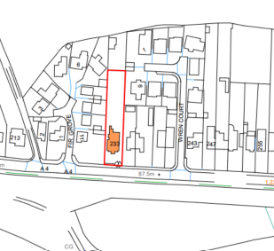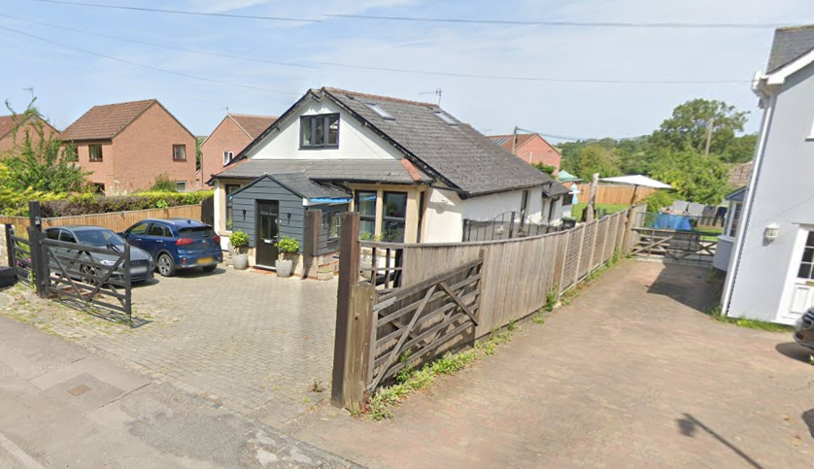
Location Plan and Google Earth Site Photo

The property sits between Fir Grove and Wren Court; both C20 modern developments. The property reads as infill between these modern developments as it is of a noticeably different form, scale and character from its immediate neighbours. Historic maps confirm it was built pre-1950 alongside the first of the modern development on this section of the village.

PROPOSAL

The proposal seeks planning permission to demolish attached rear structures and replace with a single storey with attics, rear extension. On the ground floor this would enable the creation of a larger kitchen/dining space and an additional bedroom. On the first floor, would be an additional bedroom, turning the property from a 3-bed to a 5-bed property.

Associated internal reconfiguration includes:
- New Staircase
- Division of Living Room to create an ensuite/new doorway
- Removal of partitions/WC
- Additional rooflights and bifold doors to the rear

Proposed materials include render, slate tiles, and DG windows, all to match existing.

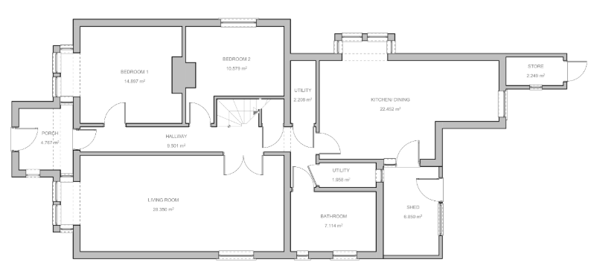

Existing Ground Floor Plan

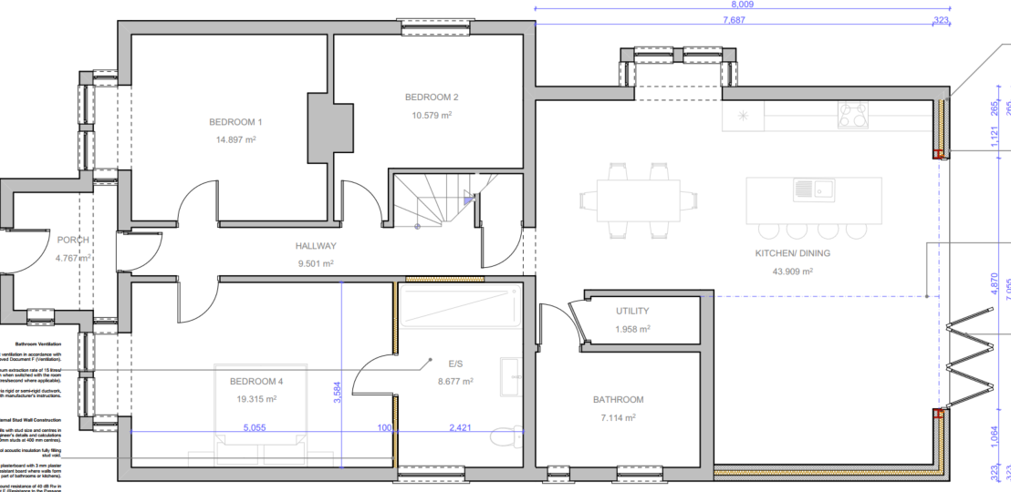

Proposed Ground Floor

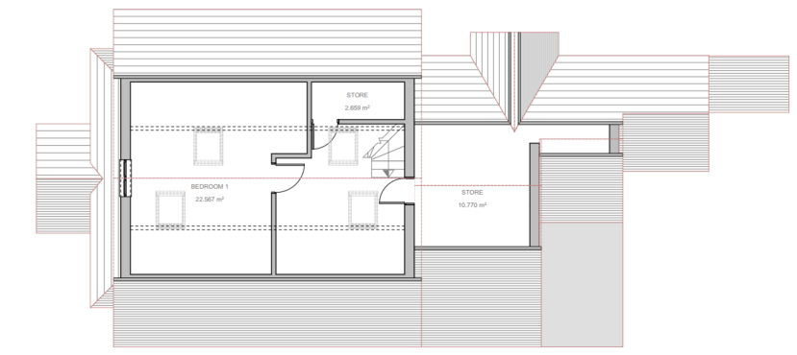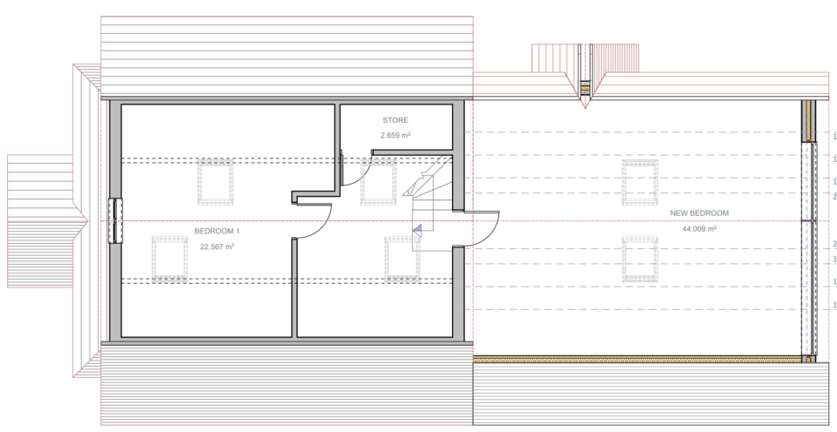

Existing and Proposed First Floor Plan

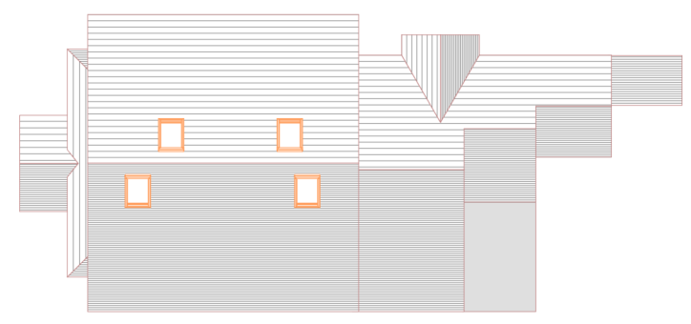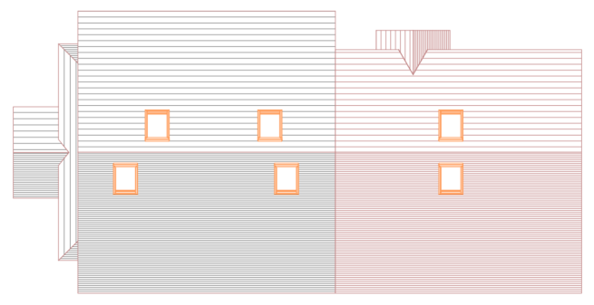

Existing and Proposed Roof Plan

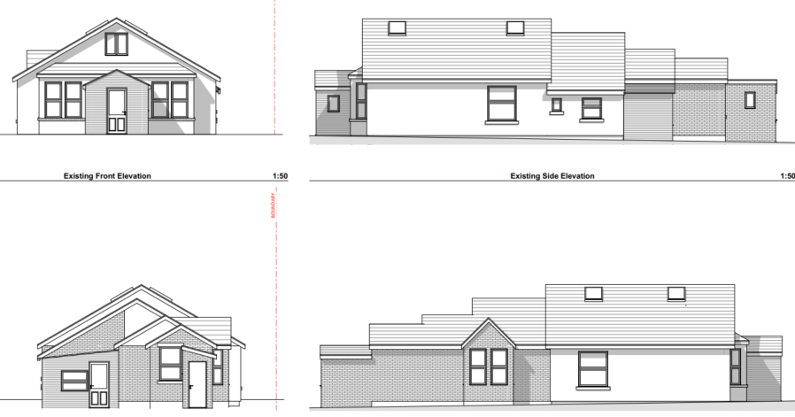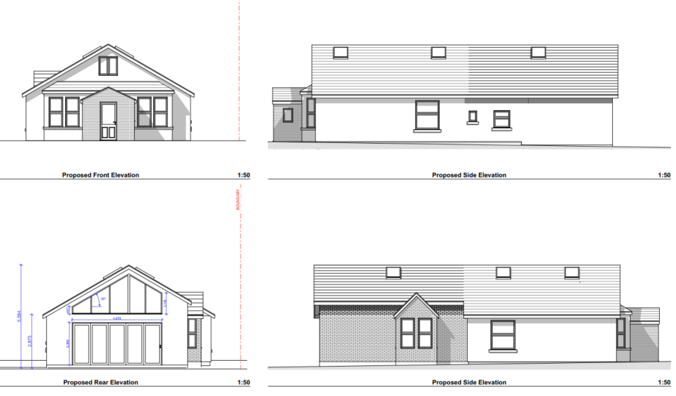

Existing and Proposed Front Elevation – no change

Existing and Proposed Side (W) Elevation

Existing and Proposed Side (E) Elevation

Existing and Proposed Rear Elevation

PLANNING HISTORY
ENF/2025/01102 – alleged unauthorised shed and small animal business sheds and spotlight

RELEVANT POLICIES AND GUIDANCE
The National Planning Policy Framework (NPPF)
The Planning Practice Guidance
National Design Guide
Wiltshire Design Guide: Appendix D – Design Guidance for Householder extensions

Wiltshire Core Strategy:
- Core Policy 57 Ensuring High Quality Design and Place Shaping
- Core Policy 61: Transport and New Development
- Core Policy 64: Demand Management

Quemerford is not within a designated Neighbourhood Plan Area.
Wiltshire Local Transport Plan 2011-2026, Car Parking Strategy

CONSULTATION RESPONSES
Calne Town Council: No objection.
Highways: No objection, subject to conditions.

REPRESENTATIONS
No comments were received.

ASSESSMENT

Principle of Development:
Section 70(2) of the Town and Country Planning Act 1990 and section 38(6) of the Planning and Compulsory Purchase Act 2004, require that the determination of planning applications must be made in accordance with the Development Plan, unless material considerations indicate otherwise.

The proposal comprises development to an existing residential property set in an established residential area within the settlement boundary of Calne. The proposal is wholly within the residential curtilage, and as such, the principle of development is acceptable subject to the following considerations.

In accordance with this statutory requirement, this application has been assessed against the relevant policies of the Development Plan, including the adopted Wiltshire Core Strategy (2015) and, where applicable, any made Neighbourhood Plans.

Design and Impact upon the character and context of the area
Core Policy 57 - Ensuring High Quality Design and Place Shaping of the Wiltshire Core Strategy seeks to ensure that all new development is of high design quality, reflecting local context, character, and distinctiveness.

The proposal is a considered redevelopment and refinement of various single storey extensions, demolishing and replacing with a simple single massing, all to the rear of the property. Proposals would not impact the front elevation.

Design details, scale and materiality will help to integrate the extension with the host dwelling, maintaining existing building lines and single roof form.

The proposal, by virtue of its scale, design, and use of materials, is considered to preserve the character and appearance of the area.

Having regard to the above, the proposal complies with the design principles set out in Core Policy 57 of the Wiltshire Core Strategy and Appendix D of the Wiltshire Design Guide.

Amenity
Point vii of Core Policy 57 - Ensuring High Quality Design and Place Shaping of the Wiltshire Core Strategy seeks to ensure that developments do not adversely affect neighbouring properties.

The National Planning Policy Framework (NPPF), particularly Paragraph 135(f), stresses that planning decisions should ensure developments provide a high standard of amenity for existing and future users.

The proposed development has been assessed in terms of its potential impact on the residential amenity of neighbouring properties, with particular regard to loss of light, overshadowing, loss of privacy, and overbearing effects.

The dwelling is a bungalow surrounded by 2-storey dwellings each within spacious plots. As a single storey extension, with attics, the proposal does not cause concerns with overshadowing or overbearing.

Two additional rooflights are proposed, close to the roof ridge, and at this height, raise no concerns regarding privacy.

The rear extension would benefit from additional large-scale glazing overlooking the long rear garden and as such cause no concerns to neighbouring or occupant privacy.

The proposal therefore accords with Core Policy 57 point vii in respect of safeguarding residential amenity and Appendix D of the Wiltshire Design Guide.

Highways Impact
Whilst CP61 looks to ensure consideration has been given to the needs of all transport users, CP64 looks to secure measures to reduce reliance on the car by imposing residential parking standards.
The Wiltshire Local Transport Plan, Car Parking Strategy dictates minimum parking standards and encourages on-site provision. The proposal for a 4+ bedroom dwelling requires 3 off-street parking spaces.

The National Planning Policy Framework (NPPF), particularly Paragraph 115 and 116, requires that development proposals do not have an unacceptable impact on highway safety and that safe and suitable access to the site can be achieved for all users.

The proposal seeks to increase the number of bedrooms from 3 to 5 so raising potential parking demands. There are no proposals to alter the access to the public highway.

Additional information was submitted in response to requests from WCC Highways to demonstrate that the parking area to the front of the property can accommodate 3 spaces in line with minimum standards for residential development. Submitted swept path analysis shows that manoeuvring space is available on site such that all vehicles can access and exit in a forward gear.

The proposed development would not result in any adverse impact on highway safety. Adequate parking and turning provision is provided in accordance with Wiltshire’s adopted parking standards, and access arrangements are acceptable.

The proposal is therefore considered to comply with Core Policies 57 (xiv), 61 and 64 of the Wiltshire Core Strategy, the NPPF, and the Wiltshire Local Transport Plan.

Biodiversity Net Gain
Householder planning applications are exempt from the requirement to deliver Biodiversity Net Gain under Schedule 7A, Section 4(2)(a) of the Town and Country Planning Act 1990, as inserted by the Environment Act 2021.

CONCLUSION
The proposed development is considered to be acceptable in terms of its design, scale, and relationship with the surrounding area. It would not result in any unacceptable harm to the character of the locality, the amenities of neighbouring occupiers, or the interests of highway safety.

The proposal is therefore considered to comply with the relevant policies of the Wiltshire Core Strategy, the Wiltshire Local Plan, and the National Planning Policy Framework. As such, the application is recommended for approval, subject to conditions.

RECOMMENDATION: That Planning Permission be GRANTED subject to conditions.

