APPLICATION FOR HOUSEHOLDER PLANNING PERMISSION DELEGATED REPORT
APPLICATION REFERENCE: | PL/2026/02139
APPLICATION TYPE: | Householder planning permission
SITE ADDRESS: | 40 Beaulieu Road, Amesbury, Salisbury, SP4 7PD
DEVELOPMENT DESCRIPTION: | Replacing original living room window with a bay window.
RECOMMENDATION: | That Planning Permission be GRANTED

PROPOSAL

The proposal seeks planning permission for the replacement of an existing living room window on the front elevation of the existing dwelling with a bay window.

Existing and proposed elevations including a photo of the front of the pair of semi-detached dwellings – 40 and 38 Beaulieu Road included below.

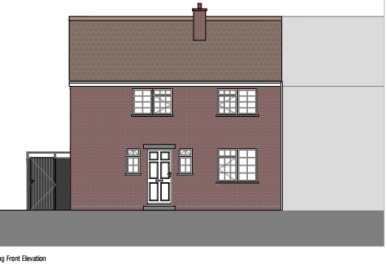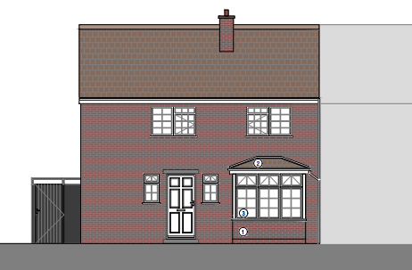

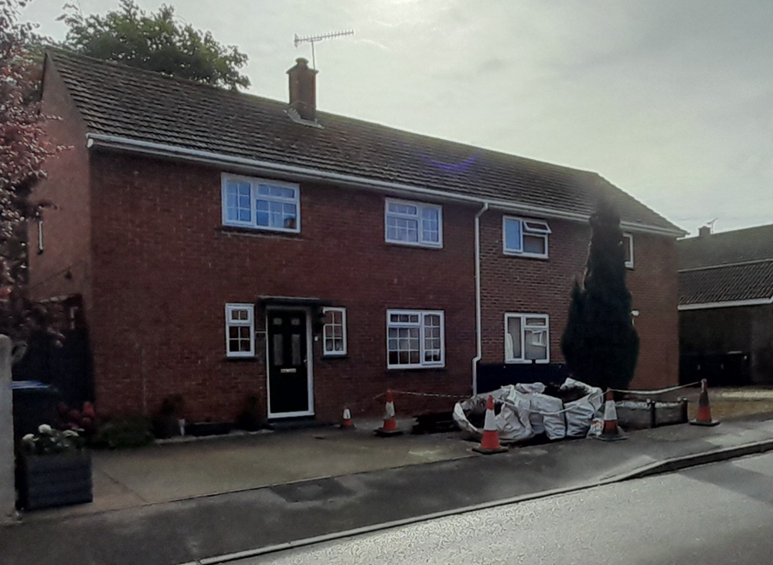

SITE DESCRIPTION/CONTEXT

The application site relates to a 2 storey semi-detached dwelling located within an established residential area in Amesbury. The dwelling is located towards the front half of the residential curtilage with an enclosed level rear garden; a small open fronted front garden provides off road parking for two vehicles.

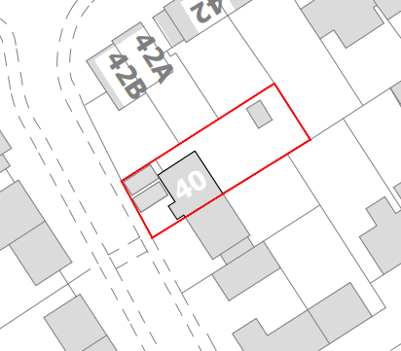

PLANNING HISTORY

None relevant

RELEVANT POLICIES AND GUIDANCE

The National Planning Policy Framework (NPPF)
The Planning Practice Guidance
National Design Guide

Wiltshire Core Strategy:

Core Policy 1: Settlement Strategy
Core Policy 2: Delivery Strategy
Core Policy 4: Spatial Strategy: Amesbury Community Area
Core Policy 50: Biodiversity
Core Policy 57: Ensuring high quality design and place shaping

Wiltshire Design Guide
Creating places design guide
Wiltshire Local Transport Plan

CONSULTATION RESPONSES

Town Council: Support

REPRESENTATIONS

No comments were received.

ASSESSMENT

Section 38(6) of the Planning and Compulsory Purchase Act 2004 states:

"If regard is to be had to the development plan for the purposes of any determination to be made under the planning Acts, the determination must be made in accordance with the plan unless material considerations indicate otherwise."

In accordance with this statutory requirement, this application has been assessed against the relevant policies of the Development Plan, including the adopted Wiltshire Core Strategy (2015) and, where applicable, any made Neighbourhood Plans.

Design and Impact upon the character and context of the area

Core Policy 57 - Ensuring High Quality Design and Place Shaping of the Wiltshire Core Strategy seeks to ensure that all new development is of high design quality, reflecting local context, character, and distinctiveness.

The proposed replacement of the existing front facing living room window with a modest bay window, finished in materials to match the existing dwelling, is considered an acceptable form of development in this instance. Whilst it is acknowledged that bay windows are not a prevailing feature within the immediate locality, this absence does not in itself render the proposal unacceptable. The addition would appear proportionate to the host dwelling, maintaining its overall character and appearance without resulting in visual harm to the street scene. Given its limited scale and sympathetic design, the proposal would preserve the character of the area and accords with the design principles set out in CP57 and Appendix D of the Wiltshire Design Guide.

Amenity

Point vii of Core Policy 57 - Ensuring High Quality Design and Place Shaping of the Wiltshire Core Strategy seeks to ensure that developments do not adversely affect neighbouring properties.

The National Planning Policy Framework (NPPF), particularly Paragraph 135(f), stresses that planning decisions should ensure developments provide a high standard of amenity for existing and future users.

The proposed development has been assessed in terms of its potential impact on the residential amenity of neighbouring properties, with particular regard to loss of light, overshadowing, loss of privacy, and overbearing effects.

In respect of residential amenity, the proposed bay window would be positioned on the front elevation in proximity to the adjoining dwelling at No. 38, including a front-facing living room window. However, given the modest scale and projection of the bay, it is not considered that the development would result in a material loss of light, outlook, or an overbearing impact to neighbouring occupiers.

Whilst the bay window may introduce some additional opportunities for overlooking, its location on the principal elevation, adjacent to the public highway, therefore similar views are already be experienced from the street, thereby limiting any perception of increased intrusion. Furthermore, views obtained from the bay window are not considered to be direct or significant in their nature. On balance, the proposal would not give rise to unacceptable harm to neighbouring amenity.

The applicant should however note that given the proximity of the development to the boundary with No38, the Party Wall Act is likely to come in to play, this however is not a planning matter but is a civil matter between affected parties.

The proposal therefore accords with Core Policy 57 point vii in respect of safeguarding residential amenity and Appendix D of the Wiltshire Design Guide.

Highways Impact

Core Policy 57 (xiv) of the Wiltshire Core Strategy seeks to ensure that development must meet the requirements of Core Policy 61. This policy requires proposals to be capable of being served by safe access to the highway network. Core Policy 64 seeks to ensure compliance with parking standards set out in the Local Transport Plan.

The National Planning Policy Framework (NPPF), particularly Paragraph 115 and 116, requires that development proposals do not have an unacceptable impact on highway safety and that safe and suitable access to the site can be achieved for all users.

The application site currently has two off road parking spaces which is adequate for a three bedroomed dwelling such as the application site and meets Wiltshire Council parking standards. The proposed bay window will not increase the number of bedrooms and will not be constructed over or impinging on the existing parking area. Therefore, there are no concerns raised regarding highway safety or parking.

The proposal is therefore considered to comply with Core Policies 57 (xiv), 61 and 64 of the Wiltshire Core Strategy, the NPPF, and the Wiltshire Local Transport Plan.

Biodiversity Net Gain

Householder planning applications are exempt from the requirement to deliver Biodiversity Net Gain under Schedule 7A, Section 4(2)(a) of the Town and Country Planning Act 1990, as inserted by the Environment Act 2021.

CONCLUSION

The proposed development is considered to be acceptable in terms of its design, scale, and relationship with the surrounding area. It would not result in any unacceptable harm to the character of the locality, the amenities of neighbouring occupiers, or the interests of highway safety.

The proposal is therefore considered to comply with the relevant policies of the Wiltshire Core Strategy, the Wiltshire Local Plan, and the National Planning Policy Framework. As such, the application is recommended for approval, subject to the conditions set out below.

RECOMMENDATION: That Planning Permission be GRANTED subject to conditions.

1) The development hereby permitted shall be begun before the expiration of three years from the date of this permission.

REASON: To comply with the provisions of Section 91 of the Town and Country Planning Act 1990 as amended by the Planning and Compulsory Purchase Act 2004.

2) The development hereby permitted shall be carried out in accordance with the following approved plans:

Application form received 31/03/2026
Location plan Drg no 00-001 Rev A received 24/04/2026
Site plan Drg no P1 Rev A received 24/04/2026
Proposed elevations 00-200 Rev P1 received 24/04/2026
Proposed floor and roof plans Drg no P1 Rev A received 24/04/2026

REASON: For the avoidance of doubt and in the interests of proper planning.

3) The materials to be used in the construction of the external surfaces of the development hereby permitted shall match in material, colour and texture those used in the existing building.

REASON: In the interests of visual amenity and the character and appearance of the area.

Informatives

1. Party Wall

The applicant is requested to note that this permission does not affect any private property rights and therefore does not authorise the carrying out of any work on land outside their control. If such works are required, it will be necessary for the applicant to obtain the landowners consent before such works commence. If you intend carrying out works in the vicinity of the site boundary, you are also advised that it may be expedient to seek your own advice with regard to the requirements of the Party Wall Act 1996.

2. BNG not required

The effect of paragraph 13 of Schedule 7A to the Town and Country Planning Act 1990 is that planning permission granted for development of land in England is deemed to have been granted subject to the condition (biodiversity gain condition) that development may not begin unless:

(a) a Biodiversity Gain Plan has been submitted to the planning authority, and
(b) the planning authority has approved the plan.
The planning authority, for the purposes of determining whether to approve a Biodiversity Gain Plan, if one is required in respect of this permission would be Wiltshire Council.
There are statutory exemptions and transitional arrangements which mean that the biodiversity gain condition does not always apply. For further information on exempt developments please refer to:
https://www.gov.uk/guidance/biodiversity-net-gain-exempt-developments
Based on the information available this permission is considered to be one which will not require the approval of a biodiversity gain plan before development is begun because one or more of the statutory exemptions or transitional arrangements is considered to apply.

