APPLICATION FOR A CERTIFICATE OF LAWFULNESS FOR EXISTING USE OR DEVELOPMENT

APPLICATION REFERENCE: | PL/2026/01395
APPLICATION TYPE: | Lawful development: Existing use
SITE ADDRESS: | 6 THE DOWN, TROWBRIDGE, BA14 8QW
DEVELOPMENT DESCRIPTION: | Lawful Development Certificate for an existing roof terrace
RECOMMENDATION: | That a Certificate of Lawfulness for Existing Development be granted

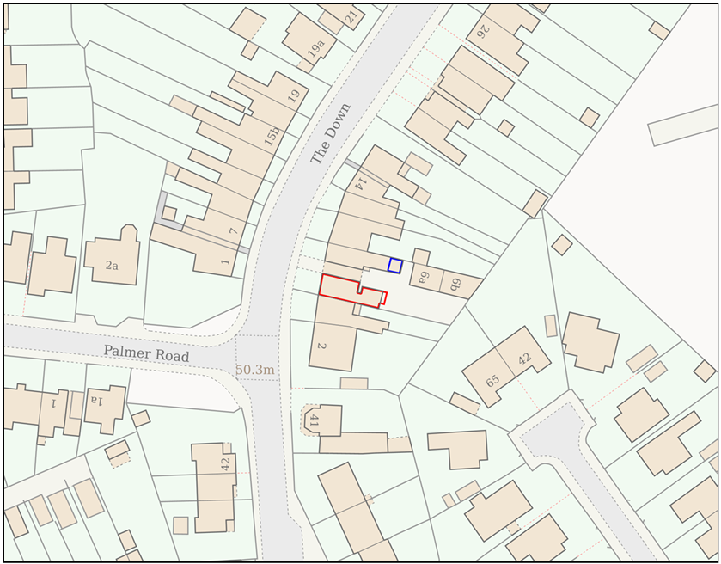

SITE DESCRIPTION AND PROPOSAL

This application is for a Certificate of Lawfulness for an Existing Use or Development (CLUED) under Section 191 of the Town and Country Planning Act 1990 (as amended). The applicant seeks to establish the lawfulness of the construction and use of a roof terrace above an existing kitchen extension, which has been in operation at the site since summer 2020. The application relates to operational development comprising the formation of a roof terrace, including associated structures such as built-in seating and external access, used for purposes incidental to the residential use of the dwellinghouse.

The application site relates to a residential property at 6 The Down, Trowbridge. The roof terrace is positioned above an existing kitchen extension and is accessed via an external staircase. The applicant states that the terrace was substantially completed in summer 2020, with additional minor works undertaken later in 2020 and a small alteration in 2023, and that it has been used continuously since that time for incidental residential purposes. The submission is supported by dated photographs and third-party statements attesting to the terrace’s continued presence and use. There is no relevant planning history identified for the construction of the terrace or associated works.

RELEVANT LEGISLATION AND CONSIDERATIONS

The statutory framework governing Certificates of Lawfulness for Existing Use or Development (CLUED) is primarily set out in Section 191(2) of the Town and Country Planning Act 1990 (as amended). This section establishes that "lawful development" refers to development against which no enforcement action may be taken and where no enforcement notice is in force, or development for which planning permission is not required.

Section 191(4) of the Town and Country Planning Act 1990 (as amended) further stipulates that a Local Planning Authority (LPA) shall issue a Certificate of Lawfulness upon request, provided that, on the balance of probabilities, the LPA is satisfied that the existing development or use described in the application is lawful. The time limits for taking enforcement action are set out in s171B of the Act.

The Planning Practice Guidance (PPG) on Lawful development certificates clarifies that the burden of proof lies with the applicant. It is the applicant's responsibility to provide sufficiently clear, precise, and unambiguous evidence to demonstrate the lawfulness of the existing development or use.

In considering whether the use or development has become immune from enforcement action, the test for granting a Certificate of Lawfulness is whether, on the balance of probabilities:
- the works were substantially completed, or,
- the use has been continuous for the required time period without interruption.

The applicant must prove that the use or development has occurred for the necessary period. A continuous use must be demonstrated without significant interruption.

It is important to note that when determining a CLUED application, the LPA must focus solely on whether, based on the facts and applicable planning law, the specific use or development is lawful. Planning merits or considerations relating to the quality or suitability of the development are not relevant.

REPRESENTATIONS

There is no legal obligation to consult third parties for this type of application, including Town/Parish Councils or neighbouring properties. However, the PPG recognises that it may be reasonable for a local planning authority to seek evidence from these sources if there is good reason to believe they may possess relevant information about the content of a specific application.

Trowbridge Town Council: No Objection, subject to no significant adverse impact on neighbouring amenity.

RELEVANT SITE HISTORY

No relevant planning history has been identified for the site subject of this application.

ASSESSMENT
The application seeks confirmation that the construction of a roof terrace above an existing extension constitutes lawful development under Section 191 of the Town and Country Planning Act 1990 (as amended).

Time Limits for Immunity from Enforcement Action

Section 171B of the Town and Country Planning Act 1990 (as amended by Section 115 of the Levelling-up and Regeneration Act 2023) now provides a 10-year period for immunity from enforcement in England.

However, the Planning Act 2008 (Commencement No. 8) and Levelling-up and Regeneration Act 2023 (Commencement No. 4 and Transitional Provisions) Regulations 2024 (SI 2024/452) introduced transitional provisions.

Regulation 3 confirms that Section 115 (amending Section 171B) came into force on 25 April 2024, and Regulation 5 provides that those amendments do not apply where operational development was substantially completed before that date.

In this case, the evidence demonstrates that the operational development was substantially completed prior to 25 April 2024, and therefore, the former 4-year immunity period applies.

Given that the development was substantially completed in summer 2020, the relevant 4-year period expired in approximately summer 2024, and no enforcement action has been taken. Accordingly, the development is immune from enforcement action.

Substantial Completion

The assessment of “substantial completion” is a matter of fact and degree, having regard to the principles established in Sage v Secretary of State [2003].

The operational development in this case comprises the formation of a roof terrace, including the installation of decking, a turfed area, and enclosing balustrade.

Photographic evidence dated 16 July 2020 shows the terrace in situ, including the decked area, turf, and boundary railings. Whilst built-in seating is not present at this time, the terrace is clearly physically complete and capable of functioning for its intended purpose.

The later addition of a built-in seating area (evidenced in January 2021) is not considered integral to the completion of the operational development. The terrace was already capable of being used as a roof terrace without the seating, as evidenced by the presence of a decked and enclosed surface. The seating is therefore considered an ancillary addition relating to the enjoyment of the space, rather than part of the operational development required to achieve substantial completion.

On this basis, it is concluded that the operational development was substantially completed in summer 2020.

Continuous Use

Whilst the application concerns operational development rather than a material change of use, the applicant has provided evidence to demonstrate the continued presence and use of the terrace since its construction.

A series of photographs spanning from 2020 onwards demonstrates the ongoing existence of the terrace. In addition, two written statements from neighbouring occupiers confirm that the terrace has been present since 2020.

There is no evidence to indicate that the terrace has been removed or altered in a manner that would interrupt its continued existence.

Planning Permission Conditions or Permitted Development

There is no evidence before the Council to indicate that the development is in breach of any planning condition which would remove permitted development rights or otherwise alter the applicable immunity period.

The development is therefore assessed solely as operational development subject to the relevant time limits under Section 171B.

Evidence Submitted by the Applicant

The applicant has submitted the following evidence in support of the application:

- Dated photographs of the terrace, including:
  - An image dated 16 July 2020 showing the terrace with decking, turf, and boundary railings in place
  - An image dated 31 January 2021 showing the addition of seating and the finished arrangement of the terrace
  - Additional photographs covering the intervening period to demonstrate continued existence and use
- Written statements from two neighbouring occupiers, confirming that the terrace has existed since 2020
- A personal statement confirming the construction timeline and ongoing use of the terrace

In addition to the submitted material, the LPA has also reviewed:
- Google Earth historical imagery, which shows no terrace present in May 2018 and the terrace being visible by September 2020
- Council aerial imagery (Get Mapping 2020), which indicates that the terrace was not present at the time of capture, supporting the conclusion that construction occurred during 2020

Assessment

Having regard to the evidence submitted and that available to the Local Planning Authority, it is considered that:

- The terrace is clearly visible in aerial imagery by late 2020
- Dated photographs demonstrate the terrace in a substantially complete form by July 2020
- The later addition of built-in seating does not form part of the substantial completion of the operational development, as the terrace was already capable of functioning for its intended purpose
- Independent neighbour statements corroborate the existence of the terrace since 2020
- There is no evidence of interruption to the existence of the development
- There is no evidence of enforcement action having been taken within the relevant period

On the balance of probabilities, the evidence is consistent, coherent, and mutually reinforcing. There are no apparent contradictions or gaps which would undermine the claimed timeline.

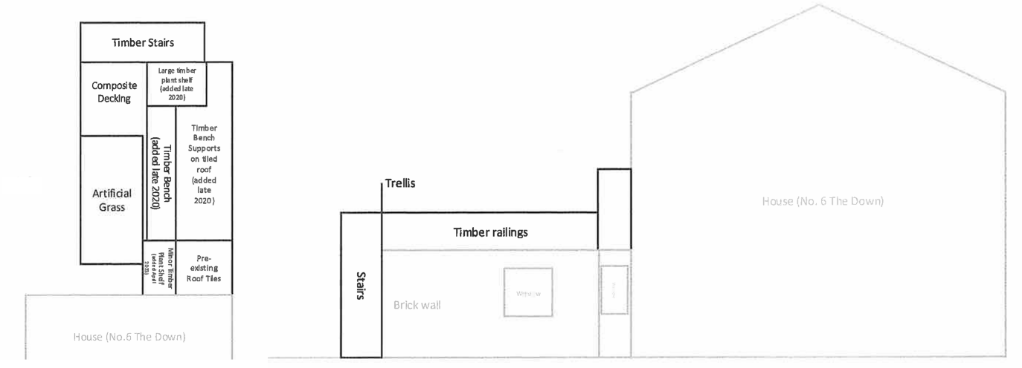
Floor Plan and Side Elevation

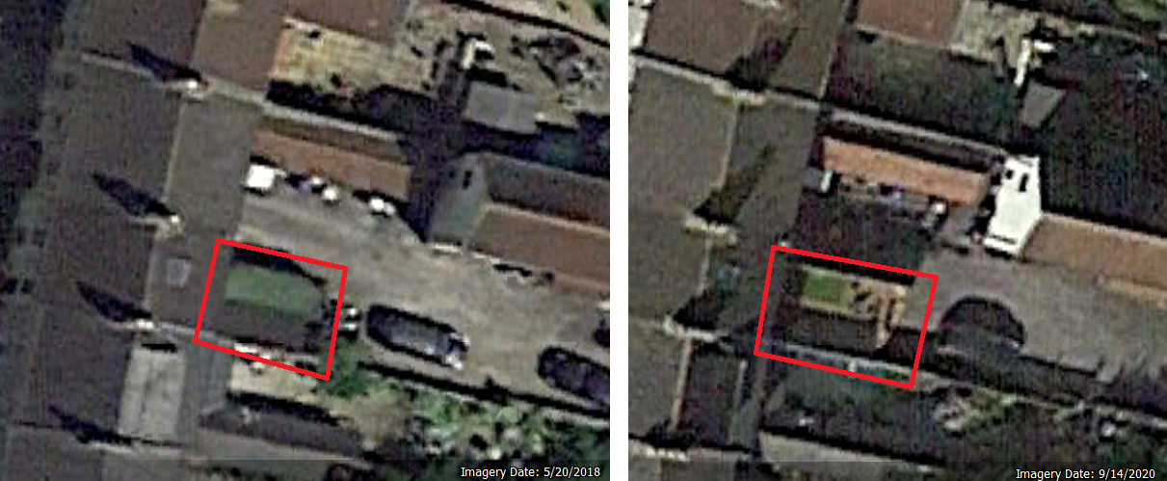
Google Earth Aerial Images May 2018 and September 2020

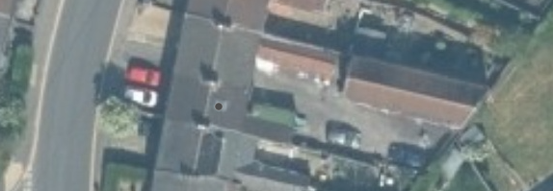
Get Mapping 2020 Aerial Image

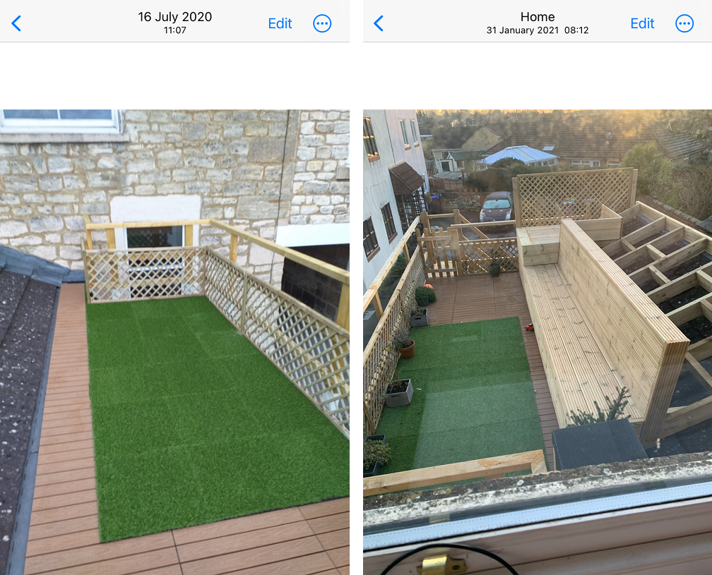
Photographic Evidence July 2020 and January 2021

The evidence submitted by the applicant demonstrates, on the balance of probabilities, that the development (including associated building works forming the roof terrace) was substantially completed at least 4 years prior to the application date, and that the development is not in breach of any planning conditions or restrictions.

Specifically, the evidence confirms that the roof terrace, comprising decking, a turfed area, and boundary railings, was substantially complete by summer 2020, as demonstrated by dated photographic evidence. Subsequent additions, including built-in seating, are not considered to form part of the substantial completion of the operational development.

Further evidence, including aerial imagery and neighbour statements, corroborates the timeline and confirms the continued existence of the terrace since that date. There are no apparent gaps in the evidence or contradictions that would cast doubt on the lawfulness of the development.

Given that the development was substantially completed prior to 25 April 2024, the transitional provisions apply, and the relevant immunity period remains four years. That period has elapsed without enforcement action being taken.

The development is therefore lawful under the provisions of the Town and Country Planning Act 1990 (as amended).

CONCLUSION

On the balance of probability, sufficient evidence has been provided to demonstrate that the construction of the roof terrace, including the decked surface, turfed area and enclosing balustrade, identified on the site plan, was substantially complete in summer 2020 and has remained in situ for a continuous period in excess of four years.

As there is no clear or unambiguous evidence to the contrary, and no record of formal enforcement action having been taken by the Council within that period, it is concluded that the development is lawful.

RECOMMENDATION

It is recommended that a Certificate of Lawfulness for Existing Development be granted for the following development:

The construction and use of a roof terrace above the existing extension, including associated decking, turfed area and enclosing balustrade.

Reason for approval:
The evidence submitted satisfies the requirements of Section 191 of the Town and Country Planning Act 1990 (as amended). The development was substantially completed more than four years prior to the date of the application and benefits from the transitional provisions introduced by SI 2024/452. The development is therefore immune from enforcement action and is considered lawful.

