APPLICATION FOR FULL-PLANNING PERMISSION
CASE OFFICER REPORT

APPLICATION REFERENCE: | PL/2025/09926
APPLICATION TYPE: | Full planning permission
SITE ADDRESS: | Clover Park, Brickworth Road, Whiteparish, Salisbury, SP5 2QG
DEVELOPMENT DESCRIPTION: | Demolition of rear building and construction of a new warehouse extension with increasing daily operating hours to permit 24-hour operation (subject to mitigation included within NIA).
RECOMMENDATION: | Refuse

SITE DESCRIPTION/CONTEXT

The application site relates to an existing established commercial premises currently used for the distribution, storage and processing of fruit and vegetables; the business is known as Roebridge Foods. The site is located on the south side of the A27 Brickworth Road in a rural location, to the west of and outside of the settlement boundary of the large village of Whiteparish as defined by core polices 1, 2 and 23 of the Wiltshire Core Strategy and is therefore in policy terms located in the countryside.

Location plan

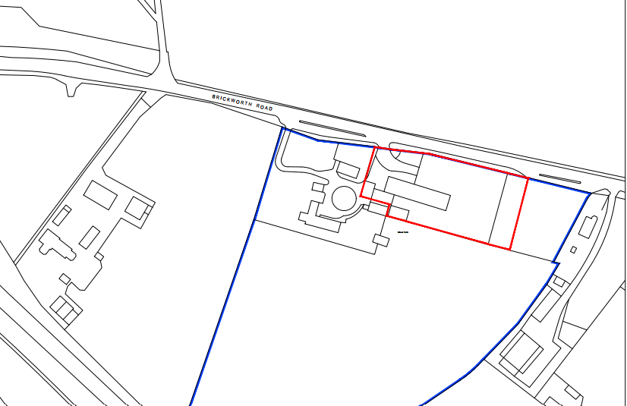

Site shown in turquoise on the left of the map extract below with the settlement boundary defined by a dark black line on the righthand side.

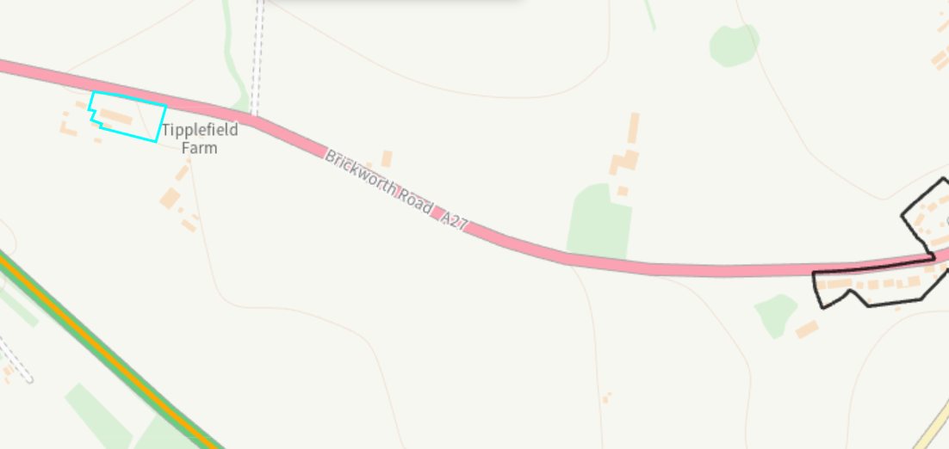

The site comprises existing buildings and associated yard area and is surrounded predominantly by agricultural land with sporadic residential dwellings.

The site is not located within a Conservation Area and does not contain any listed buildings; the site is located within a Special Landscape Area and within the River Test Catchment.

PROPOSAL

The application is seeking consent for the demolition of an existing building located to the rear of the site and the construction of a new warehouse extension to the rear of the site. The application is also seeking permission to increase the daily operating hours from the current permitted 7am to 7pm to 24 hours a day.

The reason for the proposed works as stated in the submitted planning statement is “the works will rationalize internal operations, modernize the premises, increase efficiency, and support continued business growth in a manner appropriate to the established commercial context of the site.”

During the course of the application, the applicant submitted additional/revised information relating to noise impacts and traffic to try to address concerns raised by the Council’s highways officer and public protection officer.

Existing and proposed plans and elevations included below for comparison.

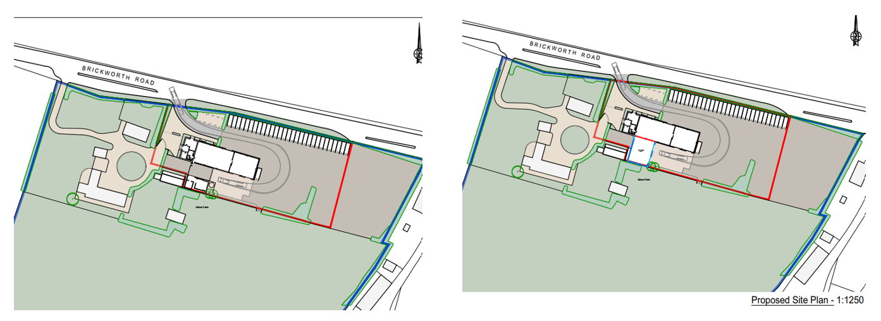

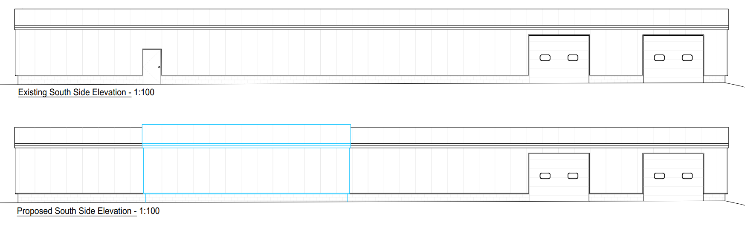

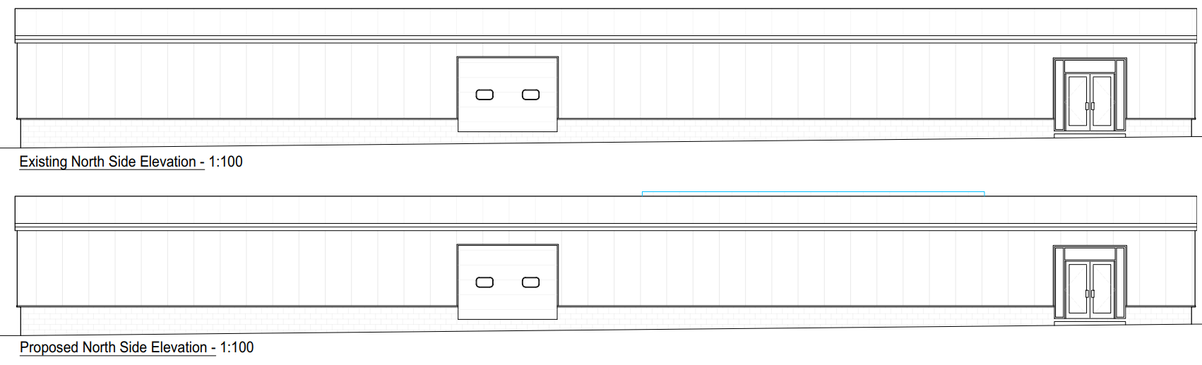

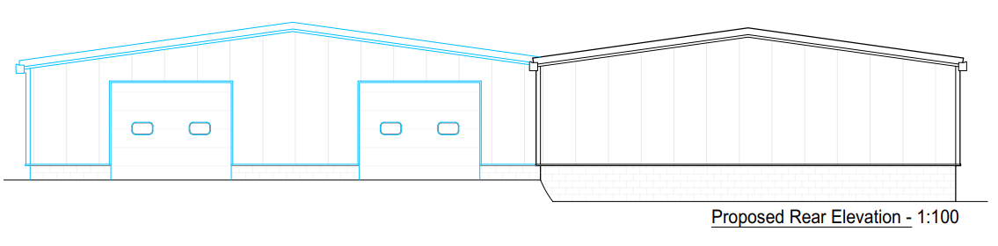

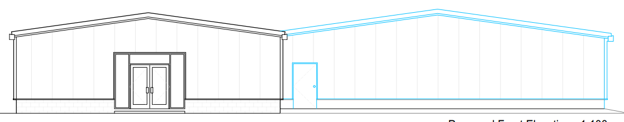

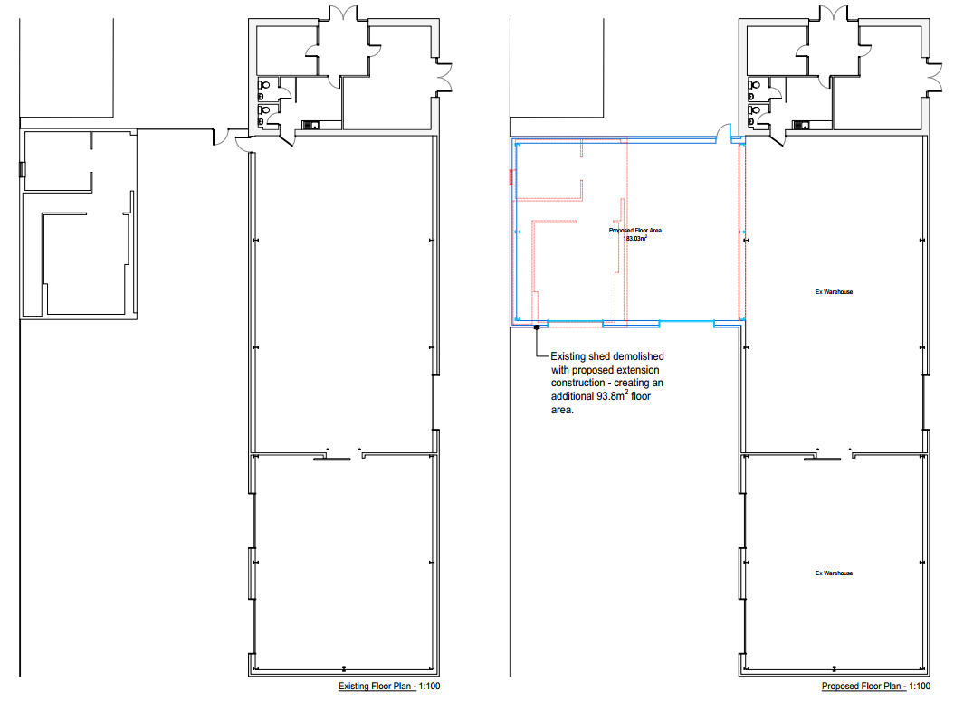

PLANNING HISTORY

15/09583/VAR Vary conditions 4 and 7 of S/2007/0596 to allow B8 use and external storage up to 2m high, no storage container to exceed 2.4m in height and no stacking of containers. Refused for the following reason:

The Council fully supports the enhancement of rural employment opportunities and has made every effort to seek a compromise regards adjusting the conditions. However, the proposed variation of Conditions requested by the applicant would result in an uncontrolled/open B8 storage and distribution use in the open countryside that would be detrimental in terms of visual amenity and would have an adverse impact on the character of the surrounding designated Special Landscape Area. In these respects, the proposal is considered discordant with Core Policies CP34, CP35, CP48 & CP51 of the adopted Wiltshire Core Strategy, and contrary to saved local plan policies C6 & E19 and the guidance contained within the NPPF in general and in particular the guidance set out at paragraph 28.

15/01453/VAR - Remove condition 6 (opening hours) and vary conditions 4 and 7 of S/2007/0596 to allow B8 use and external storage up to 2m high. Refused for the following reason.

On the basis of the information submitted with the application, it is considered the proposed removal of hours of operation restrictions (Condition 6 of planning approval S/2007/0596) for the use of the site would result in undue impacts on the amenity of neighbouring residential occupiers through the generation of noise and disturbance resulting from activities within the site.

In these respects the proposed removal of Condition 6 of planning approval S/2007/0596 would be contrary to Core Policy CP57 of the Wiltshire Core Strategy which has regard to the compatibility of adjoining buildings and uses, the impact on the amenities of existing occupants, and seeks to ensure that appropriate levels of amenity are achievable including the considerations of privacy and pollution (such as noise).

15/01462/FUL Retention of extended hardstanding for use ancillary to storage and distribution B8. Approved

S/2007/0596 Demolish existing store. Erect new store for wholesale fruit and vegetable distribution. Alter access and form car parking area. Approved

RELEVANT LEGISLATION, POLICIES AND GUIDANCE

Statutory Legislation:

National Planning Policy:

- National Planning Policy Framework (NPPF)
- Planning Practice Guidance (PPG)
- National Design Guide

Development Plan:

The development plan for Wiltshire comprises the Wiltshire Core Strategy (WCS) (adopted January 2015) and any made neighbourhood plans, which remains the principal statutory planning document guiding development across the county. In line with Section 38(6) of the Planning and Compulsory Purchase Act 2004, planning decisions must be made in accordance with the development plan unless material considerations indicate otherwise.

Though the development plan is considered as a whole, those parts deemed to be particularly relevant to this application are listed below:

The adopted Wiltshire Core Strategy (WCS), with particular regard to:

- Core Policy 1 Settlement Strategy
- Core Policy 2 Delivery Strategy
- Core Policy 3 Infrastructure Requirements
- Core Policy 23 Southern Wiltshire Community Area
- Core Policy 34 Additional Employment Land
- Core Policy 35 Existing Employment Land
- Core Policy 48 Supporting Rural Life
- Core Policy 50 Biodiversity and Geodiversity
- Core Policy 51 Landscape
- Core Policy 57 Ensuring High Quality Design and Place Shaping
- Core Policy 58 Ensuring the Conservation of the Historic Environment
- Core Policy 60 Sustainable Transport
- Core Policy 61 Transport & Development
- Core Policy 62 Development Impacts on the Transport Network
- Core Policy 64 Demand Management

Salisbury District Council Saved polices C6 Special Landscape Area and E19 Employment.

Supplementary Planning Documents and other Guidance:

Wiltshire Design Guide (adopted April 2024)
Wiltshire Local Transport Plan 2011-2026, adopted 2015 - including the Car Parking
Creating Places Design Guide

ISSUES

Principle
Design, scale and impact on the character of the area
Highways
Amenity impacts
Ecology

CONSULTATION RESPONSES

Parish Council: Object

• The application is contrary to Core Policy 57 in the Wiltshire Core Strategy and in particular sub-clause vii. ‘having regard to the compatibility of adjoining buildings and uses, the impact on the amenities of existing occupants, and ensuring that appropriate levels of amenity are achievable within the development itself, including the consideration of privacy, overshadowing, vibration, and pollution (e.g. light intrusion, noise, smoke, fumes, effluent, waste or litter)’.
• There would be an adverse impact on the residential amenity of the adjacent residential properties and, in particular, noise impacts. The neighbouring properties are already being disturbed because the applicant is constantly breaching the conditions contained in their previous approval for the site with regard to operating hours. These are supposed to be from 7 am to 7 pm but continue to be breached weekly. Consequently, the Council has little confidence that the applicant will adhere to the night time noise mitigation of not accessing the eastern side of the site between the hours of 11 pm and 7 am.
• The application contains no traffic/transport management plan to mitigate the impact of lorries accessing the site 24 hours a day 7 days a week. Nor is there any limit in hours to lorries accessing the site using the A27 from Romsey which would create constant overnight disturbance and noise for residents living alongside the A27.

Public Protection: Object

Highways: No objection subject to conditions

Local member Call- in: Application called in to committee if recommended for approval due to concerns raised relating to impact on neighbouring properties, environmental/highway issues and car parking. Other concerns include light impact, noise from out of standard working hours, vehicle movement, noise from frequent movement of refrigerated vehicles, lack of traffic management plan, not suitable location for 24 hour working, staff coming and going.

REPRESENTATIONS
In accordance with the requirements of the Town and Country Planning (Development Management Procedure) (England) Order 2015 (as amended), the application was publicised by way of:

- Neighbour notification letters sent to adjoining and nearby properties;
- A site notice displayed near the site;

These methods were used to inform interested parties and provide a period of 21 days for comments to be submitted.

Included in full are two representations received during the consultation period -

1. We have no objections to the new building proposals
However, we OBJECT in the most strongest way to the proposal for 24 hour operations.
Our Bungalow predates the fruit wholesale business, an application in 2015 for 24 hour operations was turned down on the grounds of noise to the neighbours and CP 57 Wiltshire core policy.
The only change in 2026 is that they are flagrantly breaching their operations hours daily, when we first moved to here 4 years ago, we knew there was a business next door, sometimes it was noisy early in the morning, and noisy after 7pm, but over the last 2 years the noise disturbance has gradually increased from hearing lorries at 11 pm to throughout the night and it is causing severe impact to our sleep. We have challenged the business over the years, but never officially. Over the past months it has becoming the new normal, to hear large refrigerated lorries revving as they pull in and out oft Clover Farm., usually at 11pm/11.30 pm. Then we hear the vibrations echoing in our upstairs bedrooms whilst the lorry is unloading, the clanking of metal, the noise of fork lifts. Our daughter in the front bedroom also hears some of this and gets disturbed by lorries driving slowly outside looking for Clover Farm.
After our disturbed sleep last night 20th/21st January, its very easy to write an objection,
2 am we were both awoken at by a very noisy refrigerated lorry it left just after 2.05 am
2.30 am we heard another refrigerated lorry pull in and we could hear it running until 2.45am
3.30 am banging and movements of the forklifts
4.30 am another lorry was on the premises for 5 minutes
This was an exceptionally bad night for us but is becoming illegally the new normal
Their operators hours are between 7 am and 7 pm, they are flagrantly working outside of their hours and this application is unacceptable, there is nothing to protect our property from the noise and we have the right to good nights peaceful sleep, and for the neighbouring business to operate in a compliant and environmentally friendly way.

2. We are in total objection to this planned development, the new sound survey is not fit for purpose and has been written to back up a dubious application. There have been a couple of quieter nights(only a couple as it’s usually noisy inconsiderate business as usual 7 late nights and early mornings a week) in the last few weeks, no doubt that was when the survey was done
We have a right to sleep without being awoken by noisy Lorry’s driving in, then driving away, refrigerated lorry’s causing vibration sounds in the top of our house. Noisy forklifts rumbling and banging about small lorry’s being loaded up in the early morning. This is happening outside their working hours, they don’t operate 7 am to 7 pm they operate throughout the night and we are losing all patience with these illegal pig ignorant business practices. We installed good quality triple glazed windows but most nights we are disturbed just this morning we lost 1 1/2 hours sleep due to noisy lorry’s and a forklift. Awoken at 2-45 am this is unacceptable.? Even when only one of us wakes up to their noise disturbance, the other one’s smart watch records they are waking and restless too. The forklift operators show absolutely no consideration to us, there is a lot of loud banging some nights it sounds like it’s happening just outside our window. Some nights they succeed in waking all 5 members of the household!
These working hours of this nuisance company should be enforced, they admit they are working outside their hours, and this doesn’t give them the right to be given 24 hour working. Our house was built way before this wholesale business commenced
I suspect they are also disturbing residents in the centre of Whiteparish too, as these large noisy lorry’s drive by.

ASSESSMENT

Section 38(6) of the Planning and Compulsory Purchase Act 2004 states:

"If regard is to be had to the development plan for the purposes of any determination to be made under the planning Acts, the determination must be made in accordance with the plan unless material considerations indicate otherwise."

In accordance with this statutory requirement, this application has been assessed against the relevant policies of the Development Plan, including the Wiltshire Core Strategy (2015) and, where applicable, any made Neighbourhood Plans. Consideration has also been given to the policies of the National Planning Policy Framework (NPPF) as a material consideration in the assessment.

Principle of Development

Core Policy 1: Settlement Strategy of the WCS establishes a hierarchy of settlements to guide where development should be focused. The policy prioritises growth in:
- Large and Small Villages – development should be limited and respond to local needs.
- Outside the defined settlements – development is strictly controlled and generally not supported unless exceptional circumstances apply.
.
Core Policy 2: Delivery Strategy of the WCS sets out how development will be distributed and delivered across Wiltshire. The policy emphasises:
- Sustainable patterns of growth, reducing the need to travel and supporting local services.
- Development should be plan-led, aligning with the settlement strategy and supported by infrastructure.
- Windfall development (not allocated in plans) must still comply with the principles of sustainable development.
- Development outside settlement boundaries is generally not permitted, unless it meets specific policy exceptions (as set out in paragraph 4.25 of the WCS).

Together, CP1 and CP2 ensure that new development is strategically located, sustainable, and supports the character and function of Wiltshire’s communities.

Core Policy 35 to the Wiltshire Core Strategy is not relevant since it is applicable to Principal Settlements, Market Towns, Local Service Centres and Principal Employment Areas; with the application site not being within any of these designations. However, since the application site is an established employment site adjacent to Whiteparish, Core Policy 34 is relevant since it supports the principle of new and existing rural based business development adjacent to large and small villages (Whiteparish being designed a large village by the Wiltshire Core Strategy). Specifically, CP 34 states that outside the Principal Settlements, Market Towns and Local Service Centres, developments will be supported that:

iii. are for new and existing rural based businesses within or adjacent to Large and Small Villages

NPPF Chapter 6 Building a strong, competitive economy is relevant,

Para 85 states “need to support economic growth and productivity, taking into account both local business needs and wider opportunities for development”

Para 87 states “ Planning policies and decisions should recognise and address the specific locational requirements of different sectors.

b) storage and distribution operations at a variety of scales and in suitably accessible locations that allow for the efficient and reliable handling of goods, especially where this is needed to support the supply chain, transport innovation and decarbonisation.

In this instance, the site is an existing employment site outside of a large village alongside the A27 and close to the A36, the principle of works to expand the existing business are therefore acceptable in principle. This in principle acceptability is however subject to compliance with other relevant planning polices, guidance and materials considerations which include but not necessarily limited to visual impact, amenity impacts, ecology impacts and impacts on highway safety.

Design and Impact on the Character and Appearance of the Area

Core Policy 57 of the Wiltshire Core Strategy (WCS) requires development to achieve high-quality design that:
- Enhances local character;
- Responds appropriately to the natural, historic and built environment;
- Retains important landscape features (such as trees and hedgerows);
- Supports sustainable construction and is compatible with surrounding uses; and
- Creates safe, legible and accessible environments.

Core Policy 51 requires proposals to:
- Protect, conserve and enhance landscape character and quality;
- Respect local distinctiveness, important views and visual receptors; and
- Give particular weight to impacts on National Landscapes (formerly AONBs) and locally valued landscapes.

Policy C6 states that within the Special Landscape Area, development proposals will be assessed with particular regard to the high quality of the landscape. Where development would not adversely affect landscape quality, it must also:

- (i) Be sited and scaled sympathetically within the landscape; and
- (ii) Incorporate a high standard of landscaping and design, using materials appropriate to the locality and reflecting the character of the area.
The Wiltshire Design Guide SPD (2024) promotes a context-led approach, encouraging development that integrates with existing natural features and settlement patterns, while avoiding visual intrusion. Similarly, Section 12 of the National Planning Policy Framework (NPPF) emphasises that development should be visually attractive, functionally effective, and contribute positively to the quality of the built environment.

The application seeks permission for the demolition of an existing rear outbuilding and its replacement with a warehouse extension, as described in the submitted Planning Statement.

The Planning Statement outlines that the proposed extension has been designed to:
- Improve storage capacity and operational efficiency;
- Meet modern food safety, hygiene and thermal performance standards;
- Enhance internal circulation and workflow; and
- Reduce reliance on external storage.

It further states that the extension would reflect the scale, height and materials of the existing warehouse, maintaining its industrial character while improving the overall cohesion of the building

The existing outbuilding is located to the rear (south) of the main Roebridge Foods building at Clover Park. The proposal involves constructing the extension broadly on the same footprint, extending it to connect to the main building and form a slightly offset ‘T’-shaped layout. During the site visit carried out by the case officer, it was seen that the existing building to be demolished is not currently used and was essentially empty. Therefore, the proposed warehouse additional floor space would also include the additional space currently not utilised within the outbuilding to be demolished.

The extension will utilise materials to match the existing building and will adopt a similar design and character. The structure will remain positioned to the rear, where it is largely screened from public views by the main building itself.

The site is adjacent to the A27 but benefits from mature roadside hedging, which provides effective screening. Google maps (July 2025) demonstrates that views of the site are limited to brief glimpses of the main building when passing the entrance.

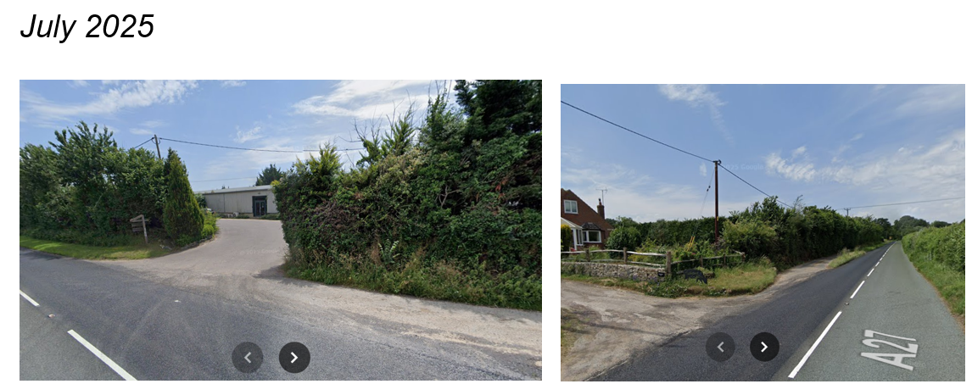

Older Google maps imagery indicates that screening has improved over time as the hedging has matured.

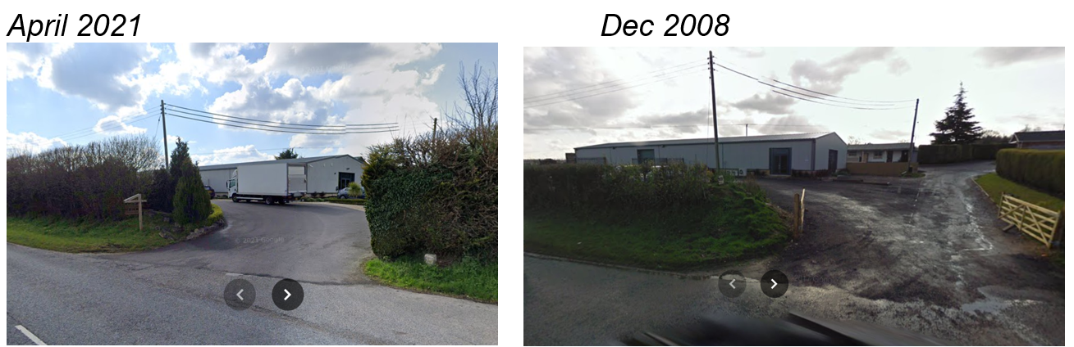

The existing outbuilding is in poor condition and lacks architectural merit, and its removal raises no concerns.

Given the siting, scale and design of the proposed extension, together with the existing screening, the development is not considered to result in significant adverse visual impacts or harm to the character and quality of the surrounding area.

The proposed extension of operating hours is not considered, in itself, to fundamentally alter the character of the area, given the established commercial nature of the site at Clover Park. Any potential impacts arising from increased activity—particularly in respect of highways and amenity considerations such as traffic movements, noise, and disturbance—are assessed in detail in the sections below.

Amenity

Core Policy 57 (Point vii) of the Wiltshire Core Strategy requires development to respect the amenity of existing occupants and ensure appropriate amenity levels for future residents.

The National Planning Policy Framework (NPPF), particularly Paragraph 135, reinforces the need for development to provide a high standard of amenity for both existing and future users.

The application site has neighbouring dwellings in close proximity to the east and west. The properties to the west (Clover Farm and Swingletrees) are under the same ownership as the application site; to the east the closest residential property is known as Tipplefield Farm. Two objections have been received from the occupiers Tipplefield Farm stating noise/disturbance has impacted their amenity from the overnight works at Clover Farm.

In terms of the amenity impacts from the erection of the proposed extension following the demolition of the existing building, the scale, siting and design is unlikely to cause amenity impacts through overshadowing or overbearing impacts. There are also no particular concerns regarding overlooking/loss of privacy towards the nearby residential properties.

In terms of amenity impacts through noise and disturbance, the application was submitted with a supporting Noise Impact Assessment; the Council’s public protection team were consulted and provided the following comments in objection to the proposed development.

The submitted Noise Impact Assessment (NIA) is not considered sufficiently robust to provide an accurate or reliable representation of the potential noise impact arising from the proposed operations. More importantly, it fails to demonstrate that either daytime or night-time activities would avoid causing adverse or significant adverse effects on nearby residential receptors.
The assessment does not follow BS 4142:2014+A1:2019, which is the UK’s recognised national standard for rating and assessing noise from commercial and industrial sources. Instead, the consultant has relied on the IOA/IEMA “change in ambient noise” methodology, which is not an appropriate substitute for BS 4142 when determining impacts on residential dwellings. The site activities described—including vehicular movements, loading and unloading, and general yard operations—fall clearly within the scope of BS 4142. The NIA does not comply with the standard for the following reasons:
1. Failure to Determine Specific Sound Levels and Rating Levels
The assessment does not identify or quantify specific sound levels for individual noise sources, nor does it calculate rating levels including penalties for tonality, impulsivity, intermittency or other acoustic characteristics as required under BS 4142. These omissions fundamentally undermine the validity of the impact assessment.
2. Inadequate Demonstration of Background Sound Levels
The NIA fails to provide:
• A description of the prevailing background acoustic environment.
• Sufficient LA90 data or statistical analysis to justify the selection of representative background sound levels.
• Any evidence that measured background levels are typical, uncontaminated by other noise events, or representative of the periods being assessed.
This is contrary to BS 4142 requirements for determining background sound level.
3. No Rating Assessment (Impact = Rating Level – Background Level)
The NIA does not assess noise impact by subtracting background levels from calculated rating levels.
This step is fundamental to BS 4142 and is the basis on which adverse or significant adverse impacts must be judged.
4. No Assessment of Measurement Uncertainty
The report does not address uncertainty, despite BS 4142 requiring that uncertainty be identified, minimised and reported. This is particularly concerning given the limitations in the data and the lack of clarity regarding specific sound sources.
5. Absence of a Measurement Location Plan
No site plan or drawing is provided showing the locations of the noise measurement positions (NMP1 and NMP2).
Without this information, it is impossible to verify:
• Whether the positions were appropriate and representative.
• Distances to reflecting surfaces or noise sources.
• Compliance with free-field measurement requirements.
The omission significantly reduces confidence in the reliability of the reported data.
6. Inadequate Measurement Periods for Specific Sound Assessment
Table 6 presents measurement periods of 4 hours (evening) and 8 hours (night-time).
BS 4142 states that assessments must use:
• 1 hour reference periods during the day (07:00–23:00), and
• 15-minute reference periods during the night (23:00–07:00).
These prescribed reference periods are necessary to correctly characterise industrial noise. The NIA does not follow these requirements. If the premises operate as a storage and distribution facility, it is expected that noise will arise from multiple sources including:
• Loading and unloading operations
• Reversing alarms
• Impulsive impact noise
• Internal and external plant
The NIA does not identify which of these sources contribute to the measured noise levels, making the assessment incomplete.
7. No Consideration of LAMAX for Night-Time Disturbance
Short-duration noise events at night can cause sleep disturbance.
WHO guidance indicates that maximum indoor noise levels should not exceed 45 dB LAMAX to prevent sleep disruption. The NIA does not assess LAMAX, despite the likelihood of impulsive and intermittent site noise.
8. Lack of Interpretation of Noise Data Presented in Appendix III
Appendix III contains graphs showing multiple significant noise spikes during both day and night-time, including levels up to 86 dB(A) at night and 74 dB(A) during the day.
No commentary or contextual explanation is provided to clarify:
• The source of these spikes
• Whether they relate to site activity
• Whether they affect background or specific sound levels
This lack of interpretation further reduces confidence in the assessment.
Conclusion and Recommendation
Due to the substantial omissions and non-compliance with BS 4142, the NIA has failed to adequately assess noise impacts associated with the proposed extension of operating hours, particularly for evening and night-time activities.
I therefore have no choice but to recommend refusal of the application as submitted.

Therefore, in summary, it is clear that the initial NIA submitted to support the proposed development is insufficient and unreliable, failing to follow BS 4142 requirements and lacking key data and analysis needed to assess impacts. It does not demonstrate that noise effects on nearby residents would be acceptable, and therefore the proposal cannot be supported, hence refusal is recommended.

The Council reasonably agreed to a technical extension of time to allow the applicant to submit further information to address the concerns raised; however, following submission of a revised NIA, the Public Protection team maintained their objection as the revised NIA still failed to demonstrate that extended operating hours would not result in unacceptable amenity impacts. Their second response is included below -

Thank you for re-consulting the Public Protection Service in respect of this application.
The proposal seeks planning permission to:
- Demolish the existing shed and construct an extension to the existing warehouse; and
- Extend the site’s operating hours to permit 24-hour operation.
The lawful use of the site is currently restricted to the hours of 07:00 to 19:00 Monday to Saturday. I note that a previous application (ref. 15/01453/VAR), submitted in 2015, sought the removal of these restrictions but was refused on the grounds that the proposal was contrary to Core Policy 57, due to the likely adverse impact on residential amenity arising from noise and disturbance.
The current proposal would introduce routine operations during the night-time period. This represents a material change in the pattern of use, occurring at times when background sound levels are lower and residential receptors are generally more sensitive. In these circumstances, assessment of noise impact should be undertaken in a manner that is consistent with the principles and methodology set out in BS 4142:2014 +A1:2019.
To assess the likely noise impacts of the proposed development, the following submitted documents have been reviewed:
- Planning Response – Technical Review of Submitted Noise Impact Assessment; and
- Noise Impact Assessment, Version 2
While I acknowledge that the revised submission now includes a BS 4142 assessment, there remain a number of areas where clarification or additional justification would be required to demonstrate that the assessment has been undertaken fully in accordance with the British Standard, and that the conclusions reached are robust.
Background and ambient sound levels:
The background and ambient sound levels reported in the assessment appear to be based on noise monitoring undertaken between 31 October 2025 and 3 November 2025.
Under BS 4142, the ambient sound level is the total sound at a given place and time, comprising the specific sound together with the residual sound. In contrast, the background sound level explicitly excludes the specific sound under assessment.
At present, it is unclear how background and ambient sound levels have been derived simultaneously from the same survey data. Given this, there is uncertainty as to whether the reported sound levels have been derived in accordance with BS 4142 and, whether they are representative.
Use of unattended noise monitoring:
The ambient and background sound levels have been derived from an unattended noise survey. Such surveys are not generally considered appropriate for the assessment of industrial or commercial noise impacts, as the measured data cannot be reliably correlated with site activity or distinguished from extraneous noise sources (e.g. rainfall and wind related noise). This introduces uncertainty as to whether the reported sound levels are truly representative.
Derivation of the specific sound:
BS 4142 sets out a hierarchical approach for the derivation of the specific sound, with preference given to logarithmic subtraction of the residual sound from the ambient sound, where practicable.
The report does not clearly set out which method has been used to derive the specific sound level, nor does it explain why certain approaches may not have been practicable. Further clarification would be required to demonstrate that the specific sound has been derived in a manner consistent with the Standard.
Acoustic character corrections:
No acoustic character corrections have been applied to the specific sound level. The report states that noise is “largely in keeping with the existing environment” and that tonal or impulsive characteristics are unlikely to be audible. The report provides no justification for not applying an ‘intermittency’ correction.
In this context, it should be noted that the Public Protection Service are currently investigating a complaint regarding noise from HGV movements, forklift operation, metal impacts and skip movements at the site during night-time hours. Council monitoring undertaken at a nearby noise-sensitive location identified audible characteristics including rumbling, reversing alarms and intermittent clanging sounds.
When considered alongside this evidence, further explanation and justification would be required to support the conclusion that no character corrections are appropriate for the purposes of the BS 4142 assessment.
It is also noted that Table 7 of the noise report relates to entertainment noise, which does not form part of a BS 4142 assessment of industrial or commercial sound.
Assessment outcome and proposed mitigation:
The assessment concludes that during the night-time period (23:00–07:00) the rating sound level at noise sensitive receptor (NSR) 2 would exceed the background sound level by approximately +8 dB. In accordance with BS 4142, a difference of this magnitude is an indication of an adverse impact (depending on context).
To address this, the applicant proposes restricting use of the eastern yard between 23:00 and 07:00. However, no robust evidence or modelling has been provided to demonstrate that this measure alone would be sufficient to mitigate the predicted impact at NSR 2, nor how compliance would be ensured in practice.
Night-time maximum sound levels and context:
While BS 4142 does not provide criteria for sleep disturbance, the Standard advises that the outcome of the assessment should be considered alongside relevant contextual information.
Appendix III presents LAFmax data indicating repeated elevated night-time noise events. The report provides no commentary to explain the source, cause, or operational relevance of these noise events, nor does it clarify whether they are attributable to site activities or external influences.
Several of the reported night-time LAFmax values appear to exceed levels generally regarded as desirable at residential façades during night-time periods, which is a relevant contextual consideration when assessing the acceptability of 24-hour operation.
Conclusion:
On the basis of the information currently submitted, it has not been demonstrated that the proposed extension of operating hours to allow 24-hour operation would avoid an unacceptable effect on the amenity of nearby residential occupiers.
As such, the proposal has not been shown to accord with Core Policy 57 of the Wiltshire Core Strategy, which seeks to ensure that development does not give rise to unacceptable impacts on residential amenity.
I therefore have no choice but to recommend refusal of the application as submitted.

In summary, given the above comments, the proposal to extend operating hours of the fruit and vegetable business to 24 hours and expand the site would introduce night-time activity in a sensitive residential context, noting that a previous application for extended hours was refused on amenity grounds due to noise and disturbance. The updated noise report still has important gaps and unclear information, particularly around background noise, how the main noise was calculated, and why no adjustments were made for certain noise characteristics. It identifies likely adverse night-time impacts, and proposed mitigation is not robustly evidenced.

Overall, it has not been demonstrated that the development would avoid unacceptable harm to residential amenity, particularly in relation to Tipplefield Farm, contrary to CP 57 and paragraph 135 of the NPPF and refusal is therefore recommended on unacceptable amenity impacts.

Highways Impacts and Parking

Transport considerations are a key factor in the assessment of planning applications, particularly for larger developments. Proposals must demonstrate, where relevant:

- Safe and suitable access for all users, including pedestrians, cyclists, and people with mobility impairments.
- That there would be no severe residual impacts on the surrounding highway network.
- Support for sustainable travel, reducing reliance on private vehicles.
- Adequate provision for parking and cycle storage in accordance with adopted standards.

Relevant policies include Core Policies 60–64 of the Wiltshire Core Strategy, supported by the Wiltshire Local Transport Plan, Car Parking Strategy, and Cycling Strategy. Further guidance on active travel infrastructure is provided by the Local Cycling and Walking Infrastructure Plan (LCWIP) and Department for Transport guidance set out in LTN 1/20.

Where necessary, applicants are required to submit Transport Assessments or Statements to evaluate impacts and identify appropriate mitigation. Planning conditions or legal agreements may be used to secure off-site highway improvements, travel plans, or contributions towards sustainable transport infrastructure.

Assessment of the Current Proposal

The application relates to an existing, established business. No changes are proposed to the existing access arrangements or parking provision. However, the development would increase the internal warehouse floorspace by approximately 94 square metres and seeks to remove the current restriction on hours of operation to allow 24-hour working.

Individually and cumulatively, these changes have the potential to increase vehicle movements to and from the site, including deliveries, staff travel, and customer visits. As such, the intensification of the use could give rise to highway safety and capacity concerns.

The Council’s Highways Officer was consulted on the application. Initial comments (05/02/2026) raised concerns that insufficient information had been provided to fully assess the highway impacts, and further details were requested. In response, the applicant submitted a Transport Statement, which was subsequently reviewed by the Highways Officer.

In their follow-up comments (19/03/2026), the Highways Officer confirmed that, subject to further clarification and the imposition of conditions, no objection would be raised. Additional clarification was provided by the applicant, particularly regarding staffing patterns and operational flexibility during the proposed 24-hour period.

Following re-consultation, the Highways Officer confirmed (07/04/2026) that, based on:

- No increase in delivery numbers, to be conditioned in accordance with the submitted Transport Statement
- A maximum of five staff on site at any one time,

the proposals would not result in an unacceptable increase in traffic generation or demand for parking and manoeuvring.

Therefore, based on the above, it is considered that there are no grounds to raise a highway objection in this instance. However, it is recommended that any permission granted is subject to a condition restricting the number of delivery vehicle movements to those set out in the submitted Transport Statement, in the interests of highway safety.

Ecology and Biodiversity

The ecological impact of development is a key planning consideration, especially for larger schemes. Proposals must assess and address potential effects on:

- Protected species
- Priority habitats
- Ecological networks

Core Policy 50 of the Wiltshire Core Strategy requires development to:

- Avoid harm to ecological assets.
- Deliver measurable Biodiversity Net Gain (BNG), in line with the Environment Act 2021.
- Support habitat restoration and connectivity.
- Integrate biodiversity into site design.

The National Planning Policy Framework (NPPF), in Paragraphs 193, requires that development minimises impacts on and provides net gains for biodiversity, including ensuring mitigation is secured where harm cannot be avoided.

No enhancement measures have been included within the proposals however; these can be secured by condition.

Habitat Regulations Assessment: River Test Catchment - This development falls within the catchment of the River Test Catchment and has potential to cause adverse effects alone or in combination with other developments through discharge of nitrates in wastewater. A test of likely significance has been carried out by the relevant Competent Authority (Wiltshire Council) as required by Regulation 63 of the Conservation of Habitats and Species Regulations 2017 (as amended). This concluded that given the scale and nature of the development there is no mechanism for adverse effect. The HRA has concluded that the application is not likely to have significant impacts on the River Test Catchment and subsequently the application is screened out of Appropriate Assessment.

New Forest SPA, New Forest SAC and New Forest Ramsar site -The site is located within the 13.8km zone of influence for the New Forest internationally protected sites, which comprises the New Forest SPA, New Forest SAC and New Forest Ramsar site. Any applications within this area are screened into appropriate assessment under the Conservation of Habitats and Species Regulations 2017 (as amended) on account of its potential to cause adverse effects on the New Forest protected sites through increased recreational pressure which may occur alone and in-combination with other plans and projects. Many of the special features of the New Forest protected sites afforded protection are vulnerable to adverse effects associated with an increase in recreation as demonstrated in Natural England’s supplementary advice issued for the SPA on 19 March 2019 and for the SAC on 18 March 2019. Following a Cabinet decision on 7 May 2024, Wiltshire Council’s “Interim recreation mitigation strategy for the New Forest internationally protected sites” (Version 1.1, 21 March 2023) is being revised. However, as the proposals relate to the extension of an existing business with extended working hours and does not involve new overnight accommodation, nor will it be bringing additional people to the locality which will impact on the New Forest protected sites it is screened out of appropriate assessment.

BNG - From 12 February 2024 Biodiversity Net Gain (BNG) became mandatory under Schedule 7A of the Town and Country Planning Act 1990 (as inserted by Schedule 14 of the Environment Act 2021). Given that the proposals relate to the extension of a warehouse to be constructed over an area of existing hardstanding, it is considered that the proposals would fall within one of the exemption categories defined within the legislation.

Other

The Council advised the applicant that the application was heading for a refused. In response, the applicant requested that the proposal be amended to relate solely to the proposed extension, removing the element concerning extended hours of operation.

However, the Council did not consider this to be a simple minor amendment and that that further supporting information would be required to demonstrate how the intensification of the business, arising from the additional floor space, could operate within the existing permitted hours particularly in relation to noise, disturbance and highway safety. It is also understood that the applicant has, in recent months, operated outside permitted hours overnight, in breach of condition, with the current/smaller floor space, resulting in disturbance to the neighbouring property at Tipplefield. A further re-consultation would also be required to consultees and third parties.

Given that the applicant had already been afforded the opportunity to submit amended or additional information during the application process, and in line with the Council’s policy of accepting only one set of amendments (Stages of a planning application - Wiltshire Council), it was considered that further amendments to the application would not be appropriate.

Also of note is the fact the applicant did not chose to engage with the Council through the pre-application process, this service would have potentially allowed the concerns to be raised at the early stage which could have led to the applicant not seeking the extension of working hours to 24 hours a day.

The applicant was therefore advised to withdraw the current application and submit a new application limited to the proposed extension; the applicant however declined to withdraw the application, indicating a preference to appeal in the event of refusal.

PLANNING BALANCE AND CONCLUSION

The application site relates to an existing business located in a rural location on the outskirts of the large village of Whiteparish, the principle of the extension of the established existing business is supported by policy CP34 to the Wiltshire Core Strategy. In this particular case, the application site is in a location with good road access alongside the A27 just a short distance from the A36, a truck road leading to the M27 to the south and Salisbury to the north. Based on the submitted transport statement and the use of an existing access with no changes proposed with adequate parking and turning provided on site there are no objections raised relating to highway safety matters.

The replacement of an existing outbuilding with an extension linked to the main building given its scale, design, materials and siting is considered to pose no significant visual impacts or impacts on the character of the area and rural landscape.

However, the business at Clover Farm was originally approved with a condition restricting the hours of use from 7am to 7pm due to potential harmful neighbour amenity impacts. A previous application sought to remove the restrictive hours of operation condition to allow 24 hour use was refused due to concerns relating to unacceptable impacts on neighbour amenity.

This new submission again to change the hours of operation to 24 hours has resulted in objections from a third party who has experienced adverse impacts due to the application site working through the night contrary to their permitted hours. The occupiers of Tipplefield to the east of the site adjacent to the outside yard have experienced noise/disturbance through fork lift trucks and lorries moving around the site as well as associated bangs with items being moved. The submitted NIA has been assessed by the Council’s public protection officer and has been found to be insufficient in detail and is not conclusive to allay concerns that the operating of the application site between 7pm and 7am would not cause significant unacceptable amenity impacts to Tipplefield Farm. It is understood that the Council’s public protection team received a noise complaint(s) relating to the overnight working at Clover Farm and carried out appropriate investigations which confirmed that unacceptable noise disturbance caused. Therefore, the Council consider the extension of operating hours to 24 hour working unacceptable on amenity grounds and contrary to policy.

In terms of reducing the scope of the proposed development to just the extension to the existing warehouse, Officers are unable to confirm this would be acceptable on amenity grounds without updated details being provided relating to noise/disturbance, traffic and how the business can operate with a larger building within the permitted hours. It is noted that this does not form part of the reason for refusal for this current application as Officers are not considering the amenity impacts of the proposed warehouse extension in this regard.

RECOMMENDATION: That Planning Permission be REFUSED.

The proposed extension to operating hours, currently restricted to 7am-7pm, to allow for 24 hour working, would result in an unacceptable harm to the amenity of occupiers of neighbouring residential dwellings, arising from increased noise and disturbance from continuous site activity, including vehicle movements and yard operations during sensitive night-time periods.

The submitted Noise Impact Assessment is insufficient and fails to robustly assess the impacts of unrestricted 24-hour operation. In particular, it does not demonstrate that harm to residential amenity, especially during night-time hours, would be avoided or adequately mitigated. Consequently, there is a lack of satisfactory evidence to conclude that the proposal would not give rise to significant adverse effects.

Tipplefield Farm to the east, as the nearest residential receptor, would be particularly affected due to its proximity and likely exposure to increased night-time noise. The proposal would therefore result in significant adverse impacts on living conditions of this adjacent dwelling.

Therefore, the proposed development, operating for 24 hours a day, is contrary to Core Policy 57 of the Wiltshire Core Strategy, which requires development to ensure compatibility with adjoining uses and to protect the amenity of existing occupiers, including from pollution such as noise and contrary to paragraph 135 of the National Planning Policy Framework, which seeks to secure a high standard of amenity.

Informative

The documents and plans considered in reaching the above decision are as follows:

Application form received 19/12/2025
Planning statement received 19/12/2025
Originally Noise Impact Assessment (later superseded) received 19/12/2025
Existing and proposed plans (elevations and site plan) Drg no 03 A EX/PP received 12/01/2026
Existing and proposed plans (floor plans) Drg no 03 A EX/PP received 12/01/2026
Location plan Drg no 01 A LP Rev A received 13/01/2026
Applicants planning response – technical review of submitted noise impact assessment received 05/03/2026
Transport Statement received 05/03/2026
Revised Noise Impact Assessment received 05/03/2026
Agents response to Council’s highways officers’ comments received 24/03/2026

