APPLICATION FOR HOUSEHOLDER PLANNING PERMISSION
DELEGATED REPORT

APPLICATION REFERENCE: | PL/2026/01446
APPLICATION TYPE: | Householder planning permission
SITE ADDRESS: | 53A Bradley Road, Trowbridge, BA14 0QR
DEVELOPMENT DESCRIPTION: | Proposed ground floor rear extension, new porch, first floor dormer conversion, internal alterations, floor plan redesign and all associated works
RECOMMENDATION: | That Planning Permission be GRANTED

SITE DESCRIPTION/CONTEXT
The subject property is a detached dormer bungalow, to the south of Trowbridge town centre.

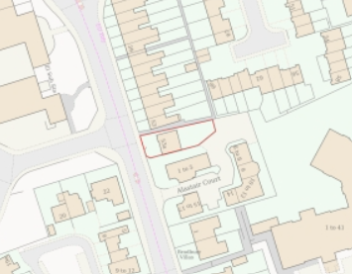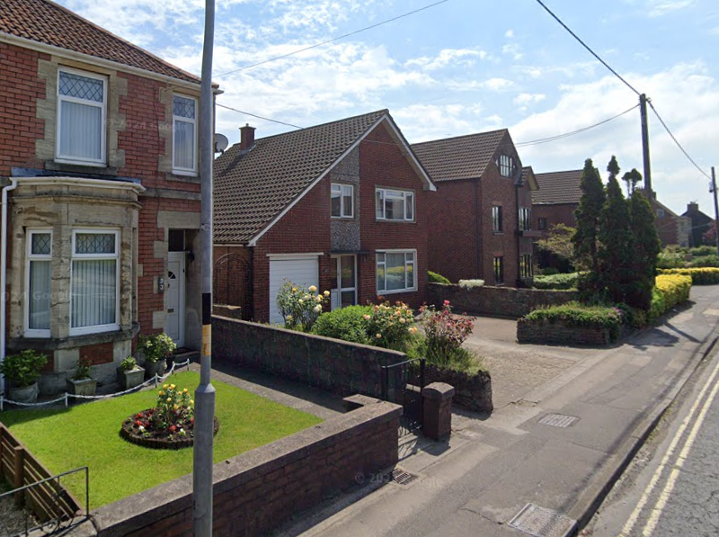

Location Plan and Google Earth Site Photo

The property is unique on the streetscape in both style and scale, sited between dominant Victoria terracing and modern development. Both the modern developments and the subject property was on land once associated with the Royal Artillery Barracks, developed post 1952. Opposite lie commercial premises, on the busy A363 as it approaches Trowbridge from the south.

PROPOSAL

The proposal seeks planning permission for:
- Ground floor rear extension, measuring 6.9m x 2.5m.
- Front porch, measuring 6.4m x 0.6m.
- Insertion of an 8m wide dormer to the side/north elevation, so extending the 4th bedroom, creating a FF office, new bathroom, and creation of a dressing area.
- Internal alterations, including knocking through at GF level to extend existing dining and kitchen into the rear extension.
- Land profiling to create a flush level patio, integral side gate entrance and infilling of side door.
- Insertion of Bifold doors under a rear roof overhang, and 2x rooflights.
- Replacement of windows. Proposed side-facing bathroom and office windows to be obscure glazed and non-opening to 1.7m from FFL.

Proposed materials include vertical timber cladding infilling the garage door against the existing red brick walls which would be painted white, smooth white render would replace pebbledash, and on the dormer cheeks, and grey aluminium panelling would be introduced within the porch. A flat roof system is proposed against existing concrete roof tiles, and grey aluminium windows to replace uPVC doors and windows.

During the lifecycle of the application, revisions have been received, setting the dormer further back from the front elevation, reducing side windows and altering materials to include render on the dormer cheeks to mitigate visual impact to the streetscape.

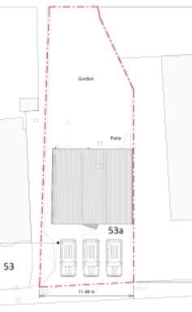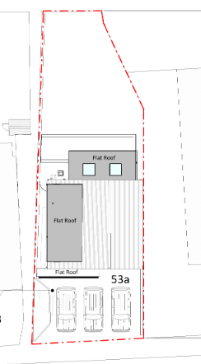

Existing and Proposed Site Plan

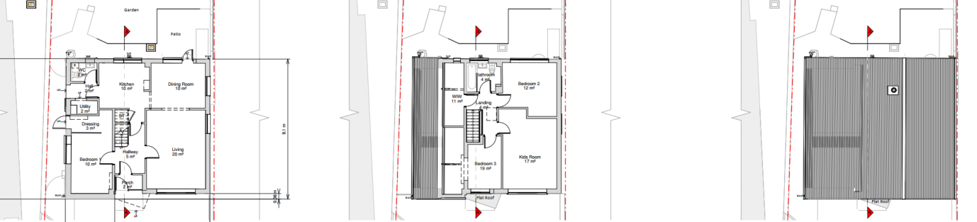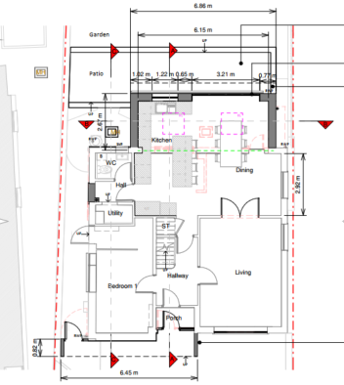

Existing and Proposed Ground Floor Plan

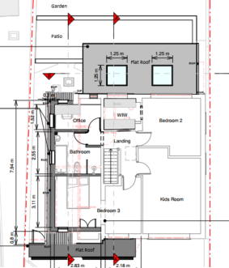

Existing and Proposed First Floor Plan

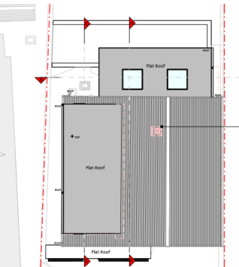

Existing and Proposed Roof Plan

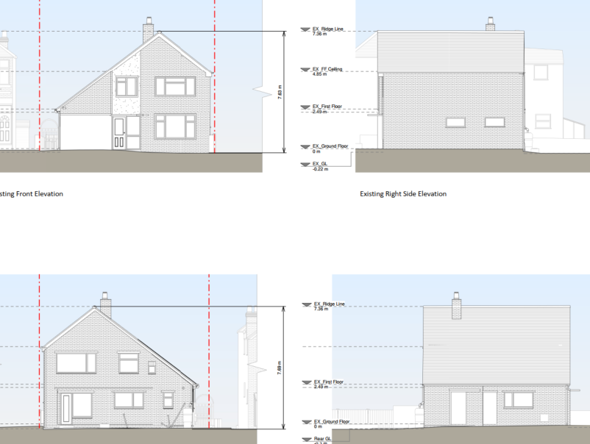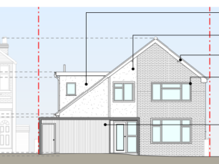

Existing and Proposed Front Elevation

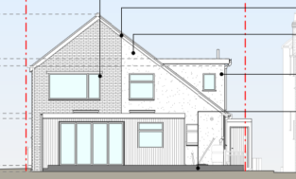

Existing and Proposed Rear Elevation

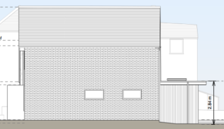

Existing and Proposed Side Elevation

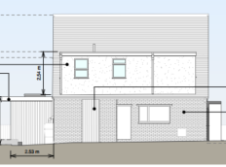

Existing and Proposed Side (north) Elevation

PLANNING HISTORY

None.

The application’s Design and Access Statement notes precedent dormer development at 125 Bradley Road, PL/2021/04141. But as images below show, these dormers are to the rear elevation, not the side, as in this application, and so is not comparable or considered precedent.
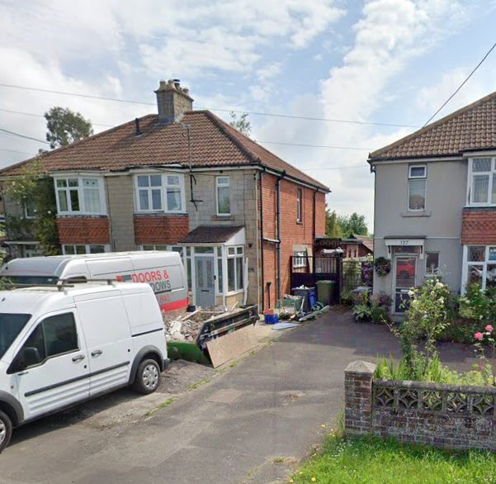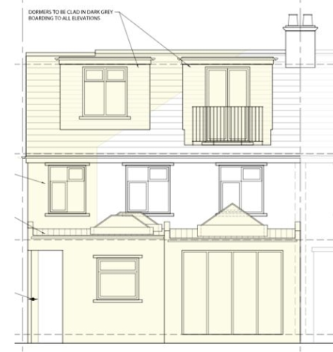

RELEVANT POLICIES AND GUIDANCE

The National Planning Policy Framework (NPPF)
The Planning Practice Guidance
National Design Guide
Wiltshire Design Guide: Appendix D – Design Guidance for Householder extensions

Wiltshire Core Strategy:
- Core Policy 57 Ensuring High Quality Design and Place Shaping

Trowbridge has a designated Neighbourhood Plan Area, but no made plans as yet.
Wiltshire Local Transport Plan 2011-2026, Car Parking Strategy

CONSULTATION RESPONSES
Trowbridge Town Council: No objection.
Highways Department: No objection.

REPRESENTATIONS
No comments were received.

ASSESSMENT

Principle of Development:
Section 70(2) of the Town and Country Planning Act 1990 and section 38(6) of the Planning and Compulsory Purchase Act 2004, require that the determination of planning applications must be made in accordance with the Development Plan, unless material considerations indicate otherwise.

The proposal comprises development to an existing residential property set in an established residential area within the settlement boundary of Trowbridge. The proposal is wholly within the residential curtilage, and as such, the principle of development is acceptable subject to the following considerations.

In accordance with this statutory requirement, this application has been assessed against the relevant policies of the Development Plan, including the adopted Wiltshire Core Strategy (2015) and, where applicable, any made Neighbourhood Plans.

Design and Impact upon the character and context of the area
Core Policy 57 - Ensuring High Quality Design and Place Shaping of the Wiltshire Core Strategy seeks to ensure that all new development is of high design quality, reflecting local context, character, and distinctiveness.

The proposed development seeks to retain the characteristic tall roof pitch but to maximise available floor space with a substantial dormer. Whilst this dormer will impact the character of the dwelling, particularly from the streetscape, altering the scale and outline, this change is not considered harmful to the dwelling or wider area.

During the lifecycle of this application, the proposed side dormer has been reduced in width, such that it is now below the main roof ridge, set back from the front elevation, and eaves, with only two windows to the side elevation and one to the front, making a more subservient, legible addition with reduced visual impact.

The proposed rear extension would be set in from side building lines, of a scale commensurate to the host dwelling and would be of less projection than immediate neighbours. As a rear extension, it would be hidden from the streetscape

The proposal would see the introduction of grey aluminium cladding and windows; details that are evident in the wider area. Vertical cladding is a modern alternative, often chosen to silver and harmonise with the grey windows. Render would upgrade the existing pebbledash and clad the dormer cheeks, aiding integration with the host dwelling.

The subject dwelling has a unique style/scale as a modern infill dwelling, compared to the various surrounding ages, styles, uses and materials. As such, any proposal would struggle to respond to the wider grain of development, which is so disparate.

However, the proposal responds to the host dwelling’s modern style, with a standard form of dormer development, with modern materials that integrate with the host dwelling, whilst also introducing modern materials, which is assessed as appropriate and will continue to define the subject dwelling’s modern aesthetic and narrative.

Having regard to the above, the proposal complies with the design principles set out in Core Policy 57 of the Wiltshire Core Strategy and Appendix D of the Wiltshire Design Guide.

Amenity
Point vii of Core Policy 57 - Ensuring High Quality Design and Place Shaping of the Wiltshire Core Strategy seeks to ensure that developments do not adversely affect neighbouring properties.

The National Planning Policy Framework (NPPF), particularly Paragraph 135(f), stresses that planning decisions should ensure developments provide a high standard of amenity for existing and future users.

The proposed development has been assessed in terms of its potential impact on the residential amenity of neighbouring properties, with particular regard to loss of light, overshadowing, loss of privacy, and overbearing effects.

The rear extension, as a single storey extension, with bifold doors facing down the rear garden, raises no concerns with overshadowing, overbearing or neighbouring privacy.

As the submitted and google earth photos below show, no.53 to the north projects further to the rear than the subject dwelling, with side-facing windows only on the rear section beyond the rear elevation of the subject dwelling.

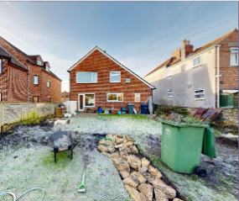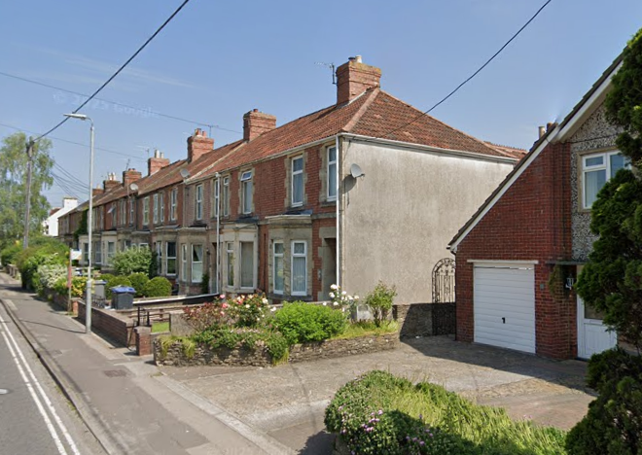

Whilst an image of no. 53 included within the submitted D&A Statement, shows works being completed, there is no planning permission for additional side windows to no.53.

The proposed dormers facing no.53 would include two opaque windows to an office and bathroom. Given the alignment of no.53’s windows, and opaque glazing, these proposed windows would not enable a new vantage point to neighbouring windows but would face a blank wall and so poses no concern to privacy.

For the same reason as above, the proposed dormers do not cause concern regarding light levels to the side elevation of no.53.

The two proposed kitchen rooflights are at a height to not cause any concern to privacy.

The proposal therefore accords with Core Policy 57 point vii in respect of safeguarding residential amenity and Appendix D of the Wiltshire Design Guide.

Highways Impact
Core Policy 57 (xiv) of the Wiltshire Core Strategy seeks to ensure that development must meet the requirements of Core Policy 61. This policy requires proposals to be capable of being served by safe access to the highway network. Core Policy 64 seeks to ensure compliance with parking standards set out in the Local Transport Plan.

The National Planning Policy Framework (NPPF), particularly Paragraph 115 and 116, requires that development proposals do not have an unacceptable impact on highway safety and that safe and suitable access to the site can be achieved for all users.

Wiltshire’s Local Car Parking Strategy dictates a 4+bedroom dwelling requires 3 off-street parking spaces.

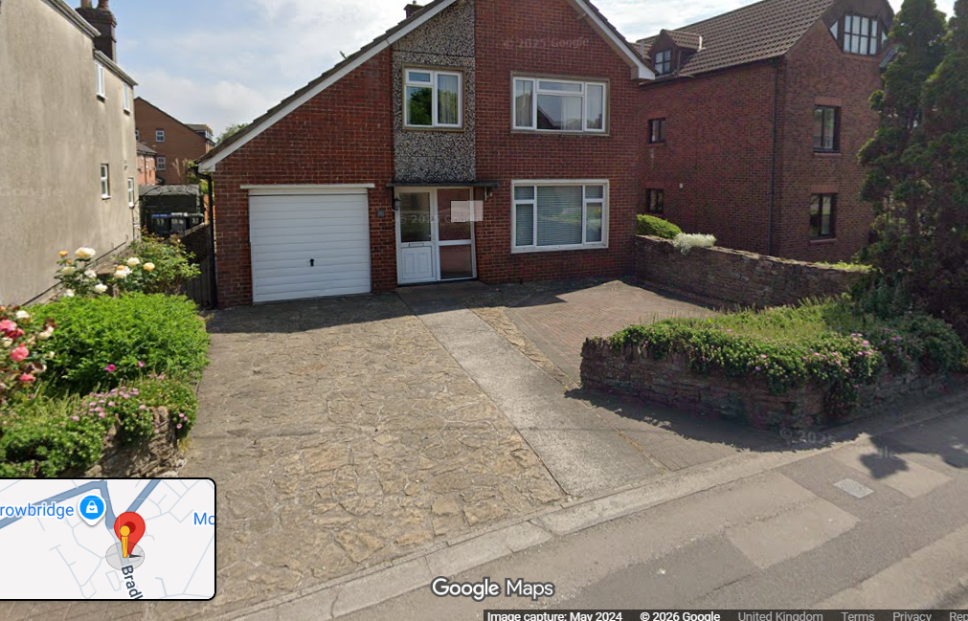

A latterly submitted revised block plan confirms that by the removal of the highway-fronting low-level wall, there is existing off-street parking for 3 vehicles and so provides sufficient parking provision. An informative is considered necessary regarding licence to drop a kerb.

The proposed development would therefore not result in any adverse impact on highway safety. Adequate parking and turning provision is provided in accordance with Wiltshire’s adopted parking standards, and access arrangements are acceptable.

The proposal is therefore considered to comply with Core Policies 57 (xiv), 61 and 64 of the Wiltshire Core Strategy, the NPPF, and the Wiltshire Local Transport Plan.

Biodiversity Net Gain
Householder planning applications are exempt from the requirement to deliver Biodiversity Net Gain under Schedule 7A, Section 4(2)(a) of the Town and Country Planning Act 1990, as inserted by the Environment Act 2021.

CONCLUSION
The proposed development is considered to be acceptable in terms of its design, scale, and relationship with the surrounding area. It would not result in any unacceptable harm to the character of the locality, the amenities of neighbouring occupiers, or the interests of highway safety, heritage, or ecology.

The proposal is therefore considered to comply with the relevant policies of the Wiltshire Core Strategy, the Wiltshire Local Plan, and the National Planning Policy Framework. As such, the application is recommended for approval, subject to conditions.

RECOMMENDATION: That Planning Permission be GRANTED subject to conditions.

