APPLICATION FOR ADVERTISEMENT CONSENT
CASE OFFICER REPORT

APPLICATION REFERENCE: | PL/2026/02959
APPLICATION TYPE: | Wiltshire Council R3
SITE ADDRESS: | Wiltshire Council, Monkton Park, Chippenham, SN15 1ER
DEVELOPMENT DESCRIPTION: | Display of a Progressive Pride flag annually between 1 June and 30 June for a period of 5 years.
RECOMMENDATION: | Approve with Conditions

SITE DESCRIPTION/CONTEXT
The application site comprises Monkton Park in Chippenham, a Wiltshire Council building. The flagpole is already in place and has been used to fly various flags over many years.

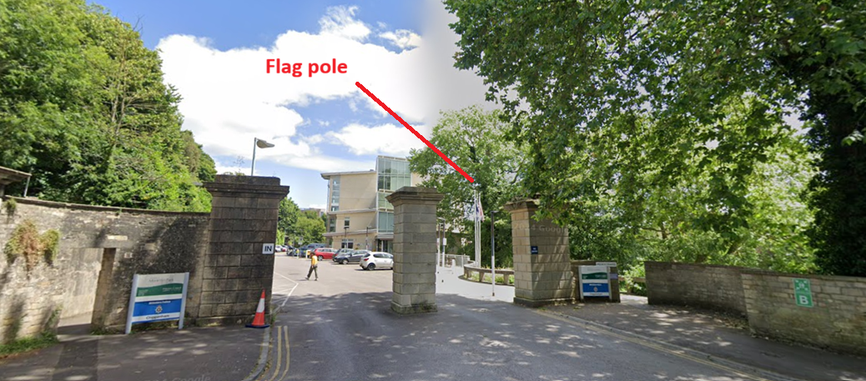

The flagpole is within the Conservation Area and sits 15m inside the Grade II listed gate piers (above) which is the nearest listed structure. The site is not within a special landscape area, and is seen within the urban context of town centre Council offices.

PROPOSAL:

The application seeks advertisement consent to display of a Progressive Pride flag annually between 1 June and 30 June for a period of 5 years.

The proposed flag constitutes an advertisement under the Town and Country Planning (Control of Advertisements) (England) Regulations 2007. Whilst certain flags benefit from deemed consent, including the “rainbow flag” as specifically defined within Class 7, this relates only to a flag comprising six horizontal stripes and does not extend to the “Progress” Pride flag, which incorporates an additional chevron device and therefore falls outside the scope of that exemption.

Furthermore, where flag advertisements are displayed on freestanding flagstaffs within a site, the Regulations impose a height restriction of 4.6 metres; in this instance the flagstaff measures approximately 8 metres in height and therefore exceeds the threshold for deemed consent. As such, express advertisement consent is required.

In the absence of consent, the fallback position would be limited to flags which either comply with the prescribed designs (including the standard rainbow flag only) and/or are displayed on flagstaffs that meet the relevant height limitations.

RELEVANT LEGISLATION, POLICIES AND GUIDANCE

The Town and Country Planning (Control of Advertisements) (England) Regulations 2007

National Planning Policy Framework (NPPF)
- Paragraph 141

Planning Practice Guidance (PPG)
- Advertisements

Wiltshire Core Strategy 2015 (WCS):
- Core Policy 57 Ensuring High Quality Design & Space Shaping
- Core Policy 58 Ensuring the Conservation of the Historic Environment
- Core Policy 62 Development Impacts on the Transport Network

Neighbourhood Plan:
Chippenham Neighbourhood Plan 2023 to 2038. Made May 2024

Supplementary Planning Documents:
Wiltshire Design Guide (2024)

Institute of Lighting Professionals: The Brightness of Illuminated Advertisements (2014) PLG 05.

Flying flags: a plain English guide – June 2021

RELEVANT PLANNING HISTORY:

Proposal / Summary
N/10/01988/ADV - Consent to display an advertisement Decision - Approve with Conditions Date: 4/8/2010 – Display of Armed Services Day Flag Outside Council Offices
PL/2022/05115 - Full planning permission Decision - Approve with Conditions Date: 26/9/2022 – Installation of commercial advertising signage to display the location of Good Energy's offices within the Monkton Park Offices building, consisting of: the erection of a flagpole with flag featuring commercial design as an addition to the existing row of flagpoles; and the installation of freestanding signage adjacent to the pedestrian entrance to the Monkton Park Offices site.
PL/2022/05382 - Consent to display an advertisement Decision - Approve with Conditions Date: 26/9/2022 – Installation of commercial advertising signage to display the location of Good Energy's offices within the Monkton Park Offices building, consisting of: the erection of a flagpole with flag featuring commercial design as an addition to the existing row of flagpoles; and the installation of freestanding signage adjacent to the pedestrian entrance to the Monkton Park Offices site.

ISSUES

The issues that are relevant to the consideration of an application for consent to display advertisements are the effects of the proposal on ‘amenity’ and ‘public safety’.

CONSULTEE RESPONSES

The following consultees were invited to comment on this application:

Town Council: No objection

RESPRESENTATIONS
Below is a summary of the representations received during the consultation period. Only material planning considerations have been taken into account in the assessment of this application. Non-material issues, such as property values or private legal disputes, cannot be considered in the determination process.

A total of three representations have been received in respect of the application, comprising objections, with two submissions from the same correspondent. The objections raise concerns that the proposed flag represents a political or ideological symbol and that its display on a council building would not reflect the perceived need for neutrality in civic spaces. Concerns are also expressed that the display could contribute to division within the community or create a perception of bias.

One representation also raises concerns regarding the description of the proposal and whether it accurately reflects the intended duration and manner of display. Reference is made to government guidance on the flying of flags and the use of alternative civic flags.

In planning terms, the material considerations arising from the consultation responses relate primarily to the potential impact of the proposed display on the character and appearance of the site and immediate surroundings, together with any implications for public safety, which according to MHCLG guidance means safety on the roads and other modes of transport.

All other matters raised, including wider issues relating to political, ideological, or social considerations, as well as matters of governance or cost, are noted but fall outside the scope of material planning considerations and are not afforded weight in the determination of the application.

ASSESSMENT
Regulation 3 of The Town and Country Planning (Control of Advertisements) (England) Regulations 2007 requires that local planning authorities exercise their powers in relation to the display of advertisements in the interests of amenity and public safety, taking into account the provisions of the development plan, in so far as they are material, and any other relevant factors.

The NPPF (141) is clear that the quality and character of places can suffer when advertisements are poorly sited and designed and should be subject to control only in the interests of amenity and public safety, also considering the cumulative impacts.

The application relates to the flying of a flag on an existing flagpole. The government’s guidance is that more flags should be flown, as they are a very British way of expressing joy and pride and emotive symbols which can boost local and national identities, strengthen community cohesion and mark civic pride. However, the flying of flags is controlled as advertisement to ensure that they do not adversely impact amenity or public safety.

Some flags require express consent from the Local Planning Authority (LPA), whereas others benefit from “deemed consent”, and in either case they are subject to conditions. Examples of flags benefitting from deemed consent are the Union Flag, the flag of the United Kingdom, and the Rainbow flag, otherwise known as the “Pride” flag, designed by Gilbert Baker.

This application is made for the display of the “Progress Pride” flag, designed by Daniel Quasar. This flag is an updated version of the Rainbow flag that includes additional colours and shapes to represent wider communities. Having regard to Schedule 3 of the Regulations, express consent is required for the flying of the Progress Pride flag.

Regulation 3(4) states that, unless it appears to the local planning authority to be required in the interests of amenity or public safety, an express consent for the display of advertisements shall not contain any limitation or restriction relating to the subject matter, content or design of what is to be displayed.

Furthermore, the Planning Practice Guidance advises that, unless the nature of the advertisement is in itself harmful to amenity or public safety, consent cannot be refused because the LPA considers the advertisement to be misleading (in so far as it makes misleading claims for products), unnecessary or offensive to public morals.

Notwithstanding the above, and while it is its effect on amenity and public safety that are determinative, regard is to be had to the Public Sector Equality Duty (PSED) contained in Section 149 of the Equality Act 2010. This sets out that, in the exercise of its functions, the LPA must have due regard to the need to, among other things, eliminate unlawful discrimination, harassment and victimisation, advance equality of opportunity and foster good relations between people who share a protected characteristic and people who do not share it.

Impact on Amenity:
Policy Context
“Amenity” is not exhaustively defined in the Town and Country Planning (Control of Advertisements) (England) Regulations 2007, but is generally understood to include both visual and aural amenity. Factors relevant to amenity include the general characteristics of the locality, such as the presence of features of historic, architectural, cultural, or similar interest.

In broader planning terms, as reflected in the National Planning Policy Framework (NPPF), amenity refers to the quality or character of an area and the elements that contribute to the overall enjoyment and liveability of a place.

CP57 requires a high standard of design in all proposals, including (x) the sensitive design of advertisements and signage.

Assessment

The flag would be flown during the month of June, for a period of five years. This aligns with the inclusive identity of the Council, respecting each other’s differences and valuing the benefits they bring. This flag would join the Council’s ability to fly various flags as part of its rotation of highlighting various issues, and as such would not result in any harm to public amenity.

The flagpole is already in place and has flown various flags over many years. This flag would not present any additional impact to the setting of heritage assets over the existing situation of flying other flags in this location. This would not be an additional flag, but rather it would replace an existing one for parts of, or the whole of, the month of June.

It is considered that the proposed advertisement would cause no harm to the visual amenity of the area, including the setting of any heritage assets, and would therefore comply with the relevant provisions of the Town and Country Planning (Control of Advertisements) Regulations 2007.

Impact on Public Safety:
Policy Context
“Public safety” is not exhaustively defined in the Town and Country Planning (Control of Advertisements) (England) Regulations 2007, but it generally refers to the potential impact of a development or advertisement on the safe use and operation of public spaces, including roads, footpaths, and other areas accessible to the public.

In assessing public safety, the Local Planning Authority (LPA) may consider:
- Whether the proposal would obstruct visibility for road users or pedestrians;
- Whether it could distract, confuse, or mislead drivers, particularly near junctions or crossings;
- Whether it interferes with traffic signs, signals, or street lighting;
- Whether it poses a physical hazard, such as through poor structural integrity or inappropriate siting.

The National Planning Policy Framework (NPPF) also supports the principle that planning decisions should ensure developments create places that are safe, inclusive, and accessible, and that they do not undermine public safety or security.

CP62 advises that proposals should provide appropriate mitigating measures to offset any adverse impacts on the transport network at both the implementation and operational stages.

Assessment

The flagpole is located 25m back from the highway. In between the flagpole and the highway are the Grade II listed gate piers. This means that views of the flag from the highway are filtered, and therefore would not interact readily with the highway and consequently would have no impact on the safety of the public. There would be no additional illumination.

The flag would be proportionate to the size of the flagpole and therefore would fit within its setting; the flagpole stands away from other existing signage. Therefore, there would be no cumulative impact from this flag on the wider issue of public safety.

It is considered that the proposal would not result in an unacceptable impact on public safety, either individually or cumulatively, and would therefore satisfy the relevant provisions of the Town and Country Planning (Control of Advertisements) Regulations 2007.

Other Matters:

The material considerations raised by the public representations have either been dealt with above, or commented on as follows:

As to whether the description of the application is accurate in terms of the duration of the display, the application seeks consent to display between the dates of 1st – 30th June each year for five years. The granting of consent would not bind the Council to display the flag the whole of each June. Rather, it gives the flexibility to display the flag on any days within that date range.

CONCLUSION:

The proposed advertisement (flag) has been assessed in accordance with the relevant provisions of the Town and Country Planning (Control of Advertisements) (England) Regulations 2007.

It is considered that the flag, by reason of its design, scale, siting, and method of illumination, would not result in harm to the visual amenity of the area, including the setting of any nearby heritage assets. Furthermore, the proposal is not considered to pose a risk to public safety, either individually or cumulatively with other signage in the vicinity.

Subject to the recommended conditions, the proposal is therefore considered acceptable and it is recommended that advertisement consent be granted.

RECOMMENDATION:
It is recommended that advertisement consent be GRANTED subject to condition(s).

1. The Progress Pride flag hereby approved shall only fly between the dates 1st June – 30th June inclusive. This consent shall expire at the end of the period of five [5] years from the date of this Notice.

REASON: To comply with Regulations 14 (7) and (8) of the Town and Country Planning (Control of Advertisements) (England) Regulations 2007.

2. The development hereby permitted shall be carried out in accordance with the following approved plans:

Application Forms, Location Plan, Progress Pride Flag detail received on 7th May 2026

REASON: For the avoidance of doubt and in the interests of proper planning.

