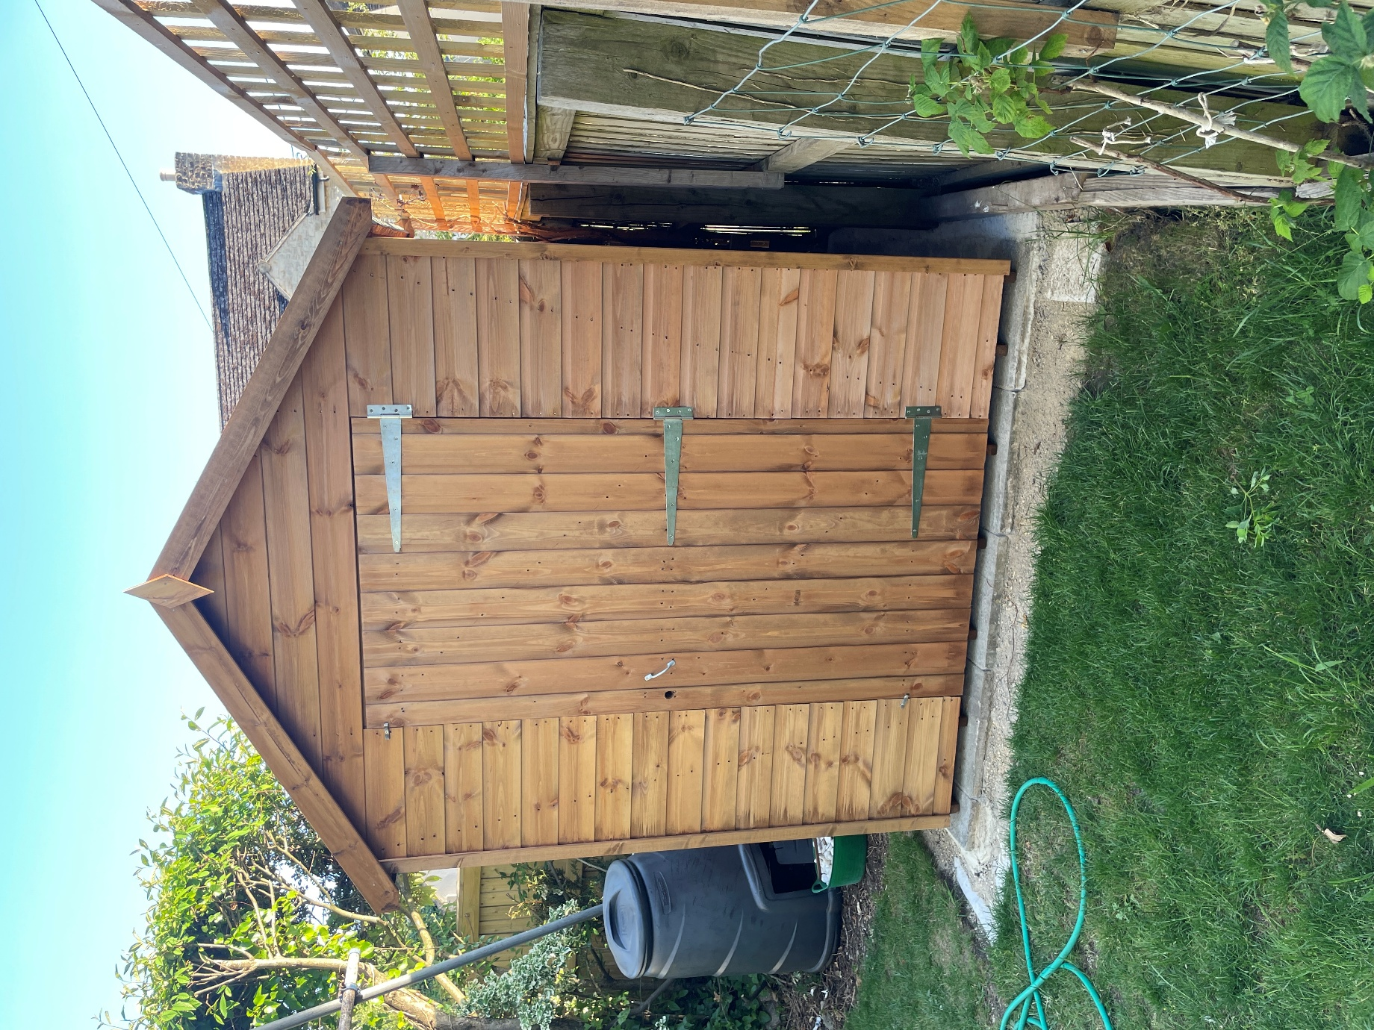
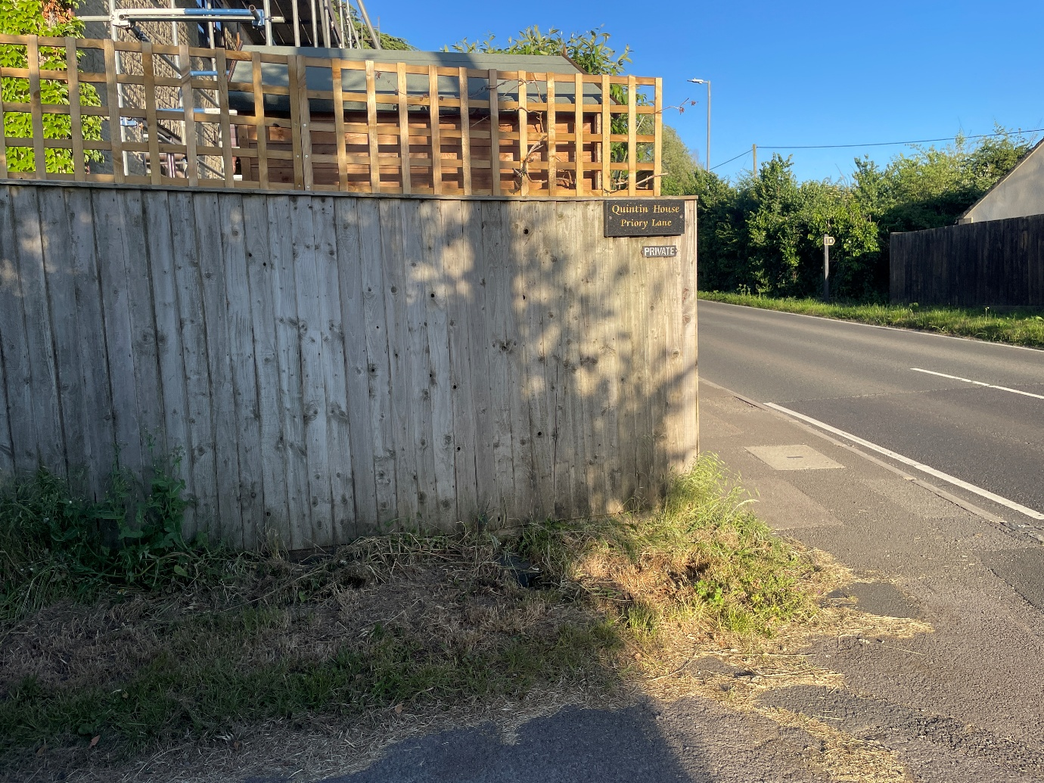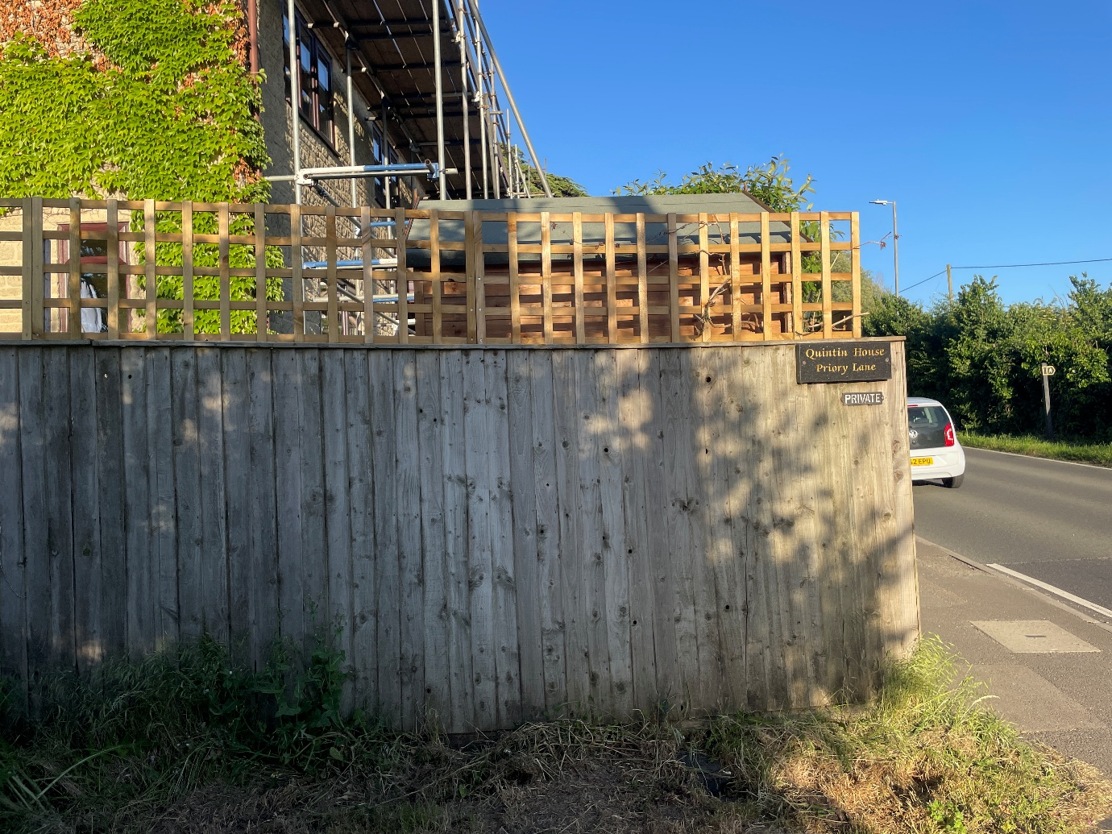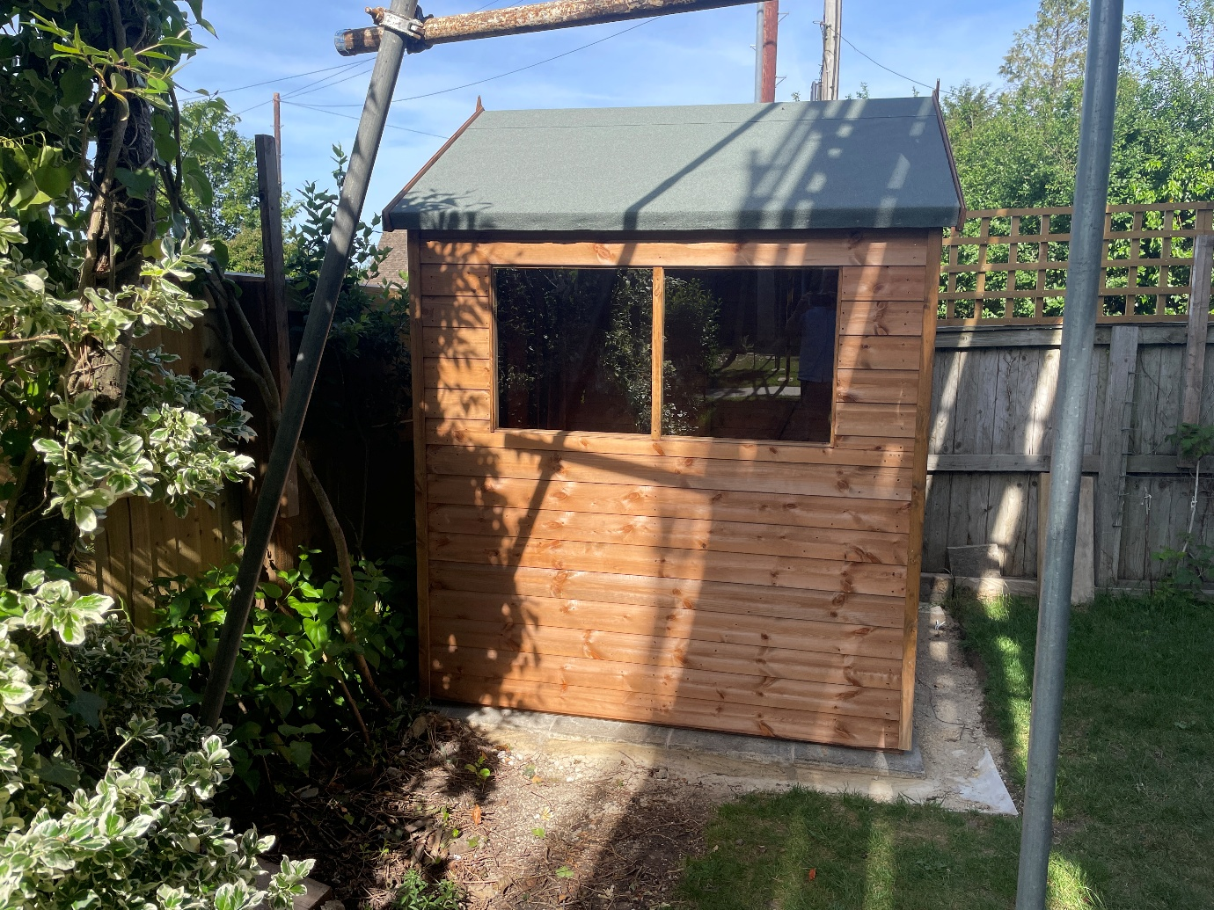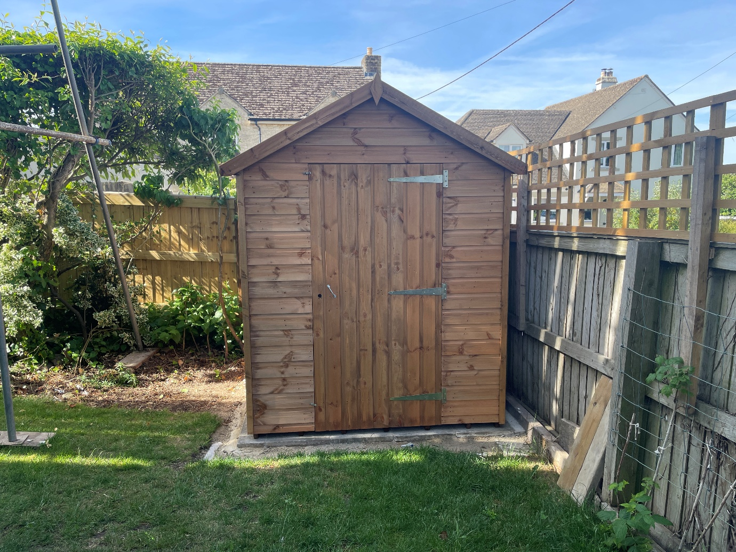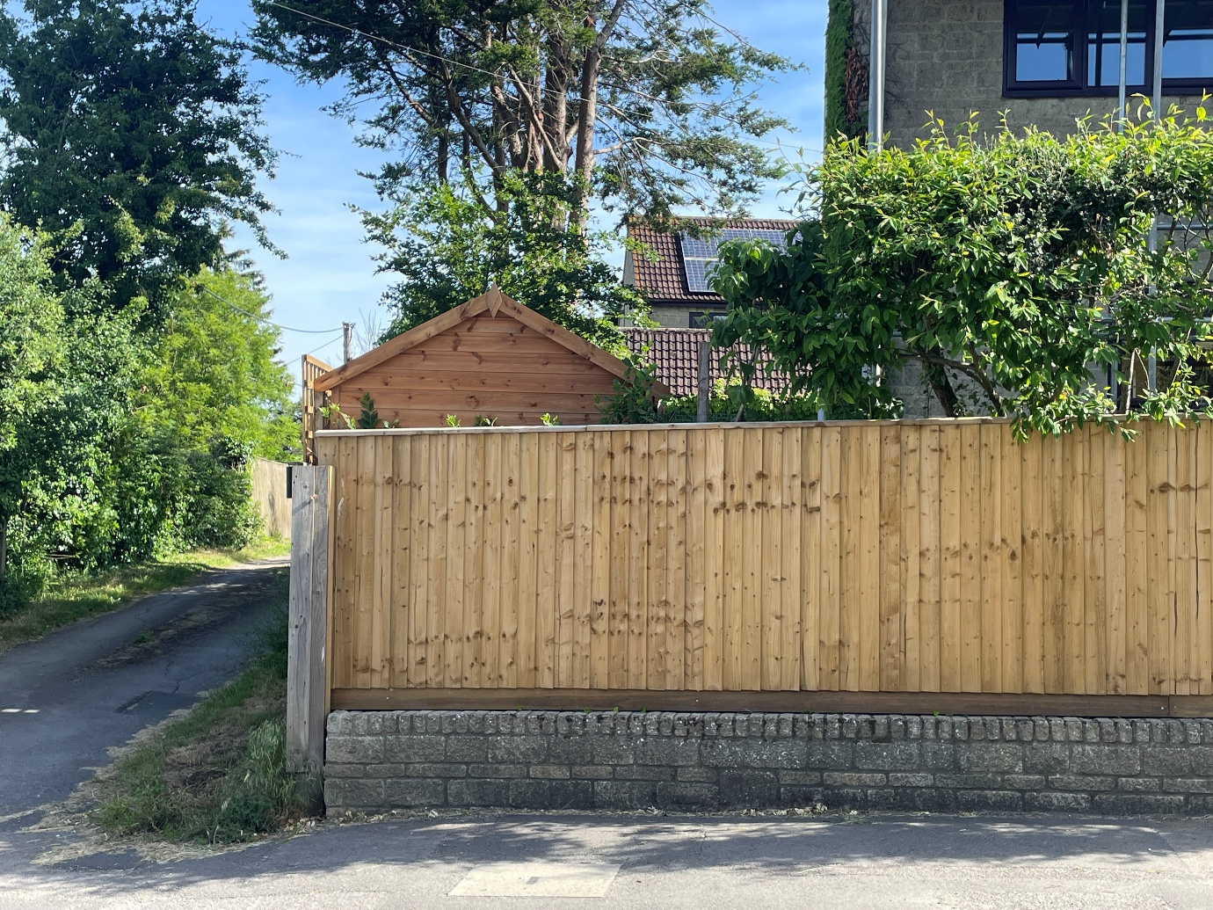
The Cedars: Garden Shed (Images sheet 1 – 30/05/26)
The Cedars: Garden Shed (Images sheet 2 – 30/05/26)
The Cedars: Garden Shed (Images sheet 3 – 30/05/26)

