The Cedars: Garden Shed
Detailed location plan (not to scale)
Date: 30/05/26

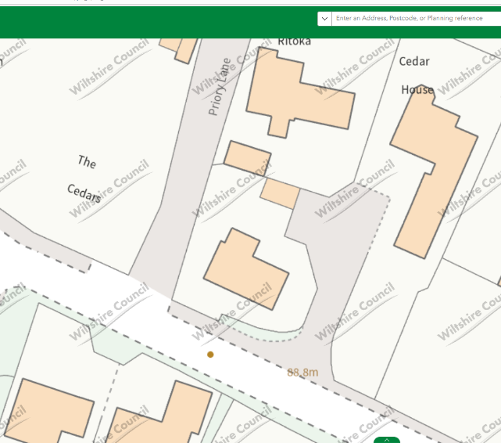
Shed location within garden plot

Panel fence and trellis (circa 2.25m)

Existing garden vegetation and hedgerow

