HOUSEHOLDER PLANNING APPLICATION.
CASE OFFICER REPORT

APPLICATION REFERENCE: | PL/2026/02247
APPLICATION TYPE: | Householder
SITE ADDRESS: | The Elms, 10 Gullivers Lane, Steeple Ashton, Trowbridge, Wiltshire, BA14 6EQ.
DEVELOPMENT DESCRIPTION: | Retrospective application for the erection of 2 rear extensions, and the replacement of existing windows and doors
RECOMMENDATION: | Approve with Conditions.

PROPOSAL
The proposal seeks retrospective planning permission for the construction of two rear single storey extensions and for the replacement of existing windows and doors.

SITE DESCRIPTION/CONTEXT
The existing dwelling is a bungalow located along Gullivers Lane, in the Large Village of Steeple Ashton, within an established residential area with similar styled dwellings. The site is not in a Conservation Area.

RELEVANT PLANNING HISTORY
Proposal / Summary
03/02029/FUL To demolish a derelict shed to construct a single storey side kitchen and utility room extension the utility room to contain a wc/wash basin. Approved.
05/02581/FUL 2 bedroom loft conversion to bungalow with porch to front pitched roof extended over garage and also future conservatory. Refused.
06/00721/FUL Two bedroom loft conversion with increased pitched roof extended over garage with hipped end, porch to front and conservatory to rear. Refused.

RELEVANT POLICIES AND GUIDANCE

Wiltshire Core Strategy:

- Core Policy 50: Biodiversity and Geodiversity
- Core Policy 57 Ensuring High Quality Design and Place Shaping
- Core Policy 61: Transport and New Development
- Core Policy 64: Demand Management

Steeple Ashton ‘Emerging’ Neighbourhood Plan

Wiltshire Design Guide: Appendix D – Design Guidance for Householder extensions

The National Planning Policy Framework (NPPF)

The Planning Practice Guidance

National Design Guide
Emerging Wiltshire Local Plan:
At Full Council on 19 May 2026, the elected members of Wiltshire Council agreed to withdraw the emerging Wiltshire Local Plan. It will now be subject to a legal process to finalise its withdrawal - which is likely to happen in July or August (2026). The said Plan has no material weight for the purposes of this application.

CONSULTATION RESPONSES
Steeple Ashton Parish Council: No objections.

REPRESENTATIONS: Three emails of representation were received from neighbours, with two neighbours being in support and one neighbour raising areas of concern.

-Supportive comments were received stating that the works fitted in with much of the rest of the street and serving to tidy up a tired site in need of care.
-Proposals would make the property more attractive and in keeping with the plot and would also be in context with the two neighbouring properties either side.
-Areas of concern related to the cumulative scale of development being excessive and out of character. The development was also considered to be close to the boundary and being dominant and overbearing. There was also concern of the extension being close to sewer.

PRINCIPLE OF THE PROPOSAL.
The principle of the proposed scheme is considered to be acceptable for the reasons as discussed below.

ASSESSMENT
Section 38(6) of the Planning and Compulsory Purchase Act 2004 states:

"If regard is to be had to the development plan for the purposes of any determination to be made under the planning Acts, the determination must be made in accordance with the plan unless material considerations indicate otherwise."

In accordance with this statutory requirement, this application has been assessed against the relevant policies of the Development Plan, including the adopted Wiltshire Core Strategy (2015).

Design and Impact upon the upon the character and context of the area

Core Policy 57 - Ensuring High Quality Design and Place Shaping of the Wiltshire Core Strategy seeks to ensure that all new development is of high design quality, reflecting local context, character, and distinctiveness.

The proposals can be viewed within the plan snippets taken from the submitted plans:
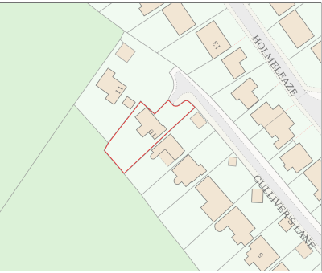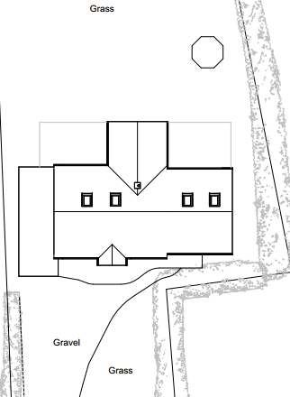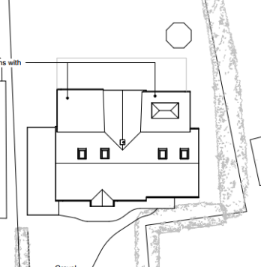
Location Plan Existing & Proposed Site Plans.

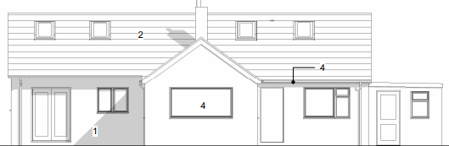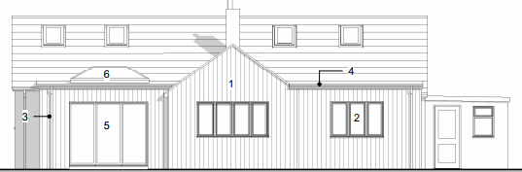
Existing & Proposed North rear Elevations.

It is understood that works have commenced on the scheme but have ceased whilst permission is sought. The proposals consist of two small sized single storey additions to the rear of the property at either side of the centrally located living room extension, which would serve to enlarge an existing bedroom and dining room area. The scheme would serve to even up or ‘square off’ the final rear elevation of the dwelling. Such proposals would be set away from and would not impact on or alter the existing boundaries of the site.

In terms of materials, the proposal would create two lightweight extensions that would be framed in natural timber and finished with vertical timber cladding. To create a sense of continuity, the timber boarding would be extended over the central bay of the house, as well as the two proposed extensions on the rear elevation.

The existing roof height of the bungalow is low and so consequently its eaves heights are also low. The new extensions being flat roofed would meet the existing principal roof slightly above the eaves, this being in order to create a usable head height in the rooms with current insulation standards in the roof.

Therefore, in summary, having regard to the above, the proposal complies with the design principles set out in Core Policy 57 of the Wiltshire Core Strategy and Appendix D of the Wiltshire Design Guide.

Amenity
Point vii of Core Policy 57 - Ensuring High Quality Design and Place Shaping of the Wiltshire Core Strategy seeks to ensure that developments do not adversely affect neighbouring properties. The National Planning Policy Framework (NPPF), particularly Paragraph 135(f), stresses that planning decisions should ensure developments provide a high standard of amenity for existing and future users.
The proposed extensions would serve to visually tidy up the rear elevation of the property, albeit the rear of the dwelling is not visible from the public realm. The proposals would be single storey with the two new windows looking directly onto the site’s rear garden area, and not impacting on neighbouring amenity.
Due to the location, orientation and separation distances of the proposals, there would not be any significant overshadowing or loss of light to the most immediate neighbour at No.11.

The proposal therefore accords with Core Policy 57 point vii. in respect of safeguarding residential amenity and Appendix D of the Wiltshire Design Guide.

Ecology Impact CP50 requires no net loss of biodiversity on site. The site is located within the Bath and Bradford on Avon Bat SAC and also within the grey/yellow hatched zone of the Trowbridge Westbury Bat Mitigation Strategy Area. The proposed development because of its minor nature and minimal impact on the existing roof structure within an established residential urbanised location is considered unlikely to result in harm to bats or their habitat. There is no mechanism for significant effects from recreational pressure since it does not result in the creation of a new dwelling. Accordingly, the proposal is acceptable in this regard. As such, the development complies with Core Policy 50 of the Wiltshire Core Strategy and the relevant provisions of the NPPF.

Biodiversity Net Gain. This application is exempt from the requirement to deliver Biodiversity Net Gain under Schedule 7A, Section 4(2)(a) of the Town and Country Planning Act 1990, as inserted by the Environment Act 2021, because the proposal is a householder extension.

Other Matters. Third party comments have been received regarding the possibility that the extension may be in close proximity to existing foul drains. It is not standard procedure to consult with Wessex Water for small scale householder development, such as this current scheme, with the onus being on Building Control to control and oversee such matters, as they have jurisdiction on such matters.

CONCLUSION
The proposed development is acceptable in terms of its design, scale, and relationship with the surrounding area. It would not result in any unacceptable harm to the character of the locality, the amenities of neighbouring occupiers, or the interests of highway safety, heritage, or ecology.

The proposal is therefore considered to comply with the relevant policies of the Wiltshire Core Strategy, the Wiltshire Local Plan, and the National Planning Policy Framework. As such, the application is recommended for approval, subject to the conditions set out below.

RECOMMENDATION: Planning Permission be GRANTED subject to conditions.

