APPLICATION FOR FULL PLANNING PERMISSION
DELEGATED REPORT

APPLICATION REFERENCE: | PL/2026/00028
APPLICATION TYPE: | Full Planning Permission
SITE ADDRESS: | Land adjacent 36, Bath Road, Bradford on Avon, BA15 1SR
DEVELOPMENT DESCRIPTION: | Part demolition of existing buildings and erection of two dwellings (use class C3) including parking, landscaping and associated works.
RECOMMENDATION: | That Planning Permission be GRANTED

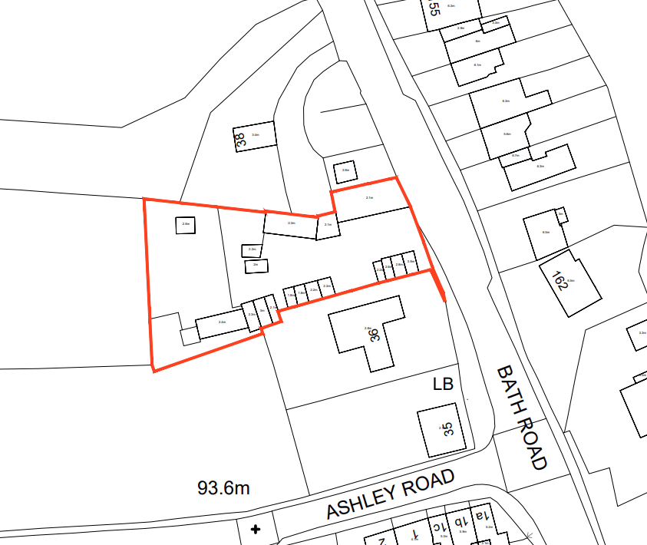

PROPOSAL

The proposal seeks full planning permission for the partial demolition of a number of existing commercial garages, sheds, stables and storage structures on the site, followed by the construction of two detached dwellings (Use Class C3), together with associated parking, landscaping and access improvements. As set out in the Design and Access Statement, the scheme includes the relocation and enhancement of the primary access onto Bath Road (A363), the reconfiguration of visibility splays through partial demolition of the northern barn, and the retention of access to the existing dwelling at 36 Bath Road. Each proposed dwelling is two storeys in height, with private gardens, external stores and on‑plot parking.

SITE DESCRIPTION / CONTEXT

The application site comprises 0.15 hectares of land associated with and located to the rear of 36 Bath Road, situated immediately outside the Bradford on Avon Settlement Boundary and within the West Wiltshire Green Belt. It sits around 21 metres north of the designated Bradford on Avon Conservation Area and approximately 29 metres north of the Grade II listed Bath Road Post Office, with the surrounding area characterised by a mix of traditional stone dwellings and mid-20th-century residential development along Bath Road. The site currently accommodates a collection of ageing and ad hoc outbuildings, with land levels generally rising westwards toward the Bearfield Recreation Ground, designated as Local Green Space. The site lies within several bat consultation zones, including GHS and LHS roost buffer areas, and falls within Flood Zone 1, although the Strategic Flood Risk Assessment identifies a low-probability (0.1% AEP) surface water flow route along the site access. The land is adjacent to and accessed directly from the A363 (30mph) and lies within Special Landscape Area SLA7 as defined by saved Policy C3 of the West Wiltshire Local Plan.

The application site is subject to the following planning policy constraints:

- West Wiltshire Green Belt
- 21m North - Bradford on Avon Conservation Zone (CA/W/31)
- 29m North - Bath Road Post Office – Grade II Listed Building (1300968)
- GHS 4km Core Roost Buffer
- GHS 4km SAC Parcel Buffer
- LHS 2km Core Roost Buffer
- Class A Highway Bath Road (A363) 30mph
- Bradford on Avon Neighbourhood Plan (2013-2026)
- Strategic Flood Risk Assessment (sFRA) indicates 0.1% AEP surface water flood risk.
- Flood Zone 1.
- Outside the Bradford on Avon Settlement Boundary.
- Special Landscape Area SLA7.

PLANNING HISTORY

Reference No. | Proposal / Summary | Decision
W/89/01322/FUL | Erection of rugby clubhouse incorporating a community room | APPROVED
20/06975/FUL | Redevelopment of Land adjacent to 36 Bath Road to provide 4 x 2 Bedroom Residential Dwellings | WITHDRAWN
W/11/01975/FUL | Single storey first floor extension over central wing of dwelling | APPROVED

RELEVANT LEGILSATION, POLICIES AND GUIDANCE

Wiltshire Core Strategy:

Core Policy 1 Settlement Strategy;
Core Policy 2 Delivery Strategy;
Core Policy 3 Infrastructure Requirements
Core Policy 7 Spatial Strategy: Bradford on Avon Community Area;
Core Policy 35 Existing Employment Sites;
Core Policy 41 Sustainable Construction and Low Carbon Energy;
Core policy 45 Meeting Wiltshire’s Housing Needs
Core Policy 48 Supporting Rural Life;
Core Policy 50 Biodiversity and Geodiversity;
Core Policy 51 Landscape;
Core Policy 57 Ensuring High-Quality Design and Place Shaping;
Core Policy 58 Ensuring Conservation of the Historic Environment;
Core Policy 60 Sustainable Transport;
Core Policy 61 Transport and Development;
Core Policy 64 Demand Management;
Core Policy 67 Flood Risk;

Bradford on Avon Neighbourhood Plan 2013-2026

The National Planning Policy Framework (NPPF)

The Planning Practice Guidance (PPG)

Wiltshire Design Guide

The Wiltshire Local Transport Plan 2011 – 2026: Car Parking Strategy (March 2015).

The Wiltshire Local Transport Plan 4 (LTP4) (March 2025)

Saved Policies - West Wiltshire District Plan
C3 Special Landscape Area
GB1 Green Belt

Emerging Policy – Wiltshire Local Plan Review
At Full Council on 19 May, the elected members of Wiltshire Council agreed to withdraw the emerging WLP. It will now be subject to a legal process to finalise its withdrawal - which is likely to happen in July or August (2026). The said Plan has no material weight for the purposes of the application.

CONSULTATION RESPONSES

Bradford on Avon Town Council – Objects
The proposed two‑storey dwellings would urbanise the site, harm the openness of the Green Belt, and adversely affect the character and setting of the nearby Conservation Area. They also highlight that the land adjoins designated Local Green Space, and the scheme conflicts with neighbourhood plan policies intended to prevent sprawl and protect open land. Additionally, they note the site’s proximity to the Bath & Bradford on Avon Bat SAC and state that the LPA must be satisfied that sufficient ecological survey information has been provided.

Conservation (Wiltshire Council) – Objects
Conservation officers acknowledge that revised plans address earlier concerns by retaining both Building A and Building L, thereby better reflecting the historic farmstead character of the site. However, they maintain concerns that the overall bulk and extent of new development toward the rear of the site would further urbanise the former agricultural plot and erode its contribution to the rural setting and character of the Conservation Area. As such, amendments are sought to reduce the impact of development on the historic form and spatial hierarchy of the site.

Ecology (Wiltshire Council) – No Objection (subject to conditions)
Following submission of updated ecological information, the Council’s ecologist raises no objection to the proposal subject to conditions. It is confirmed that the development would not result in adverse effects on the Bath and Bradford-on-Avon Bats SAC, with no removal of core bat habitat, no external lighting proposed, and suitable habitat mitigation and biodiversity enhancements secured by condition. The application is therefore screened out of the requirement for an Appropriate Assessment under the Habitats Regulations.

Public Protection (Wiltshire Council) – No Objection (subject to conditions)
Request conditions to control noise, dust, and general disturbance during demolition and construction, including submission of a Construction and Environmental Management Plan, restricted working hours, and a prohibition on burning on site. They also require a condition to address any unexpected land contamination that may be discovered during the works to ensure the development remains safe for future occupants and neighbours.

Drainage (Wiltshire Council) – No Objection (subject to condition)
Pre‑commencement condition requiring a full surface‑water drainage strategy, including evidence of water re‑use considerations, water‑quality treatment calculations, detailed SuDS construction drawings, and a manhole/inspection chamber schedule.

Local Highway Authority (Wiltshire Council) – No Objection (subject to condition)
Following revised plans which retain the barn along the Bath Road frontage, the Local Highway Authority confirms no objection to the development subject to conditions. While the retained structure slightly reduces visibility to the north so that splays extend to the road centreline only, this is considered acceptable given the existing use of the access, the absence of recorded highway safety issues, and the low likelihood of overtaking at this location. Conditions are recommended to secure the access works, parking and turning provision, surface treatment, drainage control, and ongoing visibility splays in the interests of highway safety.

REPRESENTATIONS

A total of five representations were received from members of the public and local amenity groups. These comprise two comments raising matters for consideration (neutral/neither clearly supporting nor objecting) and three formal objections.

Two comments were received raising matters for consideration, primarily focused on ecology, residential amenity and technical matters rather than opposing the principle of development. These representations highlighted the importance of protecting existing hedgerows as wildlife corridors, particularly for bats and hedgehogs, and the need to maintain dark flight routes through careful control of external lighting. Requests were made for biodiversity enhancements such as swift bricks, bird boxes, hedgehog permeability within boundary treatments, and the retention of existing trees and hedgerows. Additional concerns were raised regarding foul drainage capacity and potential noise impacts from ground‑source heat pumps, with requests for reassurance that these matters would not result in harm to neighbouring amenity.

Three objections were received, including one from the Bradford on Avon Preservation Trust, raising fundamental concerns regarding the appropriateness of the development. These objections cite conflict with Green Belt policy due to loss of openness and the introduction of two‑storey domestic development into a visually open and semi‑rural site. Concern is also raised that the scale, massing and domestic character of the proposed dwellings would urbanise the site and harm the rural setting of the Conservation Area and the historic town, with particular reference to public views from Ashley Road, Bearfield Recreation Ground and nearby footpaths.

Further objections relate to heritage impacts, asserting that the site and its traditional agricultural buildings form part of a historic farmstead and should be treated as non‑designated heritage assets whose significance is increased by their contribution to the landscape and setting of the Conservation Area. It is argued that demolition or substantial alteration of these structures would cause harm to local character, contrary to heritage policy. The objectors also reiterate objections on settlement boundary grounds, stating that the site lies outside the defined settlement and is designated Green Belt and Local Green Space, and is therefore unsuitable for new residential development.

ASSESSMENT

Section 38(6) of the Planning and Compulsory Purchase Act 2004 states:

"If regard is to be had to the development plan for the purposes of any determination to be made under the planning Acts, the determination must be made in accordance with the plan unless material considerations indicate otherwise."

In accordance with this statutory requirement, this application has been assessed against the relevant policies of the Development Plan, including the adopted Wiltshire Core Strategy (2015) and, where applicable, any made Neighbourhood Plans.

Principle of Development

The application site lies outside, but adjoining, the defined settlement boundary of Bradford on Avon, which is identified as a Market Town within the Wiltshire Core Strategy. The proposal comprises two new dwellings positioned between existing residential properties at Nos. 36 and 38 Bath Road, within a gap of approximately 41.5 metres. Bath Road is a principal approach route into the town, with continuous residential development along its eastern side and established development also present to the west. While the site lies beyond the settlement boundary, it is physically and functionally well related to the built-up area and does not represent an isolated or detached form of development.

Notwithstanding its relationship to the surrounding built form, the proposal conflicts with the spatial strategy set out in Core Policy 1, which directs significant development to within Market Towns, and Core Policy 2, which states that development outside defined settlement limits will not be permitted unless it falls within specific exceptions. The proposal comprises market housing and does not fall within any of the categories identified at paragraph 4.25 of the Core Strategy. As such, the development is contrary to the development plan when assessed in policy terms.

In addition to the erection of new dwellings, the proposal involves the redevelopment and partial change of use of a number of existing buildings on the site. These comprise a mix of former agricultural structures and more modern garages and sheds which, based on the submitted information (including the Preliminary Ecological Appraisal and Design and Access Statement), are currently used for incidental garaging and storage purposes. There is no substantive evidence to demonstrate that the site operates as an established or active employment site within a defined Use Class such as B2 or B8.

Core Policy 35 (Existing Employment Sites) seeks to protect employment land and buildings from unjustified loss. Paragraph 6.16 of the supporting text recognises, however, that redevelopment or alternative uses may be appropriate where sites are no longer viable or where their continued employment use would be inappropriate in planning terms. Given the fragmented, informal and low-intensity nature of the existing uses, together with the absence of any clear evidence of an active employment function, it is not considered that the proposal results in the loss of a meaningful employment site. The redevelopment and re-use of the site is therefore considered to broadly accord with the objectives of Core Policy 35.

Similarly, Core Policy 48 (Supporting Rural Life) supports the sensitive re-use of existing buildings in the countryside where such proposals contribute to sustainable development. In this case, the proposal retains and incorporates the more traditional buildings on the site, whilst removing poorer quality modern structures and introducing a form of development that is well related to the adjacent settlement. The scheme is therefore considered to be consistent with the aims of Core Policy 48 in promoting the appropriate reuse of rural buildings.

The Council is currently unable to demonstrate a five-year supply of deliverable housing sites, with a supply position of approximately 2.42 years. This represents a significant shortfall and is a material planning consideration which engages the tilted balance under paragraph 11(d) of the National Planning Policy Framework. Consequently, the application must be assessed in the context of whether any adverse impacts of the proposal would significantly and demonstrably outweigh the benefits when considered against the Framework as a whole.

Greenbelt

The site lies within the Western Wiltshire Green Belt. The Wiltshire Core Strategy does not have a specific policy on development in the Green Belt. CP51 of the WCS directs assessments for proposals in the Green Belt to National Policy. The proposal therefore requires careful consideration against the policies set out in Chapter 13 of the National Planning Policy Framework. The Green Belt assessment focuses on whether the development constitutes inappropriate development, the extent of any harm to openness or the purposes of including land within the Green Belt, and whether any such harm can be justified.

The proposal comprises limited residential development within a site that is partly previously developed and enclosed by existing buildings, boundary treatments, and vegetation. The site lies between existing residential properties along Bath Road and does not extend the built form further into the countryside beyond the established pattern of development. In this context, the proposal comprises limited infilling and the partial / complete redevelopment of previously developed land (including a material change of use to residential) and therefore subject to the proposal not causing substantial harm to the openness of the Green Belt, would be considered appropriate development in the green belt because it accords with paragraph 154(g) of the Framework.

Assessment of Impact on Openness

It is acknowledged that the introduction of two four-bedroom dwellings would result in some impact on Green Belt openness. From a use perspective, a new residential use would introduce domestic activity, including vehicle movements and domestic paraphernalia, where no residential use currently exists. This must be balanced against the site’s existing lawful use for garaging and storage purposes, which already gives rise to vehicular movements and activity associated with the maintenance and use of the land. While it is not possible to categorically conclude that residential trip generation would be neutral, the change in activity levels is not considered to represent substantial harm to the functional openness of the Green Belt in this location.

In spatial and visual terms, the site currently accommodates a number of existing single-storey structures, some of which are to be retained, and is visually enclosed by surrounding development, hedgerows and mature trees. The proposed two-storey dwellings would introduce additional built form and volume that would be more prominent than the existing low-profile buildings; however, they would be sited such that they are largely contained within the existing visual envelope of the site. Importantly, the site does not afford open or uninterrupted views across the Green Belt towards wider countryside, and there are no meaningful through-views which would be materially compromised by the development.

Taking these factors together, it is concluded that the proposal would not result in substantial harm to Green Belt openness and accordingly meets requirements of paragraph 154(g) of the NPPF and is considered acceptable on this basis.

Design and Impact upon the upon the character and context of the area

Core Policy 57 Ensuring High Quality Design and Place Shaping of the Wiltshire Core Strategy requires all new development to achieve a high standard of design that responds positively to its local context. Proposals must reinforce and enhance local character and distinctiveness, relate appropriately to the surrounding landscape, and demonstrate a thoughtful response to existing townscape features. This includes careful consideration of elements such as building height, scale, massing, building line, materials, and overall appearance, ensuring new development integrates harmoniously with its setting.

Core Policy 51 of the WCS states that development should conserve and protect existing landscape character. It additionally states that local features such as hedgerows and watercourses must be considered as part of any analysis, as well as other matters which relate to the overall distinctive quality of the specific locality in question.

The site currently comprises a varied collection of buildings and surfaces reflecting its former agricultural use and more recent “minor-industrial” activity. The most visually significant elements are traditional stone barn structures with red clay pantile roofs, which are clearly indicative of the site’s historic agricultural function and form important reference points within the site. Other elements, including modern concrete block garages, sheet-metal clad structures and extensive areas of aging hardstanding, are of limited visual quality and detract from the overall appearance and cohesion of the site.

The surrounding context is mixed in character. No. 36 Bath Road is a modern dwelling finished in cream render with a grey tiled roof and timber detailing, which broadly reflects the two-storey residential development found along the eastern side of Bath Road, characterised by rendered finishes, red tiled roofs and largely modern fenestration. Ashley Road, which lies slightly further away but shares some intervisibility with the site and falls partly within the Conservation Area, exhibits a stronger heritage character, with natural stone buildings, traditional detailing, and prominent local features such as cock-and-hen stone boundary walls.

Plot 1 is proposed as a two-storey dwelling with a twin-gable roof form, finished in natural coursed stone beneath a clay pantile roof, with a chimney stack to the side elevation. Fenestration is proposed in black aluminium composite frames. The design incorporates areas of burnt timber cladding to the front and rear elevations, more prominently to the rear, alongside a projecting flat-roof dormer finished in black standing-seam metal cladding spanning the width of the first floor. This treatment is echoed in a first-floor window on the front elevation, providing coherence across the elevations. Plot 2 adopts a very similar architectural language but replaces the full-width dormer with two standing-seam metal dormers framing first-floor windows. A single-storey linking element connects the dwelling to the retained barn/garage structure, allowing the historic building to remain legible while providing a functional relationship with the new dwelling. This link would introduce only limited alteration and would be largely screened from public viewpoints.

Both dwellings adopt a dual-gable “M” roof form, which is loosely reminiscent of traditional farmhouse typologies and reflects the agricultural origins of the site. The two-storey scale is consistent with much of the surrounding development along Bath Road and Ashley Road and is considered appropriate within this transitional edge-of-settlement location.

The landscaping proposals represent a significant improvement over the current condition of the site, which is characterised by fragmented, deteriorating hardstanding and visually discordant structures. The scheme replaces much of this with a defined internal access route, areas of garden space, grassed surfaces and hedgerow planting, introducing greenery into the centre of the site and improving visual coherence. While the overall approach is supported, details of surfacing materials, particularly around the retained garage structures, are not fully specified and would benefit from control through a condition requiring details of hard and soft landscaping.

The proposal includes the partial removal and re-formation of an existing natural stone boundary wall along Bath Road to facilitate a revised access arrangement. This wall, of traditional cock-and-hen construction, contributes positively to local character, and its loss would result in some harm; however, this can be mitigated through conditions requiring the reuse of reclaimed stone and construction details that reflect the existing boundary treatment. The rear garden boundaries are shown as 1.8m timber fencing backed by hedgerow planting. Given the sensitive context, further detail would be required to ensure these treatments do not appear overly suburban in wider views, which can also be addressed by condition.

Given the site’s sensitive edge-of-settlement location adjoining open agricultural land, close-boarded timber fencing is not considered an appropriate boundary treatment on the western edge of the site. Such fencing would introduce a visually suburban form of enclosure that would be harmful to the rural character and landscape setting of the site. A traditional natural stone wall of cock-and-hen construction, supplemented by native hedgerow planting, is considered a more appropriate and locally distinctive boundary treatment, and this approach is secured by condition.

Plot 1 includes a detached store building designed to match the retained barn structures, using natural coursed stone and a clay pantile roof, with a black steel garage door. This is considered a coherent and sympathetic addition. The retained garage building at the front of the site is proposed to remain largely unaltered in form, with the introduction of new doors to enclose what is currently an open-fronted structure. Although this would obscure its original cart-shed function, it represents a practical solution to provide secure garaging and does not result in significant harm to the building’s overall form or character, noting that it is a non-designated heritage asset and lies outside the Conservation Area. The smaller retained structures toward the rear of the site are incorporated with minimal alteration, with functional changes largely concealed from external views.

Overall, subject to conditions securing detailed materials, boundary treatments and landscaping, the scheme is considered to represent a positive re-use and re-ordering of a visually fragmented and run-down site and is an efficient and effective re-use of land supported by CP57 (vi) of the WCS and the NPPF at paragraphs 124 and 125 which requires planning decisions to “support the development of under-utilised land and buildings, especially if this would help to meet identified needs for housing where land supply is constrained”. The removal of poor-quality modern structures and excessive hardstanding, together with the retention and refurbishment of the most significant agricultural buildings, would result in a more coherent and attractive environment. The proposed dwellings successfully bridge the design language between the heritage character associated with Ashley Road and the more modern residential development along Bath Road. The use of natural stone and clay pantiles reflects the site’s agricultural origins, while contemporary elements such as standing-seam metal and burnt timber provide an appropriate modern interpretation for this edge-of-settlement context. Taken together, the scale, form and appearance of the development are considered to respond well to local character and would result in an overall visual enhancement to the site.

Adequate provision for the storage of refuse and recycling is an important component of good design and residential amenity. While space for bin storage is indicated within the site layout, detailed arrangements for the location and design of refuse and recycling facilities have not been fully specified. It is therefore necessary to secure these details by condition to ensure that appropriate and accessible facilities are provided for each dwelling without detriment to visual or residential amenity.

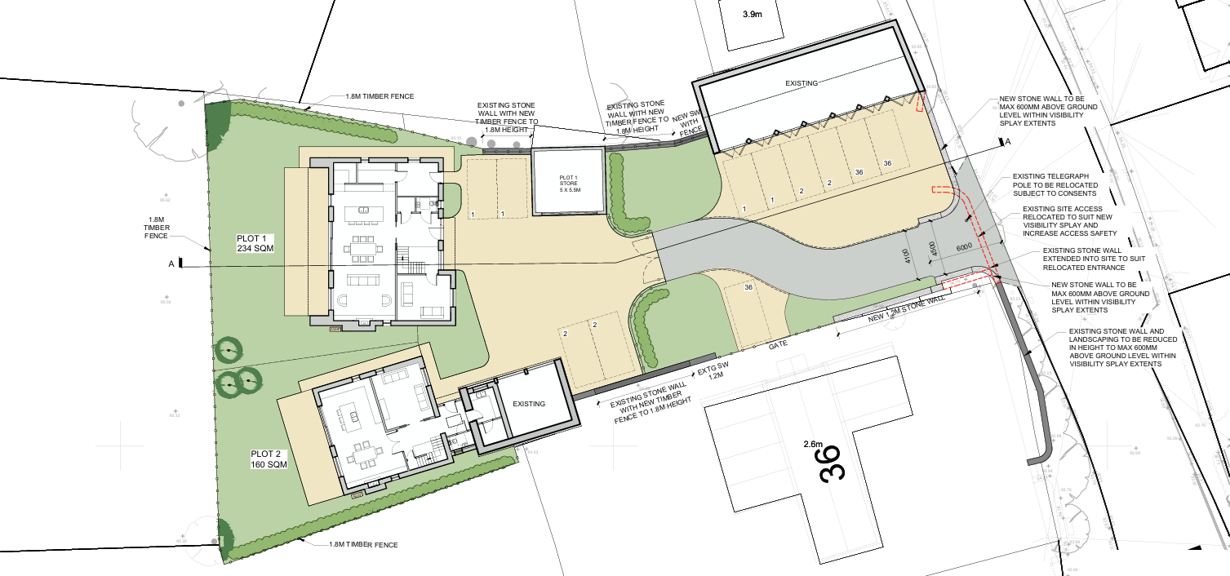
Proposed Site Plan
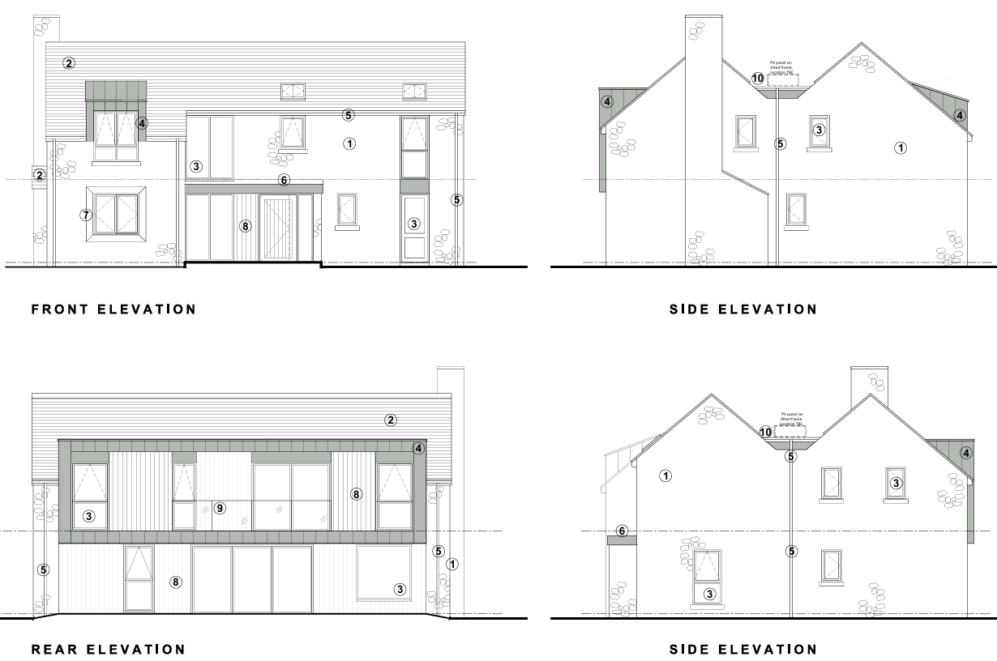
Plot 1 Proposed Elevations

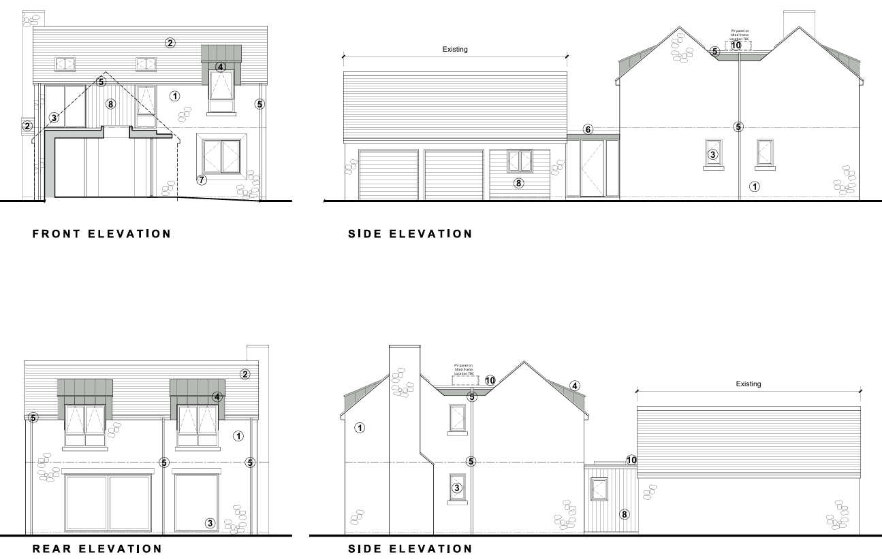
Plot 2 Proposed Elevations
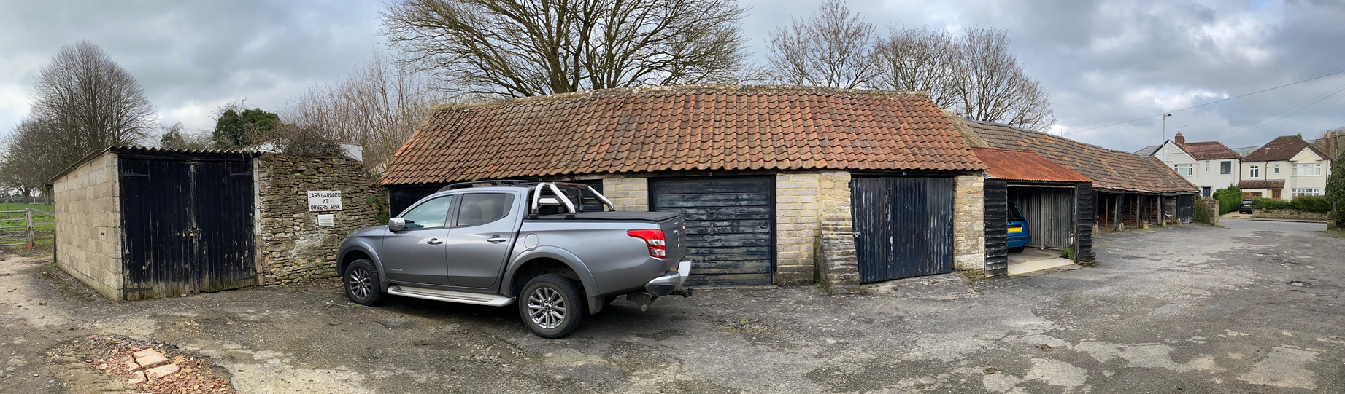
Site Visit (existing garages on northern boundary)

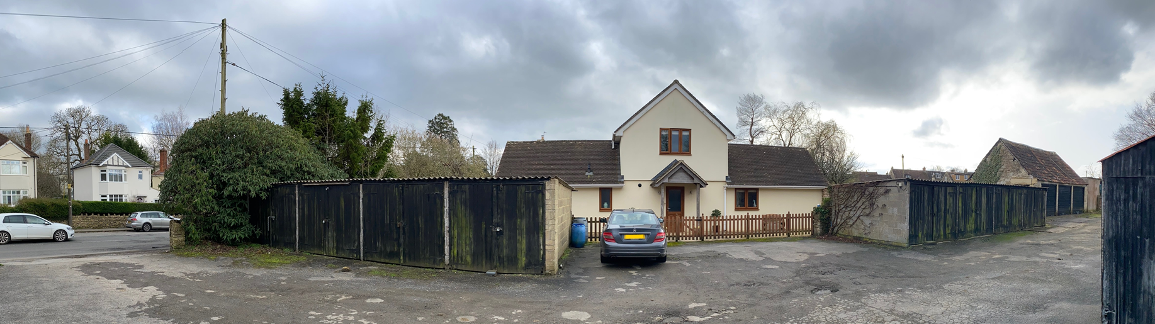
Site Visit (existing garages on southern boundary)

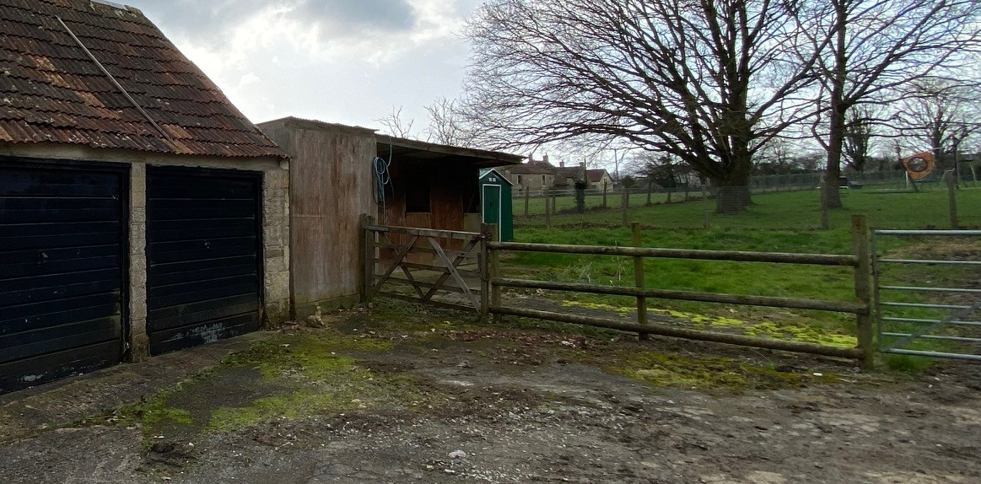
Site Visit (rear of the site)

Having regard to the above, the proposal complies with the design principles set out in Core Policy 57 of the Wiltshire Core Strategy and Appendix D of the Wiltshire Design Guide.

Conservation and Heritage

Core Policy 58 outlines development consideration with regard to the historic environment. The policy states that heritage assets and their settings must be conserved and, where appropriate, enhanced through any proposed development.

In assessing works to a listed building, Section 16(2) of the Planning (Listed Buildings and Conservation Areas) Act 1990 requires the Local Planning Authority to have special regard to the desirability of preserving the building, its setting, and any features of special architectural or historic interest it possesses. Likewise, Section 72 places a statutory duty to give special attention to the desirability of preserving or enhancing the character or appearance of the Conservation Area.

The Conservation Officer has raised a number of detailed concerns in relation to the impact of the proposal on heritage assets, including the setting of the Bradford on Avon Conservation Area, the setting of the nearby Grade II listed Bath Road Post Office, and the treatment of non-designated heritage assets within the site. These comments have been carefully considered and have directly informed the assessment set out below.

The application site itself lies outside the Conservation Area, separated from its boundary by the curtilage of No. 36 Bath Road. The proposal therefore does not result in any direct effects on the Conservation Area, and any heritage impact arises solely through consideration of setting and intervisibility. In this regard, it is noted that views between the site and the Conservation Area are limited. From Bath Road, views into the site are largely restricted by the retained frontage barn and boundary treatment, with no long-range views across the site towards the Conservation Area. From Ashley Road, where some intervisibility does occur, views are generally directed away from the Conservation Area, and where peripheral views could include both areas, these are filtered by intervening trees, hedgerows and changes in level associated with the recreation ground. As such, the site and the Conservation Area are rarely experienced together in public views, and the proposal is not considered to result in harm to the character or appearance of the Conservation Area.

The Conservation Officer has also highlighted the need to consider the setting of the Grade II listed Bath Road Post Office. In this respect, it is noted that views between the listed building and the application site are significantly limited by intervening development, boundary treatments and mature vegetation, including substantial hedgerows and trees to the rear of the listed building. No. 36 Bath Road also sits between the listed building and the site, further interrupting any direct visual relationship. As a result, the proposed dwellings would not form a prominent or intrusive backdrop in views of the listed building, and its setting would be preserved.

With regard to the non-designated heritage assets within the site, their significance derives primarily from their former agricultural use and group value as remnants of Lower Bearfield Farm. The Conservation Officer expressed strong concern in earlier iterations of the scheme regarding the potential loss or reduction of these structures, particularly the long barn fronting Bath Road and the rear barn/garage structures (Building L). In response, the applicant has revised the proposals to retain these buildings in their entirety, which is acknowledged by the Conservation Officer as a positive outcome that helps maintain the historic origins and character of the site. The retention of the Bath Road frontage barn is of particular importance, given its prominence in the street scene and its contribution to the agricultural character of the site, and this concern is therefore considered to have been satisfactorily addressed.

The Conservation Officer has expressed a preference for the Bath Road barn (Building A) to remain open-fronted, noting that the insertion of doors would alter its original appearance. This preference has been carefully considered. It is acknowledged that enclosing the structure results in a degree of change from its historic cart-shed function; however, the building is a non-designated heritage asset located outside the Conservation Area, and the introduction of doors is considered a practical and functional response to provide secure garaging. Importantly, the building’s form, scale, materials and prominence within the street scene would be preserved, and the change is not considered to result in harm to its significance.

The Conservation Officer also raised concern that incorporating Building L into Plot 2 could create future pressure for residential conversion of the retained structure. In this case, the proposal retains the majority of the structure intact, with only limited physical alteration to accommodate a linking element. The building remains clearly legible as a separate structure, and no residential conversion is proposed as part of the application. Any future change of use would require separate planning permission and cannot be presumed at this stage. While the setting of the building would inevitably change as a result of the introduction of nearby dwellings, its contribution to the character of the site would be preserved.

The loss and re-formation of a section of the traditional cock-and-hen stone boundary wall along Bath Road is acknowledged as having a detrimental impact on a locally characteristic feature. However, this wall lies outside the Conservation Area and its repositioning can be appropriately mitigated through conditions requiring the reuse of reclaimed stone and detailing to match the existing boundary treatment. Subject to such controls, this element of the proposal is considered to result in a neutral impact on heritage significance.

Overall, the Conservation Officer’s concerns have resulted in meaningful amendments to the scheme, most notably the retention of all key historic buildings on the site. While the introduction of new residential development would alter the immediate setting of these non-designated heritage assets and diminish their relative prominence, this occurs within a context that has already been substantially altered by modern development, loss of agricultural use, and the presence of visually poor modern structures and hardstanding. The proposal would remove a number of unsympathetic elements, retain and refurbish the most historically meaningful structures, and introduce a more coherent layout and materials palette that reflects local character. The proposal would result in less than substantial harm at the lower end of the scale in this respect and it is considered that the public benefits of improving the appearance of the site and providing new dwellings in the context of a substantial lack of housing supply sufficiently outweigh this identified limited harm.

Having had regard to statutory duties under Sections 66 and 72 of the Planning (Listed Buildings and Conservation Areas) Act 1990, and to the policies of the National Planning Policy Framework, it is concluded that the proposal would preserve the setting of designated heritage assets and would not result in harm to the character or appearance of the Conservation Area. The impact on non-designated heritage assets has been carefully balanced and is considered acceptable, with the significance of these assets preserved through their retention and continued legibility within the site.

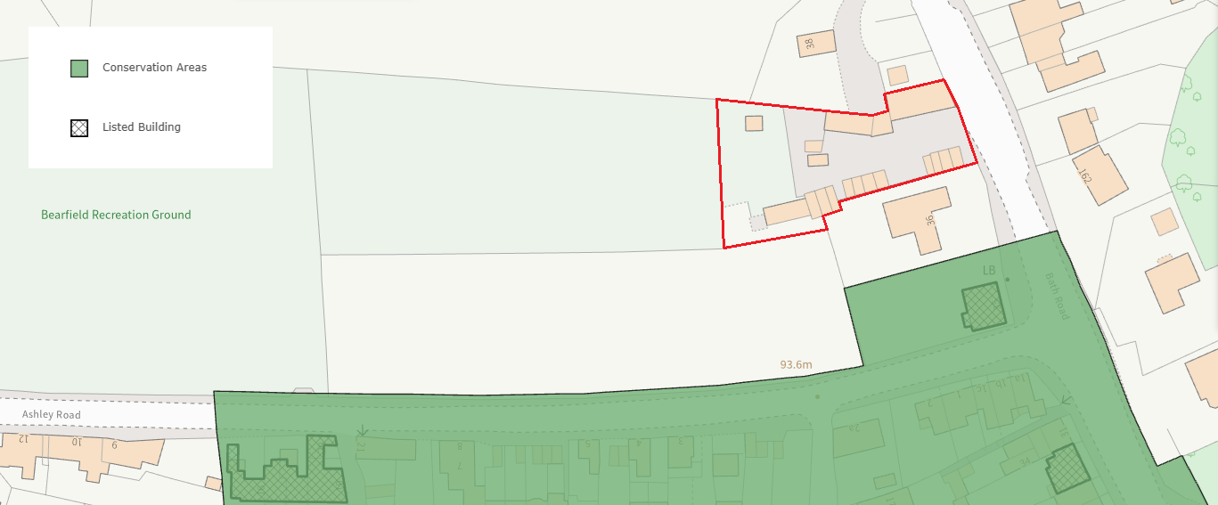
Conservation Area and Listed Buildings

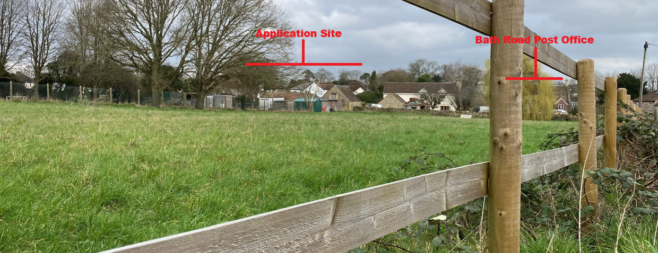
Site Visit (view from Ashley Road)

Amenity

Point vii of Core Policy 57 Ensuring High Quality Design and Place Shaping of the Wiltshire Core Strategy seeks to ensure that developments do not adversely affect neighbouring properties.

The National Planning Policy Framework (NPPF), particularly Paragraph 135, stresses that planning decisions should ensure developments provide a high standard of amenity for existing and future users.

The majority of windows within both dwellings face westwards toward the adjacent recreation ground. These elevations overlook publicly accessible open space, including the playground area, rather than neighbouring private amenity areas. As such, these windows would not give rise to any loss of privacy to nearby residents. Active frontage onto public open space is generally supported as a positive design principle, contributing to natural surveillance and a safer, more attractive public realm, and is not considered harmful in amenity terms.

The dwellings are broadly aligned on a north–south axis, albeit at a slightly oblique angle, resulting in some side-facing windows. Plot 1 (the northern dwelling) includes two first-floor windows and one ground-floor window on its southern side elevation, while Plot 2 includes ground-floor side windows on its northern elevation. The opposing ground-floor windows are separated by boundary treatments between the two plots, preventing direct overlooking. The first-floor windows on Plot 1 face toward a blank elevation of Plot 2, with no direct views into habitable rooms, and therefore do not result in harmful overlooking between the proposed dwellings.

Plot 2 also includes side-elevation windows on its northern and southern elevations; however, these face toward open agricultural land and do not overlook neighbouring residential properties. Plot 1 includes side-facing windows on its northern elevation facing toward No. 38 Bath Road. There is a separation distance of approximately 4 metres to the boundary and approximately 16 metres to the neighbouring dwelling itself. However, there is currently substantial boundary vegetation which provides screening, although it is acknowledged that this may vary seasonally or be subject to future change. One of the first-floor windows serves a secondary bedroom which is also served by a rear-facing window, and the other serves an ensuite bathroom. It is considered that of these windows, one is likely to be obscured anyway for the occupants benefit as a bathroom, and the other views onto the northern neighbour at an oblique angle and obscured by boundary vegetation. As such it is not considered that there would be any resultant overlooking.

In terms of overbearing impact, Plot 1 would be located approximately 16 metres from No. 38 Bath Road, with a ridge height of approximately 7.3 metres. Given this separation distance, the orientation of the buildings and the intervening vegetation, the development is not considered to result in an overbearing or visually oppressive impact on that property. Plot 2 is primarily affected only by Plot 1 and No. 36 Bath Road. No. 36 Bath Road is positioned at an oblique angle approximately 8.2 metres away, and the lack of a parallel relationship, together with the existing boundary treatments, ensures no unacceptable overbearing impact would occur.

With regard to daylight and sunlight, Plot 2 is the southerly of the two dwellings and would not be overshadowed by surrounding development. Plot 1 may experience some overshadowing from Plot 2 at certain times; however, the site is already subject to a degree of shading from mature trees within the adjacent recreation ground. Neither dwelling would give rise to any significant additional overshadowing of No. 36 Bath Road or No. 38 Bath Road, particularly given the presence of established vegetation and tree cover along the boundaries.

Overall, having regard to layout, orientation, separation distances and the proposed mitigation measures, it is considered that the development would provide a satisfactory level of amenity for future occupants and would not result in unacceptable impacts on the living conditions of neighbouring properties.

The proposal is appropriately sited, designed, and oriented to ensure that it would not result in unacceptable impact upon/to the amenities or living conditions of neighbouring residential occupiers, particularly in terms of outlook, privacy, or access to natural light.

The proposal therefore accords with Core Policy 57 point vii in respect of safeguarding residential amenity and Appendix D of the Wiltshire Design Guide.

Transport and Highways

Core Policy 60 of the Wiltshire Core Strategy seeks to support and encourage safe and efficient movement of people and goods, and requires that development proposals mitigate any adverse impacts on transport users and local communities where necessary. Core Policy 61 further requires that development demonstrates consideration of the hierarchy of transport users and provides safe and suitable access to the highway network. These local policies align with paragraph 116 of the National Planning Policy Framework, which states that development should only be refused on highway grounds where there would be an unacceptable impact on highway safety, or where the residual cumulative impacts on the road network would be severe following mitigation.

Core Policy 64 of the Wiltshire Core Strategy requires development to comply with the Council’s minimum parking standards. This is supported by the Wiltshire Local Transport Plan and Policy PS6, which specify that parking provision for residential development should reflect dwelling size and the likely parking demand generated. The Council’s Car Parking Strategy confirms that four‑bedroom dwellings should be provided with a minimum of three parking spaces per dwelling.

The proposal comprises two four‑bedroom dwellings, each served by two external parking spaces and an associated garage/store, thereby meeting the minimum parking standard. The development would access the highway via an existing access onto Bath Road, which currently serves a number of garage units and also provides parking and access for No. 36 Bath Road. This is therefore an established access with a lawful capacity to generate vehicle movements. The proposal would result in an increase in activity associated with the six new parking spaces serving the proposed dwellings; however, this level of trip generation is modest in scale and would largely take place during typical peak periods associated with residential use.

Following amendment to the scheme, the Local Highway Authority has confirmed that while the retention of the existing barn wall along the Bath Road frontage reduces visibility to the north such that the splay extends to the centreline of the carriageway, this arrangement is considered acceptable in this specific context. This conclusion is based on the established use of the access, the absence of recorded highway safety issues, and the characteristics of Bath Road as a long and relatively straight section of highway with good visibility in both directions and limited likelihood of overtaking movements at this location.

Accordingly, the Local Highway Authority raises no objection to the proposal subject to conditions. These conditions require the access alterations, parking and turning areas to be completed prior to occupation, the first five metres of the access to be properly surfaced to prevent loose material entering the highway, measures to prevent private surface water discharging onto the public highway, and the provision and ongoing maintenance of the approved visibility splays. An informative is also recommended advising that separate consent will be required from the Highway Authority for works within the public highway.

These conditions are considered reasonable, necessary and proportionate to ensure the development operates safely and does not adversely affect the highway network. Subject to these controls, the proposal is not considered to result in an unacceptable impact on highway safety or the operation of the local road network and is therefore compliant with Core Policies 60, 61 and 64 of the Wiltshire Core Strategy and the guidance set out in the National Planning Policy Framework.

Ecology

The Wiltshire Core Strategy, through Core Policy 50, requires development proposals to conserve and, where possible, enhance biodiversity, to avoid adverse impacts on protected species and habitats, and to ensure that appropriate mitigation and enhancement measures are secured. These principles align with the National Planning Policy Framework, which seeks to minimise impacts on biodiversity and secure ecological enhancement where proportionate.

The application site comprises a previously developed area characterised by buildings, hardstanding and associated infrastructure, with only a small area of paddock grassland located at the western end of the site. The majority of the proposed development would take place on existing buildings or areas of hardstanding, thereby limiting interaction with semi-natural habitats. As such, the overall ecological value of the site is relatively low, with potential impacts primarily relating to protected species, particularly bats, given the site’s location within the Bath and Bradford-on-Avon Bats Special Area of Conservation buffer.

A Preliminary Ecological Appraisal and bat surveys, including a dusk emergence survey, were submitted and reviewed by the Council’s Ecologist. These confirmed that the existing buildings possess low bat roosting potential and identified that no bats were recorded roosting within the structures. Limited foraging activity by common bat species was observed, consistent with the wider landscape context, and no Annex II bat species were recorded. In response to initial consultation comments, further information was provided confirming that no hedgerow removal is proposed, that no external lighting would be introduced, and that the small area of species-poor grassland to be affected would be compensated through the creation of new hedgerow planting and vegetated garden areas.

On the basis of this information, the Local Planning Authority, acting as competent authority, undertook a Habitats Regulations Assessment screening and concluded that the proposal would not result in adverse effects on the integrity of the Bath and Bradford-on-Avon Bats Special Area of Conservation. The development has therefore been screened out of the requirement for an Appropriate Assessment.

With regard to Biodiversity Net Gain, the statutory requirement for mandatory BNG applies to the development. A biodiversity metric has been submitted and reviewed by the Council’s Ecologist, who confirms that the baseline habitat values are accurate and reflective of the site’s characteristics. The site is dominated by artificial surfaces and species-poor grassland with limited ecological value, and the baseline habitats are therefore low in biodiversity units.

The submitted metric demonstrates that a net gain in biodiversity units can be achieved through on-site habitat creation, including new hedgerow planting and grassland areas. While the principle of on-site delivery is accepted, the Ecologist has advised that the proposed grassland areas are likely to function as private garden space and may need to be categorised as “vegetated garden” within the metric. Notwithstanding this, it is considered that the development is capable of achieving a compliant biodiversity uplift on site, subject to detailed design and implementation.

The statutory biodiversity gain condition will apply to the development, requiring the submission and approval of a Biodiversity Gain Plan prior to commencement. This will ensure that the proposed uplift is secured and delivered in accordance with the approved metric and for the required 30-year period. No off-site provision or statutory biodiversity credits are proposed or required in this instance, and no additional legal agreement is necessary in respect of BNG.

Notwithstanding the above, Core Policy 50 and the NPPF continue to encourage proportionate biodiversity enhancement. The Council’s Ecologist therefore recommends conditions to secure compliance with the submitted ecological mitigation measures and the provision of biodiversity enhancements, including bat roosting features, prior to occupation.

The Ecologist has also advised that works should avoid the bird nesting season unless appropriate checks confirm the absence of active nests, reflecting the protections afforded under the Wildlife and Countryside Act 1981 (as amended).

Subject to the recommended planning conditions, the proposal is considered to accord with Core Policy 50 of the Wiltshire Core Strategy and national planning policy and would not result in harm to protected species or designated ecological sites.

Flooding and Drainage

Core Policy 67 (Flood Risk) of the Wiltshire Core Strategy requires that development is located, designed and constructed to minimise vulnerability to flooding and to avoid increasing flood risk elsewhere. Proposals are expected to demonstrate that surface water can be managed safely and sustainably, incorporating appropriate drainage solutions such as Sustainable Drainage Systems (SuDS), and ensuring that post‑development runoff rates and volumes do not exceed pre‑development conditions. These objectives align with national policy, which requires a risk‑based approach to managing flood risk, as set out in the National Planning Policy Framework.

The Council’s Strategic Flood Risk Assessment identifies the site as lying entirely within Flood Zone 1, where the probability of flooding from fluvial or tidal sources is low. The SFRA further indicates that flooding from groundwater is unlikely across the site. A very limited area of the site is shown to be subject to a low surface‑water flood risk (0.3% annual exceedance probability); however, this area is confined to a narrow strip running through the centre of the site and does not intersect with any existing buildings or with the footprint of either of the proposed dwellings. On this basis, the proposed development is not located within an area at meaningful risk of flooding, and the vulnerability classification of the development is appropriate to its location.

Given that the development is proposed in Flood Zone 1 and that areas of surface‑water risk are minor, localised and avoidable, it is considered that the Sequential Test is not required in this instance. National policy confirms that the Sequential Test is only necessary where development is proposed in areas at risk of flooding, and this threshold is not met in the case of the proposed buildings. On the evidence available, there is therefore a clear justification for not applying the Sequential Test, and no further assessment is considered necessary.

The Council’s Drainage Officer has reviewed the submitted drainage information and raises no objection to the proposal, subject to conditions. The proposed drainage strategy manages surface water through infiltration‑based SuDS solutions, including soakaways and permeable surfaces, supported by infiltration testing undertaken in accordance with BRE Digest 365. This approach accords with the surface‑water hierarchy and is intended to manage runoff at source, reducing reliance on third‑party systems and minimising the risk of off‑site flooding.

The Drainage Officer recommends a pre‑commencement condition requiring the submission and approval of a detailed surface‑water drainage strategy compliant with Wiltshire Council requirements, the NPPF and National SuDS Standards. This condition seeks additional detail to demonstrate how surface‑water reuse has been maximised, to provide water‑quality treatment calculations, and to secure construction details and inspection arrangements for drainage infrastructure. These requirements are considered reasonable and necessary to ensure that the drainage system is robust, adequately designed and capable of long‑term operation without increasing flood risk or pollution.

Core Policy 67 of the Wiltshire Core Strategy requires that foul water is disposed of in a satisfactory manner without adverse impact on existing infrastructure or the environment. While detailed foul drainage proposals have not been submitted as part of this application, the site lies within an established residential area where it is reasonable to expect that a connection to the existing mains sewer network can be achieved. Given the limited scale of the development (two dwellings), no objection has been raised by consultees on this matter. A condition is recommended requiring the submission and approval of details of foul drainage prior to commencement to ensure that the development is served by an appropriate and sustainable drainage solution.

Subject to compliance with the recommended drainage condition, the proposal is considered to accord with Core Policy 67 of the Wiltshire Core Strategy and national planning policy. The development would not be exposed to unacceptable flood risk, nor would it increase flood risk elsewhere, and appropriate mitigation and control measures can be secured through condition.

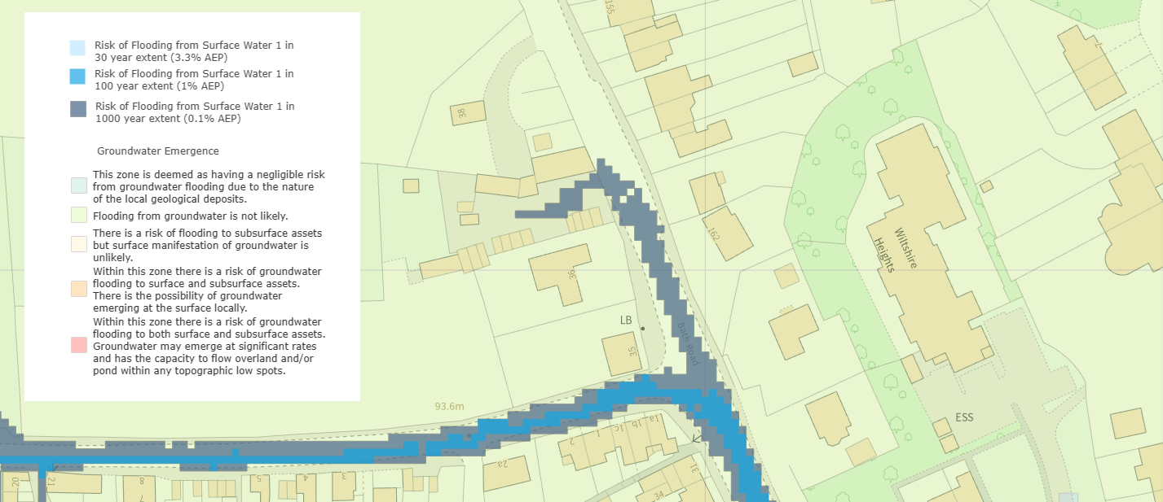
Strategic Flood Risk Assessment (Surface and Ground Water Flood Risk)

Sustainable Construction / Climate Change

Core Policy 41 of the Wiltshire Core Strategy requires new dwellings to incorporate measures to minimise carbon emissions and promote sustainable construction.

An Energy Statement has been submitted in support of the application which demonstrates that the proposed dwellings would achieve a significant reduction in regulated carbon emissions through a combination of fabric-first design and low carbon technologies. The report confirms that the dwellings would achieve in excess of the minimum required reduction in emissions, with an estimated improvement of approximately 70% compared with target emission rates.

The proposed strategy includes the use of air source heat pumps to provide heating and hot water, photovoltaic panels to generate renewable electricity, and enhanced building fabric performance to reduce energy demand. The scheme also incorporates energy efficient lighting, water efficiency measures and the use of sustainably sourced materials.

These measures are considered to accord with the requirements of Core Policy 41 and represent a positive response to the need to reduce carbon emissions and support climate change mitigation. A condition is recommended to secure the implementation of the approved energy strategy.

Planning Balance

The proposal has been assessed in accordance with Section 38(6) of the Planning and Compulsory Purchase Act 2004, having regard to the Development Plan unless material considerations indicate otherwise. As set out in the assessment above, the application site lies outside the defined settlement boundary for Bradford on Avon and the proposal therefore conflicts with the Core Strategy spatial strategy as expressed through Core Policies 1 and 2. In policy terms, the development is not supported by the Development Plan when considered in isolation.

However, the site lies immediately adjacent to the built-up area of the town, is well related to existing development along Bath Road, and does not represent an isolated or disconnected form of development in spatial or functional terms. The Local Planning Authority is also currently unable to demonstrate a five-year supply of deliverable housing sites, with a supply position of approximately 2.42 years. This shortfall represents a significant material consideration and renders policies most important for determining the application out of date. As such, paragraph 11(d) of the National Planning Policy Framework is engaged.

Paragraph 11(d) requires that permission be granted unless one of two circumstances applies. The first is where the application of policies in the Framework that protect areas or assets of particular importance provides a clear reason for refusing the development, as set out in footnote 7. In this case, the only potentially relevant constraints are Green Belt designation and heritage assets. As set out in the Green Belt and heritage sections of this report, the proposal has been carefully assessed against Chapter 13 of the Framework and statutory heritage duties. While the development would result in a limited and localised degree of change to Green Belt openness, this harm is not considered to be substantial, and the proposal meets the exception criteria for development in the Green Belt at paragraph 154 (g) of the Framework.

In relation to heritage, it has been concluded that the proposal would preserve the setting of designated heritage assets and would not result in harm to the character or appearance of the Conservation Area, with the significance of non-designated heritage assets preserved through their retention and refurbishment. Accordingly, there is no strong reason for refusal arising from the application of policies listed in footnote 7 of the Framework.

The second limb of paragraph 11(d) requires consideration of whether any adverse impacts of granting permission would significantly and demonstrably outweigh the benefits when assessed against the policies of the Framework as a whole, having particular regard to key policies for directing development to sustainable locations, making effective use of land, securing well-designed places and providing affordable homes, individually or in combination. In this regard, the adverse impacts identified include conflict with the Development Plan spatial strategy and the change of use of the site from its existing informal garaging and storage functions to residential use. However, as set out in the principle assessment above, the site does not operate as a meaningful or active employment site, and the proposal would not result in the loss of a viable employment use. The redevelopment of the site is therefore considered to broadly accord with the objectives of Core Policy 35, and this matter does not weigh significantly against the proposal in the planning balance.

Balanced against this are a number of material benefits. These include the delivery of two new dwellings in a sustainable and accessible location adjoining a Market Town, contributing to housing supply at a time when the Council is unable to demonstrate a five-year supply. The proposal makes efficient and effective use of a previously developed site and would result in the removal of poor-quality modern structures and extensive deteriorated hardstanding, replacing them with a high-quality scheme that responds positively to local character and context. The development has been assessed as sustainable in transport terms, with good access to services, facilities and public transport, and would not result in unacceptable impacts on highway safety. The scheme would safeguard residential amenity, avoid harm to protected species and ecological sites, and manage flood risk appropriately.

The proposal has been found to accord with the relevant design and placemaking principles set out in the Framework, including those relating to good design, sustainable development, and the creation of high-quality places. There are no identified technical objections from statutory consultees that would indicate severe or unacceptable impacts, and residual matters are capable of being addressed by condition and legal agreement.

On balance, having regard to the provisions of paragraph 11(d) (ii) of the National Planning Policy Framework, it is concluded that the adverse impacts of granting planning permission would not significantly and demonstrably outweigh the benefits of the proposal when assessed against the Framework as a whole. While the proposal conflicts with the Development Plan in spatial policy terms, material considerations indicate that planning permission should nevertheless be granted.

CONCLUSION

The proposal is considered to be acceptable and in accordance with the relevant policies and guidance outlined above.

RECOMMENDATION: That Planning Permission be GRANTED subject to the following conditions:

1.
The development hereby permitted shall be begun before the expiration of three years from the date of this permission.
REASON: To comply with the provisions of Section 91 of the Town and Country Planning Act 1990 as amended by the Planning and Compulsory Purchase Act 2004.

2.
The development hereby permitted shall be carried out in accordance with the following approved plans and documents:

Plot 2 Proposed Floor Plans 2834 P201 B
Location Plan 2834 L01
Plot 1 Proposed Elevations 2834 P102 B
Proposed Retained Garage 2834 P401 A
Proposed Access Location (Visibility Splay) 25101-RIDGE-XX-ZZ-DR-H-0002_P01
Proposed Site Sections 2834 P300 B
Plot 1 Proposed Floor Plans 2834 P101 A
Plot 2 Proposed Elevations 2834 P202 C
Plot 1 Proposed Store 2834 P400
Proposed Site Plan 2834 P100 F

REASON: For the avoidance of doubt and in the interests of proper planning.

3.
No development shall commence until a detailed surface water drainage strategy has been submitted to and approved in writing by the Local Planning Authority. The strategy shall comply with Wiltshire Council requirements, the National Planning Policy Framework and National SuDS Standards and shall include:

- details of surface water reuse measures or justification where not feasible;
- water‑quality treatment calculations;
- detailed construction drawings and cross‑sections of drainage features; and
- a schedule of inspection chambers including invert and cover levels.

The approved scheme shall be implemented prior to occupation and thereafter maintained.

REASON: To ensure sustainable drainage, prevent increased flood risk and protect water quality, in accordance with Core Policy 67.

4.
No development shall commence until details of foul water drainage have been submitted to and approved in writing by the Local Planning Authority. The approved scheme shall be implemented prior to occupation of the development.

REASON: To ensure satisfactory drainage of the site in accordance with Core Policy 67 of the Wiltshire Core Strategy and the National Planning Policy Framework.

5.
No development shall commence (including demolition or site clearance) until a Construction Environmental Management Plan (CEMP) has been submitted to and approved in writing by the Local Planning Authority.

The CEMP shall include details of:
- measures to control noise, dust and vibration during construction;
- site compound and contractor parking arrangements;
- loading, unloading and storage of materials;
- measures to prevent burning of waste on site; and
- procedures for responding to complaints.

The development shall thereafter be carried out in accordance with the approved CEMP.

REASON: To protect the amenities of neighbouring occupiers during construction in accordance with Core Policy 57 of the Wiltshire Core Strategy and the National Planning Policy Framework.

6.
If, during the course of development, contamination not previously identified is found to be present, no further development shall be carried out until a remediation strategy has been submitted to and approved in writing by the Local Planning Authority.

The remediation strategy shall include:
- an assessment of the extent of contamination;
- details of any necessary remediation measures; and
- a verification plan demonstrating how the remediation will be carried out and validated.

The approved remediation strategy shall be implemented in full prior to the first occupation of the development.

REASON: To ensure the site is suitable for its proposed use and to protect human health and the environment in accordance with Core Policy 57 of the Wiltshire Core Strategy and the National Planning Policy Framework.

7.
Prior to the commencement of development, the number, design and locations of ecological enhancement measures, including bat roosting features and other biodiversity enhancements, shall be submitted to and approved in writing by the Local Planning Authority. The approved measures shall be installed prior to occupation of the final dwelling.

REASON: To provide proportionate biodiversity enhancement in accordance with Core Policy 50 and the NPPF.

8.
No above‑ground works shall commence until details and samples of all external facing materials (including stone, roofing, timber cladding, metal cladding, windows, doors and rainwater goods) have been submitted to and approved in writing by the Local Planning Authority. The development shall thereafter be carried out in accordance with the approved details.

REASON: To ensure a high‑quality appearance and appropriate response to local character and heritage.

9.
No boundary treatment shall be erected along the western boundary adjoining agricultural land other than a traditional natural stone wall of cock‑and‑hen construction with native hedgerow planting to the external side. Details of the wall construction, height and associated planting shall be submitted to and approved in writing prior to commencement of above‑ground works and implemented prior to occupation.

REASON: To protect the rural character, landscape setting and heritage context of the site and to avoid suburban boundary treatments.

10.
No development shall commence until a detailed hard and soft landscaping scheme has been submitted to and approved in writing by the Local Planning Authority. The scheme shall include surfacing materials, boundary treatments, planting schedules, and details of hedgerows. The approved scheme shall be implemented in full prior to occupation and thereafter maintained.

REASON: To ensure visual integration of the development and enhance local character.

11.
Construction works shall be limited to 0800–1800 Monday to Friday, 0800–1300 Saturdays, with no works on Sundays or Bank Holidays.

REASON: To protect residential amenity.

12.
No works involving vegetation clearance, demolition or construction shall take place during the bird nesting season (March to August inclusive) unless a competent ecologist has confirmed in writing that no active nests are present.

REASON: For the protection of nesting birds under the Wildlife and Countryside Act 1981 (as amended).

13.
The development shall be carried out in strict accordance with the mitigation measures set out in:
Dusk Emergence Survey for Bats (All Ecology, September 2025) and
Technical Note: Ecology Update Response (Crossman Acquisitions, March 2026).

REASON: To protect biodiversity and safeguarded species in accordance with Core Policy 50.

14.
No external lighting shall be installed on the site unless details have first been submitted to and approved in writing by the Local Planning Authority. Any lighting shall be designed to minimise light spill and avoid harm to bats and neighbouring amenity.

REASON: To protect ecological interests and residential amenity in accordance with Core Policies 50 and 57.

15.
The development shall be carried out in accordance with the measures set out in the submitted Energy Statement (Fenton Energy Ltd, dated September 2026), including the provision of air source heat pumps and photovoltaic panels, unless otherwise agreed in writing by the Local Planning Authority.

REASON: To ensure that the development incorporates sustainable construction and low-carbon technologies in accordance with Core Policy 41 of the Wiltshire Core Strategy and the National Planning Policy Framework

16.
No part of the development shall be occupied until the access alterations, on‑site turning areas and car parking spaces shown on the approved plans have been completed. These areas shall thereafter be retained and kept available for those purposes.

REASON: In the interests of highway safety in accordance with Core Policies 60, 61 and 64.

17.
No dwelling shall be occupied until the first 5 metres of the access, measured from the edge of the carriageway, has been consolidated and surfaced in a bound material. The access shall thereafter be maintained as such.

REASON: To prevent loose material entering the highway and in the interests of highway safety.

18.
No dwelling shall be occupied until measures have been implemented to ensure that surface water from the site does not drain onto the public highway.

REASON: To ensure the highway is not inundated with private water.

19.
No dwelling shall be occupied until the visibility splays shown on the approved plans have been provided clear of obstruction to visibility at or above 600mm above carriageway level. The visibility splays shall thereafter be permanently retained.

REASON: In the interests of highway safety.

20.
No dwelling shall be occupied until details of refuse and recycling storage facilities for each dwelling have been submitted to and approved in writing by the Local Planning Authority. The approved facilities shall be provided prior to occupation and thereafter retained for those purposes.

REASON: To ensure adequate provision for waste storage in the interests of visual amenity and residential amenity in accordance with Core Policy 57 of the Wiltshire Core Strategy and the National Planning Policy Framework.

BNG INFORMATIVE

The effect of paragraph 13 of Schedule 7A to the Town and Country Planning Act 1990 is that planning permission granted for the development of land in England is deemed to have been granted subject to the condition “(the biodiversity gain condition”) that development may not begin unless:
(a) a Biodiversity Gain Plan has been submitted to the planning authority, and
(b) the planning authority has approved the plan.
The planning authority, for the purposes of determining whether to approve a Biodiversity Gain Plan if one is required in respect of this permission would be Wiltshire Council.
There are statutory exemptions and transitional arrangements which mean that the biodiversity gain condition does not always apply. For further information on exempt developments please refer to:
https://www.gov.uk/guidance/biodiversity-net-gain-exempt-developments
Based on the information available this permission is considered to be one which will require the approval of a biodiversity gain plan before development is begun because none of the statutory exemptions or transitional arrangements are considered to apply.
Irreplaceable habitat
If the onsite habitat includes irreplaceable habitat (within the meaning of the Biodiversity Gain Requirements (Irreplaceable Habitat) Regulations 2024) there are additional requirements for the content and approval of Biodiversity Gain Plans.
The Biodiversity Gain Plan must include, in addition to information about steps taken or to be taken to minimise any adverse effect of the development on the habitat, information on arrangements for compensation for any impact the development has on the biodiversity of the irreplaceable habitat.
The planning authority can only approve a Biodiversity Gain Plan if satisfied that the adverse effect of the development on the biodiversity of the irreplaceable habitat is minimised and appropriate arrangements have been made for the purpose of compensating for any impact which do not include the use of biodiversity credits.

