Construction Management Statement for PL/202502951
[8 Duck Street, Potterne, SN10 5NB]

Introduction

This construction management statement aims to meet Condition 3 of the Decision Notice for PL/202502951. The approved plan will be adhered to throughout construction, unless an unforeseen change is needed, in which case, prior approval will be sought from the Local Planning Authority.

The site address is 8, Duck Street, Potterne, Devizes, SN10 5NB. The site location plan can be seen at Appendix 1. The project covers the demolition of a rear single-storey lean-to and erection of a two-storey side and rear extension, single-storey rear extension and new front porch with internal alterations.

It is proposed that works would begin in May 2026 with the demolition of the existing kitchen extension, and (all being well) that construction works (and internal alterations) would be completed by the end of December 2026. External decoration (ie painting of walls/window frames) and internal finishing would continue thereafter, with target completion by June 2027.

The site location presents challenges in that it is does not have direct road access and is lower than the surrounding area. It is accessed via a public footpath, a shared garden path, and then down several steps. All materials need to be carried from the road. On the other hand, its location also means that construction work is less obtrusive to neighbours than it might ordinarily be. Only immediate neighbours should be impacted by noise or very low-level dust from the demolition and construction.

The public footpath is not well-maintained and has overhanging hedges and other dangerously intrusive foliage at face and head height, which narrows access considerably and poses a health and safety risk. A complaint was lodged with the Parish Council but was dismissed.

Duck Street is a narrow cul-de-sac, further narrowed by overgrown conifers and planting on the verge, which extends onto the road and results in mud and debris on the road after heavy rain. The drains are also prone to blockages from this material from time to time.

Some disruption, noise and inconvenience is inevitable with any demolition and construction project in a residential area. This construction management statement details how the project will minimise and mitigate issues, within the constraints of the location.

There are no schools or businesses in the immediate vicinity that might be impacted by the works.

Site Management

During construction, the site and project will be managed by Mark Brackstone, of Brackstone Builders Ltd, who will also be responsible for compliance with this construction management statement and for communicating it to site workers. Their offices are at Brickfield Barn, Stokes Marsh Lane, Coulston, Westbury, BA13 4NZ, and their contact number is 01380812100.

Development site layout and welfare arrangements

Since all materials must be carried from the public road up a footpath to the site, health and safety of the public and the construction workers is of paramount importance to this project.
The site will be delineated with a suitable temporary barrier providing all appropriate safety and hazard warnings for visitors and the public. A site layout is at Appendix B.

Due to infrequent use and the mismanagement of overhanging hedges and planting, the path has become dangerous to users, with protruding hazards at face height. A complaint was lodged through the proper channels, but no action was taken by the Parish Council. To protect workers, the footpath should be cleared of obstructions that could cause injury to a height of 2.5m, as stipulated in the Road Safety Act 1980. This will also protect the public using the path.

To meet health and safety needs, a mechanical wheelbarrow will be used to help convey heavy materials from the road to the site. Similarly, a small mini-digger may be used on site for any necessary excavation during the groundworks. The path will be protected during such activity and cleaned afterwards. Proper access management at both ends of the path will be provided when these items transit the footpath, with priority given to pedestrians and their safety. Similarly, site workers will also defer to pedestrians when using the path.

However, it is worth noting that pedestrian use of the footpath is extremely low, with use mainly by occasional dog walkers in the early morning and evening.

A Portaloo will be provided for site workers, and a medical kit will be available on site.

Materials handling and waste management

The site layout at Appendix B shows the location of material and waste storage areas. However, wherever possible, the plan is to have just-in-time deliveries and prompt waste removal, to minimise onsite storage, given the space and transit restrictions.

Demolition arisings will be removed by skip or van, or will be reused on site. Recycling of waste materials will always be the preferred option. Where this is not possible, responsible disposal through Council-approved methods will be followed and documentation retained. There will be no burning of waste during construction.

Materials will be stored responsibly to minimise visual impact and unsightly dispersal, including dust and dirt. If necessary, a fence can be erected along the footpath to minimise the visual impact. Given the disparity in height between the footpath and the site, a 6ft fence would hide the entire site from public view. The sunken site location also means that visual impact of the build is minimal, and noise is muffled. Any construction debris on the footpath will be swept up.

If wheel-washing is required for the mechanical equipment, it will take place on the property or off-site, to avoid mess on the footpath or public road.

Protecting the natural environment

No damage to the natural environment is anticipated. The construction area has already been cleared and no highly toxic materials are likely to be used in this construction. If any hazardous chemicals are needed, use will be limited and they will be stored on concrete and away from trees, in line with the planning approval conditions.

Gradual reclamation and landscaping of the property’s garden has been underway since late 2021 and will continue during and after the build, enhancing the natural environment.

Site operations – working hours

Working hours and deliveries (including materials and equipment) during demolition and construction will be as follows:
- 08.00 to 17.00 on Mondays to Friday
- 08.00 to 13.00 on Saturdays
- No working on Sundays or Public Holidays

These working hours cover operations and work which are audible beyond the site boundary. Any noisy operations outside these hours shall not be undertaken without prior written approval from the local planning authority.

Internal finishing activity will not continue beyond 19.00 on any day.

Parking and deliveries

Deliveries will need to be offloaded onto the public road, but will be rapidly removed and relocated to the site. No materials will be allowed to remain on the public road overnight and, during the day, will be removed as quickly as possible.

Delivery vehicles will not be permitted to wait, queue, or circulate on the public highway outside the above-mentioned working hours.

As illustrated on Google Maps Streetview, there is usually space on the road during the day. In general, no more than two vehicles (of LGV size or lower) will be parked on the road during working hours. However, delivery vehicles may temporarily obstruct Duck Street while offloading deliveries. The size of vehicle is limited by access constraints, and this will be borne in mind (and communicated to suppliers) when orders are made. No large deliveries will be concurrent.

The foundations will require poured concrete delivered (pumped via a pipe from a lorry) from Duck Street. This could take more than one load or one visit, and each delivery may last for up to 90 minutes. The builder will communicate with any potentially impacted neighbours in advance of this activity and will aim to mitigate disruption as much as possible.

Any damage related to the development will be put right (to the satisfaction of the LHA) within 6 months of the development completion.

Noise and vibration

All plant and machinery in intermittent use shall be shut down in the intervening periods between works. Plant and machinery capable of generating significant noise and vibration levels will be operated in a manner to restrict its duration.

Security lighting

If overnight lighting is required for security or safety purposes, it will be sensitively located to minimise light spill, glare or nuisance to neighbours or the public.

Appendices:

A: Site location plan
B: Site layout plan
C: Pre-condition photos

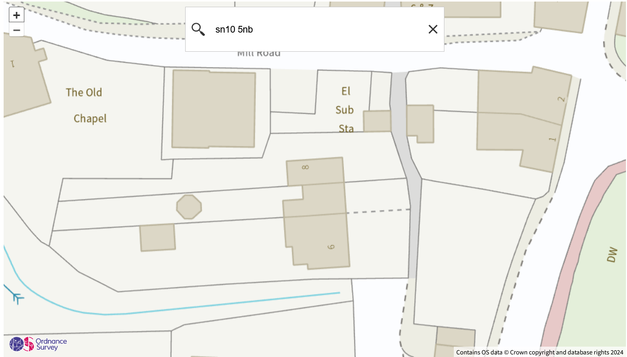

Appendix A: Site Location Plan

Works and storage areas delineated with a dashed red line. Area of construction and demolition marked in solid and dotted lines.

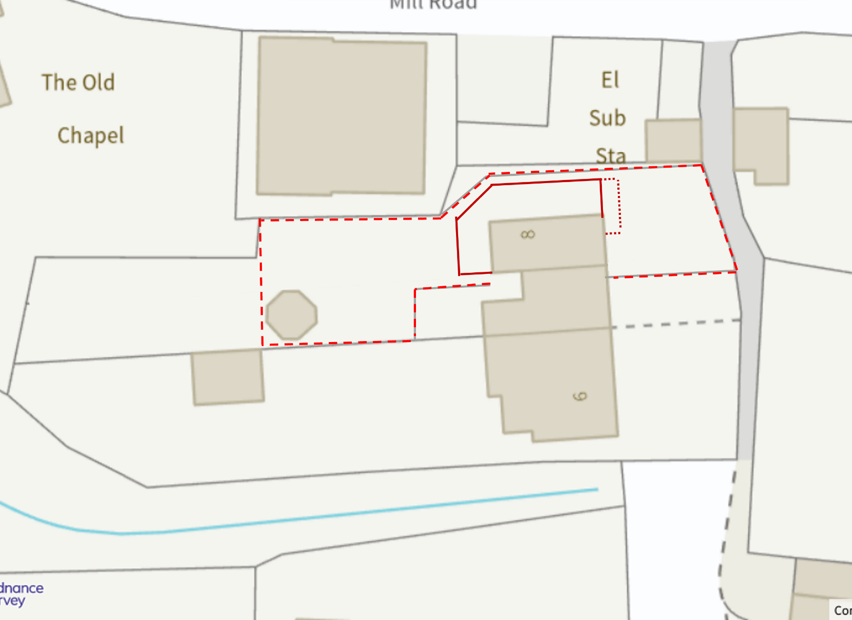

Appendix B: Site Layout Plan

Potential materials storage space marked in dark blue cross-hatched boxes. Demolition arisings will not be stored onsite for more than a week.

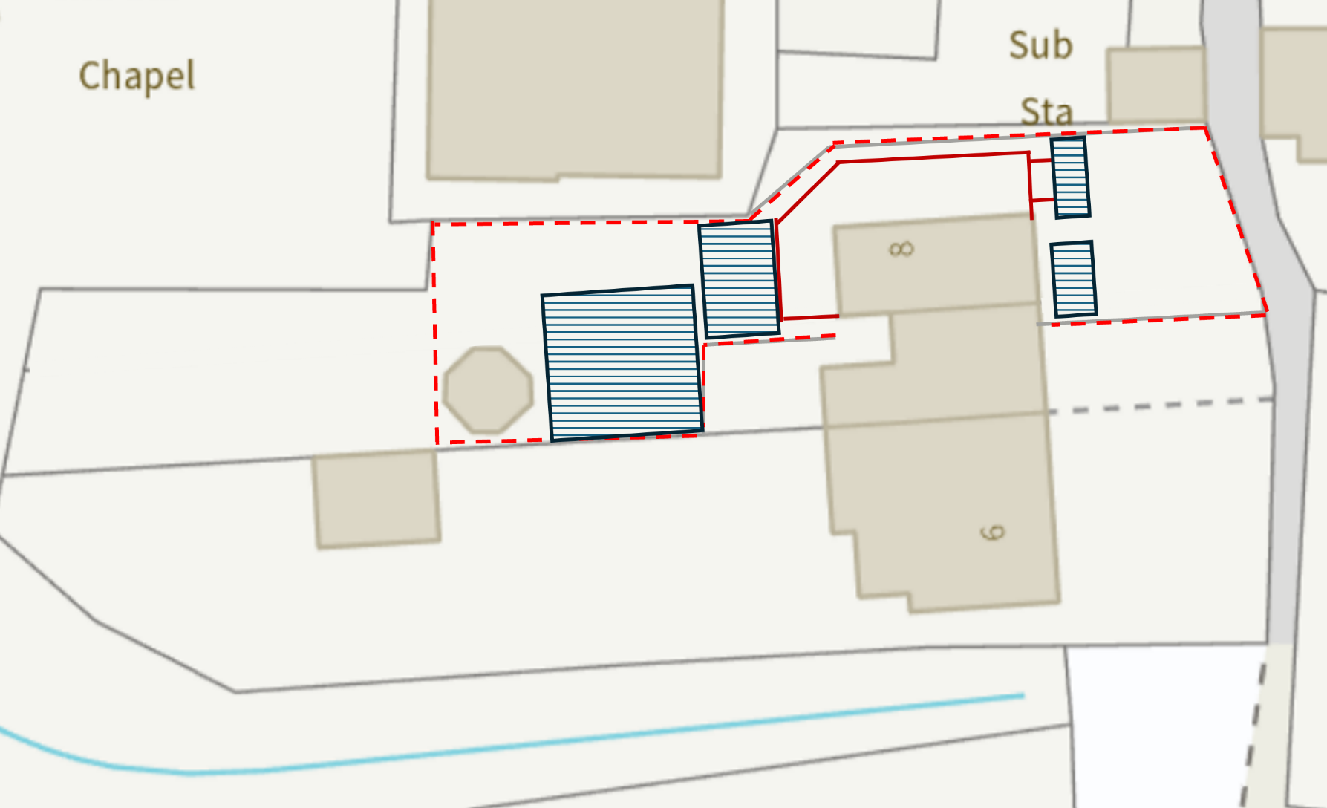

Appendix C: Pre-condition photos

