DESIGN/ACCESS AND HERITAGE STATEMENT for
PROPOSED RAISING OF CHIMNEY FOR FIRE SAFETY REASONS at
PENNYFARTHING COTTAGE, HIGH STREET, ANSTY, WILTSHIRE, SP3 5QF

INTRODUCTION

Further to inspection of the flue installation to an existing fireplace at Pennyfarthing Cottage it is necessary for fire safety reasons to raise the height of the chimney stack to a minimum of 1.80m above the thatch roof covering.

CONTEXT

Pennyfarthing Cottage is located immediately to the east side of High Street which accordingly forms the western site boundary of the site with gated vehicular access. Land on the opposite side of High Street is also in the same ownership. To the rear/north and south is domestic garden which includes an ancillary building. The property has been extended to the rear.

Given the proximity to the highway the property is prominent in terms of the public realm and contributes to the immediate and wider setting of the site.

The property features thatched roof over masonry walls. The chimney stack the subject of this application is located to the south gable end of the roof. It appears that the stack has previously been altered and a tall terracotta chimney pot installed.

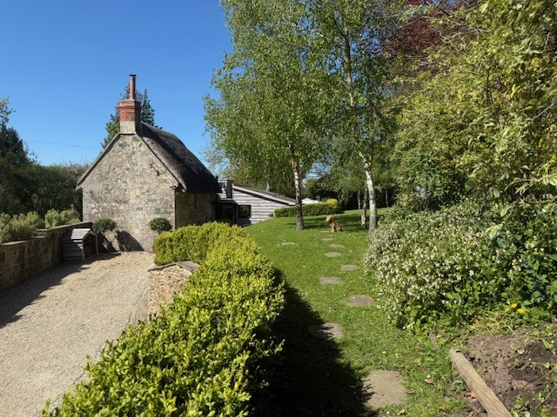
Photograph looking north from garden to existing south gable and chimney

The property is a Listed Building for which the Schedule notes the following -

Date Listed: 27th July 1985 Grade: II English Heritage Building ID: 320246
Detached cottage. C18. Uncoursed dressed limestone, thatched roof, limestone and brick stacks to right. 2-storey, 2-window. Planked door to left, 2-light casement to right and two 2-light casements to first floor. Left return is brick with light timber framing to gable, half-hipped roof, attached to left is weatherboarded extension with planked door. Right return is windowless, coped verge to roof. Interior has open fireplace with timber lintel.

HERITAGE STATEMENT

The existing fireplace which serves the principal living space of the cottage provides an important and sustainable heat source for the property. The configuration of the flue/chimney stack and height relative to the thatch roof covering has been found to not comply with the distance required for fire safety reasons.
Acknowledged guidance states the following
· the chimney, including the pot, should end at least 1.8m above the height of the ridge
· due to the risk of condensation forming as hot gases cool, chimney pots should be limited to a maximum height of 600mm
In respect of the proposed extension to the height of the chimney it is noted
that there are varying heights/types/materials of these features within the roofscape of neighbouring properties. In that context the proposal to raise the subject chimney stack would neither dominate the Listed Building nor look out of place in the context of the setting of the site.
The increase in height of the chimney stack relates to the evident and known fire risks to thatched properties. From measurement on site it is evident that the chimney termination is less than the above noted minimum (1.60m as existing – should be at least 1.80m) and the pot exceeds the above noted maximum (as existing 1m – should be a maximum of 0.60m) and as such poses a significant fire risk, with the potential of significant damage or even total loss of the asset.
The proposal is a pragmatic and practical response that significantly reduces the risk of serious damage or loss from fire without adverse impact to the Listed Building and it’s contribution to the context. As such the public benefits are evident and no harm is envisaged to be caused to the Heritage significance of the cottage.

MATERIALS
The raising of the chimney stack will be carried through in bricks/mortar to match existing with flaunched terracotta pot.
PROTECTED SPECIES
The new work will be raised on the existing chimney stack which is above the roof covering and no intrusion to the existing thatch/roof void is envisaged.
LANDSCAPING
The new work is at roof level only and will not affect existing hard and soft landscaping of the site.
ACCESS
The proposed works will not affect arrangements at the site for car parking and access for service traffic and emergency vehicles.


226015/March 2026

