APPLICATION FOR PRIOR NOTIFICATION - AGRICULTURAL
CASE OFFICER REPORT

APPLICATION REFERENCE: | PL/2026/03122
APPLICATION TYPE: | Prior notification: Building
SITE ADDRESS: | Merkins Farm, Bradford Leigh, Bradford On Avon, BA15 2RW
DEVELOPMENT DESCRIPTION: | Steel framed agricultural building
RECOMMENDATION: | Prior Approval Required and Refused

SITE DESCRIPTION/CONTEXT
The proposal site is stated to be 8ha, and to be in agricultural use for over 23 years.

The site comprises 3 fields; the western one, within the red line, is 1.3ha, and appears to be maintained as private amenity space associated with the holiday cottage (circled below). The other two fields are associated with the café at Merkins Farm and as WCC aerial photos show, include footpaths for access.

The site is within West Wiltshire Green Belt,

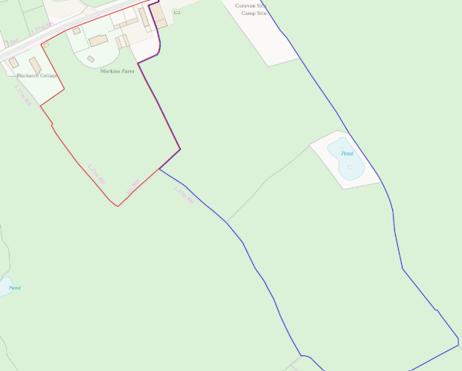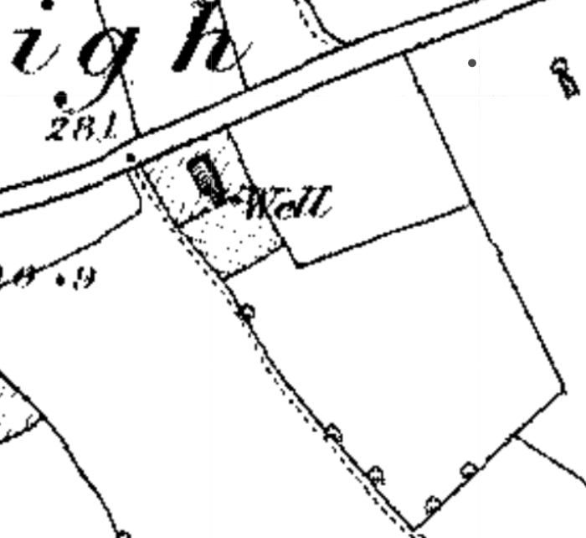
Location Plan and 1st epoch mapping

1st epoch mapping (1868-1899) shows nearest neighbour Blackacre Cottage, which historic maps show were once two cottages, and which is considered a NDHA. This cottage is included at the edge of the historic settlement of Bradford Leigh, which retains its historic form and character. GII, early C19 no.102 Bradford Leight is approx. 200m to the west, Blackacre Cottage directly interrupting sightlines between.

Merkins Farm to the east, including the holiday cottages which were a residential conversion of agricultural barns, is modern in character.

The proposal site is over 25m from a metalled road (approx. 42m), 33m from Blackacre Cottage, and 30m from the holiday cottages.

Public Right of Way SWRA23 runs south from Blackacre Cottage to Holt.

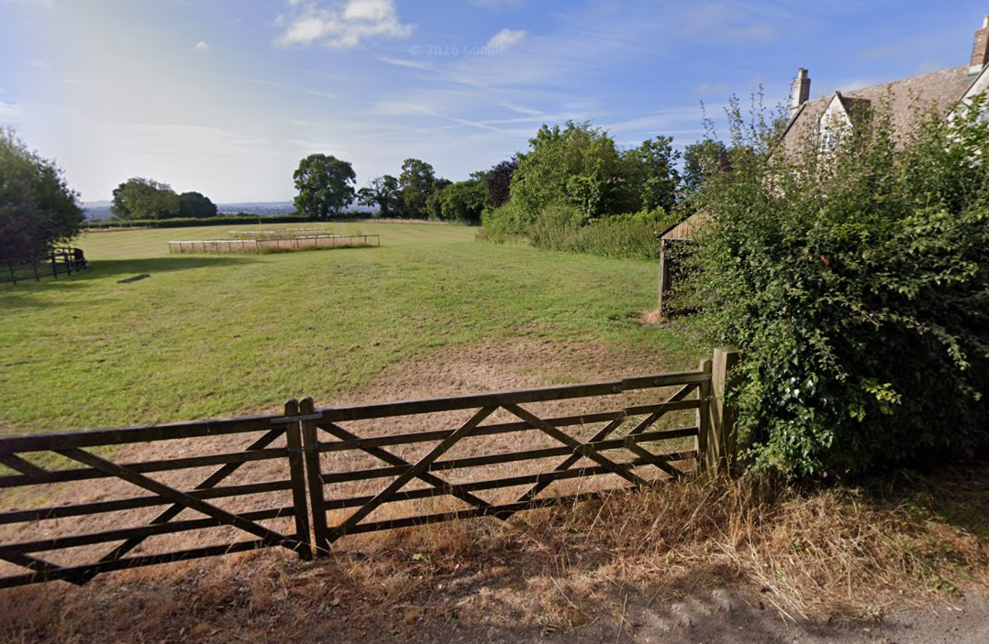
Blackacre Cottage faces directly towards Merkins Farm, with the proposal site seen here fenced.

The Merkins farm café started in 2011, having evolved from a previous caravan and camping business, which was closed in response to the burgeoning Farm Café business. The café is a converted steel portal framed agricultural building.

PROPOSAL
The proposal is for a steel-framed agricultural building for the storage of agricultural machinery, tools, equipment and hay.

The proposed building would be 13.7m long, 9.1m wide (124.7m²), 3m to eaves, 4.5m to ridge.

Proposed materials include a 900mm brick plinth with Yorkshire boarding to eaves, under a brown corrugated fibre cement sheets.

It is noted that this application does not include details of an access track.

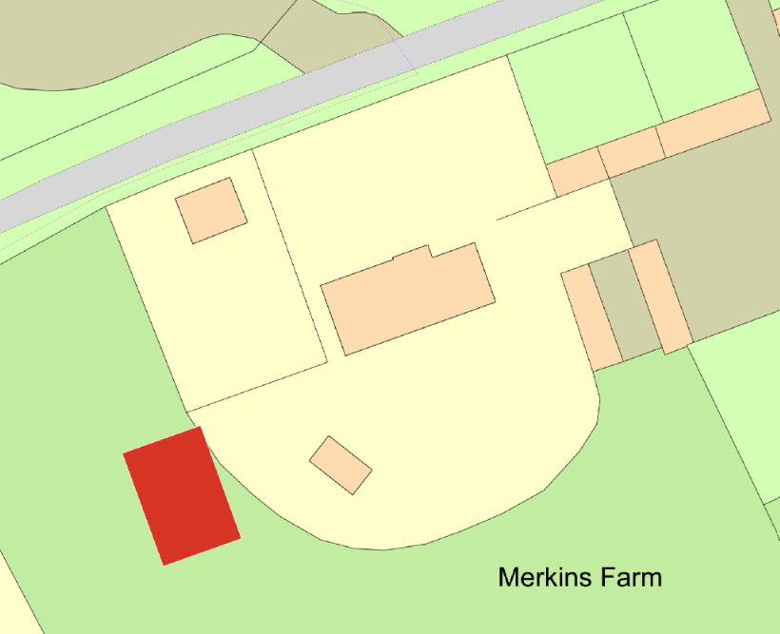
Proposed Block Plan

RELEVANT PLANNING HISTORY
18/00762/ENF - Unauthorised development - Merkins Farm Leigh Road Holt Bradford On Avon Wiltshire BA15 2RW – PD - as per 18/05367/APD – north of Merkins Farm
19/00061/ENF - Unauthorised agricultural building - Land to the North of Merkins Farm Leigh Road Holt Bradford On Avon Wiltshire BA15 2RW – no breach – as per 18/05367/APD – agricultural building for storage of fodder and machinery – north of Merkins Farm
21/00041/ENF - Unlawful extension/erection of a barn and use for housing cattle - Merkins Farm Leigh Road Holt Bradford On Avon Wiltshire BA15 2RW – temporary use for TB quarantine
ENF/2021/00253 - Possible unauthorised use of barn to house stock - MERKINS FARM, LEIGH ROAD, HOLT, BRADFORD ON AVON, BA15 2RW – No breach of the PD conditions that the barn was erected under – use of hay storage – this barn is now the holiday cottages
ENF/2022/00234 - Possible unauthorised use of site - no exemption license binding the land - CARAVAN SITE, MERKINS FARM, LEIGH ROAD, HOLT, BRADFORD ON AVON, BA15 2RW – No breach - camping business closed
W/04/02032/FUL - Full planning permission Decision - Approve with Conditions Date: 8/12/2004 – Proposed replacements front roof and proposed porch – Merkins Farm
W/04/02314/FUL - Full planning permission Decision - Approve with Conditions Date: 14/2/2005 – Change of use and associated conversion works to develop two agricultural storage barns into 3 holiday units – Barns at Merkins Farm
17/11606/FUL - Retrospective change of use from a redundant agricultural building to a cafe (A3) – approve with conditions – Merkins Café

RELEVANT LEGISLATION, POLICY AND GUIDANCE
This application is assessed under Article 3 of the Town and Country Planning (General Permitted Development) (England) Order 2015 (as amended), which grants planning permission for certain types of development described in Schedule 2 of the Order. The grant of permission is subject to the limitations, conditions, and provisions set out within the relevant Classes of permitted development.

Under Schedule 2, Part 6, Class A of the Town and Country Planning (General Permitted Development) (England) Order 2015 (as amended), certain types of agricultural development may be permitted, including:

- The erection, extension, or alteration of a building;
- The formation or alteration of a private way;
- Excavations or the deposit of waste material (where the relevant area exceeds 0.5 hectares);
- The placing or assembly of a tank in any waters.

Where such development is proposed, the developer is required to apply to the local planning authority for a determination as to whether prior approval is needed. This prior approval process is limited in scope and relates only to the following matters:

- The siting, design, and external appearance of the building;
- The siting and means of construction of the private way;
- The siting of the excavation or deposit;
- The siting and appearance of the tank.

ASSESSMENT

Does the Proposal Qualify as Permitted Development?
Having completed the detailed assessment checklist at Appendix 1 of this report, it is concluded that the proposed development does not qualify as permitted development under Schedule 2, Part 6, Class A of the Town and Country Planning (General Permitted Development) (England) Order 2015 (as amended).

Necessity

The permitted development regulations provide for new agricultural buildings where they are reasonably necessary for the purposes of an agricultural unit.

The proposal site is a greenfield primarily currently used as amenity land and not cultivated for a crop. The entire 8ha is connected to Merkins Farm Café, a very successful farm café, with holiday accommodation, however this is not primarily an agricultural use but instead at best mixed use/sui generis use class and not primarily working farm and agricultural holding.

Two fields are perennial cropping grassland (although one is used as amenity land and regularly mown), with the third field an annual arable crop, but on a small scale. The proposed barn would be located by the private amenity land and not beside the cultivated field. The proposal does not include details of tracks from the highway or within the site to the cultivated land.

Planning history includes agricultural barns stated to be redundant to the agricultural unit, converted for holiday let use, and for the farm café building itself. The application is not supported by any additional information to provide evidence of reasonable necessity. The need to store machinery is understood but without livestock in the farm holding there appears little reason for the storage of hay.

The siting, design, and external appearance of the building

The proposed barn would be located within West Wiltshire Green Belt.

Paragraph 142 of the NPPF, included here for reference only, states, ‘The government attaches great importance to Green Belts. The fundamental aim of Green Belt policy is to prevent urban sprawl by keeping land permanently open; the essential characteristics of Green Belts are their openness and their permanence.’

The proposal is for an agricultural barn to be sited less than 35m to the two nearest residential neighbours.

The proposed materials are considered appropriate to the location however a 900mm plinth is unusual and costly for an agricultural building with ramifications for ventilation and crop storage.

The site is 40m from a public highway, such that a barn in this location would result in material harm to and a detrimental visual impact on the open verdant landscape in this particular location from the highway and also the nearby PROW, as well as the two dwellings. At the proposed scale and siting, the proposed barn would be highly visible from the highway and not integrate within the wider landscape character or landform and is considered obtrusive and conspicuous especially when there are other locations that would be much more suitable for an agricultural barn of this type.

The application is stated as being for storage of machinery and hay but no access is evident and no access track is proposed so it is unclear how the building would be accessed. Furthermore, expensive agricultural machinery stored in such proximity to and in full view from to the public highway could invite theft and may encourage antisocial behaviour.

CONCLUSION
The proposed development has been assessed against the provisions, limitations, and conditions set out in Schedule 2, Part 6, Class A of the Town and Country Planning (General Permitted Development) (England) Order 2015 (as amended). Based on the submitted plans, supporting documentation, and the findings of this report, it is concluded that the proposal does not comply with the criteria for permitted development and therefore falls within the scope of Class A.

Having considered the relevant matters, it is concluded that the proposal fails to demonstrate that it is a working agricultural holding, and fails to provide sufficient evidence that a new agricultural building in this location is reasonably necessary for the workings of an agricultural unit. Furthermore, the building would not be acceptable in terms of its proposed siting. It is considered by the Local Planning Authority that for these reasons, prior approval is required, has been assessed and is consequently refused on the basis of the above.

RECOMMENDATION:
That prior approval be REFUSED.

A
APPENDIX 1 – PERMITTED DEVELOPMENT CHECKLIST
 | Permitted Development | Yes / No
A | Does the proposal involve the carrying out, on agricultural land forming part of an agricultural unit of 5 hectares or more, of either:  (a) works for the erection, extension, or alteration of a building; or  (b) any excavation or engineering operations,  which are reasonably necessary for the purposes of agriculture within that unit? | Reasonable necessity not demonstrated
Criteria (A.1) – Development not permitted by Class A:
(a) | Is the development proposed to be carried out on a separate parcel of land forming part of the agricultural unit that is less than 1 hectare in area? | No
(b) | Would the development consist of the erection or extension of any agricultural building on an established agricultural unit where development under Class Q or Class S of Part 3 (changes of use) has been carried out within the last 10 years? | No – retrospective PP for residential conversion of an agricultural barn approved
(c) | Would the development consist of, or include, the erection, extension, or alteration of a dwelling? | No
(d) | Would it involve the provision of a building, structure or works not designed for agricultural purposes? | No
(e)(i) | Would the ground area covered by any works or structures (excluding fences) for accommodating livestock or plant/machinery arising from engineering operations exceed 1,000 square metres? | No
(e)(ii) | Would the ground area of any building erected, extended, or altered under Class A exceed 1,500 square metres? | No
(f) | Is any part of the proposed building, structure, or works within 3 kilometres of the perimeter of an aerodrome and would exceed 3 metres in height? | No
(g) | Is any part of the proposed building, structure, or works not within 3 kilometres of an aerodrome and would exceed 12 metres in height? | No
(h) | Would any part of the development be within 25 metres of a metalled part of a trunk road or classified road? | No
(i) | Would the development consist of, or include, the erection or construction of, or works to, a building, structure, or excavation used or intended for the accommodation of livestock or storage of slurry/sewage sludge, and be within 400 metres of the curtilage of a protected building? | No
(j) | Would the development involve excavations or engineering operations on or over article 2(4) land that are connected with fish farming? | No
(k)(i) | Would any building for storing fuel for or waste from a biomass boiler or anaerobic digestion system be used for storing waste not produced by that system or fuel not produced on land within the unit and be within 400 metres of the curtilage of a protected building? | No
(k)(ii) | Would any building for storing fuel for or waste from a biomass boiler or anaerobic digestion system and be within 400 metres of the curtilage of a protected building? | No
(l) | Would the erection or extension of a building be carried out on land or a building that is, or is within the curtilage of, a scheduled monument? | No

